Supplementary Material
NOTCH1 collaborated with innate immune to regulate genomic instability caused by epigenetic enzyme deletion in cold tumor
Xiaojun Duan^{1,2}，Mingyang Zhang¹，Kexin Li¹，Rihan Wu³，Lei Yu¹，Jing Bai¹，Pengxia Liu¹，Changshan Wang^{1,}*
* Correspondence: Changshan Wang, changshanwang@imu.edu.cn

Supplementary Figures

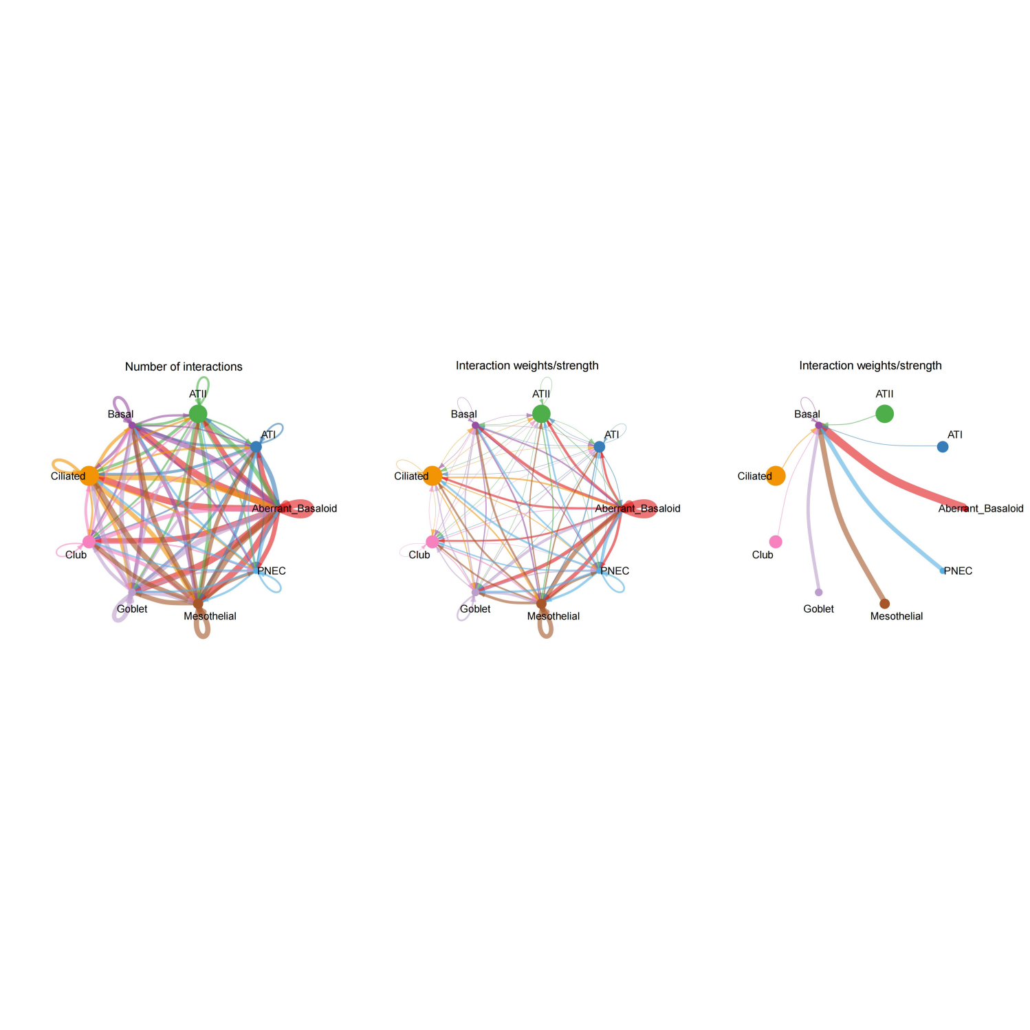
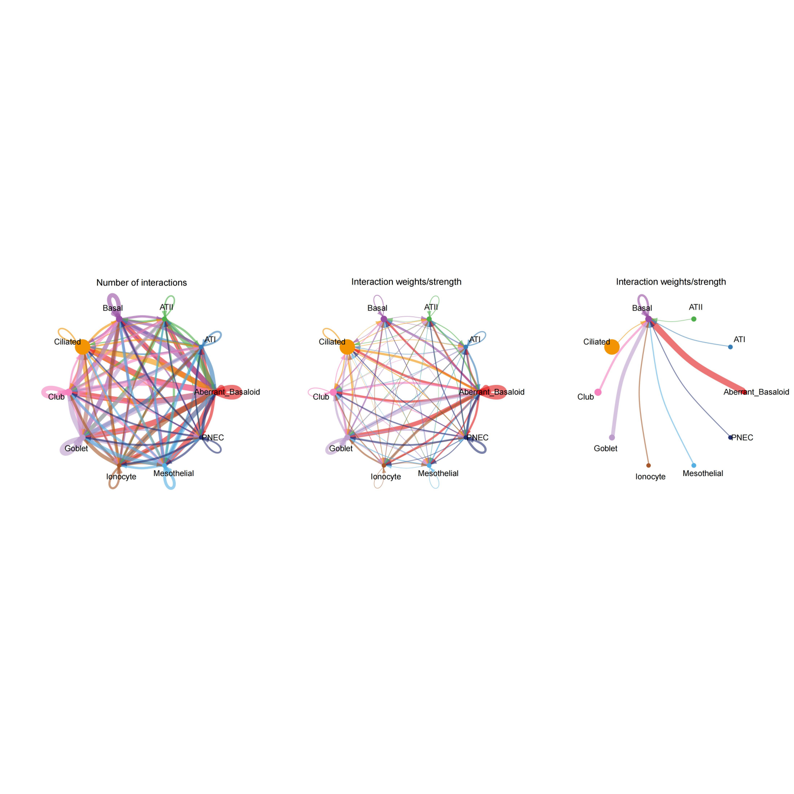
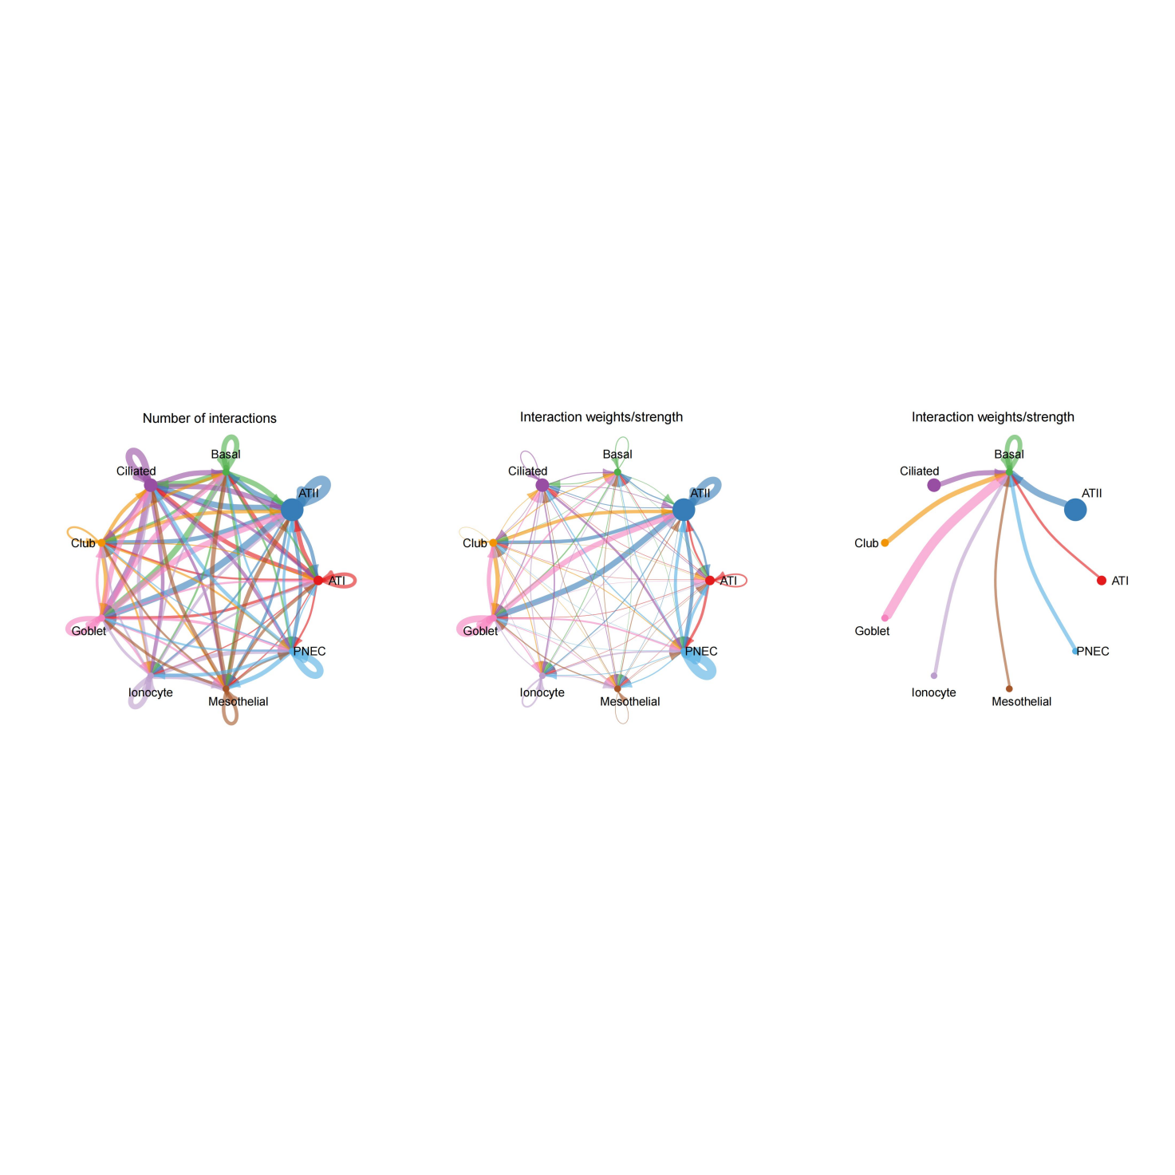
Supplementary Figure 1. Cell communication analysis of the GSE136831 showed the interaction between cells of nomal, COPD, IPF respectively.

nomal

Supplementary Figure 2. The expression of NOTCH1 was activited in basal Cell of ILD .
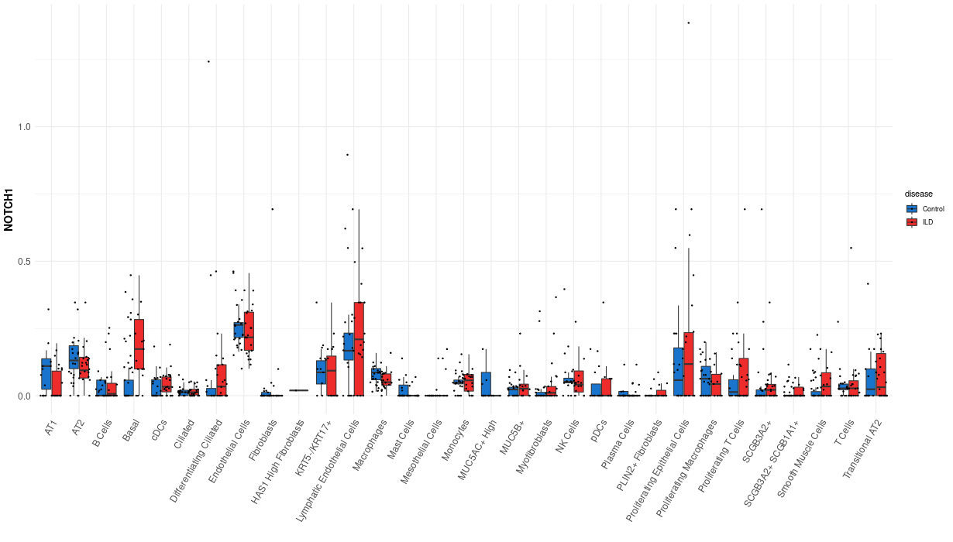

Supplementary Figure 3. The NOTCH1 singnal was activited in cells of nomal, COPD, IPF respectively .
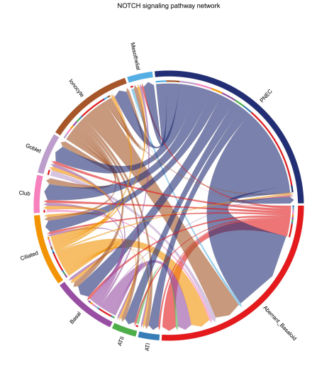
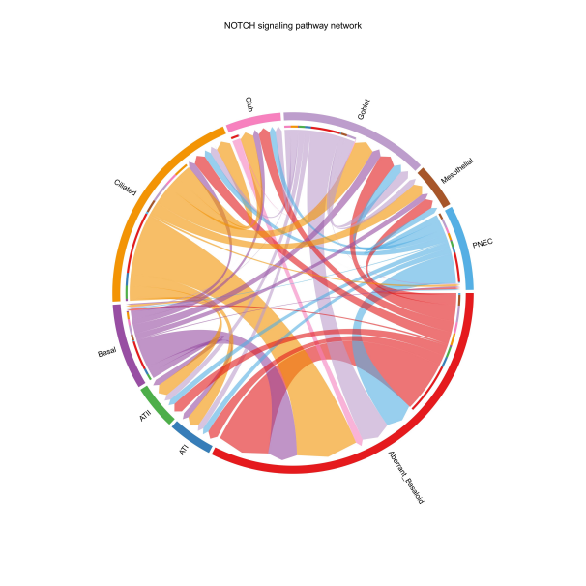
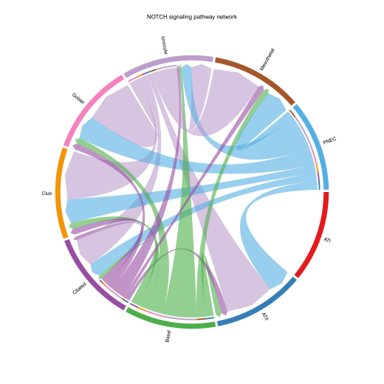

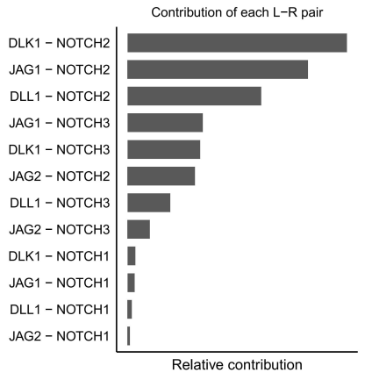
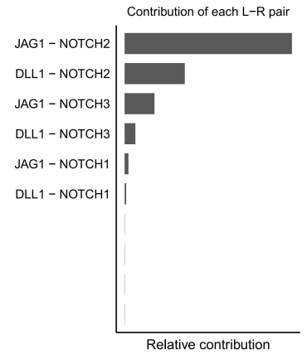
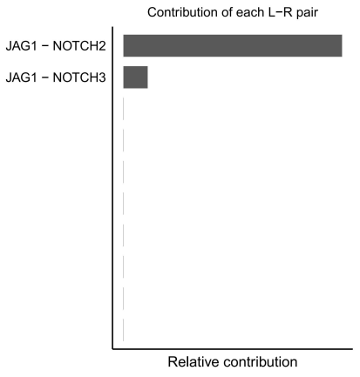

Supplementary Figure 3. The expression of NOTCH1 singnal in airway epithelial cell of IPF .

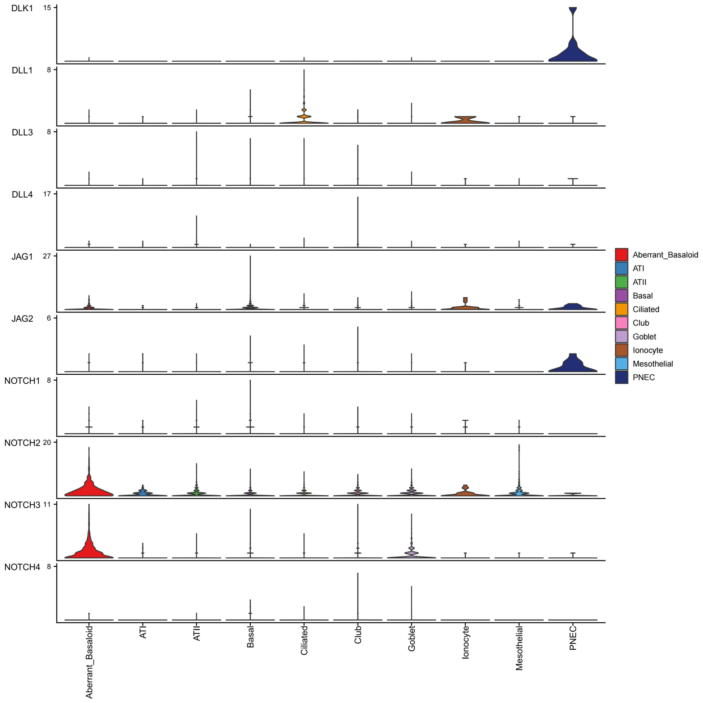

Supplementary Figure 4. The heat map of metabolites in si-NOTCH1 and nc cells.

