Facile preparation of 3D porous graphene-based composite hydrogels doped with different ratios of MXene for MB adsorption
Yaning Wang^{b}, Xiaoxia Yan^{b}, Yuxi Wang^{b}, Kai Yang^{b}, Fei Lin^{a,*}, Jiefen Shen^{b}, Xuming Sun^{b,c}, Zhigang Chen^{a,*}, Wenshuai Jiang^{a,b,c,d,*}
ª The First Affiliated Hospital of Xinxiang Medical University, Xinxiang, Henan 453003, People's Republic of China
^{b} School of Medical Engineering, Xinxiang Medical University, Xinxiang, Henan 453003, People's Republic of China
^{c} Xinxiang Key Laboratory of Neurobiosensor, Xinxiang, Henan 453003, People's Republic of China
^{d} Henan Engineering Technology Research Center of Neural Sensing and Control, Henan 453003, People's Republic of China
Corresponding author. E-mail addresses: linfeixixi@aliyun.com (Fei Lin); 1fy2000129@xxmu.edu.cn (Zhigang Chen); 171024@xxmu.edu.cn (Wenshuai Jiang).

Figure S1- Figure S9

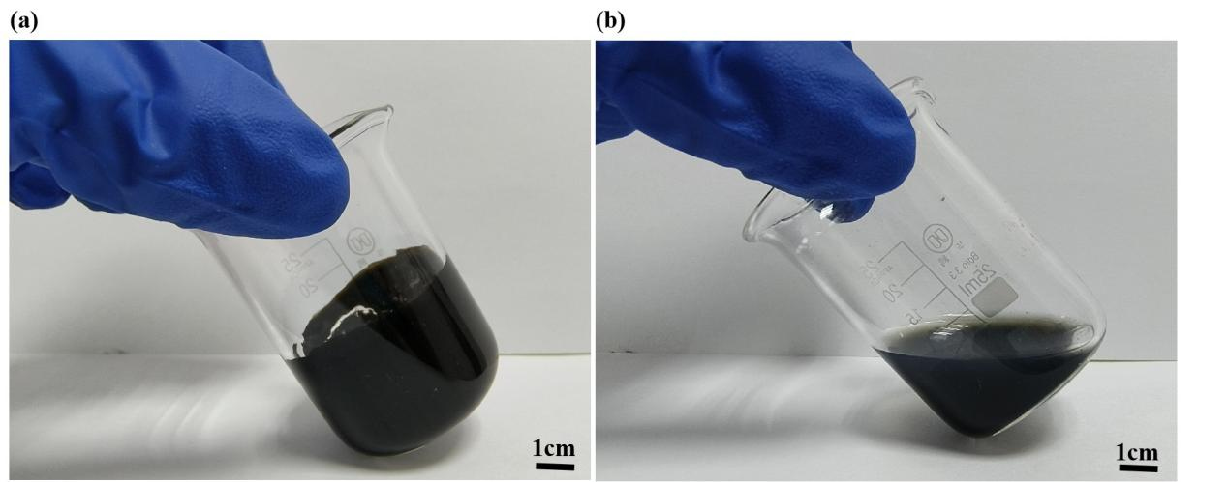
FigureS1.（a）GO;(b)MXene
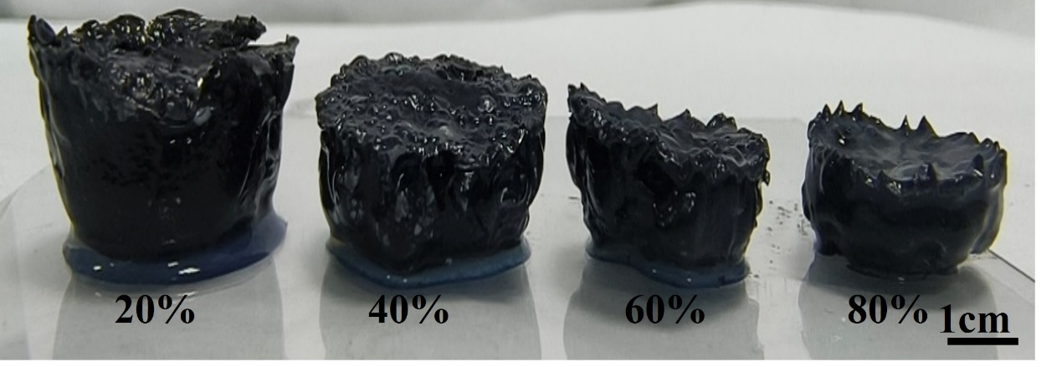
Figure S2. Digital photographs of 3D graphene@MXene composite hydrogels with different MXene contents

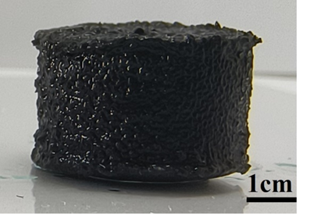
Figure S3. Pure graphene composite hydrogels
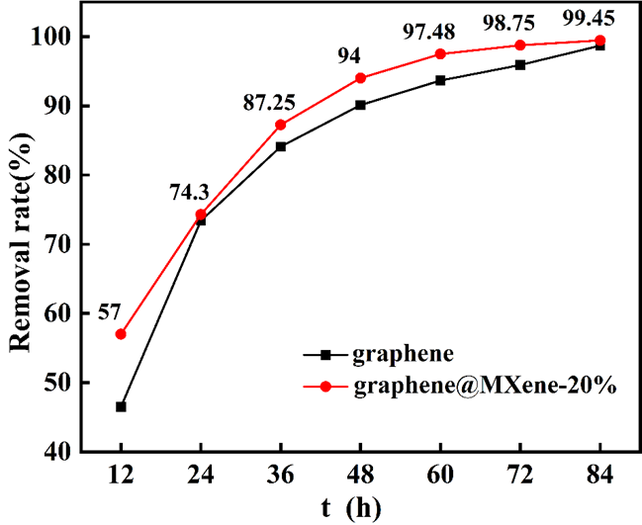
Figure S4. MB adsorption based on graphene hydrogels and Graphene@MXene composite hydrogels.

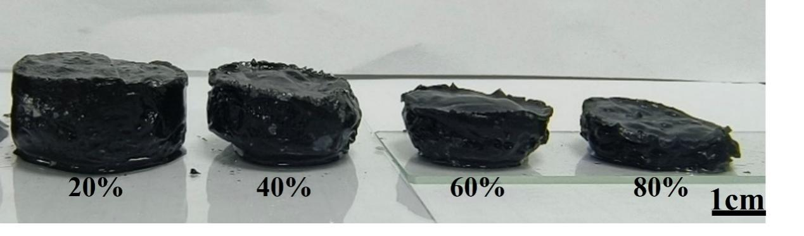
Figure S5. Digital photographs of Calcium ion-regulated graphene@MXene composite hydrogels with different MXene contents

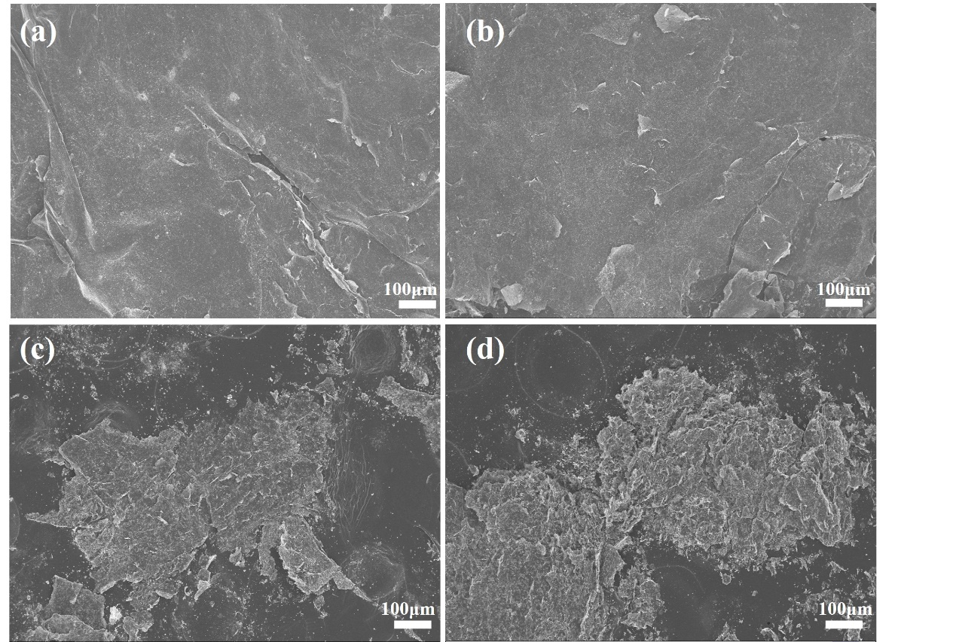
Figure S6. SEM of Ca²⁺regulated graphene@MXene composite aerogels
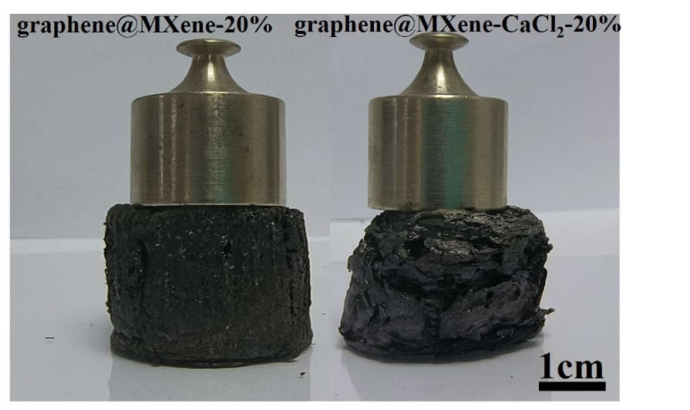
Figure S7. Elasticity test results of composite aerogels prepared before and after Ca²⁺ introduction.

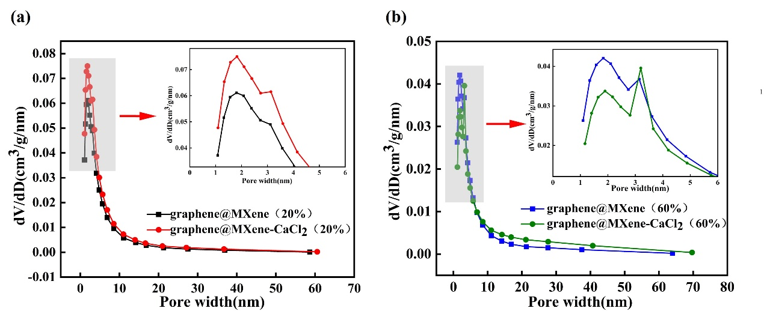
Figure S8. Changes in pore size of composite hydrogels prepared before and after Ca²⁺introduction

Figure S9. Luminescence spectra of MXene films under microwave irradiation.

Table S1-Table S2
TableS1. Sheet resistance of graphene@MXene composite membranes with different MXene contents. (50℃, heating 3h)
MXene contents | Sheet resistance
0% | 0
20% | 6.18 ± 1.69 MΩ/□
40% | 377.8 ± 46.8 KΩ/□
60% | 131.6 ± 27.6 KΩ/□
80% | 405.2 ± 95.5Ω/□
100% | 2.60 ± 0.6Ω/□

Table S2. Sheet resistance measurements of graphene@MXene aerogels with different MXene contents.
MXene contents | Sheet resistance
20% | ~321.6 KΩ/□
40% | ~ 28.7K Ω/□
60% | ~578.2 Ω/□
80% | ~54.9 Ω/□

