Supporting Information

Quantitative semen analysis using fluorometric lateral-flow assay system for male fertility diagnosis

Il-Hoon Cho^{a,b,⊥}, Jisuk Lee^{b,⊥}, Jin Hyun Jun^{a,b}, Ulhas S. Kadam^{c}, Seung-Hun Song^{d,†}, and Dong Hyung Kim^{e,f,†}

ª Department of Biomedical Laboratory Science, College of Health Science, Eulji University, Seongnam, Republic of Korea
^{b} Department of Senior Healthcare, Eulji University, Seongnam, Republic of Korea
^{c} Division of Life Science and Division of Applied Life Science (BK21 Four), Plant Molecular Biology and Biotechnology Research Center, Gyeongsang National University, Jinju, Gyeongnam, 52828, Republic of Korea
^{d} Department of Urology, Fertility Center, CHA Gangnam Medical Center, CHA University
^{e} Division of Biomedical Metrology, Korea Research Institute of Standards and Science, 267 Gajeongno, Yuseong-Gu, Daejeon 34113, Republic of Korea
^{f} KRISS School, University of Science and Technology (UST), 217 Gajeong-ro, Yuseong-gu, Daejeon 34113, Korea

⊥ These authors equally contributed to this research.

† These authors are corresponding authors
E-mail address: shsong02@cha.ac.kr (S.H. Song); donghyung.kim@kriss.re.kr (D.H. Kim)

Table S1. Comparison of the current results with the analytical performance of Commercial products for measuring sperm concentrations
Product | Detection | Method  (Materials) | Time | Accuracy  (%) | Analysis format  (Detection range) | Price | Ref.
Sperm Check | Sperm concentration | Colorimetric  (AuNPs*) | 10 ~ 15 min | 98 | Qualitative  (5x10⁶/mL and  20x10⁶/mL) | US $39.99 | ¹
Sperm OK | Sperm concentration | Colorimetric  (AuNPs) | 10 ~ 15 min | 95 | Qualitative  (15x10⁶/mL) | SGD $58.00 | ²
Fetell | Motile sperm concentration | Colorimetric  (AuNPs) | 1 hour | 95.3 | Qualitative  (10x10⁶/mL) | US $57.63 | ³
Swim Count | Motile sperm concentration | Colorimetric  (MTT**) | 1 hour | 95 | Qualitative  (3x10⁶/mL, 17x10⁶/mL and 30x10⁶/mL) | US $49.99 | ⁴
YO | Motile sperm concentration | Video  (Smartphone) | 13 min | 97 | Qualitative | US $79.95 | ⁵
O'VIEW-M PRO | Motile sperm concentration | Image  (Smartphone) | 20 min | 84.6 | Qualitative | ₩ 79,000 | ⁶
FLF | Sperm concentration | Fluorescent  (Alexa Fluor 647) | 15 min | 100 | Quantitative  (1.8x10⁶/mL ~ 140x10⁶/mL) | US $2 | This work
* AuNP, gold nanoparticles
** MTT, 3-(4 5-dimethylthiazol -2-yl)-2 5-diphenyltetrazolium bromide

Table S2. Contingency table comparing the Makler Counting Chamber test and the FLF-sperm system for sperm concentrations
Predicted FLF-sperm system | Actual FLF-sperm system |  | Total
Predicted FLF-sperm system | Negative | Positive | Total
Negative | 25 | - | 25
Positive | - | 55 | 55
Total | 25 | 55 | 80

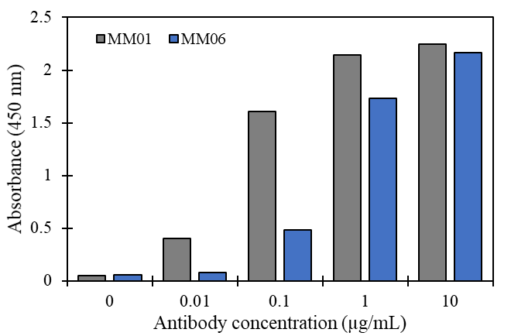
Figure S1. Binding properties of monoclonal antibodies specific to the SP-10 analyte. The binding reactions of the monoclonal antibodies (MM01 and MM06) were measured on the well plate coated with SP-10 antigen.
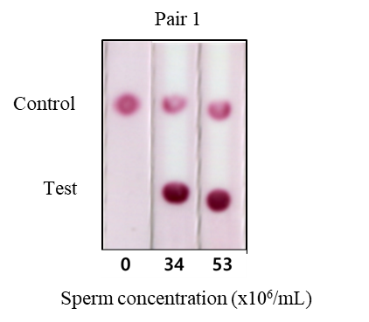
Figure S2. Reliability of the sandwich antibody pair specific to the SP-10 analyte: The selected antibody pair (Pair 1) was assessed for its reliability in specifically responding to the SP-10 biomolecule using the gold nanoparticle-assisted LFA in clinical semen samples. The azoospermia samples were used as a blank to monitor non-specific binding interactions.
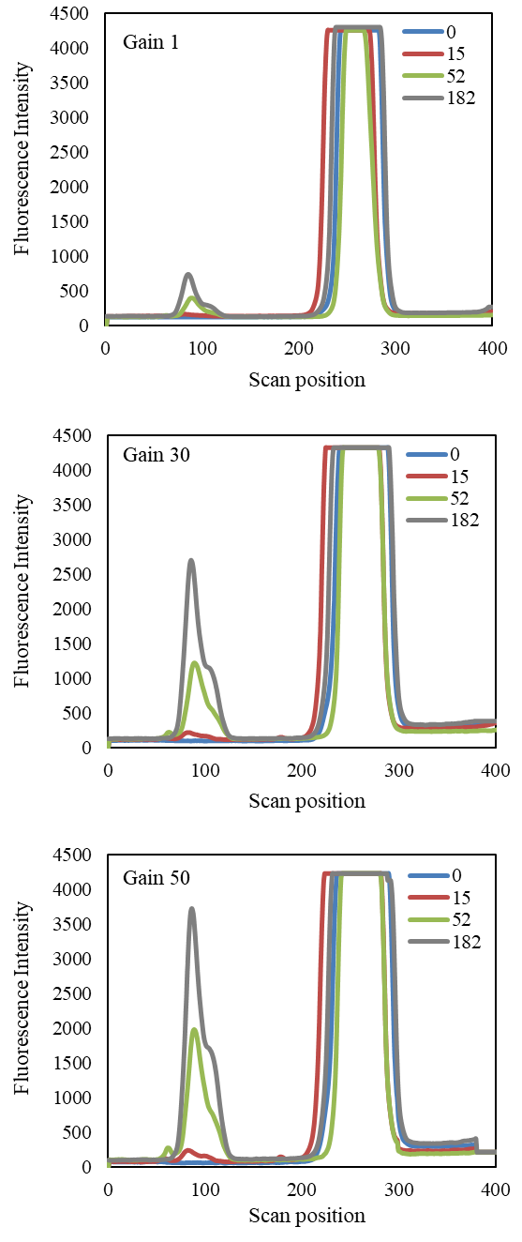
Figure S3. Profile of fluorescent intensity at different detector gains: The fluorescent signals were detected with various detector gains, digitized, and plotted to show the intensity profiles of different SP-10 concentrations along the vertical direction in an overlaid fashion.

References
1. Coppola, M. A. et al. SpermCheck® Fertility, an immunodiagnostic home test that detects normozoospermia and severe oligozoospermia. Human Reproduction 25, 853–861 (2010).
2. Male Fertility Sperm Test For Home Use Instructions for Use Cassette. Cat. No. A01-06-422.
3. Björndahl, L., Kirkman-Brown, J., Hart, G., Rattle, S. & Barratt, C. L. R. Development of a novel home sperm test. Human Reproduction 21, 145–149 (2006).
4. Yoon, Y. E. et al. Validation of SwimCountTM, a novel home-based device that detects progressively motile spermatozoa: Correlation with World Health Organization 5th semen analysis. World Journal of Men’s Health 38, 191–197 (2020).
5. Yu, S. et al. Emerging technologies for home-based semen analysis. Andrology 6, 10–19 (2018).
6. Park, M. J., Lim, M. Y., Park, H. J. & Park, N. C. Accuracy comparison study of new smartphone-based semen analyzer versus laboratory sperm quality analyzer. Investig. Clin. Urol. 62, 672–680 (2021).

