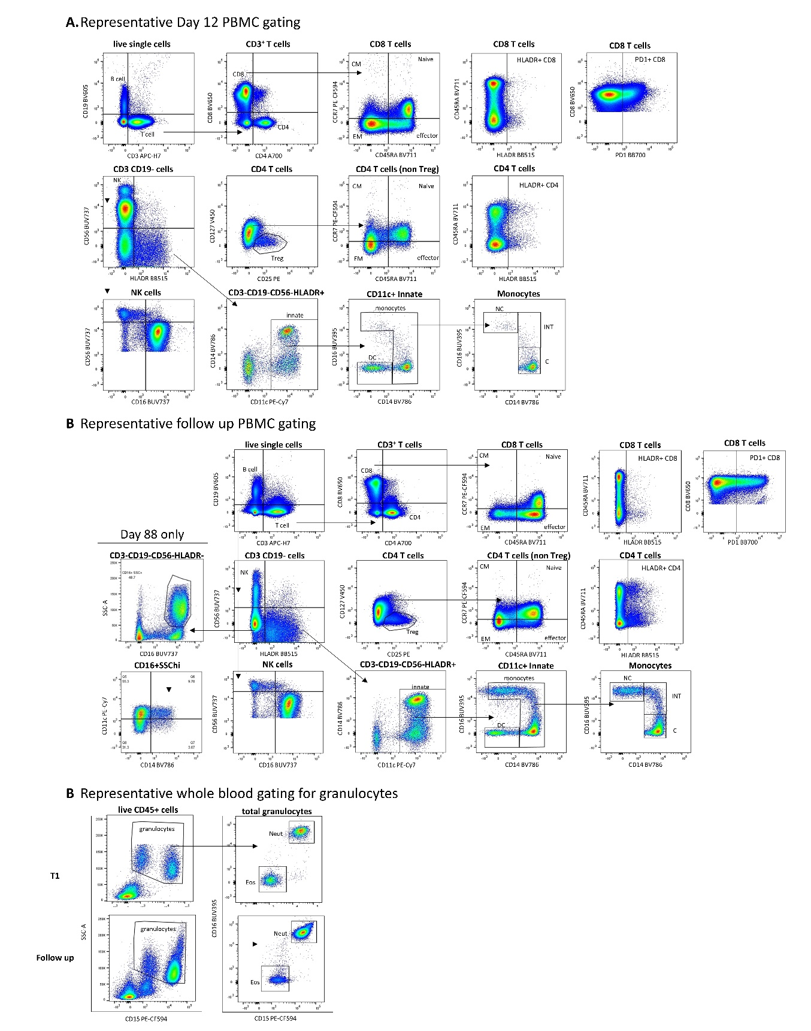

Extended Data Figure 1. Representative flow cytometry gating strategies for PBMC and whole blood at baseline and follow up. Within the PBMC fraction, B cells were selected based on CD19 expression, and the total T cell fraction based on CD3 expression. CD4 and CD8 T cells, and their naïve, effector, memory and regulatory (Treg) subsets were also quantified. HLADR⁺ and PD1⁺ T cells were investigated. CD3⁻CD19⁻ cells were classified into NK cells (CD56⁺) and innate cells (HLA-DR⁺). Within the innate cell fraction, CD14⁺ monocytes and CD11c⁺ DCs were identified. Monocyte and NK cell subsets were identified based on CD16 expression. Low density neutrophils were observed in the PBMC fraction at day 88 only, characterised by a high SSC profile, CD16, CD14 and CD11c expression. For whole blood, granulocytes were selected within CD45⁺ leukocytes based on their SSC profile and CD15 expression. Neutrophils were CD15⁺CD16⁺ and eosinophils were CD15⁺CD16⁻.
Extended Data Table 1. Flow cytometry antibody cocktails
Surface Marker | Fluorophore | Clone | Final Dilution
Whole blood panel
CD14 | BV786 | M5E2 | 1:50
CD11b | BUV805 | ICRF44 | 1:100
CD45 | BV711 | HI30 | 1:100
CD56 | BUV737 | NCAM16.2 | 1:100
CD11c | PE-Cy7 | B-ly6 | 1:100
CD63 | A647 | H5C6 | 1:100
CD4 | A700 | RPA-T4 | 1:100
CD3 | BB515 | VCHTI | 1:100
PD1 | BB700 | EH12.1 | 1:100
CD15 | PE-CF594 | W6D3 | 1:200
HLADR | V500 | G46-6 | 1:200
CD19 | BV605 | 5J25C1 | 1:200
CD8 | BV650 | RPA-T8 | 1:200
CD16 | BUV395 | 3G8 | 1:400
PBMC panel
CD25 | PE | M-A251 | 1:25
CD127 | V450 | HIL7RM21 | 1:50
CD3 | APCH7 | SK7 | 1:50
CD14 | BV786 | M5E2 | 1:50
CD45RA | BV711 | HI100 | 1:100
HLADR | BB515 | G46-6 | 1:100
CD56 | BUV737 | NCAM16.2 | 1:100
CD11c | PE-Cy7 | B-ly6 | 1:100
CD4 | A700 | RPA-T4 | 1:100
PD1 | BB700 | EH12.1 | 1:100
CCR7 | PE-CF594 | 150503 | 1:200
CD19 | BV605 | 5J25C1 | 1:200
CD8 | BV650 | RPA-T8 | 1:200
CD16 | BUV395 | 3G8 | 1:400

