Water Resources Research
Supporting Information for
Warmer Winter Under Climate Change Would Reshape the Winter Subsurface Drainage Pattern in Eastern Canada: A Bio-Physical Modeling and Machine Learning Approach
Ziwei Li¹, Zhiming Qi^{1, *}, Junzeng Xu^{2, *}, Yuchen Liu³, Ward N. Smith⁴, Andrew VanderZaag⁴, Keith Fuller⁵, Tiequan Zhang⁶, Birk Li^{1,6}, Haomiao Cheng⁷
¹Department of Bioresource Engineering, McGill University, Sainte-Anne-de-Bellevue, Quebec, Canada, H9X 3V9
²College of Agricultural Science and Engineering, Hohai University, Nanjing, China, 210024
³Department of Computer Science, Indiana University Bloomington, Bloomington, IN, United States, 47408
⁴Ottawa Research and Development Centre, Agriculture & Agri-Food Canada, Ottawa, Ontario, Canada, K1A 0C6
⁵Kentville Agricultural Research Centre, Agriculture and Agri-Food Canada, 32 Main Road, Kentville, Nova Scotia, Canada, B4N 1J5
⁶Harrow Research and Development Centre, Agriculture and Agri-Food Canada, Harrow, ON, Canada N0R 1G0
⁷School of Hydraulic Science and Engineering, Yangzhou University, Yangzhou, China, 225127
Corresponding author: Zhiming Qi (zhiming.qi@mcgill.ca (Z.Qi)), Junzeng Xu (xjz481@hhu.edu.cn(J.Xu))
†Corresponding author at McGill University, 21111 Lakeshore Road, Ste-Anne-de-Bellevue, QC H9X 3V9, Canada.
†College of Agricultural Science and Engineering, Hohai University, Nanjing, 210024, China

Contents of this file

Text S1 to S3
Figures S1 to S10
Introduction
The supporting information covers the overview of the RZ-SHAW model, and the four types of machine learning models used in the current study (Support vector machine, Cubist, Long short term memory model, Multilinear) from Text S1 to Text S2. In Text S3, the future meteorological conditions for each of the five sites at different time periods from 1950 to 2100 was described. From Figure S1 to S10, the future meteorological conditions and the machine-learning models simulated future winter subsurface drainage volume and frequency for each individual site was plotted.

Text S1. Overview of the RZ-SHAW model
The RZWQM2 is a comprehensive one-dimensional agricultural system model, designed to facilitate the simulation of water and nutrient movement and pesticide fate in agricultural soils under various management practices (Ahuja et al., 2000; Ma et al., 2012). Flerchinger et al. (1999) integrated simple routines for snow accumulation and melting into RZWQM. Later, to allow RZWQM to fully address winter hydrology and soil freeze-thaw dynamics, Flerchinger et al. (2000) incorporated the Simultaneous Heat and Water (SHAW) model into RZWQM. This addition, known as RZ-SHAW, enables the simulation of winter hydrology (with an on/off switch integrated into the original RZWQM2 model). The RZ-SHAW model can simulate the energy balance in the snowpack (RZ-SHAW defined, approximately 25 mm each layer) and soil layers (user-defined), soil freezing and thawing, snow depth (SD), and winter soil temperature (ST). In RZ–SHAW, soil water movement was simulated by RZWQM2 using the Green–Ampt infiltration equation and the Richards soil liquid water distribution equation (Ahuja et al., 2000).
The RZWQM2 model interchanges data with the SHAW model, including evaporation flux, soil liquid water content, and plant information, while receiving updates on soil temperature (ST), water content adjustments due to freeze-thaw processes, and energy balance components (Li et al., 2012; Ma et al., 2012). The SHAW model operates on hourly or sub-hourly timesteps for soil water redistribution, adopting the Clausius-Clapeyron equation to calculate the liquid water content in frozen soil, where the soil total water potential is related to the associated ST at a given layer (Flerchinger et al., 2012). In the current RZ-SHAW model, any soil water content exceeding the computed liquid water content is considered soil ice content (Flerchinger et al., 2012).
The subsurface drainage component was adapted from the DRAINMOD model in the RZ-SHAW model, based on Hooghoudt's steady-state equation as applied by Skaggs et al. (2012). Precipitation was assumed to be snow if the inputted air temperature was beneath 0°C (0°C was hardcoded in the current RZ-SHAW model as the air temperature threshold for identifying snowfall or rainfall). During snowmelt, the excess liquid water is routed through the snowpack through lag and attenuation coefficients, and the current RZ-SHAW does not consider the permeability of the snow layer. However, a set of lag attenuation empirical equations was adopted to determine the timing for the snowmelt water outflow. The influence of metamorphic changes of the snowpack compaction, settling and grain size on density and albedo were considered. Details of incorporating the RZ-SHAW and SHAW models in RZWQM2 are given by Flerchinger et al. (2000).

Text S2. Overview of the machine learning models

Text S2.1 Cubist model
The Cubist machine learning model is a rule-based model that combines decision trees with linear regression to make predictions (Kuhn, 2023). The model has been adopted and produced satisfactory performance in large-scale soil mapping (Khaledian and Miller, 2020; Mello et al., 2022), basin-scale hydrological flow (Worland et al., 2018); national-scale tile drainage volume modelling (Motarjemi et al., 2021) and hydrological partitioning of catchments (Cheng et al., 2022). It was developed as an extension of Quinlan's M5 model tree (Quinlan, 1992). It was designed to handle both regression and classification tasks. The model would construct decision trees and then derive linear regression models at the leaves of these trees. This approach allows the Cubist model to capture both the hierarchical structure of the data, as seen in decision trees, and the linear relationships among variables, as captured by linear regression. Kuhn (2023) introduced detailed descriptions of the model. The current study used the cubist package (ver. 0.1.2), based on the R wrapper, for winter daily subsurface drainage volume (${DV}_{daily}^{w }$) simulation (Aselin et al., 2024).

Text S2.2 Long Short-Term Memory Model
The Long Short-Term Memory Model (LSTM) is a type of recurrent neural network (RNN) popular in various simulation fields in recent decades in hydrological, agricultural, and environmental modelling. The LSTM model has been demonstrated to deliver outstanding performance in water quality simulation (Chen et al., 2024, Xie et al., 2024), large-scale dissolved oxygen simulation (Zhi et al., 2023); hourly time-resolution rainfall-runoff modelling (Xiang et al., 2020); large scale monthly baseflow modelling (Xie et al., 2022); Streamflow modelling for ungauged basins (Tang et al., 2023).
The model was designed to address the previous challenges of conventional RNNs in learning long-term time-series data. Conventional RNN struggled with vanishing gradients, as the influence of the input information disappeared as it moved to the next layer, making it unideal for long-time series data. As a result, Hochreiter and Schmidhuber (1997) developed the LSTM, an RNN with a unique structure and a memory cell that could maintain the information even under long periods. Each cell has three gates: an input gate that controls the feeding of the new information to the cell, a forget gate that controls whether to discard certain information in the cell and an output gate that controls the output from the gate to the LSTM network. As a result, the LSTM was more suitable for time-series forecasting than the conventional RNN (Van Houdt et al., 2020). In the current study, the Tensorflow package (ver.2.9.3, with native GPU support for the Windows operating system) was used for ${DV}_{daily}^{w }$ simulation (Abadi et al., 2016).

Text S2.3 Multilinear model
The multilinear model (or multilinear regression) is a traditional statistical model used for predicting objective variables as a linear combination of multiple categories of input variables. It is the extension of the linear regression to accommodate multiple input variables. The model assumes the relationship between the given input variables and the outcome was linear, and each type of input variable was assigned a coefficient for its contribution to predicting the outcome variable. Compared to the Cubist model and the LSTM introduced above, the multilinear model was more uncomplicated and straightforward and could not account for non-linear patterns and complex relationships. However, it has been demonstrated to be effective in modelling tasks where the input and output share a linear relationship: the prediction of large-scale runoff signatures (Zhang et al., 2018), large-scale deep drainage modelling (Wohling et al., 2012), streamflow prediction (Patel et al., 2016); urban water demand forecast (Adamowski et al., 2012). The current study used the Scikit-learn package (ver. 1.4.0) for multilinear modelling of the ${DV}_{daily}^{w }$ simulation (Scikit-learn, 2024a).

Text S2.4 Support vector machine model
The support vector machine (SVM) model was initially developed by Cortes and Vapink (1995) based on the statistical learning theory that could be used for classification and regression tasks. The model has been practiced for a long time in the field of hydrological problems. For instance, modelling of the groundwater flow rate (Kouadio et al., 2022), estimation of the soil hydraulic properties (Araya and Ghezzehei, 2019), and rainfall-runoff modelling in urban drainage (Granata et al., 2016). The preliminary goal of the SVM model was to establish decision boundaries in the feature space and separate the data points of different classes in the feature space as widely as possible. The key idea of the model was to maximize the margin between the closest points (also known as the support vectors) of different classes. SVM models can perform for linear and non-linear hyperplanes, which were proven to perform well for complex datasets.
The SVM could use different kernel functions to compute the dot product between two factors in each feature space to implicitly map the input data into a higher dimension without explicitly performing the transformation. As a result, SVM can be used for non-linear problems as it can find the linear separating hyperplane in the higher-dimensional space through kernel functions. There are generally three types of kernels: Linear, Polynomial and Radial Basis Function (RBF), where the first kernel was more appropriate for linearly separable problems, and the latter two were for separating the more complicated hyperplanes. The current study used SVM with the linear and the RBF kernel. Detailed descriptions of SVM models and their applications in hydrological modelling had been described by Raghavendra and Deka (2014). The current study used the Scikit-learn package (ver. 1.4.0) for SVM modelling of the ${DV}_{daily}^{w }$ simulation (Scikit-learn, 2024b).

Text S3. Meteorological conditions under climate change for the winter subsurface drainage sites
Overall, all sites experienced a gradual $T_{min}^{month}$ increase under future climates compared to the baseline across all winter months except November. The increase was more pronounced from January to April, ranging from 5.1 °C (January during NF) to 11.4 °C (February during FF). A similar pattern could be observed for the $T_{max}^{month}$, with a slightly lower increase, 0.7 °C (January during NF) to 10.8 °C (March during FF). For November, $T_{min}^{month}$ and $T_{max}^{month}$ demonstrated a decrease from 0.7 to 1.7 °C from NF to FF compared to baseline. Monthly total precipitation increased with the further future periods for all winter months (MF and FF had similar precipitation of 679 and 677 mm), with more increase occurring in November, January and March (average increase across all future periods of 41, 32, and 32 mm) compared to the December, February and April (average increase across all future periods of 7, 14, and 12 mm).

Figures.
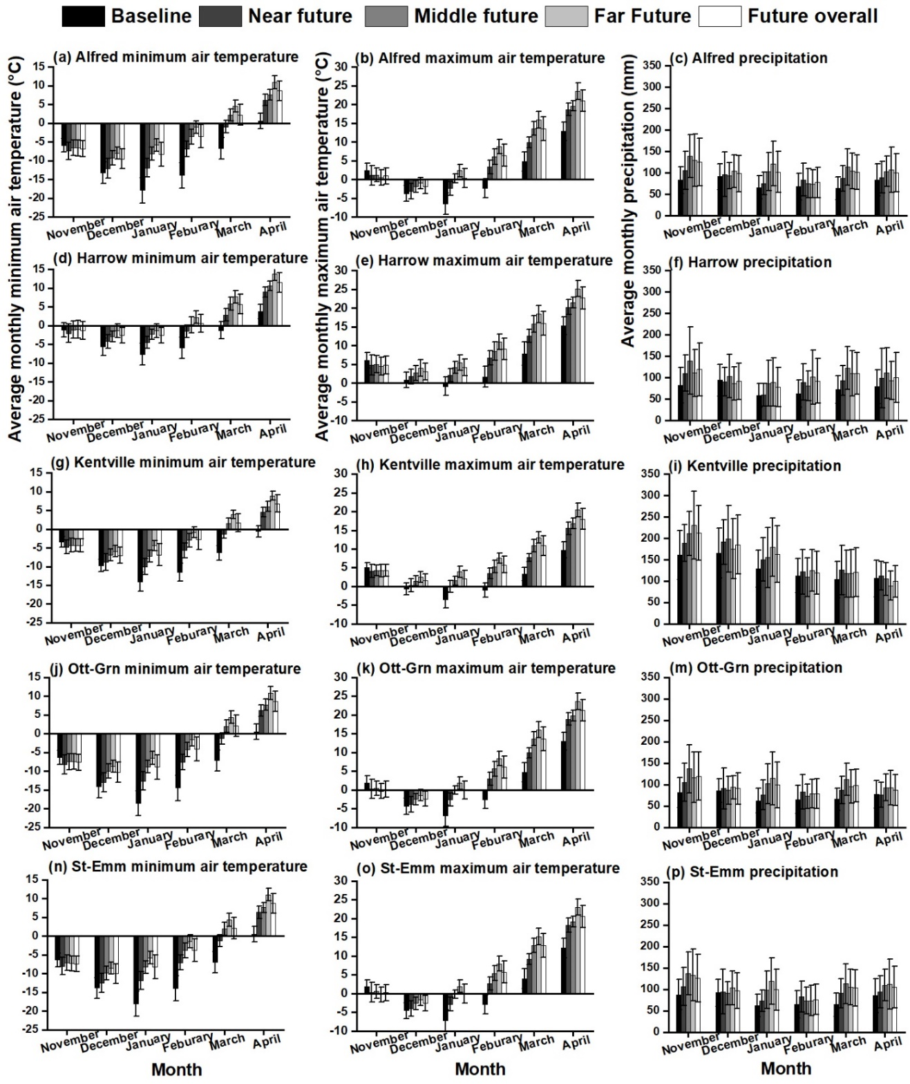
Figure S1. Monthly change in precipitation, maximum air temperature, minimum air temperature for each of the five croplands under the climate change scenario. The error bar represents the standard deviation.

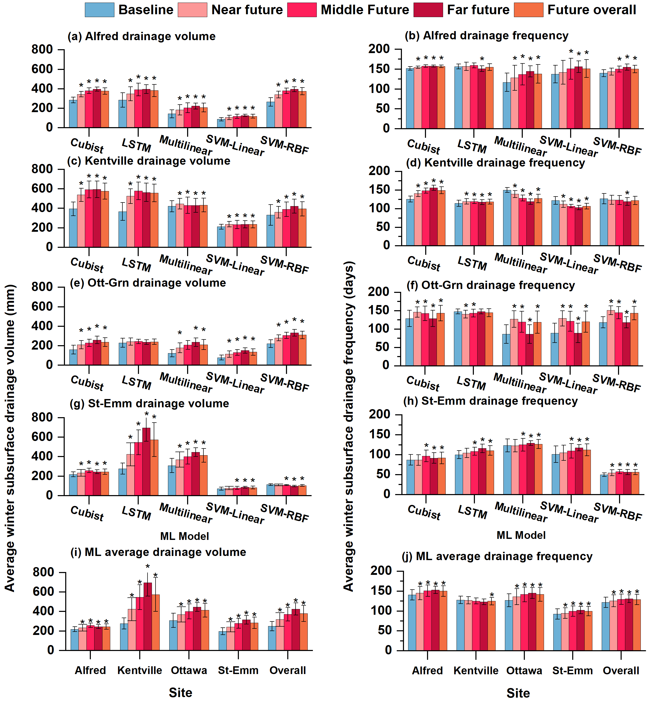
Figure S2. Machine learning (ML) models simulated average winter subsurface drainage volume and subsurface drainage frequency. for (a), (b), Alfred; (c), (d), Kentville; (e), (f), Ott-Grn; (g), (h), St-Emm; (i), (j), ML-average for each site and the average overall subsurface drainage volume and subsurface drainage frequency during different time periods of baseline (1950-2005), near future (2030-2050), middle future (2050-2070), far future (2070-2100), and future overall (2030-2100). The asterisk (*) above the bars indicates the data under that future period was significantly different from the baseline period under the 95% confidence interval. The error bar represents the standard deviation.

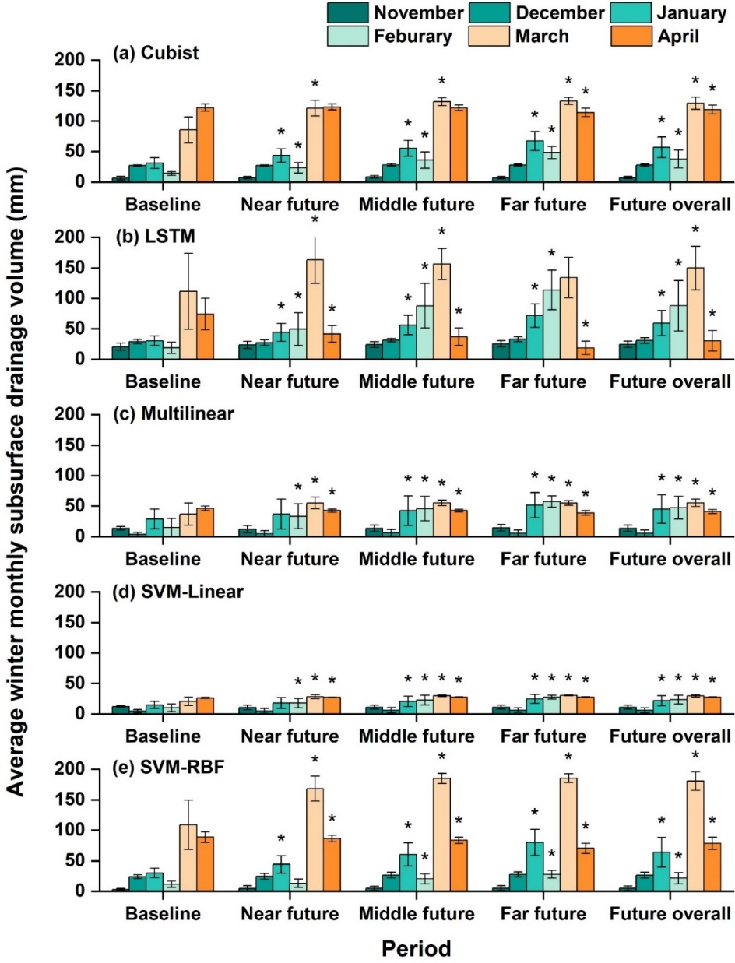
Figure S3. Machine learning (ML) models simulated average winter monthly subsurface drainage volume during different time periods of baseline (1950-2005), near future (2030-2050), middle future (2050-2070), far future (2070-2100), and future overall (2030-2100) for the site of Alfred using model (a) Cubist model, (b) LSTM model, (c) Multilinear model, (d) SVM-Linear model, (e) SVM-RBF model. The asterisk (*) above the bars indicates the data under that future period was significantly different from the baseline period under the 95% confidence interval. The error bar represents the standard deviation.
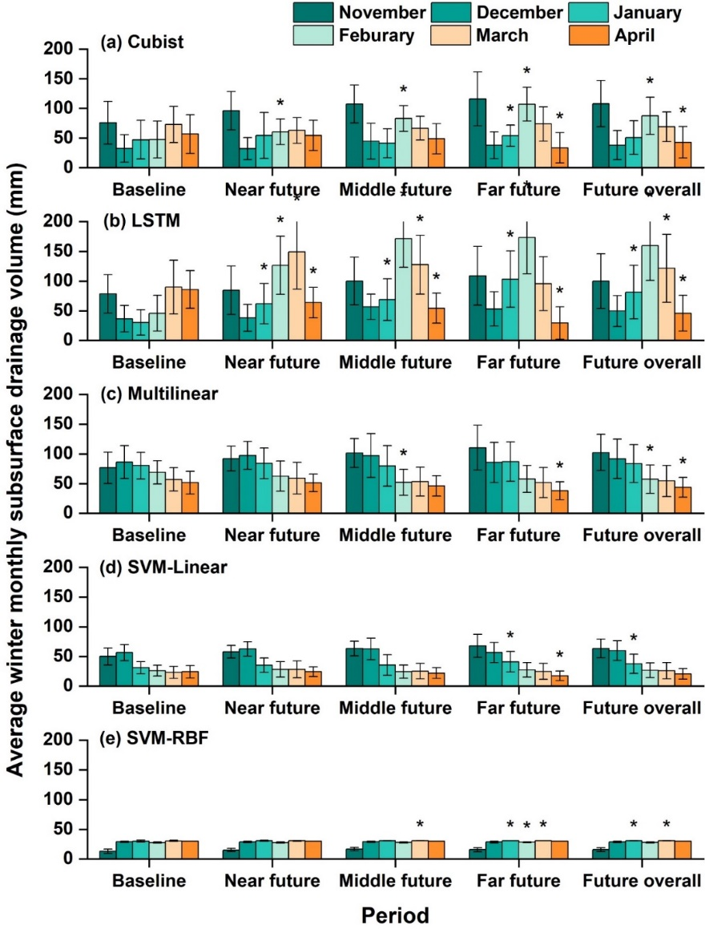
Figure S4. Machine learning (ML) models simulated average winter monthly subsurface drainage volume during different time periods of baseline (1950-2005), near future (2030-2050), middle future (2050-2070), far future (2070-2100), and future overall (2030-2100) for the site of Kentville using model (a) Cubist model, (b) LSTM model, (c) Multilinear model, (d) SVM-Linear model, (e) SVM-RBF model. The asterisk (*) above the bars indicates the data under that future period was significantly different from the baseline period under the 95% confidence interval. The error bar represents the standard deviation.
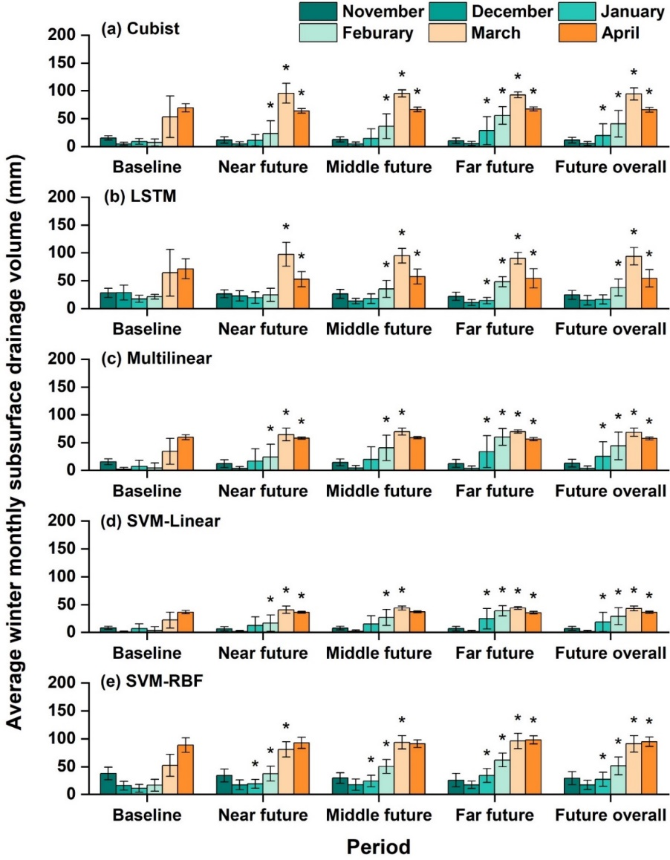
Figure S5. Machine learning (ML) models simulated average winter monthly subsurface drainage volume during different time periods of baseline (1950-2005), near future (2030-2050), middle future (2050-2070), far future (2070-2100), and future overall (2030-2100) from 1950 to 2100 for the site of Ott-Grn using model (a) Cubist model, (b) LSTM model, (c) Multilinear model, (d) SVM-Linear model, (e) SVM-RBF model. The asterisk (*) above the bars indicates the data under that future period was significantly different from the baseline period under the 95% confidence interval. The error bar represents the standard deviation.

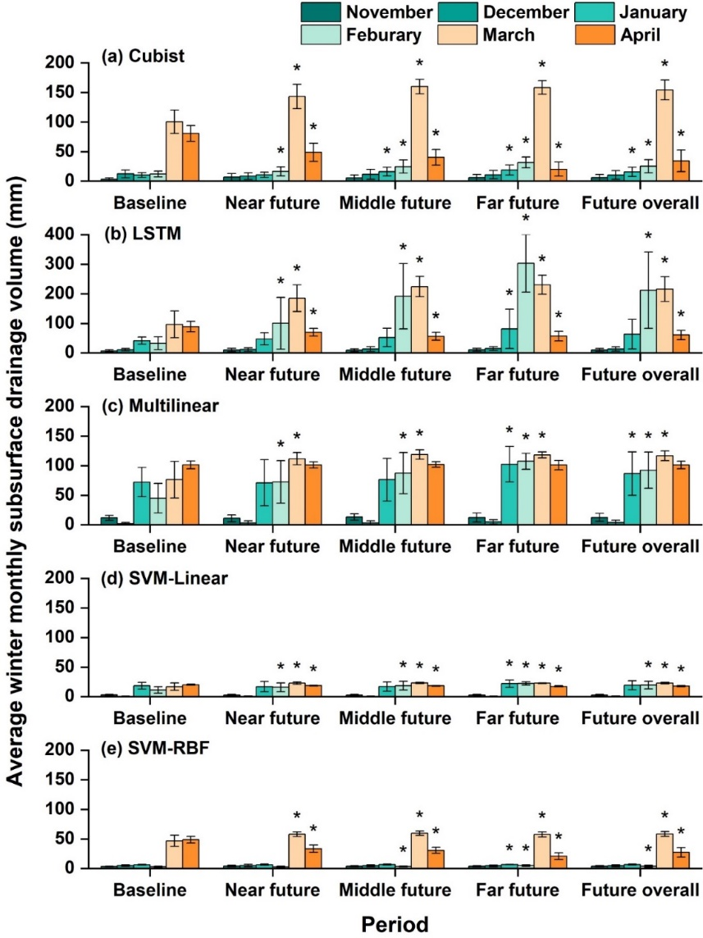
Figure S6. Machine learning (ML) models simulated average winter monthly subsurface drainage volume during different time periods of baseline (1950-2005), near future (2030-2050), middle future (2050-2070), far future (2070-2100), and future overall (2030-2100) from 1950 to 2100 for the site of St-Emm using model (a) Cubist model, (b) LSTM model, (c) Multilinear model, (d) SVM-Linear model, (e) SVM-RBF model. The asterisk (*) above the bars indicates the data under that future period was significantly different from the baseline period under the 95% confidence interval. The error bar represents the standard deviation.

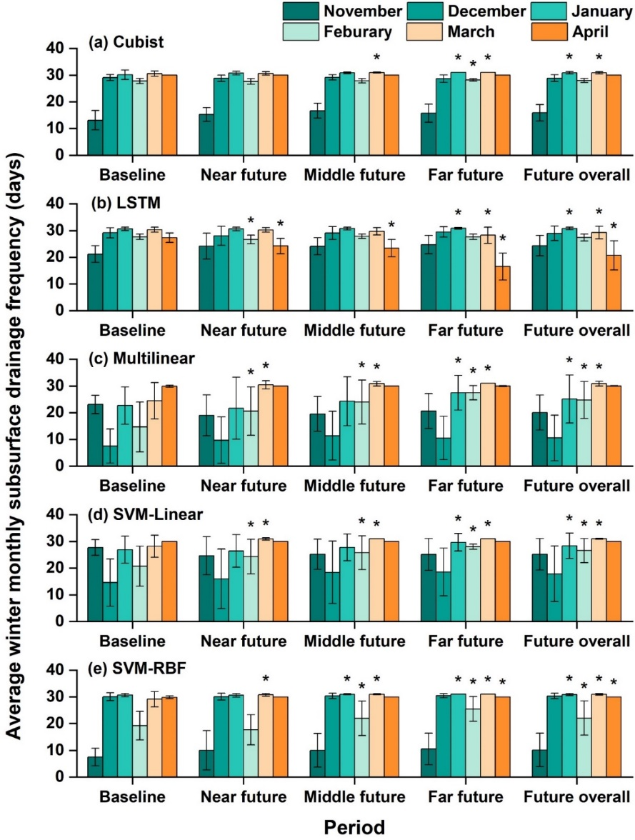
Figure S7. Machine learning (ML) models simulated average winter monthly subsurface drainage frequency during different time periods of baseline (1950-2005), near future (2030-2050), middle future (2050-2070), far future (2070-2100), and future overall (2030-2100) for the site of Alfred using model (a) Cubist model, (b) LSTM model, (c) Multilinear model, (d) SVM-Linear model, (e) SVM-RBF model. The asterisk (*) above the bars indicates the data under that future period was significantly different from the baseline period under the 95% confidence interval. The error bar represents the standard deviation.

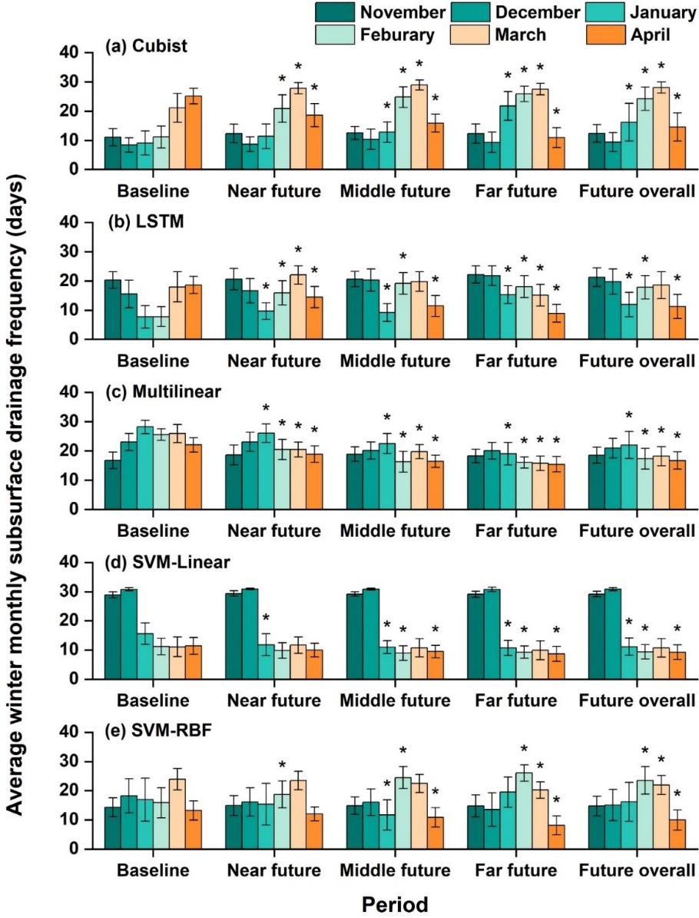
Figure S8. Machine learning (ML) models simulated average winter monthly subsurface drainage frequency during different future periods of baseline (1950-2005), near future (2030-2050), middle future (2050-2070), far future (2070-2100), and future overall (2030-2100) for the site of Kentville using model (a) Cubist model, (b) LSTM model, (c) Multilinear model, (d) SVM-Linear model, (e) SVM-RBF model. The asterisk (*) above the bars indicates the data under that future period was significantly different from the baseline period under the 95% confidence interval. The error bar represents the standard deviation.
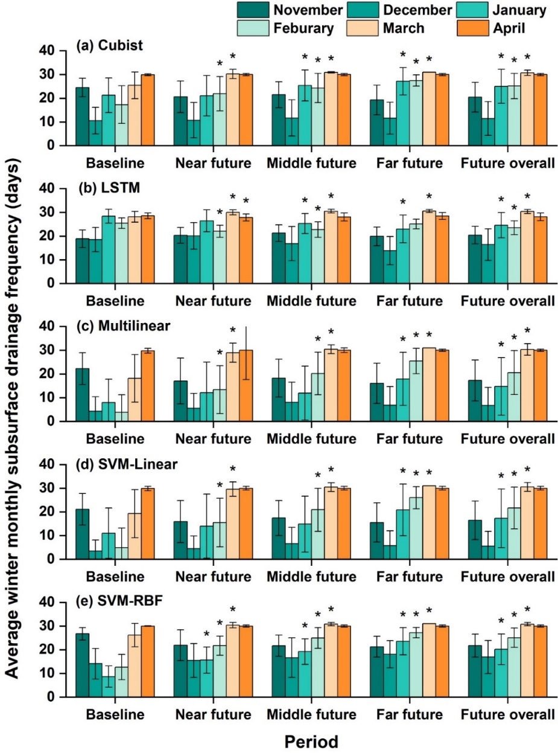
Figure S9. Machine learning (ML) models simulated average winter monthly subsurface drainage frequency during different time periods of baseline (1950-2005), near future (2030-2050), middle future (2050-2070), far future (2070-2100), and future overall (2030-2100) for the site of Ott-Grn using model (a) Cubist model, (b) LSTM model, (c) Multilinear model, (d) SVM-Linear model, (e) SVM-RBF model. The asterisk (*) above the bars indicates that the data under that future period was significantly different from the baseline period under the 95% confidence interval. The error bar represents the standard deviation.
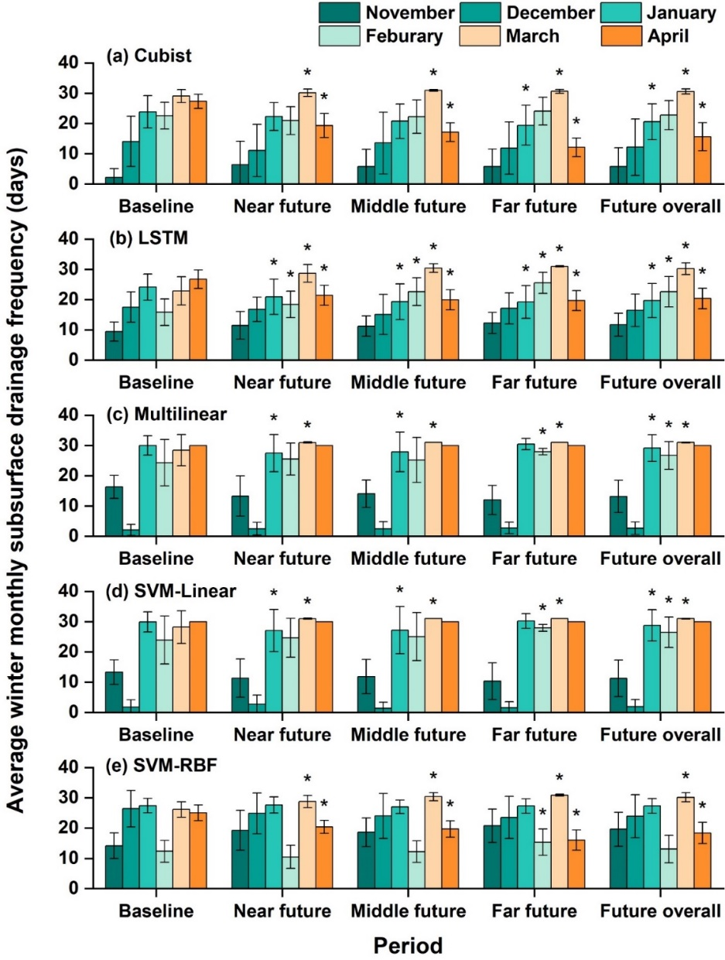
Figure S10. Machine learning (ML) models simulated average winter monthly subsurface drainage frequency during different time periods of baseline (1950-2005), near future (2030-2050), middle future (2050-2070), far future (2070-2100), and future overall (2030-2100) for the site of St-Emm using model (a) Cubist model, (b) LSTM model, (c) Multilinear model, (d) SVM-Linear model, (e) SVM-RBF model. The asterisk (*) above the bars indicates the data under that future period was significantly different from the baseline period under the 95% confidence interval. The error bar represents the standard deviation.

References
Abadi, M., Barham, P., Chen, J., Chen, Z., Davis, A., Dean, J., Devin, M., Ghemawat, S., Irving, G., Isard, M., & Kudlur, M. (2016). TensorFlow: a system for Large-Scale machine learning. arXiv preprint arXiv:1605.08695. doi.org/10.48550/arXiv.1605.08695
Adamowski, J., Fung Chan, H., Prasher, S. O., Ozga-Zielinski, B., & Sliusarieva, A. (2012). Comparison of multiple linear and nonlinear regression, autoregressive integrated moving average, artificial neural network, and wavelet artificial neural network methods for urban water demand forecasting in Montreal, Canada. Water Resources Research, 48(1). doi.org/10.1029/2010WR009945
Ahuja, L., Rojas, K. W., & Hanson, J. D. (Eds.). (2000). Root zone water quality model: modelling management effects on water quality and crop production. Colorado: Water Resources Publication.
Araya, S.N., & Ghezzehei, T.A. (2019). Using machine learning for prediction of saturated hydraulic conductivity and its sensitivity to soil structural perturbations. Water Resources Research, 55(7), pp.5715-5737. doi.org/10.1029/2018WR024357
Aseline, P. (2024). cubist. Available online at: https://github.com/pjaselin
Chen, S., Huang, J., Wang, P., Tang, X., & Zhang, Z. (2024). A coupled model to improve river water quality prediction towards addressing non-stationarity and data limitation. Water Research, 248, 120895. doi.org/10.1016/j.watres.2023.120895
Cheng, S., Cheng, L., Qin, S., Zhang, L., Liu, P., Liu, L., Xu, Z., & Wang, Q. (2022). Improved understanding of how catchment properties control hydrological partitioning through machine learning. Water Resources Research, 58(4), e2021WR031412. doi.org/10.1029/2021WR031412
Cortes, C., & Vapnik, V., (1995). Support-vector networks. Machine learning, 20, 273-297. doi.org/10.1007/BF00994018\
Flerchinger, G., Aiken, R., Rojas, K., Ahuja, L., Johnsen, K., Alonso, C., & Hanson, J. D. (1999). Soil heat transport, soil freezing and snowpack conditions. In Root Zone Water Quality Model: Modelling management effects on water quality and crop production, (p281-314). Colorado: Water Resources Publications.
Flerchinger, G.N., Aiken, R.M., Rojas, K.W., & Ahuja, L.R. (2000). Development of the Root Zone Water Quality Model (RZWQM) for over-winter conditions. Transactions of the ASAE, 43(1), pp.59-68. doi.org/10.13031/2013.2688
Granata, F., Gargano, R., & De Marinis, G. (2016). Support vector regression for rainfall-runoff modeling in urban drainage: A comparison with the EPA’s storm water management model. Water, 8(3), p.69. doi.org/10.3390/w8030069
Hochreiter, S., & Schmidhuber, J.\ (1997). Long short-term memory. Neural computation, 9(8), 1735-1780. https://doi.org/10.1162/neco.1997.9.8.1735
Khaledian, Y., & Miller, B. A. (2020). Selecting appropriate machine learning methods for digital soil mapping. Applied Mathematical Modelling, 81, 401–418. doi.org/10.1016/J.APM.2019.12.016
Kouadio, K.L., Kouame, L.N., Drissa, C., Mi, B., Kouamelan, K.S., Gnoleba, S.P.D., Zhang, H., & Xia, J. (2022). Groundwater Flow Rate Prediction From Geo‐Electrical Features Using Support Vector Machines. Water Resources Research, 58(7), p.e2021WR031623. doi.org/10.1029/2021WR031623
Kuhn M., &Quinlan R. (2023). Cubist: Rule- And Instance-Based Regression Modeling. https://topepo.github.io/Cubist/, https://github.com/topepo/Cubist/.
Li, Z., Ma, L., Flerchinger, G. N., Ahuja, L. R., Wang, H., & Li, Z. (2012). Simulation of Overwinter Soil Water and Soil Temperature with SHAW and RZ-SHAW. Soil Science Society of America Journal, 76, 1548–1563. doi:10.2136/SSSAJ2011.0434
Ma, L., Ahuja, L. R., Nolan, B. T., Malone, R. W., Trout, T. J., & Qi, Z. (2012). Root Zone Water Quality Model (RZWQM2): Model Use, Calibration, and Validation. Transactions of ASABE, 55, 1425–1446. doi:10.13031/2013.42252
Mello, F. A. O., Demattê, J. A. M., Rizzo, R., Mello, D. C. de, Poppiel, R. R., Silvero, N. E. Q., Safanelli, J. L., Bellinaso, H., Bonfatti, B. R., Gomez, A. M. R., & Sousa, G. P. B. (2022). Complex hydrological knowledge to support digital soil mapping. Geoderma, 409, 115638. doi.org/10.1016/J.GEODERMA.2021.115638
Motarjemi, S. K., Møller, A. B., Plauborg, F., & Iversen, B. V. (2021). Predicting national-scale tile drainage discharge in Denmark using machine learning algorithms. Journal of Hydrology: Regional Studies, 36, 100839. doi.org/10.1016/j.ejrh.2021.100839
Patel, S., Hardaha, M. K., Seetpal, M. K., & Madankar, K. K. (2016). Multiple Linear Regression Model for Stream Flow Estimation of Wainganga River. American Journal of Water Science and Engineering, 2(1), 1–5. doi.org/10.11648/j.ajwse.20160201.11
Quinlan, J. R. (1992). Learning with continuous classes. In 5th Australian joint conference on artificial intelligence (Vol. 92, pp. 343-348). https://doi.org/10.1142/9789814536271
Scikit-learn (2024a). LinearRegression. Available online at: https://scikit-learn.org/stable/modules/generated/sklearn.linear_model.LinearRegression.html
Scikit-learn (2024b). Support Vector Machines. Available online at: https://scikit-learn.org/stable/modules/svm.html
Tang, S., Sun, F., Liu, W., Wang, H., Feng, Y., & Li, Z. (2023). Optimal postprocessing strategies with LSTM for global streamflow prediction in ungauged basins. Water Resources Research, 59(7), e2022WR034352. doi.org/10.1029/2022WR034352
Wohling, D. L., Leaney, F. W., & Crosbie, R. S. (2012). Deep drainage estimates using multiple linear regression with percent clay content and rainfall. Hydrology and Earth System Sciences, 16(2), 563-572. doi.org/10.5194/hess-16-563-2012
Worland, S. C., Farmer, W. H., & Kiang, J. E. (2018). Improving predictions of hydrological low-flow indices in ungaged basins using machine learning. Environmental Modelling and Software, 101, 169–182. doi.org/10.1016/J.ENVSOFT.2017.12.021
Xiang, Z., Yan, J., & Demir, I., (2020). A rainfall‐runoff model with LSTM‐based sequence‐to‐sequence learning. Water resources research, 56(1), e2019WR025326. doi.org/10.1029/2019WR025326
Xie, J., Liu, X., Tian, W., Wang, K., Bai, P., & Liu, C. (2022). Estimating gridded monthly baseflow from 1981 to 2020 for the contiguous US using Long Short‐Term Memory (LSTM) networks. Water Resources Research, 58(8), e2021WR031663. doi.org/10.1029/2021WR031663
Xie, Y., Chen, Y., Wei, Q., & Yin, H. (2024). A hybrid deep learning approach to improve real-time effluent quality prediction in wastewater treatment plant. Water Research, 250, 121092. doi.org/10.1016/j.watres.2023.121092
Zhang, Y., Chiew, F. H. S., Li, M., & Post, D. (2018). Predicting Runoff Signatures Using Regression and Hydrological Modeling Approaches. Water Resources Research, 54(10), 7859–7878. doi.org/10.1029/2018WR023325
Zhi, W., Klingler, C., Liu, J., & Li, L. (2023). Widespread deoxygenation in warming rivers. Nature Climate Change, 13(10), 1105-1113. doi.org/10.1038/s41558-023-01793-3

