Extended Data
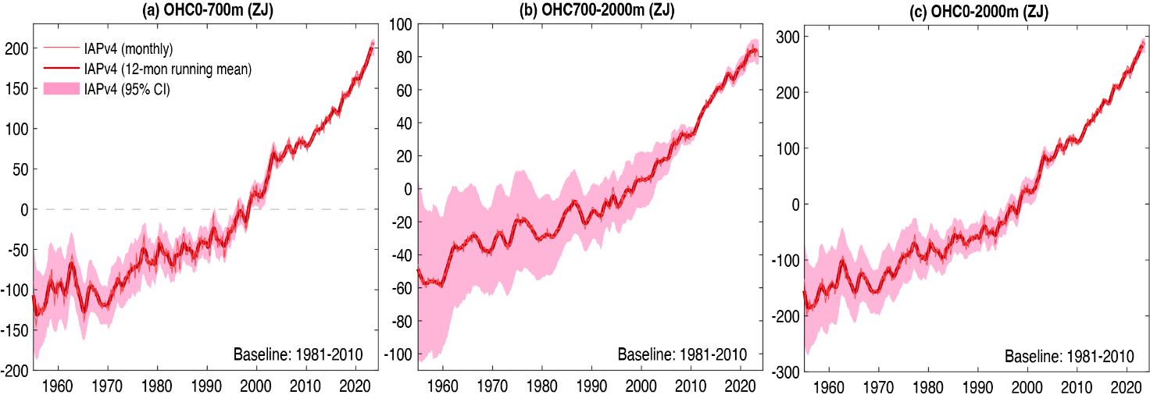
ED_Fig.1: Global OHC time series for 0-700m (a), 700-2000m (b), 0-2000m (c). All time series are relative to a 1981-2010 baseline. The shading indicates the 95% confidence interval. The units are ZJ.
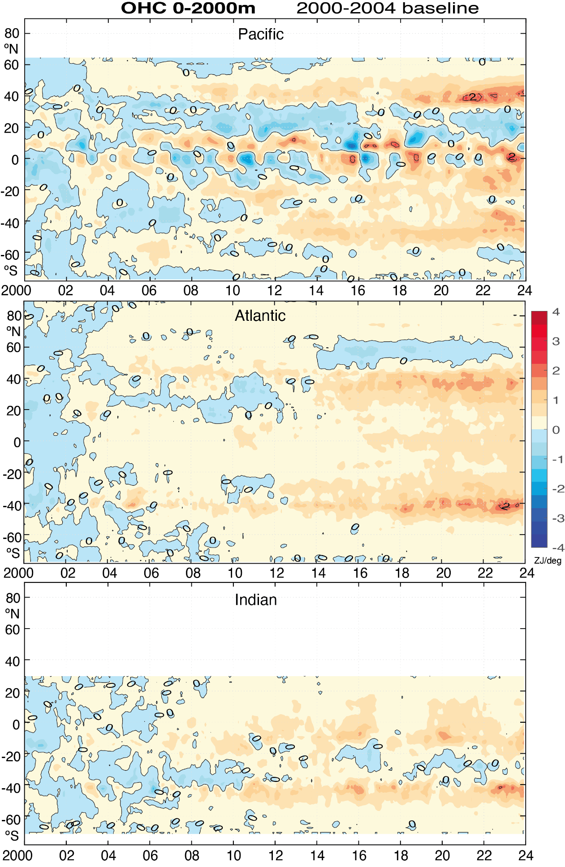

ED_Fig.2. Zonal mean OHC anomalies relative to 2000-2004 for Pacific, Atlantic and Indian Oceans for 0-2000m in ZJ per degree latitude.

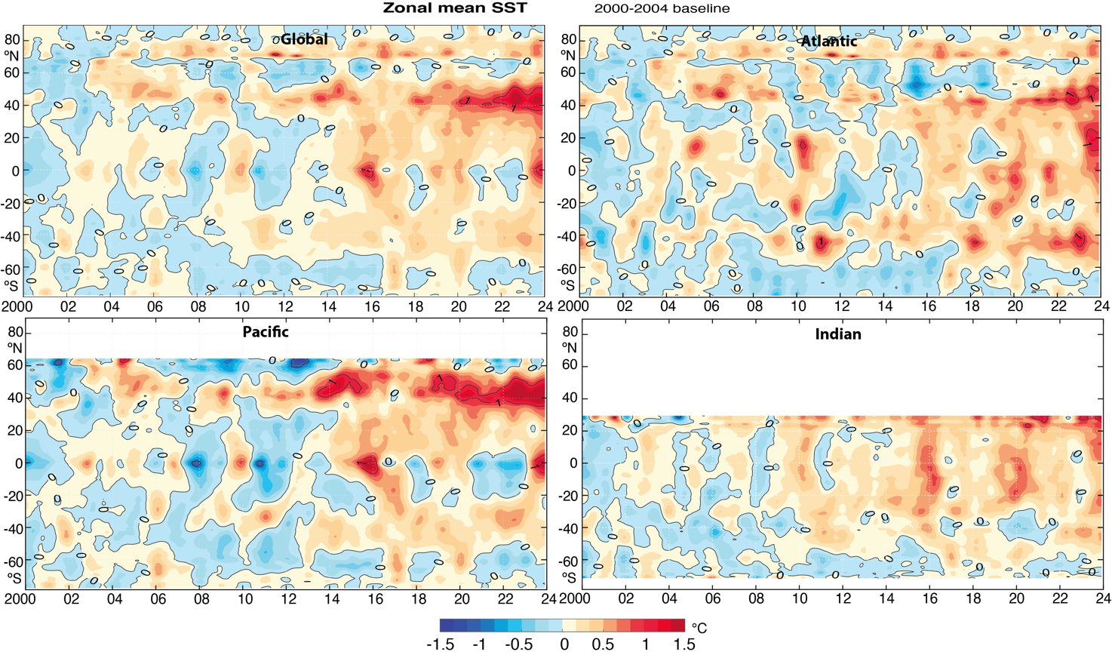
ED_Fig.3. Zonal mean sea surface temperature anomalies in °C relative to 2000-2004 for (a) global, (b) Atlantic, (c) Pacific and (d) Indian oceans.

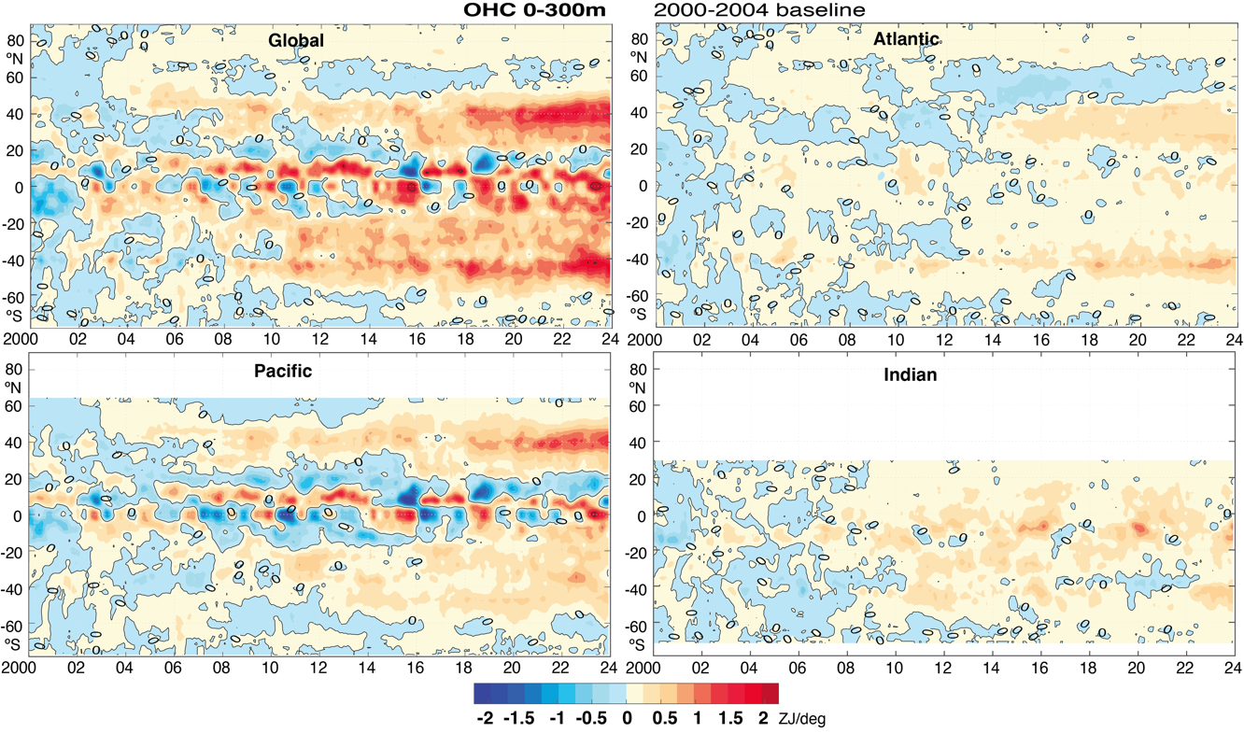
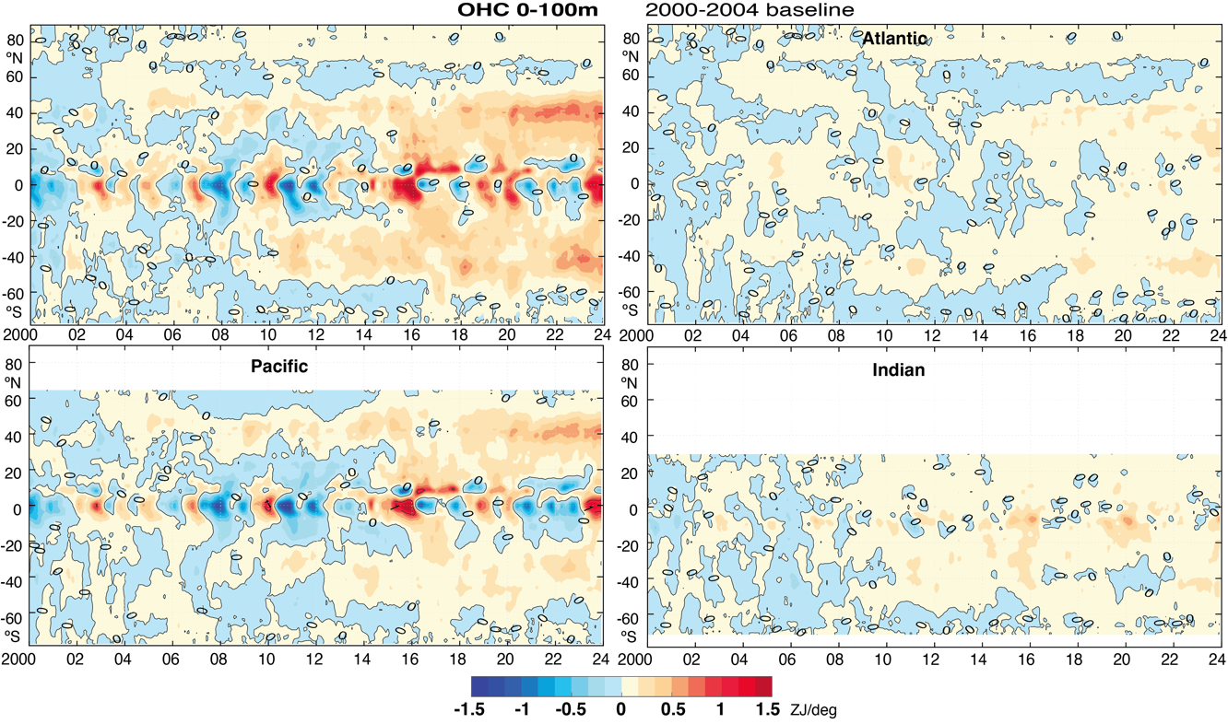
ED_Fig.4. Zonal mean accumulated OHC anomalies in ZJ/deg relative to 2000-2004 for global, Atlantic, Pacific, and Indian Oceans for 0-100m (top) and 0-300m (lower) depths.
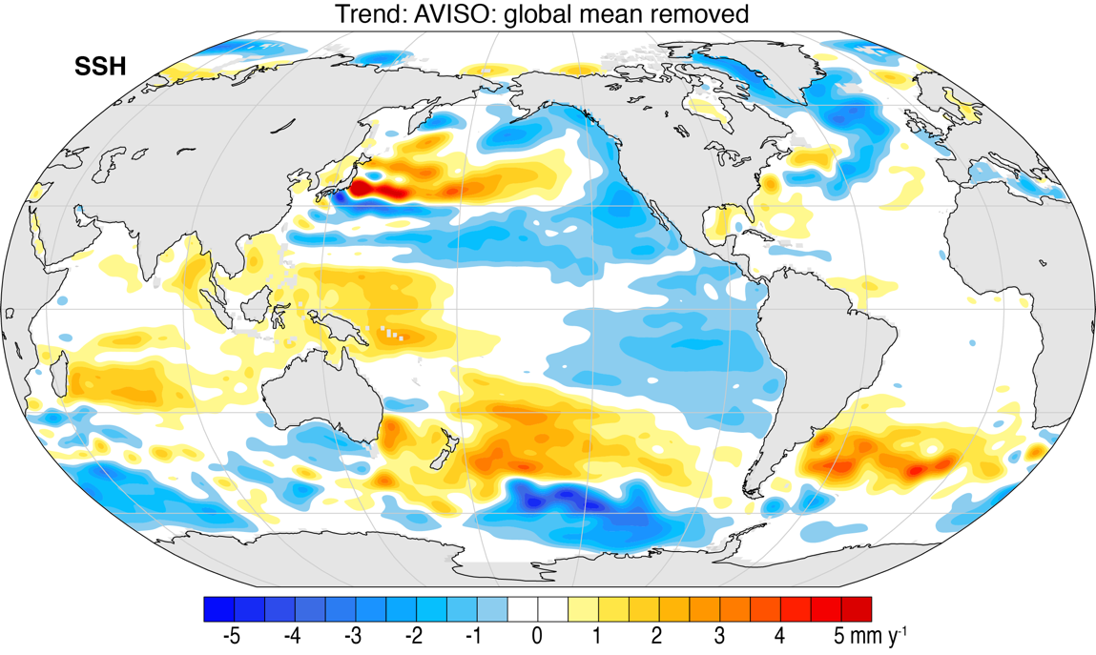
ED_Fig.5. Linear trends in sea level (sea surface height SSH), from satellite altimeter²², in mm y⁻¹ from 2000-2022 but with the global mean removed. Spatial smoothing is applied at T63, or about 180 km resolution. Data were unavailable through 2023, and hence the La Niña in 2022 influences patterns.

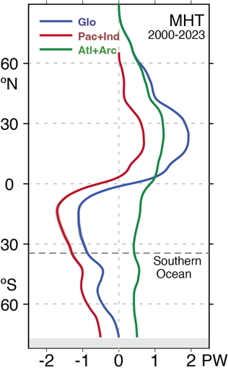

ED_Fig.6. MHT for the oceans, global, Atlantic plus Arctic, and Indo-Pacific for 2000 through 2023, including a small adjustment to ensure closure (see ref. 10).

