Suplement
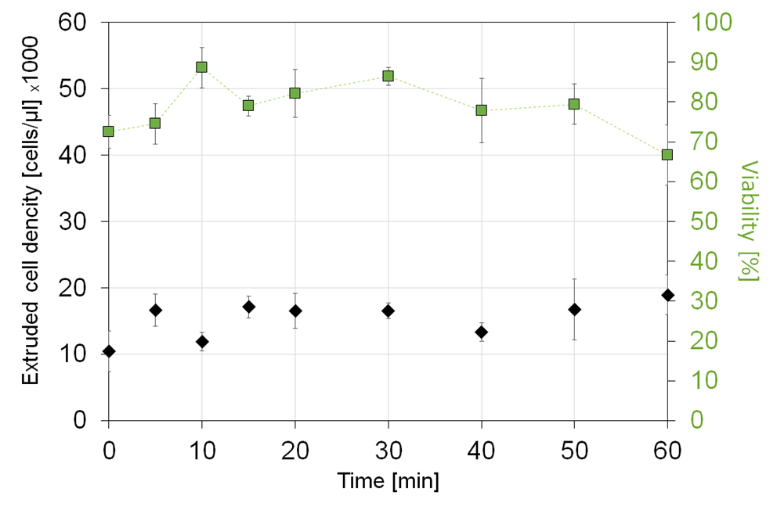
Figure S1. Sedimentation and viability of LESC inside printing nozzle for medium wit 1% MC. Cell density remains more stable over 60 min time compared to medium without MC (Fig. 2A).

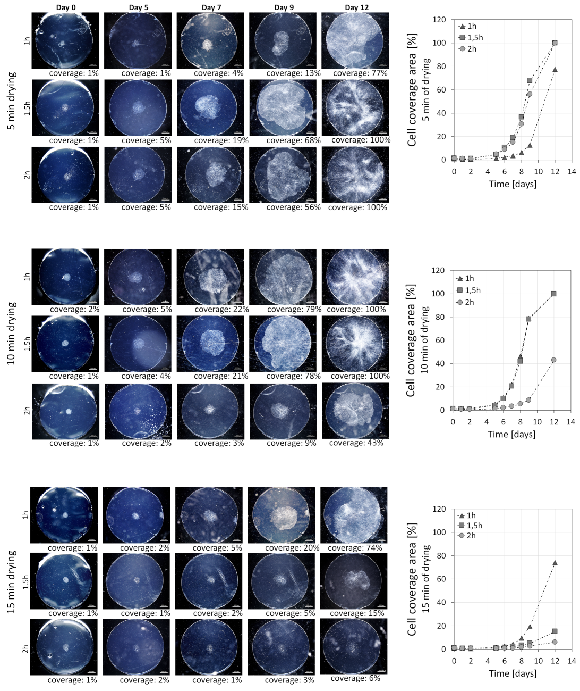
Figure S2. Initial retention of the cells and further cell spreading over surface was strongly dependent on fibrin hydration (represented by time od drying 5, 10, 15 min) and time of preincubation prior to adding medium (1, 1.5, 2h). Stronger dehydration caused either by initial fibrin drying or preincubation led to decrease in cell proliferative potential. However strong hydration of fibrin caused initial cell lost while covered by medium which led also to decreasing proliferative potential.
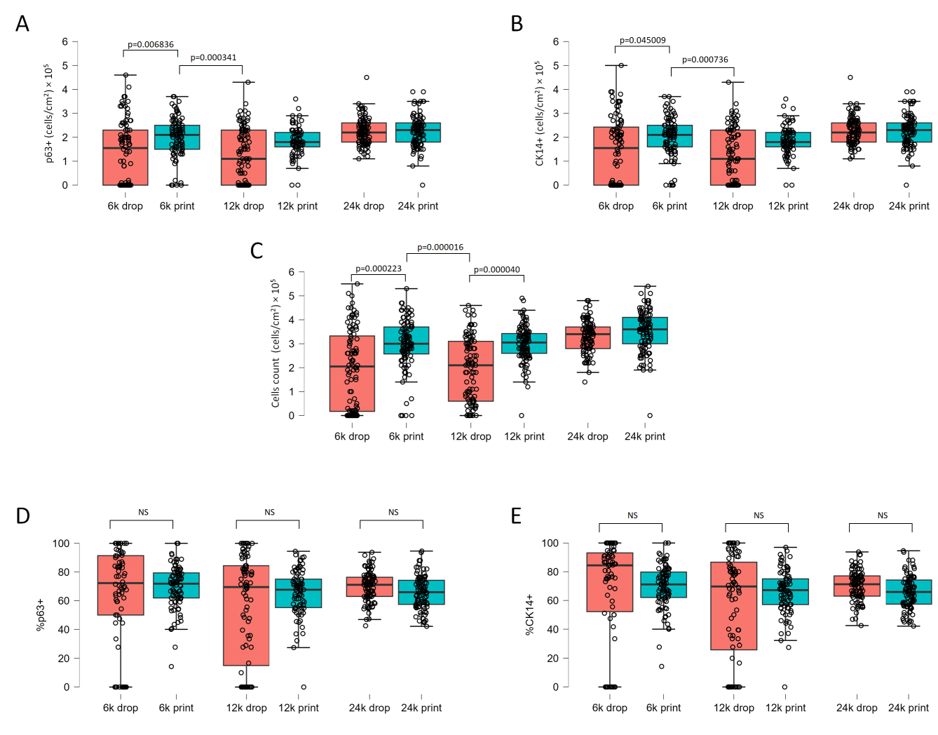
Figure S3. Quantitative characterization of p63 and CK14 antigens across the scaffold surface. Differentiated (CK14- and p63-) cells are more abundant on the edges of samples produced by drop method. Quantitative date of cell number (A, B,C) showed significance between 6k vs 12k samples. However quantitative data of p63 and CK14 percentages (D,E) did not showed significant differences between corresponding groups.

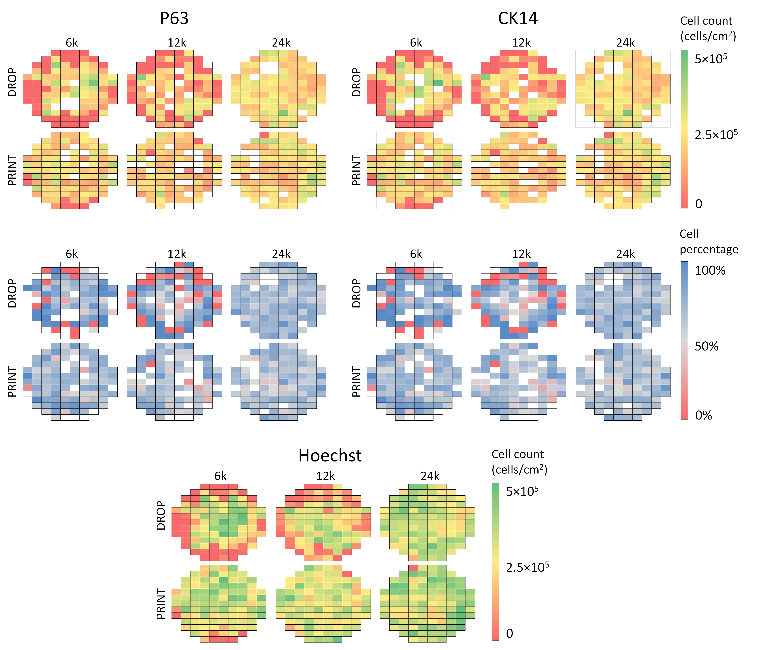
Figure S4. Distribution of p63, CK14 antigens across the scaffold surface. Samples from the traditional method were characterised by a favourable phenotype in the centre, but the edges were dominated unfavourable phenotype. Bioprinted samples were uniformly covered with cells.

