Supplementary information-1
Cross-Population Analysis of Breast Cancer Transcriptomics: Comparative Insights Between Caucasian and Indian Patients
Dipannita Ghosh¹, Srinivas Bandaru², Ishita Chopra^{1,3}, Arshiya Khan^{1,4,5}, Khushboo Sharma1,4,5, Anushka Bhardwaj^{1,4,5}, Manmeet Kaur¹, Umesh Panwar^{1,5}, Sanjeev Kumar Singh⁵, Anuraj Nayarisseri^{1,4}*
*Corresponding author email: anuraj@eminentbio.com
1. In silico Research Laboratory, Eminent Biosciences, 91-A, Sector A, Mahalakshmi Nagar, Indore - 452010, Madhya Pradesh, India.
2. Department of Biotechnology, Koneru Lakshmiah Educational Foundation (KLEF), Green Fields, Vaddeswaram, Andhra Pradesh 522302.
3. School of Medicine and Health Sciences, The George Washington University, Ross Hall, 2300 Eye Street, NW Washington, D.C. - 20037, USA.
4. Bioinformatics Research Laboratory, LeGene Biosciences Pvt Ltd, 91-A, Sector A, Mahalakshmi Nagar, Indore - 452010, Madhya Pradesh, India.
5. Computer-Aided Drug Designing and Molecular Modeling Lab, Department of Bioinformatics, Alagappa University, Karaikudi-630003, Tamil Nadu, India.

Supplementary Table 1. Sample information with sequencing details

Run | Average spot length | Bases-giga basepairs | Size | Histology | Date Published | Access Type | Age | CTC presence | CTC phenotype | t_stage | tumour_grade
SRR19262411 | 150 | 8.56Gbp | 3.5Gb | PBC | 30-06-2022 | Public | 63 | CTC- | NA | 2 | low/intermediate
SRR19262412 | 150 | 6.66Gbp | 2.5Gb | PBC | 30-06-2022 | Public | 40 | CTC+ | EMT+/EP+ | 1 | low/intermediate
SRR19262413 | 150 | 8.36Gbp | 3.4Gb | PBC | 30-06-2022 | Public | 49 | CTC- | NA | 1 | high
SRR19262414 | 150 | 9.01Gbp | 3.8Gb | PBC | 30-06-2022 | Public | 77 | CTC- | NA | 2 | high
SRR19262415 | 150 | 7.72Gbp | 3.2Gb | PBC | 30-06-2022 | Public | 57 | CTC- | NA | 1 | high
SRR19262416 | 150 | 8.04Gbp | 3.3Gb | PBC | 30-06-2022 | Public | 76 | CTC+ | EMT+ | 2 | high
SRR19262417 | 150 | 7.92Gbp | 3.1Gb | PBC | 30-06-2022 | Public | 59 | CTC+ | EMT+ | 1 | high
SRR19262418 | 150 | 7.32Gbp | 2.8Gb | Healthy | 30-06-2022 | Public | 40 | NA | NA | NA
SRR19262419 | 150 | 7.51Gbp | 2.8Gb | PBC | 30-06-2022 | Public | 56 | CTC+ | EMT+ | 2 | low/intermediate
SRR19262420 | 150 | 5.33Gbp | 2Gb | PBC | 30-06-2022 | Public | 79 | CTC+ | EMT+/EP+ | 1 | low/intermediate
SRR19262421 | 150 | 4.76Gbp | 1.8Gb | PBC | 30-06-2022 | Public | 62 | CTC+ | EP+ | 1
SRR19262422 | 150 | 7.33Gbp | 2.8Gb | PBC | 30-06-2022 | Public | 63 | CTC+ | EMT+ | 1 | low/intermediate
SRR19262423 | 150 | 5.92Gbp | 2.3Gb | Healthy | 30-06-2022 | Public | 45 | NA | NA | NA
SRR19262424 | 150 | 6.16Gbp | 2.4Gb | PBC | 30-06-2022 | Public | 41 | CTC- | NA | 1 | high
SRR19262425 | 150 | 7.19Gbp | 2.8Gb | PBC | 30-06-2022 | Public | 67 | CTC- | NA | 1 | low/intermediate
SRR19262426 | 150 | 11.47Gbp | 4.4Gb | Healthy | 30-06-2022 | Public | 50 | NA | NA | NA
SRR19262427 | 150 | 8.37Gbp | 3.1Gb | Healthy | 30-06-2022 | Public | 39 | NA | NA | NA
SRR19262428 | 150 | 7.20Gbp | 2.8Gb | Healthy | 30-06-2022 | Public | 44 | NA | NA | NA
SRR19262429 | 150 | 8.49Gbp | 3.3Gb | PBC | 30-06-2022 | Public | 48 | CTC- | NA | 1 | high
SRR19262430 | 150 | 6.57Gbp | 2.6Gb | PBC | 30-06-2022 | Public | 27 | CTC- | NA | 2 | high
SRR19262431 | 150 | 7.64Gbp | 3.0Gb | PBC | 30-06-2022 | Public | 52 | CTC- | NA | 1 | low/intermediate
SRR19262432 | 150 | 8.14Gbp | 3.4Gb | PBC | 30-06-2022 | Public | 60 | CTC+ | EMT+ | 2 | high
SRR19262433 | 150 | 9.08Gbp | 3.7Gb | PBC | 30-06-2022 | Public | 61 | CTC+ | EMT+/EP+ | 1 | high

Supplementary Table 2. FastQC report statistics of samples

Sample No. | total sequences per .fastq file | Mean Phred Score | Mean GC Content | Per Base N Content
SRR19262411 | 57085931 | 32-40 | 44 | Nil
SRR19262412 | 44404313 | 30-38 | 46 | Nil
SRR19262413 | 55727923 | 32-38 | 48 | Nil
SRR19262414 | 60059706 | 29-40 | 46 | Nil
SRR19262415 | 51441165 | 32-40 | 49 | Nil
SRR19262416 | 53571028 | 31-40 | 53 | Nil
SRR19262417 | 52831389 | ‘34-40 | 45 | Nil
SRR19262418 | 48814166 | 32-40 | 52 | Nil
SRR19262419 | 50051105 | 32-40 | 49 | Nil
SRR19262420 | 35545774 | 32-40 | 48 | Nil
SRR19262421 | 31753765 | 34-40 | 45 | Nil
SRR19262422 | 48851400 | 32-40 | 46 | Nil
SRR19262423 | 39479614 | 31-38 | 56 | Nil
SRR19262424 | 41082708 | 32-36 | 50 | Nil
SRR19262425 | 47932624 | 32-40 | 47 | Nil
SRR19262426 | 76483229 | 32-40 | 48 | Nil
SRR19262427 | 55798258 | 34-40 | 47 | Nil
SRR19262428 | 47981509 | 32-40 | 47 | Nil
SRR19262429 | 56619362 | 30-38 | 48 | Nil
SRR19262430 | 43799196 | 32-40 | 50 | Nil
SRR19262431 | 50933300 | 34-40 | 48 | Nil
SRR19262432 | 54279367 | 32-40 | 48 | Nil
SRR19262433 | 60533865 | 32-40 | 46 | Nil

Legend
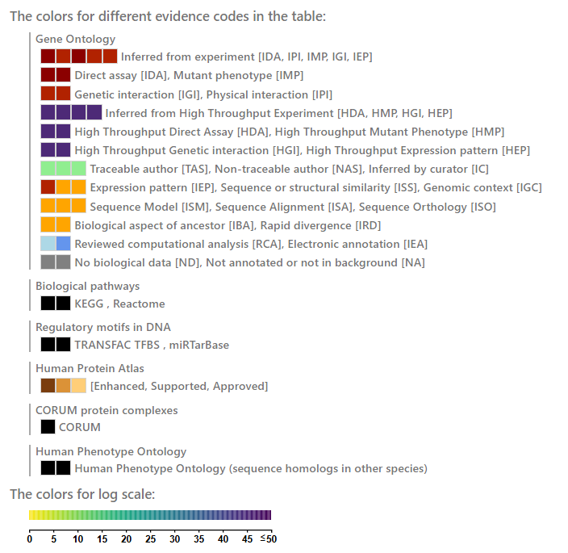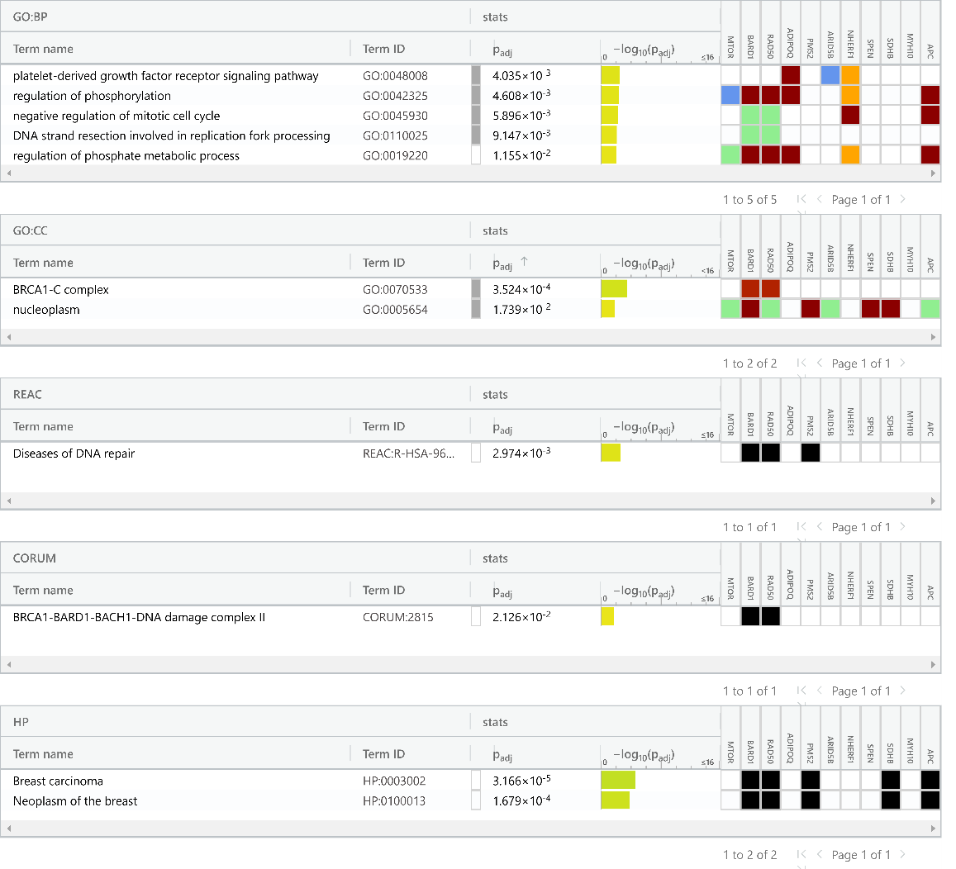
Supplementary figure 1. Gene Ontology report generated by Gprofiler with enriched genes mTOR, BARD1, RAD50, ADIPOQ, PMS2, ARID5B, NHERF1, SPEN, SDHB, MYH10 and APC.
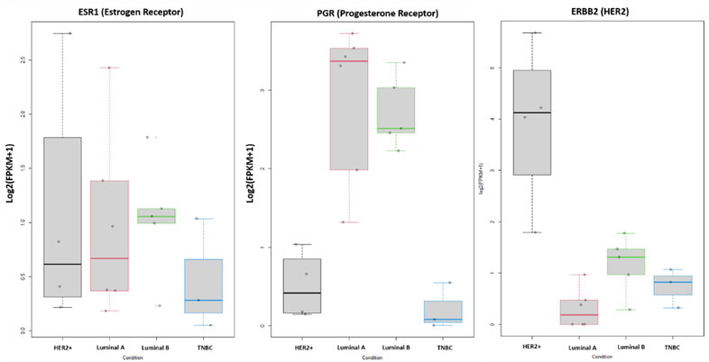
Supplementary figure 2. Expression of hormone receptors in histological classification of breast cancer. Luminal B-type cancers exhibit elevated ESR1 expression in comparison to luminal A and HER2-enriched tumours. In contrast, both luminal-A and -B tumours exhibited higher PGR levels than HER2-enriched tumours. HER2-enriched tumours exhibit notably high ERBB2 transcript levels, which were markedly lower in luminal A-type and luminal B-type tumours. Triple-negative breast cancer (TNBC) tumours exhibit reduced levels of all three proteins—ESR1, PGR, and HER2—compared to those of other classes in immunohistological subtype.

