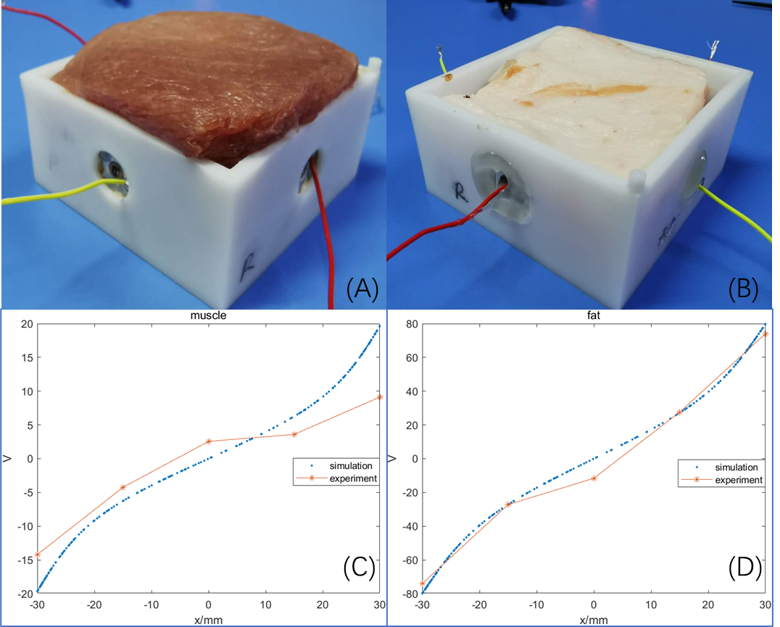
Supplementary Figure 1. The validation of the MTL model.
A) and B), muscle and fat tissues of pork were put in the simplified in vitro TTFields model. C) and D), the measured results were compared with the calculation in the MTL model accordingly.

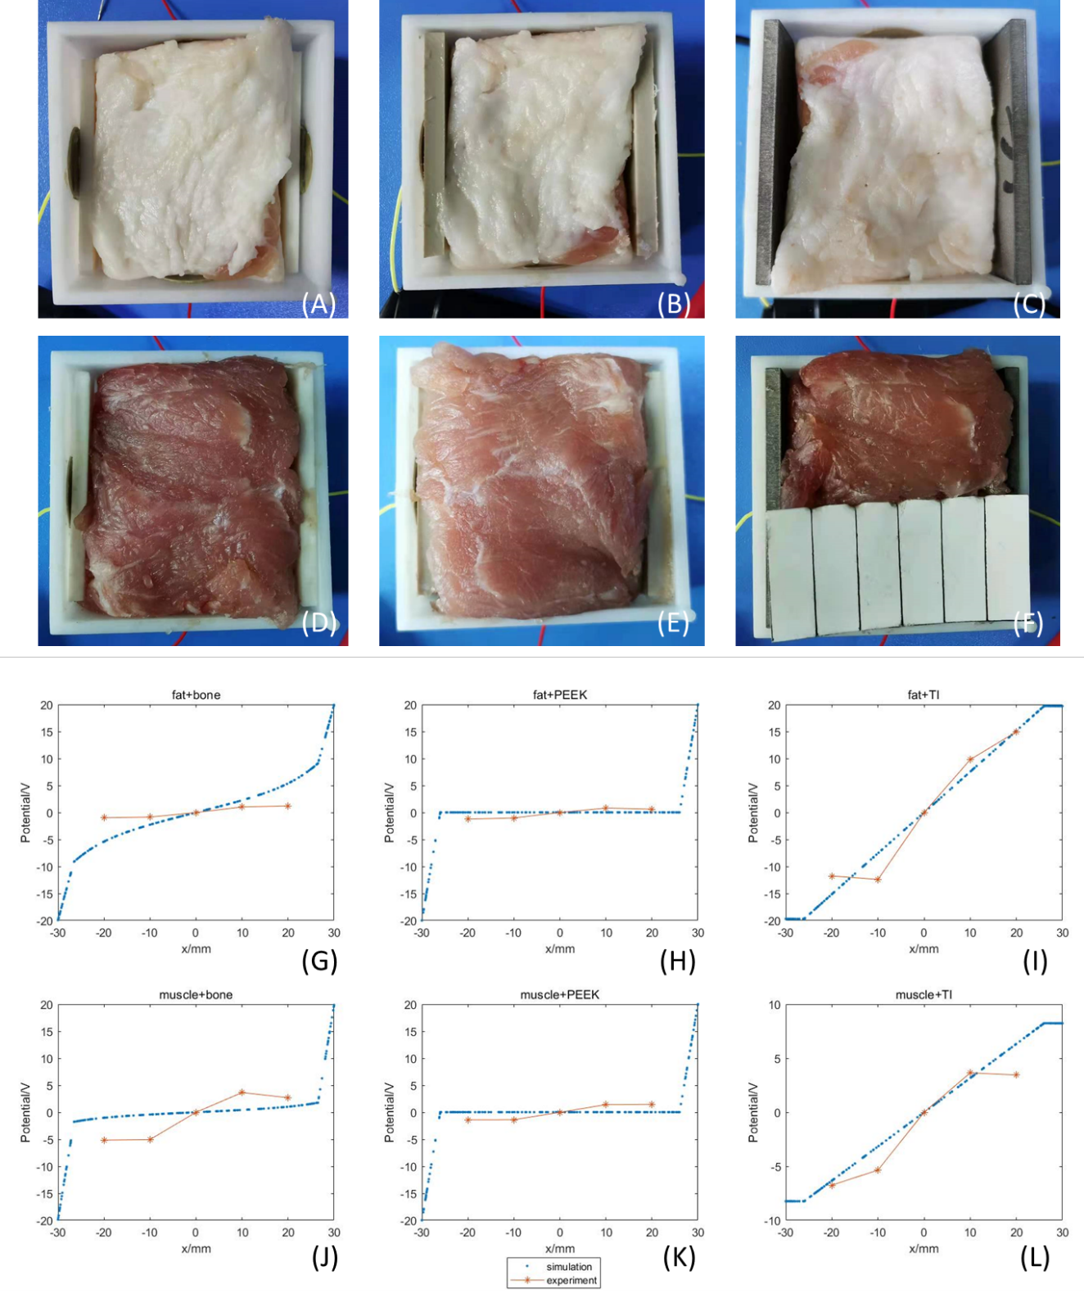
Supplementary Figure 2. The validation of the effect of alternative materials on electric field.
A), B) and C), fat tissues of pork were put in the simplified in vitro TTFields model with bovine bone plate, PEEK plate and titanium plate, which were attached to outside of the tissue separately. D), E) and F), muscle tissues of pork were put in the simplified in vitro TTFields model with bovine bone plate, PEEK plate and titanium plate, which were attached to outside of the tissue separately. G-L), the validation curves of A-F) were plotted accordingly.

