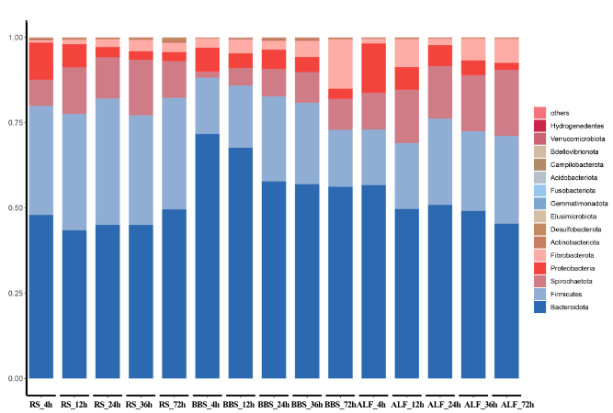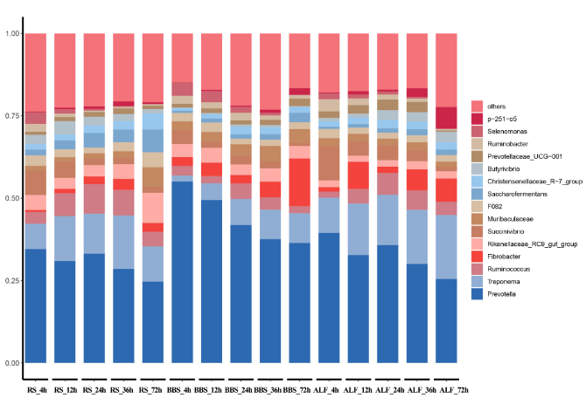
C
B
A
D
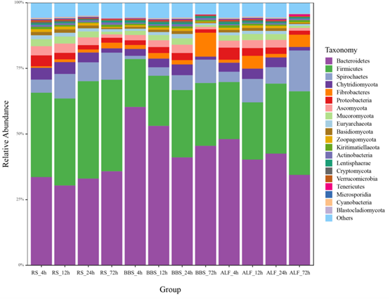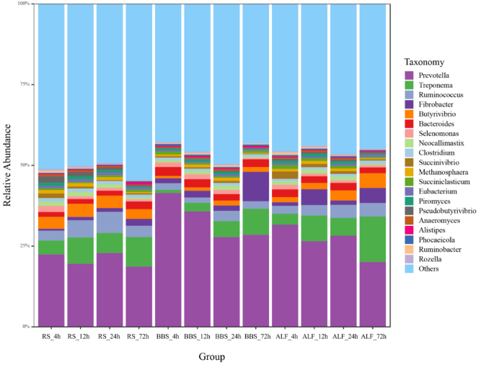
Supplementary Figure 1: Relative abundance of taxonomy at Phylum and Genus level. A: Relative abundance of 16S rRNA gene sequencing at phylum level. B: Relative abundance of 16S rRNA gene sequencing at genus level. C: Relative abundance of metagenomic sequencing at phylum level. D: Relative abundance of metagenomic sequencing at genus level.

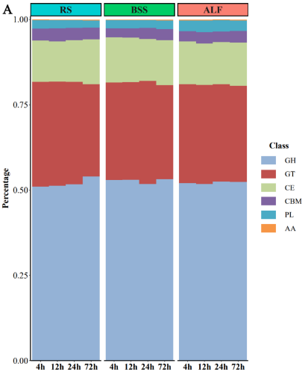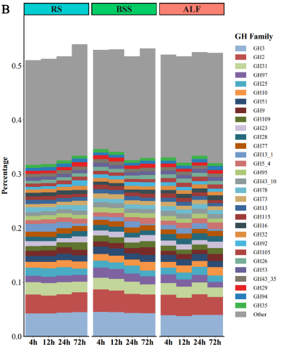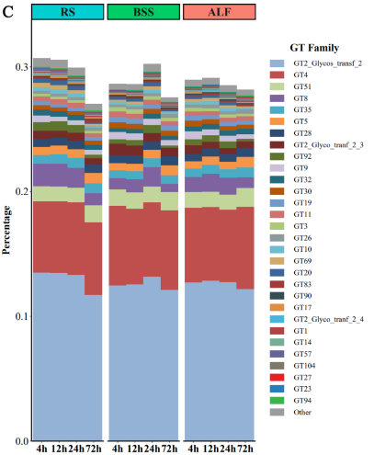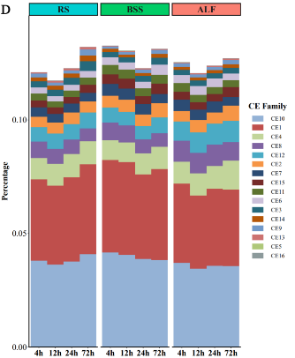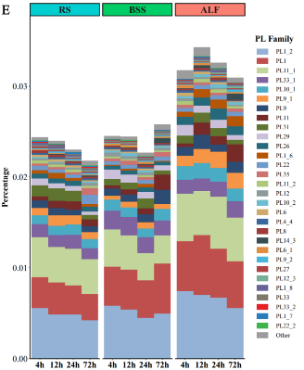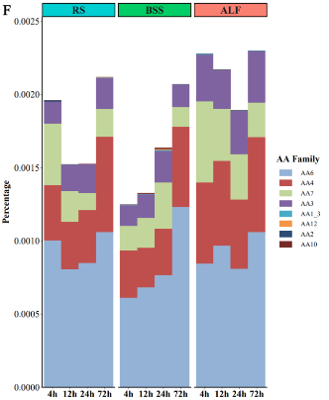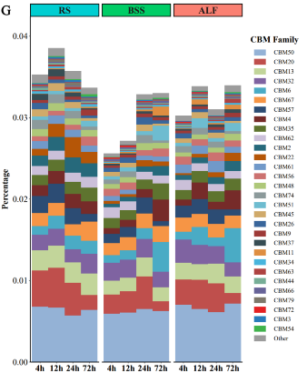

Supplementary Figure 2: Functional profile of Carbohydrate-Active enZYmes Database（CAZy. A: functional annotation of genes in the CAZyme database. B: family of glycoside hydrolases (GHs). C: family of glycosyltransferases (GTs). D: Carbohydrate esterase (CEs) family. E: polysaccharide lyase (PLs) family. F: Coenzyme (AAs) family. G: Carbohydrate binding modules (CBMs).

