Supplementary materials

Table S1. List of primers used in this study
Gene Name | Forward Primer | Reverse Primer
rbcL | AAGGACGACGAGAACATC | TGCAGGATCATGTCGTT
aclB | TGGACMATGGTDGCYGGKGGT | ATAGTTKGGSCCACCTCTTC
korA | GCCGGCTACCCCATCACCCC | ATGATGGGATGGTCCCCATG
acsA | GATACCTGGTGGCAGACCGA | TGATCACGTCGTCGACCCGG
acsE | TCATCGGCGAACGCATCAAC | AGRCCGGCTTCSATGGC
acsB | CTYTGYCAGTCMTTYGCBCC | CCCATAAABCCYGGDGTYTG
accA | GAAGGCTAYCGCAARGC | CCTTCMGGSGARATMAC
pccA | GTGMTGATCAAGGCCWC | CGSGTGTTCATYTCSAGGAA
smtA | TTTCTGGCCGGBTAYGCDGC | CGGTACGGIICCGGTYTGVCC
mct | TGGGCGCSGASGTSATMCG | TTCACSGTRTARTCSAYSGC
frdA | MTGCTGCACACSCTGTW | CCGGTSGGGTGRWACTG
gam | CGSAACTGGGAYTACCGS | TCCCACAGCCSKCGTC
abfA | CGSTAYCCSGCCGGCAAYTT | TGCCASGGNCCGTCCATYTC
xylA | TGGGGBGGTCGYGAAGG | ACTTTGGCRTCRAAGTT
cxg | YSTACGGSATGCACTGGMT | TANCGCAGRTAGTCVCCCAT
exoPG | ANCATTGGTGGCCSTGGAA | TTRAYGGCRATRCARTCRTC
mnp | MACRCCSTTCGACTCSACC | ACGTCSGAGCAGTCRAYGA
Isop | GTCATYTACTTYGGNCC | CGNGCSACATCNGCCCA
amyX | TATAAYTGGGGMTATGAYCC | CCCATYAAATCAAAWCGRAA
apu | ACVTGGATAGGYGAGCCYCA | CCRTCSGGGAAGTAGTTKCC
cdaR | CGARATGGTGGTGCTCAA | CARCGTRTTACGATGAATA
amyA | YGGTTTTCGTCTTGACGCSG | MGGCTGMGTRTCATGRTTK
manA | ATGCGCGGBGTCAACCA | TCGTTGSCGATGTTGABGA
cdh | ATWRYCTWCCGMRTHGCCMT | GTKAGSGGRTTBYKGRYCAT
naglu | TVAAYTGGTAYCTGAAATAY | CCRTGYAGVGCCATCCAGTC
chiA | TSAAGAARTACGCSGACAACG | ASGTCATCAGRCCCTTSAG
exc | GATTGGTSVCAATATGAYRG | STCCARCCACCRAYRCTRAA
glx | AACCARTCGATCATCTACGA | RTGSACGAGCTCDGGCATGG
lig | CCGCACACACTGTTGCTGC | CGAAGGATTGCCACTCGCA
pox | ACYAGTATCCATTGGCACGGT | AGATGVGARTGATACCARAA
mcrA | GGTGGTGTMGGDTTCACMCARTA | CGTTCATBGCGTAGTTVGGRTAGT
mmox | ATGGAGGCGGTCAAGGACGA | CGCTTCATGCCCTTCCACAG
pmoA | GGNGACTGGGACTTCTGG | GAASGCNGAGAAGAASGC
mxa | GCGGCACCAACTGGGGCTGGT | GGGCAGCATGAAGGGCTCCC

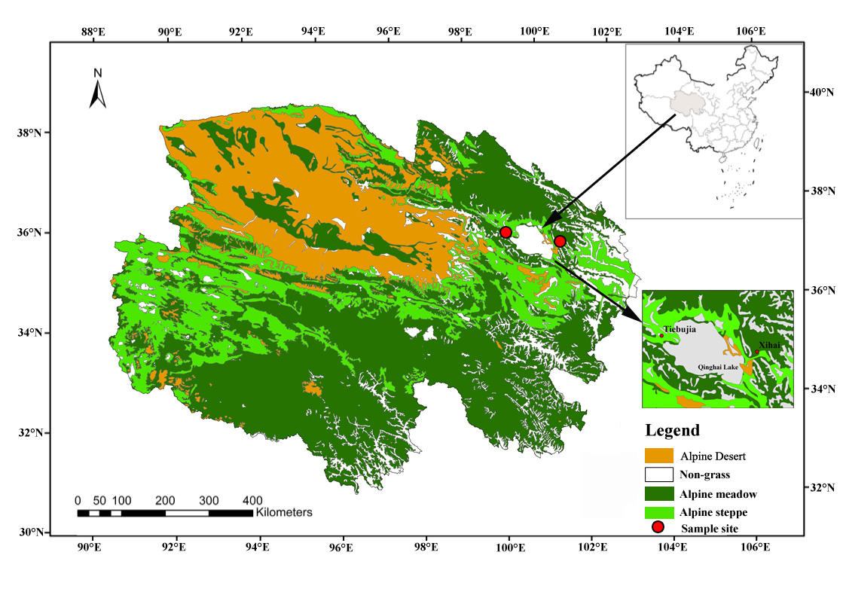Figure S1 The position of the study site on the Qinghai-Tibetan Plateau.
Figure S2 Plant variables for AM, AS and CG under different treatments. Values indicate the mean ± standard error. AM, alpine meadow; AS, alpine steppe; CG, cultivated grassland; AGB, aboveground biomass; BGB, belowround biomass; N:P_{shoot}, the N:P ratio of shoot; N:P_{root}, the N:P ratio of root. Different lowercase letters represent significant difference at P < 0.05 between experimental treatments. No letter indicates no significant difference.

Figure S3 Soil properties and microbial biomass for AM, AS and CG under different treatments. Values indicate the mean ± standard error. AM, alpine meadow; AS, alpine steppe; CG, cultivated grassland; TN, total nitrogen; TP, total phosphorus; AP, available phosphorus; DOC, dissolved organic carbon; MBC, microbial biomass carbon; MBN, microbial biomass nitrogen. Different lowercase letters represent significant difference at P < 0.05 between experimental treatments. No letter indicates no significant difference.

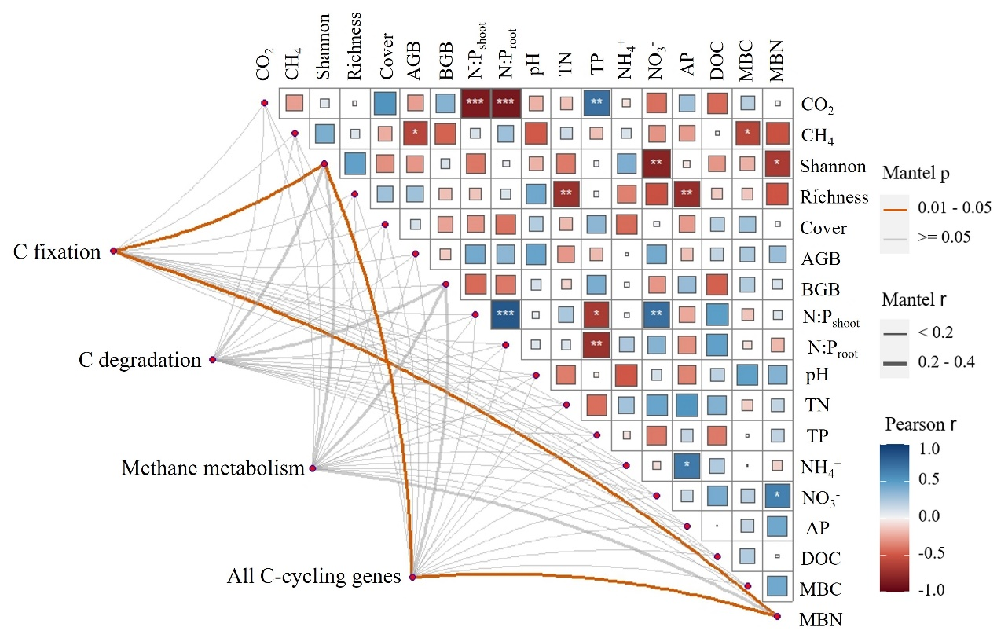
Figure S4 Relationships between C fluxes, environmental variables and C-cycling genes in alpine meadow. C-cycling genes were related to C fluxes and environmental factors by mantel test.

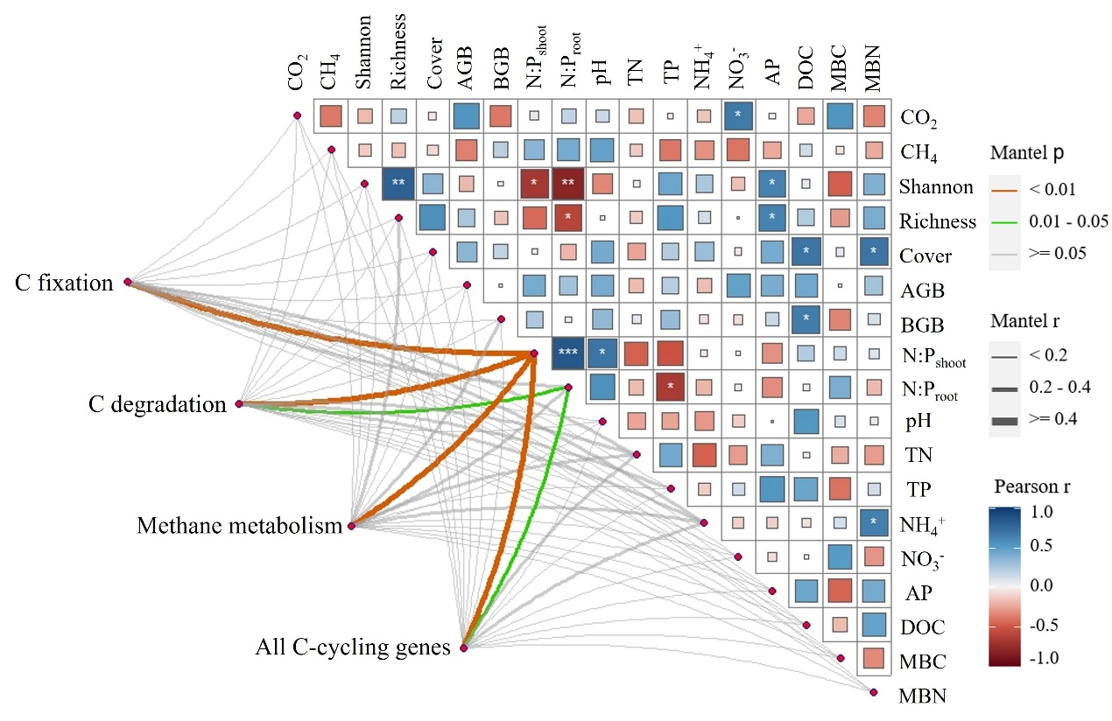
Figure S5 Relationships between C fluxes, environmental variables and C-cycling genes in alpine steppe. C-cycling genes were related to C fluxes and environmental factors by mantel test.
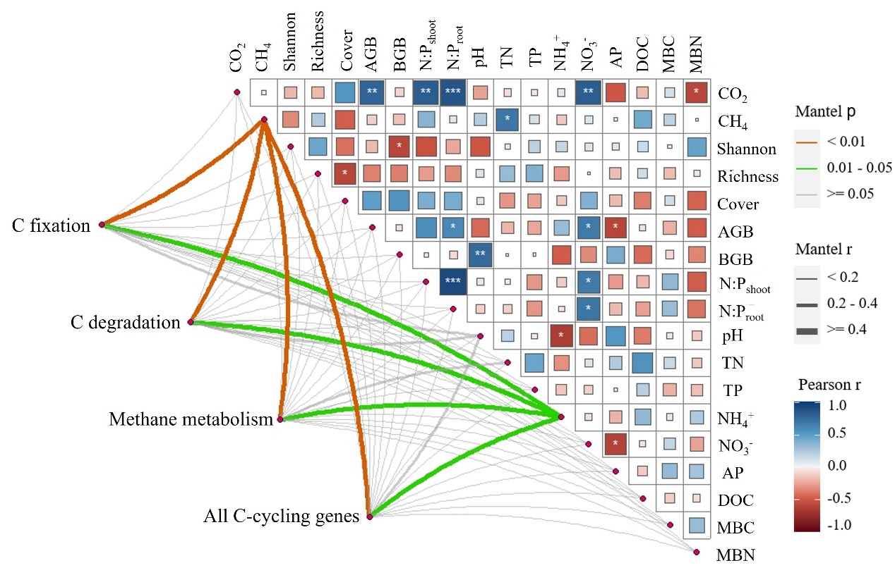
Figure S6 Relationships between C fluxes, environmental variables and C-cycling genes in cultivated grassland. C-cycling genes were related to C fluxes and environmental factors by mantel test.

