Electronic Appendix

Figure and table captions

Fig. 1 in Appendix Temporal changes in habitat features for the Mediterranean tree frog (Hyla meridionalis) in the Adra river basin. Values are average (SE) at the 38 sample points. (a) Distance to roads or paths, (b) surface of suitable habitat, (c) surface of open-air crops, (d) surface of greenhouse crops, and (e) surface of great reed (Arundo donax).

Table 1 in Appendix Sampled points by region and locality for the current (2006-2019) presence of the Mediterranean tree frog (Hyla meridionalis) in the Iberian southeastern. Number of sampled points per each locality are proportional to its surface. Shown are the average values ​​of geographic coordinates and altitude by region and locality calculated on sampling points. Current seasonality of the waterbodies is also shown, differentiating between temporary or permanent. Localities with historical (i.e. 1980s-1990s) information on the presence of the species are marked with an asterisk. Rows in bold show cumulative values per region.

Table 2 in Appendix Maximum number of individuals in the 17 sampled points with presence of Mediterranean tree frog during 2016-2019. Values are average (SE) at the 17 sample points.

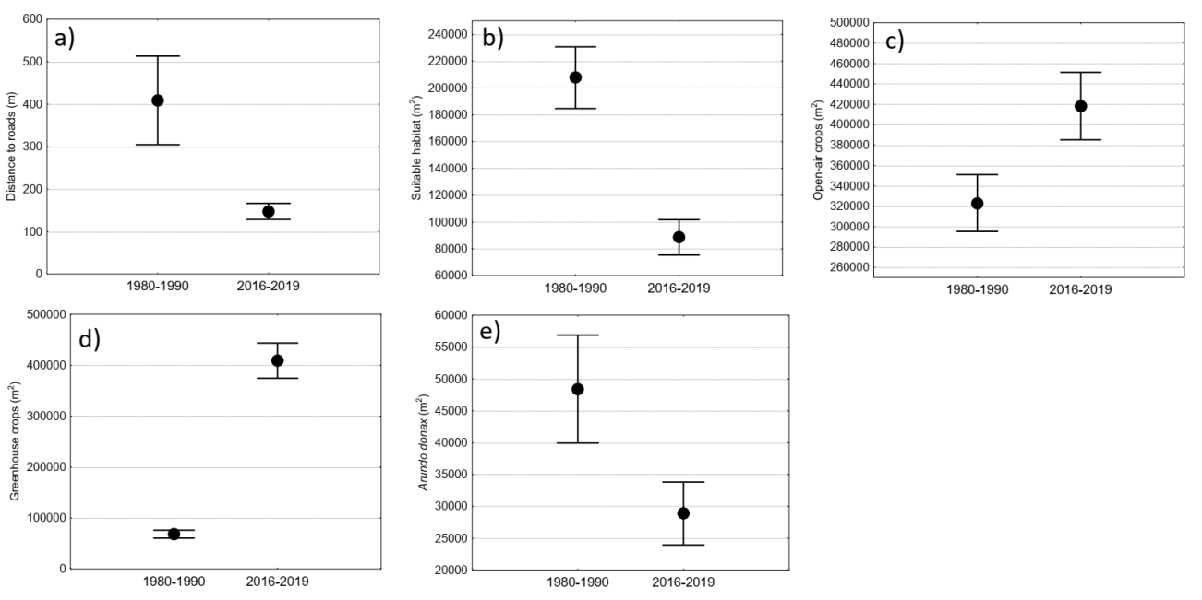

Fig. 1 in Appendix. Paracuellos et al.

Region/locality | Geographical coordinate | Altitude  (m a. s. l.) | Current seasonality | Sampled points with frog presence | Sampled points | Total num. of visits | Sampling periods
(i) West of Almería: | 36°45'27"N 2°49'9"W | 70 | Permanent and temporary | 13 | 78 | 332 | 06/04-14/07
Adra river and lagoons * | 36°46'538"N 3°0'6"W | 64 | Permanent and temporary | 12 | 38 | 186 | 06/04-16/06
Cañada de las Norias | 36°45'43"N 2°44'13"W | 25 | Permanent | 0 | 6 | 24 | 29/04-19/06
Punta Entinas-Sabinar | 36°41'34"N 2°41'58"W | 0 | Permanent and temporary | 0 | 10 | 40 | 11/05-19/06
Ribera de la Algaida | 36°47'13"N 2°35'36"W | 2 | Temporary | 0 | 2 | 8 | 05/05-13/06
Playa Serena golf course | 36°43'28"N 2°38'8"W | 1 | Permanent | 0 | 4 | 16 | 28/04-11/07
Almerimar golf course | 36°42'12"N 2°47'34"W | 4 | Permanent | 0 | 4 | 16 | 30/04-14/07
Guardias Viejas lagoons | 36°42'33"N 2°49'12"W | 4 | Permanent | 0 | 3 | 12 | 22/04-12/07
Sotomontes pond | 36°42'51"N 2°50'28"W | 16 | Permanent | 0 | 1 | 4 | 22/04-12/07
La Almunya del Sur garden | 36°45'27"N 2°51'47"W | 84 | Permanent | 1 | 1 | 2 | 26/04-25/05
El Toril | 36°45'14"N 2°52'7"W | 84 | Permanent | 0 | 1 | 2 | 26/04-25/05
Cañada de Ugíjar | 36°44'44"N 2°48'55"W | 43 | Permanent | 0 | 1 | 2 | 26/04-25/05
Cañada de Onáyar | 36°44'55"N 2°50'1"W | 40 | Permanent | 0 | 1 | 2 | 26/04-25/05
El Loco stream | 36°43'58"N 2°51'49"W | 29 | Permanent | 0 | 2 | 4 | 26/04-25/05
El Cura ravine | 36°50’12”N 2°38’21”W | 300 | Permanent and temporary | 0 | 4 | 14 | 06/04-12/06
(ii) East of Almería: | 37° 7'51"N 1°55'55"W | 172 | Permanent and temporary | 4 | 39 | 174 | 26/03-18/06
Alías river | 36°59'36"N 1°58'24"W | 98 | Permanent | 0 | 4 | 16 | 15/04-10/06
Aguas river * | 37°8'16"N 1°57'49"W | 104 | Permanent | 3 | 24 | 104 | 26/03-16/06
Antas river * | 37°12'2"N 1°48'54"W | 6 | Permanent | 0 | 4 | 20 | 26/03-14/06
Almanzora river * | 37°17'34"N 1°52'15"W | 81 | Permanent and temporary | 1 | 5 | 24 | 26/03-18/06
Los Canos salt marsh * | 37°13'20"N 1°48'37"W | 4 | Permanent | 0 | 2 | 10 | 26/03-09/06
(iii) Andarax river basin: | 37°03’32”N 2°38’00”W | 449 | Permanent | 0 | 10 | 38 | 07/04-09/06
Nacimiento river | 37°03’32”N 2°38’00”W | 449 | Permanent | 0 | 10 | 38 | 07/04-09/06
(iv) Los Vélez: | 37°41'27"N 2° 5'42"W | 1.069 | Permanent | 0 | 5 | 20 | 09/05-07/07
La Canastera ravine | 37°41'23"N 2°5'45"W | 1.064 | Permanent | 0 | 2 | 6 | 10/05-22/06
La Fuente ravine | 37°41'32"N 2° 5'38"W | 1.041 | Permanent | 0 | 3 | 14 | 09/05-07/07
(v) High plateau: | 38°36'8"N 1°14'10"W | 782 | Permanent and temporary | 0 | 4 | 17 | 18/04-30/06
Tobarrillas stream * | 38°43'59"N 1°8'42"W | 831 | Temporary | 0 | 2 | 7 | 18/04-30/06
El Pino source * | 38°32’17”N 1°17’43”W | 617 | Temporary | 0 | 1 | 5 | 18/04-30/06
El Zorro pool * | 38°28’52”N 1°20’12”W | 509 | Permanent | 0 | 1 | 5 | 18/04-30/06
(vi) South of Alicante: | 38°12'43"N 0°39'54"W | 18 | Permanent and temporary | 0 | 8 | 32 | 08/04-11/06
El Hondo | 38°10'56"N 0°45'16"W | 0 | Permanent and temporary | 0 | 4 | 16 | 08/04-11/06
Clot de Galvany | 38°14'44"N 0°31'54"W | 2 | Permanent and temporary | 0 | 4 | 16 | 15/04-10/06
Table 1 in Appendix. Paracuellos et al.

Sampled point code | Nº of individuals
AA02 | 1
AA03 | 1
AA05 | 2
AA06 | 20
AA07 | 30
AA08 | 4
AA09 | 4
AA12 | 10
AG01 | 1
AG02 | 1
AG03 | 1
AS01 | 1
DT08 | 1
DT10 | 1
MZ01 | 3
RA02 | 1
RA06 | 1
Average | 4.88
SE | 1.96

Table 2 in Appendix. Paracuellos et al.

