Table 1 presents the characteristics of the included studies,

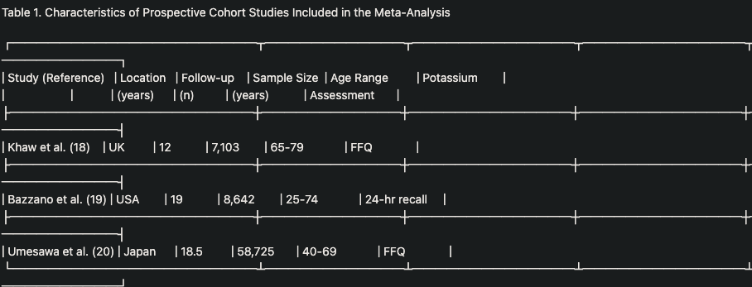

Table 2 summarizes the methodological quality assessment based on the Newcastle-Ottawa Scale.

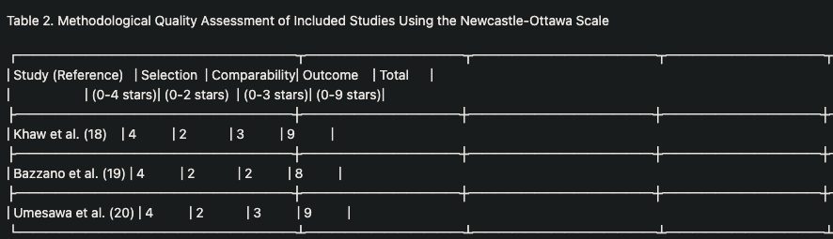

Table 3
