Figure 1: Histological scoring of OA for the medial tibial plateau in the ACLT+pMx and DMM models. Rat underwent ACLT+pMx or DMM surgery and were sacrificed at various timepoints (N=9-10 rats per timepoints). The ipsilateral or contralateral knees were taken for histological analysis. Slides were stained with toluidine blue and saffron du Gatinais and scored as detailed in the Method. Histological sections for the DMM model are shown with the region selected for scoring marked in red. The total histological score is shown for both models. Data on the graphs represent the total score for each animal (N=9-10) and the mean for each timepoint and for the selected contralateral knees. ** and **** means significantly different from contralateral with p<0.01 or p<0.0001 respectively.

Figure 2: CX and oxPTM-CII staining of the medial tibial plateau cartilage in the ACLT+pMx and DMM models. Rat underwent ACLT+pMx or DMM surgery and were sacrificed at various timepoints (N=9-10 rats per timepoints). The knees were taken for histological analysis. Representative results for toluidine blue and saffron Gatinais as well as type X collagen (blue, CX) and oxPTM type II collagen (brown, oxPTM-CII) immunostainings are shown. For the ACLT+pMx study single immunostainings were realized. For the DMM study a CX and oxPTM-CII double staining was performed as well as an oxPTM-CII collagen single staining.
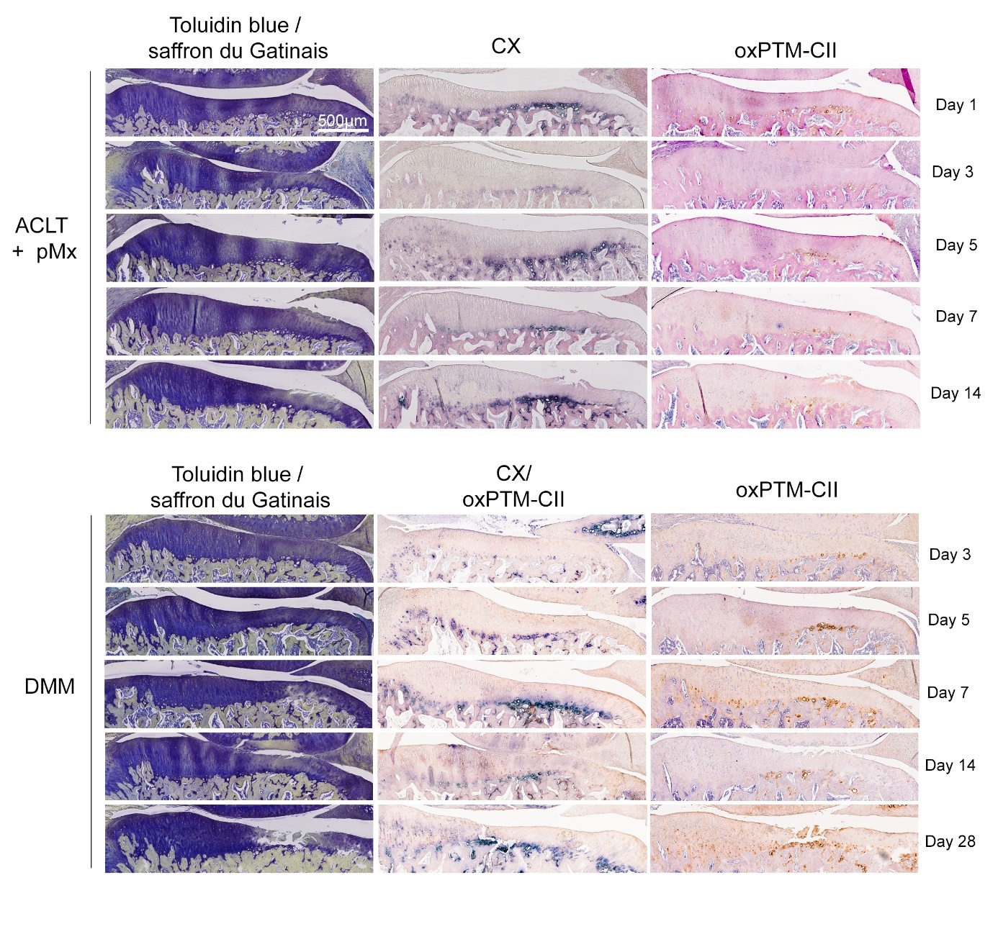

Figure 3: Partial co-localization of CX and oxPTM-CII staining in the cartilage of the medial tibial plateau and condyle in the DMM model. Rat underwent DMM surgery and were sacrificed at various timepoints (N=9-10 rats per timepoints). The knees were taken for histological analysis. Toluidin blue and saffron du Gatinais, type X collagen (blue, CX) and oxPTM type II collagen (brown, oxPTM-CII) staining are shown for cartilage of the medial tibial plateau presenting different levels of degeneration: A and B showed loss of matrix staining but no defect (both from day 14), C and D present cartilage with a small and a large defect respectively (from day 5 and 28 respectively). One example of staining for cartilage form the medial condyle is shown in E. Black arrows show examples of chondrocytes positive for oxPTM-CII but negative for CX.
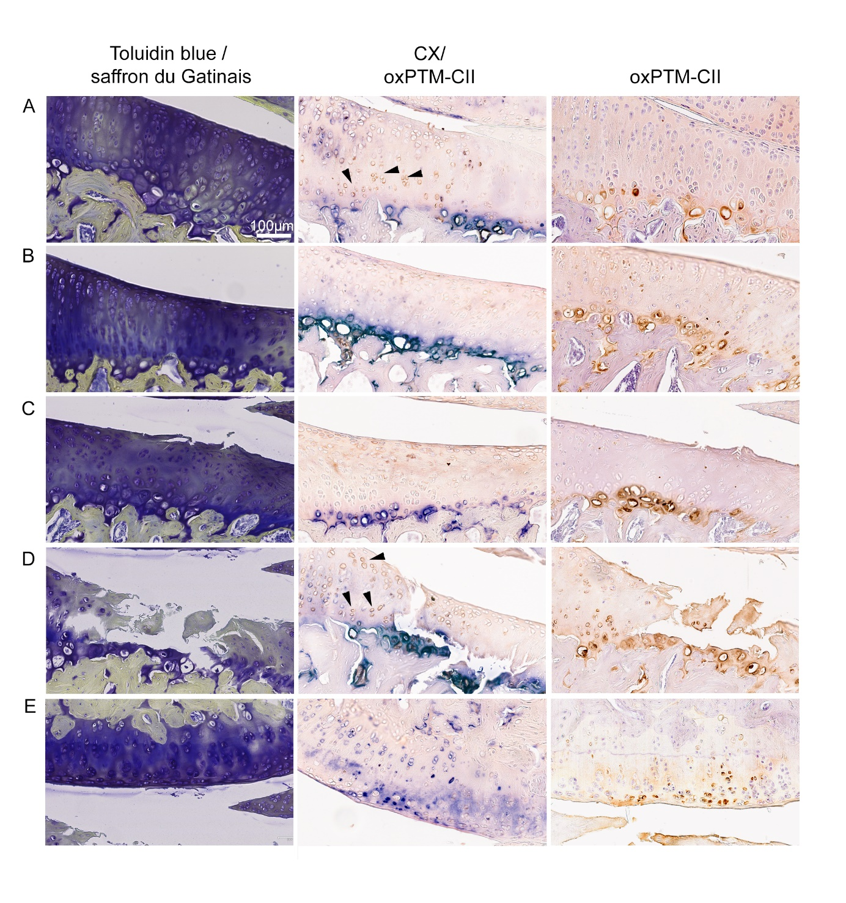

Figure 4: CX and oxPTM-CII staining in the meniscus and in the growth plate. One example of a double staining for type X collagen (blue, CX) and oxPTM type II collagen (brown, oxPTM-CII) and the single staining for oxPTM-CII is shown for the growth plate and the meniscus.
