Development of an in vitro method to assess the immunogenicity of biologics in the prevention of infectious diseases
Baran Joanna¹, Kuryk Lukasz², Garofalo Mariangela ³, Prygiel Marta², Zasada Aleksandra², Szczepińska Teresa¹, Staniszewska Anna⁴, Kala Deepak⁵, Majewski Piotr⁶, Charkiewicz Radosław⁶, Staniszewska Monika^{1*}
¹Centre for Advanced Materials and Technologies, Warsaw University of Technology, Warsaw, Poland
²National Institute of Public Health NIH – National Research Institute, Warsaw, Poland
³University of Padua, Padua, Italy
⁴Medical University of Lublin, Lublin, Poland
⁵ CENTERA Laboratory, Institute of High Pressure Physics, PAS, Warsaw, Poland
⁶Medical University of Bialystok, Bialystok, Poland
Keywords: immunology, vaccines, Calu-3, 3D model, ex vivo, in vivo, lymphocytes, cytokines, immunogenicity, SARS-CoV-2
Materials and Methods
Virus particles quantification.

Scanning Electron Microscope (SEM) imaging of hCoV-OC43, AdV1 and Calu-3 microvilli
SEM was used as a visualization method of individual virus particles. A 12-well plate containing a cell culture membrane and a 24-well plate containing glass slides or Corning® Transwell® Inserts were used. VERO E6 and H226 (10⁴ cells/mL of medium) were added to 12-well plates. VERO E6 cells (10⁵ cells/mL of medium) were added to a 24-well plates containing glass slides. After 15 days at 37°C with 5% CO₂, the cell growth medium was discarded. Two types of samples were analyzed: the infectious titer of OC43 in 500 µL of medium (5% FBS) onto the VERO E6 cell monolayer (2.84×10⁸ VP/mL); 100 VP/mL of AdV1 in 500 µL of medium (5% FBS) onto the H226 cell monolayer. After 48 h of incubation at 34.5˚C with 5% CO₂, the following sequence of washes (1 mL per insert of each reagent) and incubation conditions were performed: 5% glutaraldehyde in 0.1 M phosphate buffer (pH 7.2 for 24 h at 4°C); 0.1 M phosphate buffer for 10 min at room temperature (RT) x 3 times; 1% osmium tetroxide in 0.1 M phosphate buffer for 1-2 h at RT; distilled water for 10 min at RT x 2 times; 35% ethanol for 15 min at RT; 50% ethanol for 15 min at RT, 75% ethanol for 15 min at RT; 95% ethanol for 15 min at RT. After fixation, membranes were cut out from the 12-well plate, and coverslips were removed from the 24-well plate. Membranes and coverslips were then coated with a mixture of gold and palladium and visualized using SEM (Hitachi SU8230).

Virus particles quantification
To quantify the amount of viral RNA, the sample was first lysed, which released the RNA into solution. The measurement of the absorbance at 260 nm was performed. The dilutions of the viral suspension were prepared in a Virus Lysis Buffer (VLB: 9.75 mM Tris-EDTA pH 7.5 + 0.5% SDS) according to Table 6.
Table S1 Scheme for preparing dilutions of viral suspension in VLB buffer (9.75 mM Tris-EDTA at pH 7.5 + 0.5% SDS) for determining the amount of VP.
Dilution factor | Volume of viral suspension | VLB buffer volume
1:3 | 33 μl | 67 μl
1:5 | 20 μl | 80 μl
1:10 | 10 μl | 90 μl
1:50 | 2 μl | 98 μl
1:100 | 1 μl | 99 μl

Immunophenotyping
In this study, the development and use of three antibody panels for immunophenotyping of PBMCs were assessed. Cell staining was performed according to the manufacturer's protocol (BD Biosciences, USA). Briefly, the 50 µL of the antibodies mixture was added to 50 µL of the PBMC suspension containing 10⁶ cells. Three panels of antibodies were developed, they were described in Tables S2, S3, and S4. The suspension was then mixed, incubated for 30 min, and protected from light at room temperature. After the incubation, the cells were washed twice. Two milliliters of BD® Cell WASH were added to each tube, and the cells were centrifuged at 150×g for 5 min (Centrifuge 5910 R, Eppendorf). Each cell pellet was suspended in 250 µL of BD® Cell WASH and flow cytometry analysis was performed.

PANEL 1
Detector | BB515 | PE | PerCP | PE-Cy7 | APC | APC-H7 | Brilliant™ Stain Buffer | Stain Buffer (FBS)
Cell receptor | CD197 | CD95 | CD8 | CD4 | CD45RA | CD3 | - | -
Catalogue number (BD Biosciences) | 566764 | 555674 | 345774 | 557852 | 550855 | 560176 | 566349 | 554656
Volume per 1 sample tube [µL] | 2.5 | 10.0 | 10.0 | 2.5 | 10.0 | 2.5 | 10.0 | 2.5
Table S2 Phenotyping mixture ingredients (Panel 1).
PANEL 2
Detector | BB515 | PE | BB700 | PE-Cy7 | APC | APC-H7 | Brilliant™ Stain Buffer | Stain Buffer (FBS)
Cluster of differentiation | CD24 | CD38 | CD19 | IgD | CD27 | CD20 | - | -
Catalogue number (BD Biosciences) | 564521 | 555460 | 566396 | 561314 | 558664 | 335829 | 566349 | 554656
Volume per 1 sample tube [µL] | 2.5 | 10.0 | 2.5 | 2.5 | 10.0 | 2.5 | 10.0 | 10.0
Table S3 Phenotyping mixture ingredients (Panel 2).

PANEL 3
Detector | BB515 | PE | BB700 | PE-Cy7 | APC | APC-H7 | Brilliant™ Stain Buffer | Stain Buffer (FBS)
Cluster of differentiation | IgM | CD38 | CD19 | IgD | CD27 | IgG | - | -
Catalogue number (BD Biosciences) | 564422 | 555460 | 566396 | 561314 | 558664 | 561297 | 566349 | 554656
Volume per 1 sample tube [µL] | 2.5 | 10.0 | 2.5 | 2.5 | 10.0 | 2.5 | 10.0 | 10.0
Table S4 Phenotyping mixture ingredients (Panel 3).
Analyzes were performed using a BD FACSLyric ™ Flow Cytometry System. Before each series of analyses, the Performance QC protocol was conducted as recommended by the supplier. Gating strategies and hierarchy are shown in Figures S5-S8.

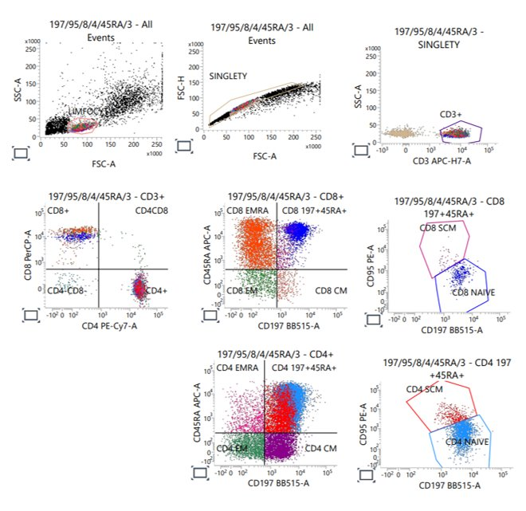
Figure S1 Gating strategy for "Panel 1" of immunophenotyping.
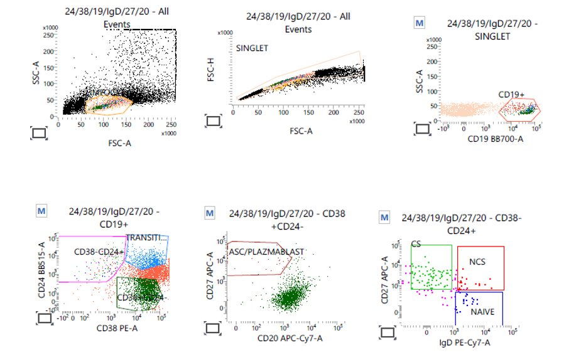
Figure S2 Gating strategy for "Panel 2" of immunophenotyping.

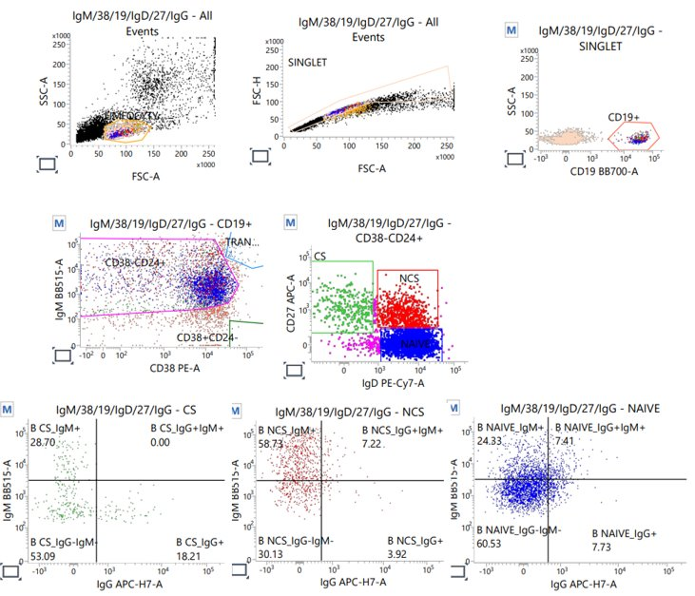Figure S3 Gating strategy for "Panel 3" of immunophenotyping.

Apoptosis assay
In the apoptosis assay, the following solutions were used (BD Biosciences, USA): 10x Binding Buffer (cat. no. 556454): 0.1 M HEPES, pH 7.4; 1.4 M NaCl; 25 mM CaCl₂; BD® Cell WASH (cat. no. 349524); Propidium Iodide (PI, cat. no. 556463); Annexin V-FITC (cat. no. 556420, 556419).
The cell staining was performed according to the manufacturer’s protocol. PBMCs were collected, washed with cold BD® Cell WASH, and suspended in 1x Binding Buffer (BD Biosciences, USA) at a concentration of 1x10⁶ cells/mL. Then, 100 µL of the cell suspension (10⁵ cells/100 µL) was transferred to a 5 mL tube. PI (0.5 µL) and Annexin V-FITC (2.5 µL) were added to a suspension and incubated for 15 min (protected from light). Then, 400 µL of 1x Binding Buffer was added. Analyzes were performed using a BD FACSLyric™ Flow Cytometry System (BD Biosciences, USA). Before each series of analyses, the Quality Control protocol was performed as recommended by the supplier (BD Biosciences, USA). The gating strategy is shown in Figure S4.
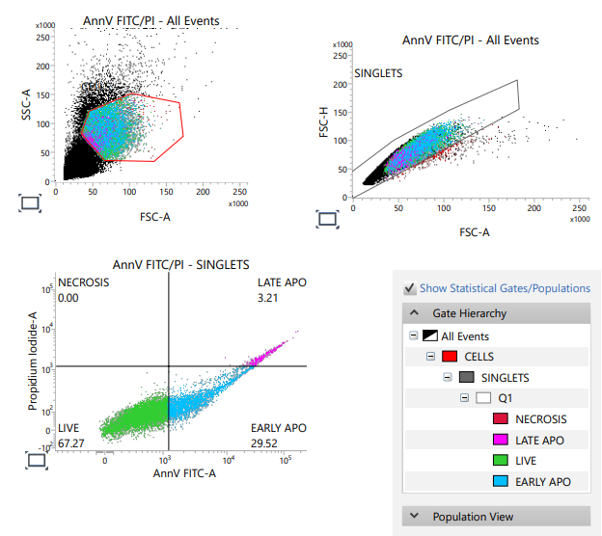
Figure S4 Gating strategy for Apoptosis assay.

Cytokine profiling
The culture medium of the immunostimulated PBMC cell suspensions in 3D models was examined for the cytokine profile. The cell supernatant after first centrifugation before the cell wash was cryopreserved and stored at -80°C until analysis (Centrifuge 5910 R, Eppendorf). Freshly thawed culture medium was diluted 100 times in the Assay buffer (BD Biosciences, USA), followed by the procedure according to the manual instruction of BD Cytometric Bead Array (CBA) Human Soluble Protein Master Buffer Kit: Preparing Human Flex Set Standards; Lyophylized standards were pooled into 15 mL centrifuge tube labeled as Top Standard (Centrifuge 5910 R, Eppendorf); 4 mL of the Assay Diluent were added to the tube. After 15 min incubation at room temperature, the suspension was mixed by gently pipetting 4-5 times. 500 µL of the Assay Diluent were pipetted to twelve cytometric tubes labeled as in Figure S5 and the top standard was serially diluted.
Figure S5 Preparation of Standard tubes. “0” stands for negative control. As negative control Assay buffer was used. Modified on the basis of: [BD CBA Human Soluble Protein Master Buffer Kit Instruction manual].

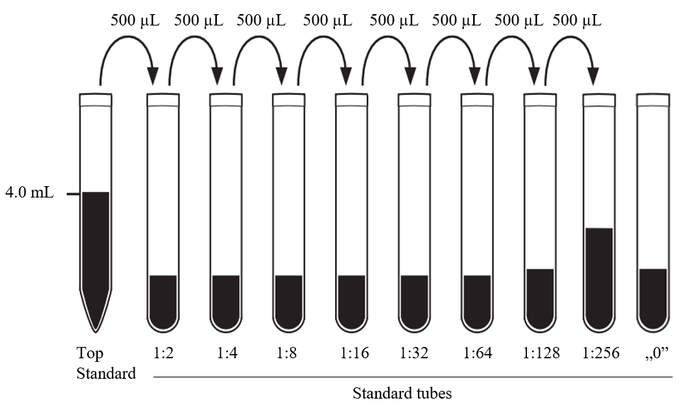
The standard concentrations in each Standard tube are presented below. Mixing Human Soluble Protein Flex Set Capture Beads: vials with capture beads were vortexed for 15 s to achieve uniform suspension; volumes of the reagents were calculated as follows:
$$V_{Mixed Capture Beads}=n×50 µL$$
Where: V_{Mixed Capture Beads} stands for the final volume of capture beads suspension; n stands for number of the assay tubes, including standards.
Individual Capture Beads are added following the rule 1.0 µL per test.
$$V_{Capture Beads Diluent}=V_{Mixed Capture Beads}-n×1 µL$$
The appropriate volumes of each capture beads (Table S5) were pipetted into a tube labeled Mixed Capture Beads.
Cytokine name | Catalogue number (BD Biosciences)
Human TNF | 558273
Human IFN-γ | 558269
Human IL-1α | 560153
Human IL-1β | 558279
Human IL-2 | 558270
Human IL-4 | 558270
Human IL-6 | 558276
Human IL-8 | 558277
Human IL-10 | 558274
Human IL-12p70 | 558283
Human 17A | 560383
Human IL-17F | 562151
Table S5 List of cytokines used in flow cytometry assay.
Preparing Human Soluble Protein Flex Set PE Detection Reagents: sing the calculations from the point 2, Human Detection Reagents were prepared:
$V_{Mixed Capture Beads}=V_{Human Detection Reagents}$;
$$V_{Capture Beads Diluent}=V_{Detection Reagent Diluent.}$$
The appropriate volumes were pipetted into a tube labeled Mixed PE Detection Reagents and stored at 4°C, protected from light until use. Assay procedure: 50 µL of Flex Set Standard dilutions were added to the labeled tubes (1-10) according to increasing concentration; 50 µL of each unknown sample were added to the separate test labeled tubes (11-X); Mixed Capture Beads were vortexed for 5 s; 50 µL of the Mixed Capture Beads were added to the assay tubes (test and standard tubes). The samples were then gently mixed; Assay tubes were incubated for 1 h at room temperature, protected from the light; 50 µL of the Mixed PE Detection Reagents were added to all assay tubes. The tubes were then gently mixed; Assay tubes were incubated for 2 h at room temperature (RT), protected from the light; 1 mL of the Wash Buffer was added to the assay tubes. Tubes were centrifuged at 200 g for 5 min (Centrifuge 5910 R, Eppendorf); The supernatants were discarded from assay tubes; 300 µL of the Wash Buffer was added to each assay tube. Tubes were vortexed before the analysis. Acquisition of the samples using the flow cytometer. Analyzes were performed using a BD FACSLyric ™ Flow Cytometry System. Data was analyzed using FCAP Array v 3 software (BD Biosciences, USA).

RNAseq
Table S5 Sample types used in the study of the RNA transcripts.
Sample number | Sample description |  | Sent material
1 | PBMC control 1 | PBMCs cultured for 72 h in cell growth medium. | RNA
2 | PBMC control 2 | PBMCs cultured for 72 h in cell growth medium. | RNA
3 | PBMC control 3 | PBMCs cultured for 72 h in cell growth medium. | RNA
7 | PBMC AdV1+S+N 1 | PBMCs treated with AdV1 (100 VP/mL), S-His and N-His (0.25 µg/mL), incubated for 72 h at 34.5°C with 5% CO₂. | RNA
8 | PBMC AdV1+S+N 2 |  | RNA
9 | PBMC AdV1+S+N 3 |  | RNA
10 | Calu-3 control 1 | Calu-3 cells cultured for 72 h in cell growth medium. | RNA
11 | Calu-3 control 2 | Calu-3 cells cultured for 72 h in cell growth medium. | RNA
12 | Calu-3 control 3 | Calu-3 cells cultured for 72 h in cell growth medium. | RNA
13 | Calu-3 AdV1+S+N 1 | Calu-3 cells treated with AdV1 (100 VP/mL), S-His and N-His (0.25 µg/mL), incubated for 72 h at 34.5°C with 5% CO₂. | RNA
14 | Calu-3 AdV1+S+N 2 |  | RNA
15 | Calu-3 AdV1+S+N 3 |  | RNA
Legend: PBMC stands for peripheral blood mononuclear cells, AdV1 stands for serotype 5/3 equipped with ICOSL and CD40L (Garofalo et al., 2021a). Spike-S1-His and Nucleocapsid-His mean recombinant protein (InvivoGen, USA). Calu-3 means human lung tumor epithelial cells (ATCC).
To prepare the sequencing libraries, rRNA depletion was conducted. The sequencing process was carried out on an Illumina NovaSeq 6000 machine, which produced 2 x 100 bp reads. The company trimmed the reads from adapters and excluded nucleotides with a Phred score below a certain threshold. Only reads that were longer than 35 nucleotides were kept. The reads were aligned to the human GRCH.38 genome with GENCODE version 43 primary annotation, using RSEM-1.3.3 coupled with STAR-2.7.10b pipeline. Estimated read counts per gene were used for differential expression analysis using the DESeq2-1.34.0 R package. However, sample nr 8 from PBMC AdV1+S+N condition was identified as an outlier due to its clustering outside of all PBMC cell samples and almost double the read count compared to other samples. The samples were clustered using the complete linkage hierarchical clustering method. The transformed read counts were measured by the R dist (Distance Matrix Computation) function with default parameters using the Euclidean distance between samples. All conditions were included in the DE-seq2 model, and three comparisons were made. Differentially expressed genes were analyzed separately for gene ontology enrichment with GPrifiler or the DAVID tool. The threshold of Benjamini-Hochberg adjusted FDR was used to extract differentially expressed genes from each comparison.
In vivo analysis of adenovirus-based platform
The study employed a mouse model BALB/c to evaluate the potential adverse effects and safety profile of the therapeutic intervention. Three mice were included in each experimental group, and the animals' health and well-being were monitored daily. The therapeutics were administered via subcutaneous injections, with a standardized dose of 500 µl. The administration of therapeutics begins on the Day 0 of the experiment. These injections were provided in a series of up to three doses, with intervals of 3-4 days between each injection. Precise administration dates were documented to monitor the timing of interventions. The experiment encompasses three cycles of therapeutic administration to assess the safety profile over an extended period. The weight of the mice was evaluated before each injection to track any changes that may indicate safety concerns. In Table S7 the details of the experiment are shown. The in vivo experiments including breeding, platform administration, and euthanasia were at the National Institute of Public Health – National Institute of Hygiene – National Research Institute. The whole procedure was performed according to the Ethical Statement no WAW2/150/2022 of December 7, 2022, of the Local Ethical Commission for Animal Experiments in Warsaw.
Experiment  Name of eppendorf | N=mouse | Treatment | Place of injection | Volume | Repetition
1 | 3 | PBS | Subcutaneously | 500 µL | 3  injections
2 | 3 | AdVwt (1×10¹⁰ VP/mL) | Subcutaneously | 500 µL | 3  injections
3 | 3 | AdV1  (1×10¹⁰ VP/mL) | Subcutaneously | 500 µL | 3  injections
4 | 3 | S-His (10 µg/mL)  +  N-His (10 µg/mL) | Subcutaneously | 500 µL | 3  injections
5 | 3 | AdVwt (1×10¹⁰ VP/mL)  +  S-His (10 µg/mL)  +  N-His (10 µg/mL) | Subcutaneously | 500 µL | 3  injections
6 | 3 | AdV1 (1×10¹⁰ VP/mL)  +  S-His (10 µg/mL)  +  N-His (10 µg/mL) | Subcutaneously | 500 µL | 3  injections
Table S7 In vivo analysis of the adenovirus-based platform. The table contains the conversion of the concentration of the viruses and proteins (S-His and N-His) into 500 µL dose volumes.

Statistical analyses
The quantitative and qualitative data obtained in this study were subjected to statistical analysis. The mean ± SD was used to express continuous data unless stated otherwise. Various tests were employed to evaluate multiple variables, such as multiple unpaired t-tests, Wilcoxon signed rank test, paired t-test, RM one-way ANOVA, and correlation (Pearson r). These tests were used to identify any significant changes in variables between the different groups. A P-value of ≤0.05 was considered statistically significant for all tests performed. GraphPad Prism 9.5.1.733 (San Diego, USA) was used to analyze the data.

Results

Optimization and validation of an ex vivo Peripheral Blood Mononuclear Cell (PBMC): cell viability and programmed cell death
The PBMCs viability was measured after 24 h, 48 h, and 7 days. As shown in Figure S6, there are no statistically significant differences between the 24-h culture and 48-h culture, however after 7 days the decrease in cell viability was significant. Due to the planned long-term experiments, the conditions of the 7-day culture were optimized.
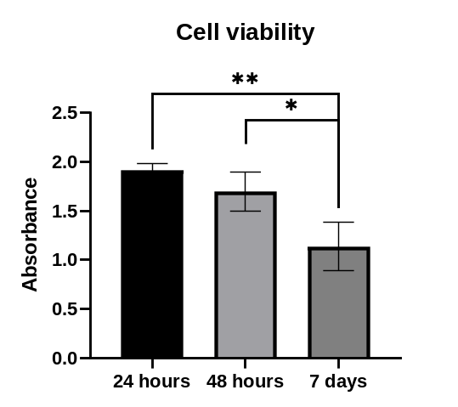
Figure S6 PBMCs viability over the time of culture (before optimization). *P ≤ 0.05, **P ≤ 0.01.
The cell apoptosis on the seventh day of culture before and after optimization is shown in Figure S7. The approximately 40% increase in the number of viable cells was achieved in the 7-day culture after optimizing the PBMCs handling conditions. PBMCs isolated from the buffy coats of healthy donors were used as the ex vivo model to study the immune response.
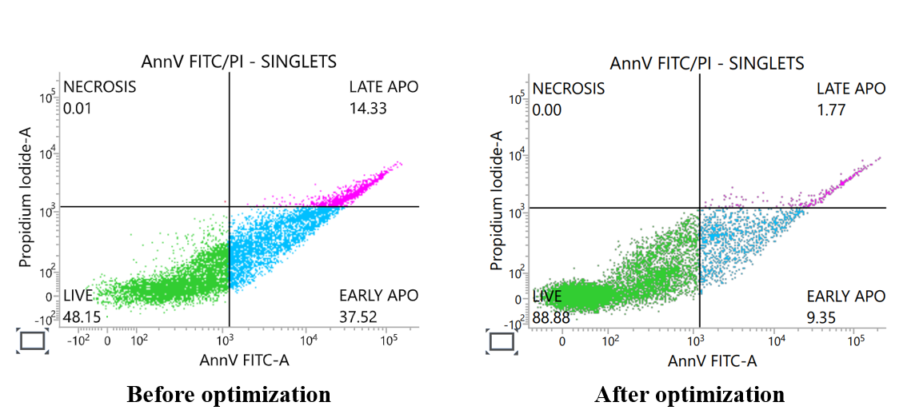
Figure S7 Apoptosis assay results of PBMCs after 7-day culture, before and after optimization of cell isolation and culture conditions. Legend: AnnV FITC-A stands for annexin V, 35 – 36 kD Ca²⁺-dependent phospholipid-binding protein conjugated to the FITC fluorochrome. PI means propidum iodide. Singlets mean single cells separated from aggregates using forward side channel-Aria (FSC-A) vs. forward side channel–height (FSC-H). EARLY APO stands for early apoptosis. LATE APO means late apoptosis.

Cytotoxicity study of the immunogenic factors
Immunogenic factors were tested in various concentrations and combinations to establish their influence on the viability and metabolic activity of the VERO E6 and PBMC cells. The VERO E6 cells were exposed to different dilutions of AdV1 (Figure S8). The VERO E6 cells treated with AdV1 in the concentration of 5.2×10⁴ VP/mL for 24 h showed a slight increase in the viability (127.0±3.0%) compared to the untreated control (100.0±16.0%) (Figure S8). The remaining results did not show any statistically significant deviations compared to the untreated control.
After selecting the immunogenic factors’ concentrations to be tested in further experiments, the PBMC metabolic activity was assessed using the MTS assay (Figure S9). No significant changes compared to the control were noted (Figure S9).

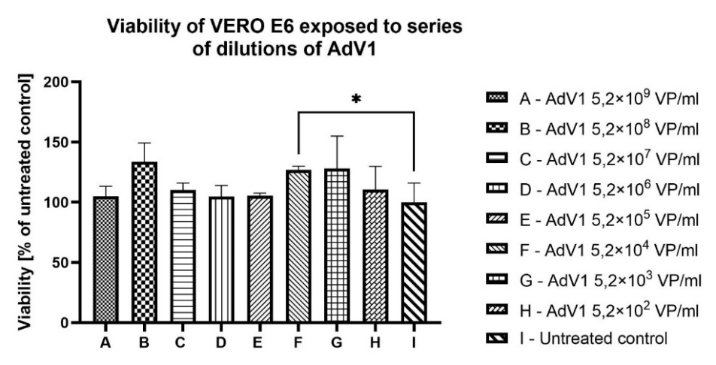
Figure S8 Viability of the VERO E6 cell line exposed to series of dilutions of AdV1 for 24 h. Legend: AdV1 stands for adenovirus serotype 5/3 with ICOSL and CD40L.

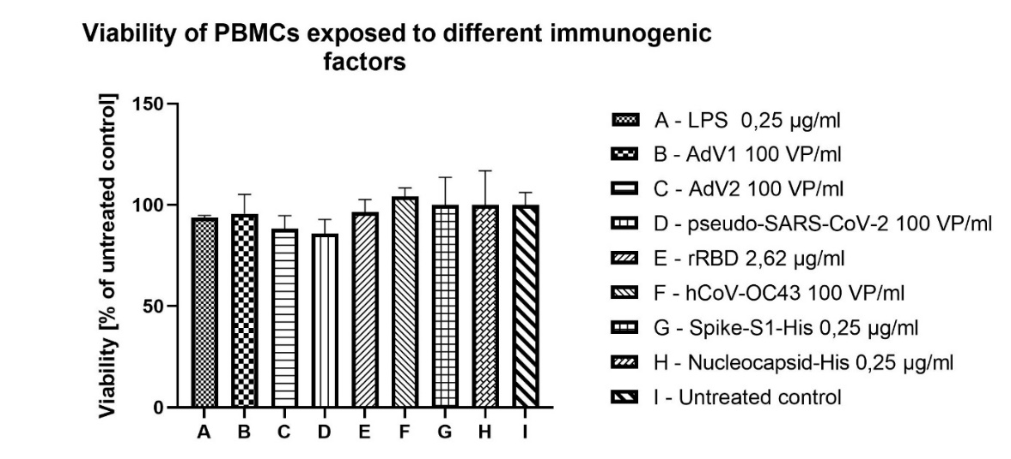
Figure S9 Viability of PBMC exposured to different immunogenic factors for 24 h. Legend: LPS means bacterial lipopolysaccharide. AdV1 stands for 5/3 serotype equipped with ICOSL and CD40L (Garofalo et al., 2021a). hCoV-OC43 means human betacoronavirus. rRBD stands for recombinant receptor binding domain protein (Baran et al., 2023 accepted for publication). ADV2 stands for serotype 5/3 without ICOSL and CD40L (Garofalo et al., 2021a). Pseudo-SARS-CoV-2 stands for pseudotyped lentivirus (Genecopeia, USA). Spike-S1-His and Nucleocapsid-His mean recombinant protein (InvivoGen, USA).

Calu-3 micovilli imaging using SEM
Calu-3 cells cultured on Corning® Transwell® Inserts developed microvilli on their surface of a maximum length 1 µm (Figure S10).
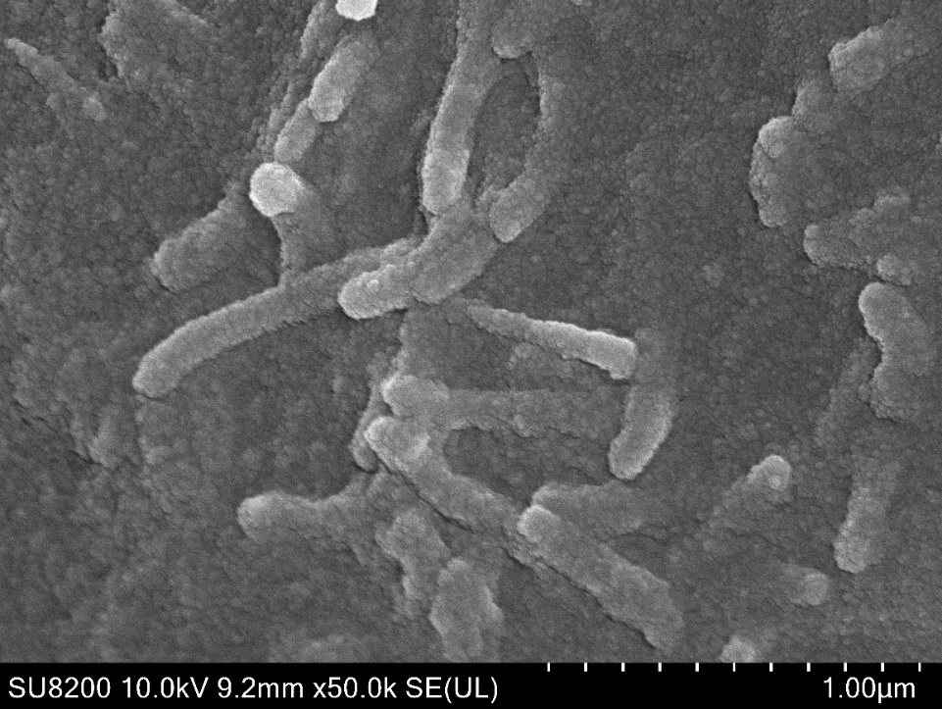
Figure S10 SEM nr 1 (Hitachi SU8230): Microvilli (yellow arrows) on the surface of Calu-3 cell line growing on Corning® Transwell® Inserts. Bar=1 µm.

In vivo analysis of adenovirus-based platform
No significant differences were observed in the size of the lungs, peritoneal sac, liver, heart, spleen and kidneys between the tested samples and the control (PBS) (Table S6).

Treatment | Lungs | Peritoneal sac | Liver | Heart | Spleen | Kidneys
PBS | 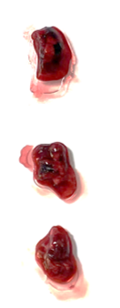 | 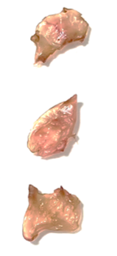 | 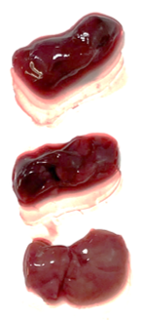 | 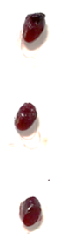 | 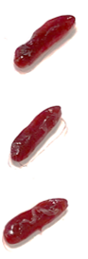 | 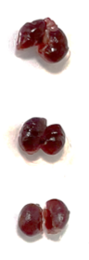
AdV wt | 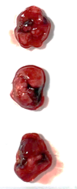 | 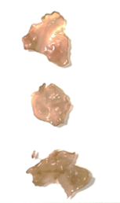 | 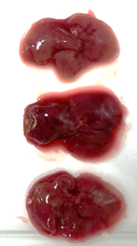 | 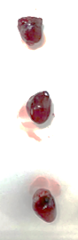 | 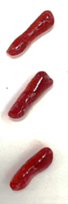 | 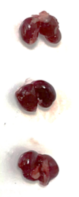
AdV1 | 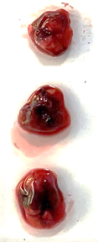 | 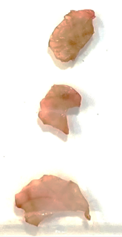 | 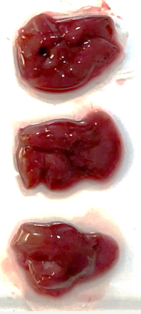 | 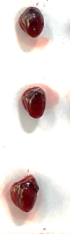 | 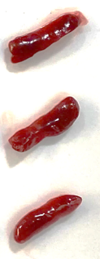 | 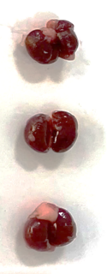
S-His+N-His | 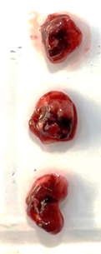 | 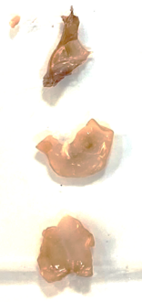 | 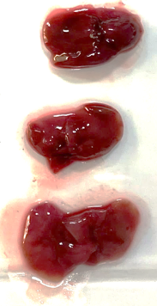 | 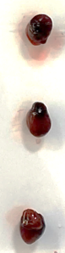 | 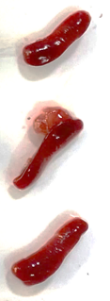 | 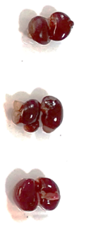
AdV wt+ S-His+N-His | 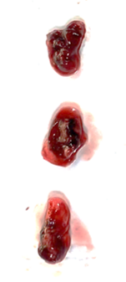 | 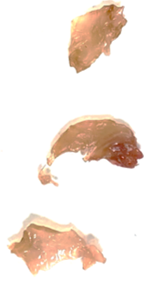 | 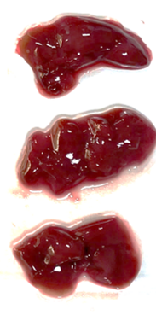 | 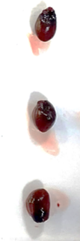 | 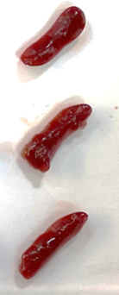 | 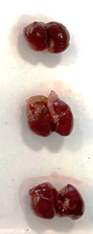
AdV1+  S-His+N-His | 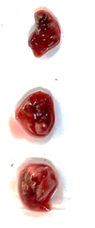 | 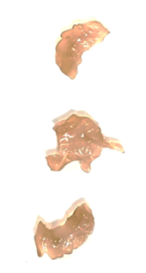 | 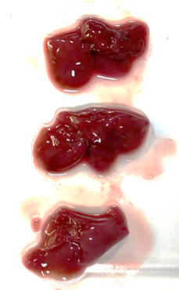 | 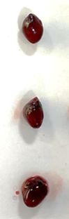 | 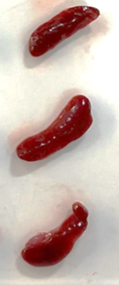 | 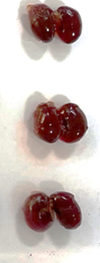
Table S6 Pictures of mouse organs prepared after day 7 of in vivo analysis of adenovirus-based platform. AdV1 stands for serotype 5/3 equipped with ICOSL and CD40L (Garofalo et al., 2021a), AdV wt stands for serotype 5/3 without costimulatory ligands. AdV’s were used in conc. of 1×10¹⁰ VP/mL. Spike-S1-His (10 µg/mL) and Nucleocapsid-His (10 µg/mL) mean recombinant protein (InvivoGen USA).

