Supplementary information
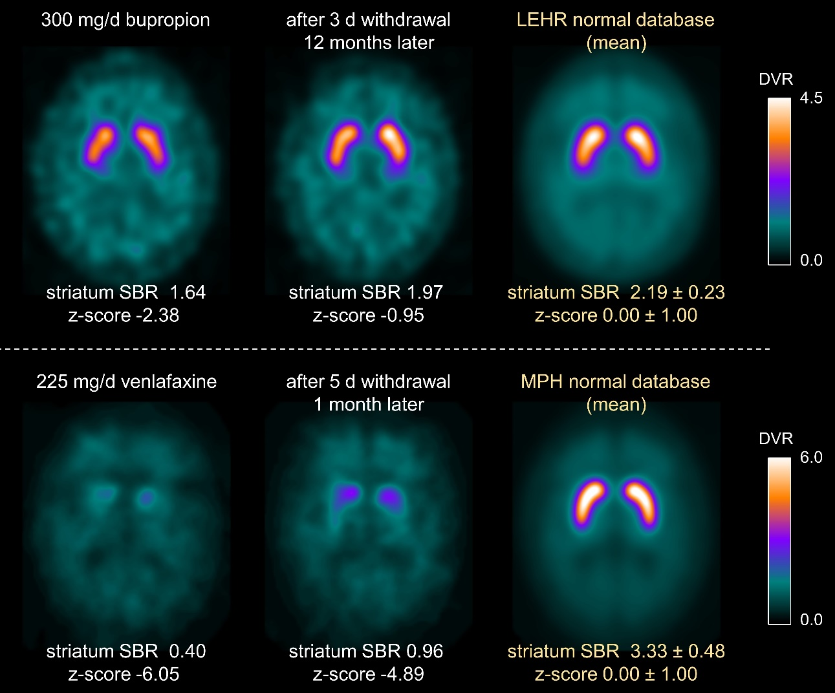
Supplementary Fig. 1 Repeat [¹²³I]FP-CIT-SPECT after 3 days withdrawal of 300 mg/d bupropion (top) and after 5 days withdrawal of 225 mg/d venlafaxine (bottom). The [¹²³I]FP-CIT-SPECT under bupropion (venlafaxine) was automatically categorized into the uniform reduction (PD-like) cluster. Repeat [¹²³I]FP-CIT-SPECT were acquired with the same camera used at baseline (top: double-head camera with LEHR collimators, bottom: triple-head camera with multiple-pinhole collimators). The voxel-wise mean image in the corresponding normative reference database is shown for comparison.

