Supplementary material
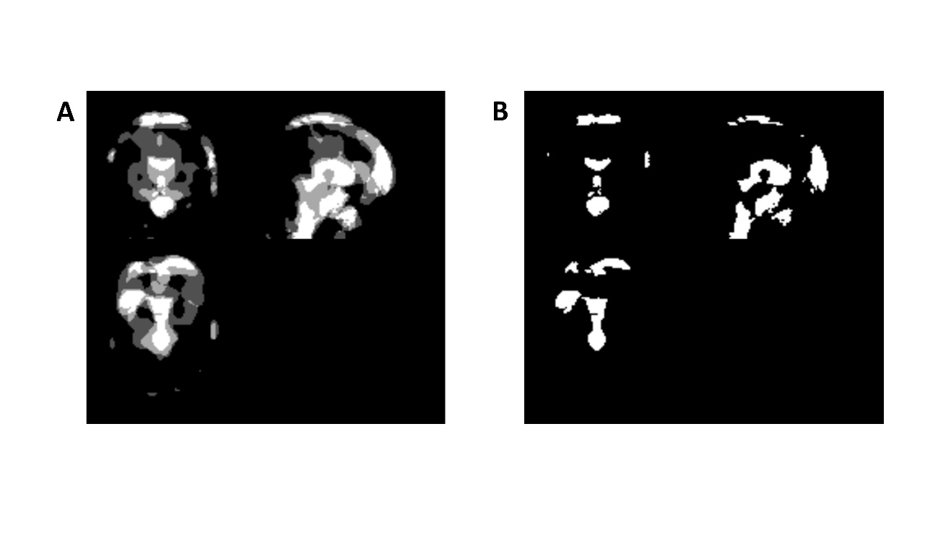
Supplementary Fig. 1. Brain regions in which spatial artifacts were likely to be observed on intraoperative fMRI and the exclusion mask to eliminate the influences of spatial artifacts
A) An overlay image of spatial artifacts on intraoperative fMRI. In this figure, brighter regions are where spatial artifacts were observed more frequently. B) Exclusion mask to eliminate the influences of spatial artifacts. This mask was created by binarising the overlay image of spatial artifacts. In this process, the binarisation threshold was set at four. That is, the value of voxels in which spatial artifacts were observed in four or more subjects was set at one.
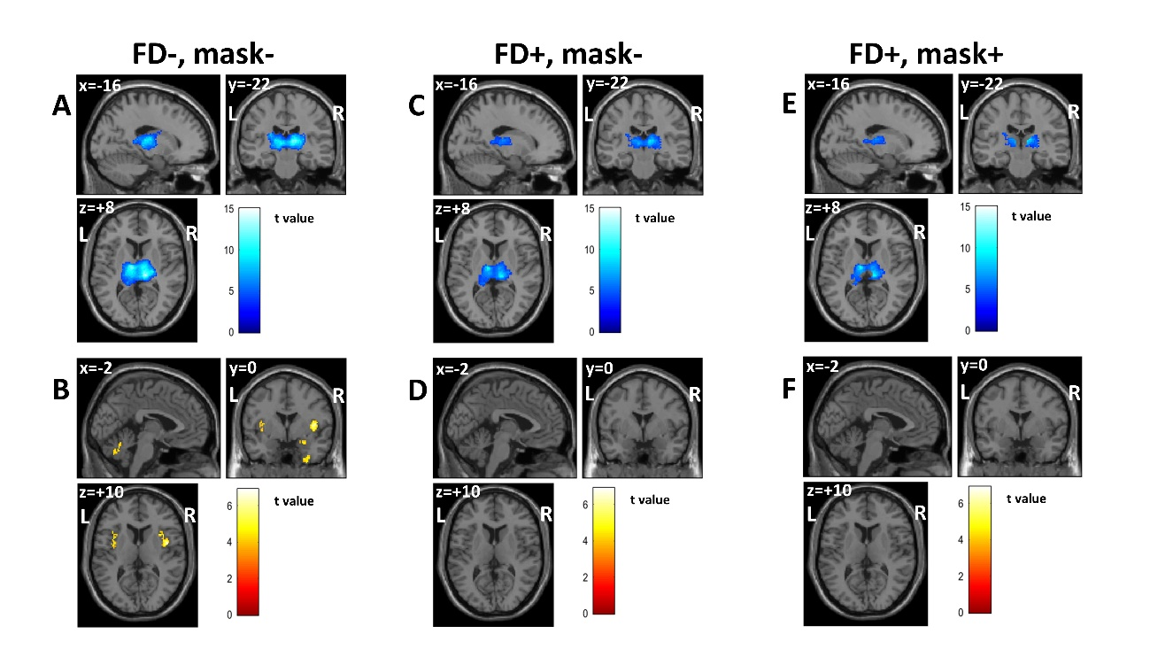
Supplementary Fig. S2. Differences in functional connectivity (FC) of the left thalamus before and during anesthesia.
A, C, E) Brain regions showing significant FC decrease during anesthesia (intraoperative MRI). B, D, F) Brain regions showing significant FC increase during anesthesia. A, B) FC maps without framewise displacement (FD) correction and the exclusion mask. C, D) FC maps with FD correction without the exclusion mask. E, F) FC maps with FD correction and the exclusion mask. All FC maps used thresholds of p < 0.001 (uncorrected for multiple comparisons) at the voxel level and p < 0.025 (FWE corrected) at the cluster level. FD+, FC map with FD correction; FD-, FC map without FD correction; mask+, FC map with the exclusion mask; mask-, FC map without the exclusion mask.

