Supplementary Material
Ultrasound-Triggered Piezoelectric Polyetheretherketone with Boosted Osteogenesis via Regulating Akt/GSK3β/β-Catenin Pathway

Yue Li^{a,1}, Yingying Fan^{a,1}, Siyu Zhao^{a*}, Bo Cheng^{a*}

ª Department of Stomatology, Zhongnan Hospital of Wuhan University, Wuhan University, Wuhan 430071, China.

¹ Yue Li and Yingying Fan contributed equally to this work.
* Corresponding authors.
E-mail addresses: zhaosiyu001122@126.com (S. Zhao), chengbo@znhospital.cn (B. Cheng).

Figures and tables
Figure S1. The cytotoxicity of BTO with different concentrations after culture with MC-3T3-E1 cells for 24, 48 and 72 h.

Figure S2. SEM image of BTO.

Figure S3. EDS patterns of PEEK, SPEEK, and PBSP.

Figure S4. EDS mapping of PBSP (scale bar=10 μm).

Figure S5. XRD pattern of BTO.

Figure S6. XRD patterns of PEEK, SPEEK, and PBSP.

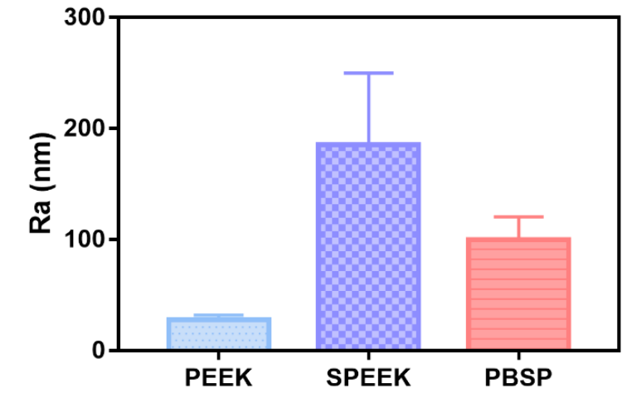
Figure S7. Roughness comparation between PEEK, SPEEK, and PBSP.
Figure S8. The content of Ba element in the extracts of PBSP after immersion in PBS for 21 days.

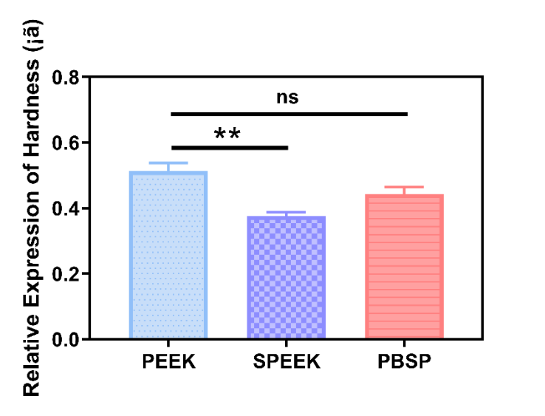
Figure S9. Hardness of PEEK, SPEEK, and PBSP.

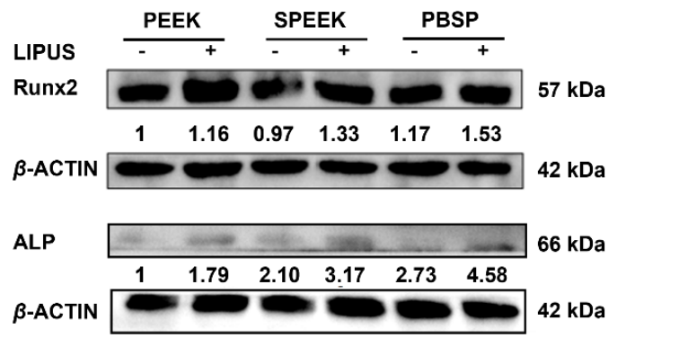
Figure S10. The protein expression of osteogenesis-related proteins in different groups.

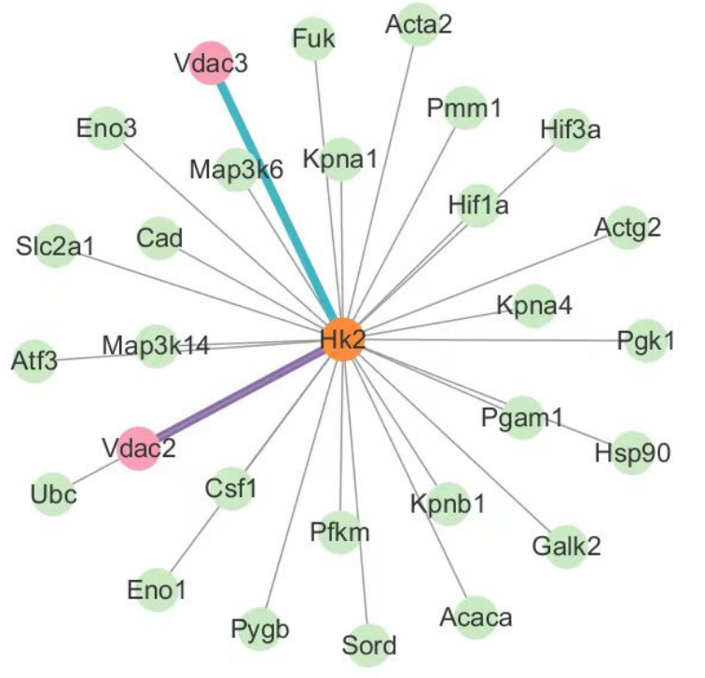
Figure S11. The protein–protein interactions in MC-3T3-E1 cells treated with PBSP+LIPUS.

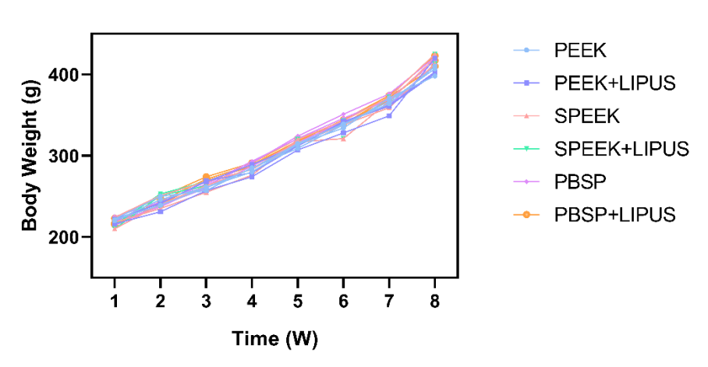
Figure S12. Body weight variation of rats in different groups.

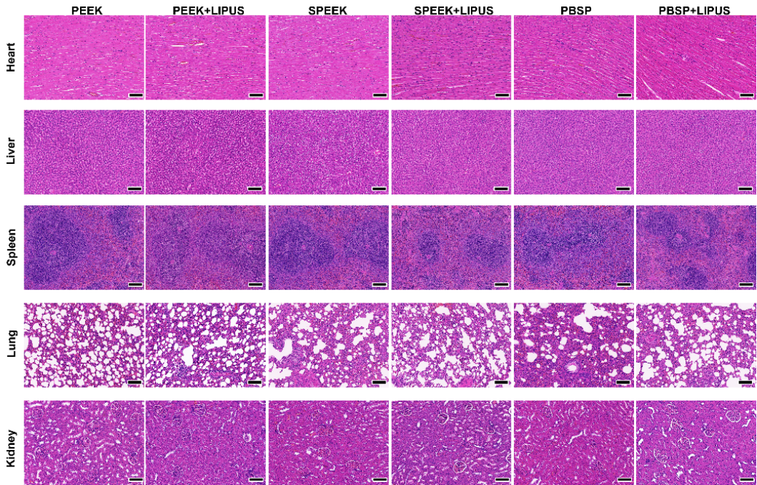
Figure S13. The representative H&E staining images of major organs in different groups after implantation for 8 weeks (scale bar = 100 μm).

Table S1. The primers used in this study.
Gene name | Sequence
COL1A1-F | GGAGCACCTGGACTAGACG
COL1A1-R | GCCTTGGACTGGTAAGCCAT
Runx2-F | GCCACCTTTACCTACACCCC
Runx2-R | ACTCTGGCTTTGGGAAGAGC
OPN-F | CCCGGTGAAAGTGACTGATTCT
OPN-R | GATCTGGGTGCAGGCTGTAAA
TRPV4-F | AACCCCATTGACCTGTTGGA
TRPV4-R | GGTAAGTGCCGTAGTCGAACAAG
TRPV6-F | AGGGGTTAATACTCTGCCTATGG
TRPV6-R | GCACCTCACATCCTTCAAACTT
Piezo1-F | GCGGCGCTATGAGAACAAG
Piezo1-R | CTGCGAGCGGTGGAAGA
GAPDH-F | CATGGCCTTCCGTGTTCCT
GAPDH-R | CCTGCTTCACCACCTTCTTGA

Table S2. GO analysis referred to Figure 5b.
ID | Term | p-value
GO:0042254 | ribosome biogenesis | 3.83E-23
GO:0022613 | ribonucleoprotein complex biogenesis | 2.04E-21
GO:0006364 | rRNA processing | 5.53E-19
GO:0016072 | rRNA metabolic process | 1.11E-18
GO:0034660 | ncRNA metabolic process | 1.17E-16
GO:0034470 | ncRNA processing | 6.58E-15
GO:0030490 | maturation of SSU-rRNA | 4.77E-12
GO:0042274 | ribosomal small subunit biogenesis | 5.85E-12
GO:0006913 | nucleocytoplasmic transport | 7.47E-12
GO:0051169 | nuclear transport | 7.47E-12
GO:0030684 | preribosome | 5.36E-22
GO:0032040 | small-subunit processome | 3.02E-15
GO:0030686 | 90S preribosome | 1.56E-12
GO:0044452 | nucleolar part | 6.01E-12
GO:0001650 | fibrillar center | 2.31E-07
GO:0044420 | extracellular matrix component | 1.40E-06
GO:0005578 | proteinaceous extracellular matrix | 1.20E-05
GO:0031012 | extracellular matrix | 1.27E-05
GO:0030687 | preribosome, large subunit precursor | 1.72E-05
GO:0034399 | nuclear periphery | 2.81E-05
GO:0030515 | snoRNA binding | 2.17E-07
GO:0016874 | ligase activity | 2.79E-07
GO:0004812 | aminoacyl-tRNA ligase activity | 3.21E-07
GO:0016875 | ligase activity, forming carbon-oxygen bonds | 3.21E-07
GO:0008135 | translation factor activity, RNA binding | 8.46E-07
GO:0003729 | mRNA binding | 9.27E-07
GO:0003743 | translation initiation factor activity | 1.06E-06
GO:0050839 | cell adhesion molecule binding | 1.14E-06
GO:0001085 | RNA polymerase II transcription factor binding | 5.02E-06
GO:0140098 | catalytic activity, acting on RNA | 6.77E-06

Table S3. KEGG pathways enrichment analysis referred to Figure 5d.
ID | Term | p-value
mmu00511 | Other glycan degradation | 0.002711699
mmu04012 | ErbB signaling pathway | 0.002623627
mmu05207 | Chemical carcinogenesis - receptor activation | 0.002597551
mmu04216 | Ferroptosis | 0.002074021
mmu04933 | AGE-RAGE signaling pathway in diabetic complications | 0.001630361
mmu05215 | Prostate cancer | 0.001570916
mmu05225 | Hepatocellular carcinoma | 0.00149913
mmu05418 | Fluid shear stress and atherosclerosis | 0.001157896
mmu04068 | FoxO signaling pathway | 0.001110849
mmu00480 | Glutathione metabolism | 0.000614845
mmu05163 | Human cytomegalovirus infection | 0.000609637
mmu05417 | Lipid and atherosclerosis | 0.000317107
mmu04510 | Focal adhesion | 0.000131391
mmu05206 | MicroRNAs in cancer | 0.000120425
mmu05205 | Proteoglycans in cancer | 6.95E-05
mmu01230 | Biosynthesis of amino acids | 2.77E-05
mmu04151 | PI3K-Akt signaling pathway | 2.42E-05
mmu01521 | EGFR tyrosine kinase inhibitor resistance | 2.40E-06
mmu00970 | Aminoacyl-tRNA biosynthesis | 2.32E-06
mmu03008 | Ribosome biogenesis in eukaryotes | 1.94E-11

 | Normal Range | PEEK | PEEK+LIPUS | SPEEK | SPEEK+LIPUS | PBSP | PBSP+LIPUS
RBC | 5.6-7.89 (10¹²/L) | 7.08 | 6.37 | 6.83 | 3.40 | 7.04 | 7.67
WBC | 2.9-15.3 (10⁹/L) | 13.2 | 8.63 | 10.55 | 4.35 | 14.44 | 9.59
PLT | 100-1610 (10⁹/L) | 568 | 382 | 666 | 166 | 577 | 630
LYMPH | 2.6-13.5 (10⁹/L) | 10.86 | 7.63 | 8.61 | 4.23 | 11.75 | 8.59
MID | 1.5-4.5 (%) | 2.8 | 2.6 | 3.5 | 1.1 | 2.9 | 1.9
HGB | 120-150 (g/L) | 140 | 126 | 132 | 126 | 138 | 148
Table S4. Blood routine markers of rats after implantation for 8 weeks in diverse groups.

Table S5. List of abbreviations in order of appearance.
Abbreviations | Full name
PEEK | Polyether ether ketone
BTO | Barium titanate
LIPUS | Low-intensity pulsed ultrasound
PDA | Polydopamine
SPEEK | Sulfonated Polyether ether ketone
Ca²⁺ | Calcium ions
FDA | Food and Drug Administration
PBSP | PDA@BTO-SPEEK
αMEM | Alpha modified eagle medium
FBS | Fetal bovine serum
ARS | Alizarin red S
CCK-8 | Cell counting kit-8
- Akt | Phosphorylated Akt
P-GSK3β | Phosphorylated GSK3β
Runx2 | Runt-related transcription factor 2
ALP | Alkaline phosphatase
SEM | Scanning electron microscopy
AFM | Atomic force microscope
Calcein-AM | Calcein-acetoxymethyl ester
PI | Propidium iodide
XRD | X-ray diffraction
XPS | X-ray photoelectron spectroscopy
DA | Dopamine hydrochloride
MC3T3-E1 | Mouse pre-osteoblast cells
CLSM | Confocal laser scanning microscope
COL1A1 | Collagen type I alpha 1 chain
OPN | Osteopontin
qRT-PCR | Quantitative real-time polymerase chain reaction
WB | Western blot
PVDF | Polyvinylidene fluoride
HRP | Horseradish peroxidase
RNA-seq | Transcriptome sequencing
DEGs | Differentially expressed genes
GO | Gene ontology
KEGG | Kyoto encyclopedia of genes and genomes
BV/TV | Bone volume per tissue volume
Tb.Th | Trabecular thickness
Tb.Sp | Trabecular separation
H&E | Hematoxylin and eosin
WCA | Water contact angle
OD | Optical density
DAPI | 4’,6-Diamidino-2-phenylindole
OCN | Osteocalcin
Piezo1 | Piezo type mechanosensitive ion channel component 1
TRPV | Transient receptor potential vanilloid
VDAC | Voltage-dependent anion channel
HK2 | Hexokinase II
MMP | Mitochondrial membrane potential
Micro-CT | Microcomputed tomography
3D | Three-dimensional

