Supplementary

Python notebook for generating synthetic data, estimating parameters and analysing experimental results
https://colab.research.google.com/drive/1ZDI-Dw-nVkADw2vFdV3h3h4WTBTzvIGJ?usp=sharing

Raw data from experiment
https://docs.google.com/spreadsheets/d/128yh9q_4I4ESLGXC-_o0lY3mMrA9-WymOggvyCfR6_A/edit?usp=sharing

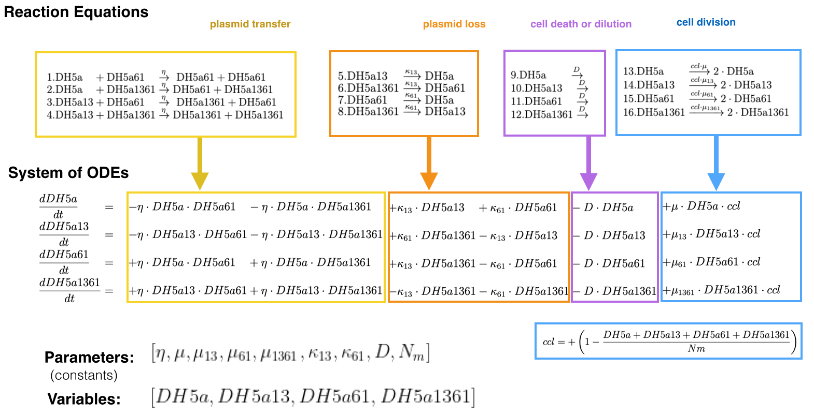
Fig S1. A mathematical model of our conjugation system. “Reaction Equations” show all possible interactions between cells in the system. “System of ODEs” is a set of ordinary differential equations (ODEs) governing the population change of each cell types. Variable [DH5a, DH5a13, DH5a61, DH5a1361] represent the population level of DH5a, DH5a-X13, DH5a-X61 and DH5a-X13-X61, respectively, at a given time point. Parameter [η, μ, μ₁₃, μ₆₁, μ₁₃₆₁, κ₁₃, ﻿κ₆₁, D, N_{m}] are time-independent constants that determine the rate of X61 conjugative transfer, DH5a growth, DH5a-X13 growth, DH5a-X61 growth, DH5a-X13-X61 growth, X13 loss, X61 loss, cell death and dilution, and carrying capacity, respectively.

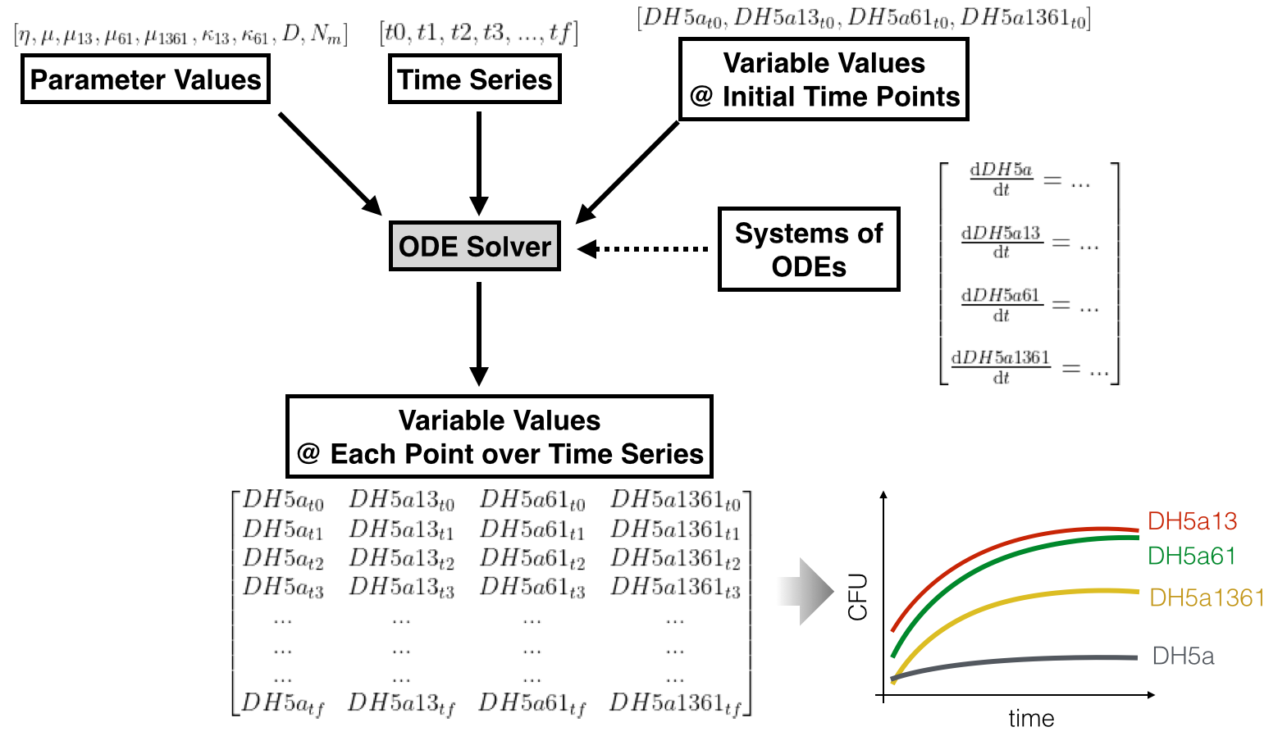
Fig S2. Components and output of the mathematical model. A given model consists of a system of ODEs (as shown in Fig S1) and parameter set which are time-independent constants representing key intrinsic properties of the system (such as growth rates, plasmid transfer rates, etc.). For a given initial condition, i.e., initial subpopulation levels of DH5a, DH5a-X13, DH5a-X61, DH5a-X13-X61, the model can simulate how these subpopulation changes over time. The output of the model is the time-courses dynamics of these subpopulations, shown as 2D matrix. Each row shows the levels of four cell types (DH5a, DH5a-X13, DH5a-X61, DH5a-X13-X61) at a given time point. This output can be visualised as a line plot of population levels VS time. For example, the first column of the matrix is the timecourse dynamics of DH5a, plotted as a grey line in this figure; the second column of the matrix is the time-course dynamics of DH5a-X13, plotted as a red line.

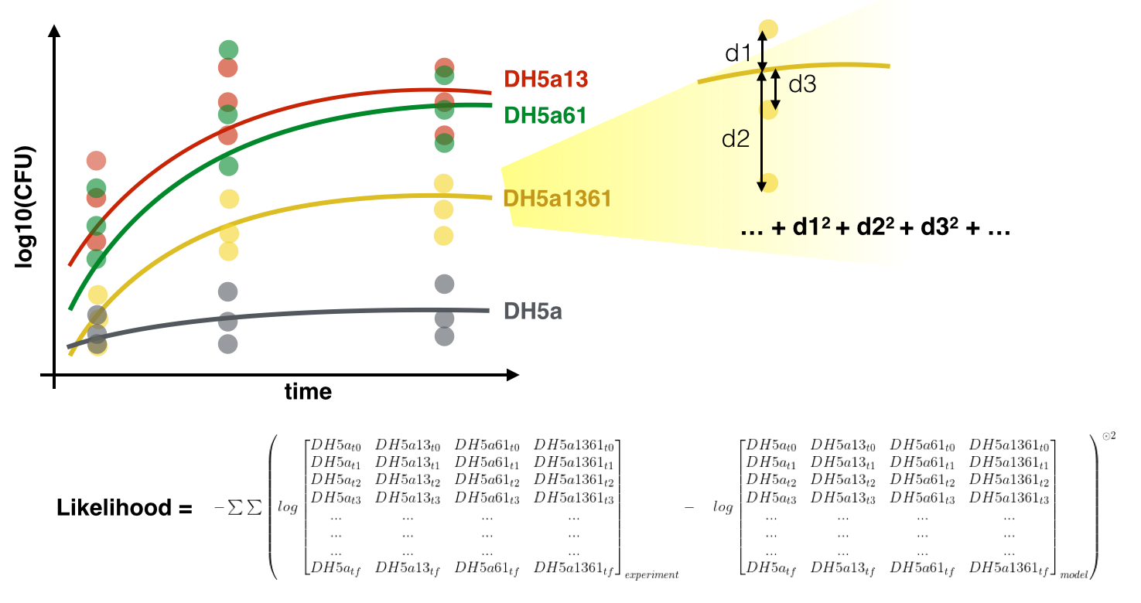
Fig S3. Evaluating a parameter set. For a given parameter set, we could evaluate how well the model (built from this parameter set) can “fit” the training data (synthetic or experimental). We calculate sum square difference between every data point and the simulated time-courses derived from the model. The differences are measured in a log scale. “Likelihood” value is defined as – of this sum square value. Thus, likelihood values are always negative. Higher likelihood value (closer to zero) implies ‘better’ model. In other words, the parameter values of the model are closer to the actual parameter values underlying the data.

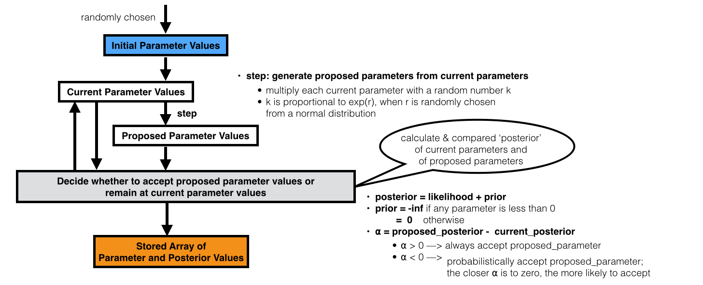
Fig S4. Metropolis Monte Carlo algorithm for obtaining ‘parameter ensemble’ from a given data. The algorithm starts by randomly choosing initial parameter values. The current parameter values are set to this initial values. From the current parameter values, the algorithm generates a proposed parameters values which are slightly different from the current parameter values. Then, the proposed and the current parameter values are compared, based on ‘posterior’ probability, to decide whether we want to accept or reject the proposed parameter values. ‘Accept’ means the current parameter values are updated to proposed parameter values; ‘reject’ means the current parameter values remain the same. The posterior value is equal to ‘likelihood’ value, unless at least one parameter is negative. In that case, the posterior value is -Inf. In other words, ‘prior’ simply puts a hard constraint that none of our parameters (η, μ, μ₁₃, μ₆₁, μ₁₃₆₁, κ₁₃, ﻿κ₆₁, D, N_{m} ) can be negative. Then, the algorithm proposed new parameters values and compare to current parameter values again. The cycle is repeated for a fixed number of iterations (20,000 iterations this study). The current parameter sets are stored in the array of parameters, each row for parameter values during each iteration. The ‘parameter ensemble’ is taken from this array of parameters (iteration 5,001 – 20,000 in this study).

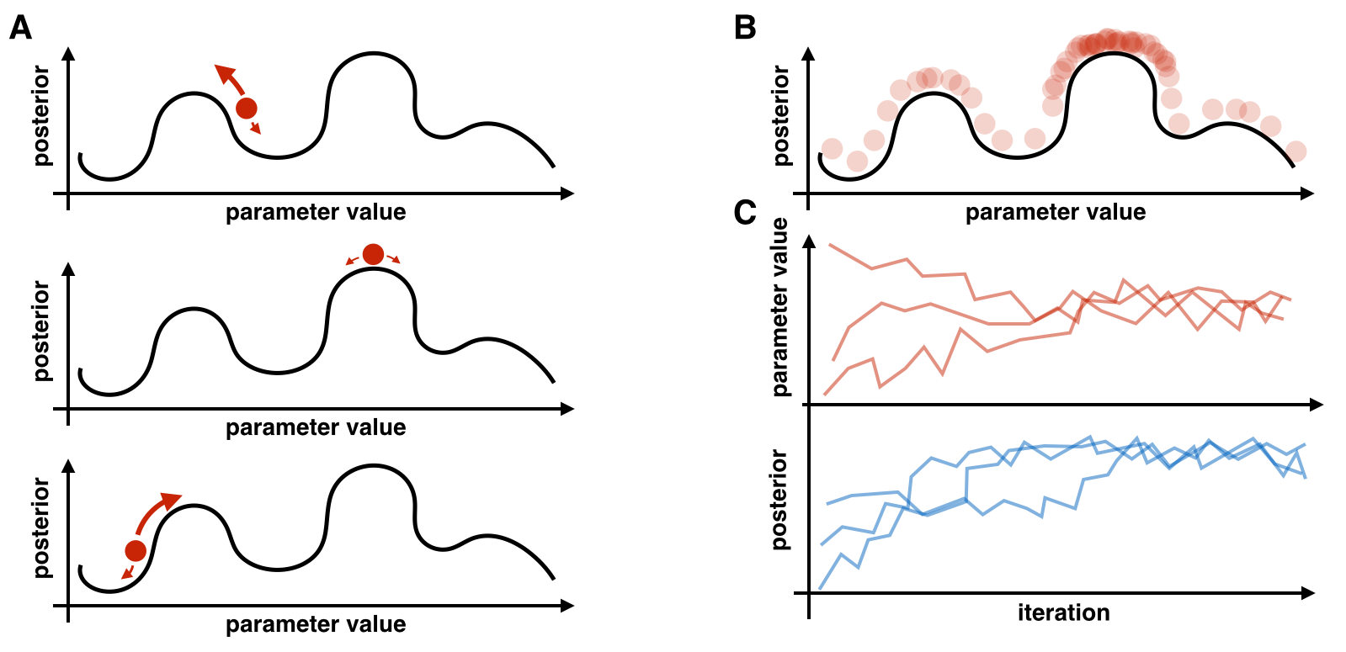
Fig S5. Exploring a parameter space with Metropolis MCMC. (A) Diagram explaining random walk of current parameter and posterior value in a hypothetical parameter space. Black curvy lines represent hypothetical landscapes of the parameter space (with a single parameter in this hypothetical example, the parameter space is one dimensional; our actual parameter space is 8 dimensional: [η, μ, μ₁₃, μ₆₁, μ₁₃₆₁, κ₁₃, ﻿κ₆₁, D]). Each parameter value has a corresponding posterior value which can be calculated using formula shown in Fig S3 and Fig S4. A higher posterior value implies that its corresponding parameter value is more likely to be correct, i.e., the simulated results from this parameter value is closer to a given data set. Red dots represent current parameter and posterior values as we run Metropolis MCMC. Red arrows represent steps toward newly proposed parameter values. Sizes of these arrows indicate how likely the algorithm would accept the proposed parameter values; larger size corresponds to higher accepting probability. Notice that the arrows are larger in the direction upward (proposed parameter has higher posterior than current parameter) than in the direction downward (proposed parameter has lower posterior than current parameter). There are still arrows in the direction downward; this mean that it is also possible to accept a proposed parameter that gives lower posterior (as indicated in the formula shown in Fig 4S.) (B) Diagram explaining distribution of parameter values in the parameter ensemble. After many iterations, the current parameter should random walk the entire parameter space (regardless of where current parameter start). Since the random walk is more likely to step up (toward higher posterior value) than to step down, we should expect that the random walk will spend most time at parameter values with high posterior. In this diagram, opaque red circles indicate how likely the random walk is to be found at a given parameter value. Thus, we would expect denser red circles at higher posterior. In other words, we can use the distribution of current parameter values during random walk (as stored in parameter ensemble) to probe the parameter landscape. (C) Hypothetical plots showing changes in current parameter value and posterior value over many iterations. Regardless of initial parameter values, the current parameter values should converge toward the actual parameter value while the current posterior value should keep increasing toward zero.

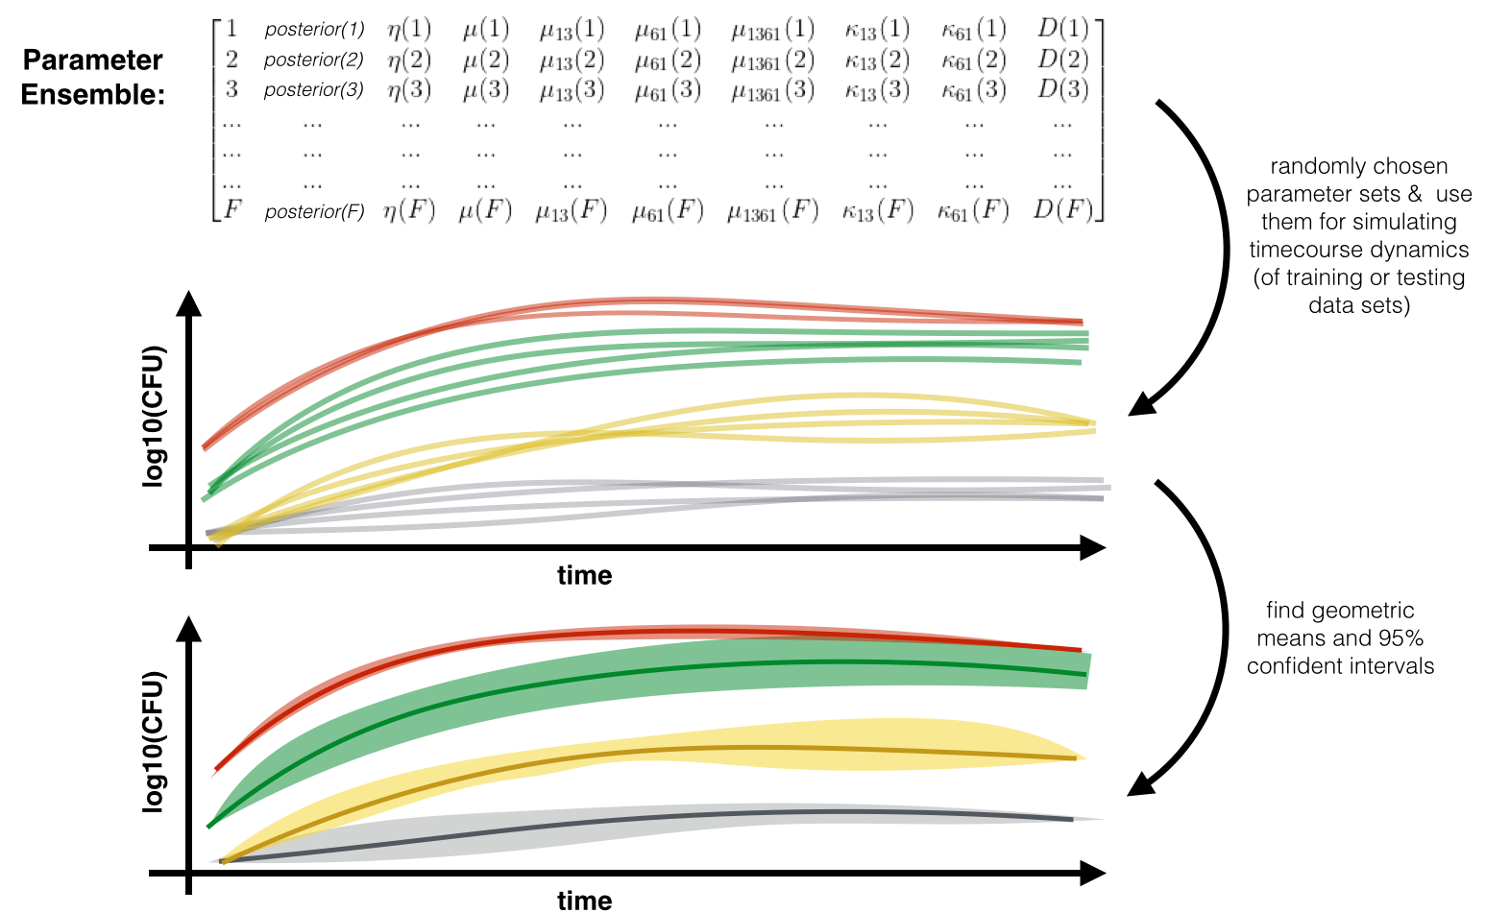
Fig S6. Hypothetical Simulation timecourse from parameter ensemble. After deriving parameter ensemble from Metropolis Monte Carlo (Fig S4), we randomly choose F parameter sets (F = 200 sets from iteration 5001 to iteration 20000 in this study) to be used for running simulation, one parameter set gives one simulated timecourses of [DH5a, DH5a13, DH5a61, DH5a1361]. From these (200) timecourses, we find the 2.5 and 97.5 percentiles for plotting the boundaries of 95% confident interval as well as geometric mean.

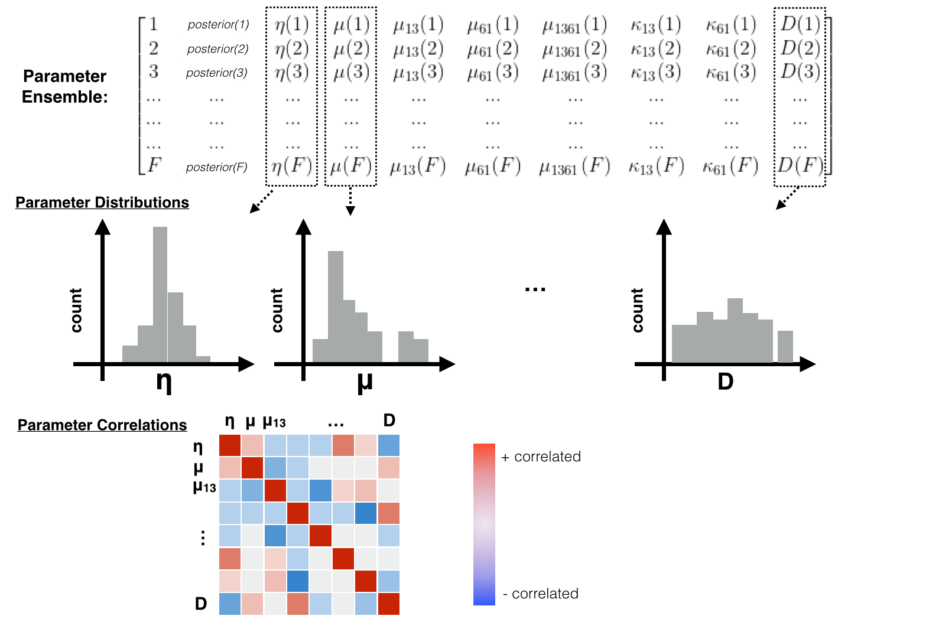
Fig S7. Hypothetical Analysis of parameter ensemble. After deriving parameter ensemble from Metropolis Monte Carlo (Fig S4), we randomly choose parameter sets (200 sets from iteration 5001 to iteration 20000 in this study) to be used for running analysis. The analysis includes visualisation of each parameter distribution and Spearman’s correlation between every pair of parameters.

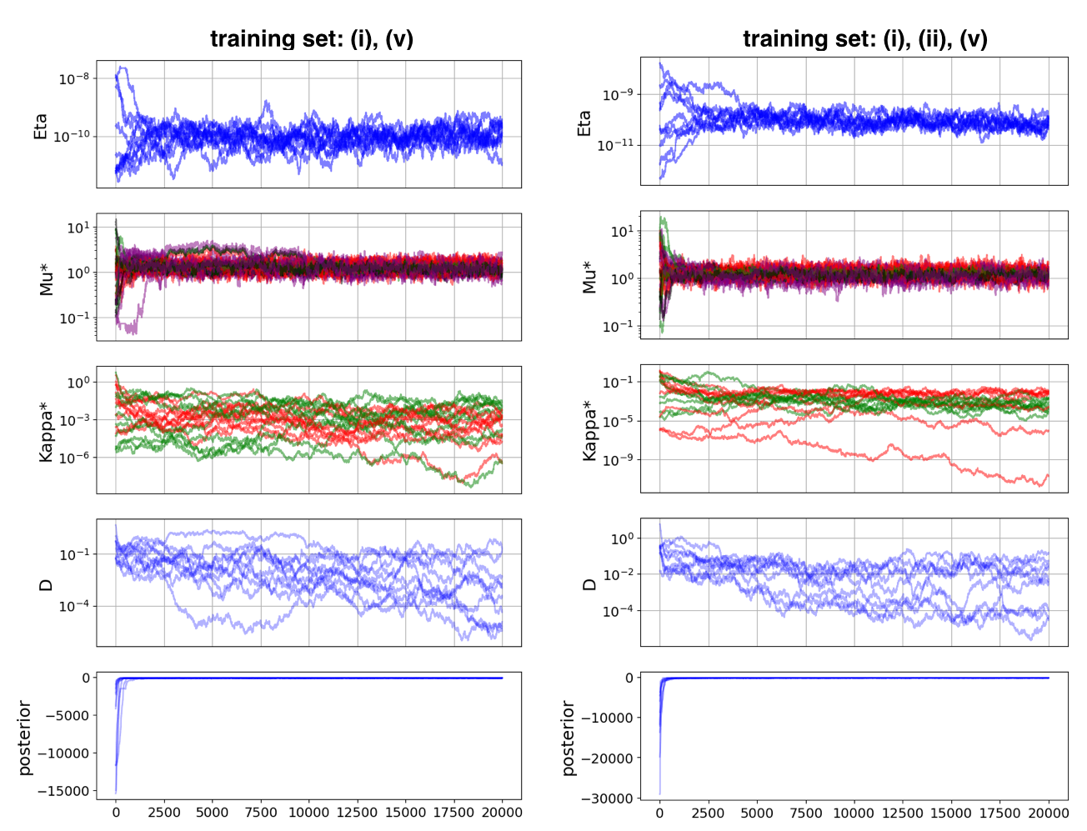
Fig S8. Metropolis Monte Carlo on synthetic data. Metropolis algorithm were executed for 20,000 iteration, started from 10 randomly chosen parameter set ([η, μ, μ₁₃, μ₆₁, μ₁₃₆₁, κ₁₃, ﻿κ₆₁, D] within range: min_values = [1E-13, 0.1, 0.1, 0.1, 0.1, 1E-7, 1E-7, 0.01] max_values = [1E-7, 10, 10, 10, 10, 10, 10, 10], log uniform distribution). The value of each parameter and the value of posterior are plotted against iteration number. Growth rate parameter of different cell types are shown in different lines colour as the following: μ, μ₁₃, μ₆₁, μ₁₃₆₁ shown in red, green, black, purple, respectively; plasmid loss rate parameters, κ₁₃ ﻿and κ₆₁, are shown in red and green, respectively.

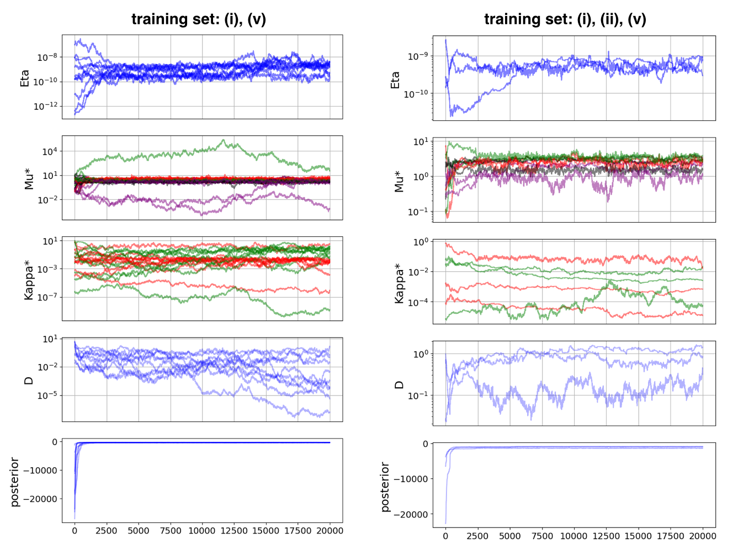
Fig S9. Metropolis Monte Carlo on experimental data. Metropolis algorithm were executed for 20,000 iteration, started from 10 randomly chosen parameter value ([η, μ, μ₁₃, μ₆₁, μ₁₃₆₁, κ₁₃, ﻿κ₆₁, D, N_{m}] with in range: min_values = [1E-13, 0.1, 0.1, 0.1, 0.1, 1E-7, 1E-7, 0.01] max_values = [1E-7, 10, 10, 10, 10, 10, 10, 10], log uniform distribution). The value of each parameter and the value of posterior are plotted against iteration number. Growth rate parameter of different cell types are shown in different lines colour as the following: μ, μ₁₃, μ₆₁, μ₁₃₆₁ shown in red, green, black, purple, respectively; plasmid loss rate parameter, κ₁₃ ﻿and κ₆₁, are shown in red and green, respectively. Random walks that whose posterior value failed to converge were removed.

