Table 1
Frequencies and Percentages of Demographic Variable Responses
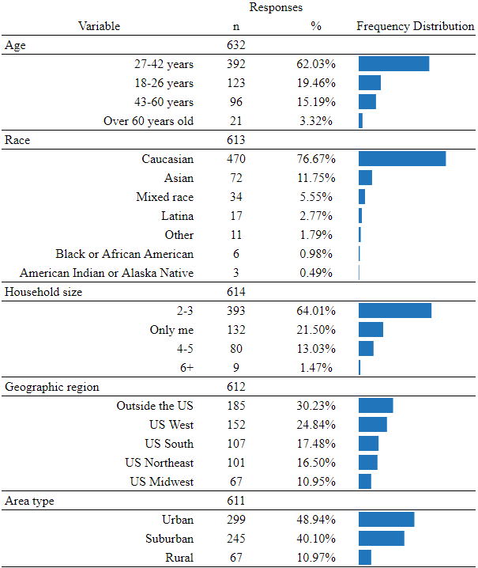
Note: Due to rounding errors, percentage totals may not equal 100%.
Table 2
STEM Background Variables
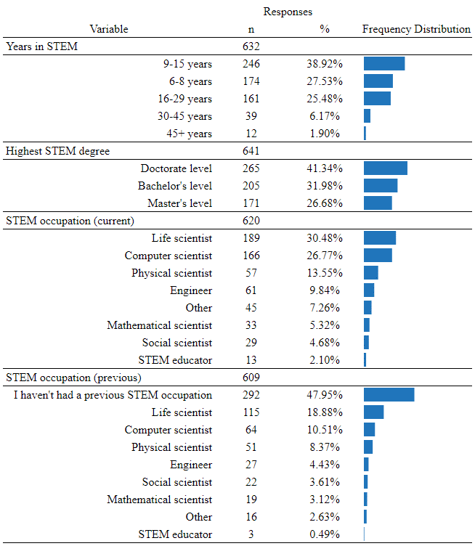
Note: Due to rounding errors, percentage totals may not equal 100%.
Table 3
Summary Statistics for Combined and Individual Construct Satisfaction Scores
Variable | Mean | Std Dev | n | Min | Max | Mode
Combined satisfaction | 48.40 | 9.65 | 477 | 7.00 | 60.00 | 54.00
Autonomy satisfaction | 15.75 | 3.84 | 477 | 3.00 | 20.00 | 20.00
Competence satisfaction | 16.70 | 3.43 | 469 | 4.00 | 20.00 | 20.00
Relatedness satisfaction | 16.69 | 3.65 | 464 | 4.00 | 20.00 | 20.00

Table 4
Summary Statistics for Combined and Individual Construct Frustration Scores
Variable | Mean | Std Dev | n | Min | Max | Mode
Combined frustration | 30.64 | 10.28 | 471 | 7.00 | 60.00 | 28.00
Autonomy frustration | 12.07 | 4.20 | 470 | 3.00 | 20.00 | 11.00
Competence frustration | 10.17 | 4.52 | 465 | 3.00 | 20.00 | 4.00
Relatedness frustration | 8.82 | 4.11 | 457 | 2.00 | 20.00 | 4.00

Table 5
Results of ANOVA Examination of Theoretical Constructs and Years in STEM
Variable 1 | Variable 2 | SS | df | F | p | η_{p}²
Combined Satisfaction | Years in STEM | 879.35 | 3 | 3.19* | .023 | .02
Combined Frustration | Years in STEM | 1149.60 | 3 | 3.69* | .012 | .02
Autonomy Satisfaction | Years in STEM | 100.11 | 3 | 2.28 | 0.78 | .01
Autonomy Frustration | Years in STEM | 20.34 | 3 | .38 | .766 | .00
Competence Satisfaction | Years in STEM | 392.31 | 3 | 11.90* | < .001 | .07
Competence Frustration | Years in STEM | 840.99 | 3 | 14.98* | < .001 | .09
Relatedness Satisfaction | Years in STEM | 28.43 | 3 | .71 | .546 | .00
Relatedness Frustration | Years in STEM | 63.65 | 3 | 1.26 | .288 | .01
Note. * ANOVA examined based on alpha value of .05.
Table 6
Autonomy, Competence, and Relatedness Satisfaction Themes
Theme | Construct | Codes | Short description | Illustrative quote
Be yourself | Autonomy satisfaction | 10 | Ability to be authentic, not needing to act or look like others. | "…you don’t have to act like your male colleagues, be yourself. "
Purpose | Autonomy satisfaction | 16 | Having a sense of purpose, having reasons for doing activities. | “Stay positive and remind myself of why I am doing this.”
Self-care and health | Autonomy satisfaction | 45 | Maintaining physical or mental health. | "...exercising regularly, keeping a routine sleep schedule, and going to therapy."
Work-life balance | Autonomy satisfaction | 112 | Having work-life balance, keeping work separate from pleasure. | "Be strong in setting your own work-life balance boundaries..."
Genuine interest | Autonomy satisfaction | 151 | Having interest in a topic, curiosity, being fascinated, not being bored. | "I've always been interested in science and discovery..."
Choice and input | Autonomy satisfaction | 151 | Having volitional control over actions, speaking up. | "I now choose to work in places that have more diversity..."
Enjoyment | Autonomy satisfaction | 280 | Loving or having passion for a subject or activity, having fun. | "I love STEM. I love the way it makes my brain light up. "
Effort | Competence satisfaction | 40 | Working toward a degree or career, investing time or money. | "My educational and work background has set me on a path to stay in STEM.”
Science identity | Competence satisfaction | 42 | Feeling like science is a good fit, born to do science, identifying with occupation. | "I enjoy science. It is the only field I see myself in. This has been the same since childhood. "
Grit, perseverance | Competence satisfaction | 60 | Work ethic, will, stubbornness, perseverance, resilience. | "…there is nothing that will stop me. It's a mindset. Failure is not an option. "
Growth mindset | Competence satisfaction | 141 | Accepting challenges and failures as learning opportunities. | “Understanding that hardships/struggles are common and don’t mean I am a failure."
Self-efficacy | Competence satisfaction | 170 | Confidence in one’s ability, mastery, expertise. | "I find problem solving fun and have a particular aptitude for doing so..."
Communication skills | Relatedness satisfaction | 27 | Communicating effectively, knowing how to negotiate, having social skills. | "I wish I learned to negotiate earlier and diplomatically navigate tough situations."
Role models | Relatedness satisfaction | 141 | Positive real-life or fictional role model, mentor, peer exemplar. | “Mentorship from other women is key.”
Belonging | Relatedness satisfaction | 152 | Being part of a community, shared experiences, being accepted, feeling connected. | “STEM specific social media helps me feel involved in a community and that positively impacts my motivation to stay in STEM."
Communal benefit | Relatedness satisfaction | 243 | Working with or to benefit others, mentoring, networking. | “I remain here because I feel like I am moving humanity and the Earth forward."
Social support | Relatedness satisfaction | 310 | Having supportive relationships, commiserating, social coping. | “Support from friends… has been the single most important thing that has pulled me through tough spots."

Table 7
Autonomy, Competence, and Relatedness Frustration Themes
Theme | Construct | Codes |  | Short description | Illustrative quote
Lack of interest | Autonomy frustration | 7 | Not interested or not aware of an interest. |  | “I’m not that interested in social media."
Lack of enjoyment | Autonomy frustration | 14 | Not liking or enjoying something, finding it unpleasant or boring. |  | "Not everything is a fun challenge or an interesting puzzle.”
Lack of work-life balance | Autonomy frustration | 16 | Unreasonable hours, giving up other activities for work. |  | “The time commitment is tremendous and the work-life balance is awful.”
Lack of choice | Autonomy frustration | 19 | Feeling forced to persist, trapped, pressured, not being heard. |  | “Invisible pressure from my parents...”
Disappointment | Autonomy frustration | 48 | General disappointment, resignation. |  | “24 years on, the percentage of women in STEM is still the same.”
Lack of confidence | Competence frustration | 23 | Lack of confidence, imposter syndrome, low self-efficacy. |  | “My biggest obstacle has probably been self doubt and lack of confidence."
Lack of career benefits | Competence frustration | 32 | Trouble finding jobs, insufficient pay/benefits, lack of advancement, low professional status. |  | “It’s not necessarily the golden goose of financial stability it has always been presented to me to be.”
Lack of knowledge | Competence frustration | 52 | Not knowing about options, opportunities, resources. |  | “I wish I had more opportunities to experience STEM careers first hand."
Lack of role models | Relatedness frustration | 21 | Lacking mentors or role models, guidance; negative experiences with advisors. |  | “I wish I was exposed to other women in STEM who had made difficult career decisions."
Lack of relatedness | Relatedness frustration | 104 | Lack of social support/community, toxic environment. |  | “Competitiveness is rampant and that makes forming meaningful, trustworthy relationships hard.”

Table 8
Sociocultural Factors Themes
Theme | Construct | Codes |  | Short description | Illustrative quote
Discrimination and bias | Sociocultural | 175 | Experiencing misogyny, sexism, racism, lack of diversity, etc. |  | "I’ve encountered a sexual harassment case at every place I’ve worked and I’m sick of it. "
Career and money | Sociocultural | 147 | Financial and career benefits, career stability. |  | “I stay in STEM because I have a stable job that pays my bills."
Problems with men | Sociocultural | 49 | Experiencing harassment, feeling unsafe, undervalued, outnumbered. |  | “I feel very uncomfortable with a male boss; I especially hate being alone with them."
Concern about family | Sociocultural | 32 | Lack of support for mothers, dependent care, unfair assumptions. |  | “I’m terrified of losing my place if my husband and I decide to start a family."
Academia culture | Sociocultural | 27 | Difficulties with university culture, uncertainty, unfair treatment. |  | “Academia is a never ending, often soul crushing grind."
Problems with women | Sociocultural | 12 | Trouble with women, toxic behavior, bullying. |  | “Female managers/senior are literally the worst in my profession; more likely to bully and harass staff.”

Table 9
Integrated Display of Key Quantitative and Qualitative Findings
Variable | BPNSFS Score | F, p | Themes | Illustrative quote
Autonomy satisfaction | M = 15.75  SD = 3.84 | 2.28, .078 | Enjoyment, Choice and Input, Genuine Interest, Work-life Balance, Self-care and Health, Purpose, Be Yourself | "I really enjoy math and I find it fulfilling."
Autonomy frustration | M = 12.07  SD = 4.20 | .38, .766 | Disappointment, Lack of Choice, Lack of Work-life Balance, Lack of Enjoyment, Lack of Interest | "It really sucks, honestly... would not choose again."
Competence satisfaction | M = 16.70  SD = 3.43 | 11.90*, .001 | Self-efficacy, Growth Mindset, Grit and Perseverance, Science Identity, Effort | "There is nothing that will stop me. It's a mindset. Failure is not an option."
Competence frustration | M = 10.17  SD = 4.52 | 14.98*, .001 | Lack of Knowledge, Lack of Career Benefits, Lack of Confidence | "I would've simply liked to know how it all works, without a roadmap it's so hard."
Relatedness satisfaction | M = 16.69  SD = 3.65 | .71, .546 | Social Support, Communal Benefit, Belonging, Role Models, Communication Skills | "I like contributing to society's scientific knowledge, mentoring and supporting younger researchers..."
Relatedness frustration | M = 8.82  SD = 4.11 | 1.26, .288 | Lack of Relatedness, Lack of Role Models | "It is filled to the brim with males who hate me for being a woman."
Combined satisfaction | M = 48.40  SD = 9.65 | 3.19*, .023
Combined frustration | M = 30.64  SD = 10.28 | 3.69*, .012

Note. * ANOVA (F) examined based on alpha value of .05 when calculated for Years in STEM and variables. Detailed results shown in Table 5.

