Appendix . Additional robustness tests
(1) Alternative dependent variable
To further validate the robustness of the baseline regression findings, we employ a method of substituting the dependent variable to conduct a robustness examination. As previously noted, most scholars currently utilize total factor productivity (TFP) of enterprises as a proxy indicator for HQDE. We calculate firms' TFP using both the LP and OP methods. Subsequently, we substitute these two TFP indicators as alternative proxies for HQDE and conduct regressions using the baseline model (1).
The results in columns (1) and (2) of Table A1 show that after replacing the dependent variable with the two TFP indicators (TFP_LP and TFP_OP), the impact of the CSS policy on HQDE remains significantly positive at the 5% statistical level. This finding is consistent with the baseline regression conclusion, indicating that our research results withstand robustness checks.
(2) PSM-DID method
Given that governments frequently formulate industrial policies based on the current status of industry development, the evaluation of policy effects may encounter self-selection bias, potentially compromising the unbiasedness of the estimates. To mitigate this bias, we employ the nearest neighbor matching within caliper method of Propensity Score Matching (PSM) to match the treatment and control group samples.
The first step of the PSM method is to select a set of enterprise characteristic variables as covariates and constructing a logistic regression model to match firms from the treatment and control groups based on similar characteristics. We utilize treat and enterprise-level control variables as the dependent and covariate variables in the logistic regression model, respectively. After obtaining propensity scores from the logistic model, we conduct 1:2 nearest neighbor matching with a caliper value set at 0.05. To ensure the credibility of the PSM results, we perform a balance test to examine changes in the standardized deviation of covariates before and after matching, as shown in Fig. A1. It is observed that the standardized deviation of all covariates significantly decreases after matching, with values within 10%, passing the balance test. Additionally, we plot the density distribution of propensity scores before and after matching, as illustrated in Fig. A2, to examine changes in the distribution disparity between the treatment and control groups. Similarly, we find a significant reduction in distribution disparity between the two groups after matching. These findings indicate the reliability and effectiveness of the PSM method we employed.
Subsequently, we conduct DID model regression using the matched sample. The results in column (3) of Table A1 indicate that after PSM matching, the impact of the CSS policy on HQDE remains significantly positive at the 1% level. This finding is consistent with the baseline regression results, demonstrating the robustness of our results.
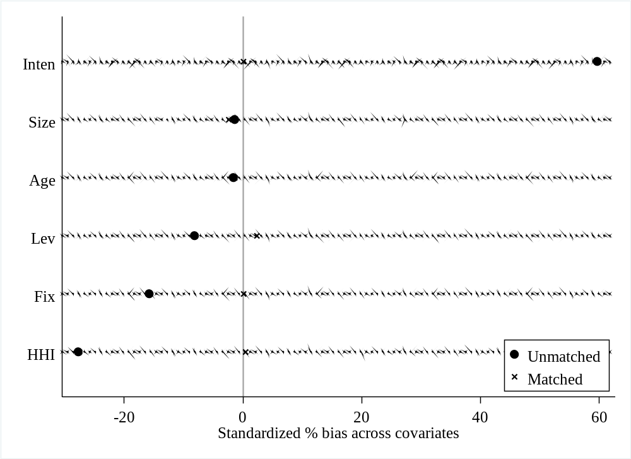
Fig. A1. Standardization deviation of covariates before and after matching.
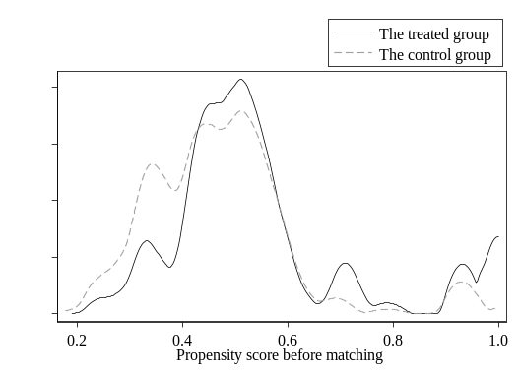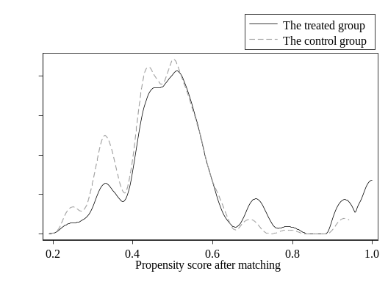
Fig. A2. Kernel density distribution of propensity scores before and after matching.

Table A1
Robustness test results
Variable | Alternative dependent variable |  | PSM-DID
 | (1) | (2) | (3)
 | TFP_LP | TFP_OP | PSM-DID
CSS | 0.030** | 0.026** | 0.007***
 | (2.356) | (2.573) | (2.697)
Control | Yes | Yes | Yes
Firm FE | Yes | Yes | Yes
Year FE | Yes | Yes | Yes
Ind FE | Yes | Yes | Yes
N | 6281 | 6281 | 6157
Adj. R² | 0.496 | 0.545 | 0.156
Note: (1) The robust-adjusted t-statistics clustered at provinces are in parentheses. (2) *, **, *** denote significance levels at 10%, 5%, and 1%, respectively. (3) Firm FE, Year FE, Ind FE represent firm fixed effects, year fixed effects, and industry fixed effects, respectively. (4)Due to space limitations, no control variables were listed.

