Pan-Cancer TCGA Analysis Reveals the Potential Involvement of Lamin B2 in Dysregulating Chromosome Segregation in Human Cancer
Subhadip Kundu ¹, Bimal Prasad Jit ¹, Ashok Sharma ^{1,2*}
¹ Laboratory of Chromatin and Cancer Epigenetics, Department of Biochemistry, AIIMS, New Delhi, India- 110029
² National Cancer Institute, AIIMS, Jhajjar, Haryana, India
*Correspondence: ashok.sharma@aiims.edu

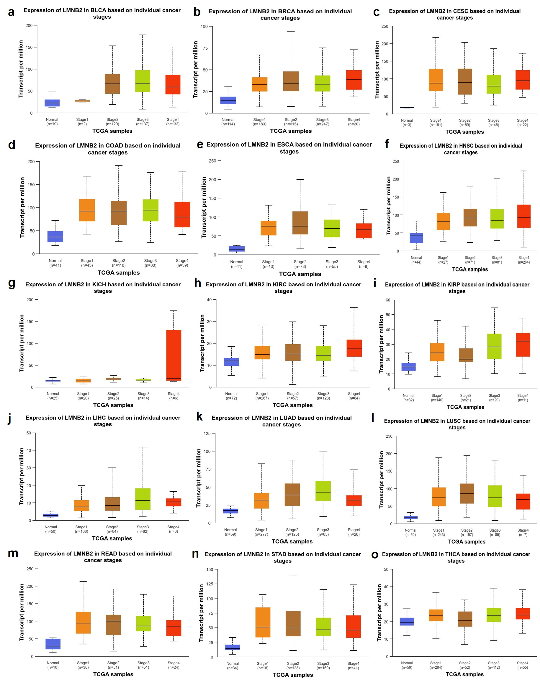
Fig. S1: Stage-wise mRNA expression of lamin B2 in different cancers. [a] Stage-wise mRNA expression of LMNB2 in bladder urothelial carcinoma (BLCA); [b] Stage-wise mRNA expression of LMNB2 in breast invasive carcinoma (BRCA); [c] Stage-wise mRNA expression of LMNB2 in cervical squamous cell carcinoma (CESC); [d] Stage-wise mRNA expression of LMNB2 in colon adenocarcinoma (COAD); [e] Stage-wise mRNA expression of LMNB2 in esophageal carcinoma (ESCA); [f] Stage-wise mRNA expression of LMNB2 in head and neck squamous cell carcinoma (HNSC); [g] Stage-wise mRNA expression of LMNB2 in kidney chromophobe (KICH); [h] Stage-wise mRNA expression of LMNB2 in kidney renal clear cell carcinoma (KIRC); [i] Stage-wise mRNA expression of LMNB2 in kidney renal papillary cell carcinoma (KIRP); [j] Stage-wise mRNA expression of LMNB2 in liver hepatocellular carcinoma (LIHC); [k] Stage-wise mRNA expression of LMNB2 in lung adenocarcinoma (LUAD); [l] Stage-wise mRNA expression of LMNB2 in liver squamous cell carcinoma (LUSC); [m] Stage-wise mRNA expression of LMNB2 in rectum adenocarcinoma (READ); [n] Stage-wise mRNA expression of LMNB2 in stomach adenocarcinoma (STAD); [o] Stage-wise mRNA expression of LMNB2 in thyroid carcinoma (THCA).

