Table 8. Summary results in time domain
Afyon Dinar earthquake constituted the largest analysis result parameter in the masonry arch bridge structure with a displacement value of 1,079 mm. It is thought that the Afyon Dinar earthquake caused limited damage to the bridge structure. | 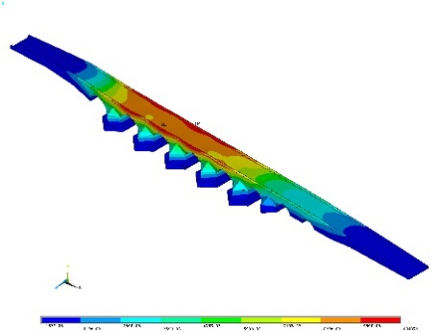
Bingöl earthquake created an acceleration value of 0.465g in the support areas of the bridge and where the shear force effect was greatest. | 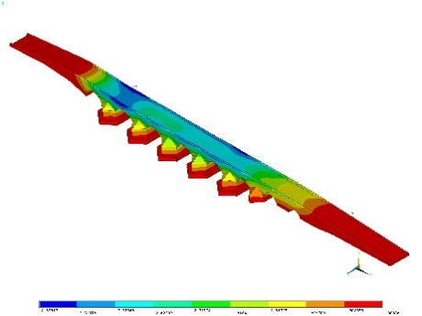
The ChiChi earthquake caused a deformation of 0.00223 in the support areas of the bridge. It was thought that the ChiChi earthquake might cause limited cracks in the supports of the bridge. | 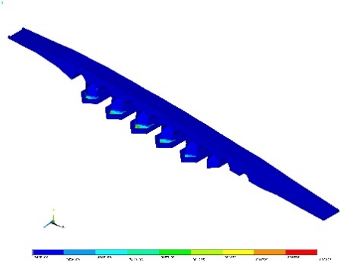
Elbistan earthquake created an acceleration value of 0.561g in the support areas of the bridge and where the shear force effect was greatest. | 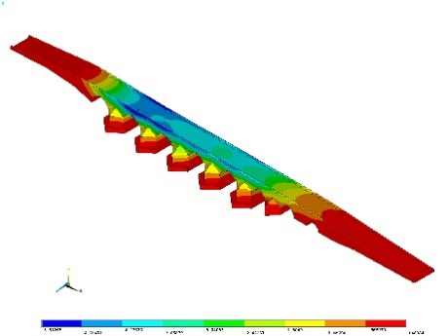
The Erzincan earthquake caused a deformation of 0.00123 in the support areas of the bridge. It was thought that the Erzincan earthquake might cause limited cracks in the supports of the bridge. | 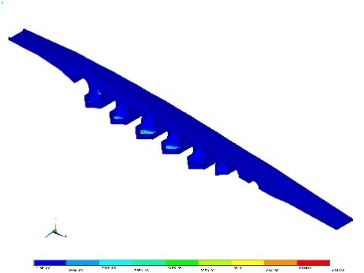
Van earthquake created an acceleration value of 0.370g in the spans where shear force effect was greatest. | 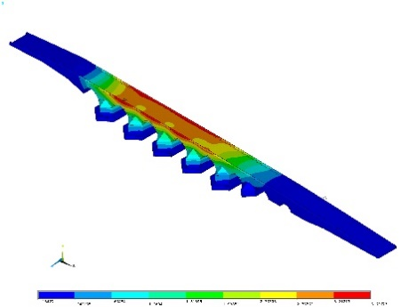
The Imper Valley earthquake created a tensile stress of 1.90 MPa where the bridge supports joints the arch. Since this value is above 1 MPa, it is expected that significant cracks may occur in these regions. | 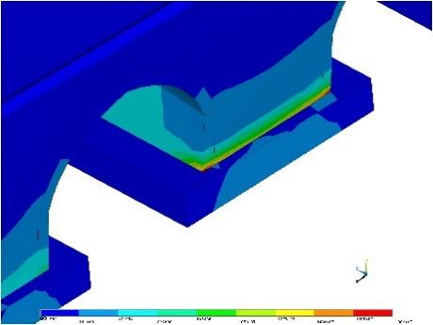
İzmit earthquake created an acceleration value of 0.462g in the spans where shear force effect was greatest. | 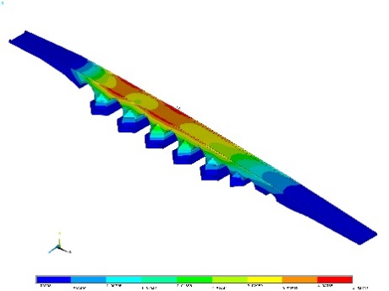
Although the acceleration value created by the Kobe earthquake in the bridge structure is less than the acceleration values created by the Izmit, Elbistan and Bingöl earthquakes, the acceleration in the supports and shear openings of the bridge is a remarkable result. The Kobe earthquake produced the largest response acceleration of 0.393g. | 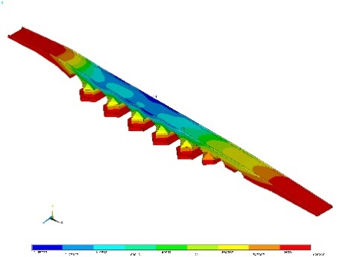
Although the maximum ground acceleration value of the Nurdağı earthquake was larger than most earthquakes used in the study, it produced maximum acceleration values ​​in the shear span of the bridge structure in only one direction. Due to the effect of the Nurdağı earthquake, the largest acceleration value of 0.482g occurred in the bridge structure. | 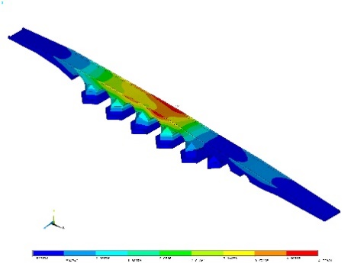
Sivrice earthquake created an acceleration value of 0.528g in the support areas of the bridge and where the shear force effect was greatest. | 