Impact of Spinal Muscular Atrophy on Caregivers’ Daily Activities and Health-Related Quality of Life

Running Title: Impact of SMA on caregivers

Authors: Er Chen MPP¹, Komal Bawa Pharm.D¹, Josh M. Noone Ph.D², Sarah M. Whitmire MS², J. Daniel Buchenberger MS², W. David Arnold MD³, Rosalina Mills BA², Stacy Dixon MD, PhD⁴
- Genentech Inc, San Francisco, CA, USA
- Ipsos Healthcare, New York, NY, USA
- The Ohio State University Department of Neurology
- University of Colorado School of Medicine, Department of Neurology

Abstract Word Count: 307
Manuscript Word Count: 4,116
Contact Information:
Komal Bawa, PharmD.
US Medical Affairs - Evidence for Access
Genentech Inc. A Member of the Roche Group
1 DNA Way, MS 35-7a, South San Francisco, CA 94080
Email: bawak@gene.com

ABSTRACT
Background:
Spinal muscular atrophy (SMA) is a genetic debilitating disease affecting approximately 10,000 individuals in the United States. Individuals with SMA frequently require caregiver support and care. Through a partnership with Cure SMA, we surveyed caregivers of individuals with SMA <18 years of age to understand the impact of SMA on caregivers with respect to their daily activities and health-related quality of life (HRQoL). In addition to structured questions, a standardized HRQoL instrument, the EQ-5D-5L and visual analogue scale, were administered.
Results:
The sample consisted of 45 unpaid caregivers of children with SMA. Of them, 22% reported that they were sole caregivers that received no additional caregiving support and 98% were parents of an affected individual. The majority of caregivers cared for individuals with type 2 (58%), followed by type 1 (38%) and type 3 (4%) SMA. Sixty-four percent of the individuals with SMA were able to sit without support or better, while 31% had some motor function and 5% reported no motor function. Across SMA types, caregivers reported spending a median 80 hours per month managing the overall care and treatment of the affected individual.. Most of the individuals (91%) were reported to have received nusinersen. Caregiver time investment correlated directly with disease severity measured by both SMA type and patient motor function level. The mean EQ-5D utility score for caregivers was 0.71 and their mean score on the EQ-5D visual analogue scale was 76. Specifically, 42% of caregivers reported any inability to do their usual activities and 73% reported any anxiety or depression.
Conclusions:
SMA negatively affects caregiver’s daily activities and HRQoL, representing a substantial burden. Disease severity is associated with an increasing amount of time required for care and support for patients with SMA and a decrease in a caregiver’s HRQoL. As treatments become available, evaluation of these treatments should include effects on the family as well.

Key Words: burden, caregiver, Quality of life, QOL, “Spinal Muscular Atrophy”, SMA, nusinersen

Introduction
Spinal muscular atrophy (SMA) is a rare autosomal recessive neuromuscular disorder that results in progressive muscle weakness and atrophy [1, 2]. The disorder manifests due to a defect and/or deletion in the survival motor neuron 1 (SMN1) gene, resulting in low levels of the survival motor neuron (SMN) protein [1]. A second paralogous gene, SMN2, also produces low, insufficient levels of functional SMN protein and the number of copies of the SMN2 gene is inversely correlated with SMA severity in most cases [3]. As such, SMA has been a leading genetic cause of morbidity in infants and young children, with an estimated incidence of approximately as 9.4 in 100,000 live births in the US [4].

There are multiple subtypes of SMA which are categorized as types 0-4 based on clinical criteria such as age of symptom onset and achievement (or failure) of motor milestones [5, 6]. Type 0 SMA is rare. Type 1 SMA is the most common and severe subtype, which has an onset between 0-6 months. Based on natural history, these patients have severe hypotonia, cannot control their head movements, and will never sit independently [1]. Patients with type 1 SMA also have severe impairment of swallowing, respiratory function and survival. Patients with type 2 or type 3 SMA experience disease onset before and after the age of 18 months, respectively. Those with type 2 SMA are unable to stand or walk without support, whereas patients with type 3 SMA are able to stand and walk until the disease progresses [1]. Type 4 SMA is diagnosed in adulthood and results in milder muscle weakness. As SMA progresses there is general loss of motor and respiratory function resulting in increased dependence on a caregiver (i.e., person tending to the needs of the person with the disease). Fear of disease progression and respiratory complications could also lead to profound, emotional, and psychosocial consequences on caregivers and their families [7, 8]. More generally, parents of children with SMA have been shown to exhibit higher levels of stress than parents of otherwise healthy children [9].

Historically, SMA management was limited to supportive care. The landscape changed in December 2016 with the Food and Drug Administration (FDA) approval of Spinraza® (nusinersen), an SMN2 targeting anti-sense oligonucleotide, as a disease-modifying therapy (DMT) for SMA. Nusinersen is administered intrathecally, with four loading doses followed by maintenance doses every 4 months [10]. Additionally, a gene therapy, Zolgensma® (onasemnogene abeparvovec-xioi), which replaces the SMN1 gene received FDA approval in May 2019 for the treatment patients with SMA less than 2 years of age [11].

Since the advent of novel DMTs for a previously untreatable condition, the burden of the disease and disease management on caregivers has likely changed. Caregiver burden encompasses the challenges caregivers face relating to their emotional and physical health, as well as their work and financial situations [8, 12]. Cure SMA published the Voice of the Patient report, which highlighted the severity of SMA and the impact of the disease on caregivers’ daily life [8]. Specifically for type 1 SMA, there was an emphasis on the all-consuming nature of caring for the child, and the vast physical, psychosocial, emotional, and financial burdens associated with providing full-time care to children who are entirely dependent [8]. Given the severity of SMA, studies have shown there is a significant impact of caregivers’ lives [7, 13, 14]. Studies have also assessed the health-related quality of life (HRQoL) in SMA showing there is deterioration of HRQoL in SMA patients as well as their caregivers compared with the overall population [14, 15]. Qian et al. surveyed the impact of SMA on patients (n=21) and their parents (n=64) and found SMA has a considerable impact on social-emotional aspects of parents’ daily living such as loss of sleep or stress from the idea of premature death [13].

However, to our knowledge, there is limited published data on the impact of SMA on a caregiver’s HRQoL and the social implications of the disease in the US after the introduction of the DMTs. Additionally, unlike most other countries, the US has a complex health insurance system made up of private and public parties with some individuals lacking insurance altogether [16]. The aim of this study was to understand the impact of SMA management on a caregiver’s HRQoL and daily activities. This study provides valuable insight into caregiver reports of overall HRQoL and potential challenges they face.
Note: Nusinersen was the only FDA approved treatment at the time this study was conducted, and as such, any treatment results described herein reflect experiences with nusinersen.

Methods

Data Source
This is a sub-study of a larger patient and caregiver survey, which aimed to understand the ongoing unmet needs in SMA after introduction of SMA DMTs. This paper summarizes the findings reported exclusively by caregivers as related to their HRQoL and their daily activities. Results of the larger survey reported elsewhere (accepted by Muscle and Nerve- MUS-20-0176).

De-identified data was directly collected from a survey administered to unpaid caregivers (if patients <18 years old) and patients (≥18 years old). A caregiver, identified with initial screener questions, was defined as an unpaid individual >18 years old, who was routinely involved in managing the care of the individual with SMA. To ensure the respondents understood what was being asked, a screener question included examples of what managing care included (e.g., medical appointments, treatment decisions, support with physical therapy). The survey was sent electronically through an online platform and was fielded in February 2019. Recruitment ended when 100 patients and caregivers completed the survey. The final survey sample was comprised of 101 respondents including 56 adult patients and 45 unpaid caregivers of pediatric patients.

Survey Design
Through partnership with Cure SMA, the largest SMA patient advocacy organization in the US, a survey was sent to 1,251 email addresses of affiliated patients and caregivers. Any patients diagnosed with type 1-4 SMA who were ≥18 years or non-professional caregivers were eligible for the study. The SMA diagnosis and disease-related information were self-reported.

The survey was developed in collaboration with Cure SMA, with reviewers providing input on the survey questions, phrasing, and response options. Subsequently, Cure SMA directly facilitated the survey recruitment. To recruit participants, a survey e-link was distributed through an email listserv and posted on the Cure SMA website between January and February 2019. The survey contained 53 structured questions, divided into multiple sections collating patient and caregiver demographics, patient health history, treatment and care, and their experience with treatment (See Appendix – Survey).

Two sections were dedicated to collecting information on caregiver involvement in the management and care of SMA and HRQoL to infer the impact of the disease and disease management on caregivers’ daily activities. Specifically, one section concentrated on time spent on various aspects associated with the medical management of SMA (e.g., frequency of discussion with insurers, time spent on commuting to an infusion center, time spent on SMA-related and SMA treatment-related activities) and the other on caregiver QoL utilizing the EQ-5D-5L (EuroQoL-5 dimension-5 level) and EQ-5D visual analogue scale (VAS). Attributes such as treatment, the amount of the time that came from paid work, unpaid work, and social activities (e.g., household chores, childcare, hobbies, or lifestyle activities) were included to understand the proportion of time spent on disease management. The phrasing of the survey questions explicitly asked about SMA medical management, however, the severity of disease, in addition to extensive psychosocial impact, could have limited time for what would constitute normal parental care [8]. For example, a caregiver of a patient with type 1 SMA often needs to aid with turning or positioning, toileting, eating, etc. Therefore, the reference to time dedicated to care and management of SMA could have included matters such as assistance with activity of daily living, as perceived relevant by survey respondents. To minimize recall bias, the survey questions were posed with regard to specific recall periods such as within a “typical month” or “today”.

In order to ascertain the caregiver time commitment with regard to SMA management, questions such as the following were phrased as ‘in a typical month, how much time do you spend doing the following activities related to SMA’ or ‘in a typical month, what percent of your time is spent on SMA management and treatment’. The time spent on SMA care was calculated by summing and averaging the total time on various activities queried over multiple question or was provided by respondents and averaged.

The EQ-5D-5L and VAS were also administered to caregivers [17]. The EQ-5D, a simple validated instrument developed by a multi-disciplinary group of researchers, is commonly used to assess HRQoL in both the general population and a population with a disease [18]. The EQ-5D assesses five dimensions of health: mobility, self-care, usual activities (e.g., work, study, housework, or leisure activities), pain/discomfort, and anxiety/depression. It is also a common tool used in health economic evaluations to calculate utility values, which capture the change of a patient or caregivers’ HRQoL, as related to a treatment. In the EQ-5D-5L, each dimension has 5 levels: no problems, slight problems, moderate problems, severe problems, and extreme problems [19]. The respondent results are scored ranging from 0 to 1, where 0 corresponds to death and 1 corresponds to perfect health (negative value may be possible in certain instances). In addition, an EQ VAS records the patient’s self-rated health on a vertical scale, with the ends labelled ‘The best health you can imagine’ and ‘The worst health you can imagine’. The EQ VAS can be used as a quantitative measure of health outcomes that reflects the respondent’s own judgement. A central Institutional Review Board reviewed and approved the study.

Quality Assurance and Data Analysis
The data quality assurance and quality control included multiple steps. Various tests and skip patterns were employed throughout the survey to ensure logical and relevant replies. Multiple researchers also verified program accuracy using test links. Further, a preliminary check of the program was conducted after approximately 10% of the sample had been recruited to ensure accuracy.

The caregiver sample was described with respect to demographics, and other characteristics of caregivers, as well as the demographics and clinical characterizes of the SMA patients less than 18 years old for whom they care. Descriptive statistics were used to characterize the study data to show the point estimate values and variability of the results. Frequencies and percentages were reported for categorical variables as well as means, medians, and standard deviations for continuous variables. The two sub-analyses performed were by type (type 1 vs. type 2/3), and by current motor function status (minimal motor function, sitting/crawling, and standing/walking). The data for type 2 and 3 were pooled; caregivers of patients with type 3 SMA were few therefore pooling allowed an assessment of the results segmented by disease severity. Similarly, results were pooled by motor function. Results were reported for the total sample as well as subgroups (i.e., by motor function at time of survey and by SMA type). In some cases we grouped subgroups due to low sample size in individual groups (i.e., minimal motor function included no function and some function). The analysis was conducted in SAS version 9.3 and R version 3.3.

Results

Caregiver Demographics
The caregiver sample (N=45) was predominantly female (82%), non-Hispanic white (87%), and parents of children with SMA (98%) [Table 1]. Of the respondents, 22% reported that they were sole caregivers that received no additional caregiving support and 78% reported they received additional caregiving support that was paid (47%) or unpaid (31%). These caregivers were dispersed across the US.

Of the 45 caregivers, 18 (40%) reported full-time employment, while 17 (38%), 6 (13%), and 4 (9%) reported being full-time caregivers, unemployed, and part-time employed, respectively. Caregivers also reported household income, insurance status, and additional caregiver support [Table 1]. A third of caregivers (33%) had private medical insurance while 18% of the caregivers reported having Medicaid. Of the 29 caregivers who reported having Medicaid for the patient, 14 (48%) reported a household income >$50,000. Importantly, the majority of caregivers with additional paid support (15 of 21) were caring for individuals with type 1 and 2 SMA, who were Medicaid beneficiaries.

Patient Health History
The patients cared for ranged from <1 to 17 years old and 51% were female. The SMA diagnosis, as reported by the caregiver, was established in 33% of patients before 6 months of age, 56% of patients between 6-18 months of age, and 11% of patients after they were 18 months old. Of the patients with type 1 SMA, 14 (82%) were diagnosed before the age of 6 months and of the 26 patients with type 2, 21 (81%) were diagnosed between 6-18 months of age. Sixty-four percent of patients achieved sitting without support or better; 31% were reported to have some motor function but were unable to sit, and 4% reported having no motor function. At the time of the survey, 41 caregivers (91%) responded that their SMA patients were receiving treatment with nusinersen, of which 33 (81%) had been receiving treatment for over 1 year.

SMA Impact on Caregiver Activities of Daily Living and Time Burden
Caregivers reported spending a mean 136 hours (SD 193) or median 80 hours per month working with the individual for whom they care (across all SMA types). Sub-analyses of monthly time spent by SMA type and motor function status of the patient were conducted [Figure 1].
Of the median 80 hours per month, noted above, each week caregivers reported spending a median 8 hours specifically managing treatment (office visits, occupational therapy, and physical therapy) with a minimum of 1 hour to a maximum of 168 hours. Forty two percent of the respondents noted speaking with their insurance provider about medication access or medical bills at least once a month. In the month patients received nusinersen treatment (n=41), caregivers reported spending a monthly average of 4 hours (SD 6) meeting with the medical team, 4 hours (SD 9) in post procedure recovery, and 2 hours (SD 6) working with the insurance provider. Of note, 56% of caregivers reported driving for at least one hour to receive nusinersen treatment. Caregivers also reported in a typical month, 15% of the time spent on SMA management and treatment came from paid work, while 85% came from unpaid work and social activities (such as household chores, unpaid obligations, childcare, hobbies, or lifestyle activities).

SMA Impact on Caregiver’s HRQoL
Caregivers reported a mean perceived health status of 76 out of 100 (SD 17) using the EQ-5D VAS. Of the 45 respondents, 35 caregivers (78%) noted they did not have any concerns with mobility or self-care on the EQ-5D-5L [Figure 2]. The EQ-5D utilities, ranging from 0 = dead to 1 = perfect health, representing general preferences of HRQoL are presented in [Table 2]. The utility scores were calculated for caregivers based on SMA type, motor function status, as well as employment status and additional caregiver support. A lower mean caregiver HRQoL utility score of 0.61 (SD 0.28) and VAS score of 67 (SD 22) was found for caregivers of patients with type 1 SMA compared with those caring for type 2/3 SMA patients [0.76 (SD 0.27) and 82 (SD 10)], respectively. Similarly, the utility and VAS scores increased with improved motor function status. Caregivers with paid support had lower mean utility scores than those with unpaid support/no support (0.65 vs. 0.75) likely, because the majority of caregivers with additional paid support (15 of 21) were caring for individuals with type 1 and 2 SMA.

Discussion
Multiple studies have been published on the caregiver burden associated with geriatric illnesses (e.g. Alzheimer’s Disease, Parkinson’s Disease), however there is limited data available on disease impact of chronic pediatric diseases on caregiver HRQoL [20, 21]. Parents, who become caregivers, may confront more challenges than those caring for geriatric patients primarily as their role is rarely voluntary [22]. The findings of this survey suggest that SMA has a substantial impact on caregivers’ daily activities as well as their HRQoL. The vast majority of the caregivers in this study were parents who reported their patients were receiving treatment with nusinersen. In the primary study of this survey the majority of these caregivers reported they were either ‘very’ or ‘extremely satisfied’ with the current DMT [23]. While patients with type 1 SMA now have improved survival and caregivers overall valued the advancement in the treatment landscape, there continues to be a large time expenditure required in managing the treatment and care for their SMA patients. The time burden may be attributed to multiple factors such as caregivers working with insurance providers and managing treatment related details such as driving to a treatment center. Treatment management may consume some portion of a caregiver’s time; however, other elements such as equipment management, occupational and physical therapy, positioning, and transferring likely contribute to the majority of the time spent on managing care. The Voice of the Patient Report from Cure SMA, details the challenges caregivers and patients face with regard to burden and the impact on their daily lives [8].

Importantly, this study suggests that a more severe disease status, as measured by SMA type or patient motor function, was also associated with more time spent managing patient care and lower overall HRQoL for the caregivers. Caregivers of patients with type 1 SMA spent on average an additional 13 hours per month managing the care of their patients compared with caregivers of patients with type 2/3 SMA. Similarly, caregivers of patients with minimal function reported spending an average of 63 additional hours every month caregiving compared with caregivers of SMA patients who could stand or walk. Although we surveyed a very heterogeneous caregiver population, our study shows a directional trend with regard to caregiver HRQoL, patient phenotype, and motor function ability.

It is difficult to compare these results with other chronic childhood illnesses given the progressive and debilitating nature of SMA. While not fully analogous, Duchenne muscular dystrophy is also a rare neuromuscular pediatric condition with considerable caregiving needs. Landfeldt et al. found a mean EQ-5D ranged between 0.85 - 0.77 across ambulatory groups and 0.88 - 0.57 across caregivers’ rating of the child’s health and mental status [24]. In our study, the EQ-5D utility scores reported for caregivers of type 1 SMA patients (0.61 ± 0.28) were markedly lower than for those of type 2/3 SMA patients (0.76 ± 0.27), suggesting the additional onus felt by caregivers in tending to patients with more severe disease. Similarly, caregivers of patients who could stand or walk reported utility scores that were near 1 (perfect health) compared with those caring for patients with minimal motor function.

Moreover, while the overall HRQoL score for SMA caregivers was similar to the US population average, the percentage of caregivers reporting [25]any problem was higher in 3 dimensions [Figure 4] [25]. While it is difficult to establish a rationale for the caregivers who reported an inability to walk or perform activities of daily living, it is plausible that caregivers may have potentially misinterpreted the question, these caregivers may have a milder type of SMA themselves, or that the caregiving burden prevents them from caring for themselves.

The EQ-5D-5L methodology employed in this study has been utilized in other studies assessing caregiver outcomes in SMA [14]. López-Bastida et al. noted a reduced HRQoL (utility score = 0.49) in caregivers of SMA patients from a Spanish population, showing a stronger deterioration in HRQoL relative to our study [14]. The study also similarly reported caregivers spent around 8 hours per day providing care to the children owing to limitations caused by SMA. A Dutch study utilizing the Caregiver Strain Index (CSI) also assessed perceived caregiver burden by mothers of SMA patients [26]. The study found 76% of mothers had a high caregiver burden, yet 77% also maintained paid employment.

It is also worth noting that a majority of respondents reported utilizing additional caregiving; this support was likely from another family member (unpaid) or a professional (paid). The need for additional support suggests our study may underestimate the impact of the disease on the family and the society. A recent health technology assessment for an SMA treatment acknowledged more than one caregiver may be involved in the care of patients, however as the HRQoL impact remains difficult to quantify for each caregiver, the final assessment only included one caregiver [27]. In this study, we found despite the majority of the sample population earning >$20,000 annually, 71% of those receiving additional paid support were also Medicaid beneficiaries. Medicaid, typically limited to low-income people, is also available to those with severe disabilities, such as SMA, with higher incomes to cover benefits such as long term care [28]. More research is needed in this area to better understand how the disease may affect multiple caregivers.

Furthermore, this study showed that despite reaching a higher educational threshold than the national average, as 56% of caregivers held an undergraduate and/or graduate degree compared with the national average of 31% in 2017 (US Census), only 40% were employed full-time [29]. Employed caregivers also reported about 15% of the time they spent caring for their patients was time spent away from paid work. Given the vast majority of caregivers in the survey were parents, the monthly time investment for the management and treatment of SMA may be seen as prohibitive to maintaining full time employment.

As with any survey recall bias may be a concern, however the impact should be minimal as the questions were formulated with specific timeframes (i.e., ‘in a typical month’, ‘today’, etc.). Furthermore, while we provided the mean estimates for the data points, the large SD indicate there is much variability. Outliers who reported the entire day (24 hours) was spent working with the individual for whom he/she cared, skewed the results to a higher average. However, this is to be expected as each patient and family are unique. Caregivers were responsible for patients on a spectrum, where some likely required around-the-clock care and others maintained some level of independence.

The results of this study indicate there is plausible rationale for lost productivity and absenteeism that are not formally assessed at present when therapies are evaluated for cost-effectiveness. The findings of this study are in line with other studies that have assessed caregiver burden and stress prior to the introduction of the disease modifying therapies [13, 14, 26]. A holistic approach to SMA care should also include the impact on the caregiver’s quality of life.

Limitations
The caregiver impact assessed in this study only captures a fraction of the disease burden on the family and society. For example, 78% of respondents reported receiving additional support (paid or unpaid), as such the impact on the additional caregivers also needs to be considered. In addition, 40% of the respondents reported being employed full time, which suggests there is significant indirect cost associated with lost productivity of unemployment or reduced productivity (absenteeism) for employed caregivers.

This survey was distributed by an email listserv from a patient advocacy group that may limit the generalizability of these results. The survey participants may have been more engaged with the advocacy group and therefore potentially more likely to take time to inform the study with their responses. As part of the survey design, caregivers of older patients (≥18 years old) were not recruited for this study. Additionally, the sample size was limited to 45 caregivers and the sample may not be representative of all SMA caregivers. Furthermore, the survey was limited to how respondents felt at a single point in time. While the intent of the questionnaire was to assess the time expenditure on the medical management of SMA, the various activities specific to patients with SMA, namely type 1, leave patients entirely dependent upon their caregivers. Therefore, the caregivers interpretation of the questions may have been skewed as there is no clear cut differentiation between ‘normal’ and SMA care for these caregivers [8]. Lastly, while most of SMA patients were receiving treatment with nusinersen, due to the small sample size and relatively short duration of treatment, it is premature to assess the impact of treatment on caregiver outcomes within this study. Future longitudinal studies are needed to further understand how the impact of the disease may change as the treatment landscape continues to evolve and patient outcome continue to improve over time.

Conclusion
This study indicates that SMA has a significant impact on caregivers’ daily activities and HRQoL, leading to potential productivity loss and indirect costs. The overall time required to care for a patient with SMA and the support for current treatment are evidence of the disease impact on families. Family spillover effects should therefore be considered as part of economic assessments for SMA treatments.

List of Abbreviations
5L 5-Level
DMT disease-modifying therapy
EQ EuroQoL
EQ-5D EuroQoL-5 Dimension
FDA Food and Drug Administration
HMO health maintenance organization
HRQoL health-related quality of life
PPO preferred provider organization
QoL quality of life
SD standard deviation
SMA Spinal Muscular Atrophy
SMN survival motor neuron
US United States
VAS visual analogue scale

Declarations:

Ethics approval and consent to participate: We confirm that we have read the Journal’s position on issues involved in ethical publication and affirm that this report is consistent with those guidelines. The study was reviewed and approved by Pearl Institutional Review Board (Pearl IRB, 29 E McCarty St, #100, Indianapolis, IN 46225) reference number 19-IPSO-123 on 1/24/2019.

Consent for publication: Not Applicable

Availability of data and material: The datasets generated and/or analyzed during the current study are not publicly available as this is proprietary information but are available from the corresponding author on reasonable request.

Competing interests / Conflict of Interest Disclosures: Authors KB and EC are employees of Genentech, Inc. All other authors declare that they have no competing interests.
Funding: Study funded by Genentech Inc., a member of the Roche Group
Authors' Contributions:
Er Chen MPP: Study lead has made substantial contributions to the conception; design of the work; the acquisition, analysis, and interpretation of data; substantively revised the manuscript.
Komal Bawa Pharm.D: Made substantial contributions to the study conception; analyzed and interpreted the data; and drafted the manuscript.
Josh M. Noone Ph.D: Made substantial contributions to the conception; design of the work; the acquisition, analysis, and interpretation of data.
Sarah M. Whitmire MS: Made substantial contributions to the conception; design of the work; the acquisition, analysis, and interpretation of data.
J. Daniel Buchenberger MS: Made substantial contributions to the conception; design of the work; the acquisition, analysis, and interpretation of data.
W. David Arnold MD: Made substantial contributions to the study conception; interpreted the data; and substantively revised the draft manuscript.
Rosalina Mills BA: Made substantial contributions to the conception; design of the work; the acquisition, analysis, and interpretation of data.
Stacy Dixon MD, PhD: Made substantial contributions to the study conception; interpreted the data; and substantively revised the draft manuscript.

Acknowledgements: The authors would like to thank Cure SMA for their assistance in the survey recruitment, and the patients and caregivers who shared their experience by completing the survey.
Author list and contact information: We confirm that all authors have reviewed and approved the manuscript for submission.

- Er Chen MPP; Genentech Inc, San Francisco, CA, USA; er_chen2002@hotmail.com (first author)
- Komal Bawa Pharm.D; Genentech Inc, San Francisco, CA, USA; bawak@gene.com (corresponding author)
- Josh M. Noone Ph.D; Ipsos Healthcare, New York, NY, USA; jnoone1@uncc.edu
- Sarah M. Whitmire MS; Ipsos Healthcare, New York, NY, USA; smwhitmire@gmail.com
- J. Daniel Buchenberger MS; Ipsos Healthcare, New York, NY, USA; Daniel.Buchenberger@ipsos.com
- W. David Arnold MD; The Ohio State University Department of Neurology; William.Arnold@osumc.edu
- Rosalina Mills BA; Ipsos Healthcare, New York, NY, USA; rosalina.mills@hsc.wvu.edu
- Stacy Dixon MD, PhD; University of Colorado School of Medicine, Department of Neurology; stacy.dixon@ucdenver.edu

Tables/Figures:

Table 1: Demographic information for caregivers of individuals with SMA
Caregiver age, yrs (SD) | 37 (7)
Unpaid status, n (%) | 45 (100%)
Gender of caregiver, n (%)
Female | 37 (82%)
Male | 8 (18%)
US region where caregiver resides, n (%)
Northeast | 9 (20%)
Midwest | 17 (38%)
South | 12 (27%)
West | 7 (16%)
Race of caregiver, n (%)
Non-Hispanic White | 39 (87%)
Hispanic | 1 (2%)
Black or African American | 1 (2%)
Asian | 3 (7%)
Mixed race/ethnicity | 1 (2%)
SMA subtype of patients, n (%)
Type 1 | 17 (38%)
Type 2 | 26 (58%)
Type 3 | 2 (4%)
Type 4 | 0 (0%)
Caregiver's household income, n (%)
<$20,000 | 5 (11%)
$20,000 to $49,999 | 13 (29%)
$50,000 to $99,999 | 8 (18%)
≥ $100,000 | 18 (40%)
Prefer to not state | 1 (2%)
Caregiver’s education, n (%)
Less than high school | 1 (2%)
High school or GED equivalent | 8 (18%)
Some college | 11 (24)
Undergraduate degree | 17 (38%)
Graduate degree | 8 (18%)
Caregiver’s insurance type*, n (%)
Medicare | 5 (11%)
Medicaid | 24 (53%)
Private insurance (HMO) | 12 (27%)
Private insurance (PPO) | 21 (47%)
Other | 2 (4%)
Uninsured | 1 (2%)
*respondents may have selected more than one options

Figure 1: Average number of caregiver hours per month spent on managing care by SMA type and current motor function status, N=45
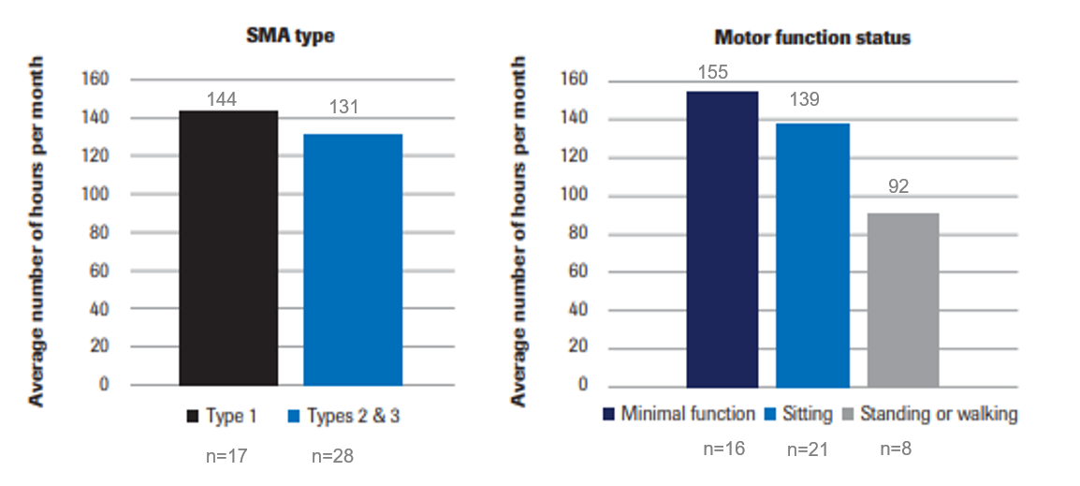

Figure 2: Caregiver EQ-5D-5L responses
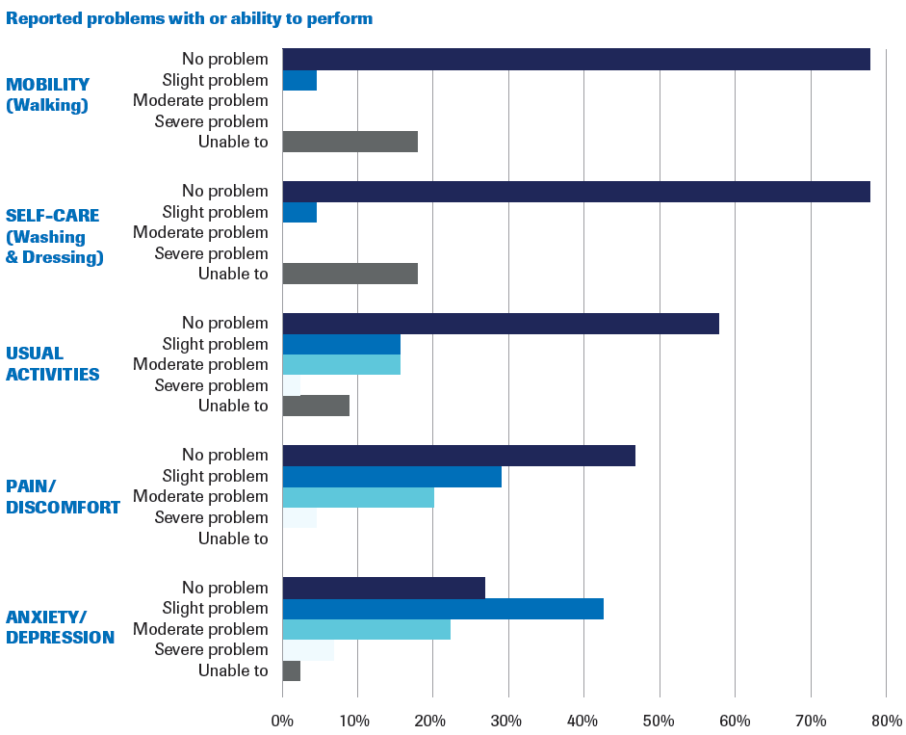
Table 2: EQ-5D Utility Scores
 | n | Mean | SD | Min | Max
Overall | 45 | 0.71 | 0.28 | 0.12 | 1
Employment Status
Employed (Full-time/Part-time) | 22 | 0.74 | 0.26 | 0.16 | 1
Unemployed/Full-time caregiver | 23 | 0.67 | 0.3 | 0.12 | 1
Caregiver Support
Paid Support | 21 | 0.65 | 0.3 | 0.12 | 1
Unpaid support/No support | 24 | 0.75 | 0.25 | 0.16 | 1
SMA Type
Type 1 | 17 | 0.61 | 0.28 | 0.15 | 0.86
Type 2 & 3 | 28 | 0.76 | 0.27 | 0.12 | 1
Motor Function Status
Minimal function | 16 | 0.6 | 0.3 | 0.12 | 0.88
Sitting | 21 | 0.7 | 0.26 | 0.15 | 0.88
Standing or walking | 8 | 0.95 | 0.07 | 0.84 | 1

Figure 3: Caregiver Quality of Life compared to US Norms [25]
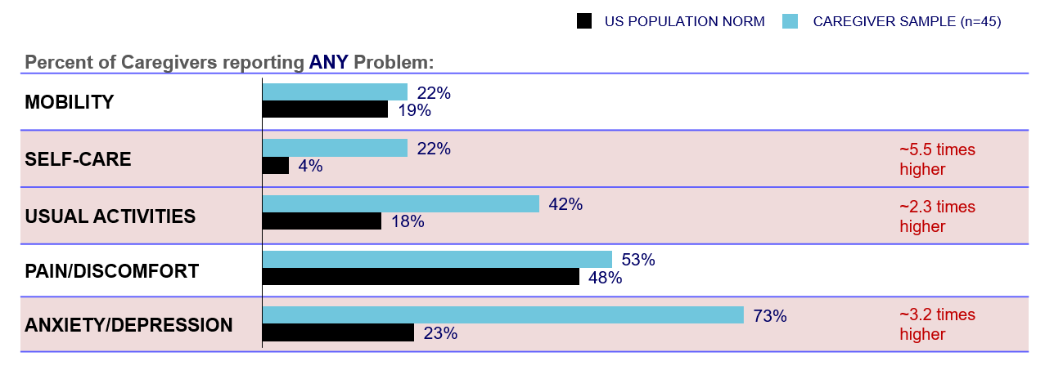
References
1. Lunn, M.R. and C.H. Wang, Spinal muscular atrophy. Lancet, 2008. 371(9630): p. 2120-33.
2. Mercuri, E., et al., Diagnosis and management of spinal muscular atrophy: Part 1: Recommendations for diagnosis, rehabilitation, orthopedic and nutritional care. Neuromuscul Disord, 2018. 28(2): p. 103-115.
3. Prior, T.W., Perspectives and diagnostic considerations in spinal muscular atrophy. Genet Med, 2010. 12(3): p. 145-52.
4. Lally, C., et al., Indirect estimation of the prevalence of spinal muscular atrophy Type I, II, and III in the United States. Orphanet J Rare Dis, 2017. 12(1): p. 175.
5. Munsat, T.L. and K.E. Davies, International SMA consortium meeting. (26-28 June 1992, Bonn, Germany). Neuromuscul Disord, 1992. 2(5-6): p. 423-8.
6. Butchbach, M.E., Copy Number Variations in the Survival Motor Neuron Genes: Implications for Spinal Muscular Atrophy and Other Neurodegenerative Diseases. Front Mol Biosci, 2016. 3: p. 7.
7. Farrar, M.A., et al. Financial, opportunity and psychosocial costs of spinal muscular atrophy: an exploratory qualitative analysis of Australian carer perspectives. BMJ open, 2018. 8, e020907 DOI: 10.1136/bmjopen-2017-020907.
8. The Voice of the Patient Report for Spinal Muscular Atrophy. Cure SMA; 2018. Accessed November 14, 2019.
9. von Gontard, A., S. Rudnik-Schoneborn, and K. Zerres, Stress and coping in parents of children and adolescents with spinal muscular atrophy. Klin Padiatr, 2012. 224(4): p. 247-51.
10. Biogen, Spinzara® (nuinersen) prescribing information. June 2019; Available at: http://www.spinraza.com.
11. AveXis and Inc, Zolgensma® (onasemnogene abeparvovec-xioi) prescribing information. 2019; Available at: https://www.avexis.com/content/pdf/prescribing_information.pdf.
12. Pearlin, L.I., et al., Caregiving and the Stress Process: An Overview of Concepts and Their Measures1. The Gerontologist, 1990. 30(5): p. 583-594.
13. Qian, Y., et al., Understanding the experiences and needs of individuals with Spinal Muscular Atrophy and their parents: a qualitative study. BMC Neurol, 2015. 15: p. 217.
14. López-Bastida, J., et al., Social/economic costs and health-related quality of life in patients with spinal muscular atrophy (SMA) in Spain. Orphanet Journal of Rare Diseases, 2017. 12(1).
15. Klug, C., et al., Disease burden of spinal muscular atrophy in Germany. Orphanet Journal of Rare Diseases, 2016. 11(1).
16. Ridic, G., S. Gleason, and O. Ridic, Comparisons of health care systems in the United States, Germany and Canada. Materia socio-medica, 2012. 24(2): p. 112-120.
17. Szende, A. and B. Janssen, Socio-demographic Indicators Based on EQ-5D, in Self-Reported Population Health: An International Perspective based on EQ-5D, A. Szende, B. Janssen, and J. Cabases, Editors. 2014: Dordrecht. p. 37-46.
18. Brooks, R., EuroQol: the current state of play. Health Policy, 1996. 37(1): p. 53-72.
19. Herdman, M., et al., Development and preliminary testing of the new five-level version of EQ-5D (EQ-5D-5L). Quality of Life Research, 2011. 20(10): p. 1727-1736.
20. Markowitz, J.S., et al., Health-Related Quality of Life for Caregivers of Patients With Alzheimer Disease. Alzheimer Disease & Associated Disorders, 2003. 17(4): p. 209-214.
21. Schrag, A., et al., Caregiver-burden in parkinson's disease is closely associated with psychiatric symptoms, falls, and disability. Parkinsonism & Related Disorders, 2006. 12(1): p. 35-41.
22. Adelman, R.D., et al., Caregiver burden: a clinical review. Jama, 2014. 311(10): p. 1052-60.
23. Noone JM, W.S., Buchenberger D, et al., Clinical experience of spinal muscular atrophy (SMA) treatment: A combination of perspectives from a large survey. Presented at the SMA Researcher Meeting in Anaheim, CA; 2019 June 28-30. SMA Poster
24. Landfeldt, E., et al., Quantifying the burden of caregiving in Duchenne muscular dystrophy. Journal of Neurology, 2016. 263(5): p. 906-915.
25. Janssen, B. and A. Szende, Population Norms for the EQ-5D, in Self-Reported Population Health: An International Perspective based on EQ-5D, A. Szende, B. Janssen, and J. Cabases, Editors. 2014: Dordrecht. p. 19-30.
26. Cremers, C.H., et al., Participation and mental well-being of mothers of home-living patients with spinal muscular atrophy. Neuromuscular Disorders, 2019. 29(4): p. 321-329.
27. National Institute for Health and Care Excellence. Final appraisal document: Nusinersen for treating spinal muscular atrophy. June 3, 2019. https://www.nice.org.uk/guidance/ta588/documents/final-appraisal-determination-document. Accessed September 25, 2019.
28. U.S. Department of Health & Human Services (HHS). Who is eligible for Medicaid? 2018; https://www.hhs.gov/answers/medicare-and-medicaid/who-is-eligible-for-medicaid/index.html. Accessed June 20, 2020.
29. The United States Census Bureau. Educational Attainment in the United States: 2017; Available at: https://www.census.gov/data/tables/2017/demo/education-attainment/cps-detailed-tables.html. Accessed August 1, 2019.

