Supplementary Information
Tumor-specific high-valence bismuth(V) nanoplatform potentiates cancer immunotherapy with exogenous excitation-free endogenous H₂O₂- and O₂-independent ROS generation
Yizhang Tang¹, Xujiang Yu¹*, Liangrui He¹, Meng Tang², Wenji Yue¹, Ruitong Chen¹, Jie Zhao¹, Qi Pan³ and Wanwan Li¹*
¹ State Key Lab of Metal Matrix Composites
School of Materials Science and Engineering
Zhangjiang Institute for Advanced Study
Shanghai Jiao Tong University
800 Dongchuan Road, Shanghai 200240, P. R. China

² Department of Comprehensive Oncology
National Cancer Center/National Clinical Research Center for Cancer/Cancer Hospital
Chinese Academy of Medical Sciences and Peking Union Medical College
Beijing 100021, China
³ Department of Urology
Shanghai General Hospital, Shanghai Jiao Tong University School of Medicine

Shanghai 200080, China
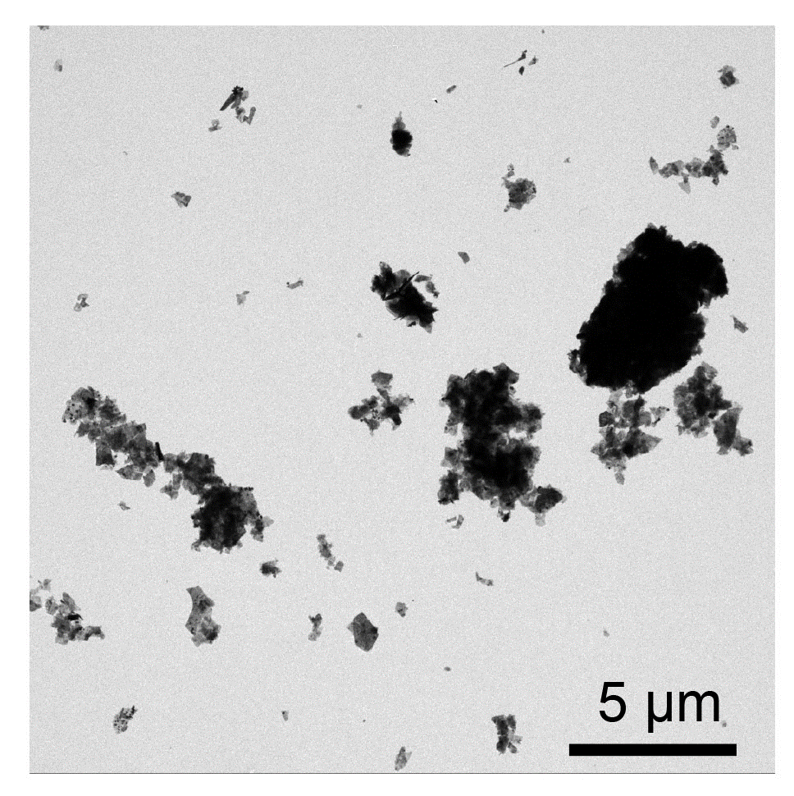
Supplementary Fig. 1 | A representative transmission electron microscopy (TEM) image of commercially purchased sodium bismuthate (Macklin).

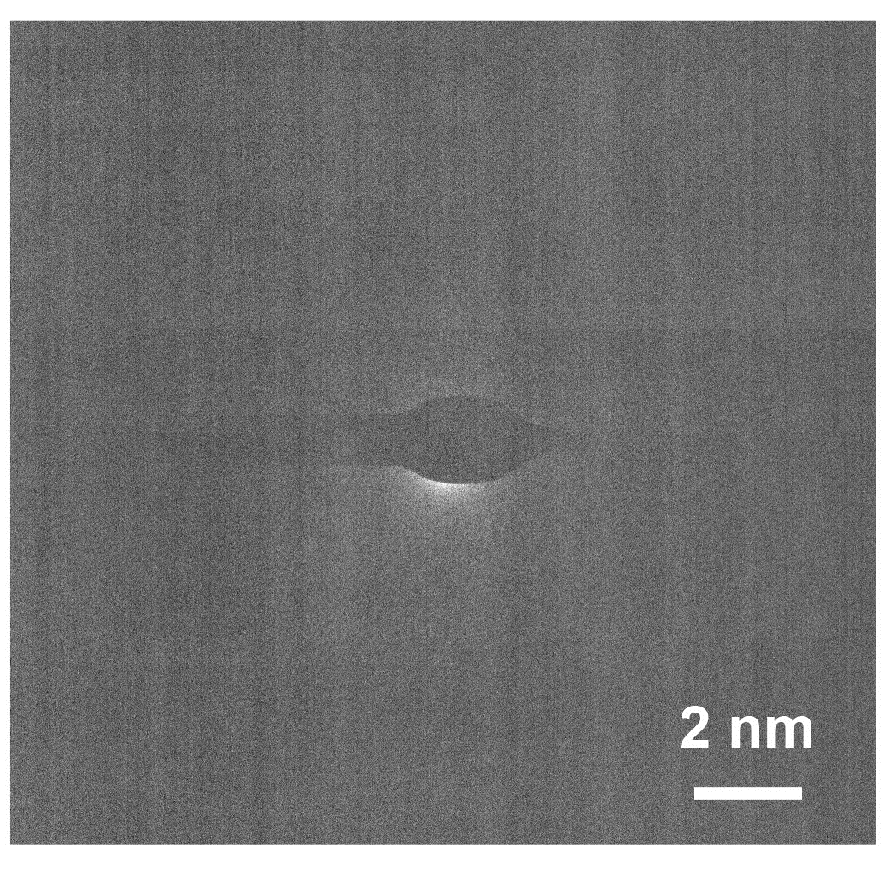

Supplementary Fig. 2 | Selected-area electron diffraction pattern of Bi^{III}O_{x}.

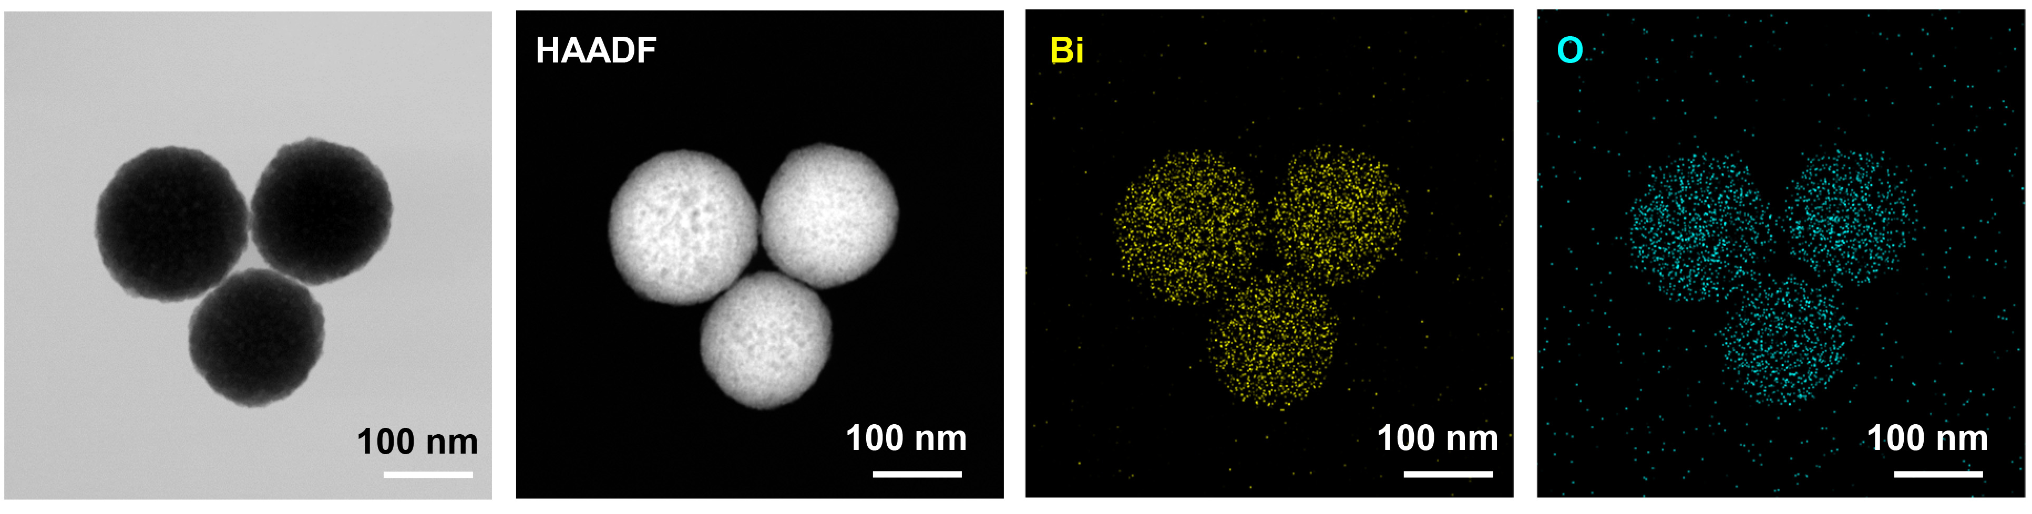

Supplementary Fig. 3 | HADDF imageand element mapping of Bi^{III}O_{x}.

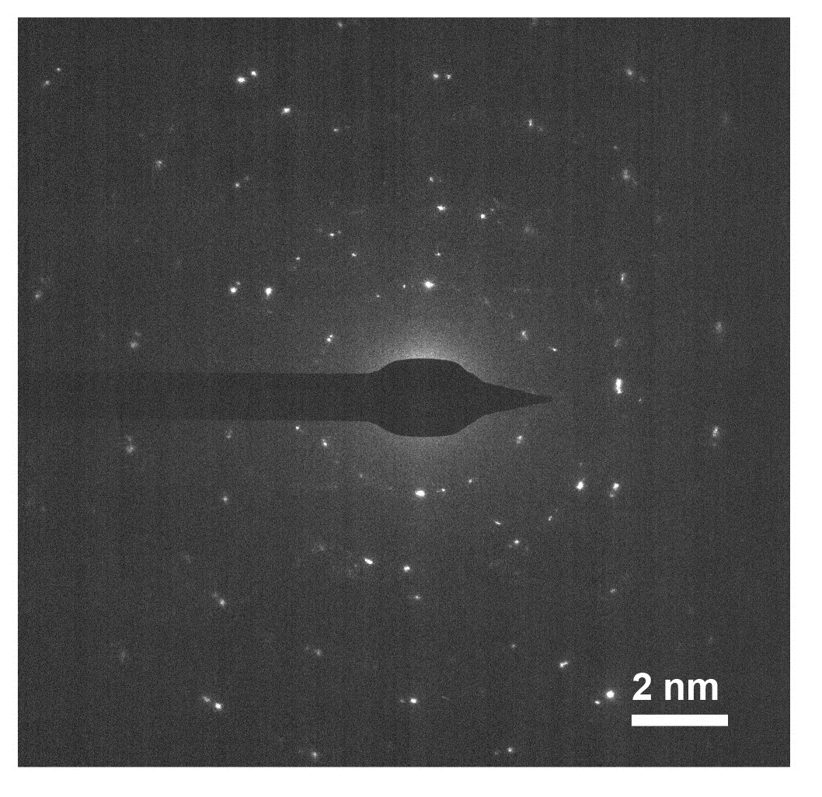

Supplementary Fig. 4 | Selected-area electron diffraction pattern of NaBi^{V}O₃.

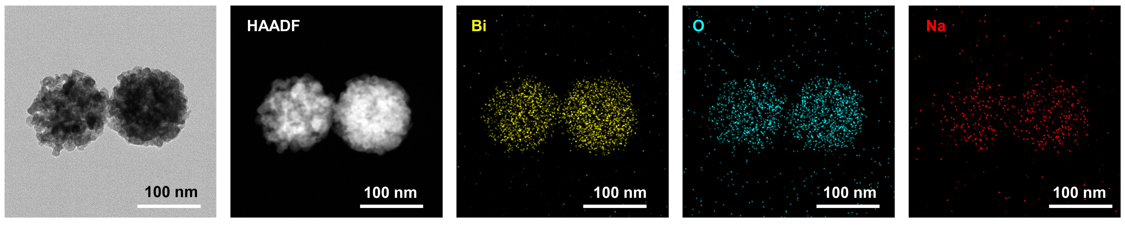

Supplementary Fig. 5 | HADDF imageand element mapping of NaBi^{V}O₃.

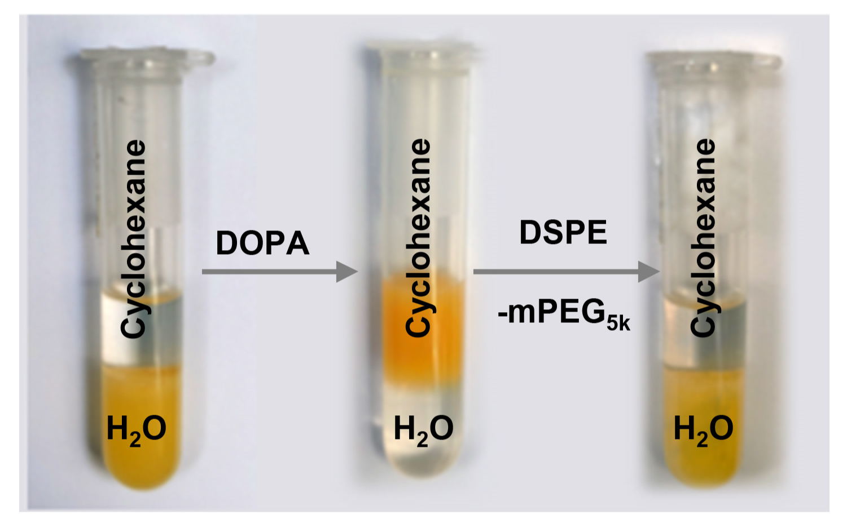
Supplementary Fig. 6 | A photograph of NaBi^{V}O₃-PEG prepared by two-step for PEGylation modification.

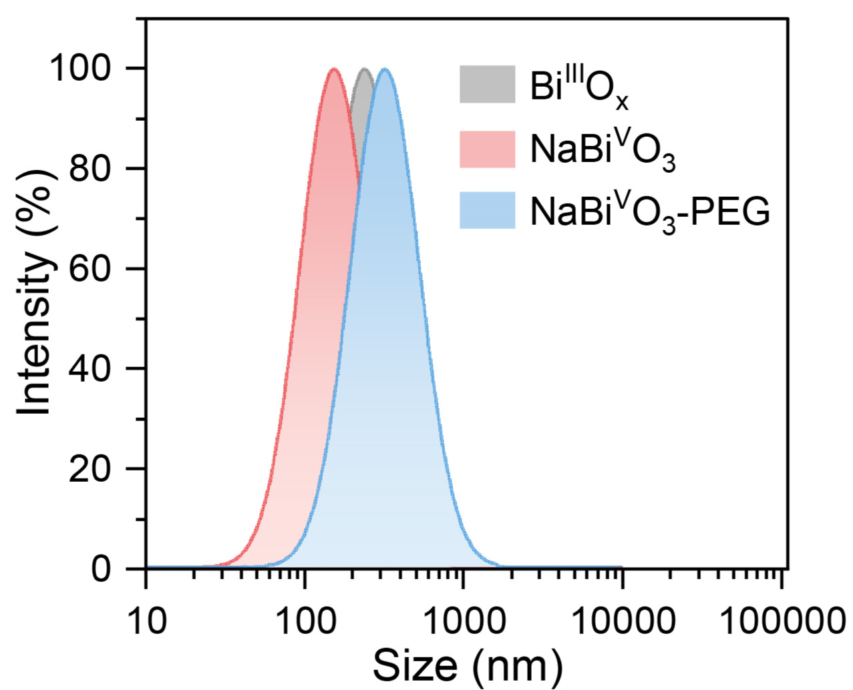
Supplementary Fig. 7 | Dynamic light scattering (DLS) data of Bi^{III}O_{x}, NaBi^{V}O₃ and NaBi^{V}O₃-PEG in the aqueous solution.

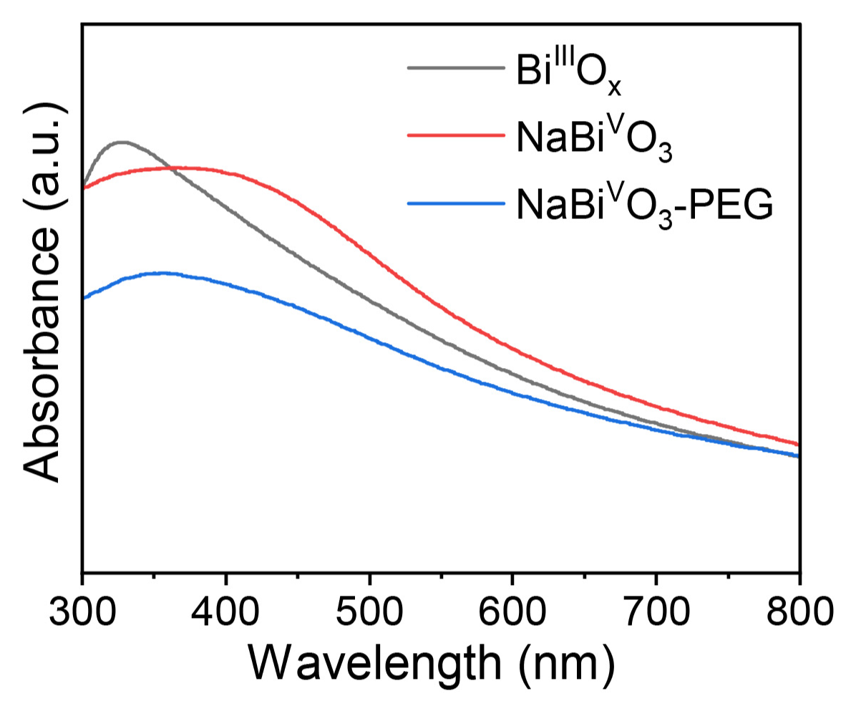
Supplementary Fig. 8 | UV–Vis–NIR spectra of Bi^{III}O_{x}, NaBi^{V}O₃ and NaBi^{V}O₃-PEG solutions.

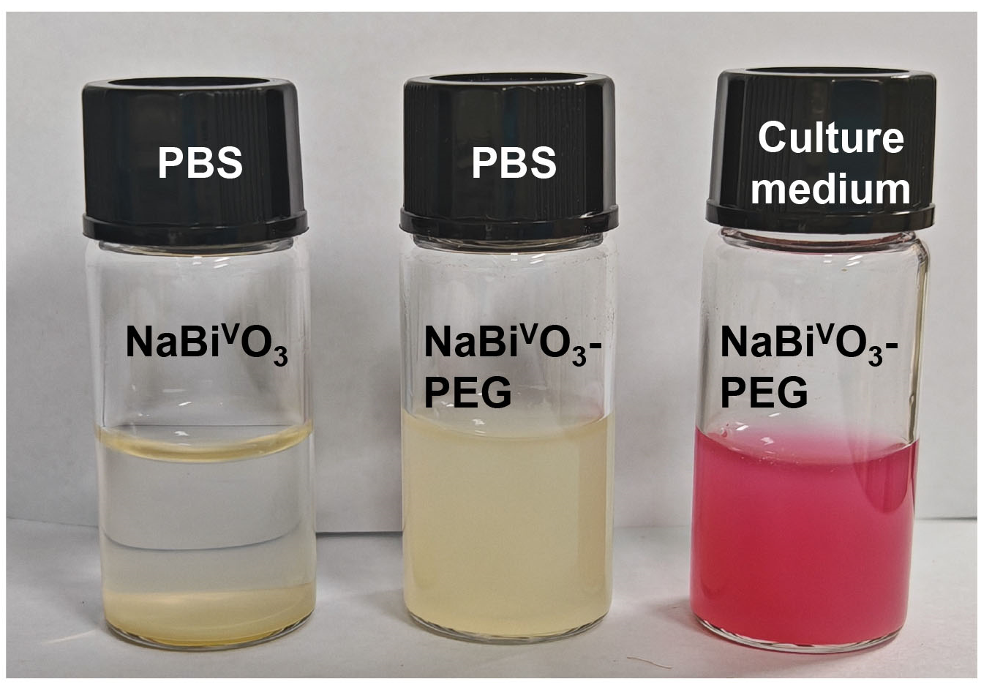
Supplementary Fig. 9 | Photographs of NaBi^{V}O₃ nanoparticles in PBS and NaBi^{V}O₃-PEG nanoparticles in PBS and culture medium.

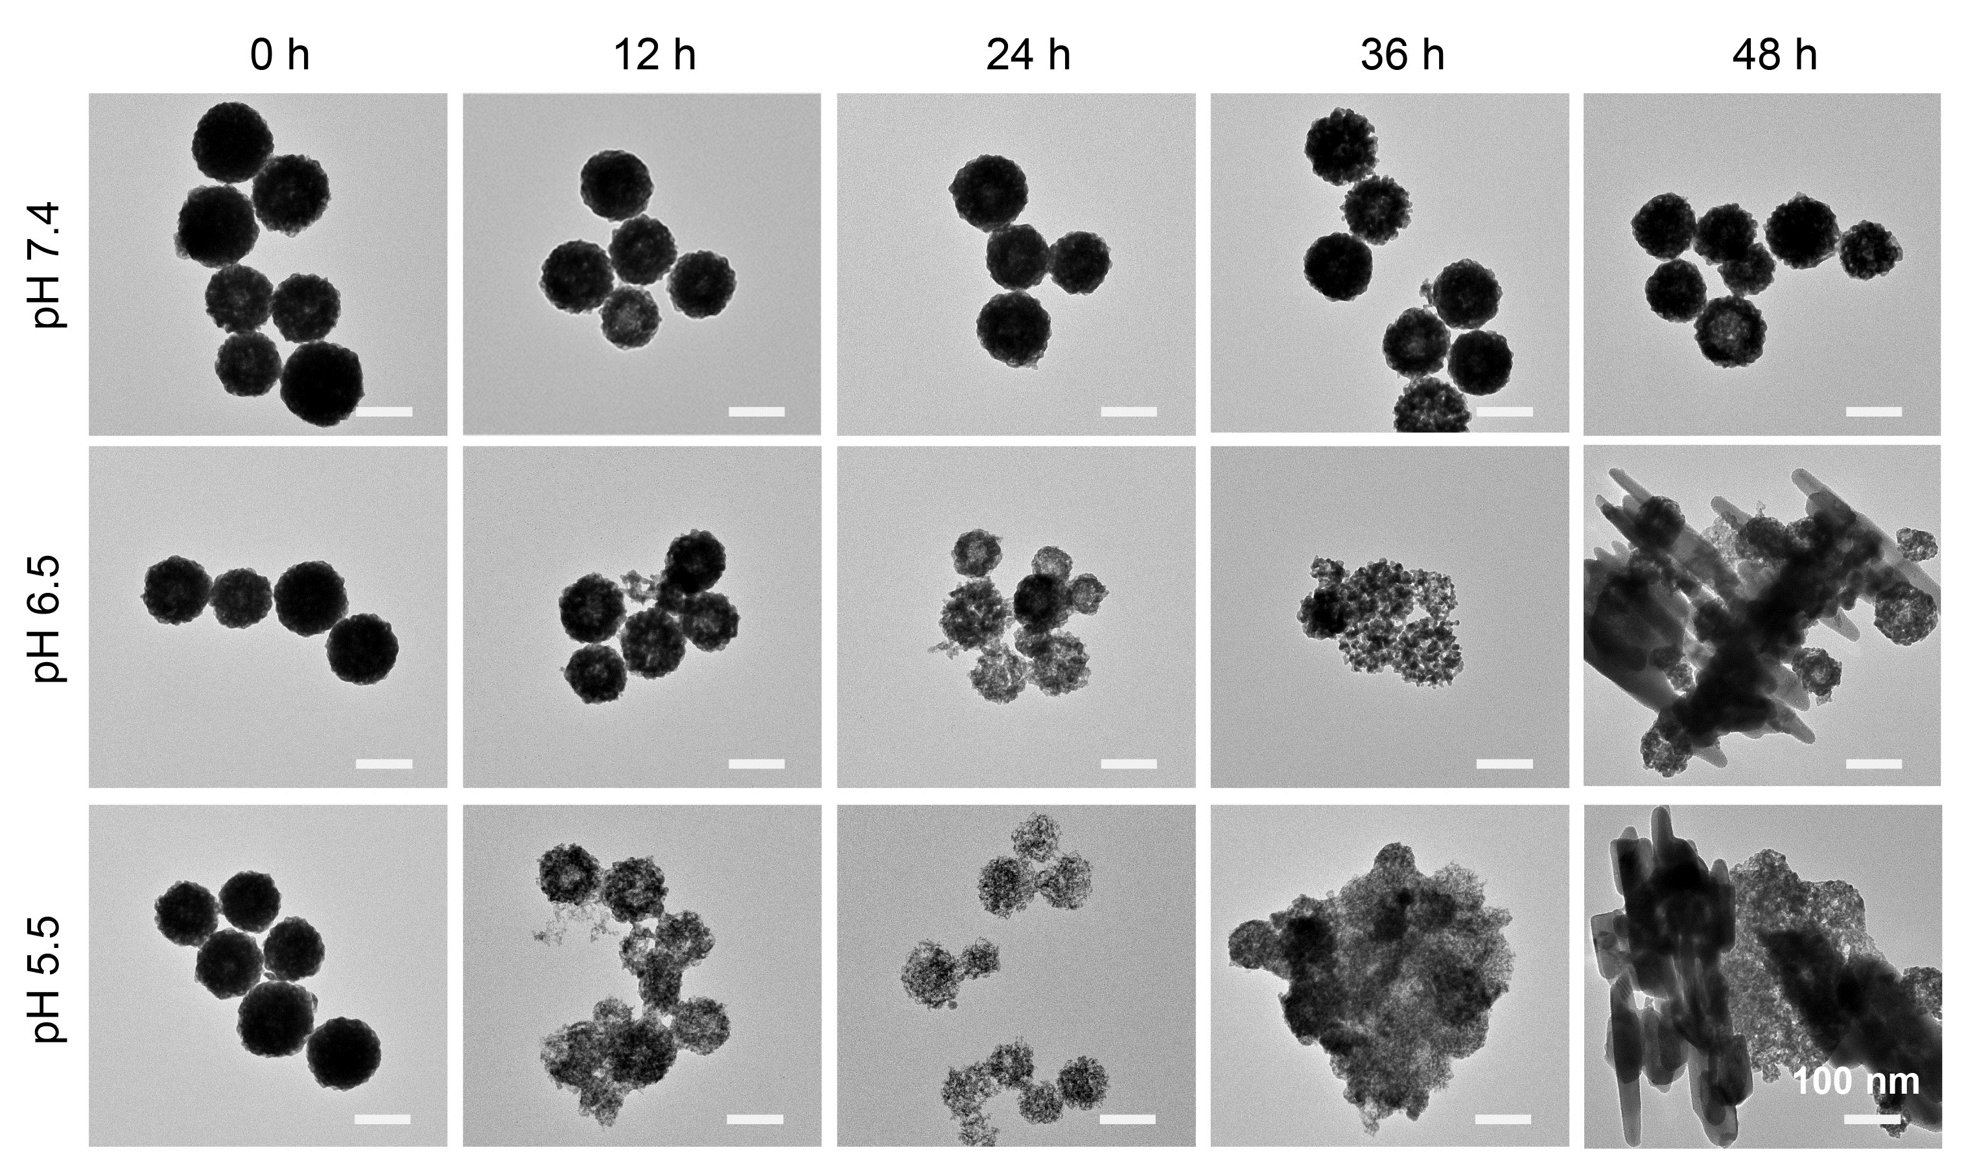
Supplementary Fig. 10 | Time-dependent TEM images of NaBi^{V}O₃-PEG when dispersed in PBS with different pH values.

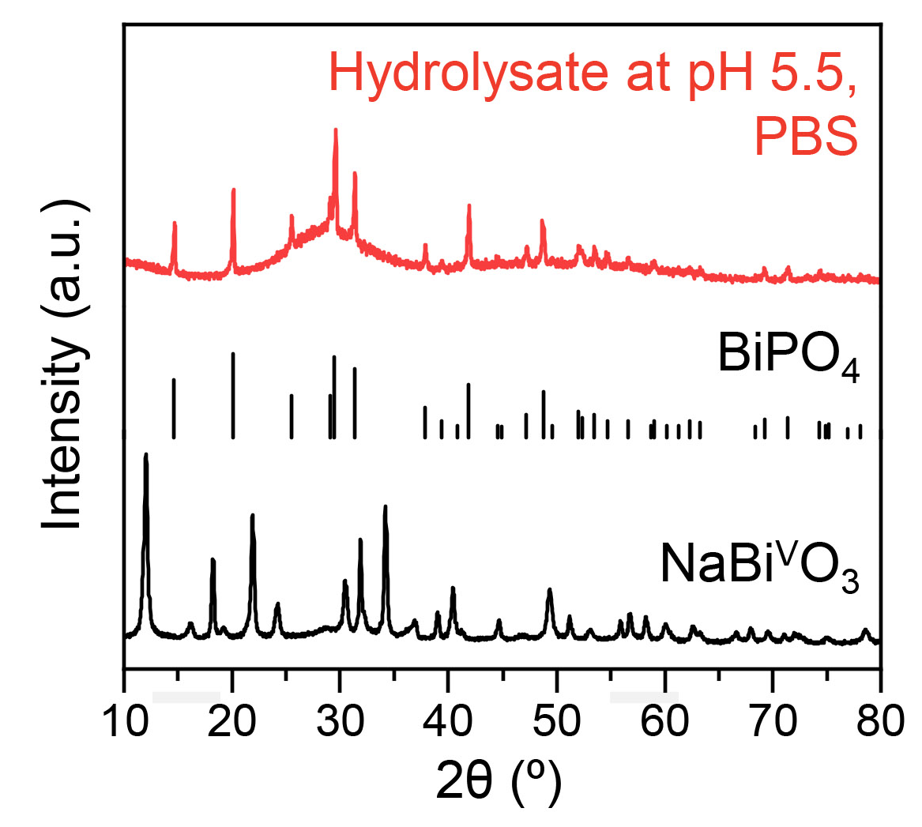
Supplementary Fig. 11 | XRD pattern of NaBi^{V}O₃-PEG and hydrolystate after NaBi^{V}O₃-PEG dispersed in PBS for 48 h at pH 5.5.

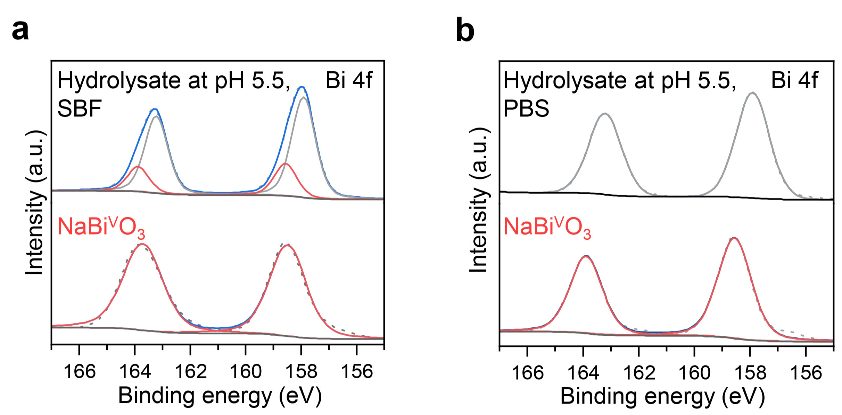
Supplementary Fig. 12 | High-resolution XPS spectra of Bi 4f of NaBi^{V}O₃-PEG and hydrolystates after NaBi^{V}O₃-PEG dispersed in SBF(a) and PBS (b) for 48 h at pH 5.5.

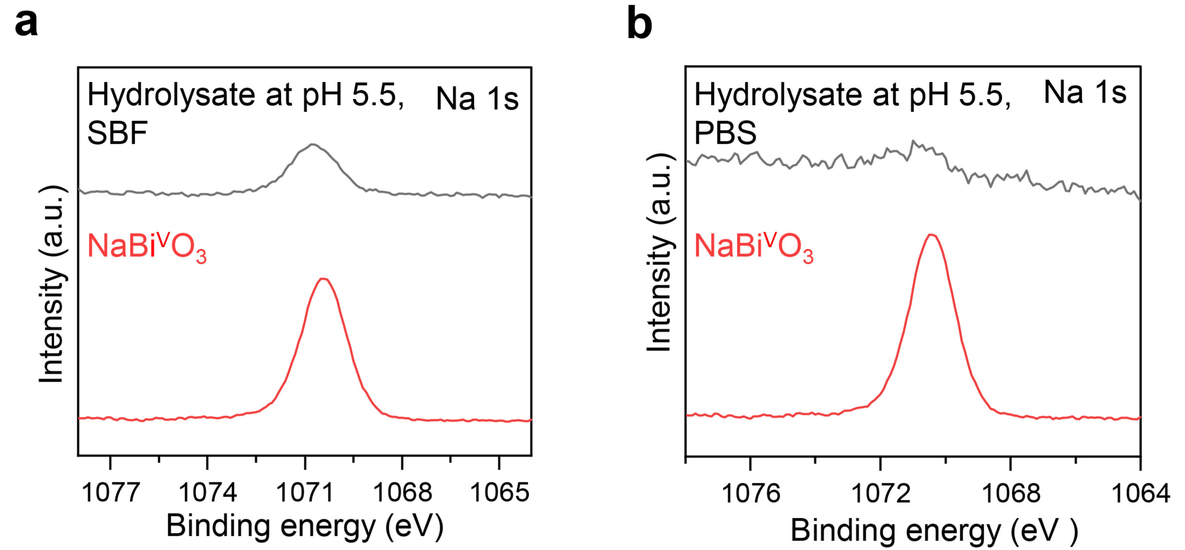
Supplementary Fig. 13 | High-resolution XPS spectra of Na 1s of NaBi^{V}O₃-PEG and hydrolystates after NaBi^{V}O₃-PEG dispersed in SBF(a) and PBS (b) for 48 h at pH 5.5.

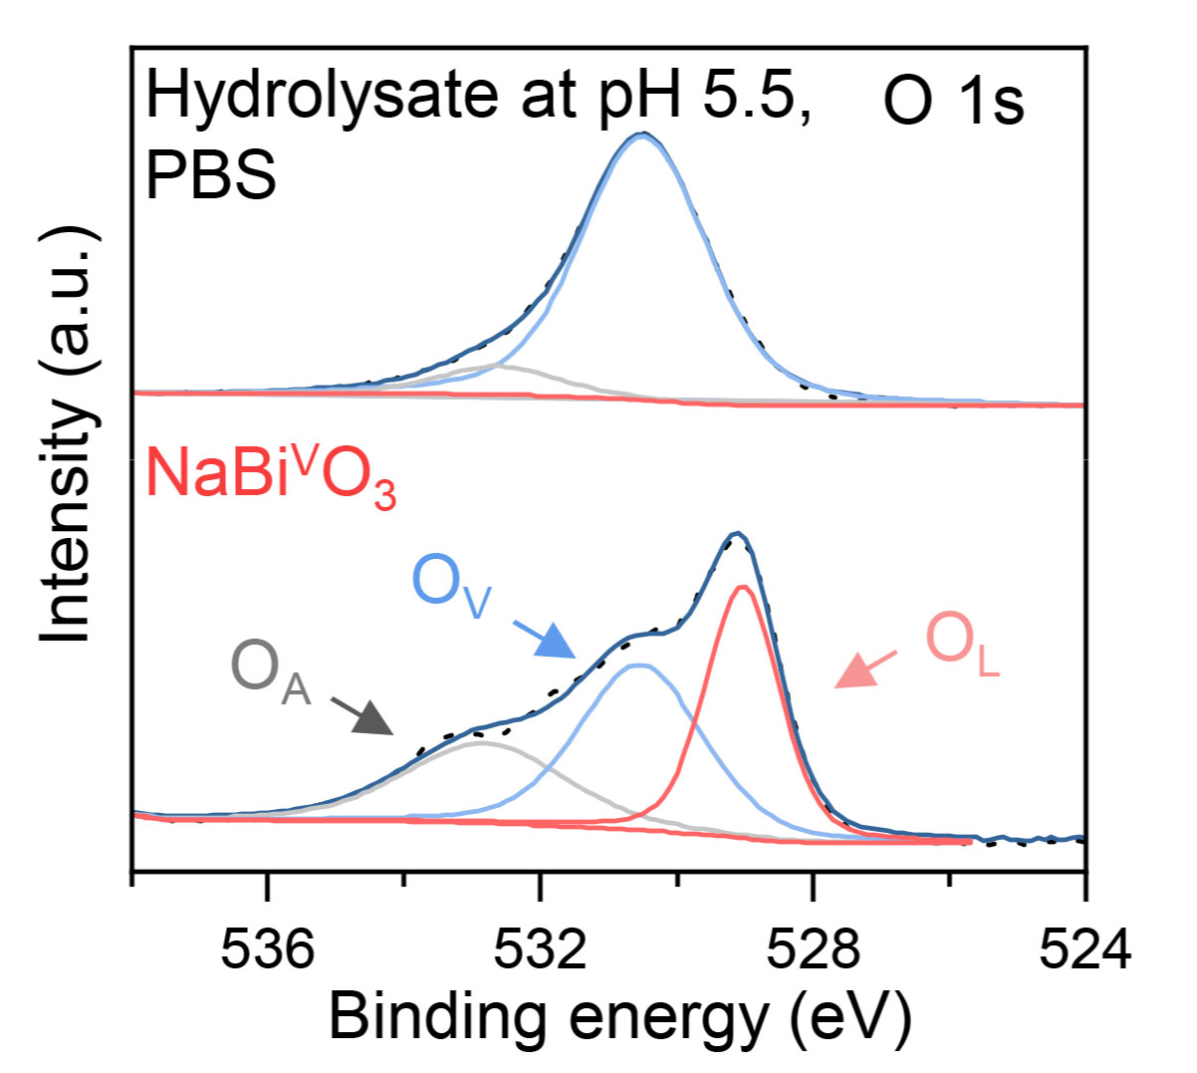
Supplementary Fig. 14 | High-resolution XPS spectra of O 1s of NaBi^{V}O₃-PEG and hydrolystates after NaBi^{V}O₃-PEG dispersed in PBS for 48 h at pH 5.5.

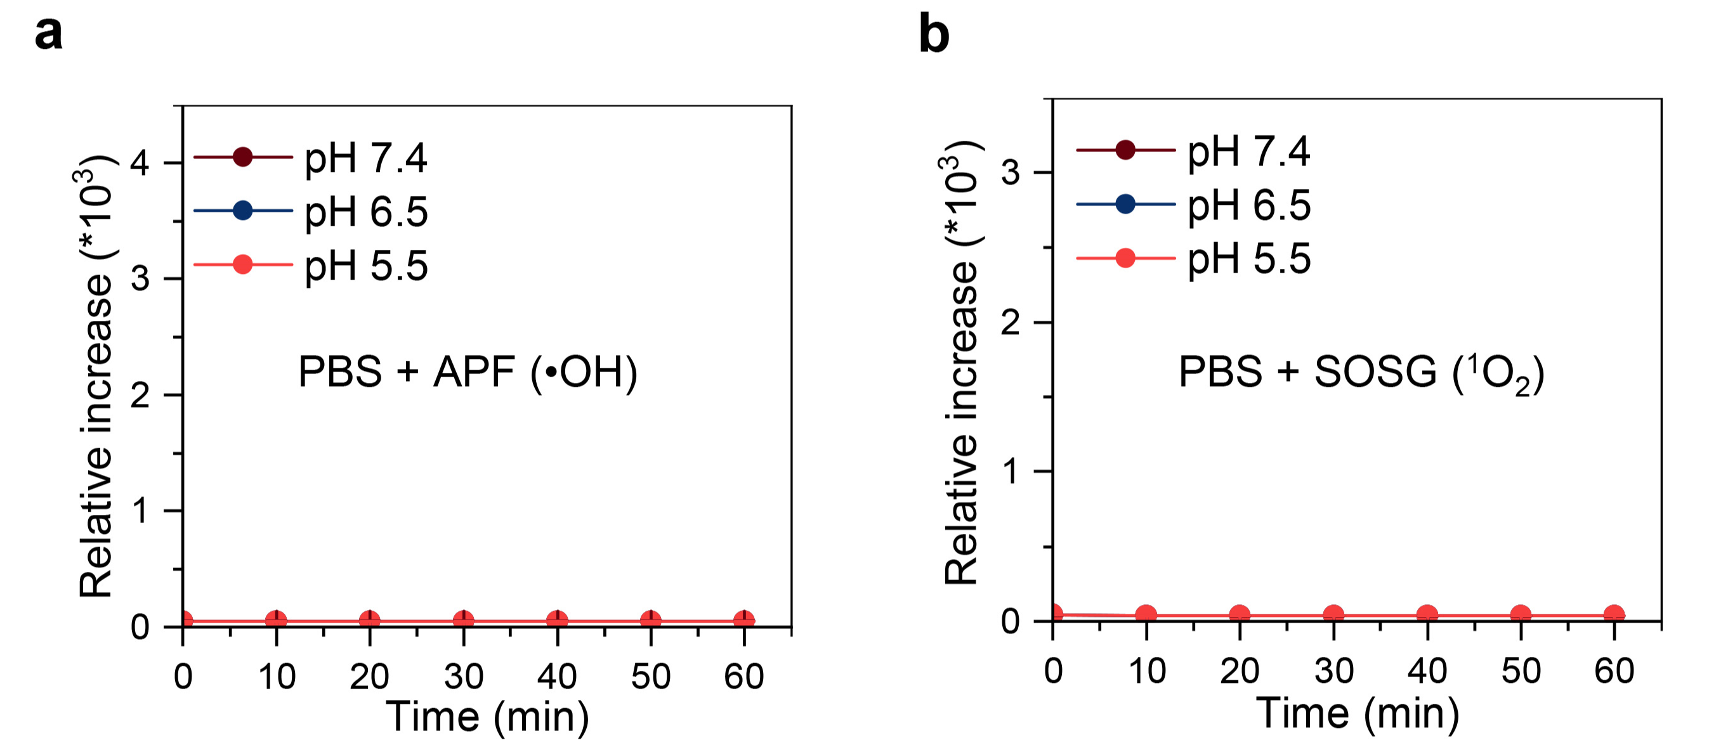
Supplementary Fig. 15 | a, Time-dependent fluorescence intensity of PBS recorded at 525 nm after incubation with APF in buffers at different pH values. b, Time-dependent fluorescence intensity of PBS recorded at 525 nm after incubation with SOSG in buffers at different pH values. Data were shown as mean ± s.d.

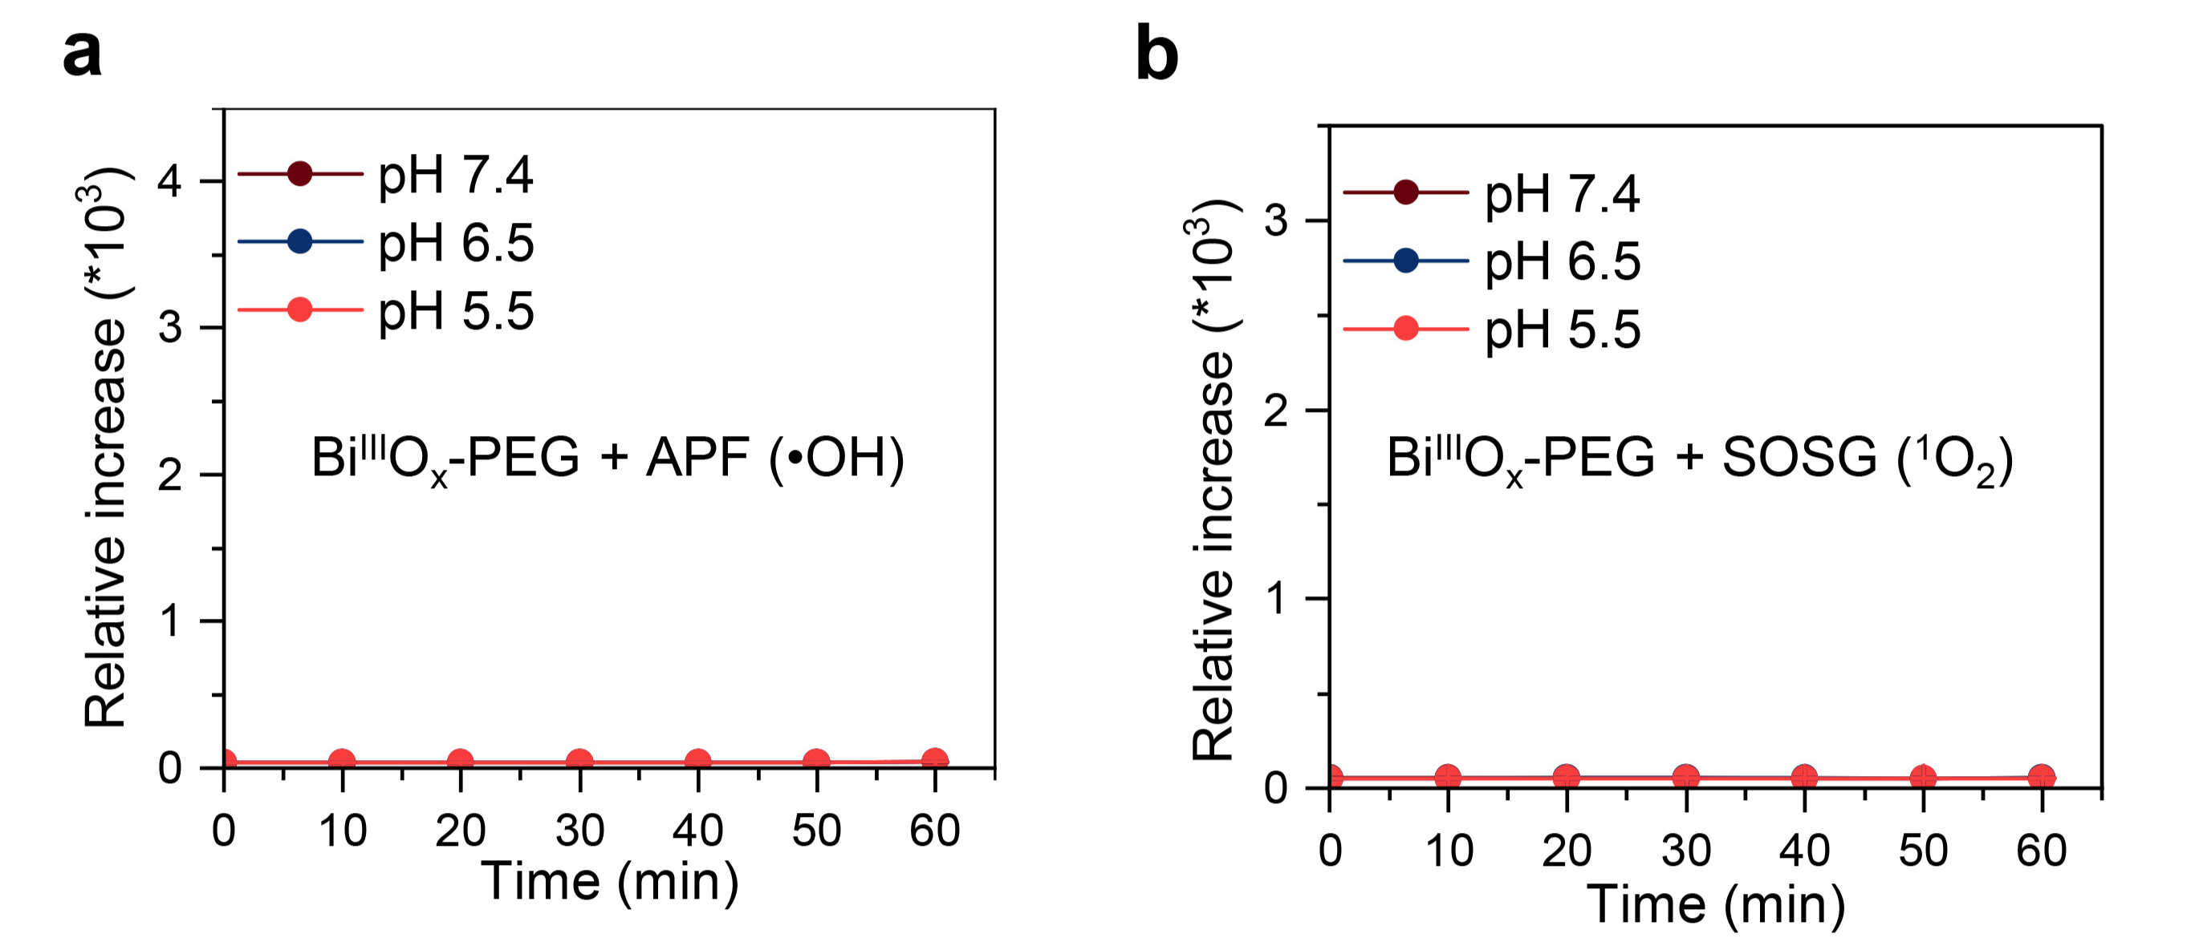
Supplementary Fig. 16 | a, Time-dependent fluorescence intensity of Bi^{III}O_{x}-PEG recorded at 525 nm after incubation with APF in buffers at different pH values. b, Time-dependent fluorescence intensity of Bi^{III}O_{x}-PEG recorded at 525 nm after incubation with SOSG in buffers at different pH values. Data were shown as mean ± s.d.

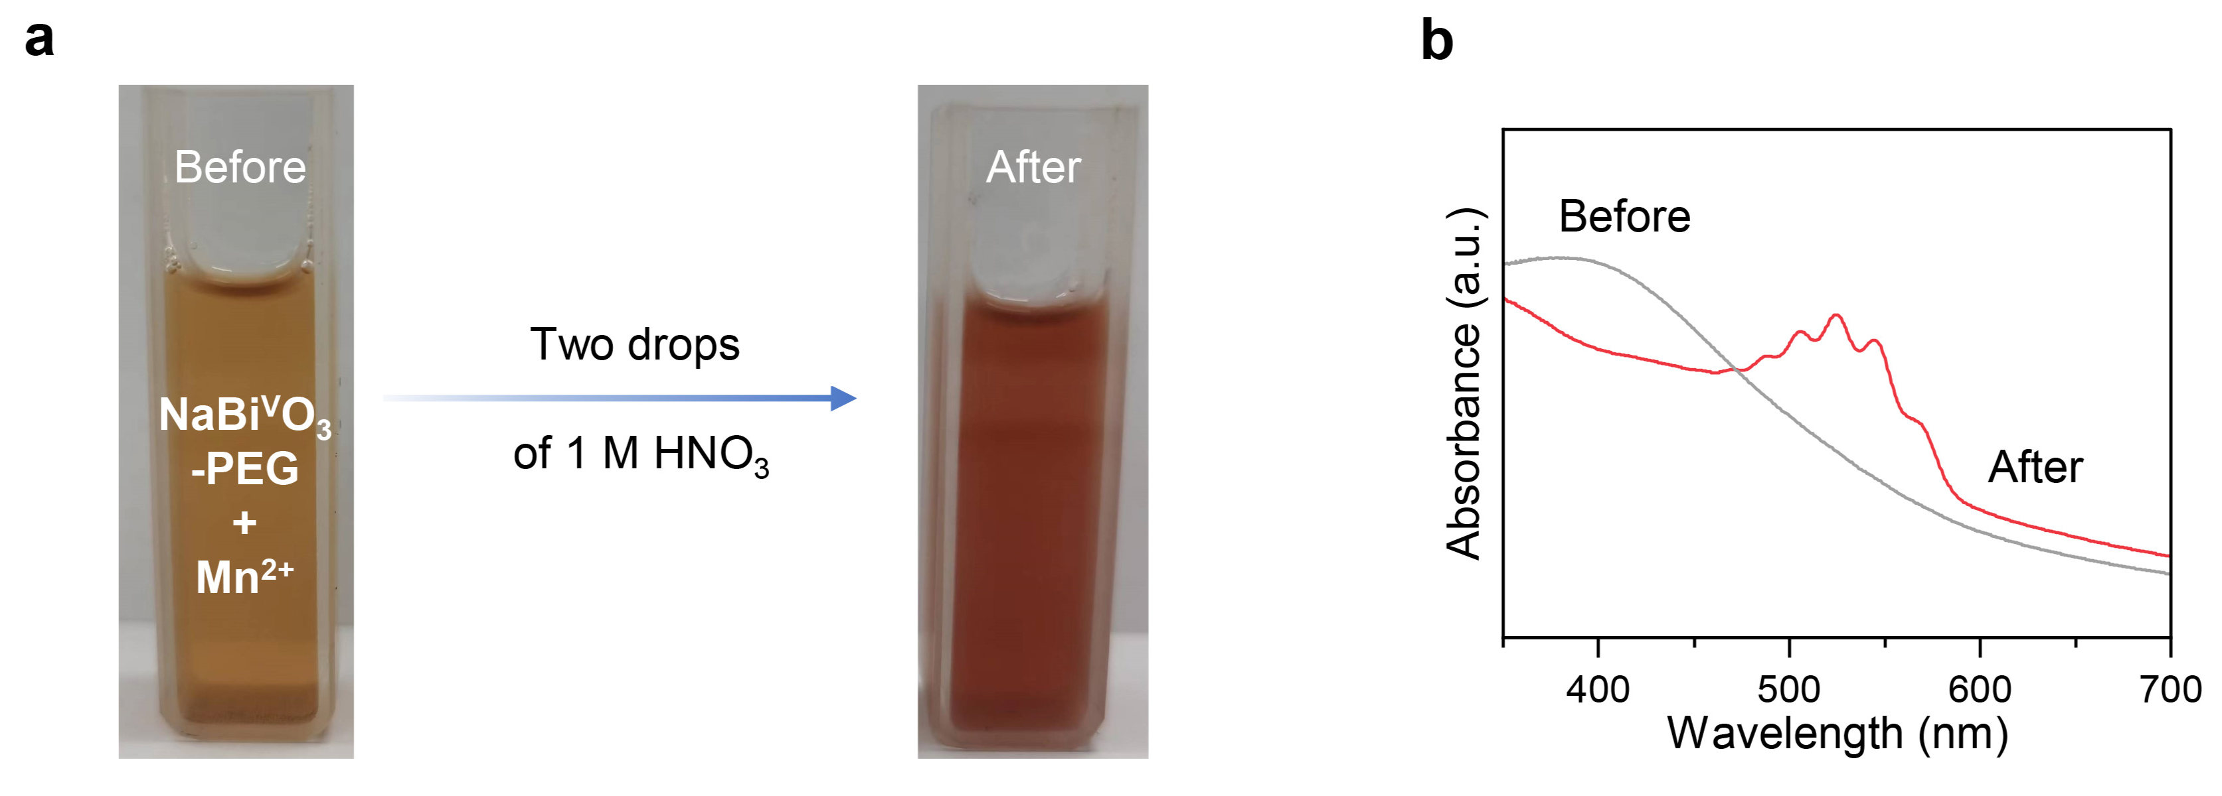
Supplementary Fig. 17 | a, A photograph of the mixed solution of NaBi^{V}O₃-PEG and Mn²⁺ before (left) and after (right) dropping two drops of 1 M HNO₃. b, UV–Vis–NIR spectra of the mixed solution of NaBi^{V}O₃-PEG and Mn²⁺ before and after dropping two drops of 1 M HNO₃.

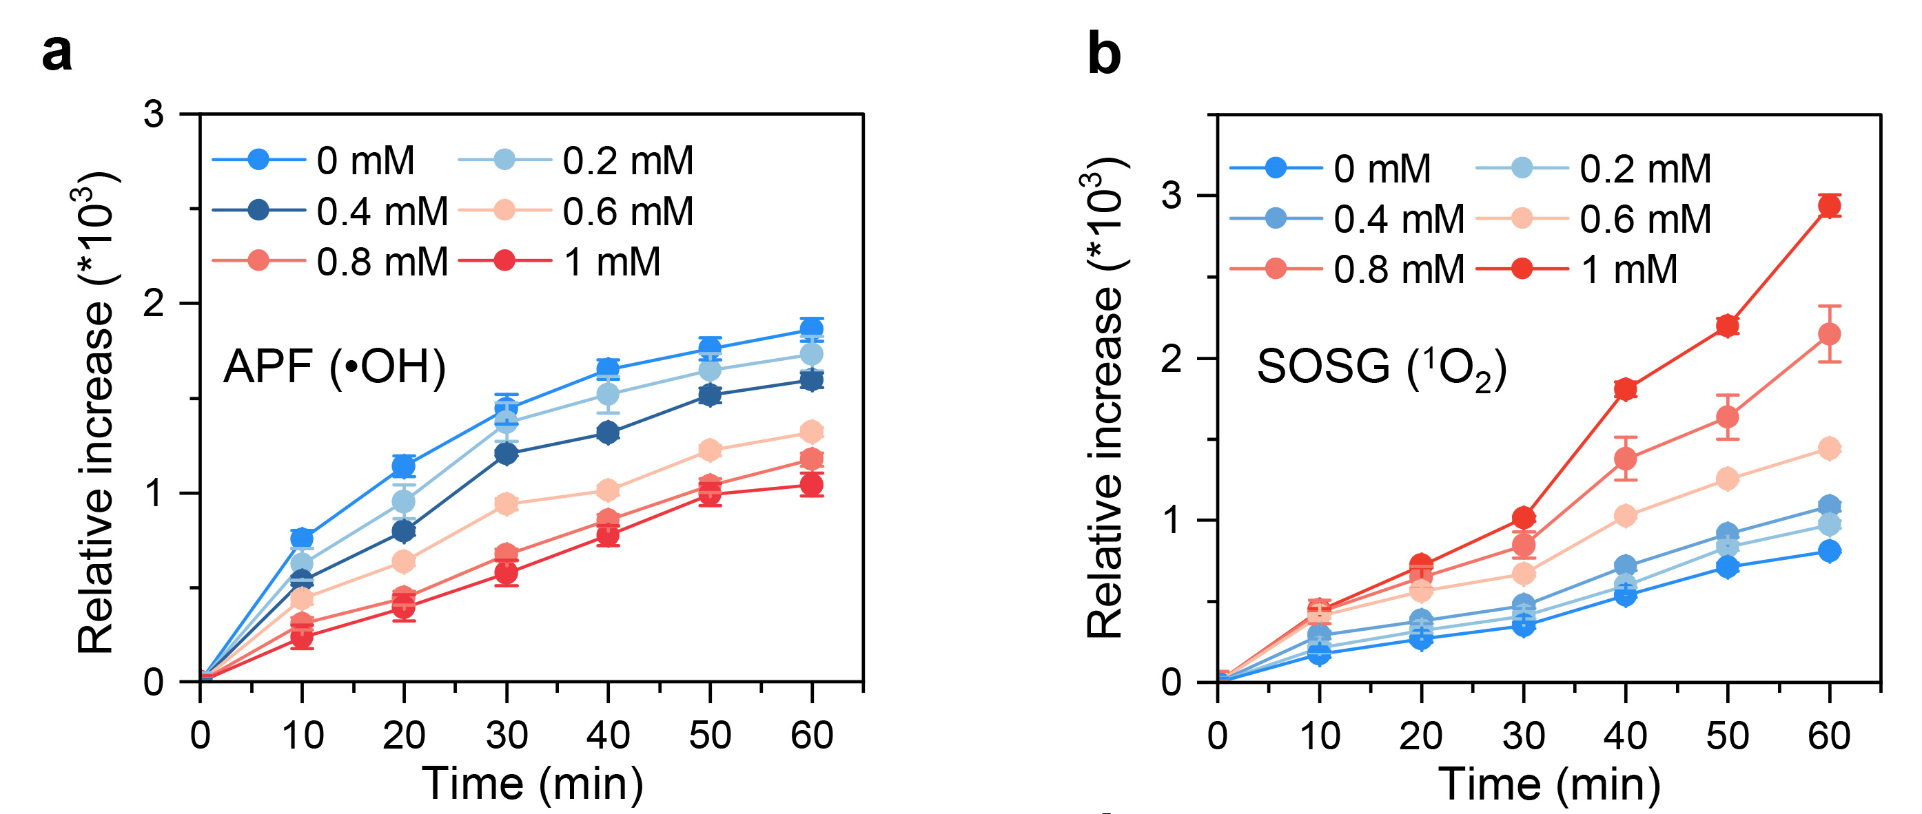
Supplementary Fig. 18 | a, Time-dependent fluorescence intensity of NaBi^{V}O₃-PEG recorded at 525 nm after incubation with APF in buffers at different H₂O₂ concentration. b, Time-dependent fluorescence intensity of NaBi^{V}O₃-PEG recorded at 525 nm after incubation with SOSG in buffers at different H₂O₂ concentration. Data were shown as mean ± s.d.

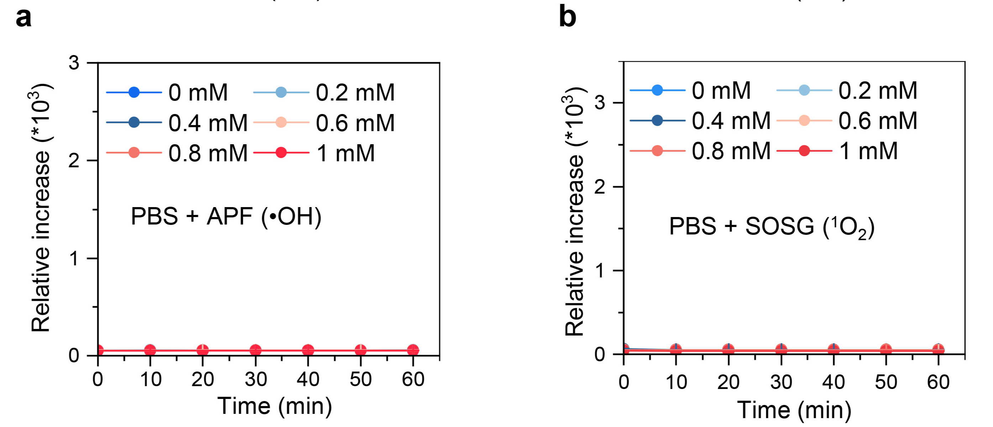
Supplementary Fig. 19 | a, Time-dependent fluorescence intensity of PBS recorded at 525 nm after incubation with APF in buffers at different H₂O₂ concentration. b, Time-dependent fluorescence intensity of PBS recorded at 525 nm after incubation with SOSG in buffers at different H₂O₂ concentration. Data were shown as mean ± s.d.

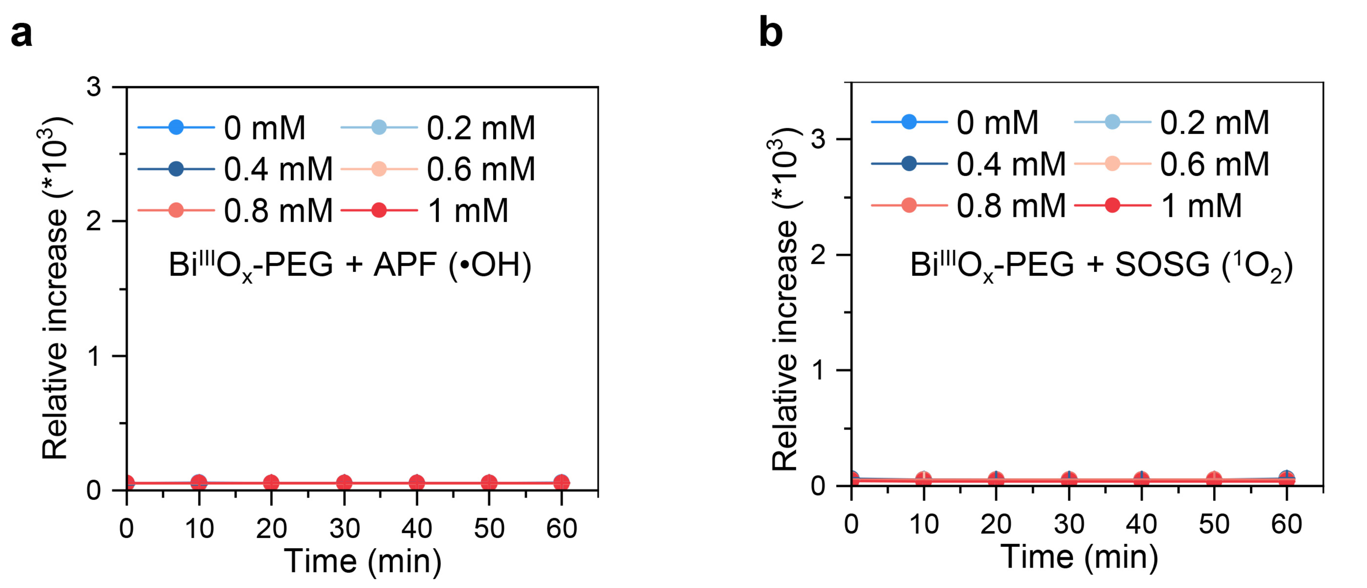
Supplementary Fig. 20 | a, Time-dependent fluorescence intensity of Bi^{III}O_{x}-PEG recorded at 525 nm after incubation with APF in buffers at different H₂O₂ concentration. b, Time-dependent fluorescence intensity of Bi^{III}O_{x}-PEG recorded at 525 nm after incubation with SOSG in buffers at different H₂O₂ concentration. Data were shown as mean ± s.d.

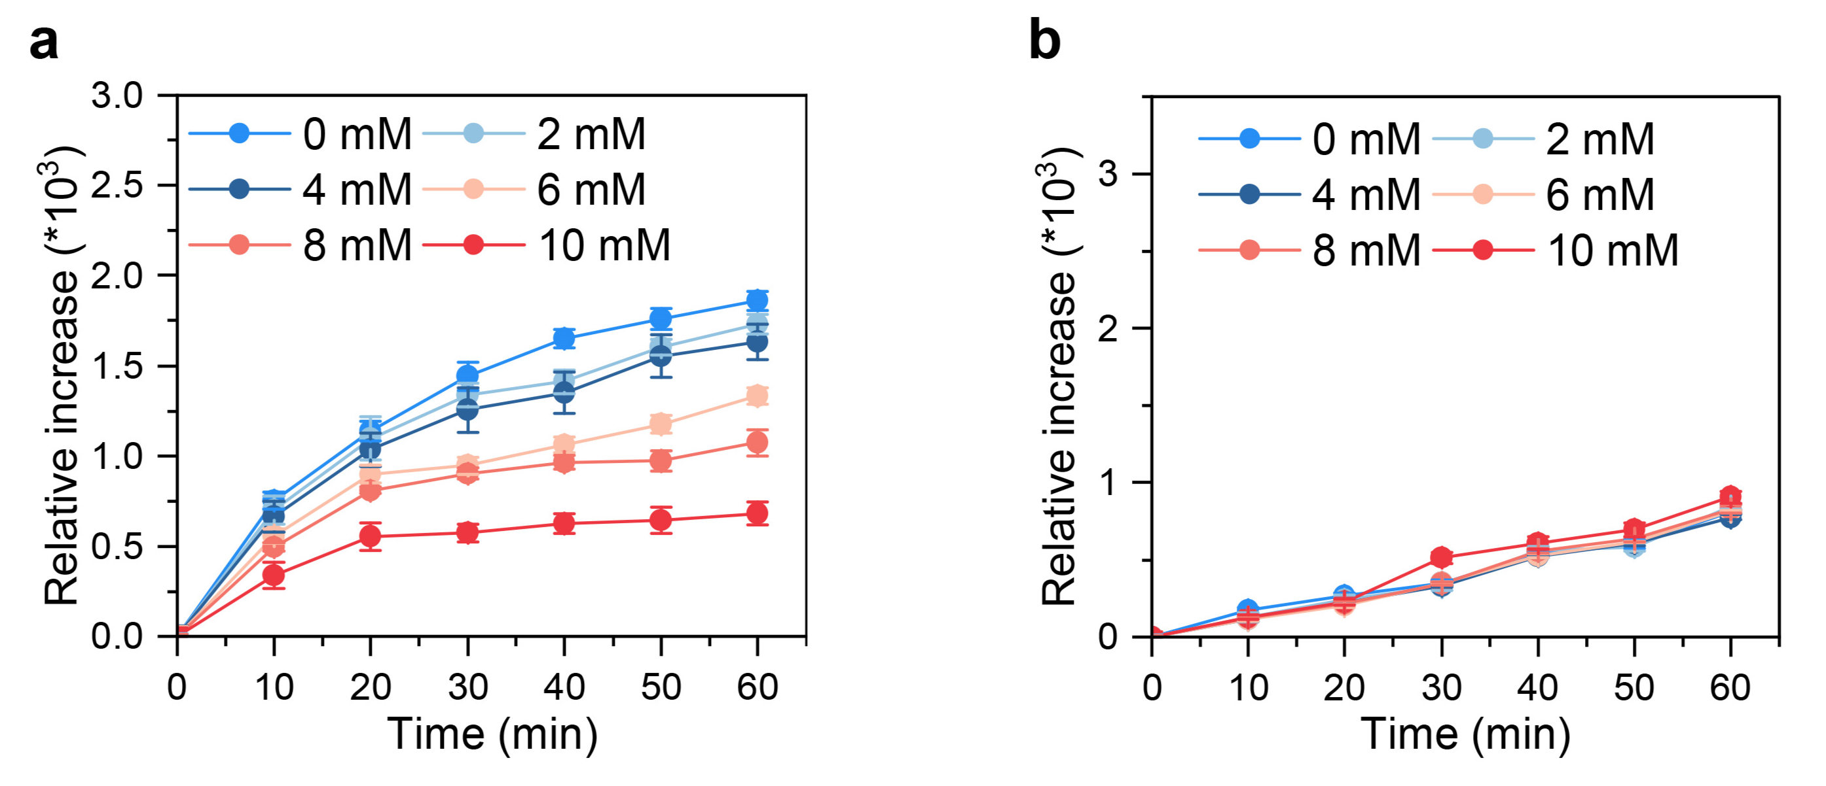
Supplementary Fig. 21 | a, Time-dependent fluorescence intensity of NaBi^{V}O₃-PEG recorded at 525 nm after incubation with APF in buffers at different GSH concentration. b, Time-dependent fluorescence intensity of NaBi^{V}O₃-PEG recorded at 525 nm after incubation with SOSG in buffers at different GSH concentration. Data were shown as mean ± s.d.

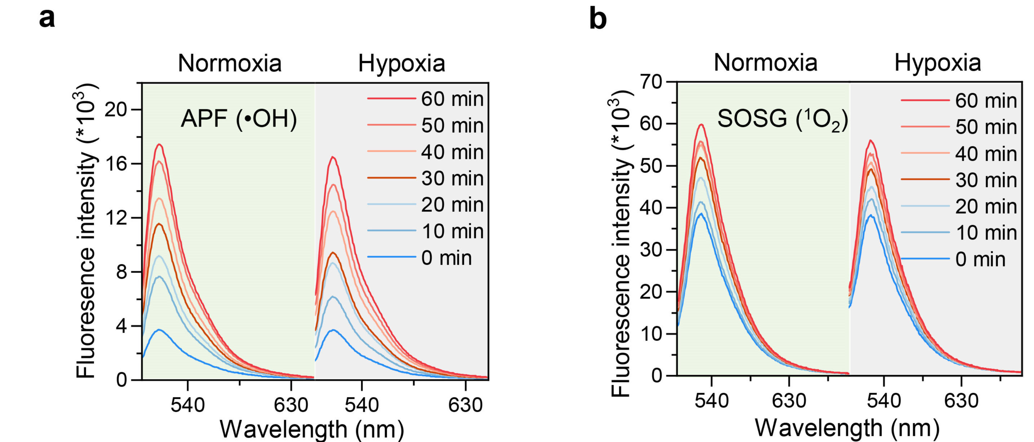
Supplementary Fig. 22 | a, Time-dependent fluorescence spectra of NaBi^{V}O₃-PEG after incubation with APF in pH 5.5 PBS under normoxic and hypoxic conditions b, Time-dependent fluorescence spectra of NaBi^{V}O₃-PEG after incubation with SOSG in PBS at pH 5.5 under normoxic and hypoxic conditions.
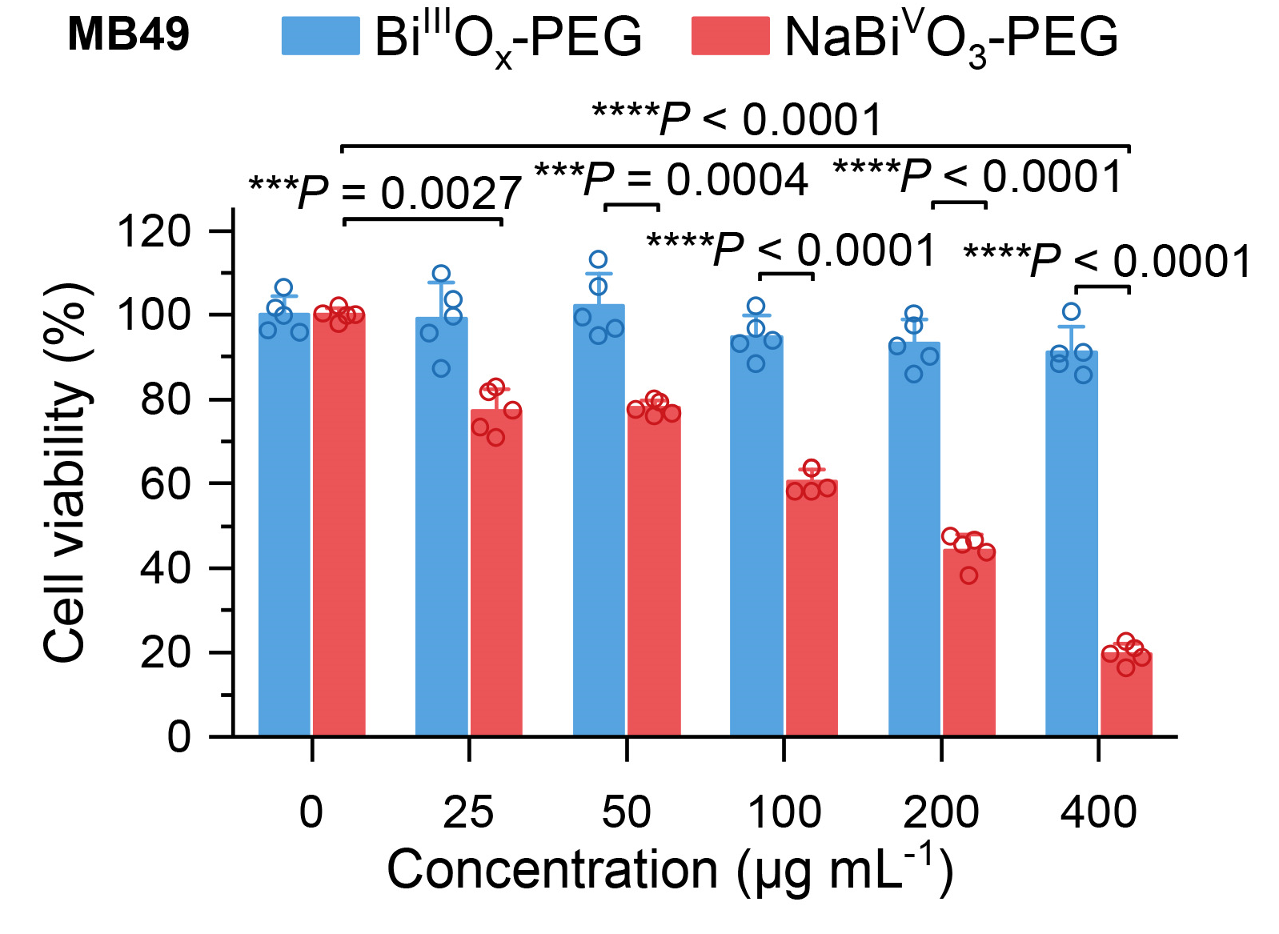
Supplementary Fig. 23 | Cytotoxicity of B^{III}O_{x}-PEG and NaBi^{V}O₃-PEG on MB49. Data were shown as mean ± s.d. The P values were calculated by one-way ANOVA and Tukey multiple-comparison test. *P < 0.05, **P < 0.01, ***P < 0.001, ****P < 0.0001, and n.s., not significant.

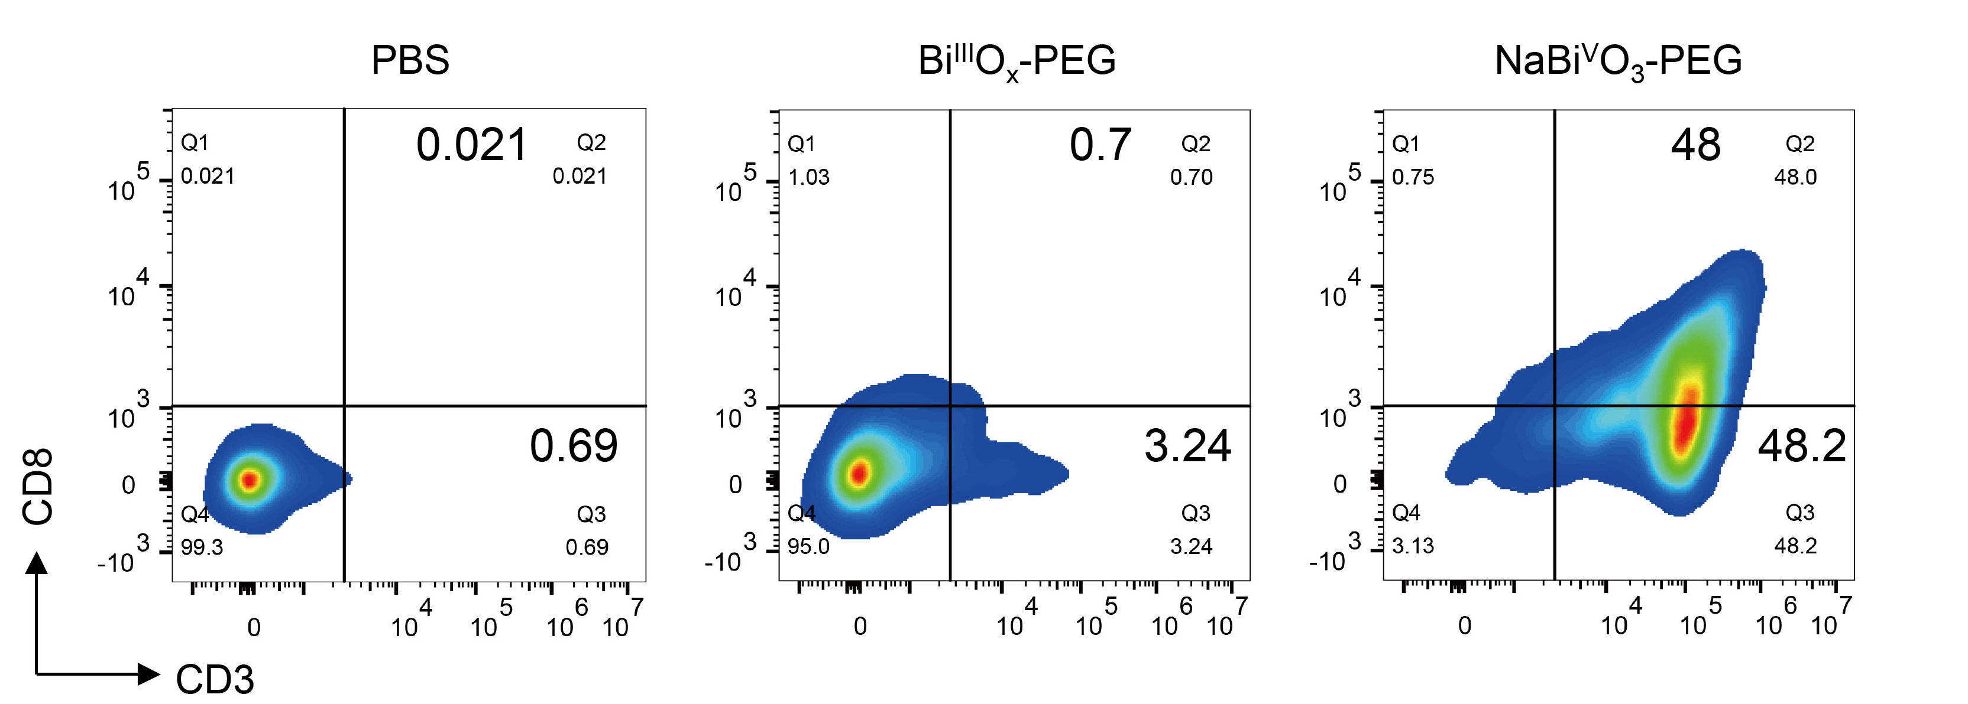
Supplementary Fig. 24 | Apoptosis of 4T1 cells conducted by flow cytometry analysis with different treatments.

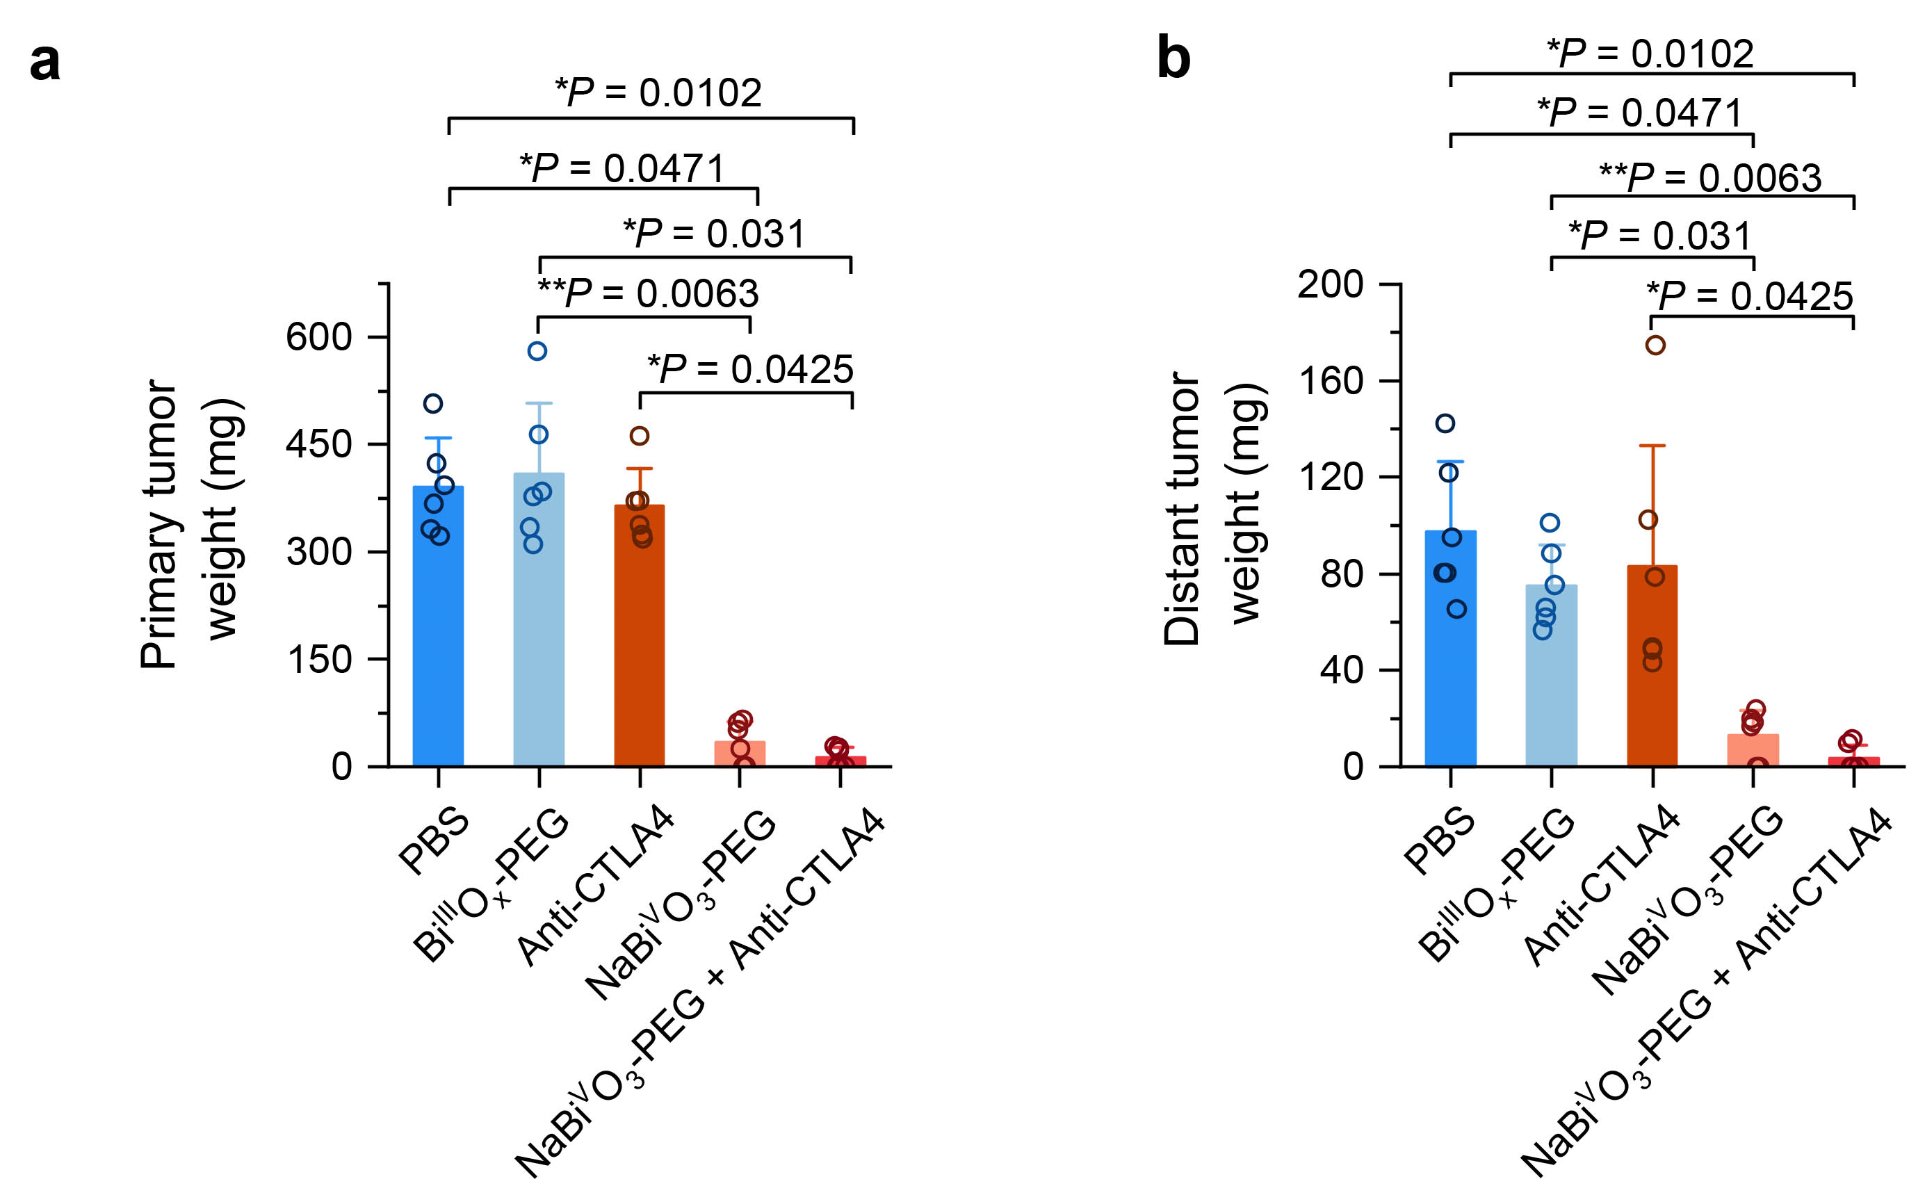
Supplementary Fig. 25 | Average weights of primary tumor (a) and distant tumor (b) collected from mice at day 14 after various treatments indicated. Data were shown as mean ± s.d. The P values were calculated by Kruskal-Wallis and Dunn multiple-comparison test. *P < 0.05, **P < 0.01, ***P < 0.001, ****P < 0.0001, and n.s., not significant.

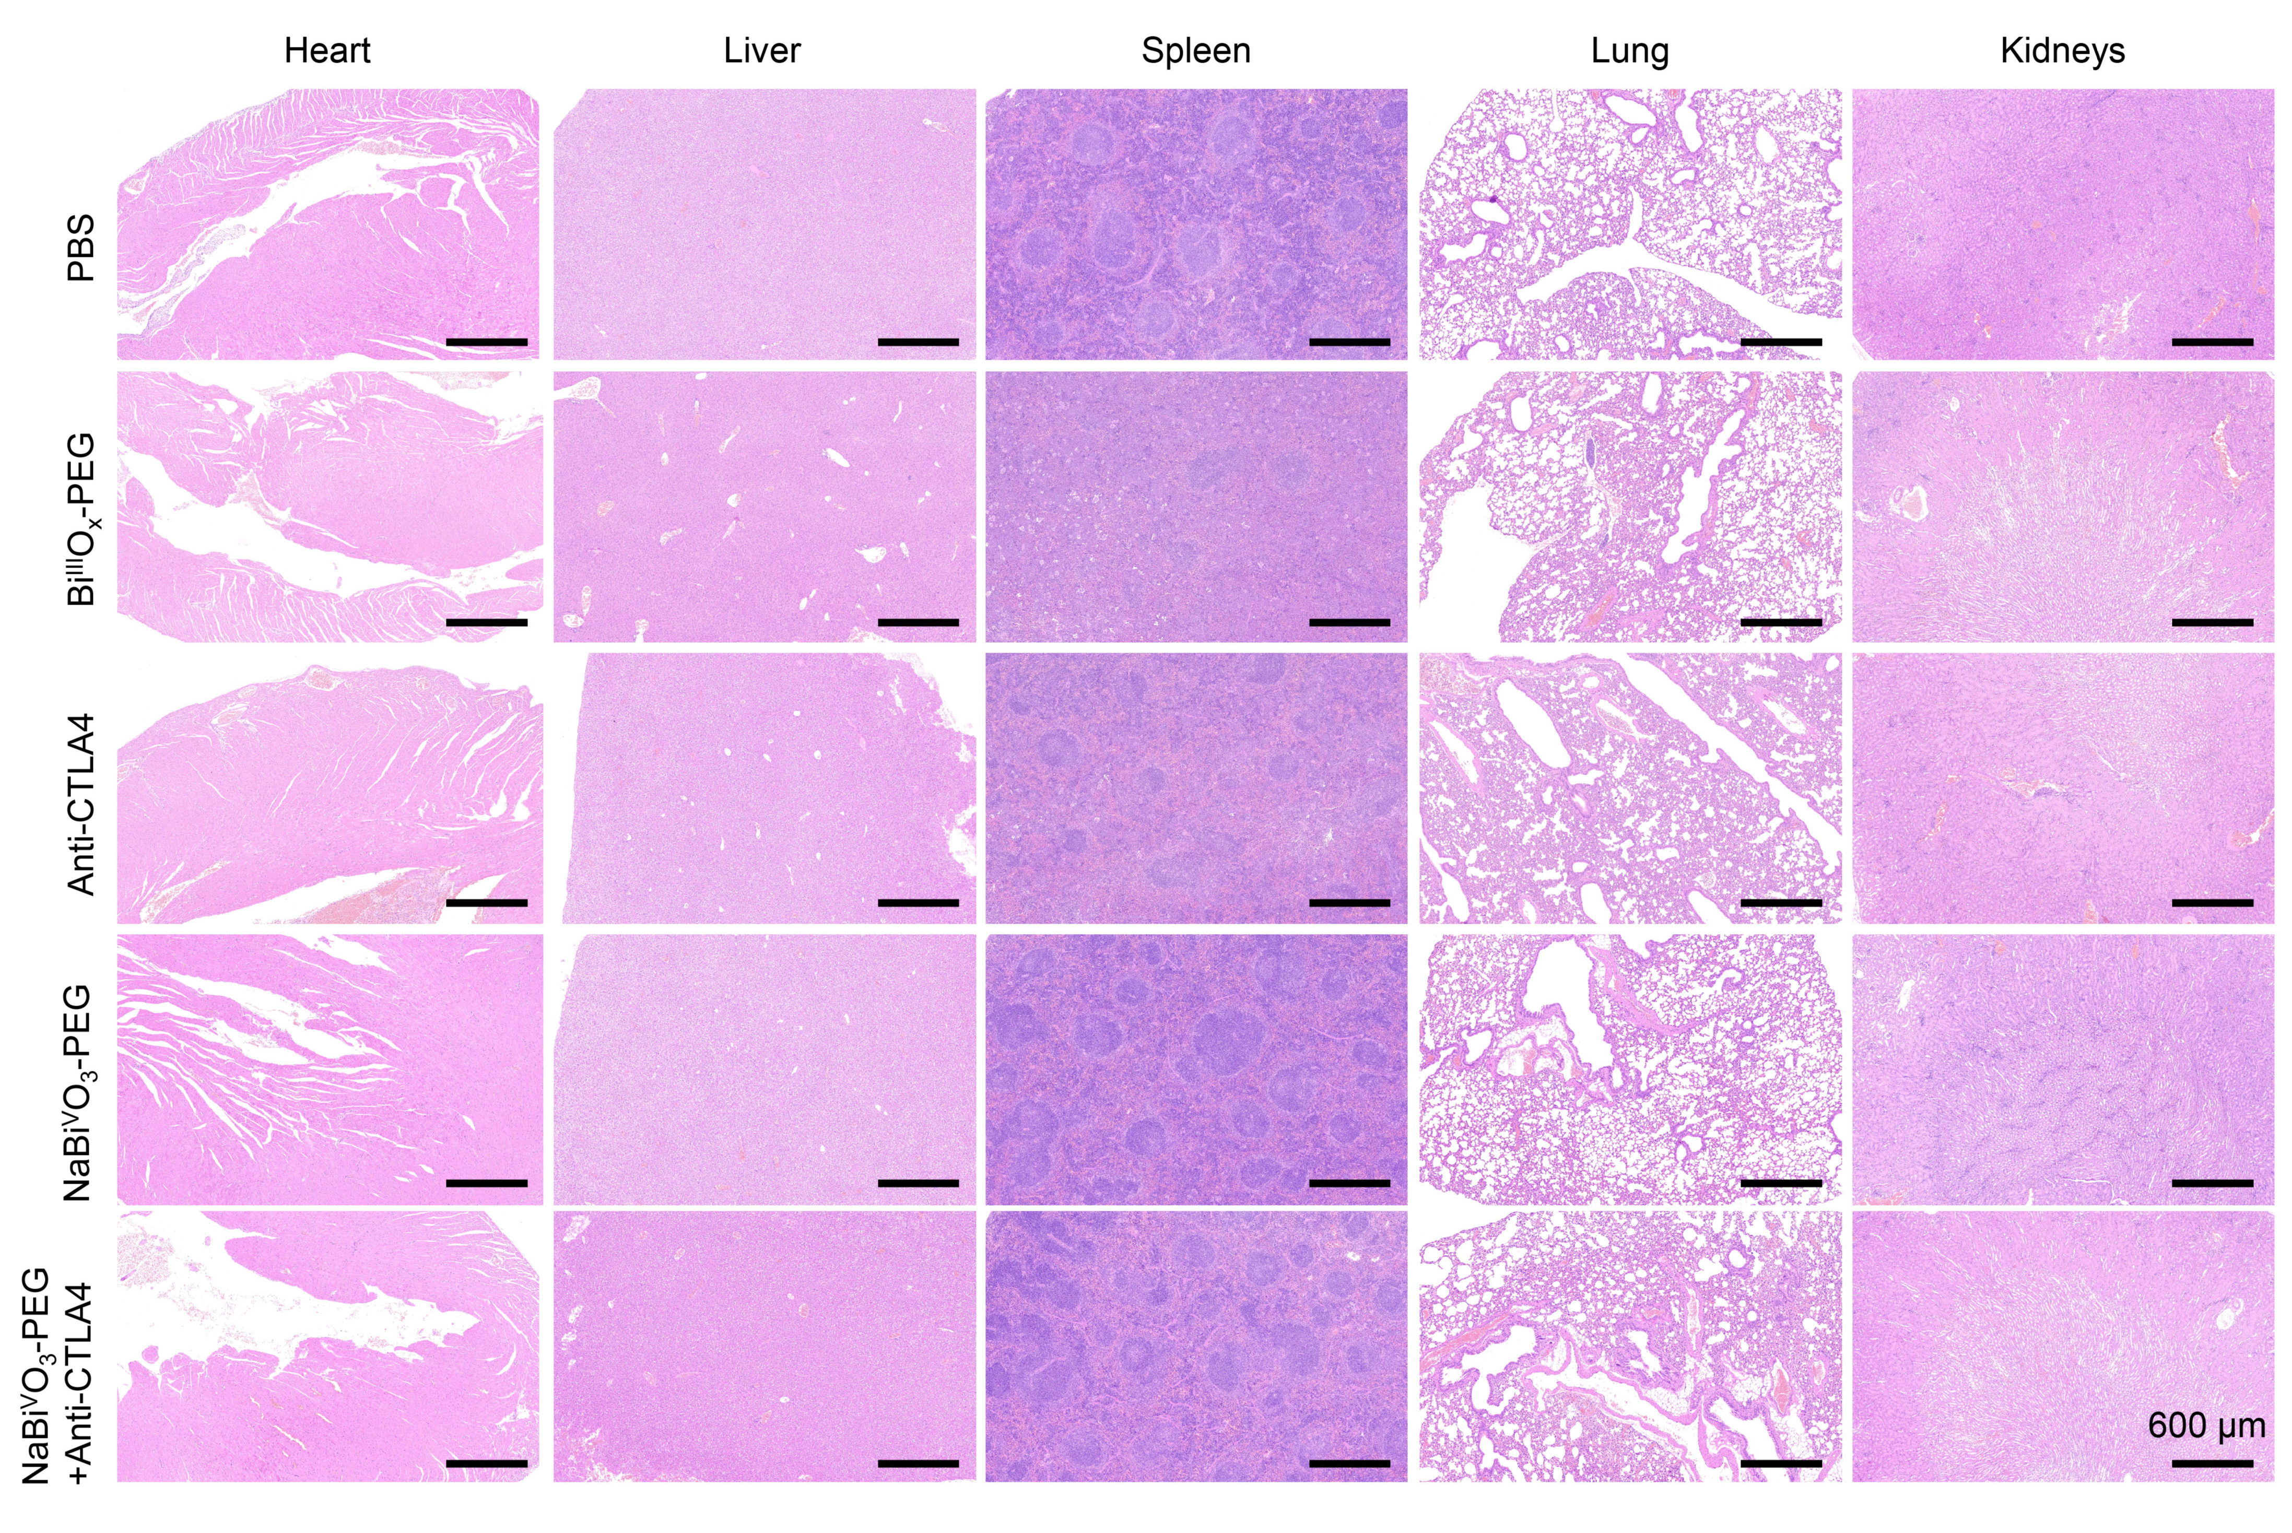
Supplementary Fig. 26 | Representative H&E-stained images of the heart, liver, lung, kidney, and spleen at day 14 under different treatments.
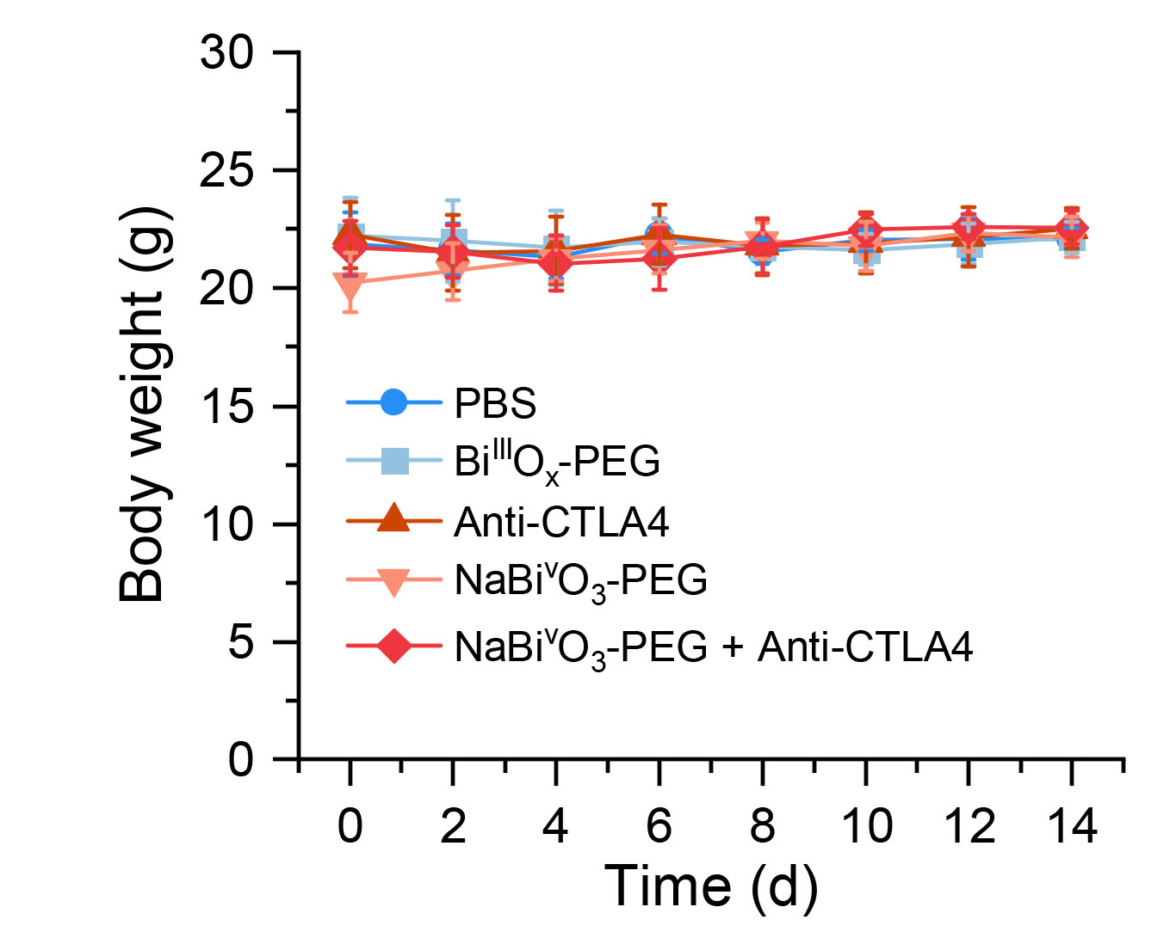
Supplementary Fig. 27 | The body weight of mice after different treatments. Data were shown as mean ± s.d.

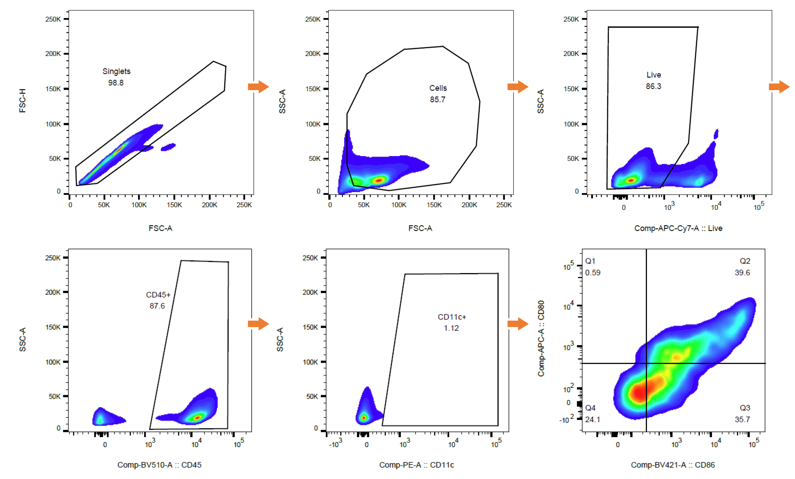
Supplementary Fig. 28 | Schematic diagram of cell sorting process for analysis of DCs (CD11c⁺ CD80⁺ CD86⁺) in mouse lymph node.
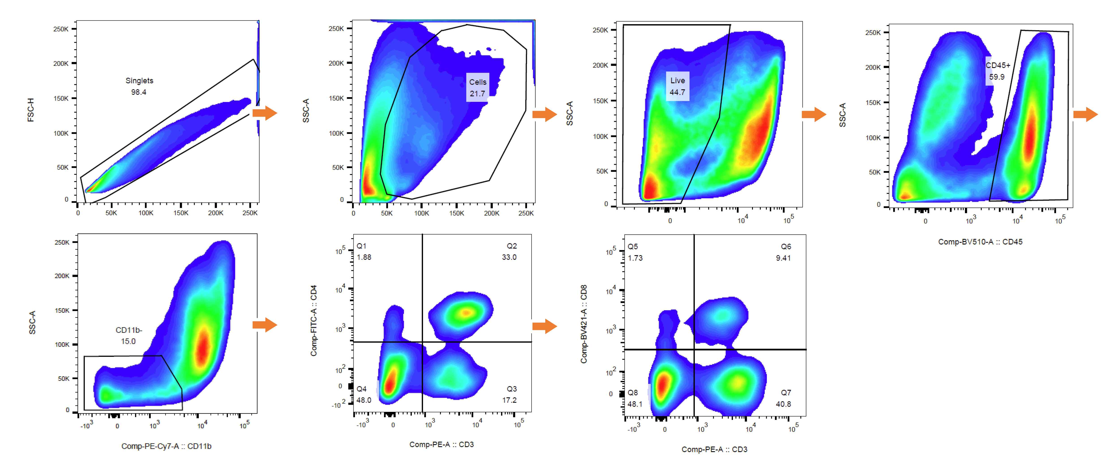
Supplementary Fig. 29 | Schematic diagram of cell sorting process for analysis of DCs (CD3⁺ CD4⁺ CD8⁺) in mouse distant tumor.

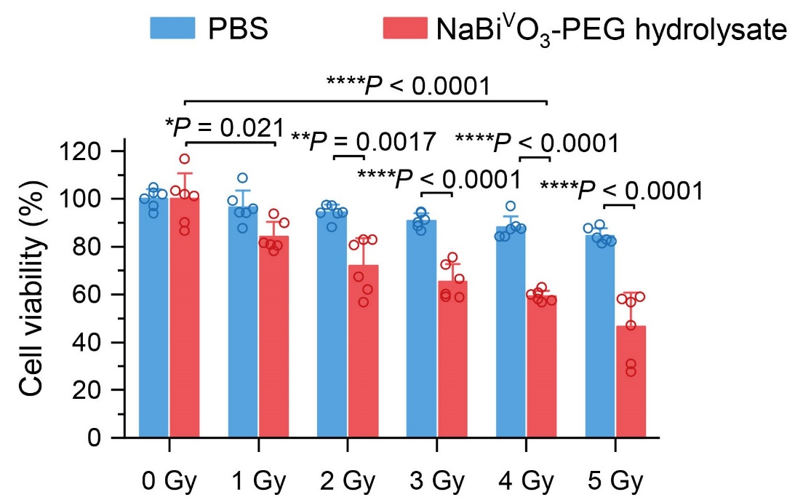
Supplementary Fig. 30 | Survival fractions of 4T1 cells incubated with PBS, and degraded NaBi^{V}O₃-PEG under various X-ray doses (100 μg mL⁻¹). Data were shown as mean ± s.d. The P values were calculated by one-way ANOVA and Tukey multiple-comparison test. *P < 0.05, **P < 0.01, ***P < 0.001, ****P < 0.0001, and n.s., not significant.

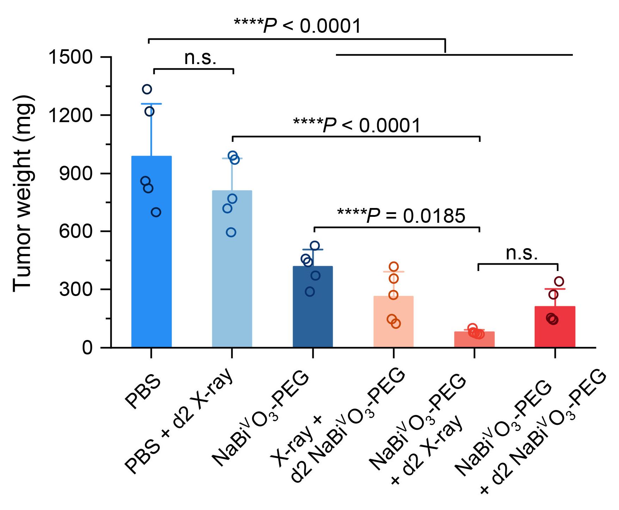
Supplementary Fig. 31 | Average weights of tumor collected from mice at day 14 after various treatments indicated. Data were shown as mean ± s.d. The P values were calculated by one-way ANOVA and Tukey multiple-comparison test. *P < 0.05, **P < 0.01, ***P < 0.001, ****P < 0.0001, and n.s., not significant.

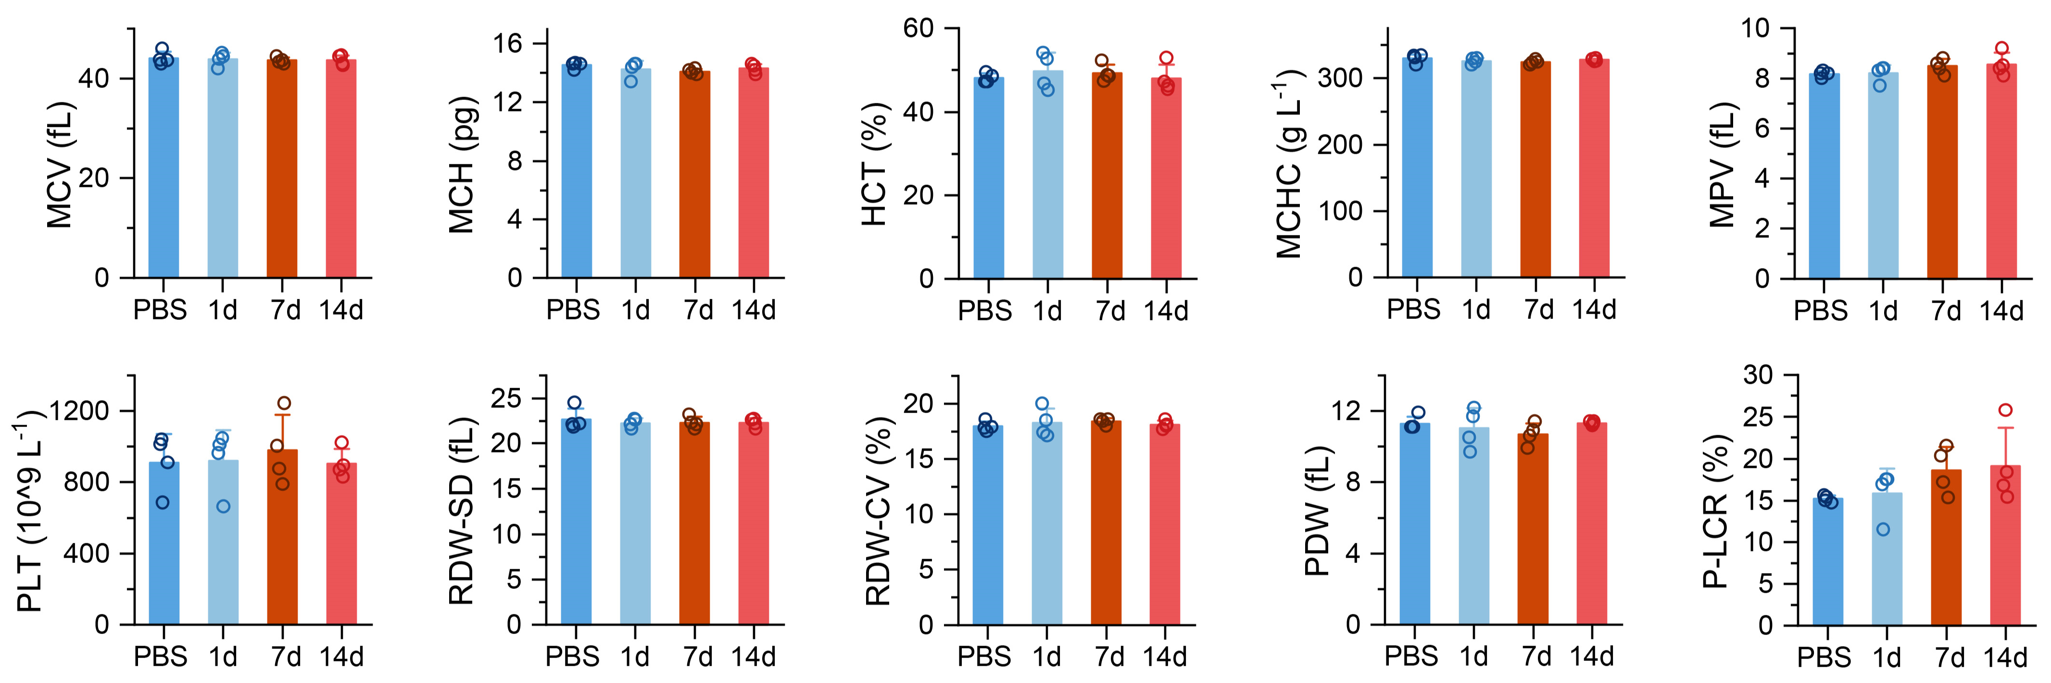
Supplementary Fig. 32 | Blood routine test of mice evaluated at day 1, 7,and 14 day after intravenous Injection with NaBi^{V}O₃-PEG. Data were shown as mean ± s.d.

