Supporting Information
Simultaneous detection of CaMV35S and NOS using fluorescence sensors with dual emission silver nanoclusters and catalytic hairpin amplification strategy
Yongkang Ye ^{,2}, Yinghui Zhai ³, Chenlu Zhang ², Xu Li ², Shaopeng Wang ², Yuexi Lu ², Xiaodong Cao ² Shudong He ², Haisong Zheng ³, Yunfei Li ³, Yunlai Tao ⁴

Experimental
Materials and reagents
Ascorbic acid (AA), silver nitrate (AgNO₃), sodium borohydride (NaBH₄) and 4-(2-hydroxyethyl) piperazine-1-ethanesulfonic acid (HEPES) were obtained from National Medicine Group Shanghai Chemical Reagent Co., Ltd. (Shanghai, China). N-hydroxysuccinimide (NHS), 1-(3-dimethylaminopropyl)-3-ethylcarbondiimide (EDC) and tri (hydroxymethyl) aminomethane (Tris) were purchased from Aladdin Industrial Co., Ltd. (Shanghai, China). Nanomagnetic ferric tetroxide (Fe₃O₄) was provided by Shanghai Chaowei Nano Tech. Co., Ltd. (Shanghai, China). Dialysis bag with the MWCO of 1000 was purchased from Shanghai Yuanye Bio-Technology Co., Ltd. (Shanghai, China). Trans 2 K Plus Marker were purchased from TransGen Biotech Co., Ltd. (Beijing, China). Shanghai Sangon Biotechnology Co., Ltd. (Shanghai, China) provided 10 × TAE, 2 × Taq PCR Mix and ddH₂O. All other chemicals were of analytical grade and used without further treatment. Ultrapure water was used in all experiments.
All DNA sequences that synthesized and purified by Shanghai Sangon Biotechnology Co., Ltd. (Shanghai, China) are listed in Table S1.
Instruments
X-ray photoelectron spectra (XPS) was obtained on an ESCALAB250 X-ray photoelectron spectrometer (Thermo Fisher Scientific, USA) using Al Kα (1486.6 eV) radiation at a power of 225 W. The morphological feature and particle size of H1-AgNCs and H2-AgNCs were characterized by a JEOL JEM-2100 field emission transmission electron microscopy (FETEM, Japan) at an accelerating voltage of 200 kV. PCR reactions were carried out on a TC-96/T/H PCR amplifier (Hangzhou Bayer Technology Co., Ltd., China). Gel electrophoresis and imaging were performed on a Qiaxcel full-automatic capillary electrophoresis instrument with a ZF-288 Automatic gel imaging analyzer (Shanghai Jiapeng Technology Co., Ltd., China). Fluorescence measurements were performed on a F97pro fluorometer (Shanghai Lengguang Technology Co., Ltd., China).
Table S1 DNA sequences employed in the experiment.
Name | DNA sequence from 5’ to 3’
H1 | CCC ACC CAC CCT CCC AAT ATC TCT CAT AAA TAA CGT CAT GCG GGT GGG GTG GCA TGA CGT T
H2 | CCC TTA ATC CCC ATA GAC GTA AGG GAT GAC GCA CAA TGG GTG GGG TGA TTG TGC GTC
T1 (NOS) | GCA TGA CGT TAT TTA TGA GAG A
T2 (CaMV35S) | ATT GTG CGT CAT CCC TTA CGT C
HP1 | GTC ATG CCA CCC CAC CCG CAT GAC GTT ATT TAT GAG AGA TAT GGG TGG GGT GGG GTG GGG
HP2 | GCA CAA TCA CCC CAC CCA TTG TGC GTC ATC CCT TAC GTC TAT GGG TGG GGT GGG GTG GGG
Mis1-1 | GCA TGA CGT TGT TTA TGA GAG A
Mis2-1 | GCA TGA CTT TGT TTA TGA GAG A
Mis3-1 | GCA TGA CTT TGT TTA TAA GAG A
Mis1-2 | ATT GTG CGT GAT CCC TTA CGT C
Mis2-2 | ATT CTG CGT GAT CCC TTA CGT C
Mis3-2 | ATT CTG CGT GAT CCC TTA GGT C
NC | TGC AAT TAA AGC AAG GAT ACA G
Primer F-1 | TTA AGA TTG AAT CCT GTT GCC GGT
Primer R-1 | GCG CGC GAT AAT TTA TCC TAG TTT G
Primer F-2 | CTT CCT TTC TCG CCA CGT T
Primer R-2 | CTT AAT AAC ACA TTG CGG ACG TT

Detected concentration of target in GM soybean PCR product (nmol L⁻¹) | Added  (nmol L⁻¹) | Detected  (nmol L⁻¹) | Recovery  (%) | RSD  (%)
NOS: 28.25 | 10 | 36.77±1.97 | 96.13 | 5.15
NOS: 28.25 | 50 | 72.29±6.79 | 92.38 | 8.68
NOS: 28.25 | 200 | 242.22±30.07 | 106.12 | 13.17
CaMV35S: 15.96 | 10 | 24.63±2.50 | 94.88 | 9.63
CaMV35S: 15.96 | 50 | 58.19±7.72 | 88.22 | 11.70
CaMV35S: 15.96 | 100 | 112.48±6.35 | 97.00 | 5.48
Table S2 Recovery results of NOS and CaMV35S in GM soybean PCR product.
Note: RSD refers to relative standard deviation.

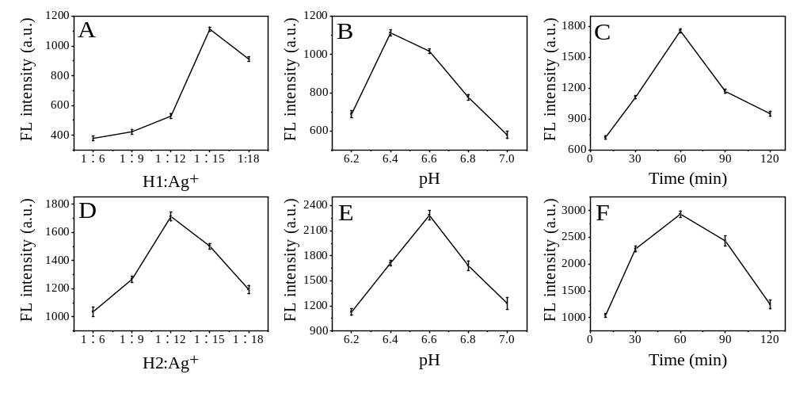Fig. S1. Parameter optimization for the preparation of H1-AgNCs and H2-AgNCs. (A) to (C) are the molar ratio of H1 to Ag⁺, pH and reaction time optimization for preparation of H1-AgNCs. (D) to (E) are the molar ratio of H2 to Ag⁺, pH and reaction time optimization for preparation of H2-AgNCs.

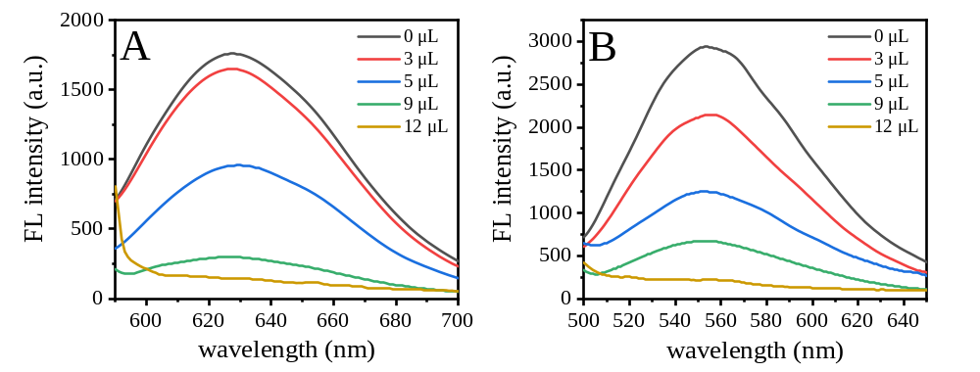Fig. S2. The optimization of added volume of Fe₃O₄@GO. The evaluation was performed in PBS (pH 6.4, 0.1 mol L⁻¹). The total volume was 100 μL that contained 10 μL H1-AgNCs and 10 μL H2-AgNCs. The concentration of Fe₃O₄@GO was 2 mg mL⁻¹.

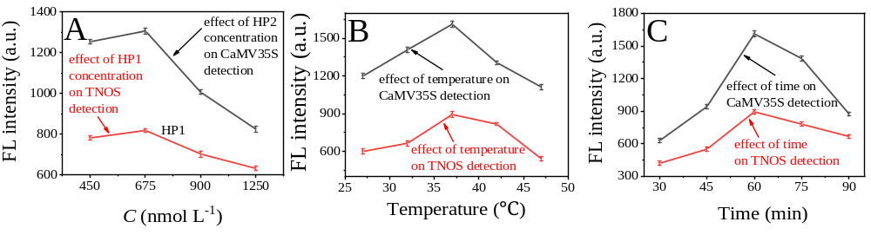Fig. S3. Parameter optimization for the detection of NOS and CaMV35S. (A) Effect of HP1/HP2 concentration on the detection of NOS/CaMV35S. (B) Effect of hybridization temperature on the detection of NOS/CaMV35S. (C) Effect of hybridization time on the detection of NOS/CaMV35S.

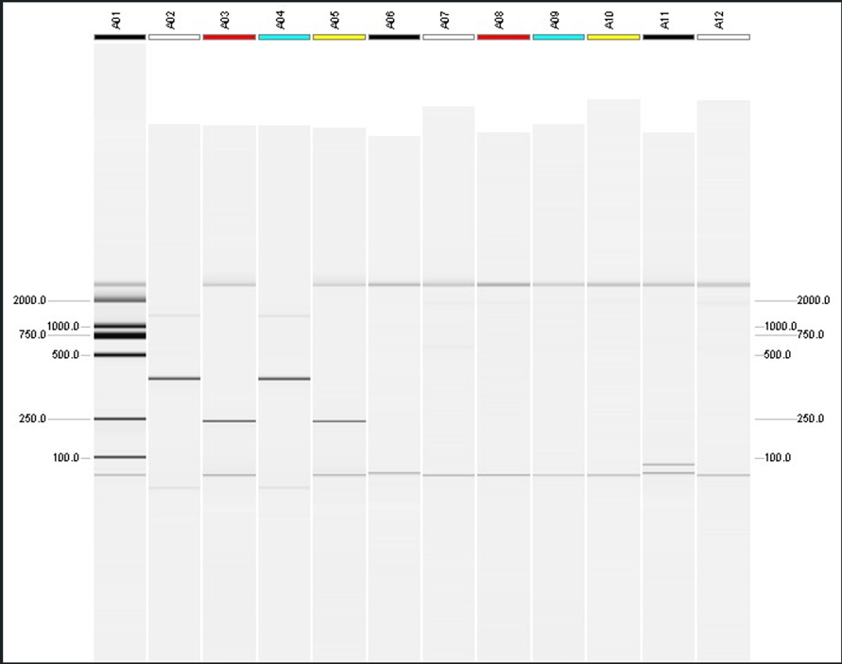
Fig. S4. Qiaxcel capillary electrophoresis image of various PCR products. A01: Marker; A02 and A04: P35S; A03 and A05: TNOS; A06: w/o primer for P35S; A07: w/o primer for TNOS; A08 and A10: negative control for P35S; A09~A12: negative control for TNOS.

Yongkang Ye and Yinghui Zhai contributed equally. Xiaodong Cao xiaodongcao@hfut.edu.cn Yunfei Li 63362685@qq.com Yunlai Tao tyl3333@sohu.com School of Biological Science and Engineering, North Minzu University, Yinchuan 750021, China ² School of Food and Biological Engineering, Hefei University of Technology, Hefei 230009, China ³ Technology Center of Hefei Customs District, Hefei 230022, China ⁴ Anhui Institute of Food and Drug Inspection, Hefei 230051, China

