Table 1. Structures of oxadiazole-2-oxide derivatives and their inhibitory activities against the TrxR activity of SWAP containing wtSjTGR and rSjTGR-Sec.
compounds |  | R’ | IC₅₀ of SWAP containing wtSjTGR (µM) | IC₅₀ of rSjTGR-Sec (µM)
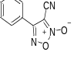 | Furoxan | / | 4.00±0.42 | 5.87±1.37
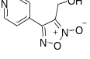 | 6a | / | 0.07±0.01 | 0.036±0.002
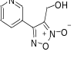 | 6b | / | 0.14±0.03 | 0.39±0.02
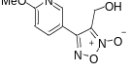 | 6c | / | 1.12±0.27 | 2.38±0.42
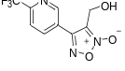 | 6d | / | 0.00747±0.00095 | 0.05580±0.00318
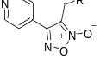 | 7aa | 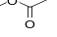 | >50 | >50
 | 7ab | 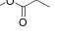 | >50 | >50
 | 7ac | 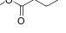 | >50 | >50
 | 7ad | 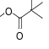 | >50 | >50
 | 7ae | 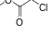 | 4.23±0.54 | >50
 | 7af | 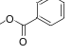 | 8.87±0.46 | 3.23±0.05
 | 7ag | 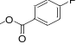 | >50 | >50
 | 7ah | 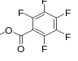 | >50 | >50
 | 7ai | 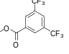 | >50 | >50
 | 9aa | 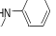 | 21.57±1.44 | >50
 | 9ab | 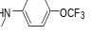 | 0.62±0.03 | 1.52±0.20
 | 9ac | 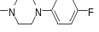 | >50 | >50
 | 9ad | 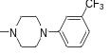 | >50 | >50
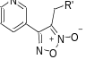 | 7ba |  | >50 | >50
 | 7bb |  | >50 | >50
 | 7bc |  | >50 | >50
 | 7bd |  | >50 | >50
 | 7be |  | 16.40±0.67 | 14.82±3.67
 | 7bf |  | >50 | >50
 | 7bg |  | >50 | >50
 | 7bh |  | >50 | >50
 | 7bi |  | >50 | >50
 | 7bj | 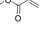 | 5.80±1.55 | >50
 | 7bk | 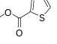 | >50 | >50
 | 9ba |  | >50 | >50
 | 9bb |  | >50 | >50
 | 9bc |  | >50 | >50
 | 9bd |  | 0.042±0.01 | NA
 | 9be | 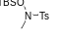 | 0.63±0.11 | 0.22±0.01
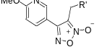 | 7ca |  | 34.77±1.33 | >50
 | 7cf |  | 12.51±0.68 | >50
 | 9ca |  | >50 | >50
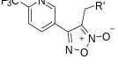 | 7da |  | >50 | >50
 | 7df |  | >50 | >50
 | 9da |  | 11.62±1.93 | 3.73±1.67
IC50 values >50 μM signify lack of fitted curve through the dose-response data—that is, flat response within the range tested. NA, not applicable.

