Synthesis of oxadiazole-2-oxide derivatives as potential drug candidates for schistosomiasis targeted on SjTGR
Gongming Li^{§,1,3}, Qianqian Guo^{§,2,3}, Chao Feng ^{1,3}, Huan Chen¹, Wenjiao Zhao^{1,3}, Shu Li³, Yang Hong*^{,2} and Dequn Sun*^{,1}
1. School of Life Science and Engineering, Southwest University of Science and Technology, Mianyang 621010, China.
2. National Reference Laboratory of Animal Schistosomiasis, Key Laboratory of Animal Parasitology of Ministry of Agriculture, Shanghai Veterinary Research Institute, Chinese Academy of Agricultural Sciences, Shanghai 200241, China.
3. Marine College, Shandong university (weihai), Weihai 264209, China.
* Correspondence: dqsun@swust.edu.cn (Dequn Sun)
* Correspondence: hongyang@shvri.ac.cn (Yang Hong)
§ These authors contributed equally to this work.
Keywords: Anti-schistosomiasis; Schistosoma japonicum; SjTGR; Oxadiazole-2-oxides; Furoxan
1. Synthesis of Oxadiazole-2-oxide derivatives
1.1. Synthesis of furoxan 2
Compound 2 was prepared as previously report[1].
1.2. General procedure for the synthesis of ethyl (E)-3-(pyridin-3-yl)acrylates 4a-d.
To a stirred solution of triethyl phosphonoacetate (28 mmol) in THF (100 ml) was added NaH (28 mmol) at 0℃. The mixture was stirred at the same temperature for 1.5 h. and then it was stirred at room temperature for 1 h. Nicotinaldehyde (18.67 mmol) was added slowly to reaction mixture and the mixture was stirred at room temperature overnight. The reaction was quenched with 30ml brine and the THF was removed under vacuum. The water phase was extracted with ethyl acetate and dried with anhydrous Na₂SO_{4.} Then the mixture was filtered and ethyl acetate was removed under vacuum. The concentrate was purified by chromatography on a silica gel column to give 4a-d.
1.2.1. Characterization data of ethyl (E)-3-(pyridin-4-yl)acrylate 4a[2].
Yield 81%; white solid; ¹H-NMR (400 MHz, Chloroform-d) δ 8.66 (dd, J = 4.6, 1.5 Hz, 2H, pyridine-H), 7.60 (d, J = 16.1 Hz, 1H, CH), 7.37 (dd, J = 4.6, 1.4 Hz, 2H, pyridine-H), 6.60 (d, J = 16.1 Hz, 1H, CH), 4.29 (q, J = 7.1 Hz, 2H, CH2), 1.35 (d, J =14.3 Hz, 3H, CH3).
1.2.2. Characterization data of ethyl (E)-3-(pyridin-3-yl)acrylate 4b[3].
Yield 94%; yellowish oil; ¹H NMR (400 MHz, Chloroform-d) δ 8.75 (s, 1H, pyridine-H), 8.63~8.58 (m, 1H, pyridine-H), 7.8~7.81 (m, 1H, pyridine-H), 7.67 (d, J= 16.1 Hz, 1H, CH), 7.33 (dd, J = 7.7, 4.8 Hz, 1H, pyridine-H), 6.52 (d, J = 16.1 Hz, 1H, CH), 4.28 (q, J = 7.1 Hz, 2H, CH2), 1.35 (t, J = 7.1 Hz, 3H, CH3).
1.2.3. Characterization data of ethyl (E)-3-(6-methoxypyridin-3-yl)acrylate 4c[4].
Yield 99%; white solid; ¹H-NMR (400 MHz, Chloroform-d) δ 8.27 (d, J = 2.5 Hz, 1H, pyridine-H), 7.77 (dd, J = 8.7, 2.5 Hz, 1H, pyridine-H), 7.63 (d, J = 16.0 Hz, 1H, pyridine-H), 6.77 (d, J = 8.7 Hz, 1H, CH), 6.33 (d, J = 16.0 Hz, 1H, CH), 4.26 (q, J = 7.1 Hz, 2H, CH2), 3.97 (s, 3H, CH3), 1.34 (t, J = 7.1 Hz, 3H, CH3).
1.2.4. Characterization data of ethyl (E)-3-(6-(trifluoromethyl)pyridin-3-yl)acrylate 4d[5].
Yield 82%; white solid; ¹H NMR (400 MHz, Chloroform-d) δ 8.85 (s, 1H, pyridine-H), 7.99 (d, J = 8.1 Hz, 1H, pyridine-H), 7.72 (d, J = 2.5 Hz, 1H, pyridine-H), 7.69 (d, J = 10.6 Hz, 1H, CH), 6.59 (d, J = 16.1 Hz, 1H, CH), 4.30 (q, J = 7.1 Hz, 2H, CH2), 1.36 (t, J = 7.1 Hz, 3H, CH3).
1.3. General procedure for the synthesis of (E)-3-(pyridin-3-yl)prop-2-en-1-ols 5a-d.
To a solution of 4a-d (14 mmol) in CH₂Cl₂ (30 ml) was added dropwise DIBAL-H (1.5M in toluene, 42 mmol) at -78℃ over 50 min. The reaction mixture was stirred at same temperature for 4 h. The reaction was quenched with MeOH and the mixture was stirred for 0.5 additional hour. Then the flask was move to air atmosphere and excess sodium potassium tartrate aqueous solution was added. The mixture was stirred at room temperature for 4 h. The organic layer was separated and the aqueous layer was extracted with ethyl acetate. The combined organic layer was washed with brine and water, dried with anhydrous Na₂SO₄, filtered with celite and concentrated under vacuum. The crude product was purified by chromatography on a silica gel column to give 5a-d.
1.3.1. Characterization data of (E)-3-(pyridin-4-yl)prop-2-en-1-ol 5a[2].
Yield 73%; white solid; ¹H-NMR (400 MHz, Chloroform-d) δ 8.49 (dd, J = 4.6, 1.4Hz, 2H, pyridine-H), 7.24 (dd, J = 4.7, 1.4 Hz, 2H, pyridine-H), 6.59~6.55 (m, 2H, CH=CH), 4.39 (d, J = 2.0 Hz, 2H, CH2).
1.3.2. Characterization data of (E)-3-(pyridin-3-yl)prop-2-en-1-ol 5b[3].
Yield 84%; yellowish oil; ¹H NMR (400 MHz, Chloroform-d) δ 8.51 (s, 1H, pyridine-H), 8.42~8.35 (m, 1H, pyridine-H), 7.70~7.64 (m, 1H, pyridine-H), 7.22 (dd, J = 7.8, 4.9 Hz, 1H, pyridine-H), 6.60 (d, J = 16.1 Hz, 1H, CH), 6.43 (dt, J = 16.0, 5.0Hz, 1H, CH), 5.24 (s, 1H, OH), 4.35 (d, J = 4.9 Hz, 2H, CH2).
1.3.3. Characterization data of (E)-3-(6-methoxypyridin-3-yl)prop-2-en-1-ol 5c[6].
Yield 84%; white soli; ¹H-NMR (400 MHz, Chloroform-d) δ 8.08 (d, J = 2.5 Hz, 1H, pyridine-H), 7.63 (dd, J = 8.6, 2.5 Hz, 1H, pyridine-H), 6.70 (d, J = 8.6 Hz, 1H, pyridine-H), 6.52 (d, J = 16.0 Hz, 1H, CH), 6.24 (dt, J = 15.9, 5.6 Hz, 1H, CH), 4.30 (t, J = 4.6 Hz, 2H, CH2), 3.93 (s, 3H, CH3), 2.51 (s, 1H, OH).
1.3.4. Characterization data of (E)-3-(6-(trifluoromethyl)pyridin-3-yl)prop-2-en-1-ol 5d[5].
Yield 78%;white solid; ¹H-NMR (400 MHz, Chloroform-d) δ 8.67 (s, 1H, pyridine-H), 7.84 (d, J = 7.8 Hz, 1H, pyridine-H), 7.62 (d, J = 8.2 Hz, 1H, pyridine-H), 6.69 (d, J = 16.1 Hz, 1H, CH), 6.55 (dt, J = 16.0, 4.8 Hz, 1H, CH), 4.40 (d, J = 4.2 Hz, 2H, CH2), 2.77 (s, 1H, OH).
1.4. General procedure for synthesis of 3-(hydroxymethyl)-4-pyridin-1,2,5-oxadiazole 2-oxides 6a-d.
To a solution of (E)-3-pyridinprop-2-en-1-ol (5a-d, 1.85 mmol) in AcOH (5 ml) was added sodium nitrite(4.63 mmol) portion wise over 45 min. The reaction was stirred at 60℃ for 10.5 h. The solvent was removed under vacuum and the residue was dissolved in ethyl acetate. The organic layer was washed with brine and water, dried with anhydrous Na₂SO₄, filtered and concentrated under vacuum to afford crude product which was purified by chromatography on a silica gel column to give 6a-d.
1.4.1. Characterization data of 3-(hydroxymethyl)-4-(pyridin-4-yl)-1,2,5-oxadiazole 2-oxide 6a
Yield 30%; White solid; m.p: 142-146℃; ¹H-NMR (400 MHz, Chloroform-d) δ 8.84 (d, J = 5.9 Hz, 2H, pyridine-H), 7.81 (d, J = 6.0 Hz, 2H, pyridine-H), 4.78 (s, 2H, CH2), 3.04 (s, 1H, OH); ¹³C NMR(100MHz, Chloroform-d) δ 53.464, 114.133, 121.840, 134.204, 151.129, 155.045; HRMS: (m/z)[M+H]⁺ calcd for C₈H₇N₃O₃: 194.0560. Found: 194.0766.
1.4.2. Characterization data of 3-(hydroxymethyl)-4-(pyridin-3-yl)-1,2,5-oxadiazole 2-oxide 6b.
Yield 31%; white solid; m.p: 113-119℃; ¹H-NMR (400 MHz, Methanol-d4) δ 9.08 (s, 1H, pyridine-H), 8.78~8.70 (m, 1H, pyridine-H), 8.42~8.32 (m, 1H, pyridine-H), 7.64 (dd, J = 7.7, 5.1 Hz, 1H, pyridine-H), 4.66 (s, 2H, CH2); ¹³C-NMR (101 MHz, Methanol-d4) δ 154.70, 151.02, 147.67, 135.92, 124.20, 123.75, 114.25, 52.17; HRMS: (m/z)[M+H]⁺ calcd for C₈H₇N₃O₃: 194.0560. Found: 194.0753.
1.4.3. Characterization data of 3-(hydroxymethyl)-4-(6-methoxypyridin-3-yl)-1,2,5-oxadi- azole 2-oxide 6c.
Yield 47%;white solid; m.p: 130-142℃; ¹H-NMR (400 MHz, Methanol-d4) δ 8.69 (d, J = 2.3 Hz, 1H, pyridine-H), 8.17 (dd, J = 8.7, 2.4 Hz, 1H, pyridine-H), 6.96 (d, J = 8.7 Hz, 1H, pyridine-H), 4.63 (s, 2H, CH2), 3.99 (s, 3H, CH3); ¹³C-NMR (101MHz, Methanol-d4) δ 165.79, 154.84, 146.38, 137.74, 116.56, 114.26, 111.03, 53.04, 52.15; HRMS: (m/z)[M+H]⁺ calcd for C₉H₉N₃O₄: 224.0671. Found: 224.0663.
1.4.4. Characterization data of 3-(hydroxymethyl)-4-(6-(trifluoromethyl)pyridine-3-yl)-1,2,5-oxadiazole 2-oxide 6d.
Yield 39%; white solid; m.p: 90-96℃; ¹H-NMR (400 MHz, Chloroform-d) δ 9.25 (s, 1H, pyridine-H), 8.45 (d, J = 7.9 Hz, 1H, pyridine-H), 7.89 (d, J = 8.1 Hz, 1H, pyridine-H), 4.79 (d, J = 3.2 Hz, 2H, CH2), 3.0~2.89 (m, 1H, OH); ¹³C-NMR (101 MHz, Chloroform-d) δ 150.15 (q, J = 35.5 Hz), 148.69, 137.01, 125.64, 120.99 (q, J = 275.6Hz ), 120.97 (m), 113.97, 53.16; HRMS: (m/z)[M+H]⁺ calcd for C₉H₆F₃N₃O₃: 262.0440. Found: 262.0429
1.5. General procedure for synthesis of 7.
To a solution of 6a-d (0.16 mmol) and DMAP (0.032 mmol) in anhydrous CH₂Cl₂ (5 ml) was added triethylamine (dissolved in 1 ml CH₂Cl₂, 0.24 mmol) at 0℃. The reaction mixture was stirred for 0.5 h at same temperature. Then acyl chloride (dissolved in 1 ml CH₂Cl₂, 0.24 mmol) was added and the reaction mixture was stirred at room temperature. When the reaction was completed, the reaction mixture was washed with brine, water and dried with anhydrous Na₂SO₄. The organic phase was filtered and concentrated, the concentrate was purified by chromatography on a silica gel column to give 7.
1.5.1. Characterization data of 3-(acetoxymethyl)-4-(pyridin-4-yl)-1,2,5-oxadiazole 2-oxide 7aa.
Yield 67%; yellowish solid; m.p : 62-64℃; ¹H-NMR (400 MHz, Chloroform-d) δ 2.12 (s, 3H, CH3), 5.24 (s, 2H, CH2), 7.72 (m, 2H, pyridine–H), 9.00 (m, 2H,pyridine–H); ¹³C-NMR (101 MHz, Chloroform-d) δ 20.532, 54.047, 110.877, 121.704, 133.848, 151.133, 154.799, 169.979; HRMS:(m/z)[M+H]⁺ calcd for C₁₀H₉N₃O₃: 236.0666. Found: 236.0765.
1.5.2. Characterization data of 3-((propionyloxy)methyl)-4-(pyridin-4-yl)-1,2,5 -oxadiazole 2-oxide 7ab.
Yield 86%; yellowish solid; m.p : 46-53℃; ¹H-NMR (400 MHz, Chloroform-d) δ 8.85 (d, J = 5.4 Hz, 2H, pyridine-H), 7.67 (d, J = 5.7 Hz, 2H, pyridine-H), 5.18 (s, 2H, CH2), 2.39 (q, J = 7.5 Hz, 2H, CH2), 1.14 (t, J = 7.5 Hz, 3H, CH3); ¹³C-NMR (101 MHz, Chloroform-d) δ 173.36, 154.55, 151.03, 133.64, 121.37, 110.80, 53.76, 27.07, 8.84; HRMS: (m/z)[M+H]⁺ calcd for C₁₁H₁₁N₃O₄: 250.0822. Found: 250.0823.
1.5.3. Characterization data of 3-((butyryloxy)methyl)-4-(pyridin-4-yl)-1,2,5-oxadiazole 2-oxide 7ac.
Yield 91%; yellowish oil; ¹H-NMR (400 MHz, Chloroform-d) δ 8.85 (s, 2H, pyridine-H), 7.68 (d, J = 4.7 Hz, 2H, pyridine-H), 5.18 (s, 2H, CH2), 2.34 (t, J = 7.4 Hz, 2H, CH2), 1.65 (h, J = 7.2 Hz, 2H, CH2), 0.94 (t, J = 7.4 Hz, 3H, CH3); ¹³C-NMR (101 MHz, Chloroform-d) δ 172.57, 154.53, 151.00, 133.67, 121.40, 110.81, 53.67, 35.52, 18.20, 13.55; HRMS: (m/z)[M+H]⁺ calcd for C₁₂H₁₃N₃O₄: 264.0979. Found: 264.0975.
1.5.4. Characterization data of 3-((pivaloyloxy)methyl)-4-(pyridin-4-yl)-1,2,5-oxadiazole 2-oxide 7ad.
Yield 89%; yellowish oil; ¹H-NMR (400 MHz, Chloroform-d) δ 8.83 (d, J = 4.4 Hz, 2H, pyridine-H), 7.68 (d, J = 5.3 Hz, 2H, pyridine-H), 5.17 (s, 2H, CH2), 1.16 (s, 9H, CH3); ¹³C-NMR (101 MHz, Chloroform-d) δ 177.42, 154.40, 150.88, 133.80, 121.35, 110.75, 54.10, 38.98, 26.95; HRMS: (m/z)[M+H]⁺ calcd for C₁₃H₁₅N₃O₄: 278.1135. Found: 278.1307.
1.5.5. Characterization data of 3-((2-chloroacetoxy)methyl)-4-(pyridin-4-yl)-1,2,5- oxadiazole 2-oxide 7ae.
Yield 71%; yellowish solid; m.p : 84-88℃; ¹H-NMR (400 MHz, Chloroform-d) δ 4.11 (s, 2H, CH2-Cl), 5.28 (s, 2H, CH2-O), 7.66 (m, J = 4.8Hz, 2H, pyridine–H), 8.86 (m, J = 5.2Hz, 2H, pyridine–H); ¹³C-NMR (400 MHz, Chloroform-d) δ 40.101, 55.147, 110.116, 121.365, 133.354, 151.116, 154.533, 166.460; HRMS:(m/z)[M+H]⁺ calcd for C₁₀H₈ClN₃O₄: 270.0276. Found: 270.0484.
1.5.6. Characterization data of 3-((benzoyloxy)methyl)-4-(pyridin-4-yl)-1,2,5-oxadiazole 2-oxide 7af.
Yield 62%; white solid; m.p : 86-90℃; ¹H-NMR (400 MHz, Chloroform-d) δ 5.42 (s, 2H, CH2), 7.43 (m, J = 8Hz, 2H, 3,5-ph), 7.59 (t, J = 7.2Hz, 1H, 4-ph), 7.71 (dd, J = 1.6Hz, J = 4.8Hz, 2H, 3,5-py), 7.96 (dd, J = 1.2Hz, J = 8Hz, 2H, 2,6-ph), 8.82 (dd, J = 1.6Hz, J = 4.8Hz, 2H, 2,6-py); ¹³C-NMR(400MHz, Chloroform-d) δ 57.241, 110.788, 121.368, 128.203, 128.666, 129.801, 133.616, 133.966, 151.044, 151.829, 165.499; HRMS:(m/z)[M+H]⁺ calcd for C₁₅H₁₁N₃O₄: 298.0822. Found: 298.0958.
1.5.7 Characterization data of 3-(((4-fluorobenzoyl)oxy)methyl)-4-(pyridin-4-yl)-1,2,5- oxadiazole 2-oxide 7ag.
Yield 76%; white solid; m.p : 108-110℃; ¹H-NMR (400 MHz, Chloroform-d) δ 5.42 (s, 2H, CH2), 7.10 (m, J = 2.4Hz，J = 8.4Hz, 2H, 3,5-ph), 7.70 (m, J = 1.6 Hz, J = 1.6Hz, 2H, 3,5-py), 7.98 (m, 2H, 2,6-ph), 8.82 (m, J = 1.6Hz, J = 4.8Hz, 2H, 2,6-py); ¹³C-NMR (400 MHz, Chloroform-d) δ 110.788, 121.368, 128.203, 128.666, 129.801, 133.616, 133.966, 151.044, 151.829, 165.499; HRMS:(m/z)[M+H]⁺ calcd for C₁₅H₁₁N₃O₄: 316.0728. Found: 316.0756.
1.5.8. Characterization data of 3-(((perfluorobenzoyl)oxy)methyl)-4-(pyridin-4-yl)- 1,2,5-oxadiazole 2-oxide 7ah.
Yield 83%; yellow solid; m.p : 96-102℃; ¹H-NMR (400 MHz, Chloroform-d) δ 8.84 (s, 2H, pyridine-H), 7.67 (d, J = 4.4 Hz, 2H, pyridine-H), 5.45 (s, 2H, CH2); ¹³C-NMR (101 MHz, Chloroform-d) δ 158.13, 154.53, 151.08, 147.03 (m), 145.30 (m), 144.44 (m), 142.68 (m), 139.09 (m), 136.50 (m), 133.36, 121.31, 109.86, 106.20 (m), 55.51; HRMS: (m/z)[M+H]⁺ calcd for C₁₅H₆F₅N₃O₄: 388.0351. Found: 388.0483.
1.5.9. Characterization data of 3-(((3,5-bis(trifluoromethyl)benzoyl)oxy)methyl)-4- (pyridin-4-yl)-1,2,5-oxadiazole 2-oxide 7ai.
Yield 83%; white solid; m.p : 134-139℃; ¹H-NMR (400 MHz, Chloroform-d) δ 8.83 (d, J = 5.1 Hz, 2H, pyridine-H), 8.39 (s, 2H, benzene-H), 8.09 (s, 1H, benzene-H), 7.68 (d, J = 5.7 Hz, 2H, pyridine-H), 5.50 (s, 2H, CH2); ¹³C-NMR (101 MHz, Chloroform-d) δ 163.10, 154.45, 151.07, 133.50, 132.56 (q, J = 34.5 Hz), 130.48, 129.88 (d, J = 3.0 Hz), 127.27 (m), 122.57 (q, J = 274.2 Hz), 121.34, 110.31, 55.25; HRMS: (m/z)[M+H]⁺ calcd for C₁₇H₉F₆N₃O₄: 434.0570. Found: 434.0685.
1.5.10. Characterization data of 3-(acetoxymethyl)-4-(pyridin-3-yl)-1,2,5-oxadiazole 2-oxide 7ba.
Yield 98%; colorless oil; ¹H-NMR (400 MHz, Chloroform-d) δ 8.97 (dd, J = 2.3, 0.9 Hz, 1H, pyridine-H), 8.83 (dd, J = 4.9, 1.7 Hz, 1H, pyridine-H), 8.10 (ddd, J = 8.0, 2.3, 1.7 Hz, 1H, pyridine-H), 7.52 (ddd, J = 8.0, 4.9, 0.9 Hz, 1H, pyridine-H), 5.15 (s, 2H, CH2), 2.12 (s, 3H, CH3); ¹³C-NMR (101 MHz, Chloroform-d) δ 169.81, 154.29, 152.25, 148.28, 135.06, 124.06, 122.67, 110.92, 53.85, 20.36; HRMS: (m/z)[M+H]⁺ calcd for C₁₀H₉N₃O₄: 236.0666. Found: 236.0838.
1.5.11. Characterization data of 3-((propionyloxy)methyl)-4-(pyridin-3-yl)-1,2,5 -oxadiazole 2-oxide 7bb.
Yield 90%; white solid; m.p: 42-48℃; ¹H-NMR (400 MHz, Chloroform-d) δ 8.97 (dd, J = 2.3, 0.8 Hz, 1H, pyridine-H), 8.82 (dd, J = 4.9, 1.6 Hz, 1H, pyridine-H), 8.11 (ddd, J = 8.0, 2.3, 1.7 Hz, 1H, pyridine-H), 7.52 (ddd, J = 8.0, 4.9, 0.9 Hz, 1H, pyridine-H), 5.16 (s, 2H, CH₂), 2.38 (q, J = 7.5 Hz, 2H, CH₂), 1.13 (t, J = 7.5 Hz, 3H, CH₃); ¹³C-NMR (101 MHz, Chloroform-d) δ 173.28, 154.28, 152.27, 148.32, 134.99, 123.98, 122.62, 110.98, 53.80, 27.03, 8.78; HRMS: (m/z)[M+H]⁺ calcd for C₁₁H₁₁N₃O₄: 250.0822. Found: 250.0961.
1.5.12. Characterization data of 3-((butyryloxy)methyl)-4-(pyridin-3-yl)-1,2,5-oxadiazole 2-oxide 7bc.
Yield 79%; colorless oil; ¹H-NMR (400 MHz, Chloroform-d) δ 8.98 (s, 1H, pyridine-H), 8.82 (d, J = 5.0 Hz, 1H, pyridine-H), 8.10 (d, J = 7.9 Hz, 1H, pyridine-H), 7.51 (dd, J = 8.0, 4.9 Hz, 1H, pyridine-H), 5.16 (s, 2H, CH2), 2.33 (t, J = 7.3 Hz, 2H, CH2), 1.64 (h, J = 7.0 Hz, 2H, CH2), 0.93 (t, J = 7.3 Hz, 3H, CH3); ¹³C-NMR (101 MHz, Chloroform-d) δ 172.48, 154.26, 152.29, 148.34, 134.97, 123.98, 122.65, 110.96, 53.71, 35.52, 18.18, 13.50; HRMS: (m/z)[M+H]⁺ calcd for C₁₂H₁₃N₃O₄: 264.0979. Found: 264.0975.
1.5.13. Characterization data of 3-((pivaloyloxy)methyl)-4-(pyridin-3-yl)-1,2,5-oxadiazole 2-oxide 7bd.
Yield 98%; white solid; m.p: 54-61℃; ¹H-NMR (400 MHz, Chloroform-d) δ 8.98 (s, 1H, pyridine-H), 8.82 (d, J = 4.8 Hz, 1H, pyridine-H), 8.15~8.10 (m, 1H, pyridine-H), 7.52 (dd, J = 8.0, 4.9 Hz, 1H, pyridine-H), 5.16 (s, 2H, CH2), 1.16 (s, 9H, CH3); ¹³C-NMR (101 MHz, Chloroform-d) δ 177.47, 154.14, 152.18, 148.15, 135.03, 124.08, 122.74, 110.97, 54.16, 38.96, 26.96; HRMS:(m/z)[M+H]⁺ calcd for C₁₃H₁₅N₃O₄: 278.1135. Found: 278.1178.
1.5.14. Characterization data of 3-((2-chloroacetoxy)methyl)-4-(pyridin-3-yl)-1,2,5- oxadiazole 2-oxide 7be.
Yield 82%; white solid; m.p: 87-101℃; ¹H-NMR (400 MHz, Chloroform-d) δ 8.97 (d, J = 2.3 Hz, 1H, pyridine-H), 8.84 (dd, J = 5.0, 1.6 Hz, 1H, pyridine-H), 8.12~8.08 (m, 1H, pyridine-H), 7.56~7.50 (m, 1H, pyridine-H), 5.26 (s, 2H, CH2), 4.12 (s, 2H, CH2); ¹³C-NMR (101 MHz, Chloroform-d) δ 166.47, 154.25, 152.46, 148.27, 135.06, 124.12, 122.40, 110.33, 55.22, 40.12; HRMS: (m/z)[M+H]⁺ calcd forC₁₀H₈ClN₃O₄: 270.0276. Found: 270.0543.
1.5.15. Characterization data of 3-((benzoyloxy)methyl)-4-(pyridin-3-yl)-1,2,5-oxadiazole 2-oxide 7bf.
Yield 80%; white solid; m.p: 69-76℃; ¹H-NMR (400 MHz, Chloroform-d) δ 9.04 (d, J = 2.3 Hz, 1H, pyridine-H), 8.80 (dd, J = 4.9, 1.7 Hz, 1H, pyridine-H), 8.14 (dt, J= 8.1, 2.0 Hz, 1H, pyridine-H), 8.00~7.95 (m, 2H, benzene-H), 7.60 (t, J = 7.4 Hz, 1H, benzene-H), 7.50 (dd, J = 8.0, 4.8 Hz, 1H, pyridine-H), 7.44 (t, J = 7.8 Hz, 2H, benzene-H), 5.40 (s, 2H, CH2); ¹³C-NMR (101 MHz, Chloroform-d) δ 165.51, 154.37, 152.33, 148.35, 135.03, 133.90, 129.83, 128.64, 128.29, 124.05, 122.63, 111.01, 54.42; HRMS: (m/z)[M+H]⁺ calcd for C₁₅H₁₁N₃O₄: 298.0822. Found: 298.1056.
1.5.16. Characterization data of 3-(((4-fluorobenzoyl)oxy)methyl)-4-(pyridine-3-yl)-1,2,5 -oxadiazole 2-oxide 7bg.
Yield 79%; yellowish oil; ¹H-NMR (400 MHz, Chloroform-d) δ 9.02 (s, 1H, pyridine-H), 8.80 (d, J = 4.8 Hz, 1H, pyridine-H), 8.13 (dt, J = 8.0, 1.9 Hz, 1H, pyridine-H), 7.98 (dd, J = 8.7, 5.4 Hz, 2H, benzene-H), 7.50 (dd, J = 8.0, 4.8 Hz, 1H, pyridine-H), 7.10 (t, J = 8.6 Hz, 2H, benzene-H), 5.39 (s, 2H, CH2); ¹³C-NMR (101 MHz, Chloroform-d) δ 166.23 (d, J = 255.9 Hz), 164.54, 154.26, 152.26, 148.26, 135.08, 132.50 (d, J = 9.5 Hz), 124.57 (d, J = 3.0 Hz), 124.09, 122.68, 115.91 (d, J = 22.2 Hz), 110.91 , 54.51; HRMS: (m/z)[M+H]⁺ calcd for C₁₅H₁₀FN₃O₄: 316.0728. Found: 316.0760.
1.5.17. Characterization data of 3-(((perfluorobenzoyl)oxy)methyl)-4-(pyridine-3-yl)-1,2,5- oxadiazole 2-oxide 7bh.
Yield 88%; white solid; m.p: 75-80℃; ¹H-NMR (400 MHz, Chloroform-d) δ 8.98 (s, 1H, pyridine-H), 8.82 (d, J = 4.8 Hz, 1H, pyridine-H), 8.11 (dt, J = 8.1, 1.7 Hz, 1H, pyridine-H), 7.53 (dd, J = 8.0, 4.7 Hz, 1H, pyridine-H), 5.43 (s, 2H, CH2); ¹³C-NMR (101 MHz, Chloroform-d) δ 158.12, 154.24, 152.47, 148.19, 147.05 (m), 145.31 (m), 144.45 (m), 142.65 (m), 139.01 (m), 136.50 (m), 134.99, 124.13, 122.37, 110.05, 106.20 (m), 55.57; HRMS: (m/z)[M+H]⁺ calcd for C₁₅H₆F₅N₃O₄: 388.0351. Found: 388.0538.
1.5.18. Characterization data of 3-(((3,5-bis(trifluoromethyl)benzoyl)oxy)methyl)-4- (pyridin-3-yl)-1,2,5-oxadiazole 2-oxide 7bi.
Yield 94%; yellowish oil; ¹H-NMR (400 MHz, Chloroform-d) δ 8.99 (s, 1H, pyridine-H), 8.83 (d, J = 4.4 Hz, 1H, pyridine-H), 8.39 (s, 2H, benzene-H), 8.17~8.12 (m, 1H, pyridine-H), 8.11 (s, 1H, benzene-H), 7.54 (dd, J = 7.7, 4.9 Hz, 1H, pyridine-H), 5.50 (s, 2H, CH2); ¹³C-NMR (101 MHz, Chloroform-d) δ 163.10, 154.17, 152.50, 148.21, 135.02, 132.49 (q, J = 34.4 Hz), 130.49, 129.92 (d, J = 2.9 Hz), 127.24 (m), 124.14, 122.58 (q, J = 274.2 Hz), 122.46, 110.51, 55.37; HRMS: (m/z)[M+H]⁺ calcd for C₁₇H₉F₆N₃O₄: 434.0570. Found: 434.0686.
1.5.19. Characterization data of 3-((acryloyloxy)methyl)-4-(pyridin-3-yl)-1,2,5-oxadiazole 2-oxide 7bj.
Yield 22%; yellowish oil; ¹H-NMR (400 MHz, Chloroform-d) δ 8.99 (d, J = 2.3 Hz, 1H, pyridine-H), 8.82 (dd, J = 4.9, 1.6 Hz, 1H, pyridine-H), 8.14~8.08 (m, 1H, pyridine-H), 7.51 (dd, J = 8.0, 4.9 Hz, 1H, pyridine-H), 6.46 (d, J = 17.3 Hz, 1H, CH2-H), 6.12 (dd, J = 17.3, 10.5 Hz, 1H, CH), 5.94 (d, J = 10.5 Hz, 1H, CH2-H), 5.24 (s, 2H, CH2); ¹³C-NMR (101 MHz, Chloroform-d) δ 164.93, 154.32, 152.32, 148.32, 135.05, 133.30, 126.58, 124.07, 122.60, 110.87, 53.98; HRMS:(m/z)[M+H]⁺ calcd for C₁₁H₉N₃O₄: 248.0666. Found: 248.0769.
1.5.20. Characterization data of 4-(pyridin-3-yl)-3-(((thiophene-2-carbonyl)oxy)methyl) -1,2,5-oxadiazole 2-oxide 7bk.
Yield 91%; colorless oil; ¹H-NMR (400 MHz, Chloroform-d) δ 9.04 (d, J = 2.3 Hz, 1H, pyridine-H), 8.80 (dd, J = 4.9, 1.7 Hz, 1H, pyridine-H), 8.14 (dt, J = 8.1, 2.0 Hz, 1H, pyridine-H), 7.79 (d, J = 3.6 Hz, 1H, thiophene-H), 7.62 (d, J = 4.8 Hz, 1H, thiophene-H), 7.50 (dd, J = 8.0, 4.8 Hz, 1H, pyridine-H), 7.11 (t, J = 4.3 Hz, 1H, thiophene-H), 5.37 (s, 2H, CH2); ¹³C-NMR (101 MHz, Chloroform-d) δ 160.92, 154.38, 152.29, 148.39, 135.07, 134.78, 133.88, 131.35, 128.11, 124.01, 122.61, 110.86, 54.43; HRMS: (m/z)[M+H]⁺ calcd for C₁₃H₉N₃O₄S: 304.0387. Found: 304.0391.
1.5.21 Characterization data of 3-(acetoxymethyl)-4-(6-methoxypyridin-3-yl)-1,2,5- oxadiazole 2-oxide 7ca.
Yield 89%; white solid; m.p : 67-75℃; ¹H-NMR (400 MHz, Chloroform-d) δ 8.51 (d, J = 2.3 Hz, 1H, pyridine-H), 7.97 (dd, J = 8.7, 2.5 Hz, 1H, pyridine-H), 6.92 (d, J =8.7 Hz, 1H, pyridine-H), 5.13 (s, 2H, CH2), 4.02 (s, 3H, CH3), 2.13 (s, 3H, CH3); ¹³C-NMR (101 MHz, Chloroform-d) δ 169.86, 165.88, 154.36, 146.38, 137.34, 115.73, 111.98, 110.91, 53.99, 20.42； HRMS: (m/z)[M+H]⁺ calcd for C₁₁H₁₁N₃O₅: 266.0771. Found: 266.0772.
1.5.22. Characterization data of 3-((benzoyloxy)methyl)-4-(6-methoxypyridin-3-yl)-1,2,5- oxadiazole 2-oxide 7cf.
Yield 94%; white solid; m.p : 62-69℃; ¹H-NMR (400 MHz, Chloroform-d) δ 8.59~8.56 (m, 1H, pyridine-H), 8.03~7.96 (m, 3H, pyridine-H, benzene-H), 7.60 (t, J =7.4 Hz, 1H, benzene-H), 7.44 (t, J = 7.7 Hz, 2H, benzene-H), 6.89 (d, J = 8.7 Hz, 1H, pyridine-H), 5.38 (s, 2H, CH2), 3.99 (s, 3H, CH3); ¹³C-NMR (101 MHz, Chloroform-d) δ 165.89, 165.55, 154.41, 146.45, 137.34, 133.78, 129.86, 128.58, 128.49, 115.78, 111.97, 110.96, 54.58, 53.97; HRMS: (m/z)[M+H]⁺ calcd for C₁₆H₁₃N₃O₅: 328.0928. Found: 328.0931.
1.5.23. Characterization data of 3-(acetoxymethyl)-4-(6-(trifluoromethyl)pyridin-3-yl)- 1,2,5-oxadiazole 2-oxide 7da.
Yield 96%; yellowish solid; m.p: 73-78℃; ¹H-NMR (400 MHz, Chloroform-d) δ 9.12 (s, 1H, pyridine-H), 8.36 (d, J = 7.7 Hz, 1H, pyridine-H), 7.92 (d, J = 8.0 Hz, 1H, pyridine-H), 5.16 (s, 2H, CH2), 2.13 (s, 3H, CH3); ¹³C-NMR (101 MHz, Chloroform-d) δ 169.79, 153.18, 150.34 (q, J = 35.6 Hz), 148.47, 136.71, 125.41, 120.97 (q, J =275.8 Hz), 120.92 (m), 110.71, 53.70, 20.29; HRMS: (m/z)[M+H]⁺ calcd for C₁₁H₈F₃N₃O₄: 304.0540. Found: 304.0545.
1.5.24. Characterization data of 3-((benzoyloxy)methyl)-4-(6-(trifluoromethyl)pyridin-3 -yl)-1,2,5-oxadiazole 2-oxide 7df.
Yield 98%; yellowish solid; m.p :102-107℃; ¹H-NMR (400 MHz, Chloroform-d) δ 9.17 (s, 1H, pyridine-H), 8.37 (d, J = 8.2 Hz, 1H, pyridine-H), 8.05~7.75 (m, 3H, pyridine-H, benzene-H), 7.66~7.54 (m, 1H, benzene-H), 7.52~7.35 (m, 2H, benzene-H), 5.41 (s, 2H, CH2); ¹³C-NMR (101 MHz, Chloroform-d) δ 165.48, 153.17, 150.38 (q, J = 35.7 Hz), 148.55, 136.73, 134.03, 129.80, 128.68, 128.09, 125.45, 120.96 (q, J= 275.6 Hz), 120.90 (m), 110.80, 54.31; HRMS: (m/z)[M+H]⁺ calcd for C₁₆H₁₀F₃N₃O₄: 366.0696. Found: 366.0693.
1.6. General procedure for synthesis of 8a-d.
To a solution of 6a-d (0.16 mmol) and DMAP (0.032 mmol) in anhydrous CH₂Cl₂ (5 ml) was added triethylamine (dissolved in CH₂Cl₂, 0.24 mmol) at 0℃. The reaction mixture was stirred for 0.5 h at same temperature. Then Benzene sulfonyl chloride (dissolved in CH₂Cl₂, 0.24 mmol) was added and the reaction mixture was stirred at room temperature. When the reaction was completed, the reaction mixture was washed with brine, water and dried with anhydrous Na₂SO₄. The organic phase was filtered and concentrated, the concentrate was purified by chromatography on a silica gel column gave 8a-d.
1.7. General procedure for synthesis of 9.
A mixture of fresh 8a-d (0.15 mmol), amine (0.225 mmol), sodium iodide (0.03 mmol) and potassium carbonate (0.225 mmol) in acetonitrile (5 ml) was stirred at room temperature overnight. The solvent was removed under vacuum and the residue was dissolve in ethyl acetate. The organic phase was washed with brine, water and dried with anhydrous Na₂SO₄, filtered and concentrated, the concentrate was purified by chromatography on a silica gel column to give 9.
1.7.1. Characterization data of 3-((phenylamino)methyl)-4-(pyridin-4-yl)-1,2,5-oxad-iazole 2-oxide 9aa.
Yield 65%; white solid; m.p : 93-104℃; ¹H-NMR (400 MHz, Chloroform-d) δ 8.82 (d, J = 5.0 Hz, 2H, pyridine-H), 7.63 (d, J = 5.0 Hz, 2H, pyridine-H), 7.18 (t, J = 7.7 Hz, 2H, benzene-H), 6.82 (t, J = 7.4 Hz, 1H, benzene-H), 6.57 (d, J = 7.9 Hz, 2H, benzene-H), 4.46 (s, 2H, CH2), 4.12 (s, 1H, NH); ¹³C-NMR (101 MHz, Chloroform-d) δ 154.83, 150.97, 145.51, 134.09, 129.58, 121.67, 119.84, 113.72, 113.12, 37.44; HRMS: (m/z)[M+H]⁺ calcd for C₁₄H₁₂N₄O₂: 269.1033. Found: 269.1032.
1.7.2. Characterization data of 4-(pyridin-4-yl)-3-(((4-(trifluoromethoxy)phenyl)amino) methyl)-1,2,5-oxadiazole 2-oxide 9ab.
Yield 47%; white solid; m.p : 99-108℃; ¹H-NMR (400 MHz, Chloroform-d) δ 8.83 (d, J = 5.6 Hz, 2H, pyridine-H), 7.61 (d, J = 5.8 Hz, 2H, pyridine-H), 7.03 (d, J = 8.5 Hz, 2H, benzene-H), 6.54 (d, J = 8.9 Hz, 2H, benzene-H), 4.45 (d, J = 6.4 Hz, 2H, CH2), 4.25 (t, J = 5.8 Hz, 1H, NH); ¹³C-NMR (101 MHz, Chloroform-d) δ 154.70, 150.99, 144.30, 142.10, 133.95, 122.65, 121.58, 120.52 (q, J = 257.1 Hz), 114.17, 37.56; HRMS: (m/z)[M+H]⁺ calcd for C₁₅H₁₁F₃N₄O₃: 353.0856. Found: 353.0858.
1.7.3. Characterization data of 3-((4-(4-fluorophenyl)piperazin-1-yl)methyl)-4-(pyridin-4-yl)-1,2,5-oxadiazole 2-oxide 9ac.
Yield 79%; white solid; m.p : 128-137℃; ¹H-NMR (400 MHz, Chloroform-d) δ 8.82 (d, J = 4.3 Hz, 2H, pyridine-H), 7.96 (d, J = 5.1 Hz, 2H, pyridine-H), 6.97 (t, J = 8.6 Hz, 2H, benzene-H), 6.92~6.83 (m, 2H, benzene-H), 3.63 (s, 2H, CH2), 3.14 (t, J = 4.7 Hz 4H, CH2), 2.74 (t, J = 4.8 Hz, 4H, CH2); ¹³C-NMR (101 MHz, Chloroform-d) δ 158.52, 156.14, 155.58, 150.83, 147.51, 134.36, 121.88, 118.05 (d, J = 7.7 Hz), 115.59 (d, J = 22.1 Hz), 112.03, 52.88, 50.05; HRMS: (m/z)[M+H]⁺ calcd for C₁₈H₁₈FN₅O₂: 356.1517. Found: 356.1514.
1.7.4. Characterization data of 4-(pyridin-4-yl)-3-((4-(3-(trifluoromethyl)phenyl)piperazin-1-yl)methyl)-1,2,5-oxadiazole 2-oxide 9ad.
Yield 72%; white solid; m.p : 89-103℃; ¹H-NMR (400 MHz, Chloroform-d) δ 8.83 (d, J = 5.1 Hz, 2H, pyridine-H), 7.96 (d, J = 5.0 Hz, 2H, pyridine-H), 7.36 (t, J = 8.1 Hz, 1H, benzene-H), 7.16~7.03 (m, 3H, benzene-H), 3.64 (s, 2H, CH2), 3.27 (t, J = 4.8 Hz, 4H, CH2), 2.75 (t, J = 4.8 Hz, 4H, CH2); ¹³C-NMR (101 MHz, Chloroform-d) δ 155.56, 150.97, 150.84, 134.31, 131.39 (q, J = 31.7 Hz), 129.62, 124.20 (q, J = 273.7 Hz), 121.84, 119.07, 116.48-116.24 (m), 112.46-112.23 (m), 111.98, 52.65, 50.02, 48.60; HRMS: (m/z)[M+H]⁺ calcd for C₁₉H₁₈F₃N₅O₂: 406.1485. Found: 406.1487.
1.7.5. Characterization data of 3-((phenylamino)methyl)-4-(pyridin-3-yl)-1,2,5- oxadiazole 2-oxide 9ba.
Yield 67%;white solid; m.p : 142-147℃; ¹H-NMR (400 MHz, Chloroform-d) δ 8.97 (s, 1H, pyridine-H), 8.80 (d, J = 4.7 Hz, 1H, pyridine-H), 8.03 (dt, J = 8.1, 1.8 Hz, 1H, pyridine-H), 7.47 (dd, J = 7.9, 4.8 Hz, 1H, pyridine-H), 7.15 (t, J = 7.8 Hz, 2H, benzene-H), 6.79 (t, J = 7.3 Hz, 1H, benzene-H), 6.54 (d, J = 8.2 Hz, 2H, benzene-H), 4.45 (s, 2H, CH2); ¹³C-NMR (101 MHz, Chloroform-d) δ 154.47, 152.00, 148.33, 145.58, 135.36, 129.51, 124.04, 123.07, 119.65, 113.66, 113.37, 37.50; HRMS: (m/z)[M+H]⁺ calcd for C₁₄H₁₂N₄O₂: 269.1033. Found: 269.1040.
1.7.6. Characterization data of 4-(pyridin-3-yl)-3-(((4-(trifluoromethoxy)phenyl)amino)methyl)-1,2,5-oxadiazole 2-oxide 9bb.
Yield 25%; white solid; m.p : 121-128℃; ¹H-NMR (400 MHz, DMSO-d6) δ 8.98 (d, J = 2.3 Hz, 1H, pyridine-H), 8.79 (dd, J = 4.9, 1.6 Hz, 1H, pyridine-H), 8.21 (dt, J = 8.0, 2.0 Hz, 1H, pyridine-H), 7.60 (dd, J = 8.0, 4.8 Hz, 1H, pyridine-H), 7.08 (d, J = 8.5 Hz, 2H, benzene-H), 6.58 (d, J = 8.9 Hz, 2H, benzene-H), 6.53 (t, J = 5.5 Hz, 1H, NH), 4.44 (d, J = 4.5 Hz, 2H, CH2); ¹³C-NMR (101 MHz, DMSO-d6) δ 155.69, 152.32, 148.53, 146.80, 139.88, 135.88, 124.46, 122.91, 122.61,120.71 (q, J = 255.4 Hz), 114.35, 113.24, 37.17; HRMS: (m/z)[M+H]⁺ calcd for C₁₅H₁₁F₃N₄O₃: 353.0856. Found: 353.0874.
1.7.7. Characterization data of 3-((4-(4-fluorophenyl)piperazin-1-yl)methyl)-4- (pyridin-3-yl)-1,2,5-oxadiazole 2-oxide 9bc.
Yield 77%; white solid; m.p :103-109℃; ¹H-NMR (400 MHz, Chloroform-d) δ 9.22 (s, 1H, pyridine-H), 8.77 (d, J = 4.8 Hz, 1H, pyridine-H), 8.32 (d, J = 8.0 Hz, 1H, pyridine-H), 7.46 (dd, J = 8.1, 4.8 Hz, 1H, pyridine-H), 6.93 (t, J = 8.5 Hz, 2H, benzene-H), 6.88~6.79 (m, 2H, benzene-H), 3.61 (s, 2H, CH2), 3.10 (t, J = 4.8 Hz, 4H, CH2), 2.70 (t, J = 4.8 Hz, 4H, CH2); ¹³C-NMR (101 MHz, Chloroform-d) δ 158.46, 156.08, 155.20, 152.01, 149.01, 147.57, 135.34, 123.83, 123.33, 118.01 (d, J = 7.6 Hz), 115.53 (d, J = 22.1 Hz), 112.18, 52.86, 50.06, 50.00; HRMS:(m/z)[M+H]⁺ calcd for C₁₈H₁₈FN₅O₂: 356.1517. Found: 356.1544.
1.7.8. Characterization data of 4-(pyridin-3-yl)-3-((4-(3-(trifluoromethyl)phenyl) piperazin-1-yl)methyl)-1,2,5-oxadiazole 2-oxide 9bd.
Yield 73%; white solid; m.p : 112-117℃; ¹H-NMR (400 MHz, Chloroform-d) δ 9.23 (s, 1H, pyridine-H), 8.78 (d, J = 4.0 Hz, 1H, pyridine-H), 8.33 (dt, J = 7.9, 1.9 Hz, 1H, pyridine-H), 7.48 (dd, J = 8.0, 4.7 Hz, 1H, pyridine-H), 7.34 (t, J = 8.1 Hz, 1H, benzene-H), 7.11~7.01 (m, 3H, benzene-H), 3.63 (s, 2H, CH2), 3.23 (t, J = 4.9 Hz, 4H, CH2), 2.72 (t, J = 4.9 Hz 4H, CH2); ¹³C-NMR (101 MHz, Chloroform-d) δ 155.17, 152.05, 151.02, 148.98, 135.32, 131.40 (q, J = 31.8 Hz), 129.59, 124.23 (q, J = 273.6 Hz), 123.85, 123.30, 119.01, 116.22 (q, J = 3.5 Hz), 112.33 (q, J = 3.6 Hz), 112.11, 52.65, 50.05, 48.57; HRMS: (m/z)[M+H]⁺ calcd for C₁₉H₁₈F₃N₅O₂: 406.1485. Found: 406.1509.
1.7.9. 3-(((N-((tert-butyldimethylsilyl)oxy)-4-methylphenyl)sulfonamido)methyl)-4-(pyridin-3-yl)-1,2,5-oxadiazole 2-oxide 9be
Yield 46%; white solid; m.p : 132-137℃; ¹H-NMR (400 MHz, Chloroform-d) δ 9.17 (s, 1H, pyridine-H), 8.82 (d, J = 4.9 Hz, 1H, pyridine-H), 8.31 (d, J = 7.9 Hz, 1H, pyridine-H), 7.72 (d, J = 7.9 Hz, 2H, benzene-H), 7.54 (dd, J = 8.0, 4.8 Hz, 1H, pyridine-H), 7.39 (d, J = 7.9 Hz, 2H, benzene-H), 4.13 (s, 2H, CH₂), 2.48 (s, 3H, CH₃), 0.86 (s, 8H, CH₃), 0.00 (s, 6H, CH₃); ¹³C-NMR (101 MHz, Chloroform-d) δ 159.51, 156.99, 153.23, 150.86, 140.31, 134.86, 134.66, 132.72, 128.80, 127.26, 114.97, 53.29, 30.56, 26.59, 22.56, 0.00; HRMS: (m/z)[M+H]⁺ calcd for C₂₁H₂₈N₄O₅SSi: 477.1622. Found: 477.1617.
1.7.10. Characterization data of 4-(6-methoxypyridin-3-yl)-3-((phenylamino)methyl)- 1,2,5-oxadiazole 2-oxide 9ca.
Yield 77%; yellowish solid; m.p : 86-91℃; ¹H-NMR (400 MHz, Chloroform-d) δ 8.50 (d, J = 2.5 Hz, 1H, pyridine-H), 7.89 (dd, J = 8.7, 2.5 Hz, 1H, pyridine-H), 7.15 (t, J = 7.8 Hz, 2H, benzene-H), 6.87 (d, J = 8.7 Hz, 1H, pyridine-H), 6.78 (t, J = 7.4 Hz, 1H, benzene-H), 6.56 (d, J = 8.0 Hz, 2H, benzene-H), 4.39 (s, 2H, CH2), 4.00 (s, 3H, CH3); ¹³C-NMR (101 MHz, Chloroform-d) δ 165.79, 154.57, 146.48, 145.80, 137.61, 129.48, 119.53, 116.0, 113.67, 113.40, 111.88, 54.02, 37.44; HRMS: (m/z)[M+H]⁺ calcd for C₁₅H₁₄N₄O₃: 299.1139. Found: 299.1145.
1.7.11. Characterization data of 3-((phenylamino)methyl)-4-(6-(trifluoromethyl)pyridin-3-yl)-1,2,5-oxadiazole 2-oxide 9da.
Yield 53%; yellowish solid; m.p : 111-116℃; ¹H-NMR (400 MHz, Chloroform-d) δ 9.10 (s, 1H, pyridine-H), 8.24 (d, J = 7.8 Hz, 1H, pyridine-H), 7.83 (d, J = 8.1 Hz, 1H, pyridine-H), 7.18 (t, J = 7.7 Hz, 2H, benzene-H), 6.83 (t, J = 7.4 Hz, 1H, benzeneH), 6.56 (d, J = 7.9 Hz, 2H, benzene-H), 4.46 (d, J = 6.2 Hz, 2H, CH2), 4.12 (t, J = 6.1 Hz, 1H, NH); ¹³C-NMR (101 MHz, Chloroform-d) δ 153.49, 150.11 (q, J = 35.5 Hz), 148.64, 145.29, 137.00, 129.61, 125.70, 120.99 (q, J = 275.8 Hz), 120.93-120.73 (m), 120.02, 113.72, 113.11, 37.72; HRMS: (m/z)[M+H]⁺ calcd for C₁₅H₁₁F₃N₄O₂: 337.0907. Found: 337.0907.

2. Spectra of Oxadiazole-2-oxide derivatives
¹H-NMR spectra of compounds 4a-d and 5a-d.
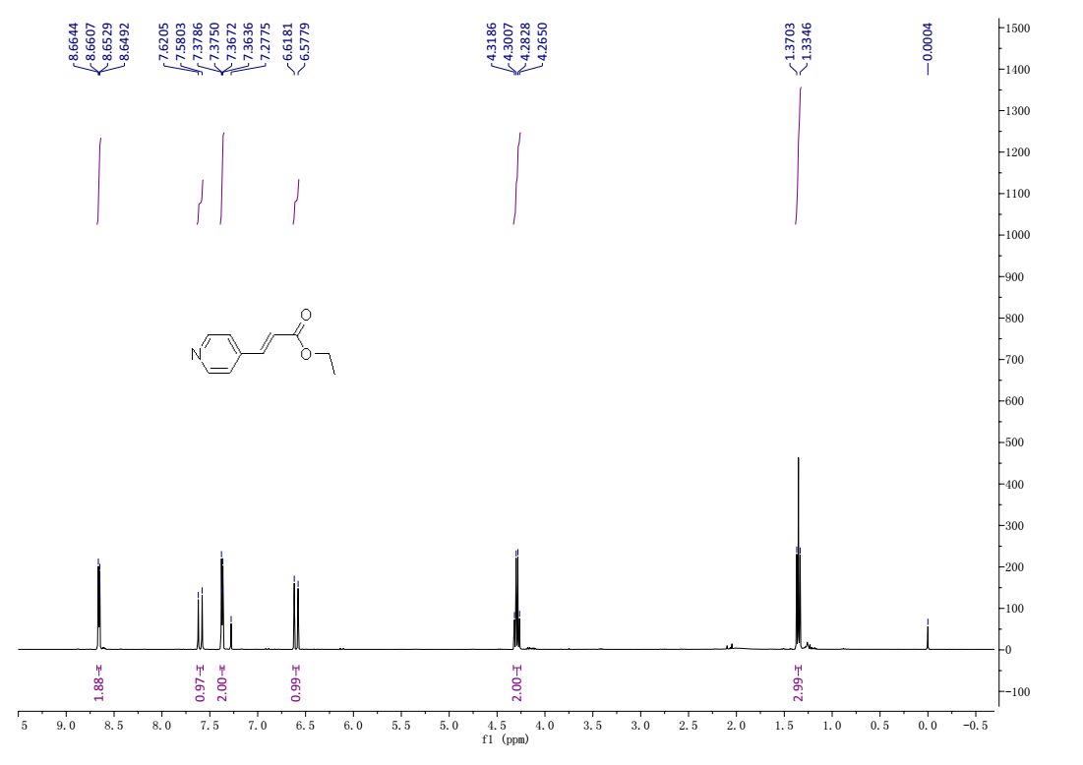
¹H-NMR (400 MHz, Chloroform-d) spectrum of 4a.
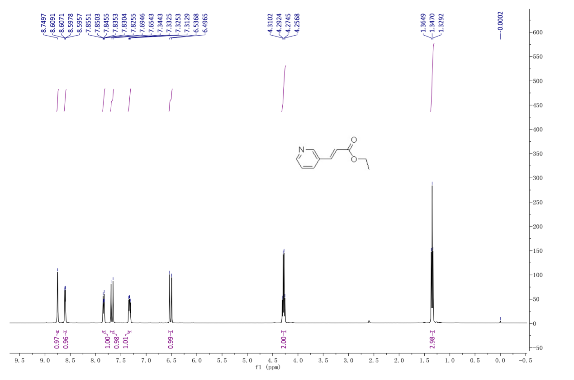
¹H-NMR (400 MHz, Chloroform-d) spectrum of 4b.
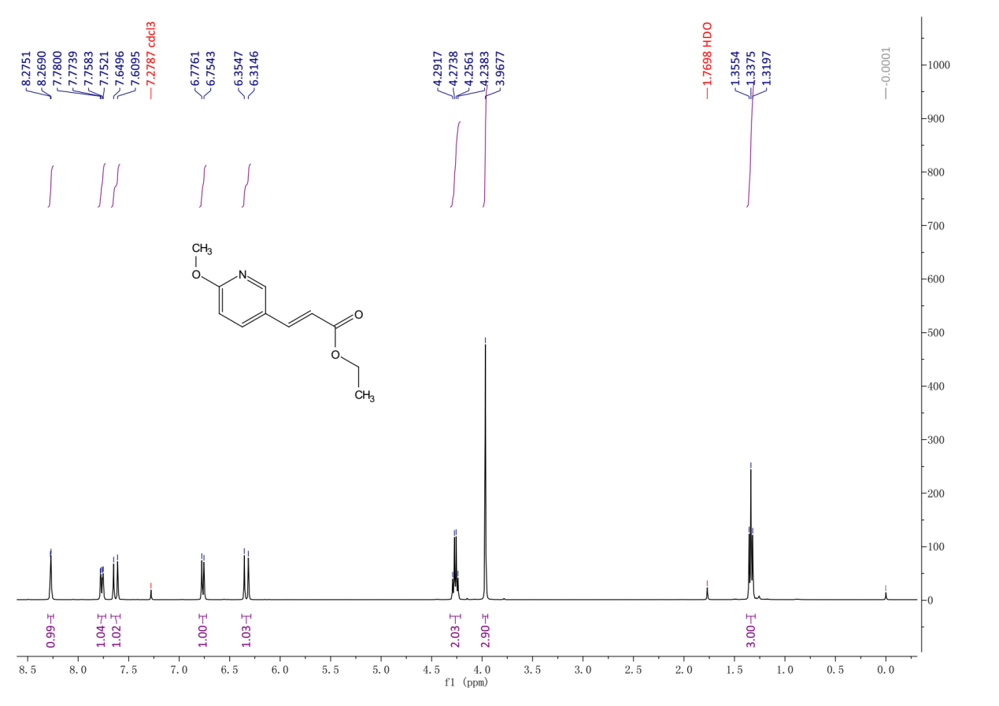
¹H-NMR (400 MHz, Chloroform-d) spectrum of 4c.

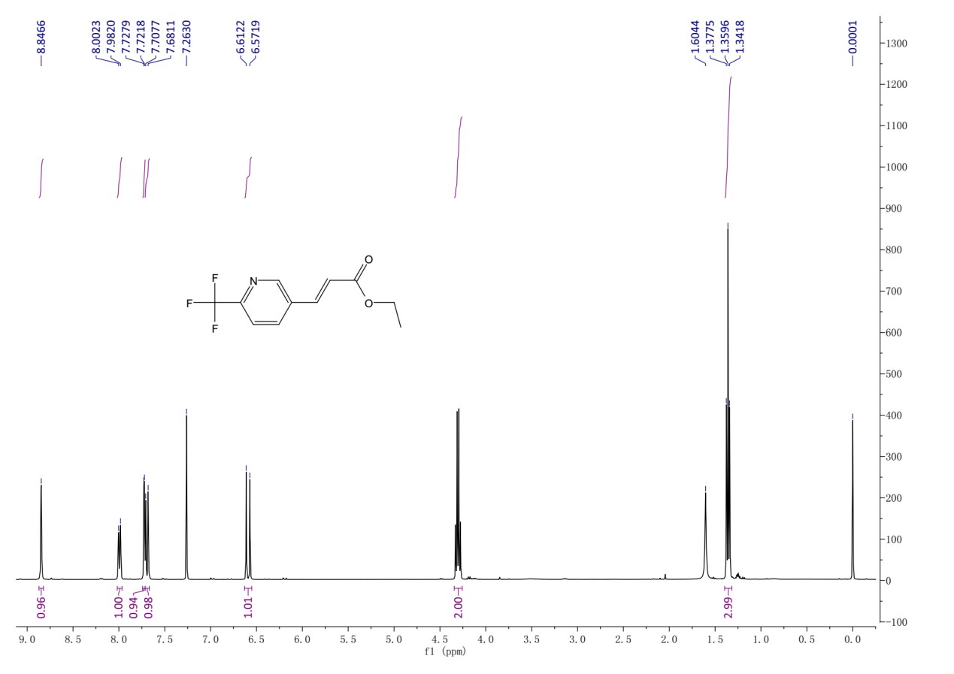
¹H-NMR (400 MHz, Chloroform-d) spectrum of 4d.
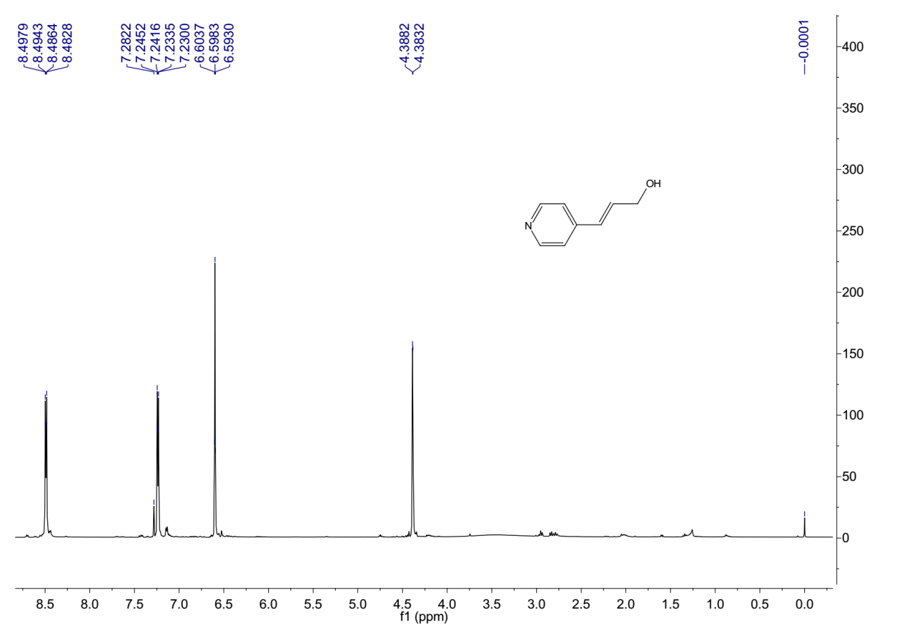
¹H-NMR (400 MHz, Chloroform-d) spectrum of 5a.

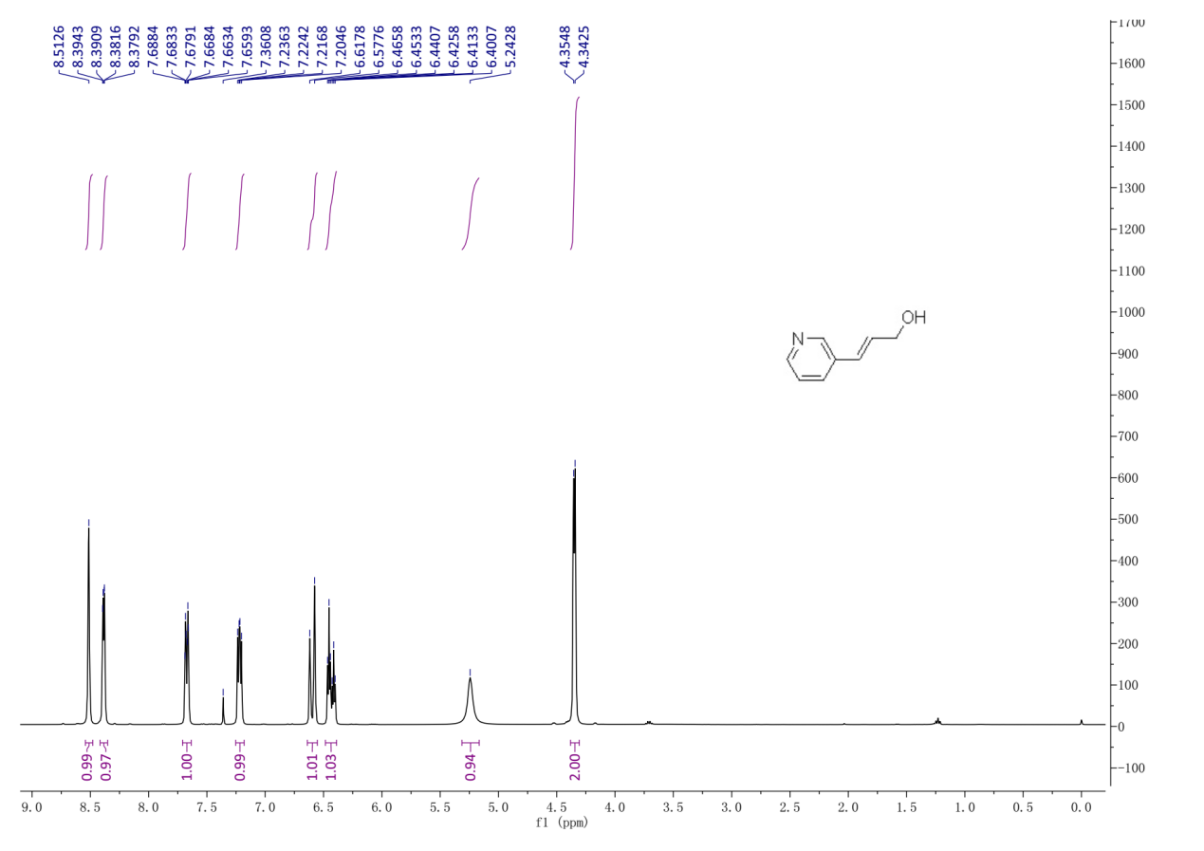
¹H-NMR (400 MHz, Chloroform-d) spectrum of 5b.
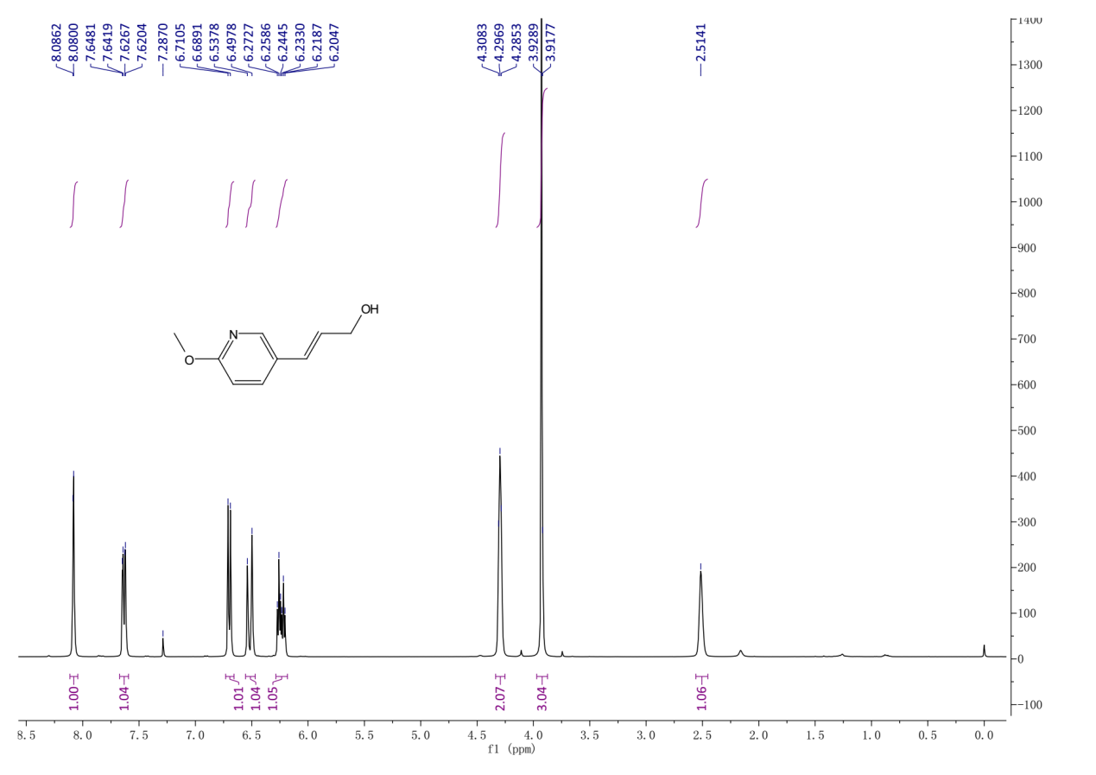
¹H-NMR (400 MHz, Chloroform-d) spectrum of 5c.

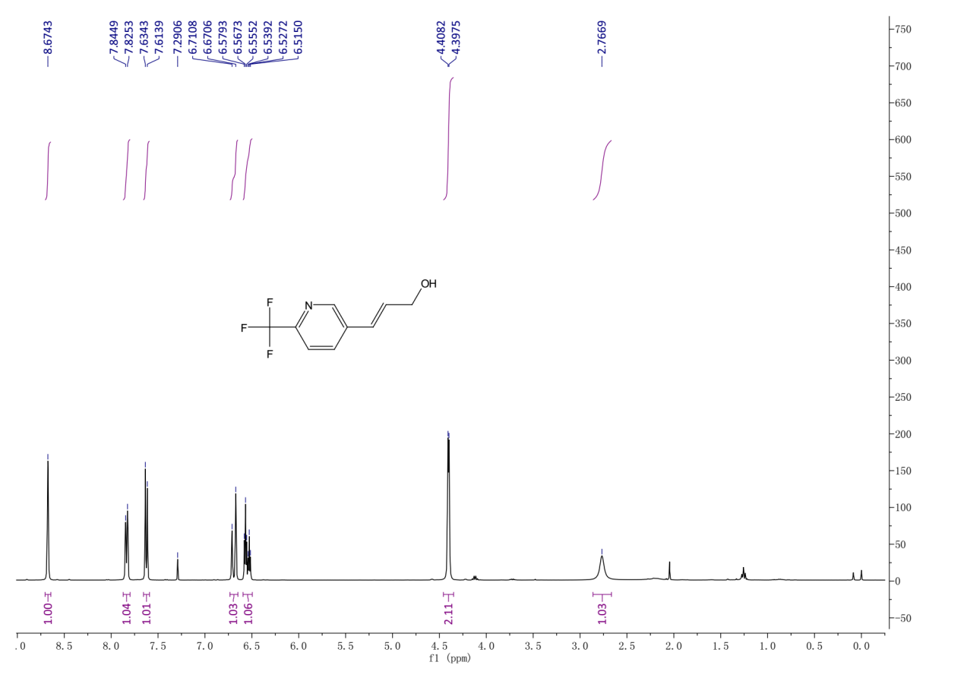
¹H-NMR (400 MHz, Chloroform-d) spectrum of 5d.
¹H-NMR , ¹³C-NMR and HRMS spectra of compounds 6a-d, 7 and 9.
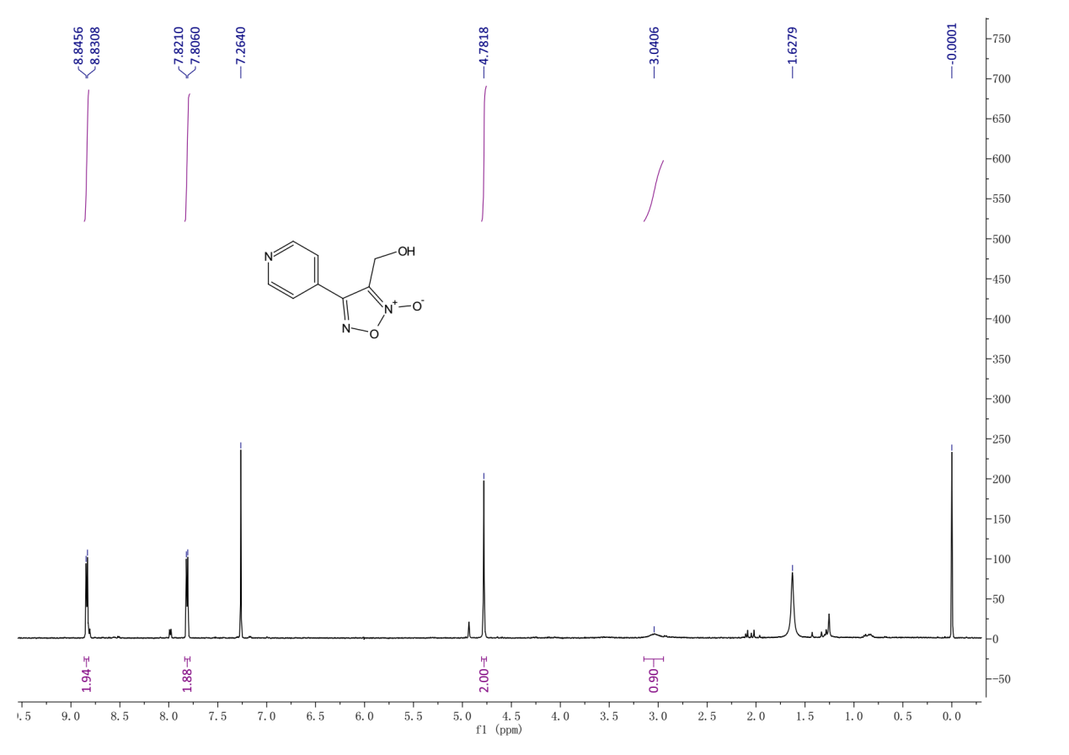
¹H-NMR (400 MHz, Chloroform-d) spectrum of 6a.
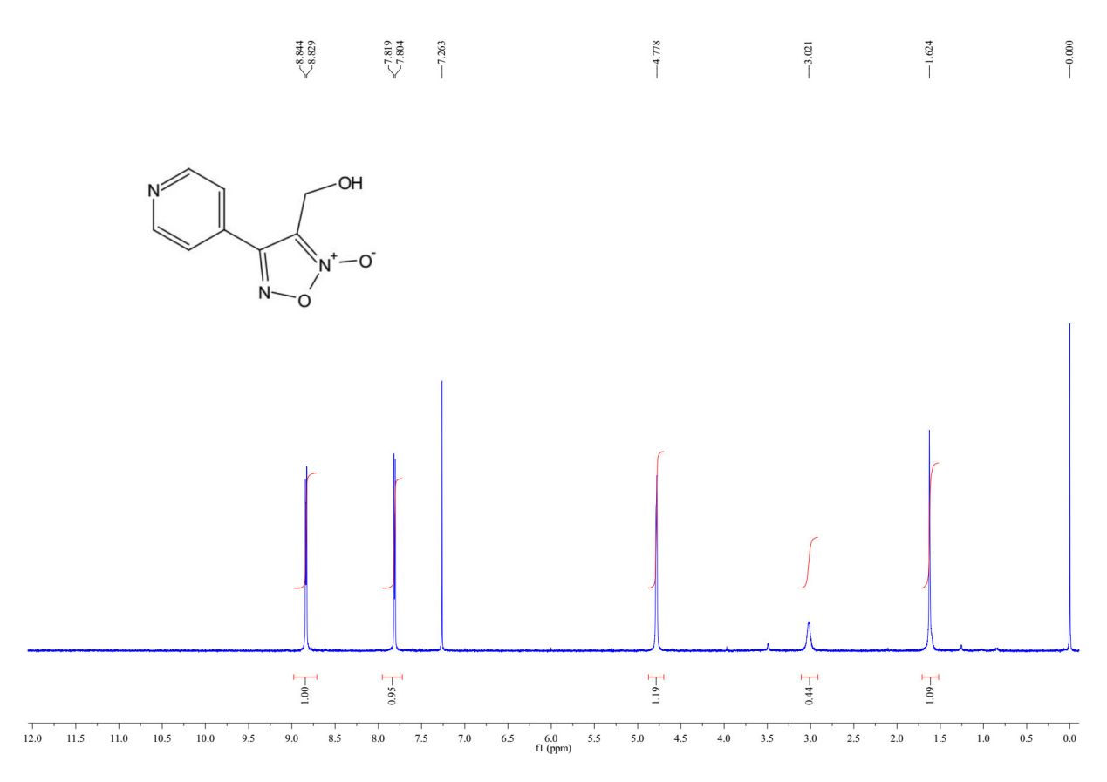
¹³C-NMR (101 MHz, Chloroform-d) spectrum of 6a.
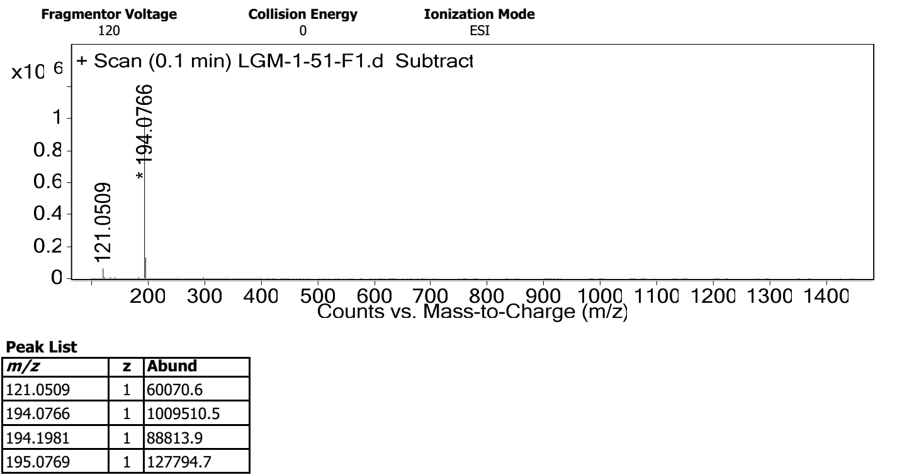
HRMS spectrum of 6a.

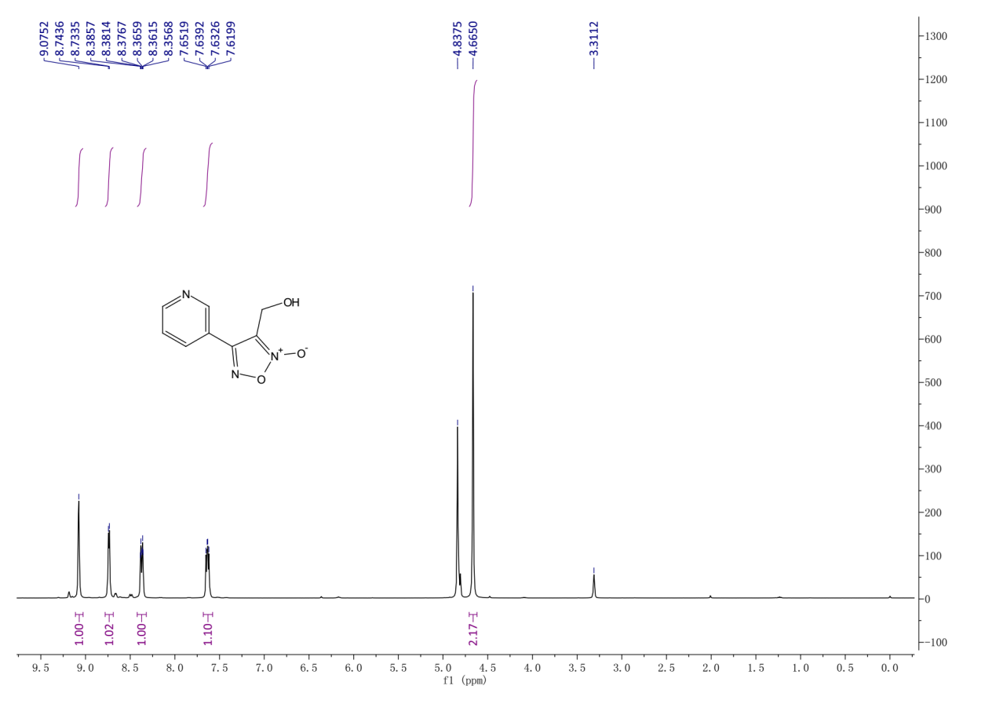
¹H-NMR (400 MHz, Methanol-d4) spectrum of 6b.
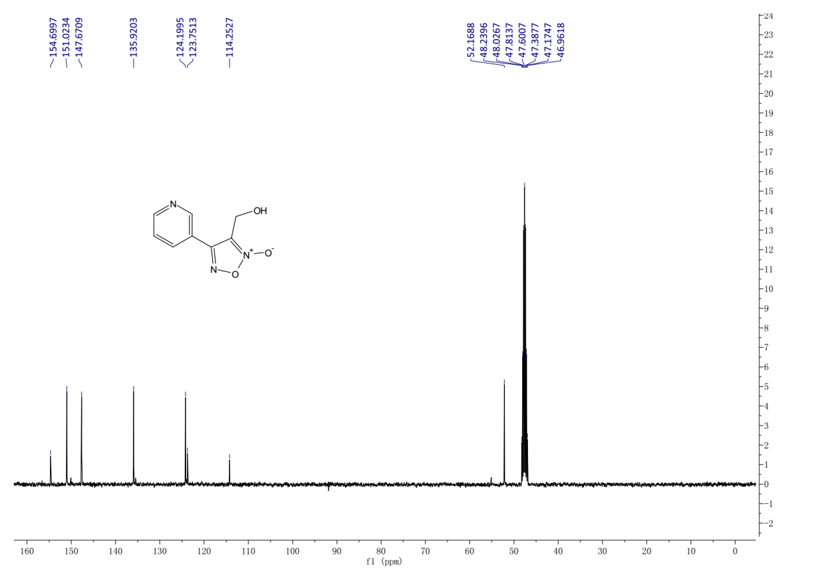
¹³C-NMR (101 MHz, Methanol-d4) spectrum of 6b.

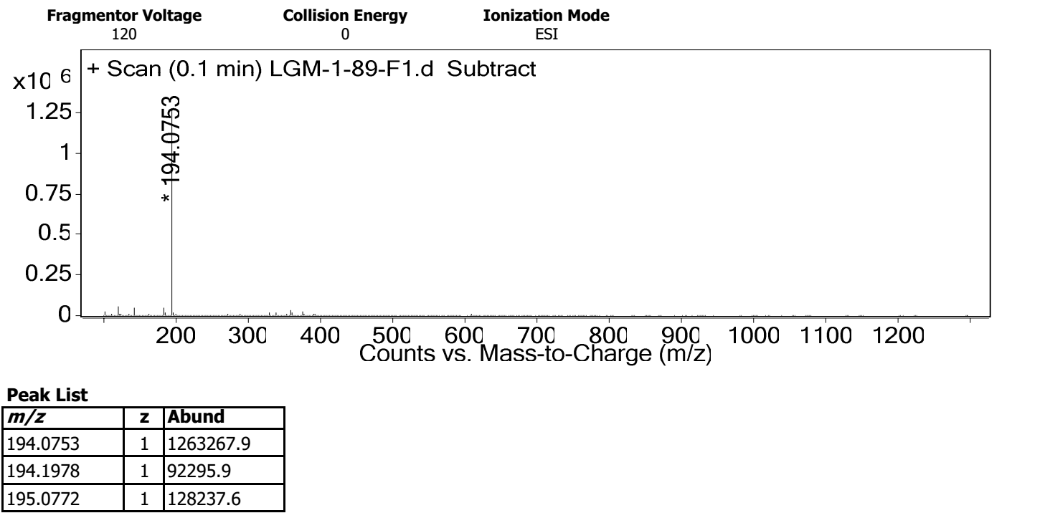
HRMS spectrum of 6b.
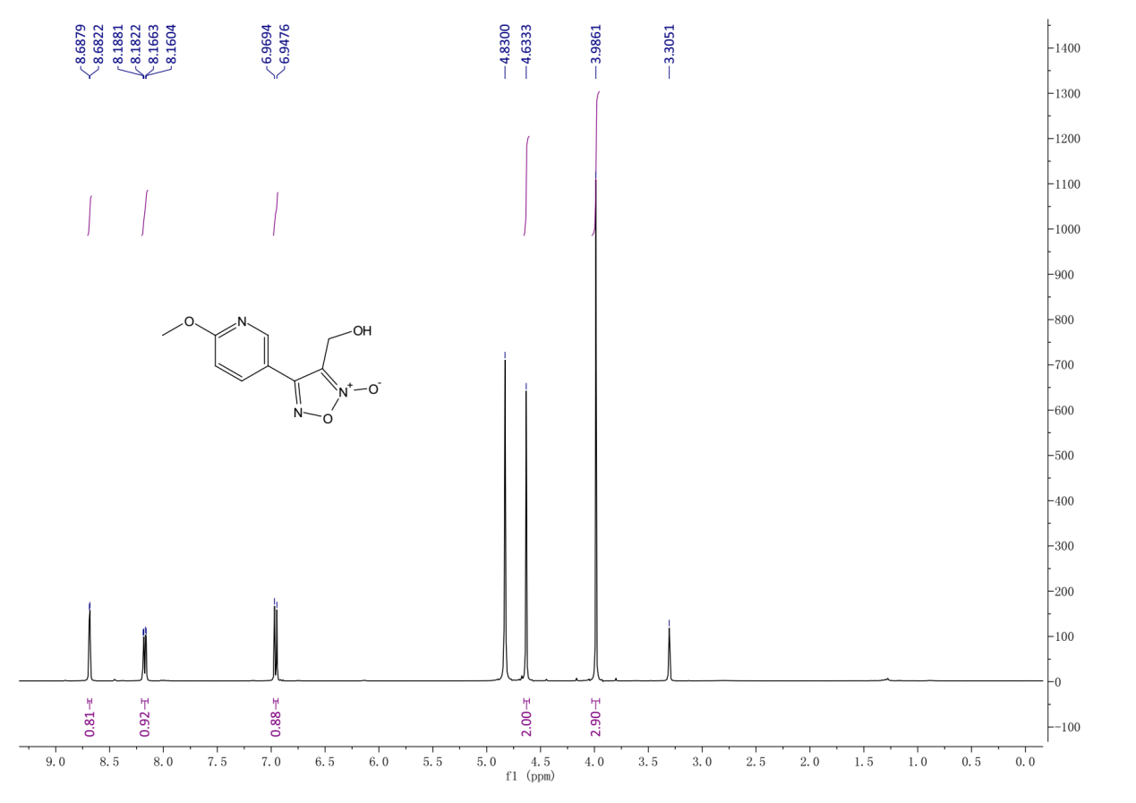
¹H-NMR (400 MHz, Methanol-d4) spectrum of 6c.

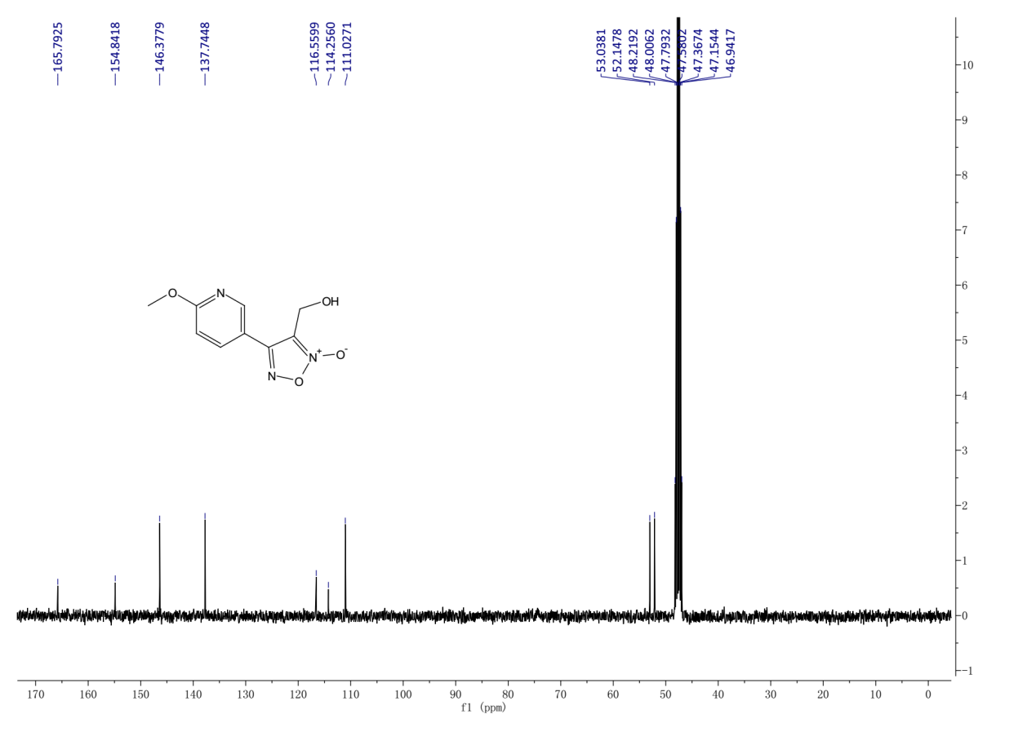
¹³C-NMR (101MHz, Methanol-d4) spectrum of 6c.
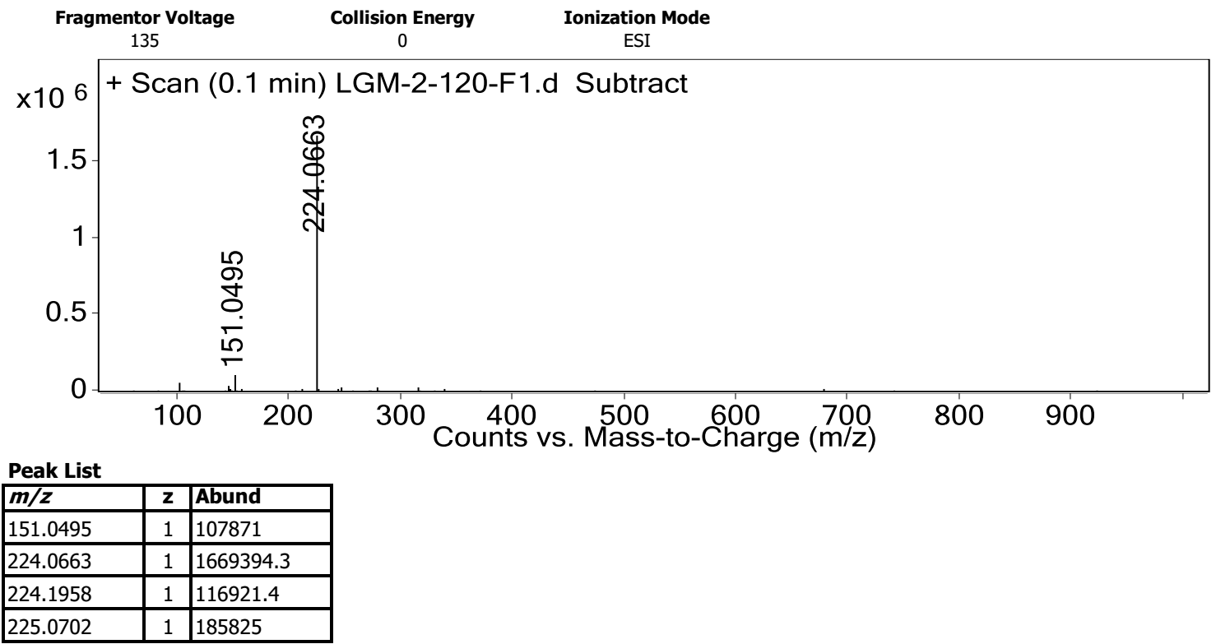
HRMS spectrum of 6c.

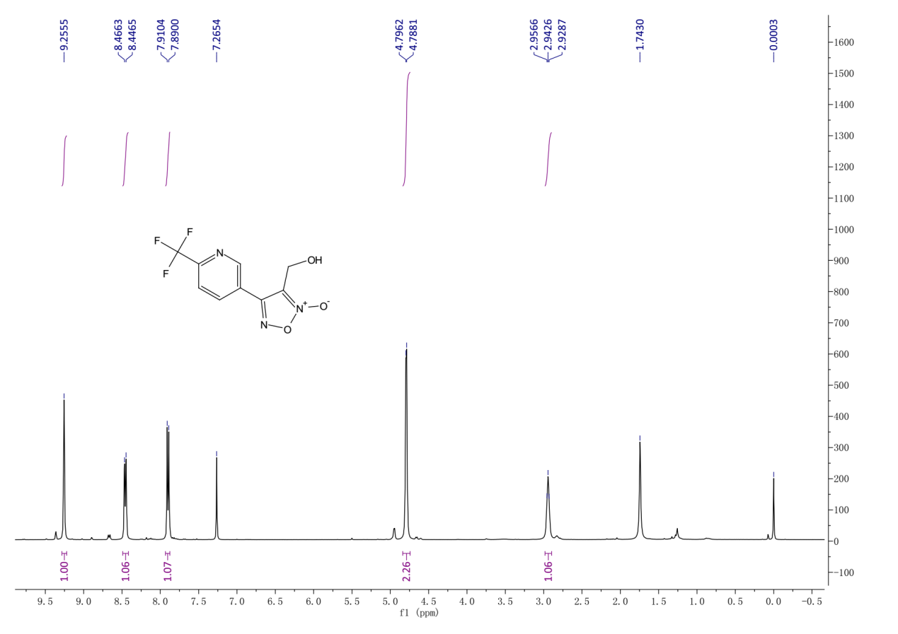
¹H-NMR (400 MHz, Chloroform-d) spectrum of 6d.
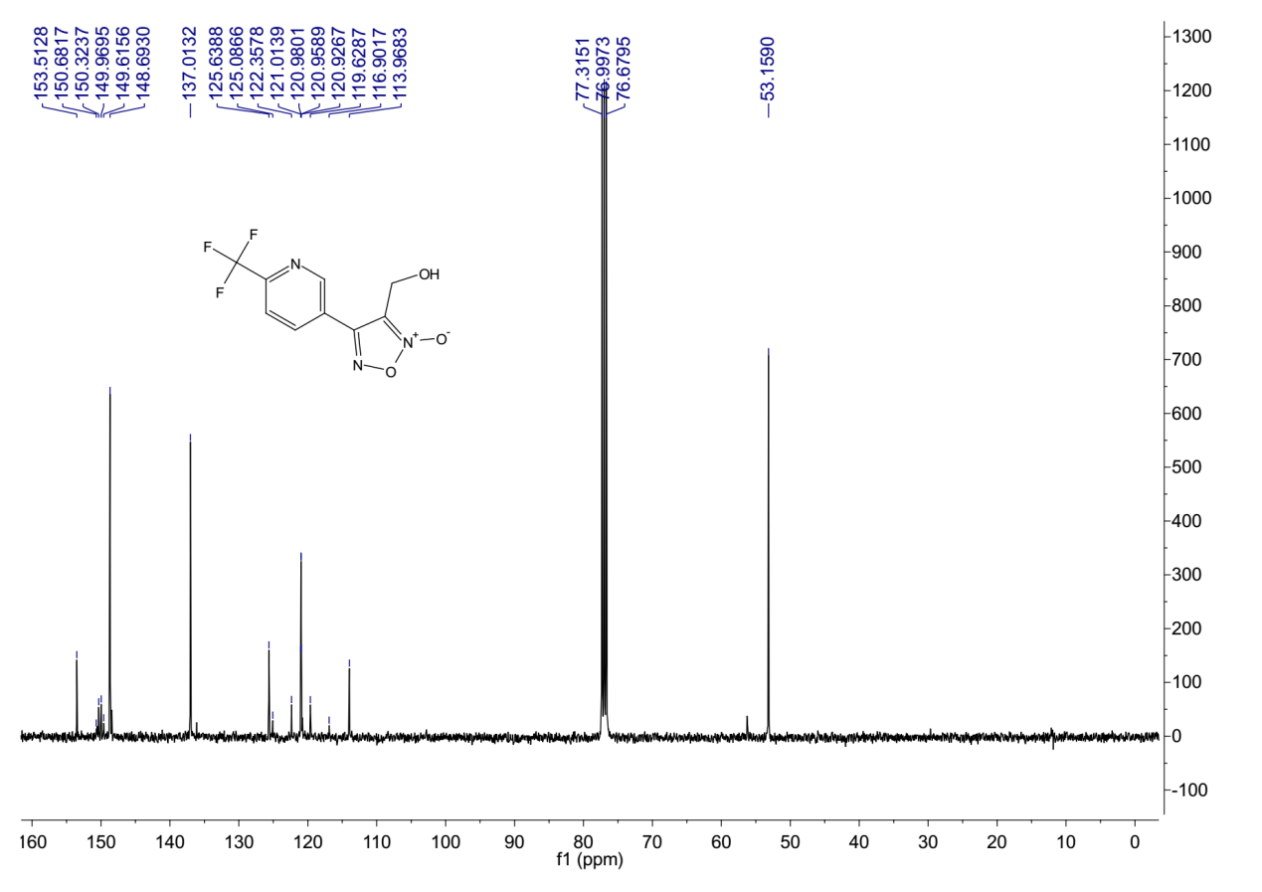
¹³C-NMR (101 MHz, Chloroform-d) spectrum of 6d.

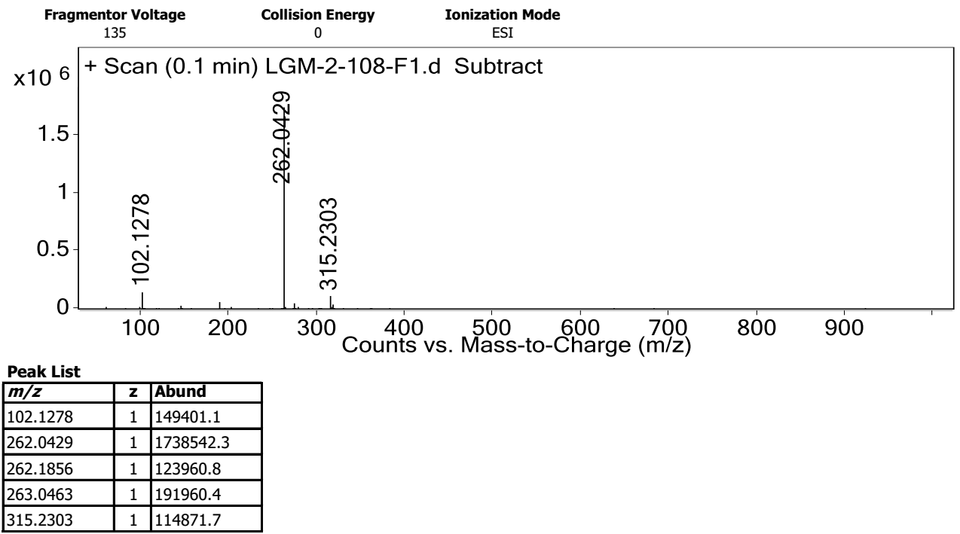
HRMS spectrum of 6d.
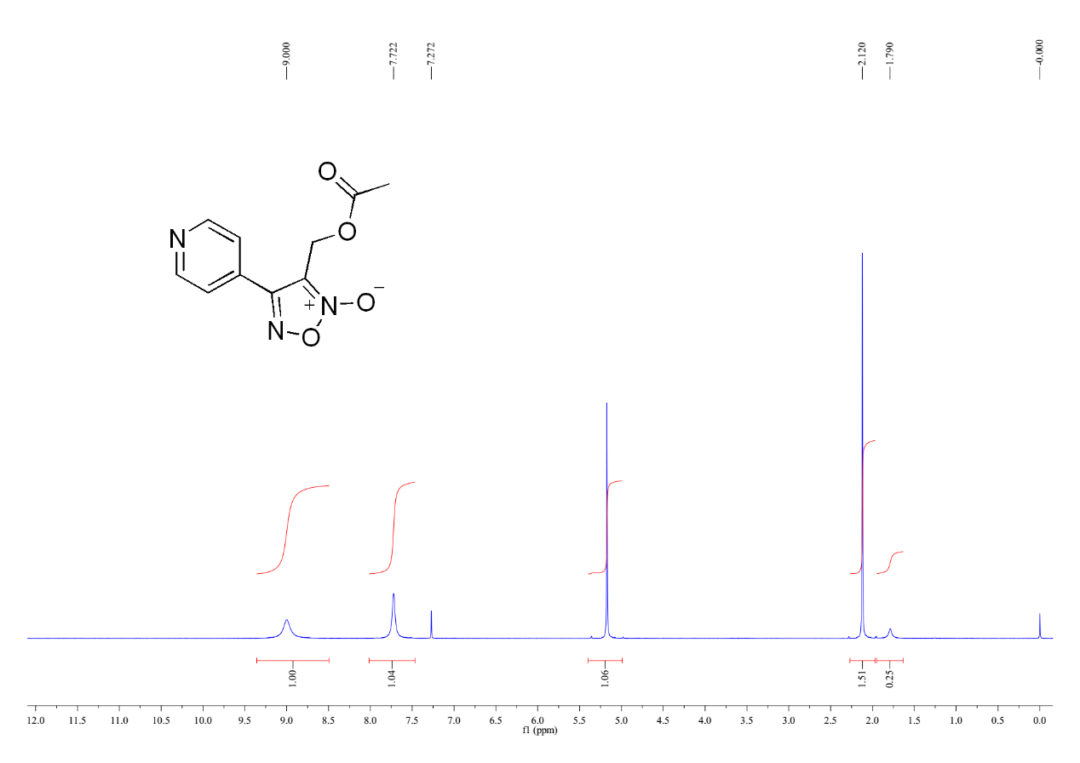
¹H-NMR (400 MHz, Chloroform-d) spectrum of 7aa.

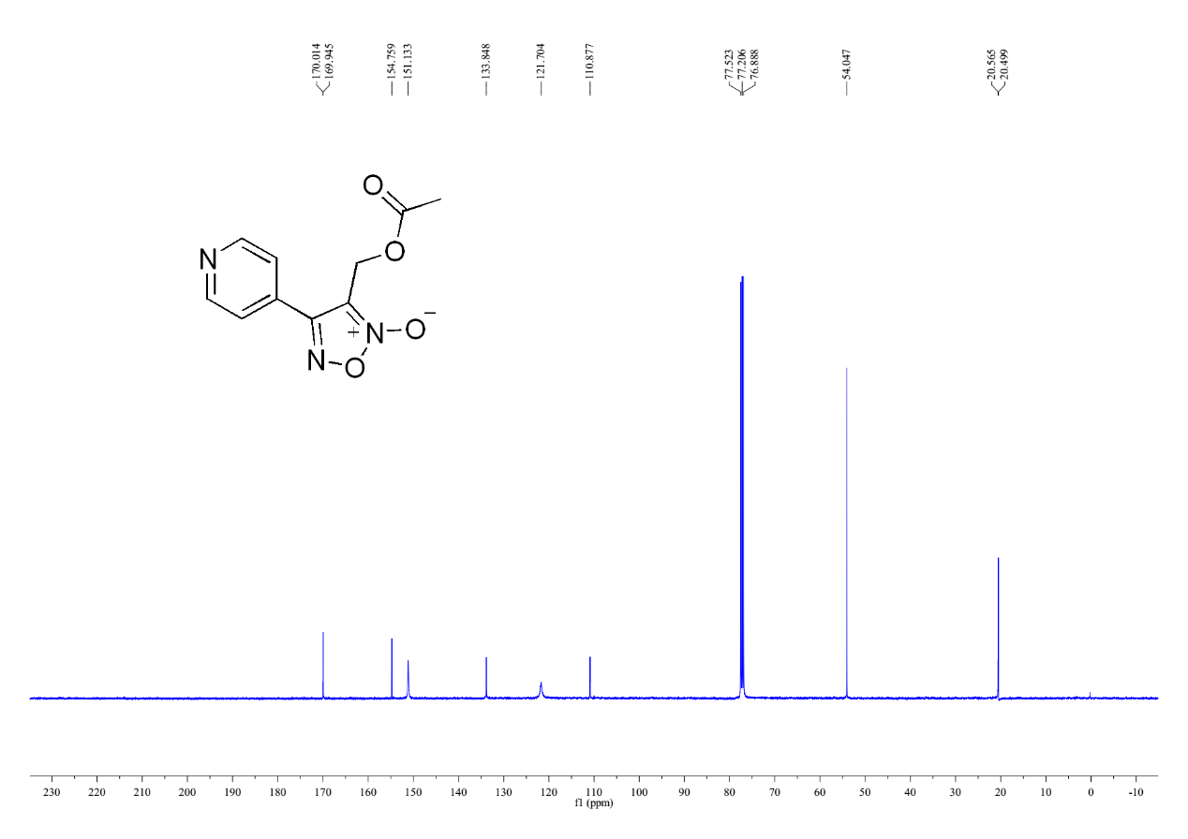
¹³C-NMR (101 MHz, Chloroform-d) spectrum of 7aa.
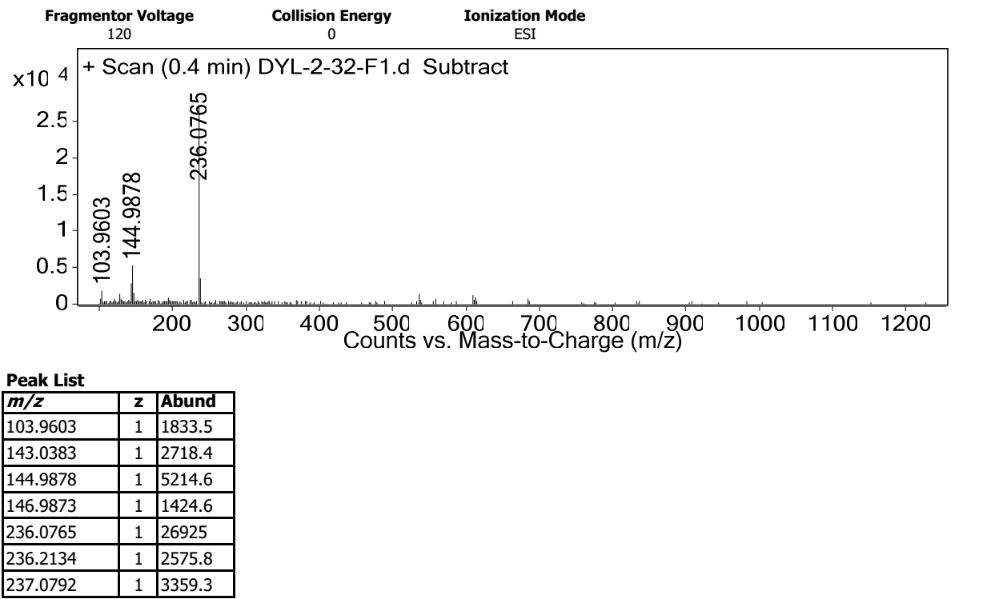
HRMS spectrum of 7aa.

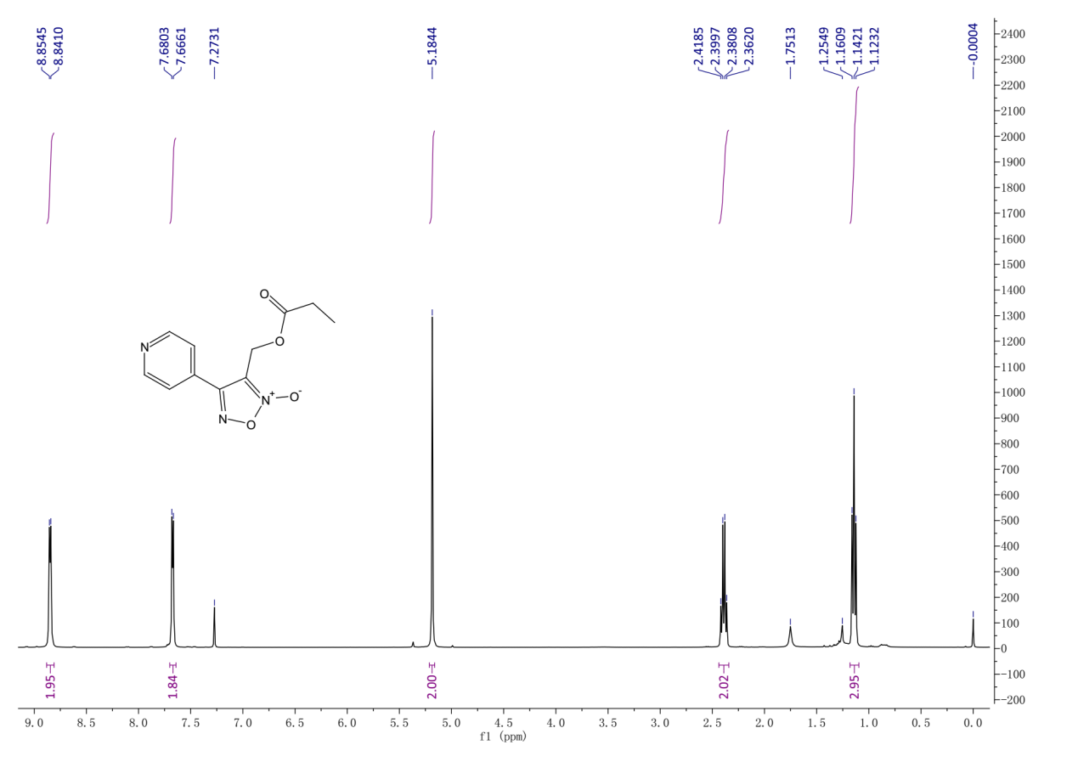
¹H-NMR (400 MHz, Chloroform-d) spectrum of 7ab.
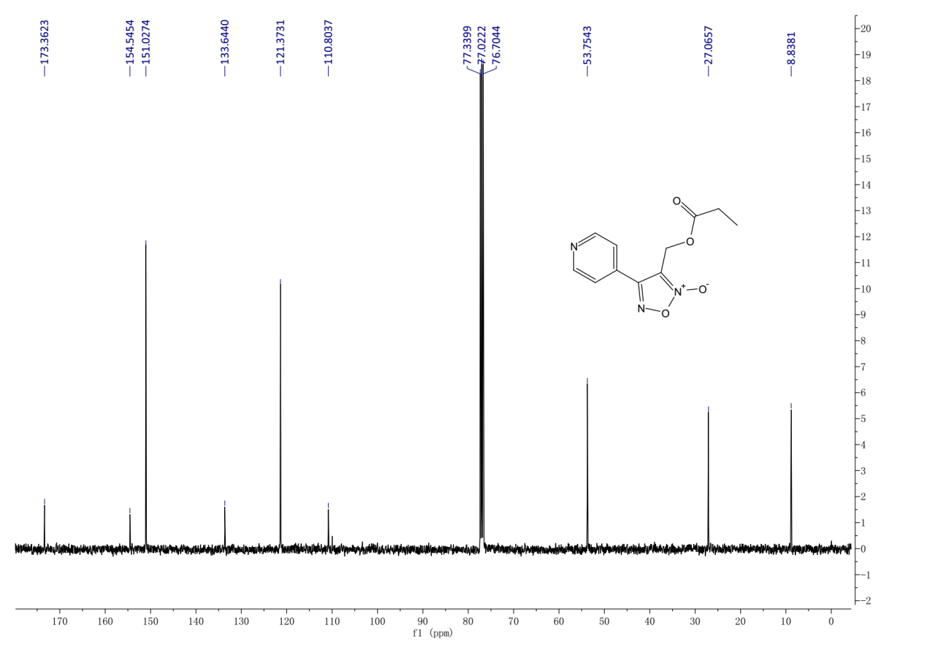
¹³C-NMR (101 MHz, Chloroform-d) spectrum of 7ab.

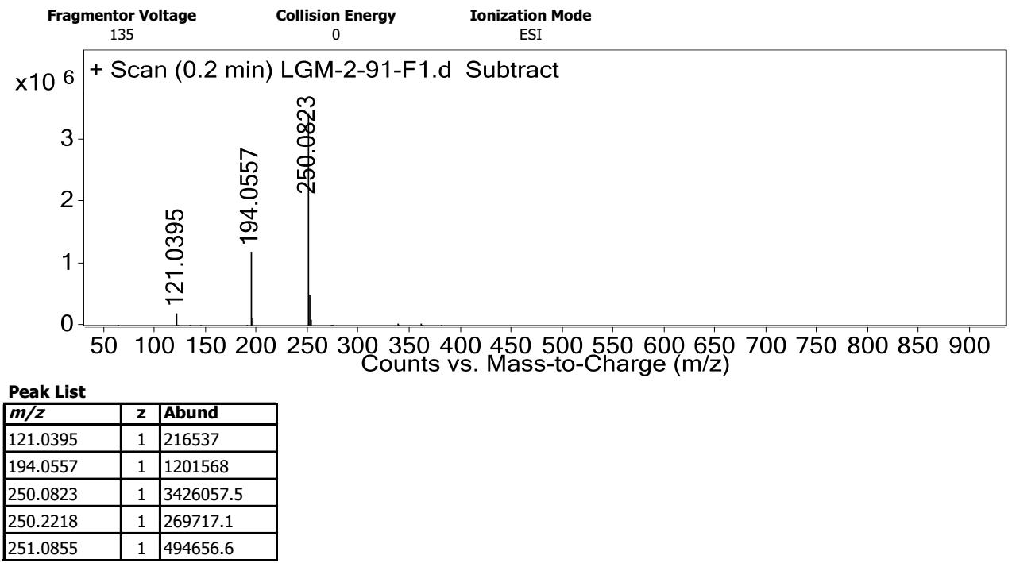
HRMS spectrum of 7ab.
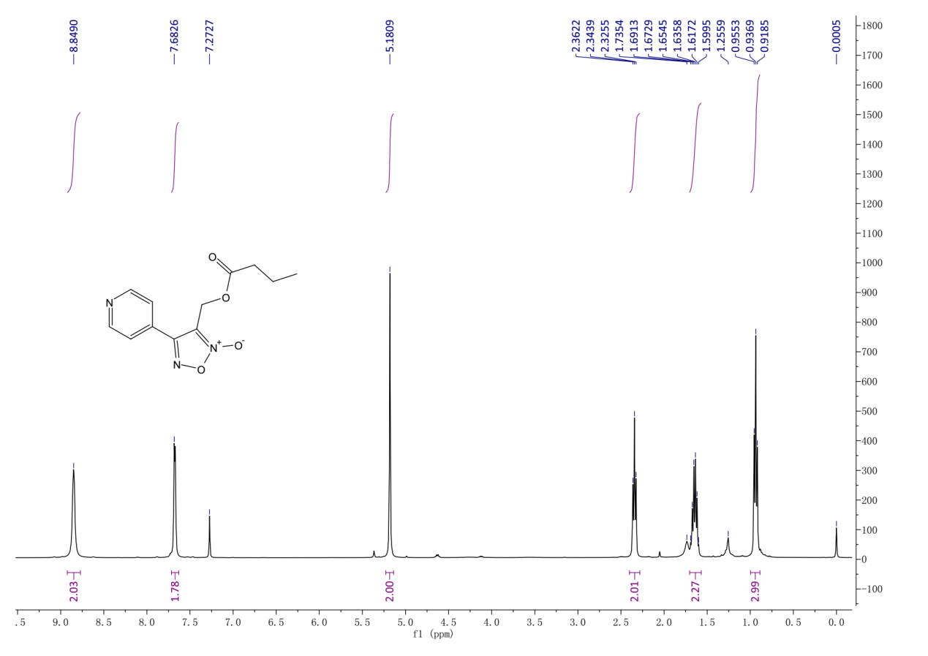
¹H-NMR (400 MHz, Chloroform-d) spectrum of 7ac.

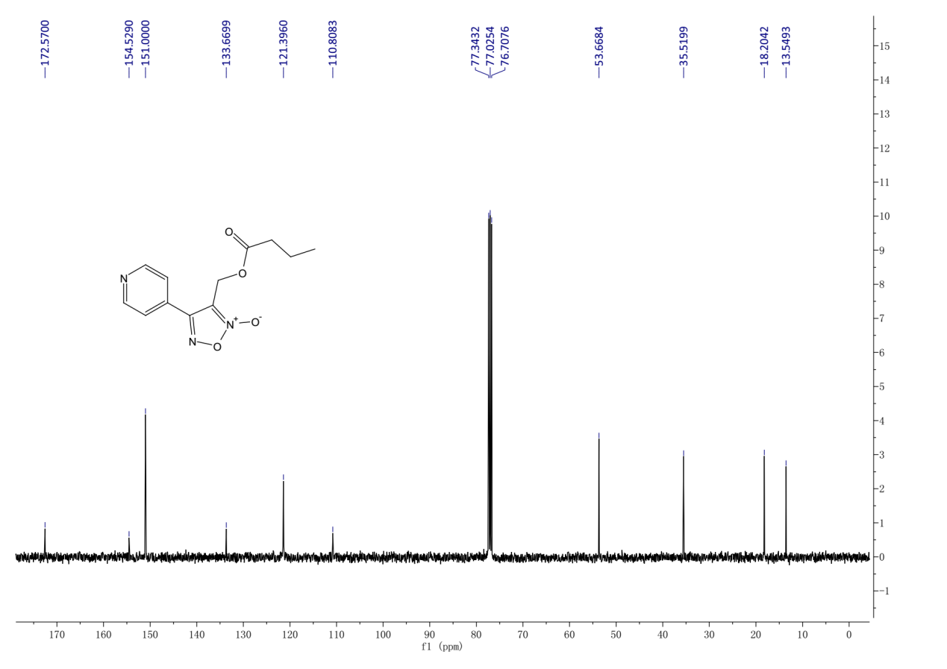
¹³C-NMR (101 MHz, Chloroform-d) spectrum of 7ac.
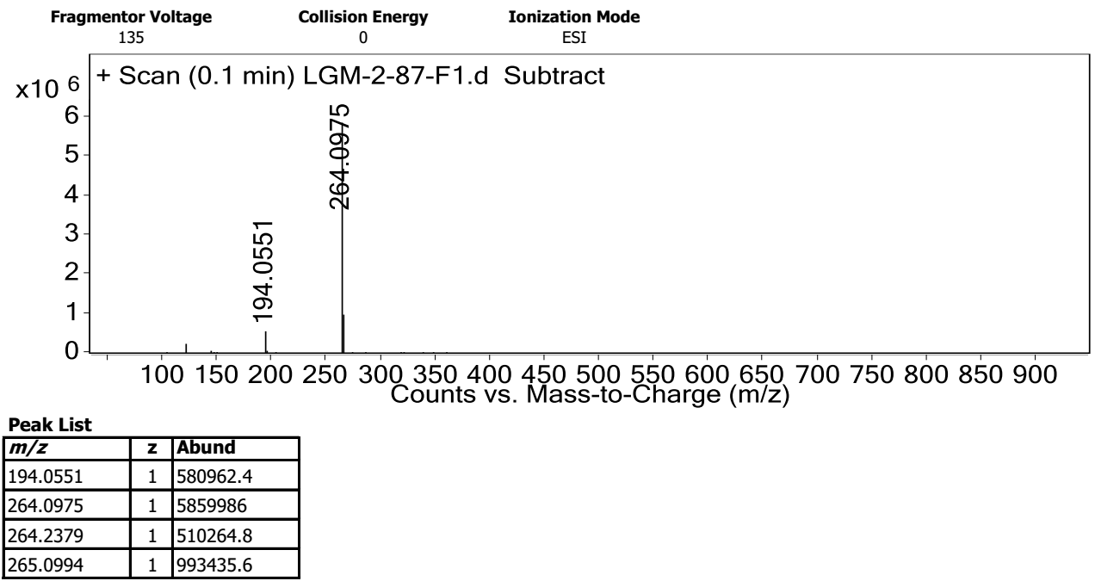
HRMS spectrum of 7ac.

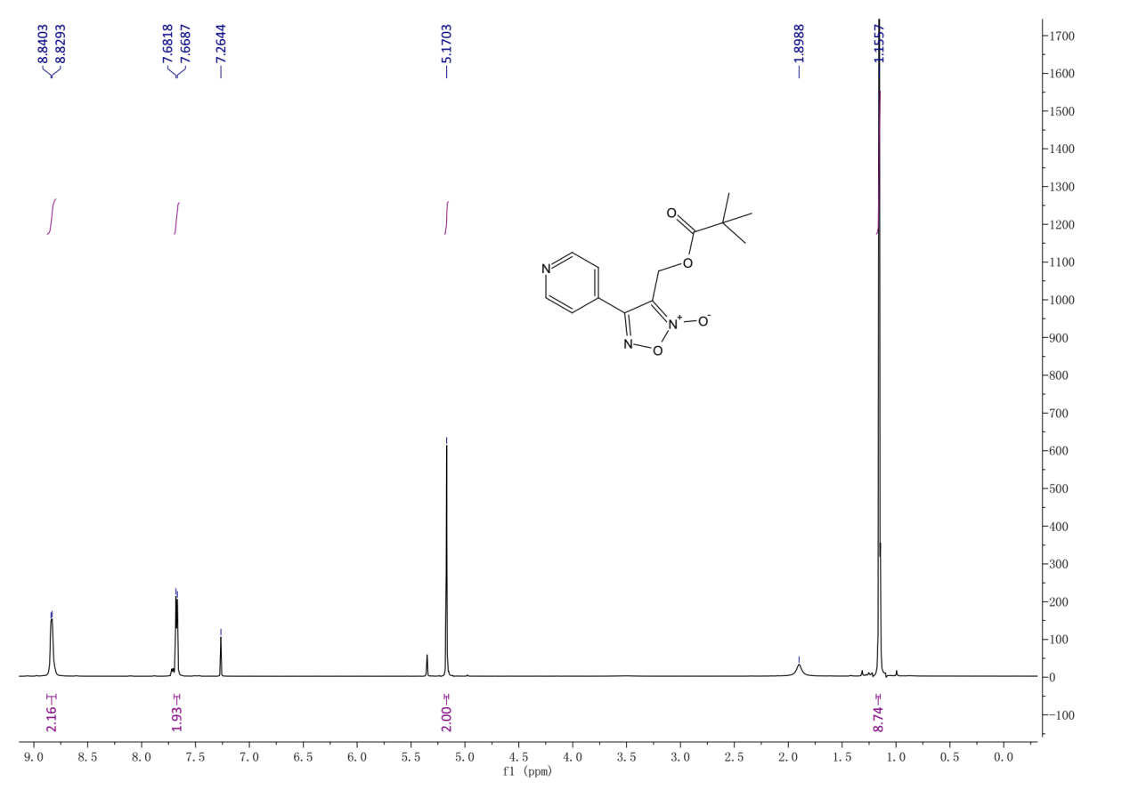¹H-NMR (400 MHz, Chloroform-d) spectrum of 7ad..
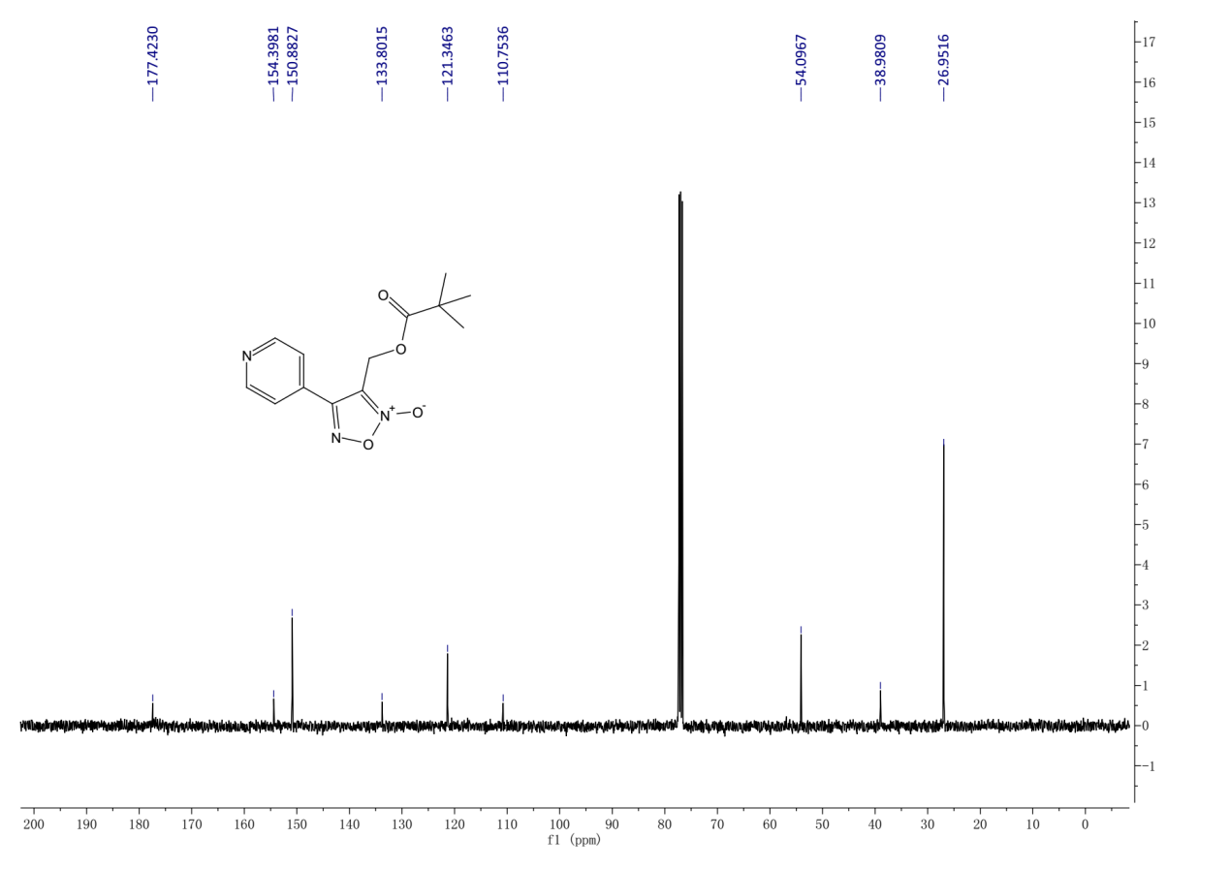
¹³C-NMR (101 MHz, Chloroform-d) spectrum of 7ad.

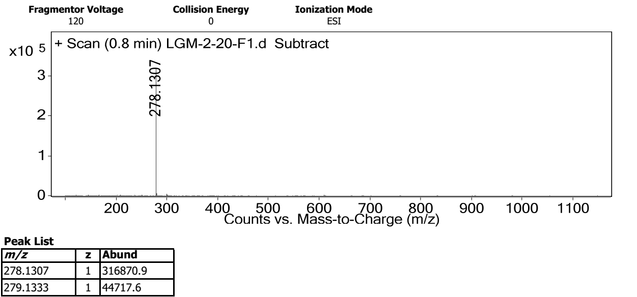
HRMS spectrum of 7ad.
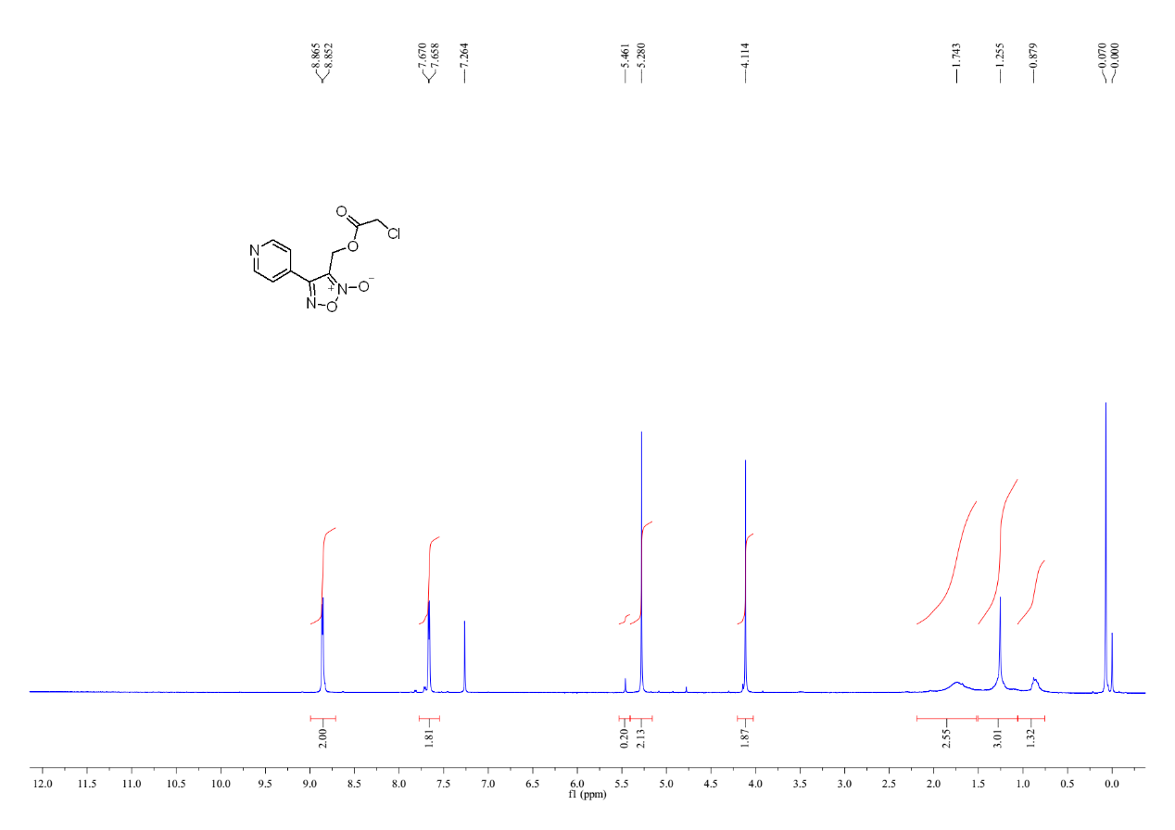
¹H-NMR (400 MHz, Chloroform-d) spectrum of 7ae.

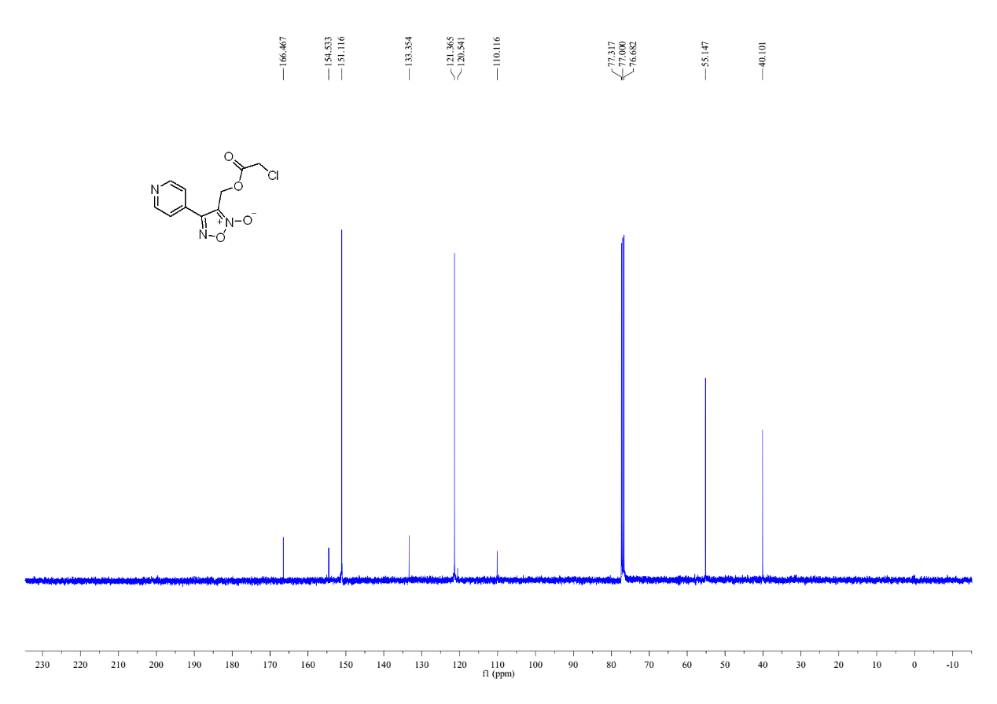
¹³C-NMR (400 MHz, Chloroform-d) spectrum of 7ae.
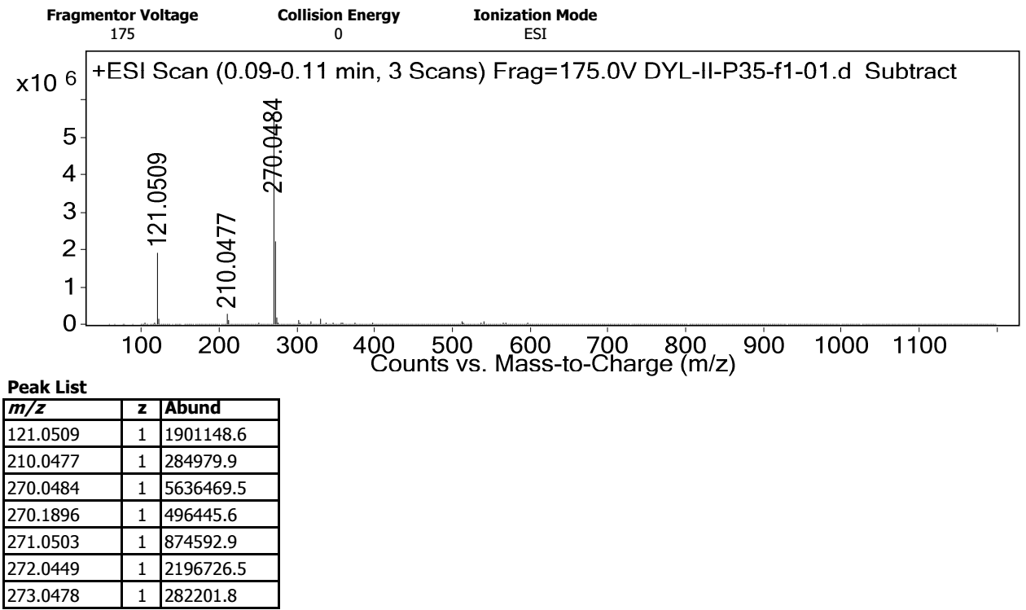
HRMS spectrum of 7ae.

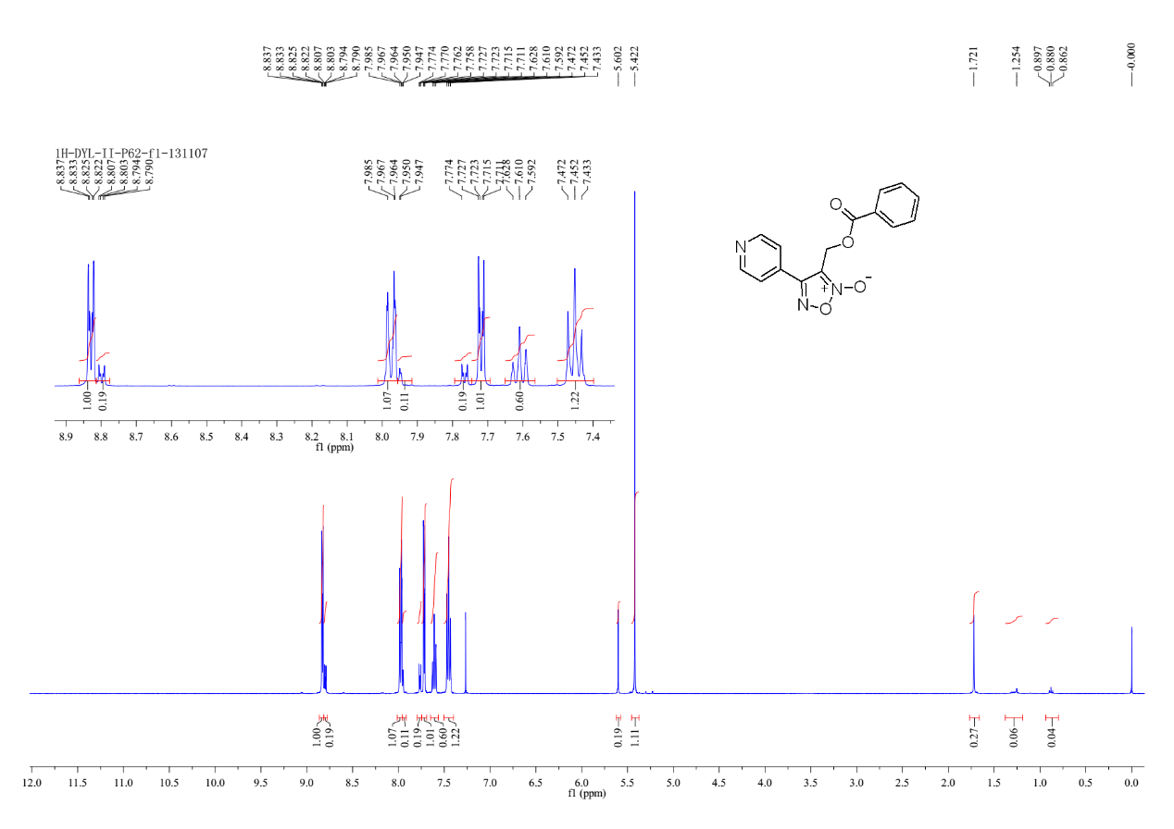
¹H-NMR (400 MHz, Chloroform-d) spectrum of 7af.
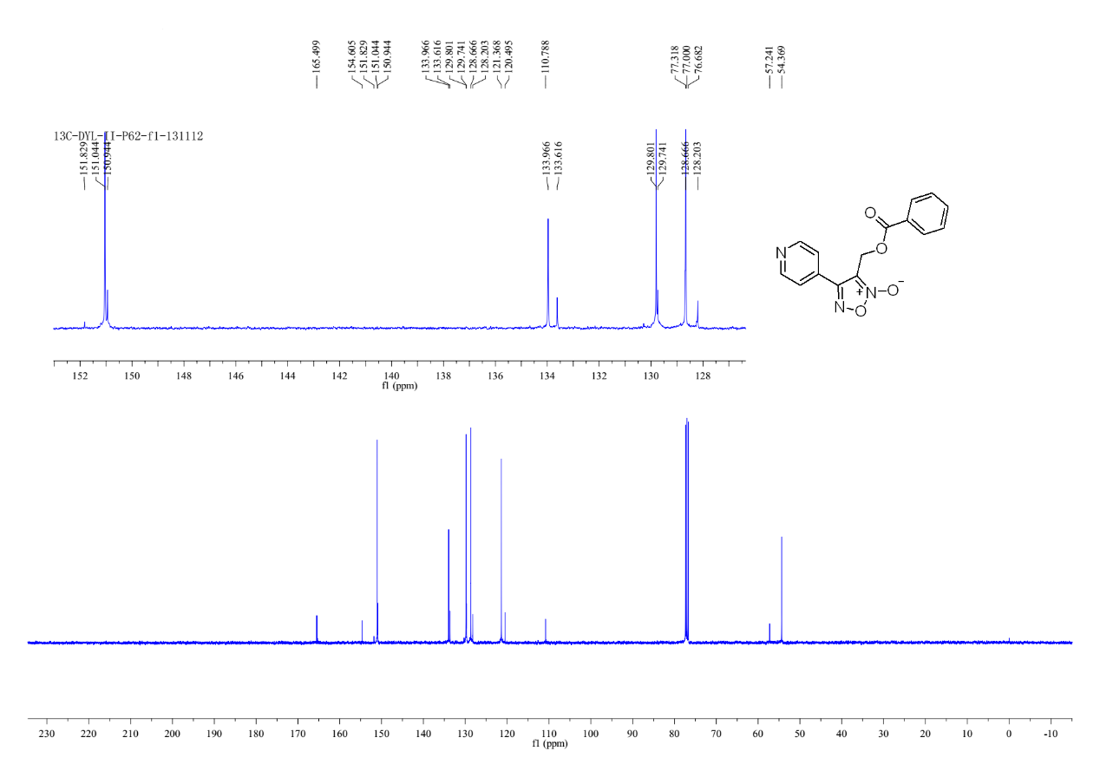
¹³C-NMR(400MHz, Chloroform-d) spectrum of 7af.

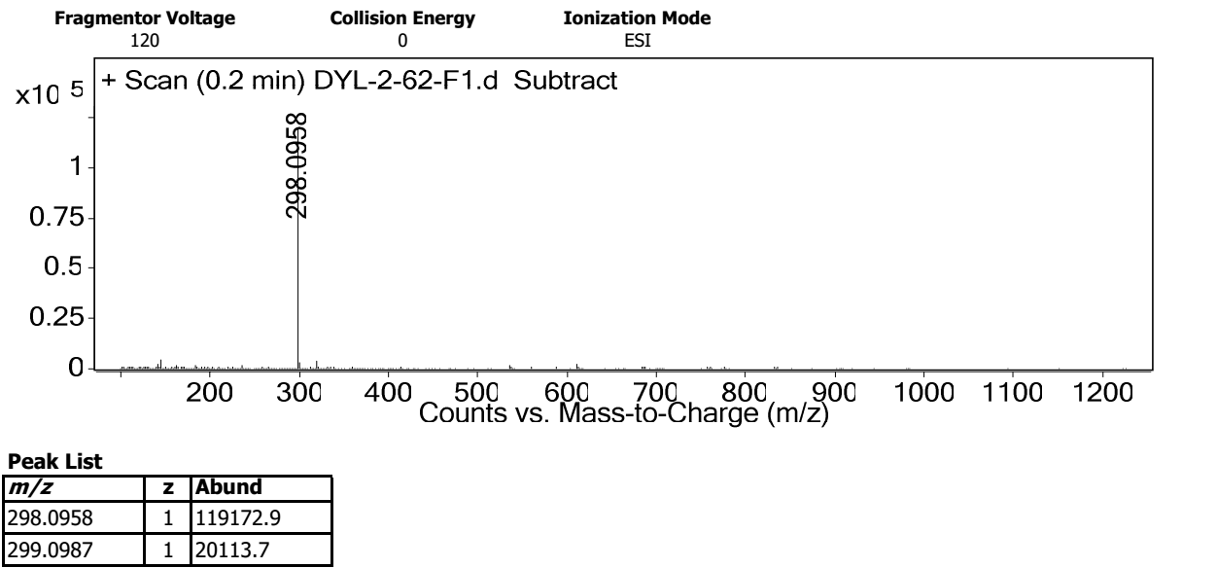
HRMS spectrum of 7af.
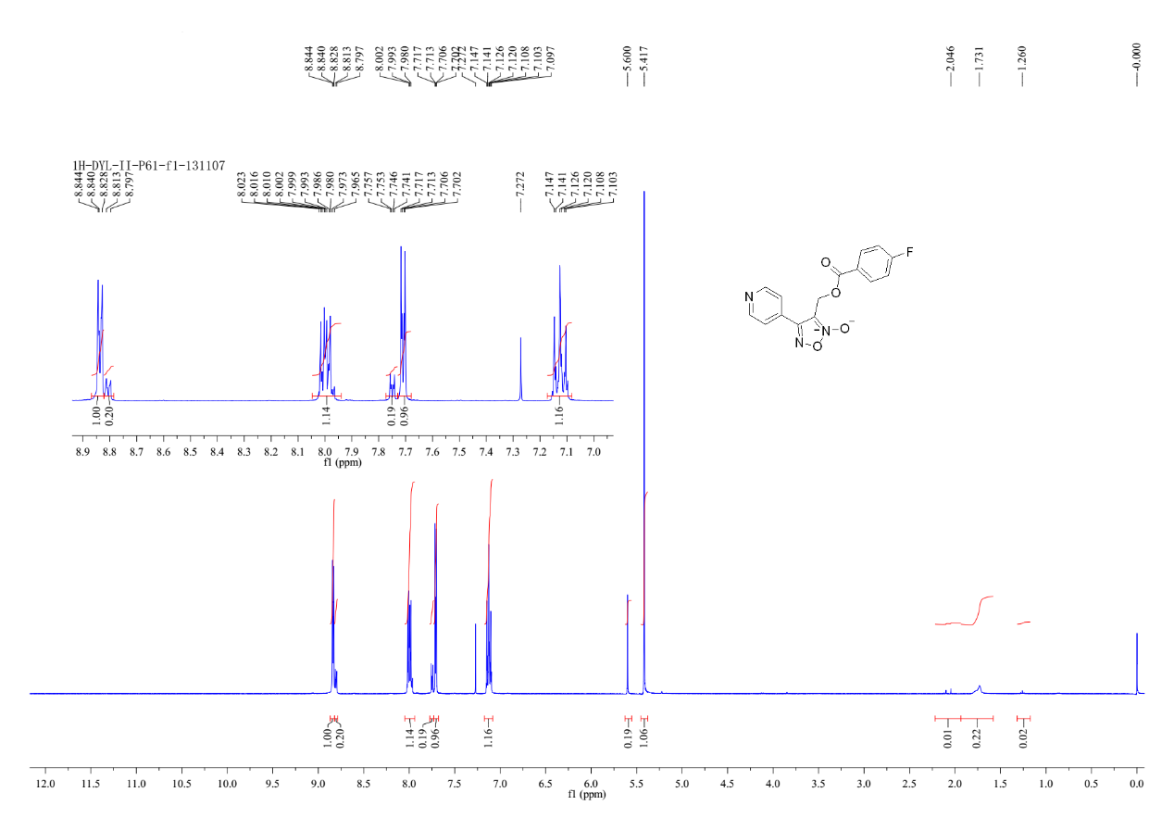
¹H-NMR (400 MHz, Chloroform-d) spectrum of 7ag.

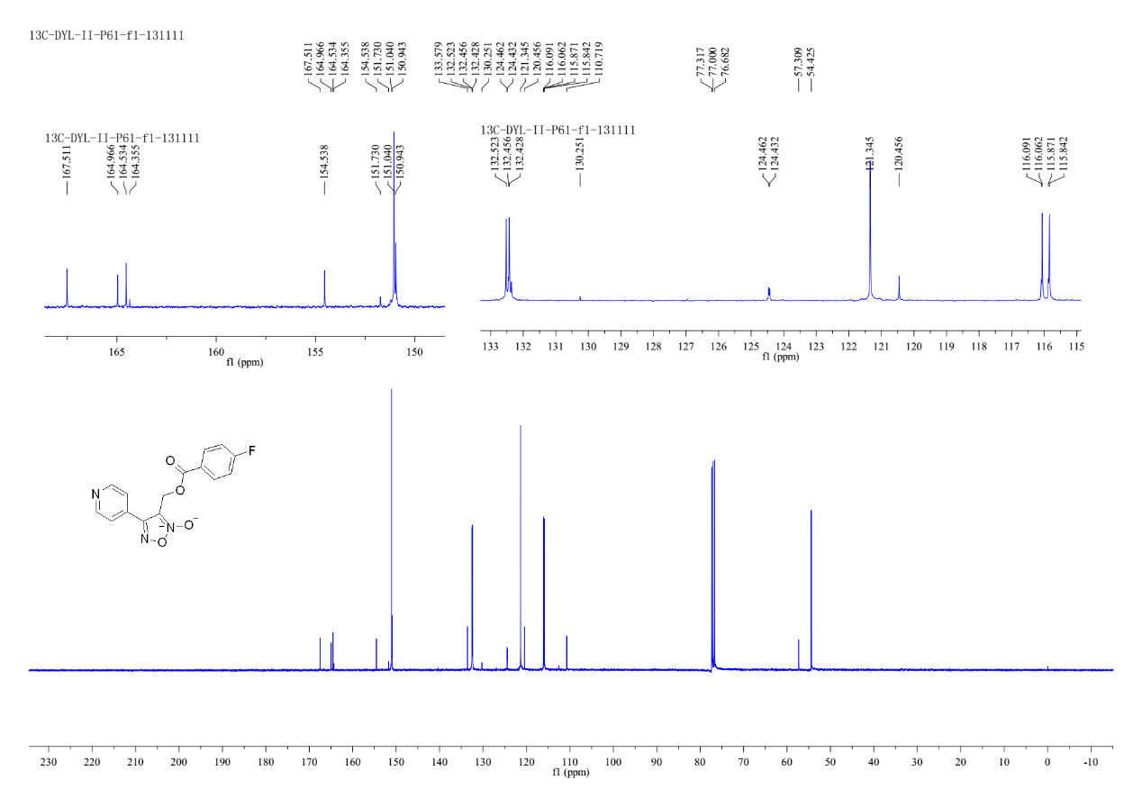
¹³C-NMR(400MHz, Chloroform-d) spectrum of 7ag.
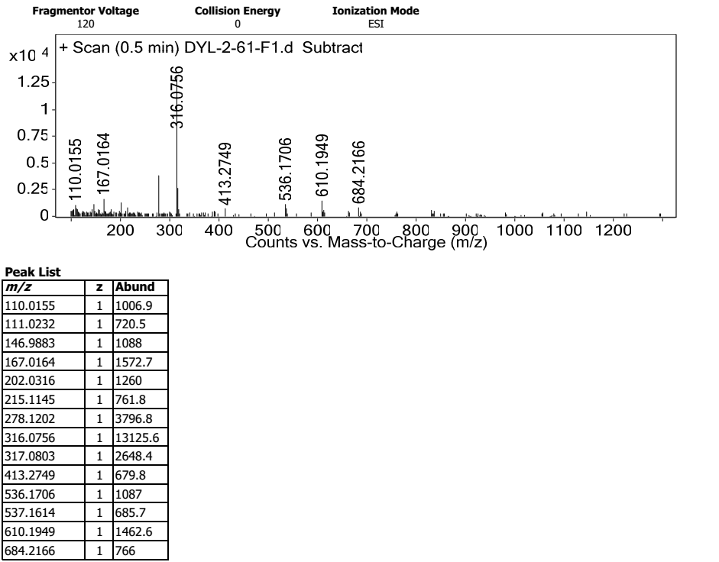
HRMS spectrum of 7ag.
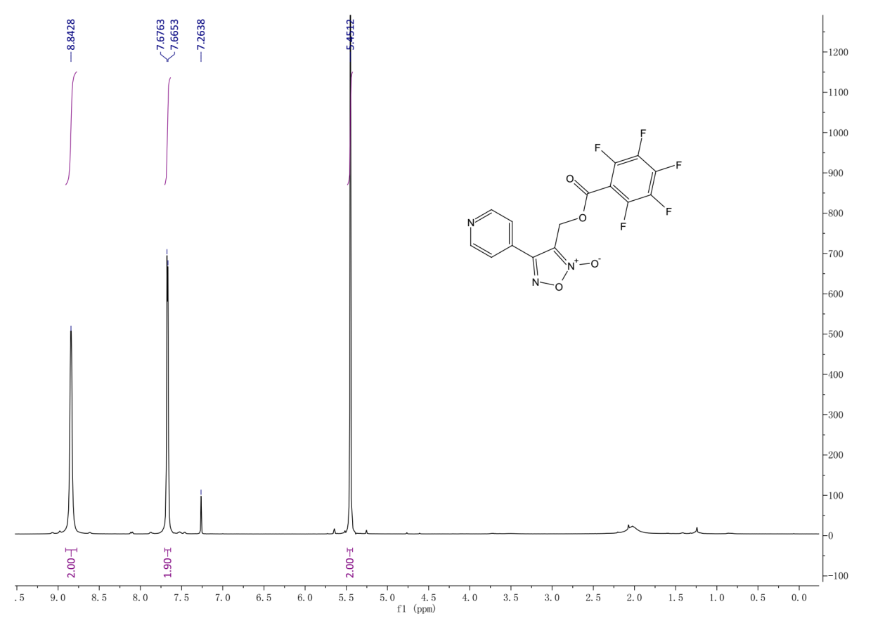
¹H-NMR (400 MHz, Chloroform-d) spectrum of 7ah.
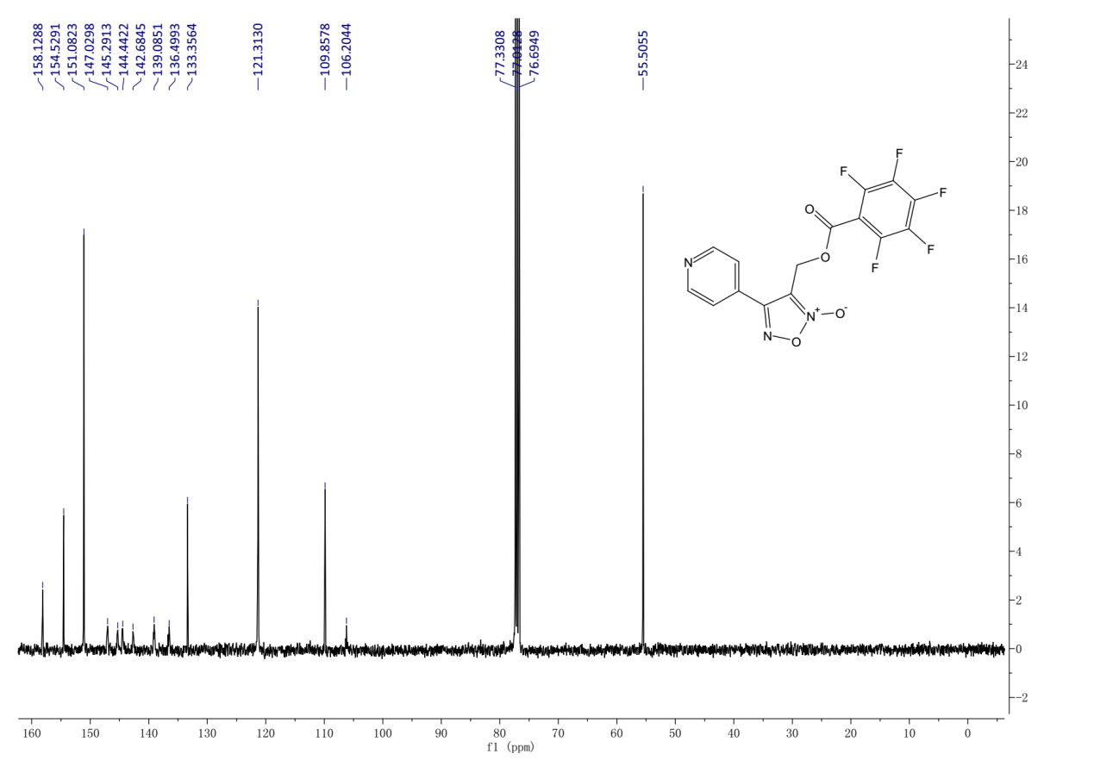¹³CNMR (101 MHz, Chloroform-d) spectrum of 7ah.

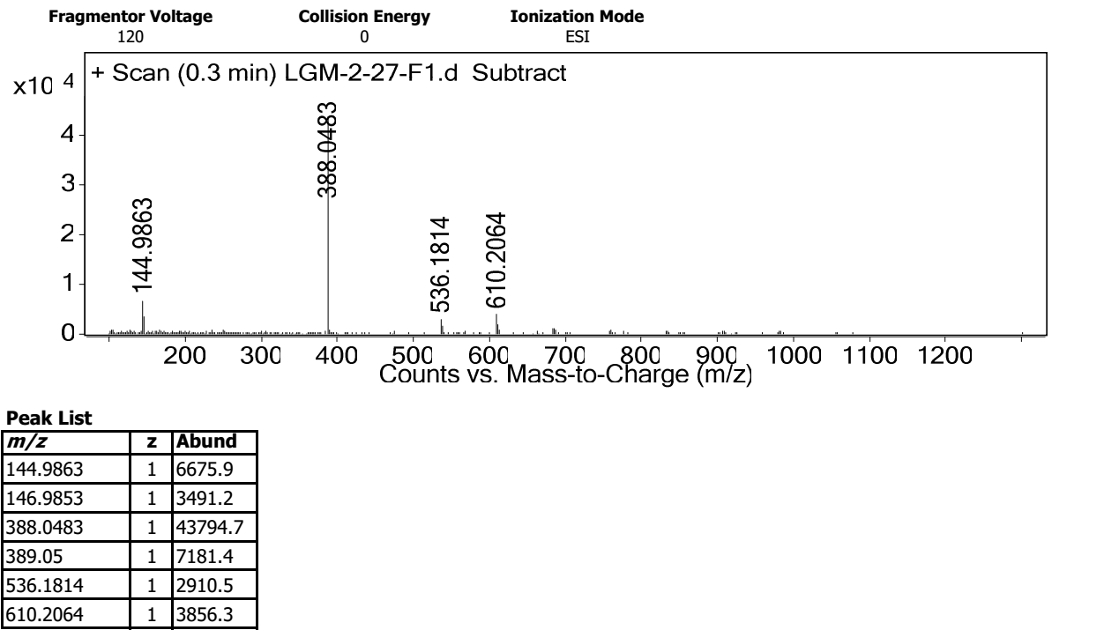
HRMS spectrum of 7ah.
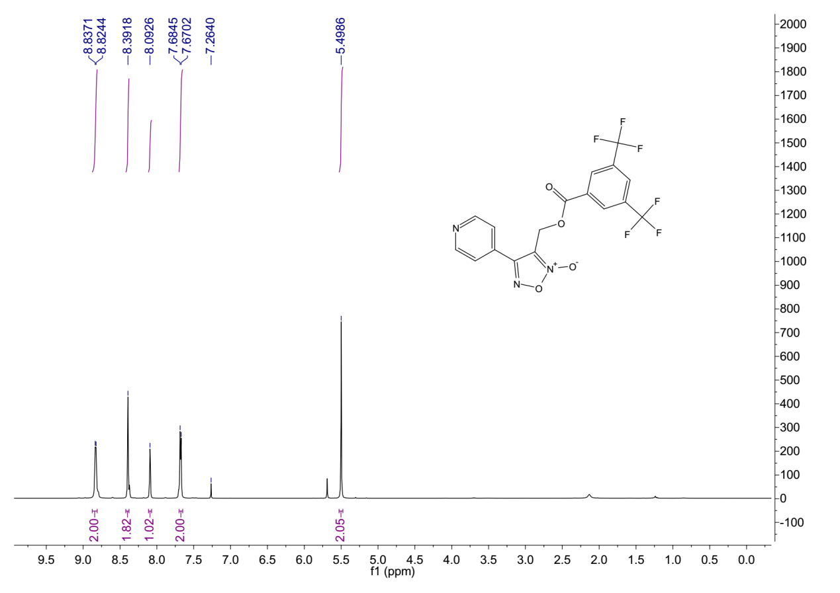
¹H-NMR (400 MHz, Chloroform-d) spectrum of 7ai.

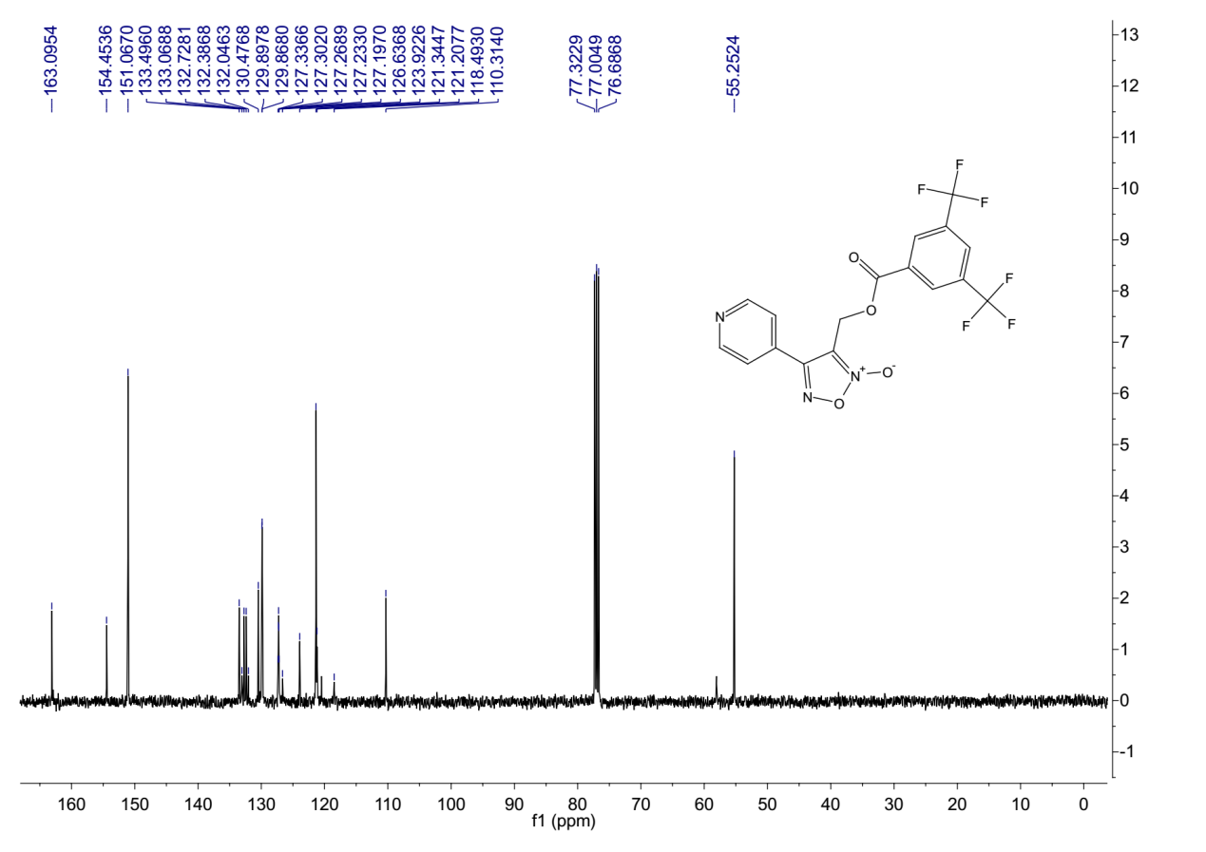
¹³C-NMR (101 MHz, Chloroform-d) spectrum of 7ai.
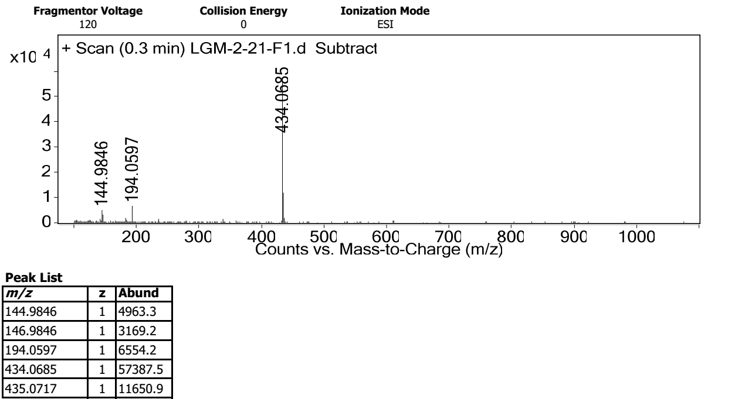
HRMS spectrum of 7ai.

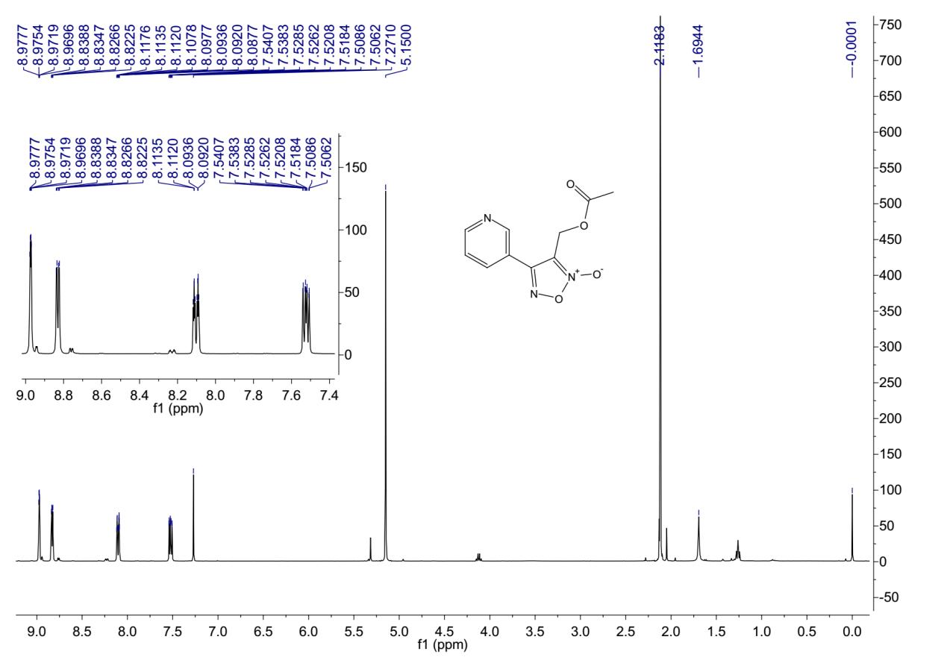
¹H-NMR (400 MHz, Chloroform-d) spectrum of 7ba.
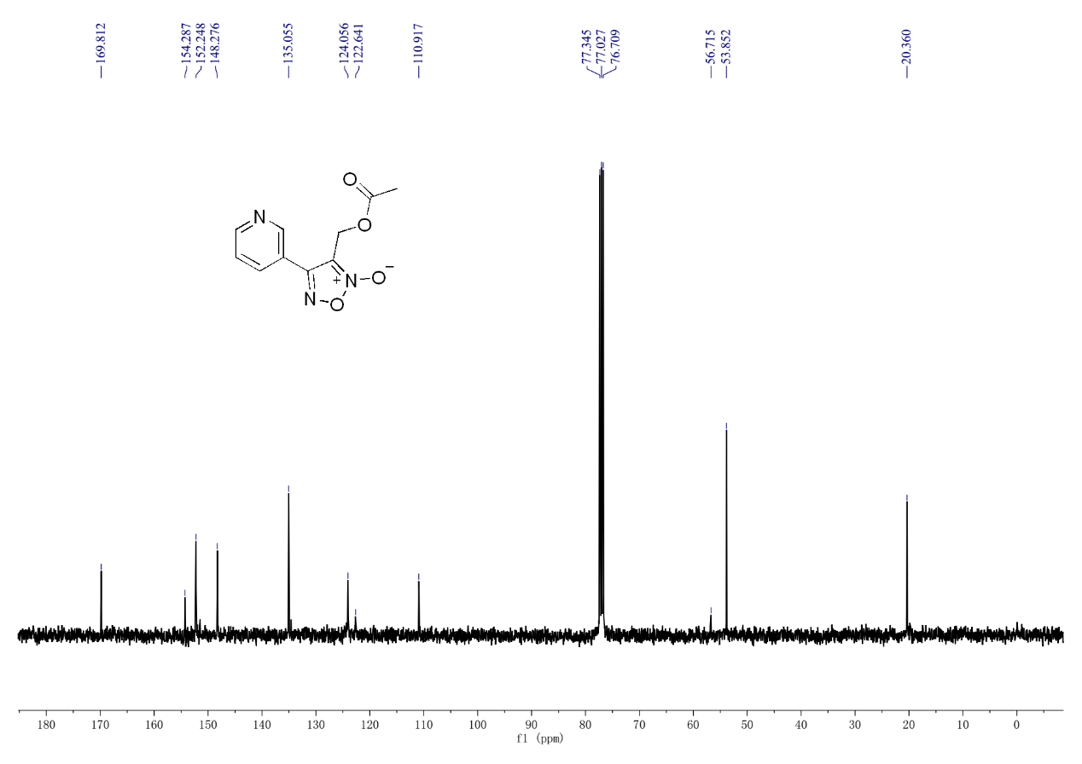
¹³C-NMR (101 MHz, Chloroform-d) spectrum of 7ba.

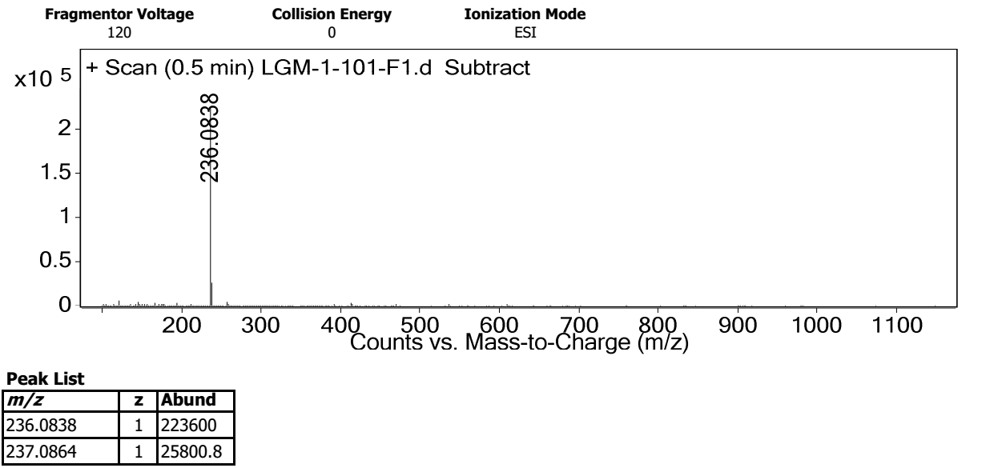
HRMS spectrum of 7ba.
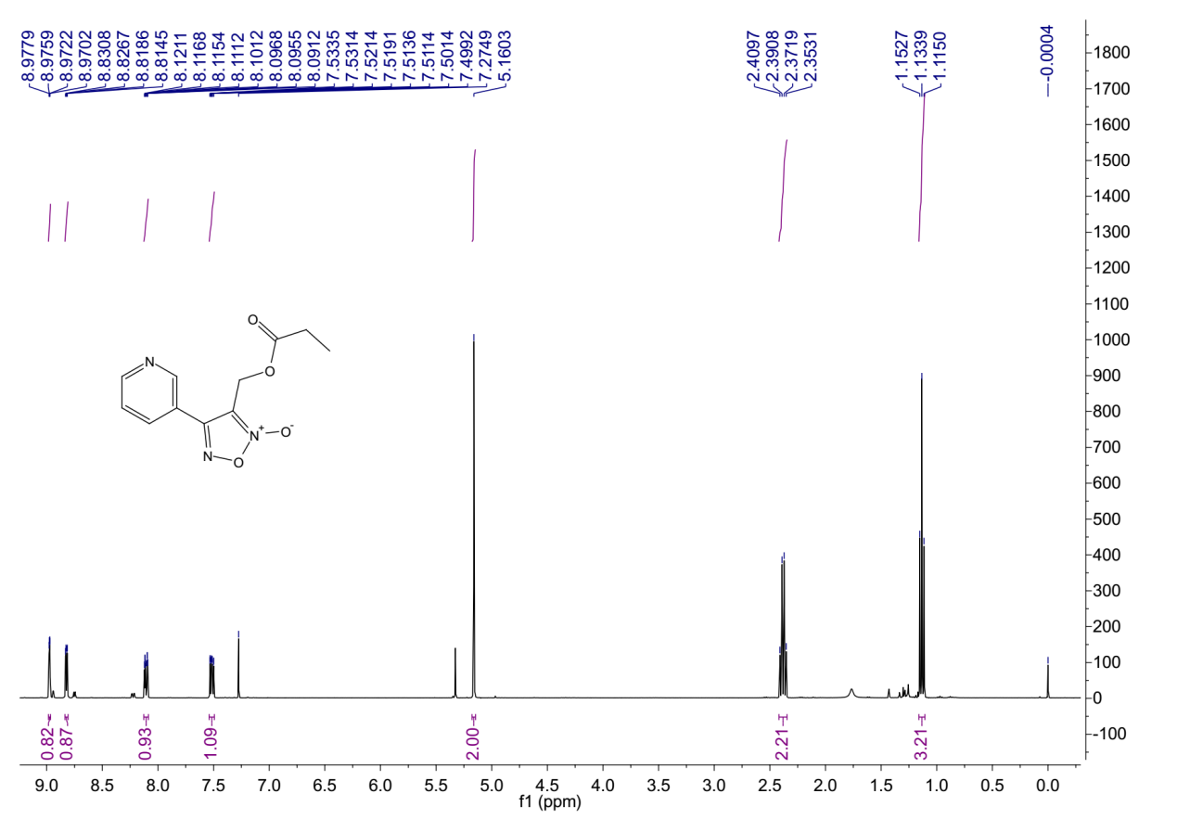
¹H-NMR (400 MHz, Chloroform-d) spectrum of 7bb.

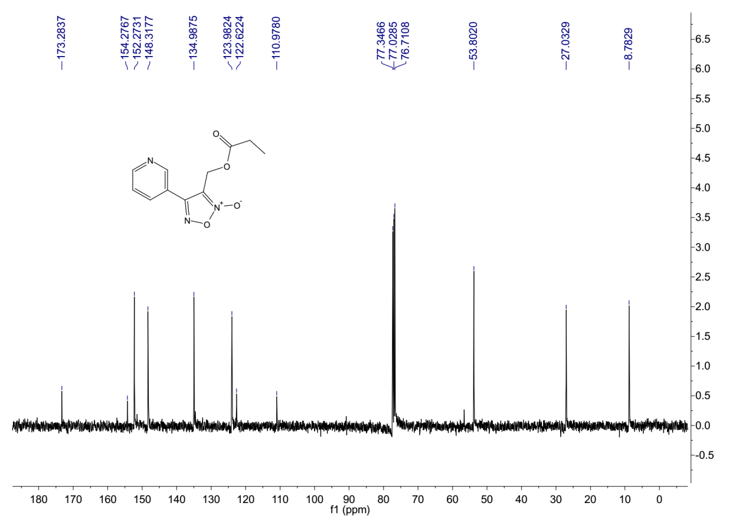
¹³C-NMR (101 MHz, Chloroform-d) spectrum of 7bb.
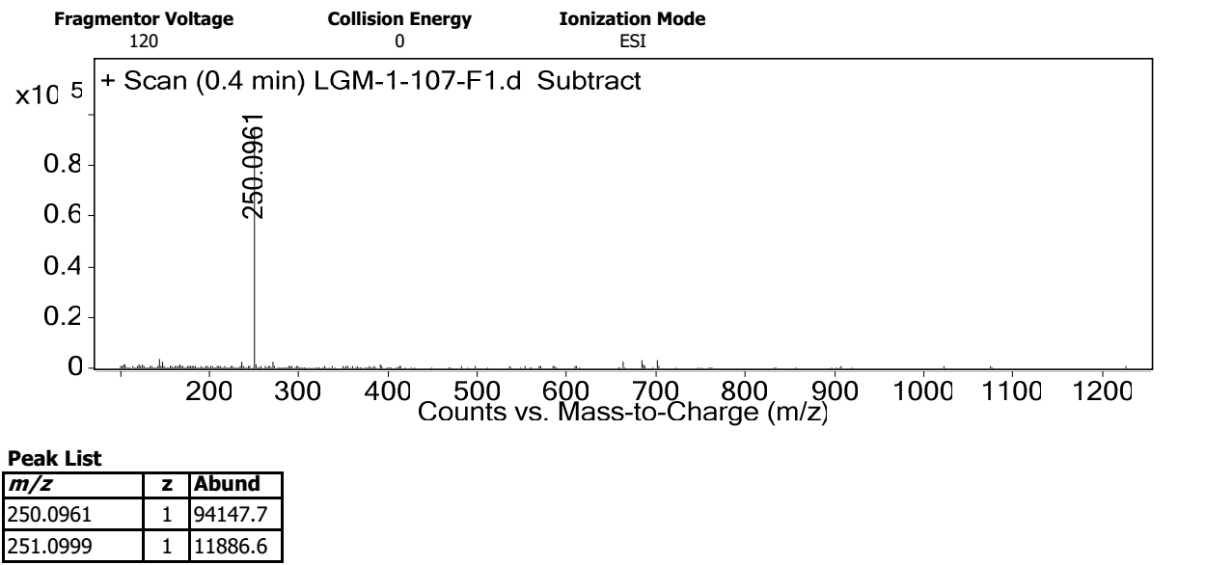
HRMS spectrum of 7bb.

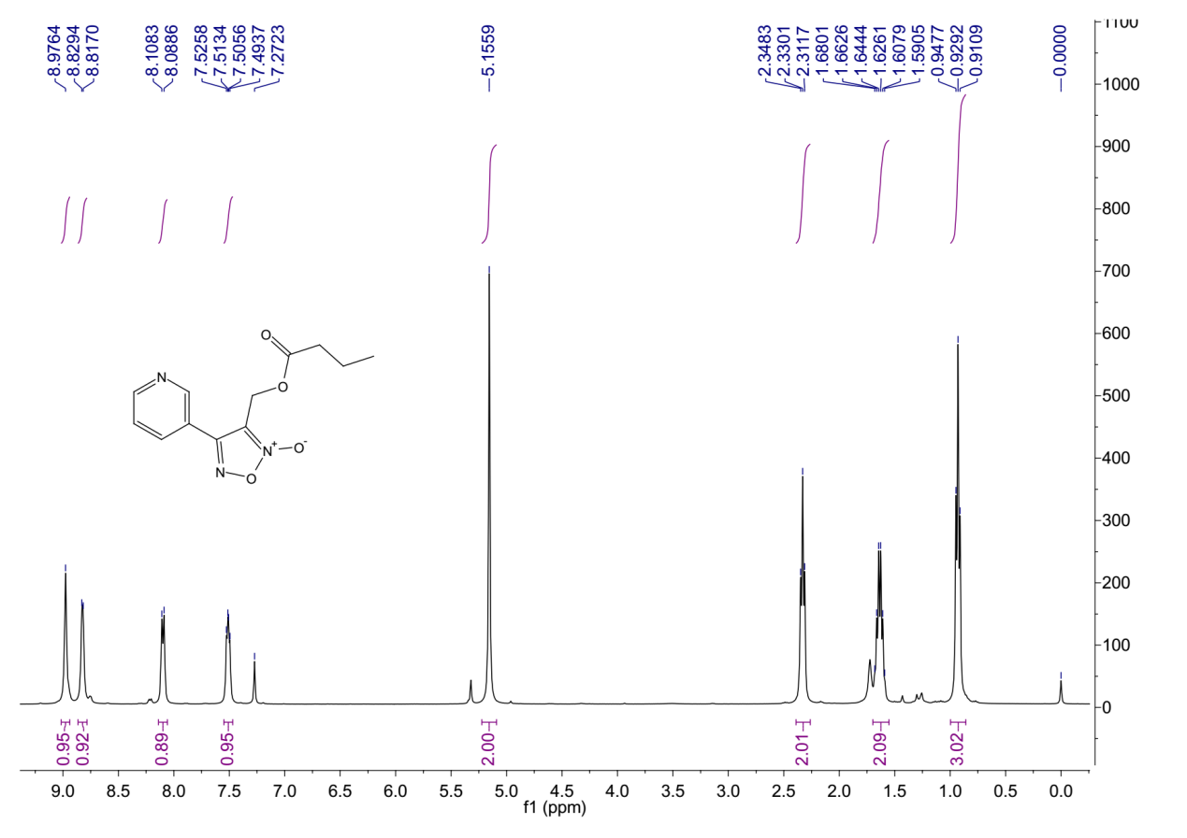
¹H-NMR (400 MHz, Chloroform-d) spectrum of 7bc.
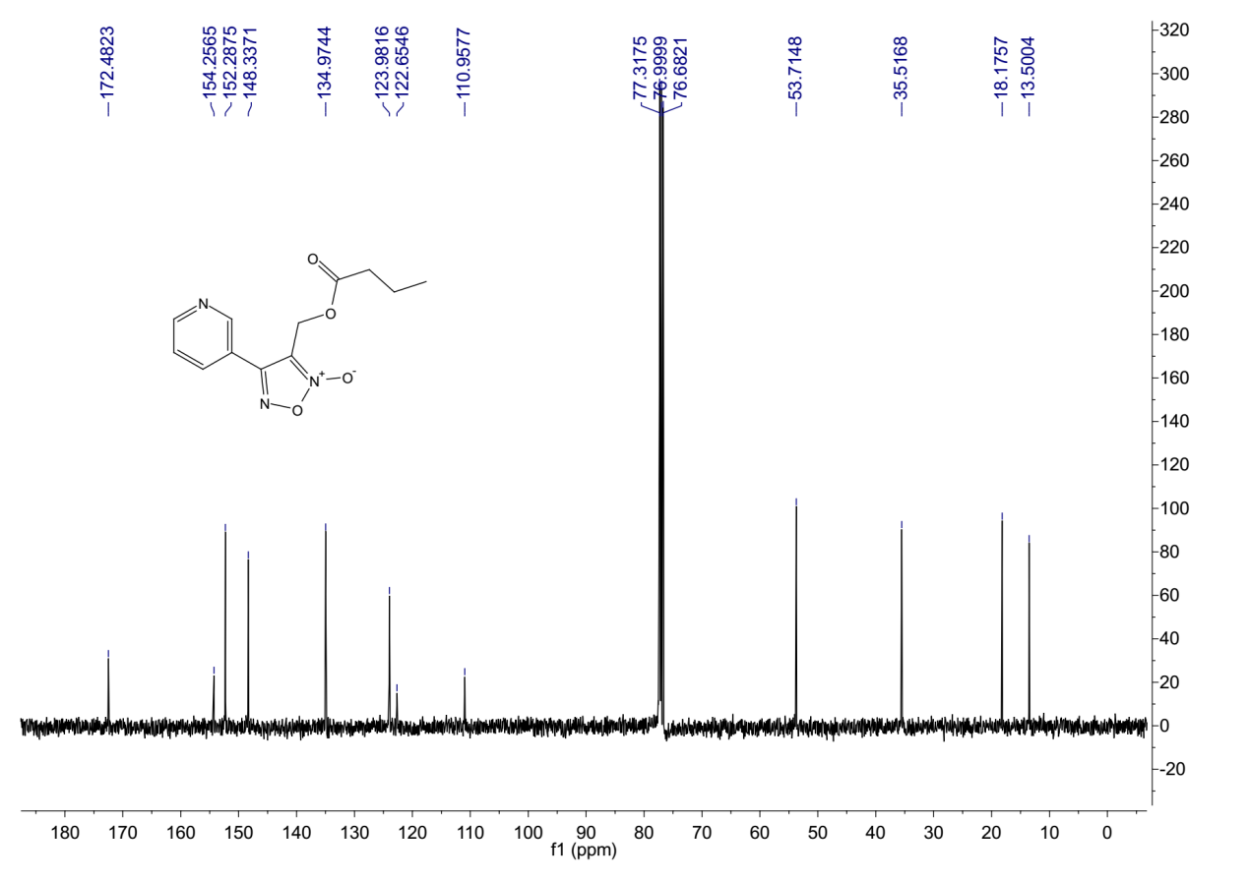
¹³C-NMR (101 MHz, Chloroform-d) spectrum of 7bc.

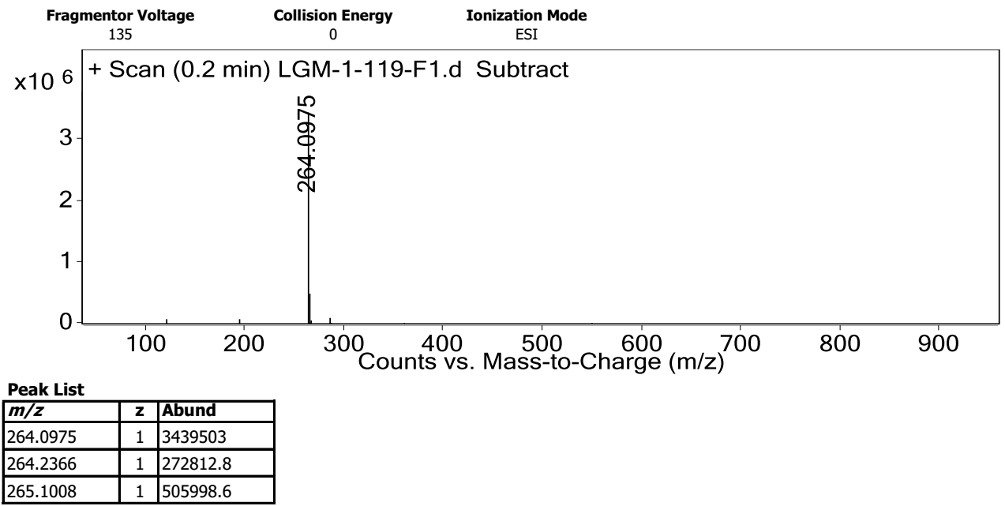
HRMS spectrum of 7bc.
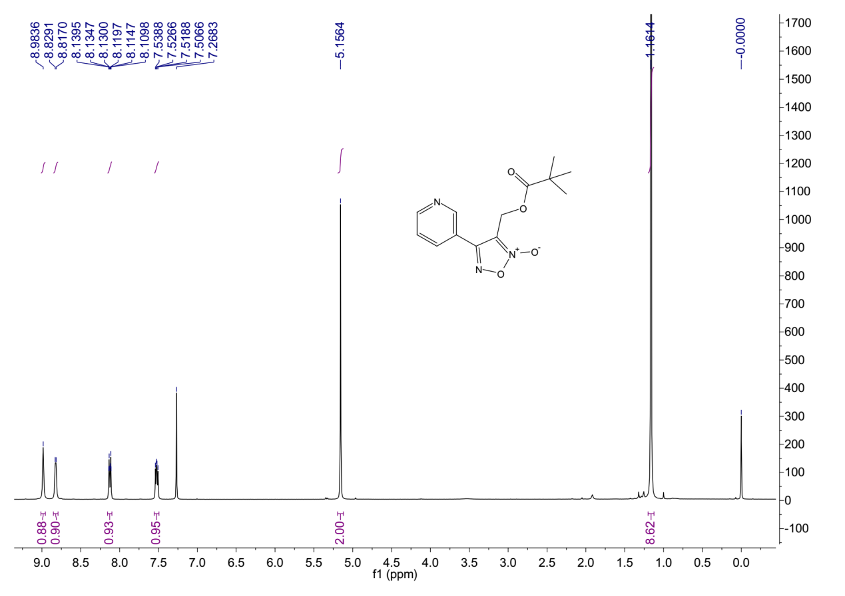
¹H-NMR (400 MHz, Chloroform-d) spectrum of 7bd.

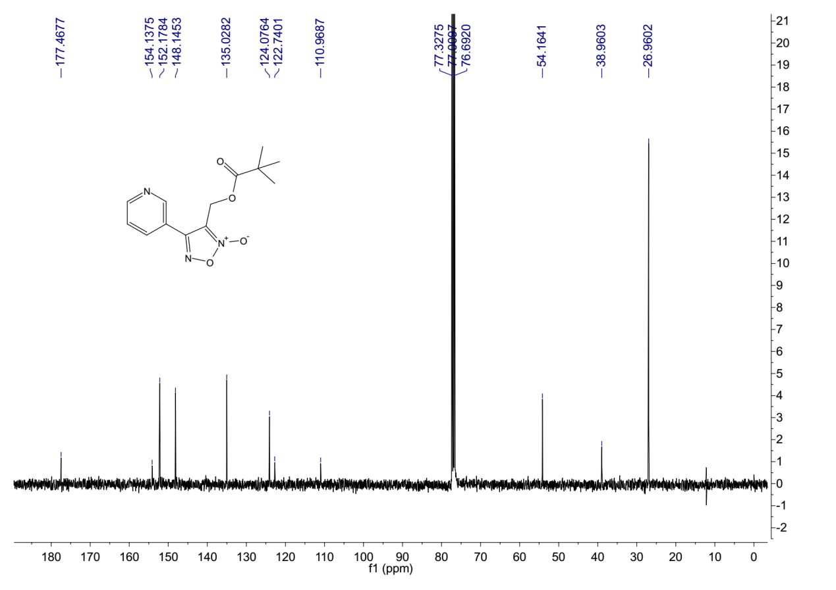
¹³C-NMR (101 MHz, Chloroform-d) spectrum of 7bd.
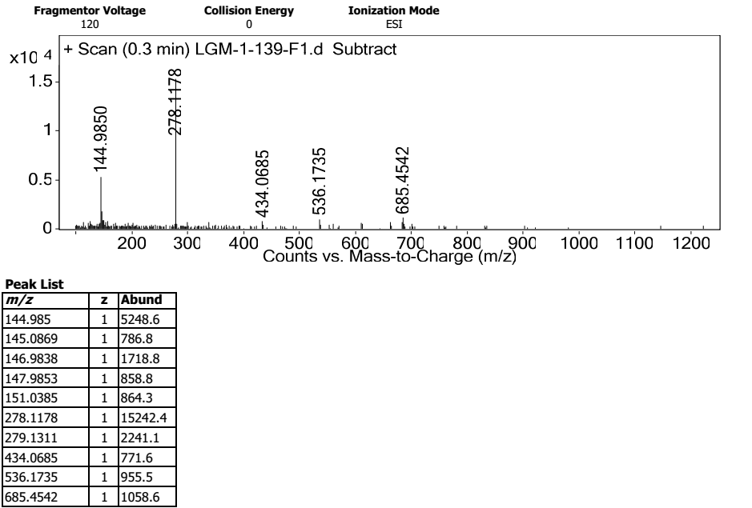
HRMS spectrum of 7bd.

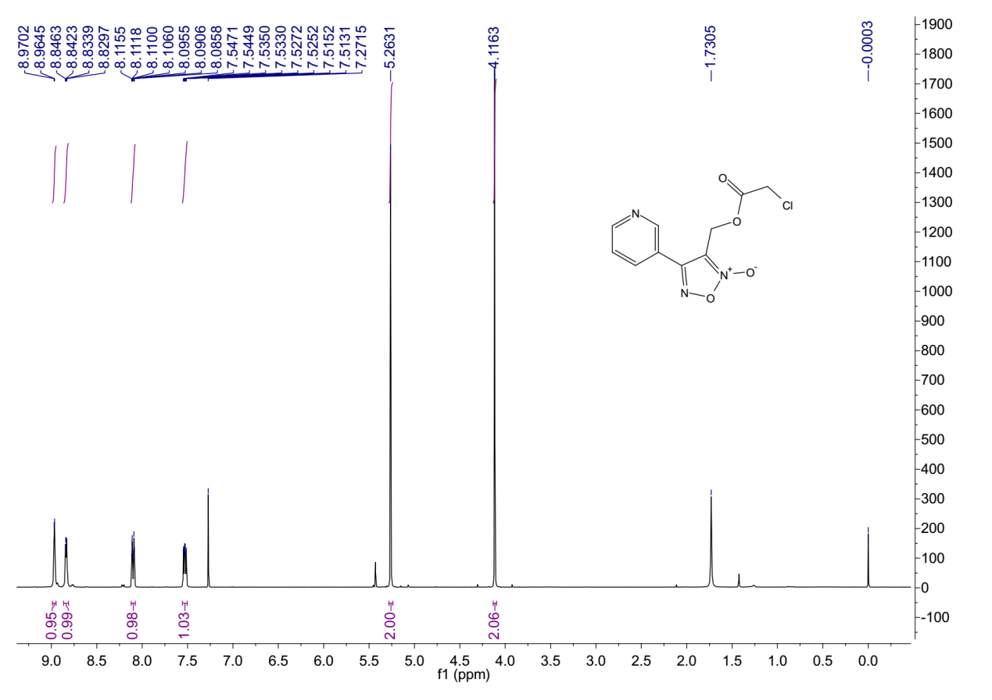
¹H-NMR (400 MHz, Chloroform-d) spectrum of 7be.
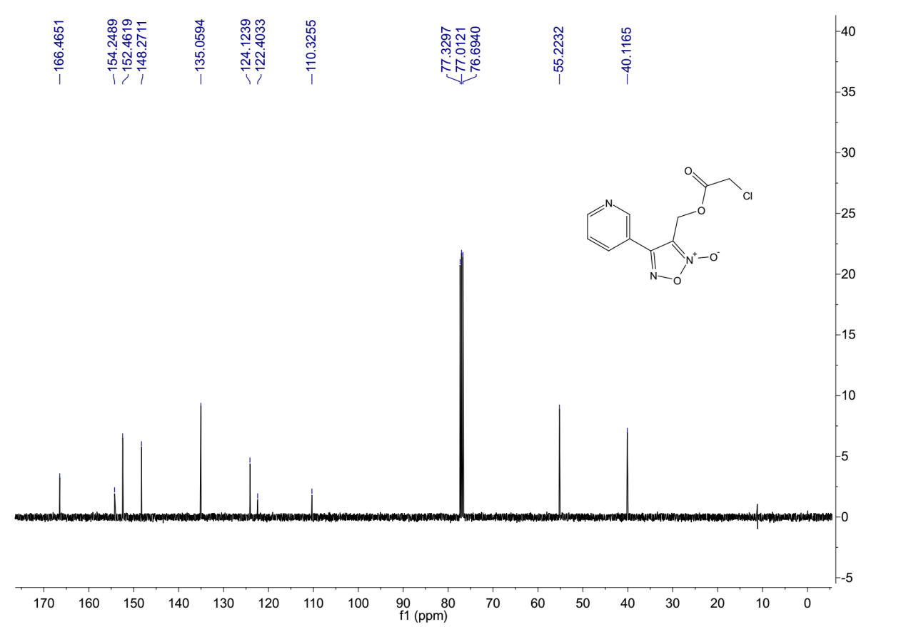
¹³C-NMR (101 MHz, Chloroform-d) spectrum of 7be.

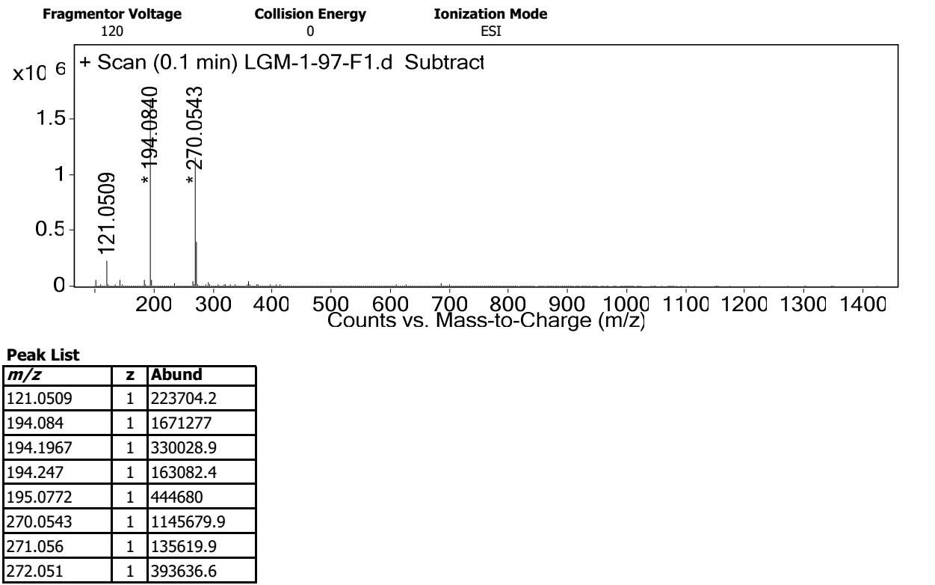
HRMS spectrum of 7be.
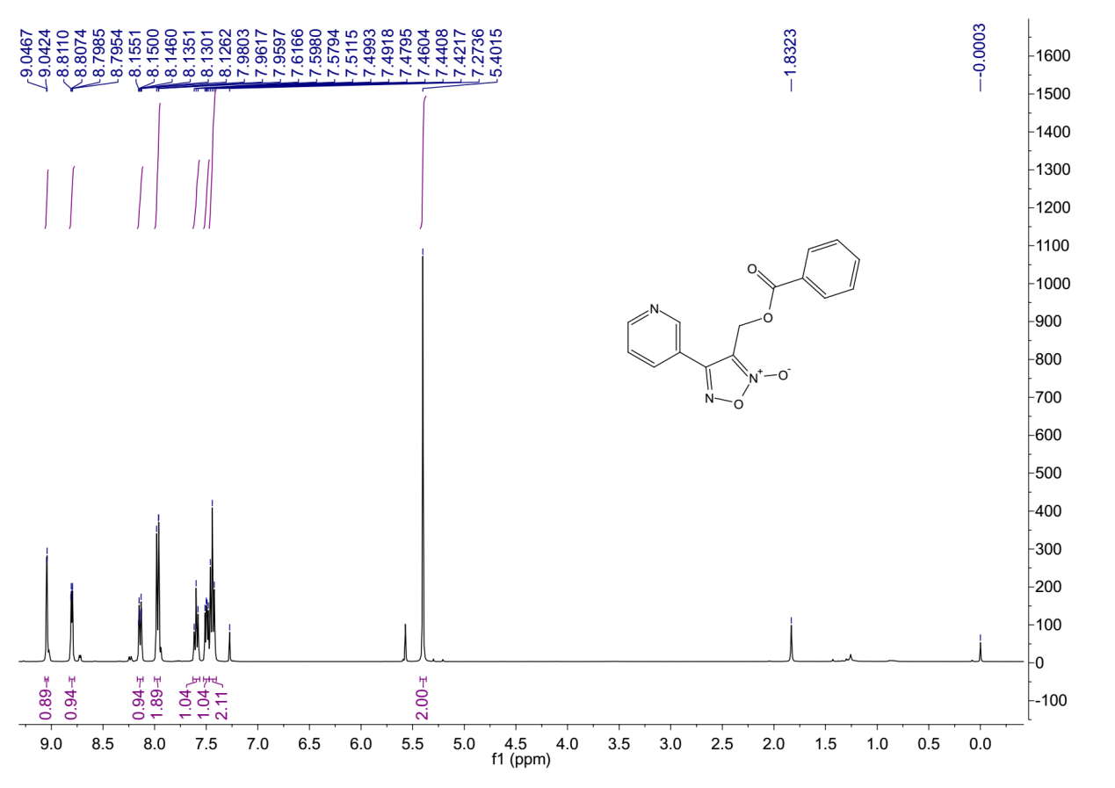
¹H-NMR (400 MHz, Chloroform-d) spectrum of 7bf.

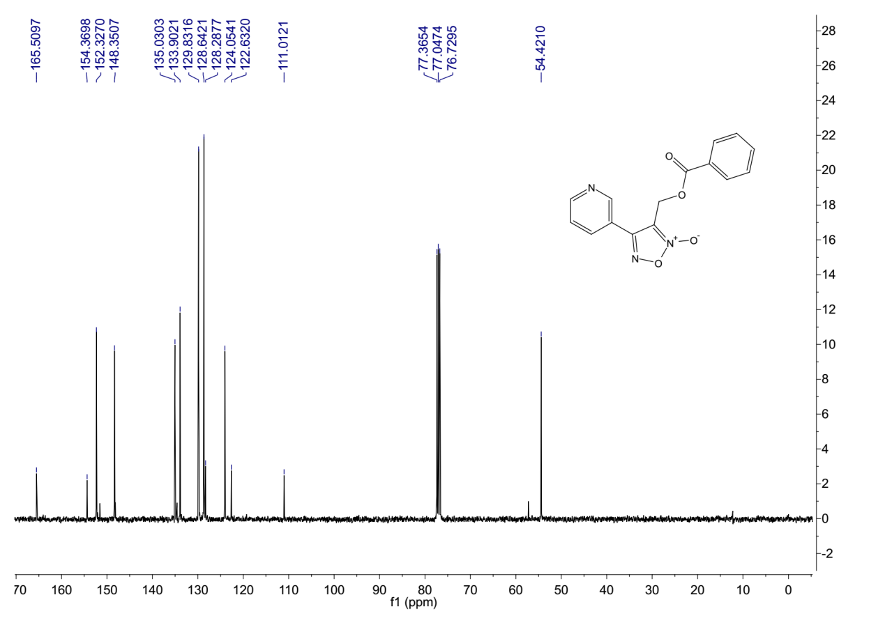
¹³C-NMR (101 MHz, Chloroform-d) spectrum of 7bf.
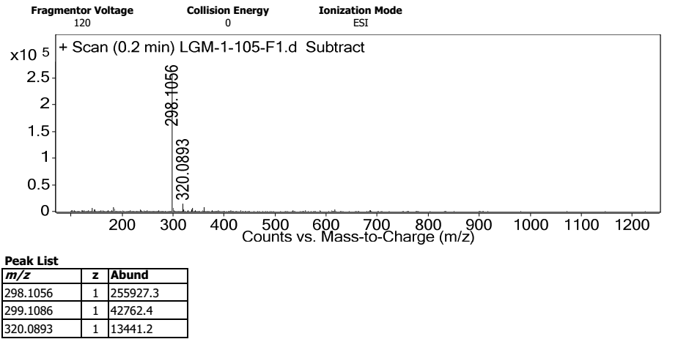
HRMS spectrum of 7bf.

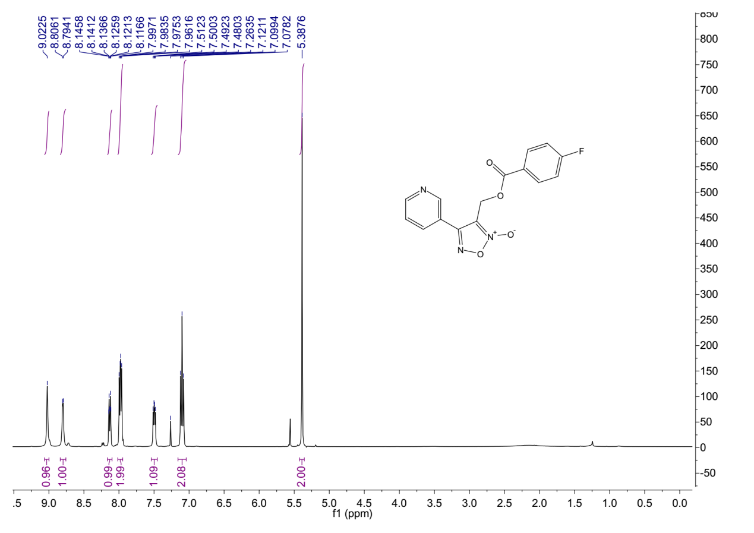
¹H-NMR (400 MHz, Chloroform-d) spectrum of 7bg.
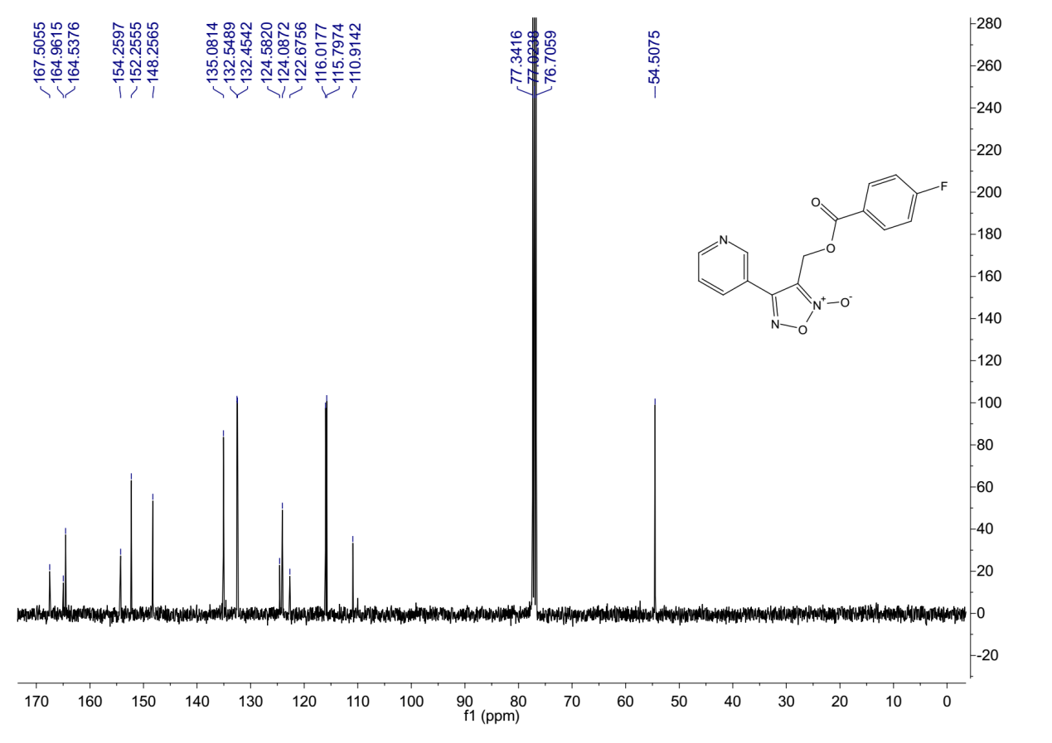
¹³C-NMR (101 MHz, Chloroform-d) spectrum of 7bg.

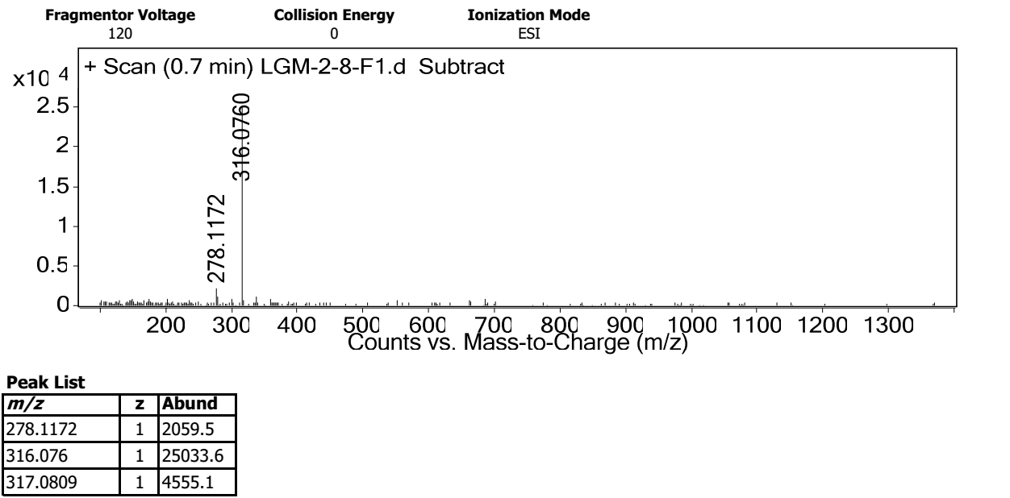
HRMS spectrum of 7bg.
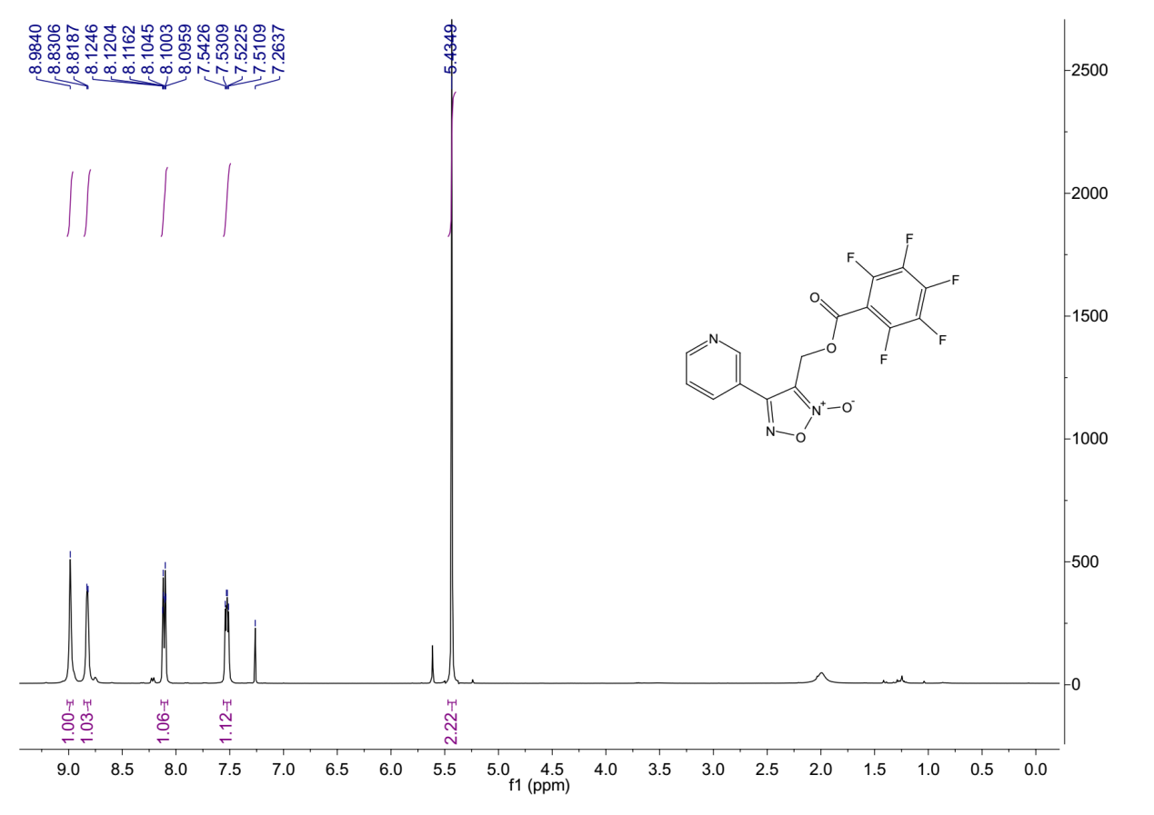
¹H-NMR (400 MHz, Chloroform-d) spectrum of 7bh.

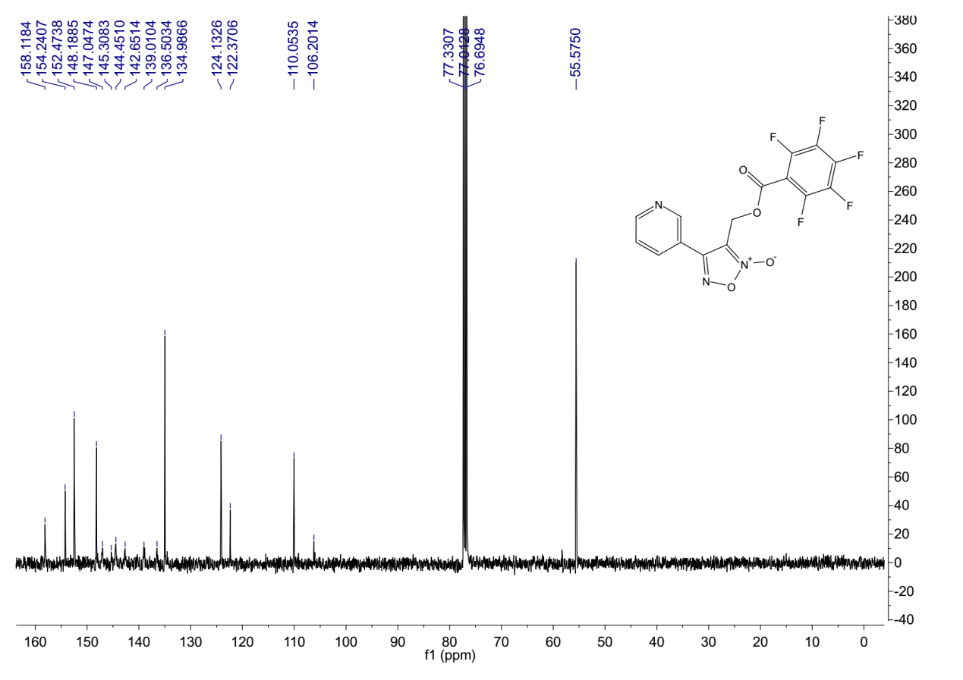
¹³C-NMR (101 MHz, Chloroform-d) spectrum of 7bh.
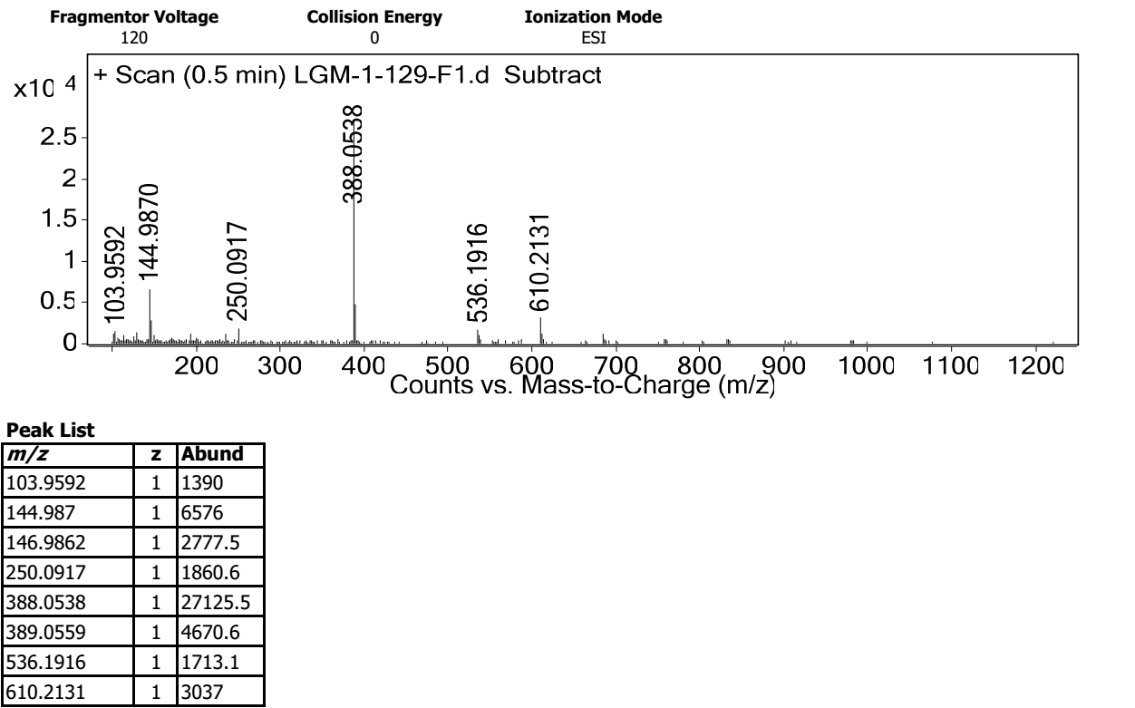
HRMS spectrum of 7bh.

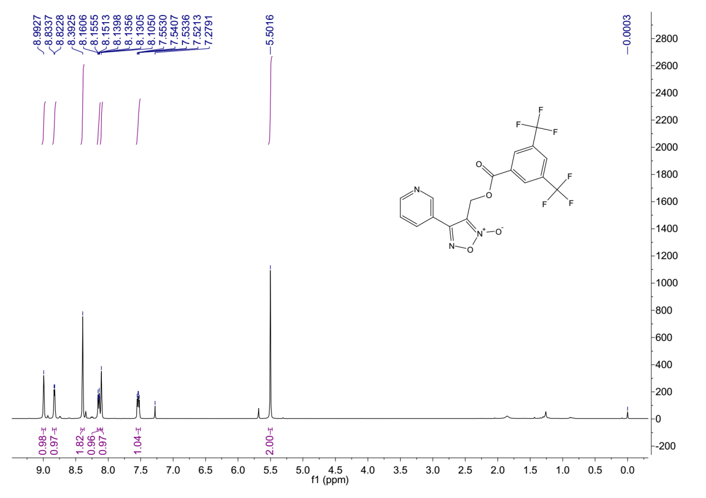
¹H-NMR (400 MHz, Chloroform-d) spectrum of 7bi.
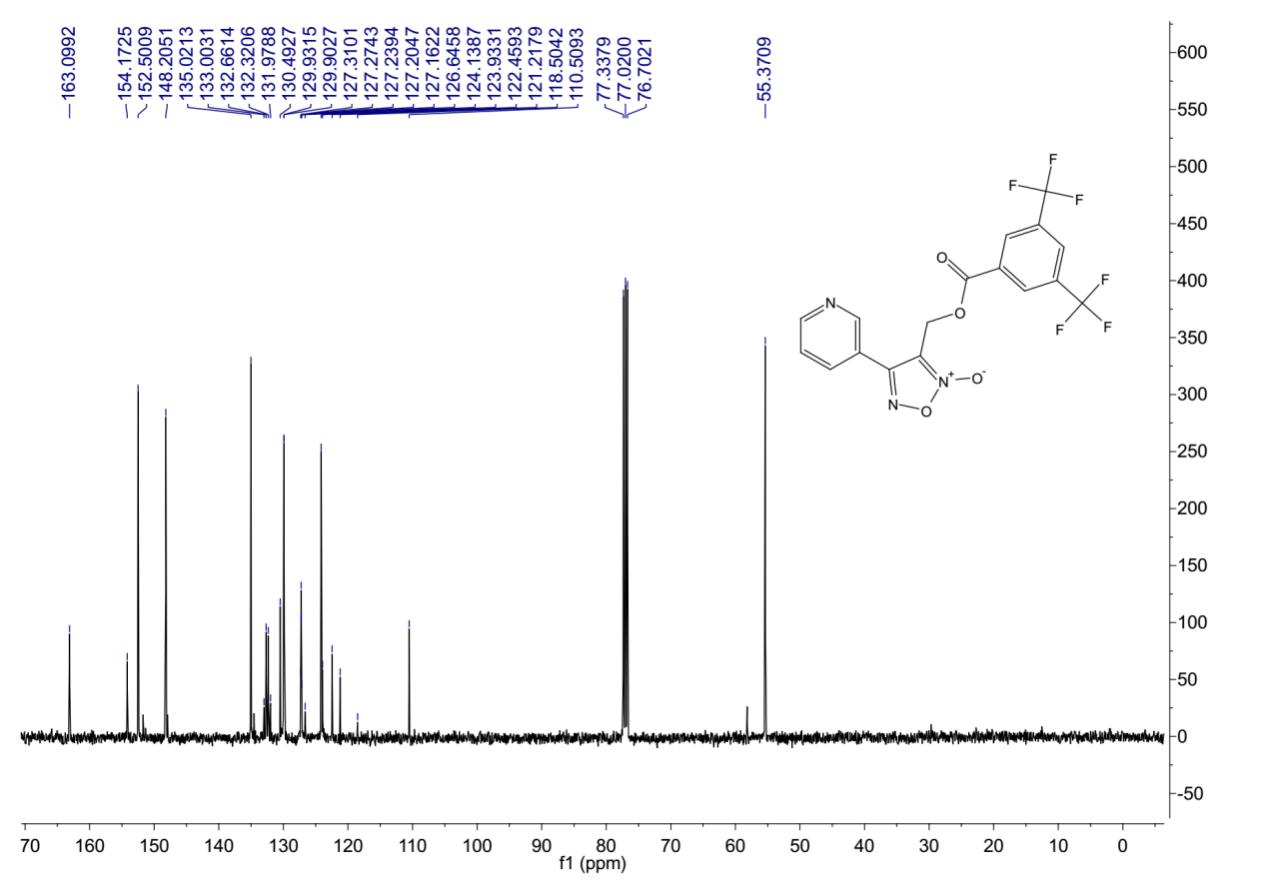
¹³C-NMR (101 MHz, Chloroform-d) spectrum of 7bi.

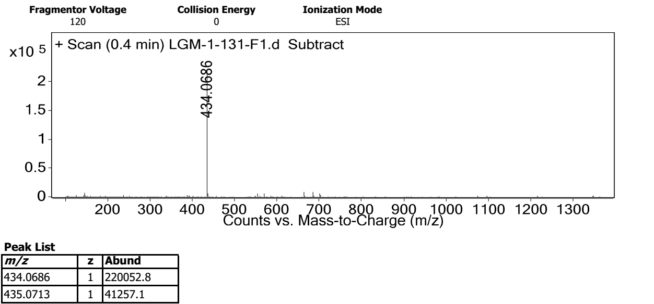
HRMS spectrum of 7bi.
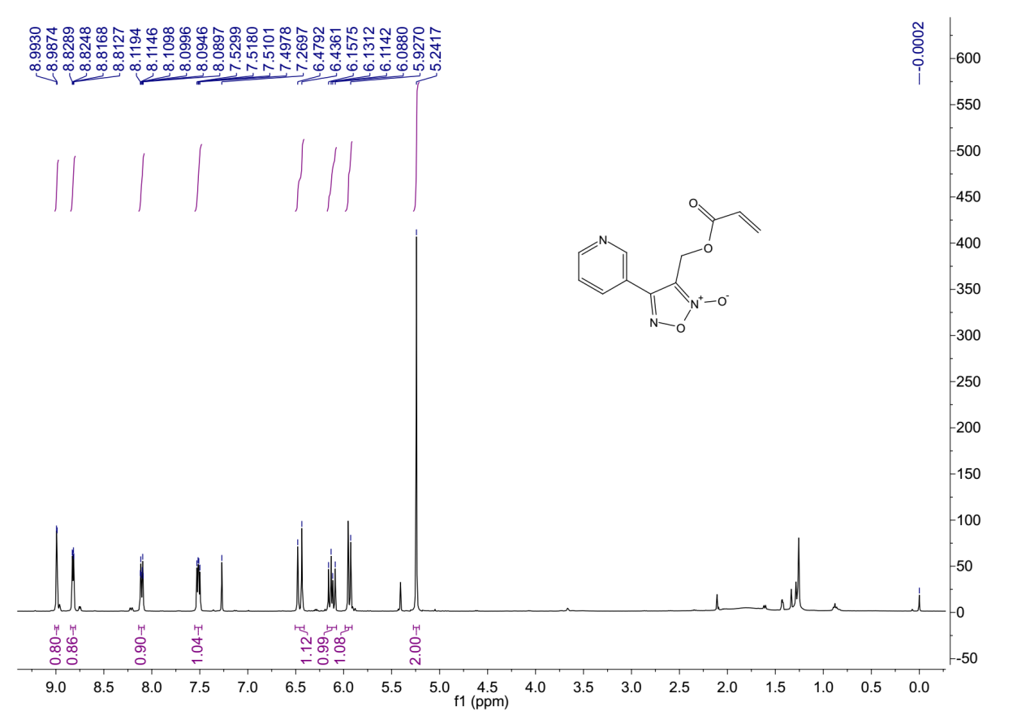
¹H-NMR (400 MHz, Chloroform-d) spectrum of 7bj.

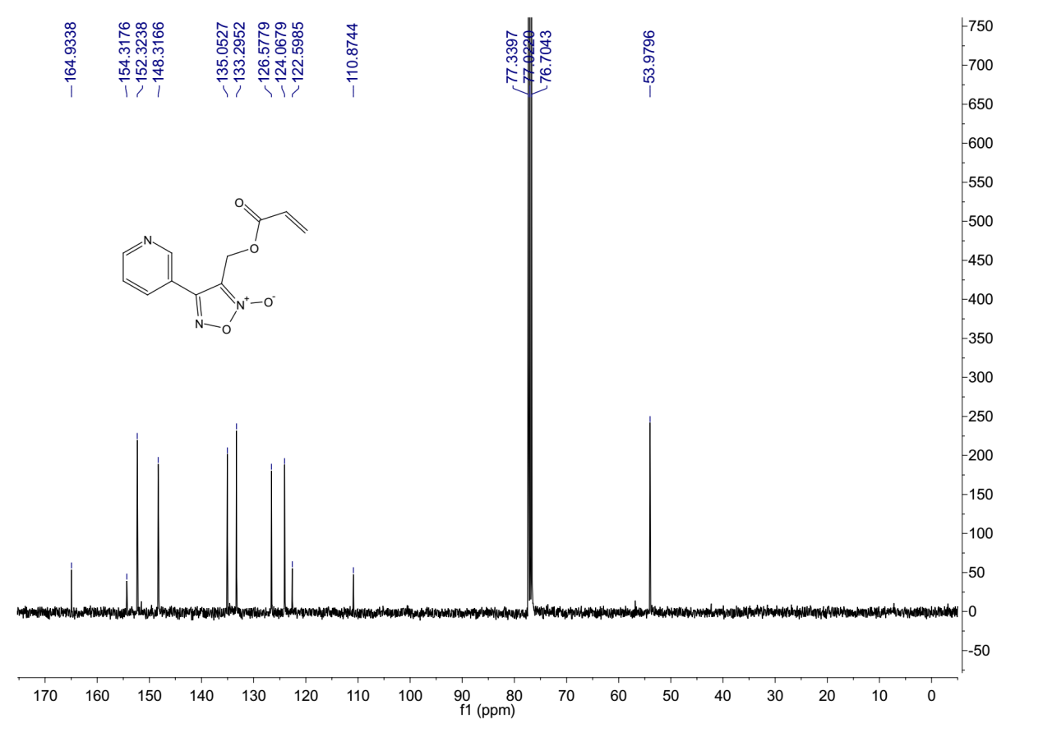
¹³C-NMR (101 MHz, Chloroform-d) spectrum of 7bj.
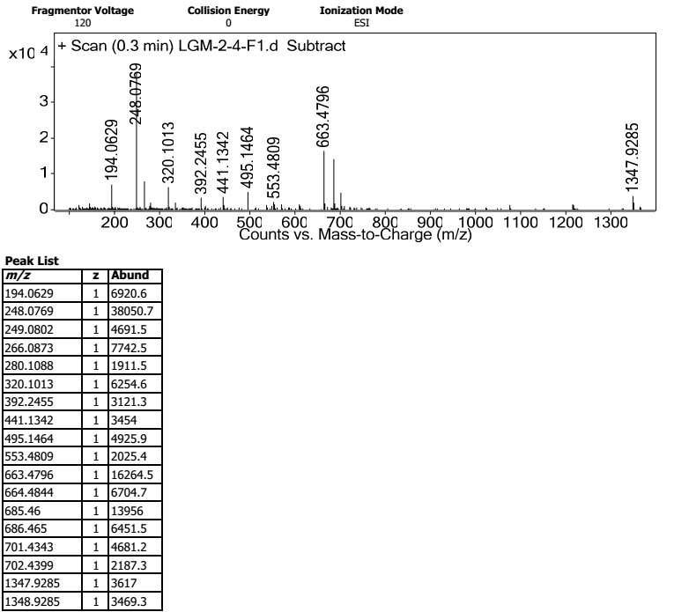
HRMS spectrum of 7bj.
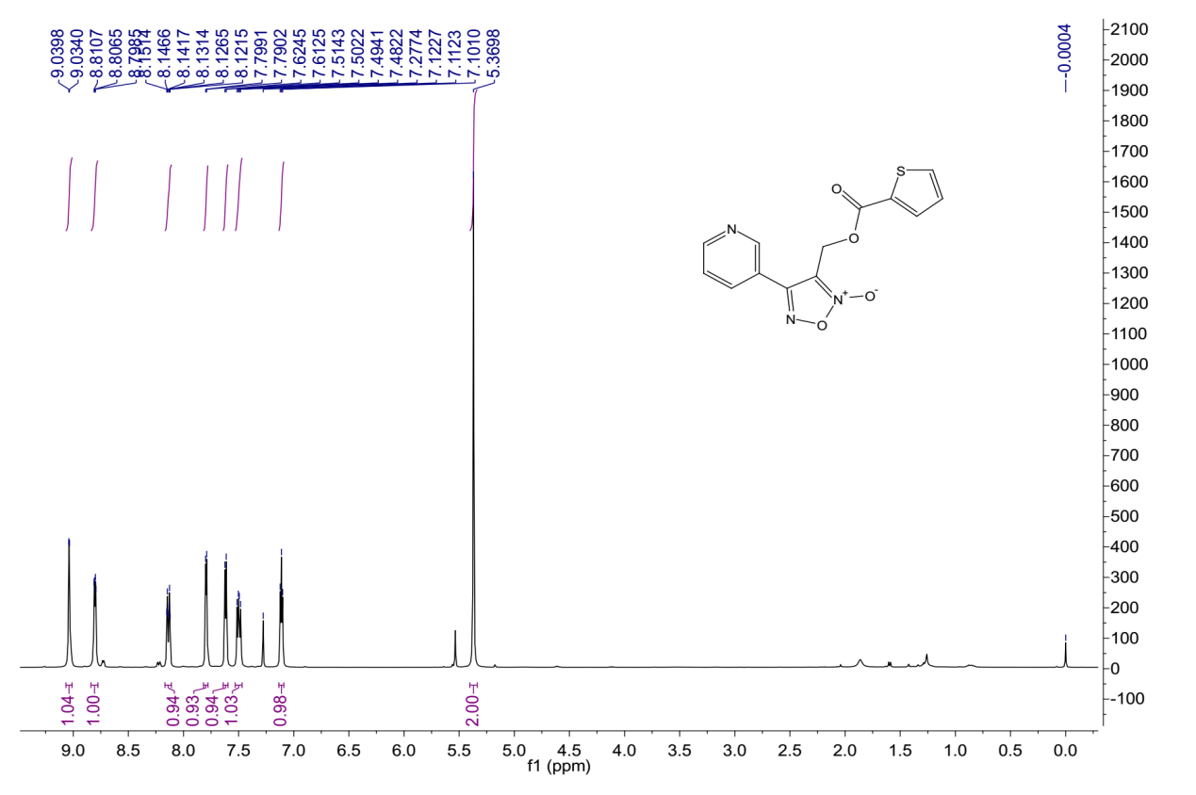
¹H-NMR (400 MHz, Chloroform-d) spectrum of 7bk.
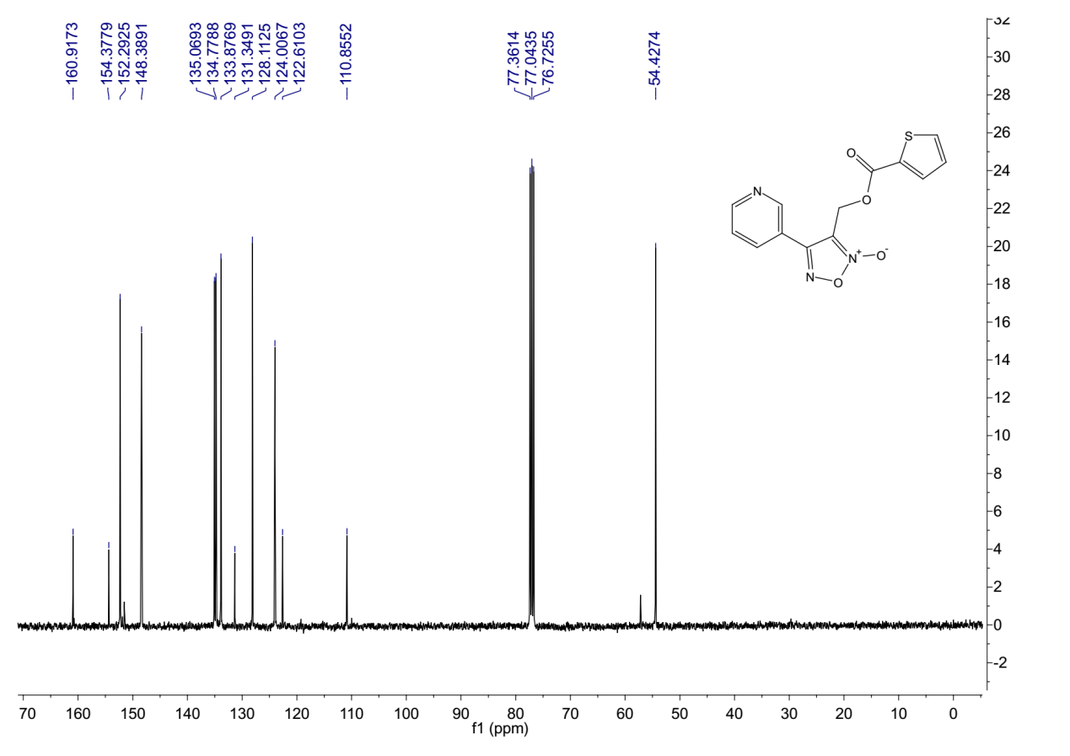
¹³C-NMR (101 MHz, Chloroform-d) spectrum of 7bk.

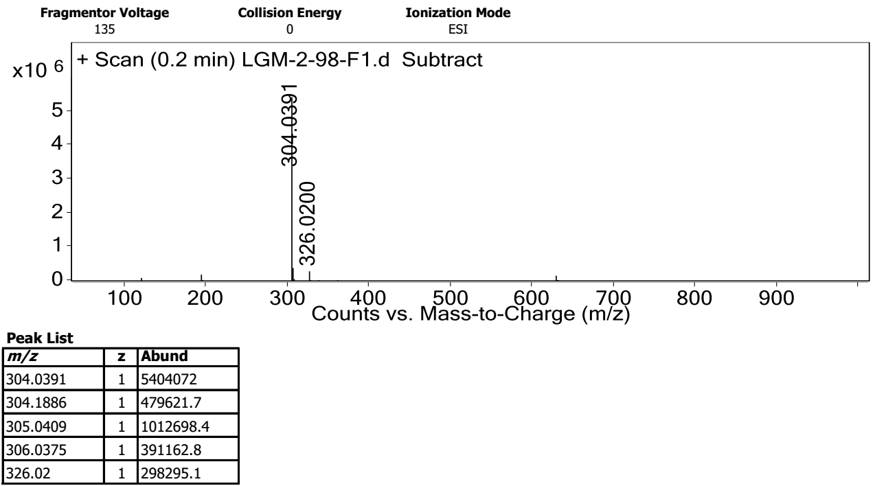
HRMS spectrum of 7bk.
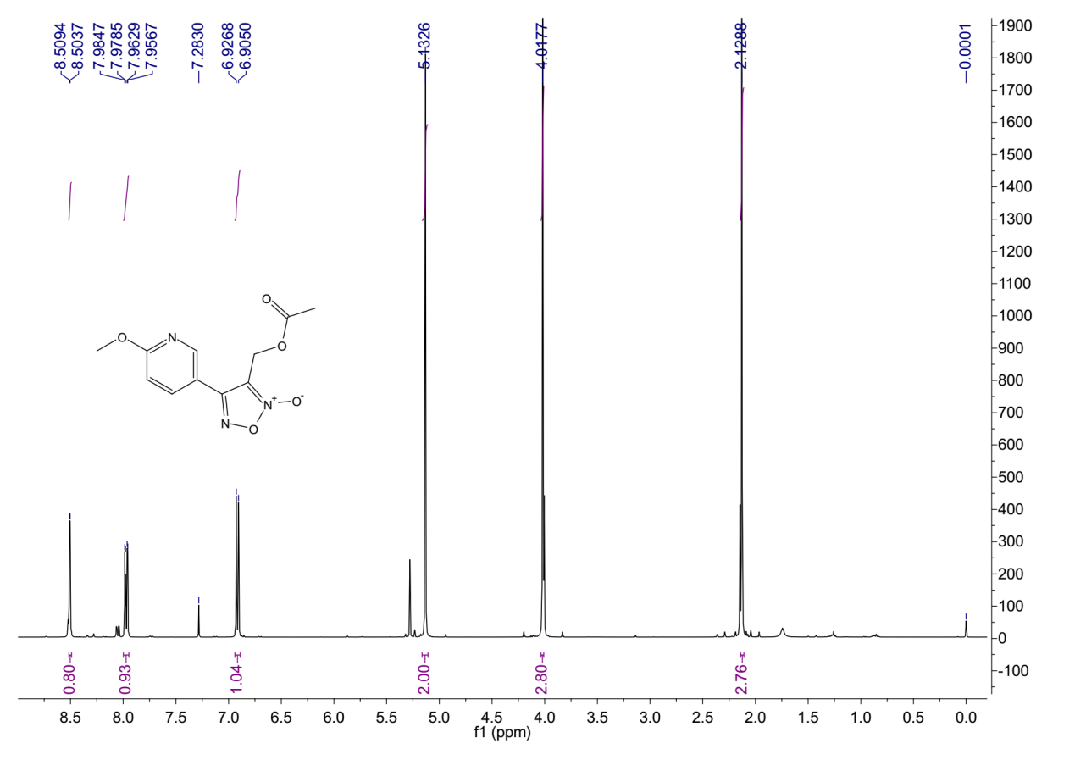
¹H-NMR (400 MHz, Chloroform-d) spectrum of 7ca.

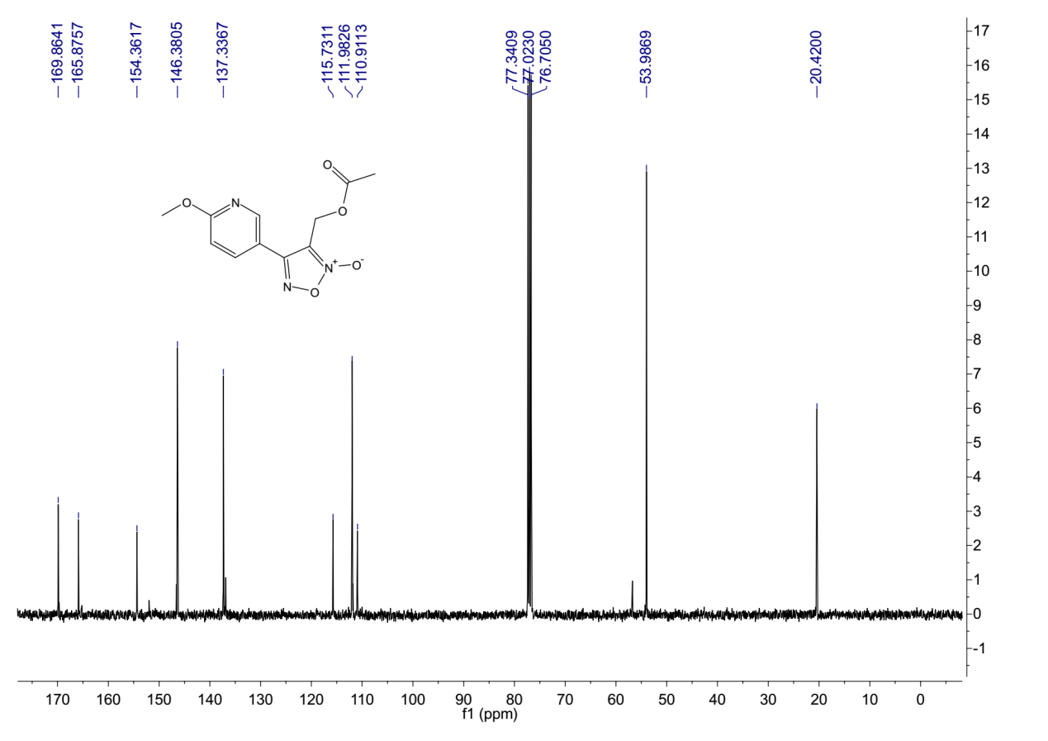
¹³C-NMR (101 MHz, Chloroform-d) spectrum of 7ca.
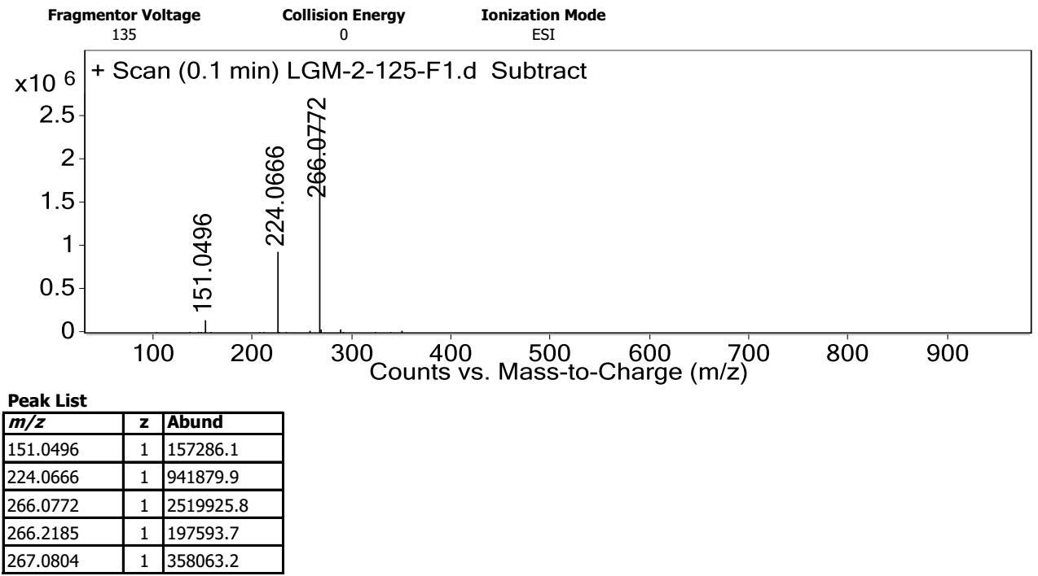
HRMS spectrum of 7ca.

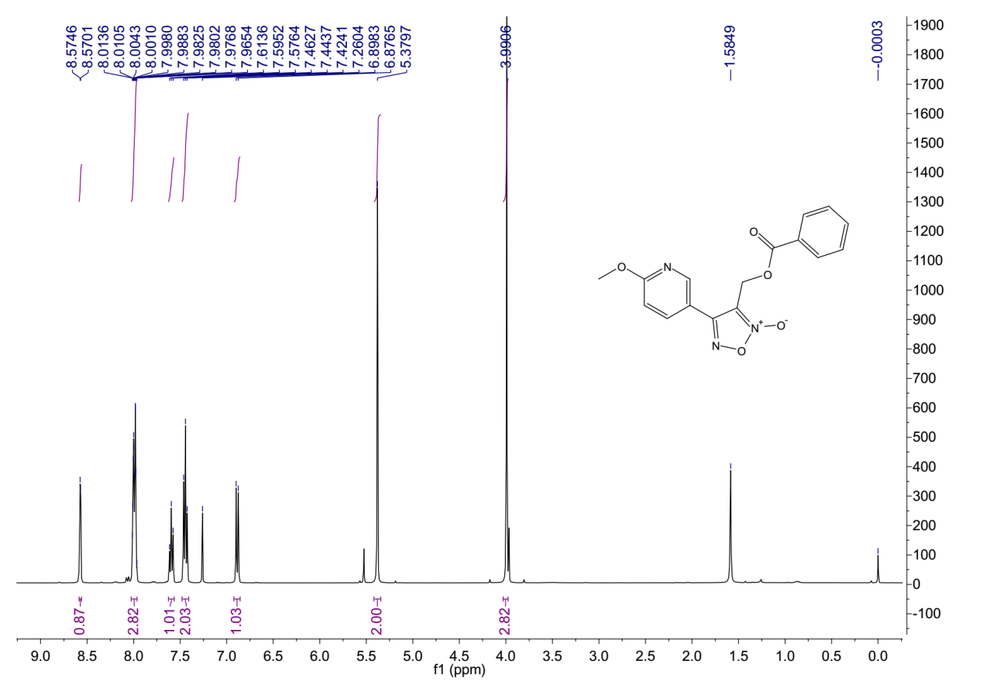
¹H-NMR (400 MHz, Chloroform-d) spectrum of 7cf.
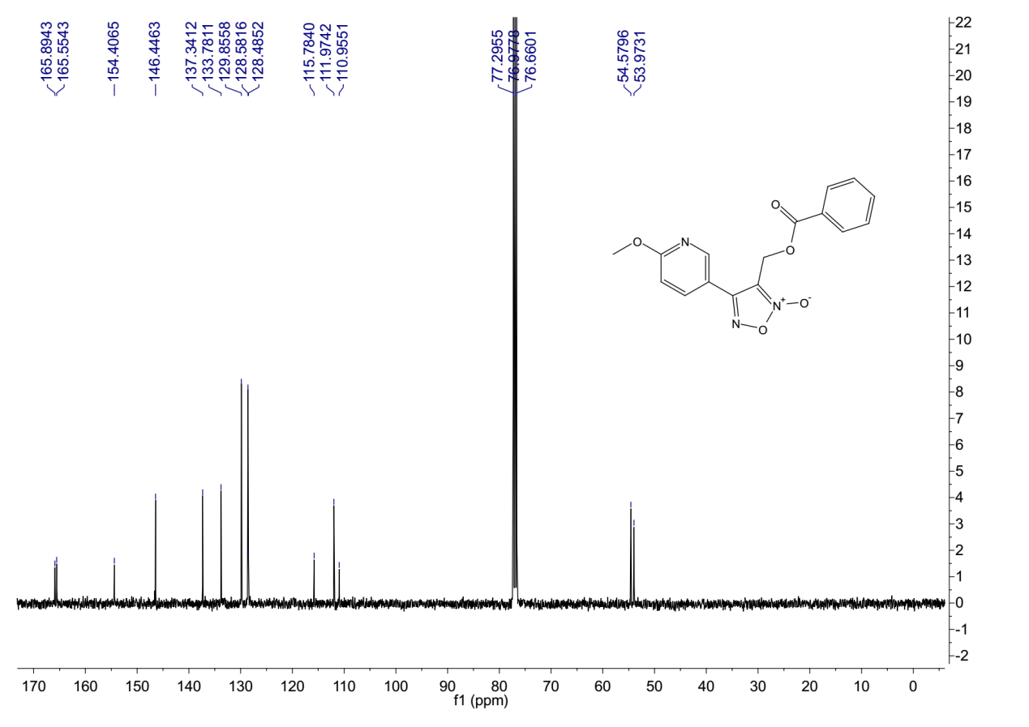
¹³C-NMR (101 MHz, Chloroform-d) spectrum of 7cf.

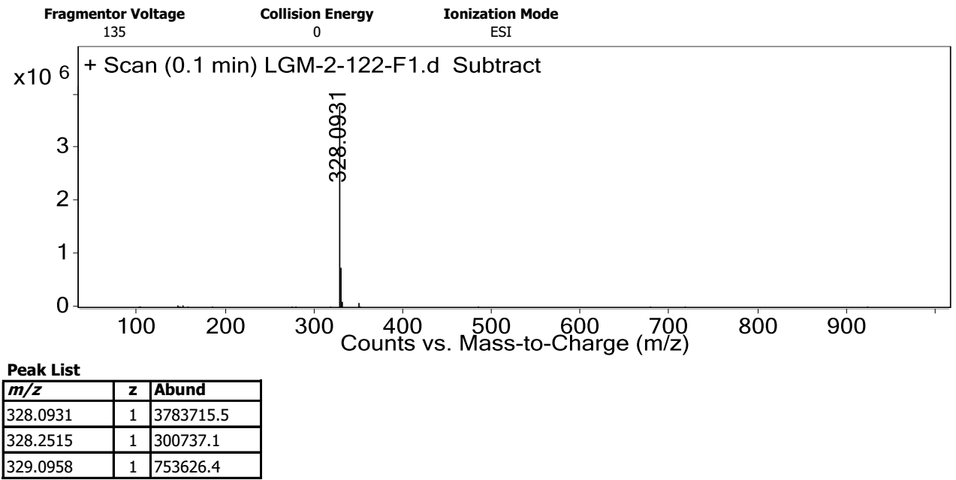
HRMS spectrum of 7cf.
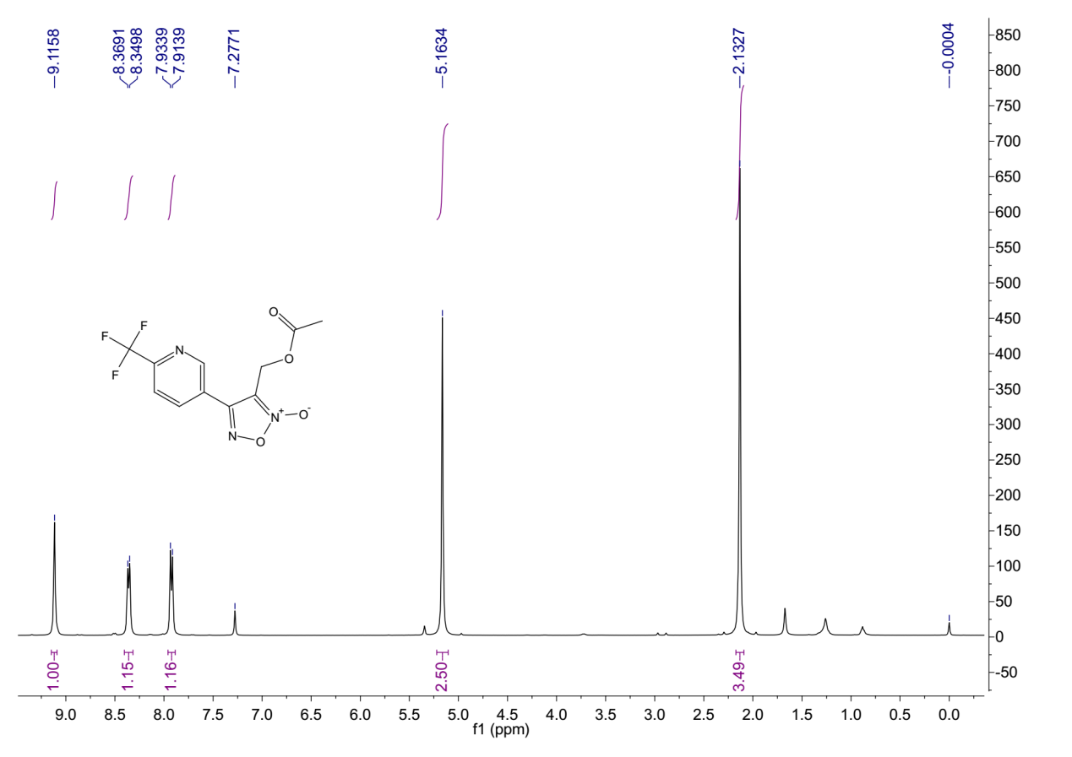
¹H-NMR (400 MHz, Chloroform-d) spectrum of 7da.

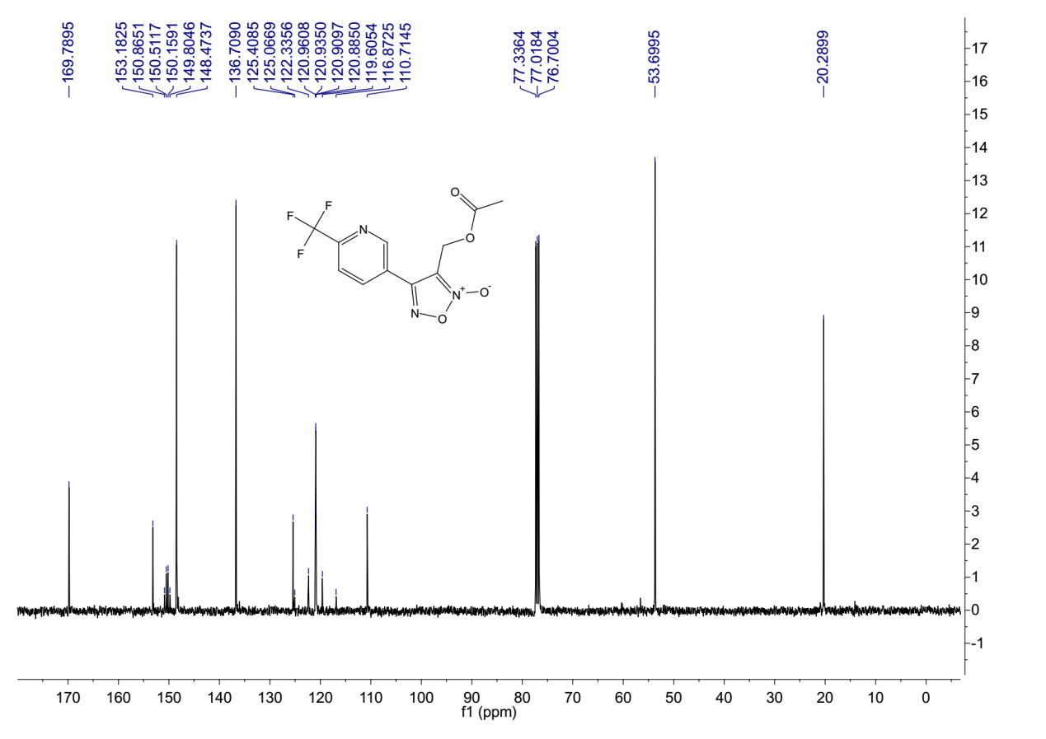
¹³C-NMR (101 MHz, Chloroform-d) spectrum of 7da.
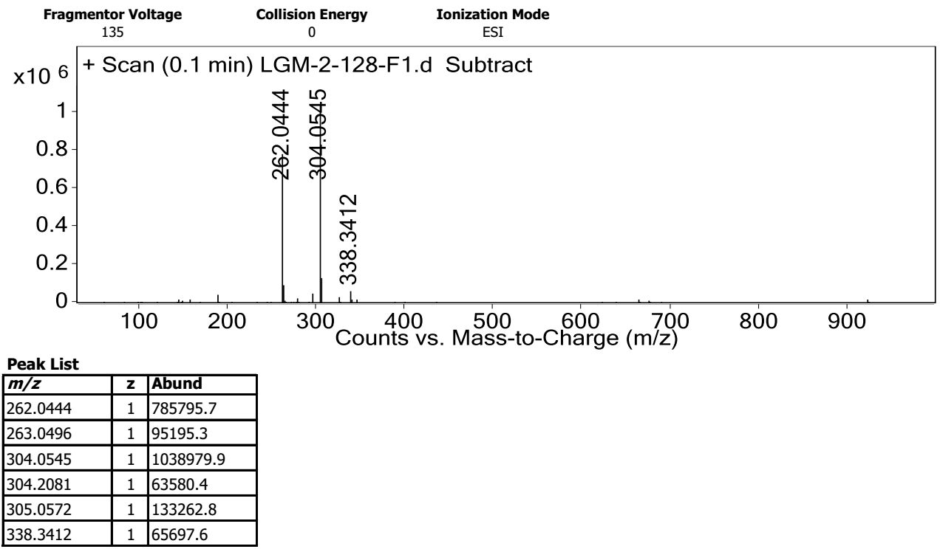
HRMS spectrum of 7da.

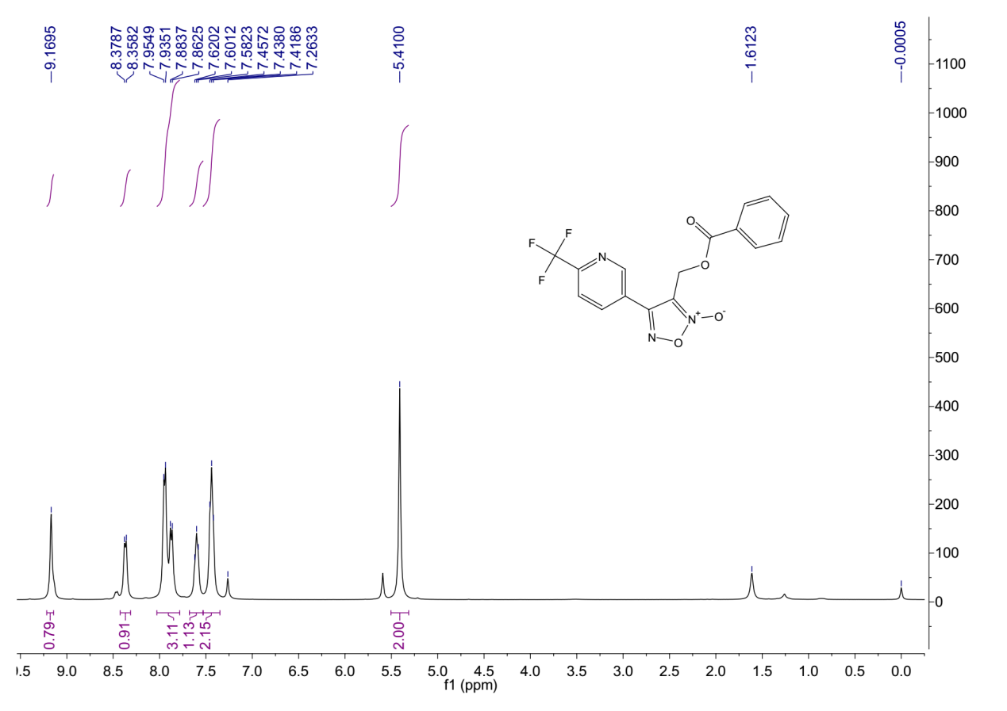
¹H-NMR (400 MHz, Chloroform-d) spectrum of 7df.
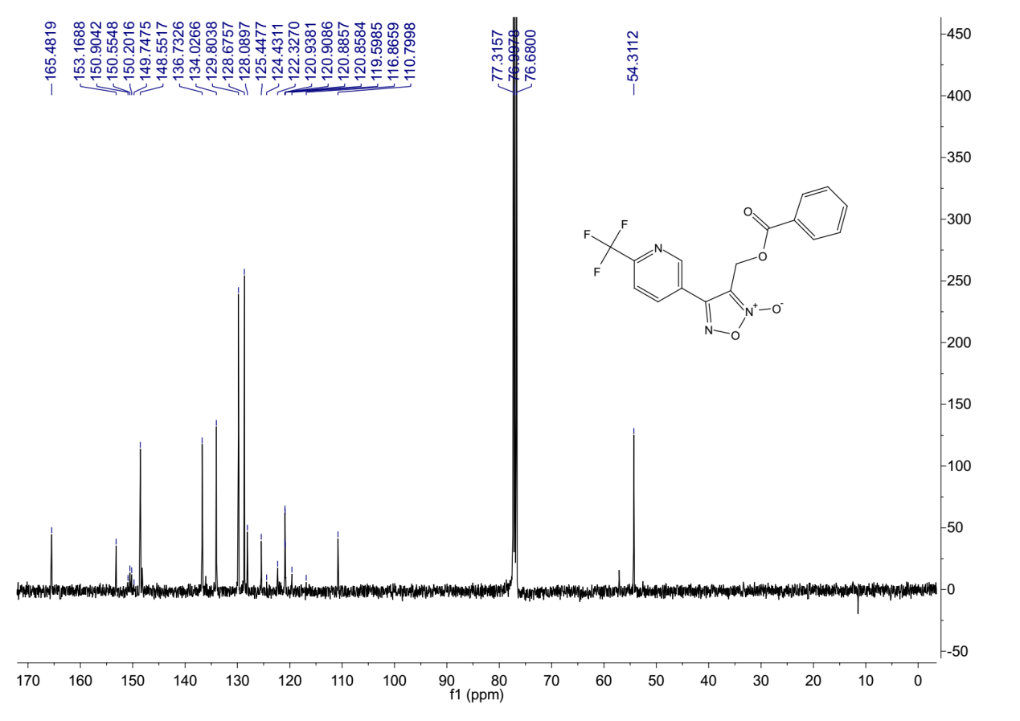
¹³C-NMR (101 MHz, Chloroform-d) spectrum of 7df.

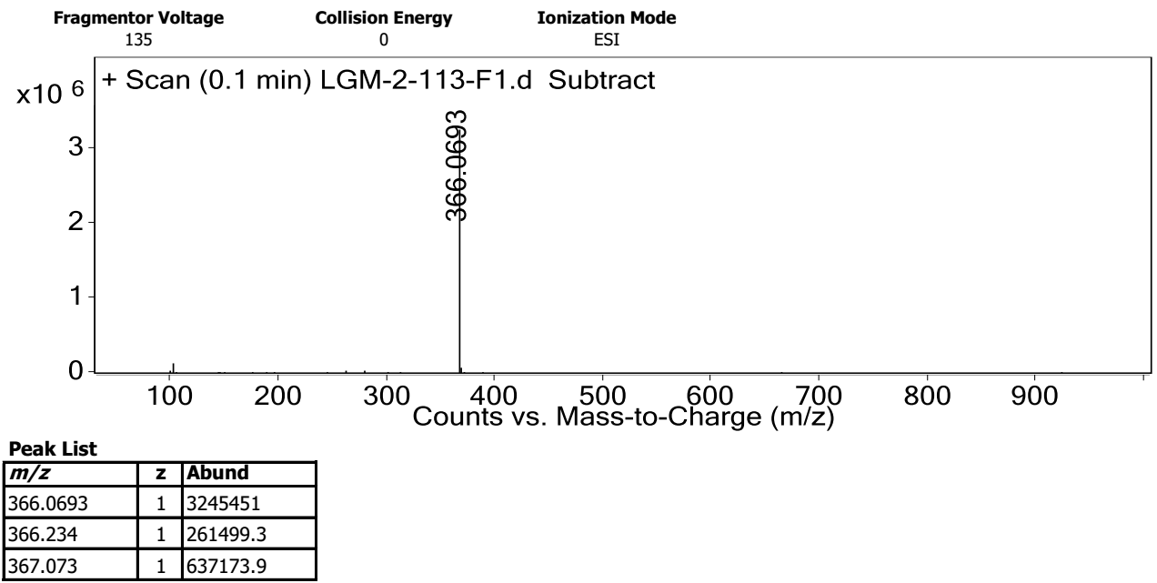
HRMS spectrum of 7df.
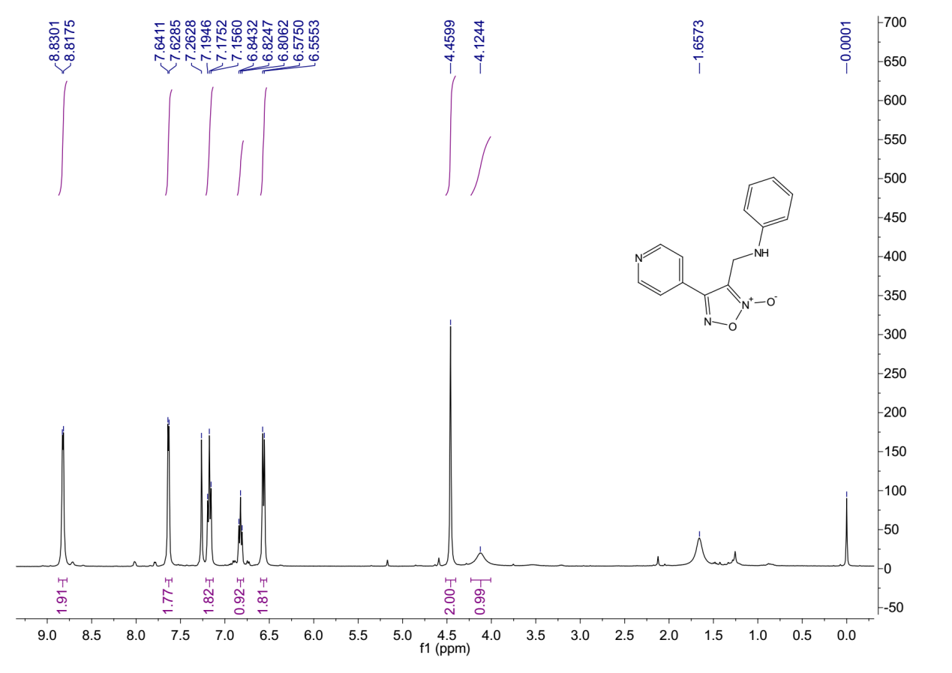
¹H-NMR (400 MHz, Chloroform-d) spectrum of 9aa.

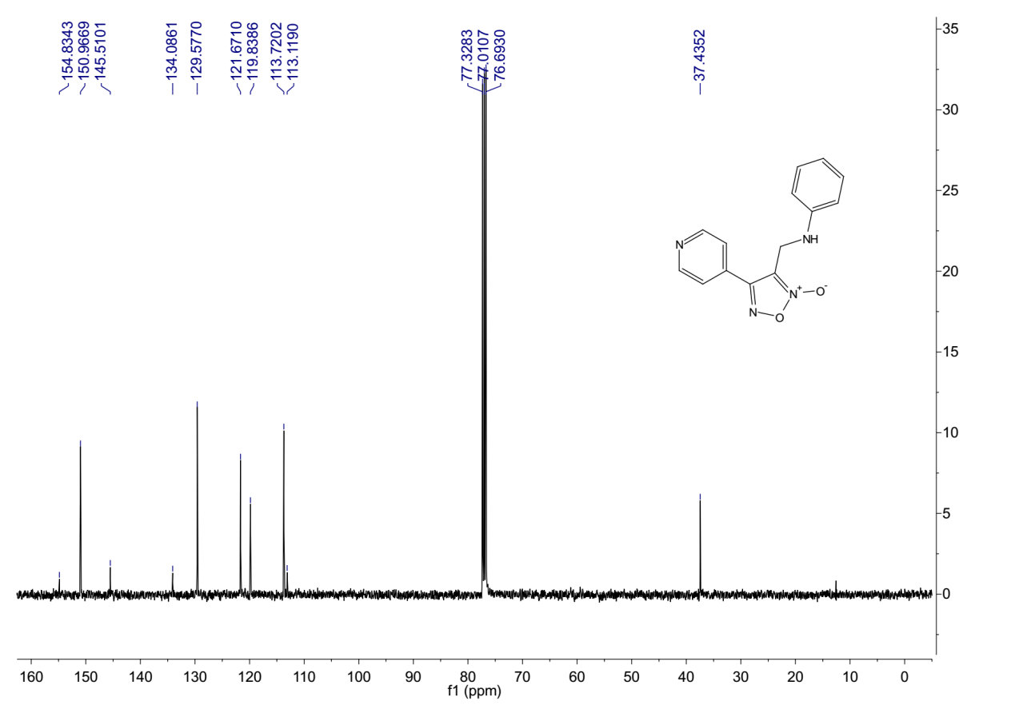
¹³C-NMR (101 MHz, Chloroform-d) spectrum of 9aa.
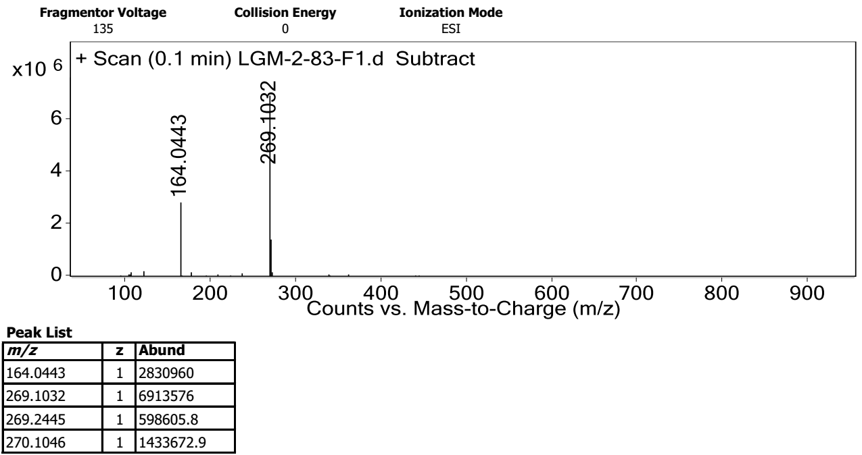
HRMS spectrum of 9aa.

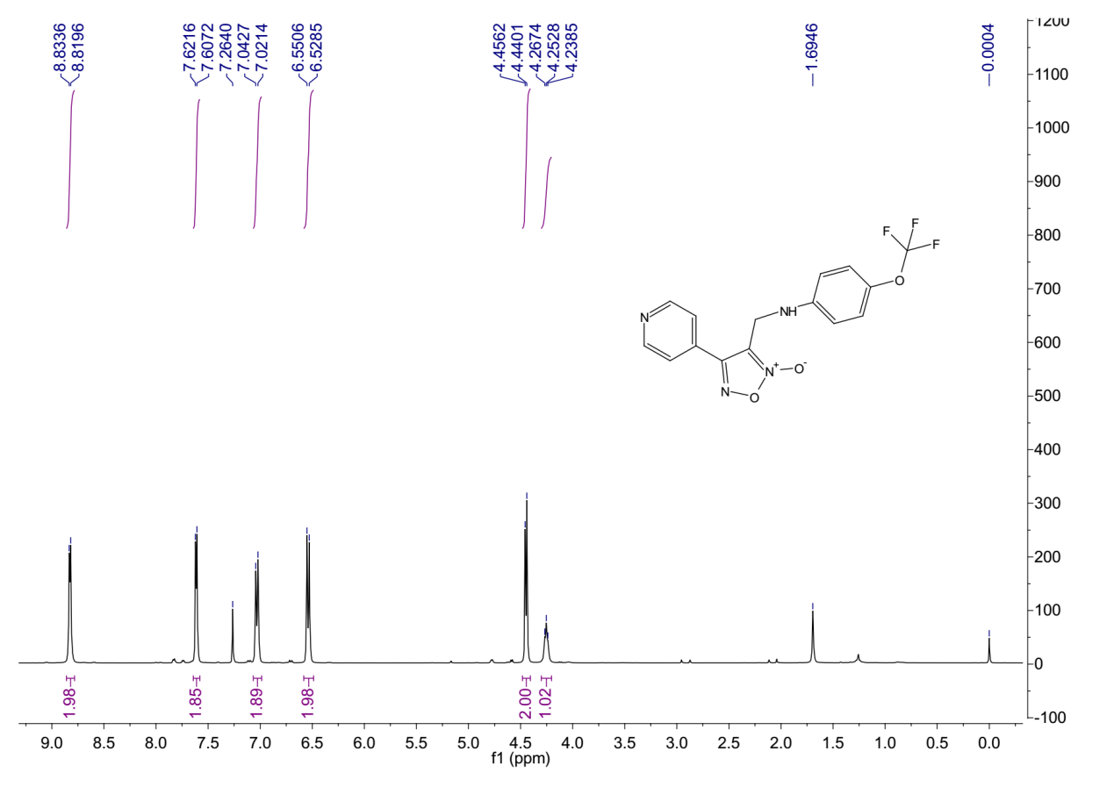
¹H-NMR (400 MHz, Chloroform-d) spectrum of 9ab.
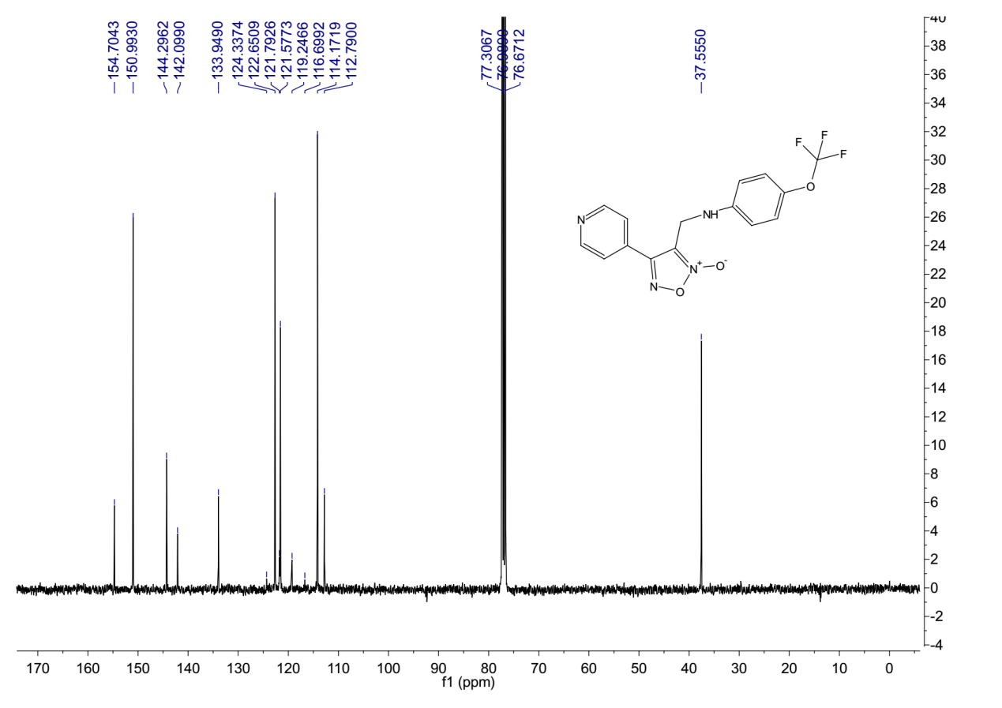
¹³C-NMR (101 MHz, Chloroform-d) spectrum of 9ab.

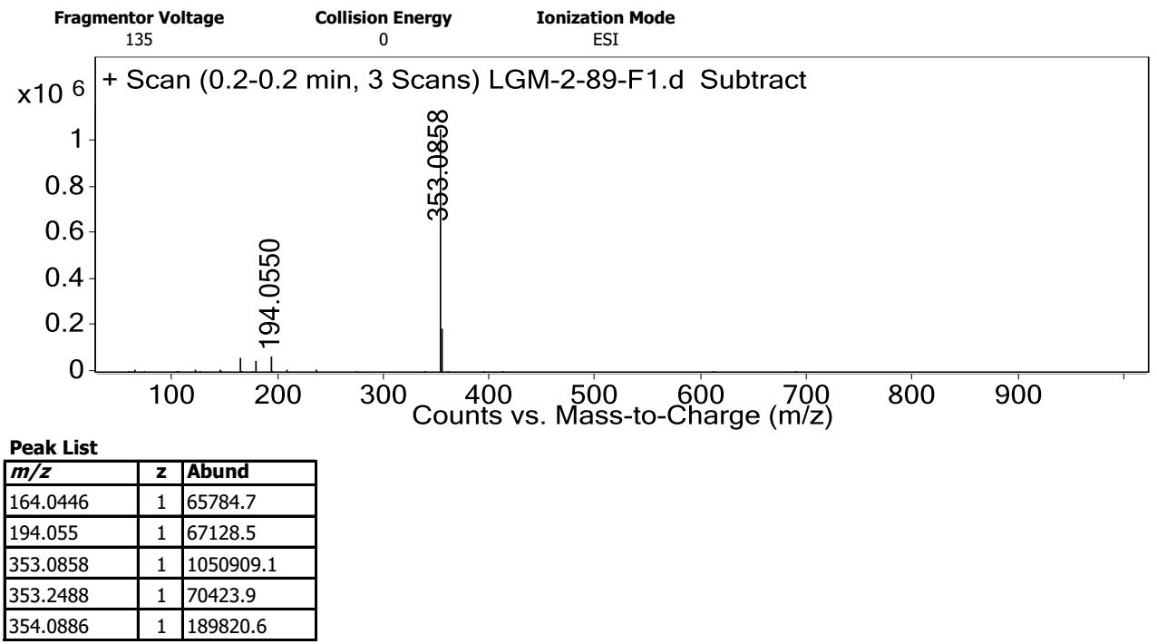
HRMS spectrum of 9ab.
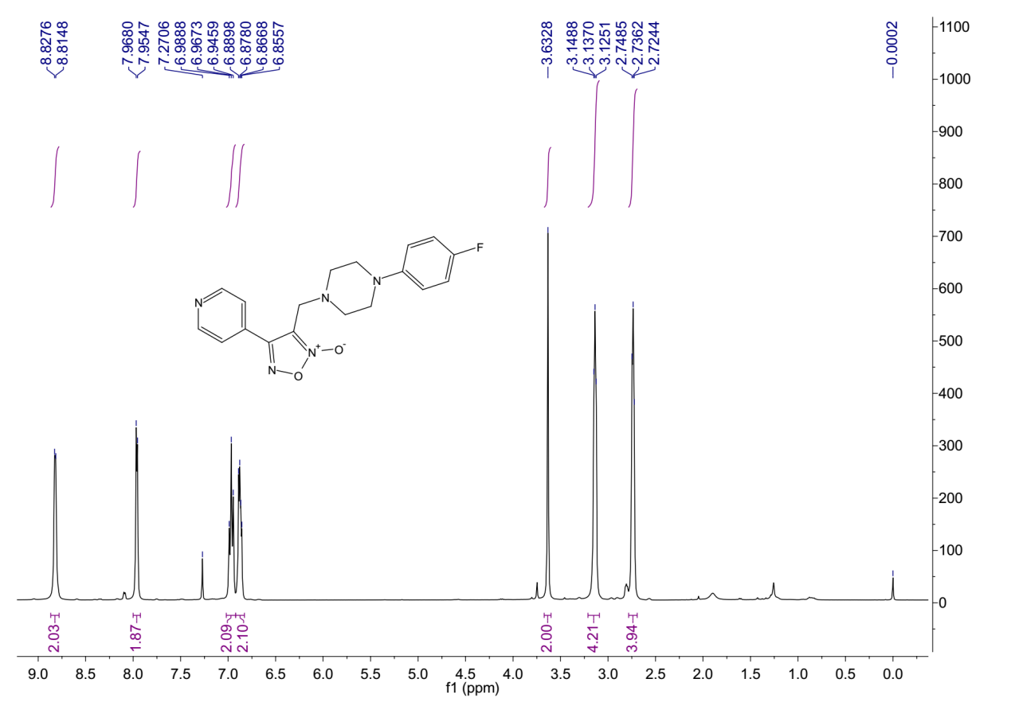
¹H-NMR (400 MHz, Chloroform-d) spectrum of 9ac.

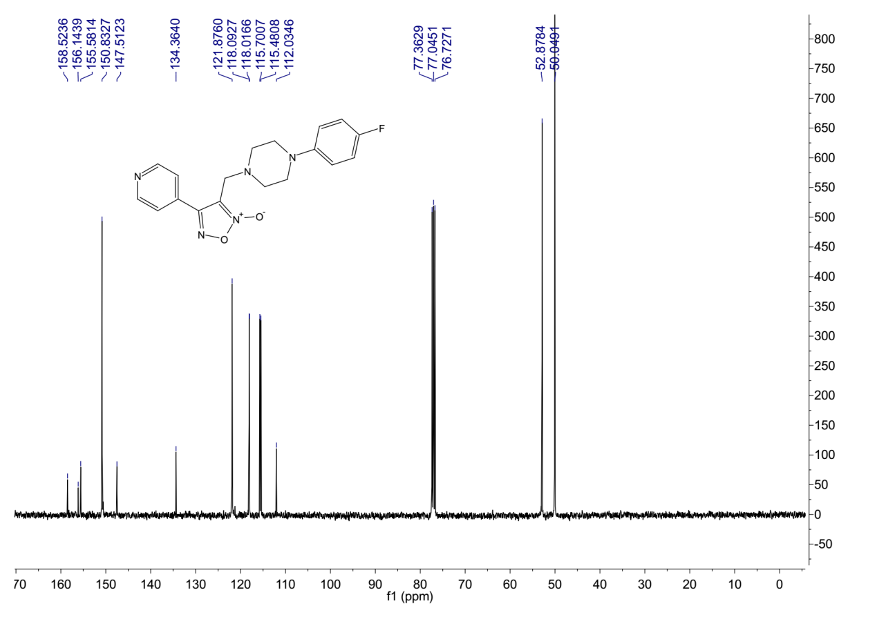
¹³C-NMR (101 MHz, Chloroform-d) spectrum of 9ac.
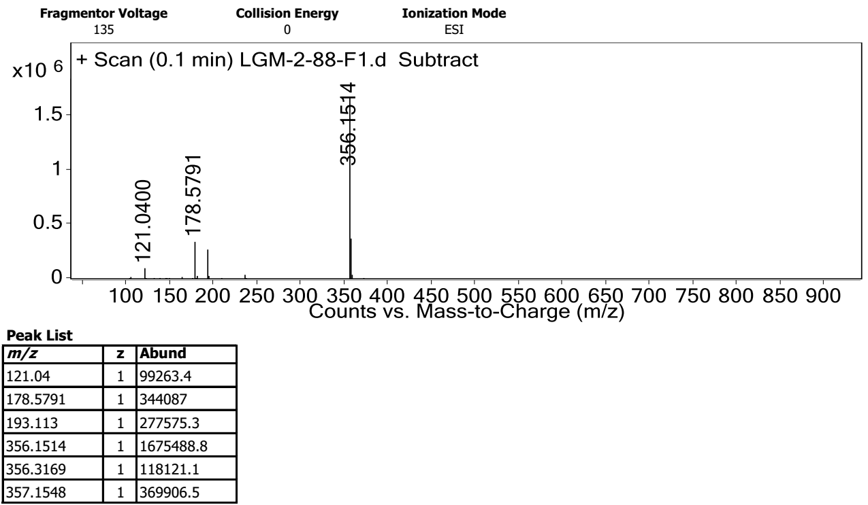
HRMS spectrum of 9ac.

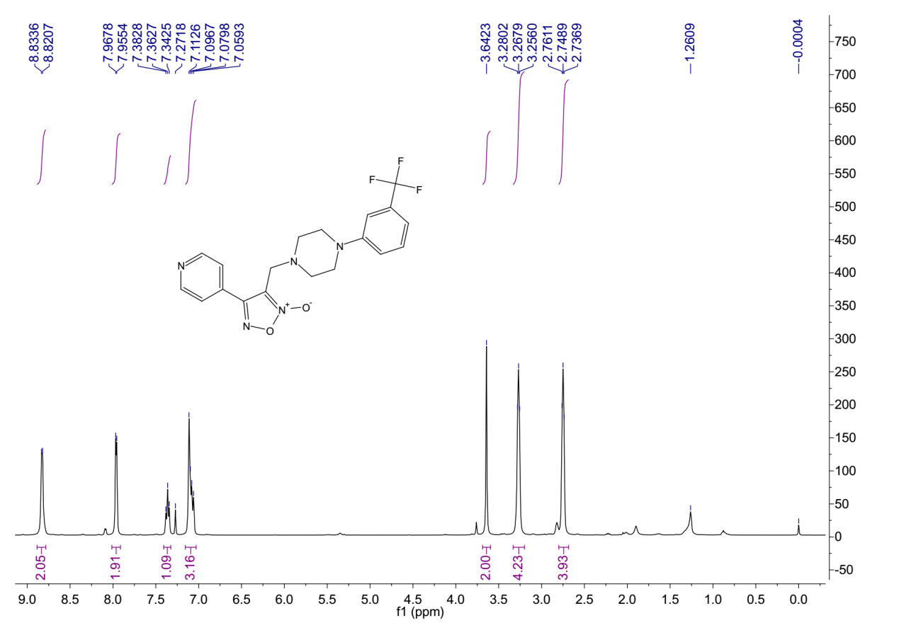
¹H-NMR (400 MHz, Chloroform-d) spectrum of 9ad.
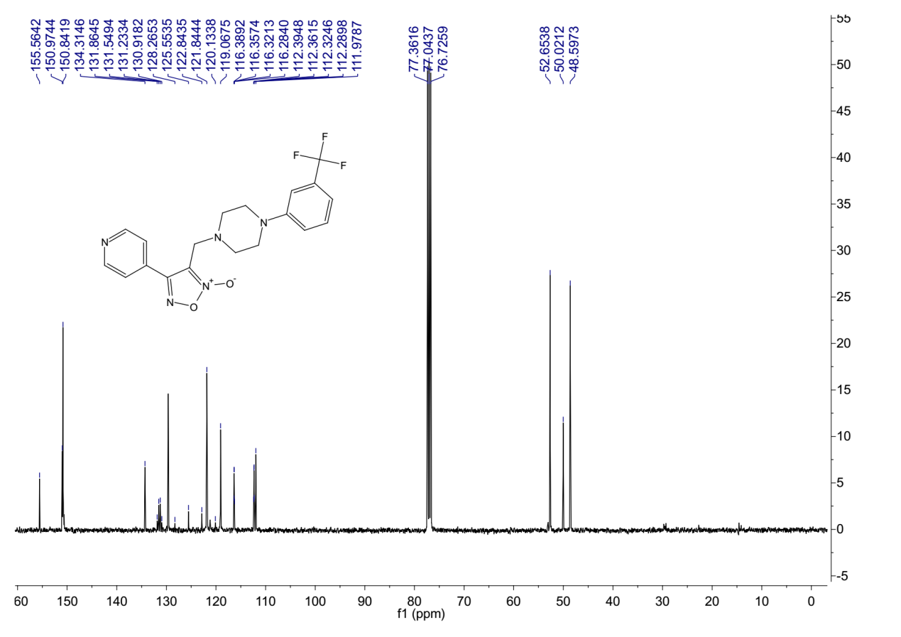
¹³C-NMR (101 MHz, Chloroform-d) spectrum of 9ad.

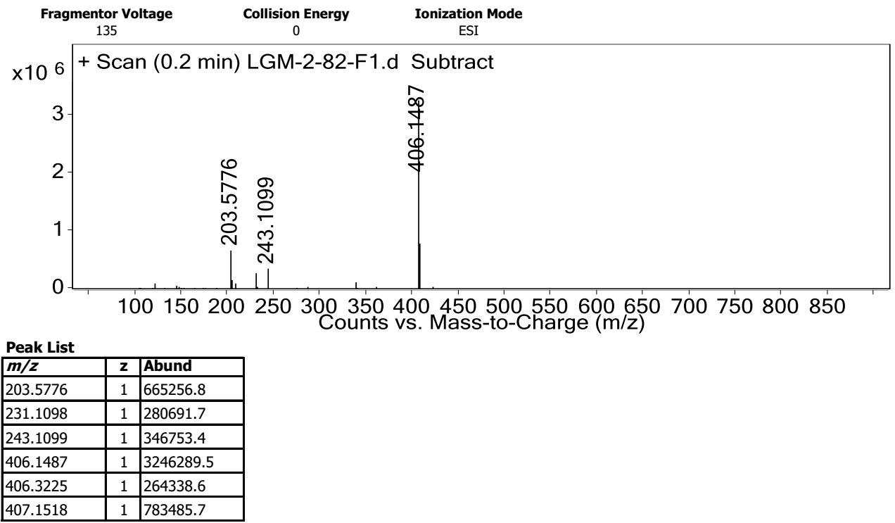
HRMS spectrum of 9ad.
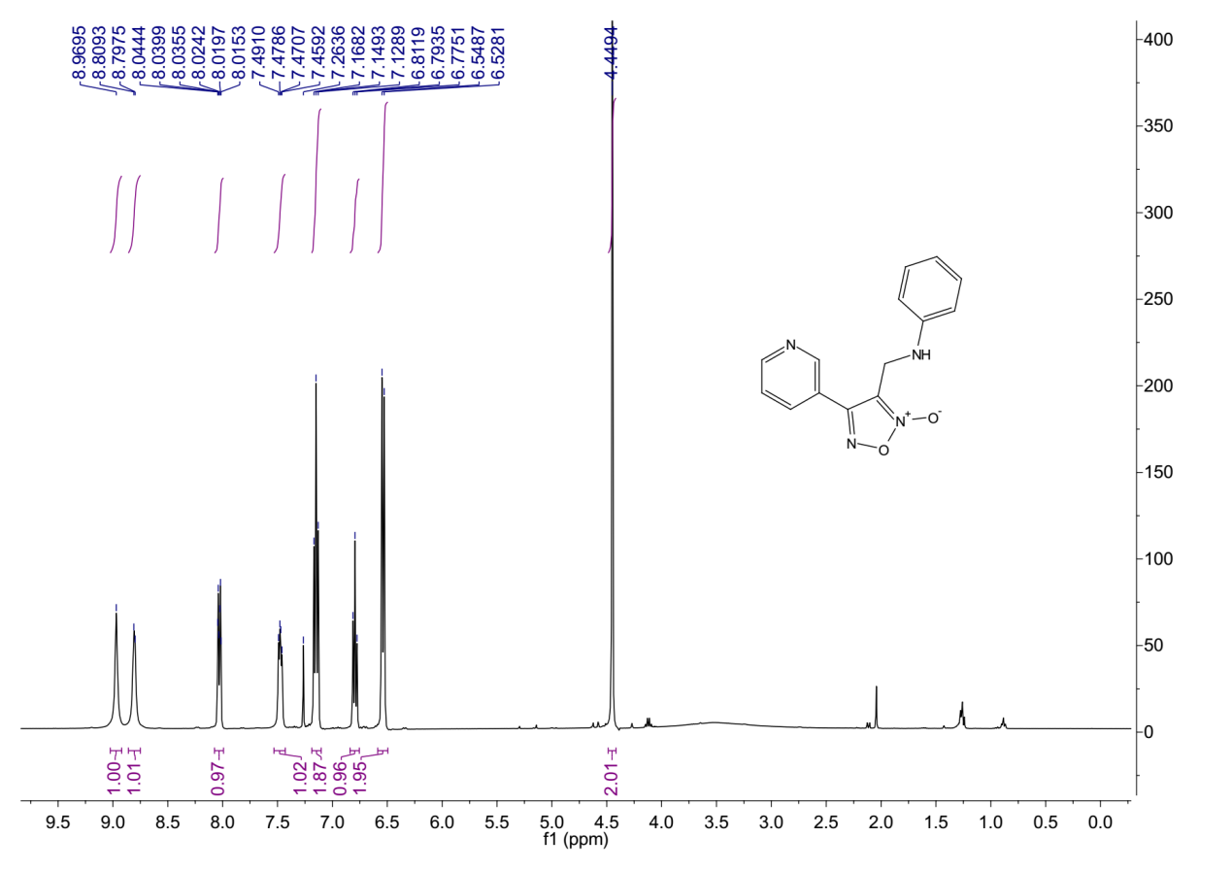
¹H-NMR (400 MHz, Chloroform-d) spectrum of 9ba.

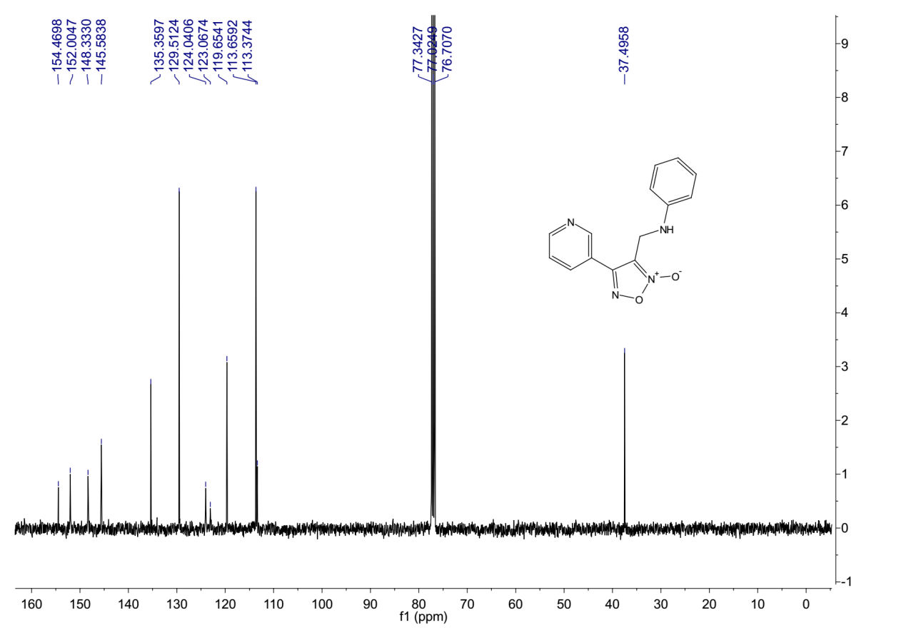
¹³C-NMR (101 MHz, Chloroform-d) spectrum of 9ba.
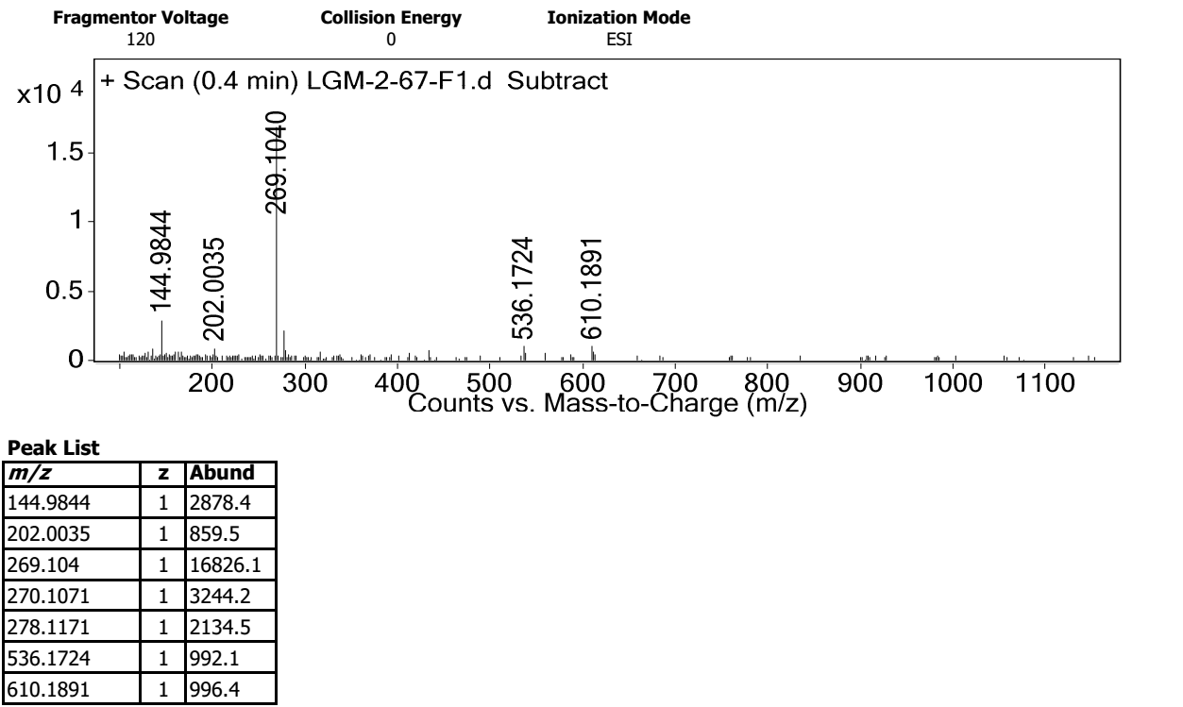
HRMS spectrum of 9ba.

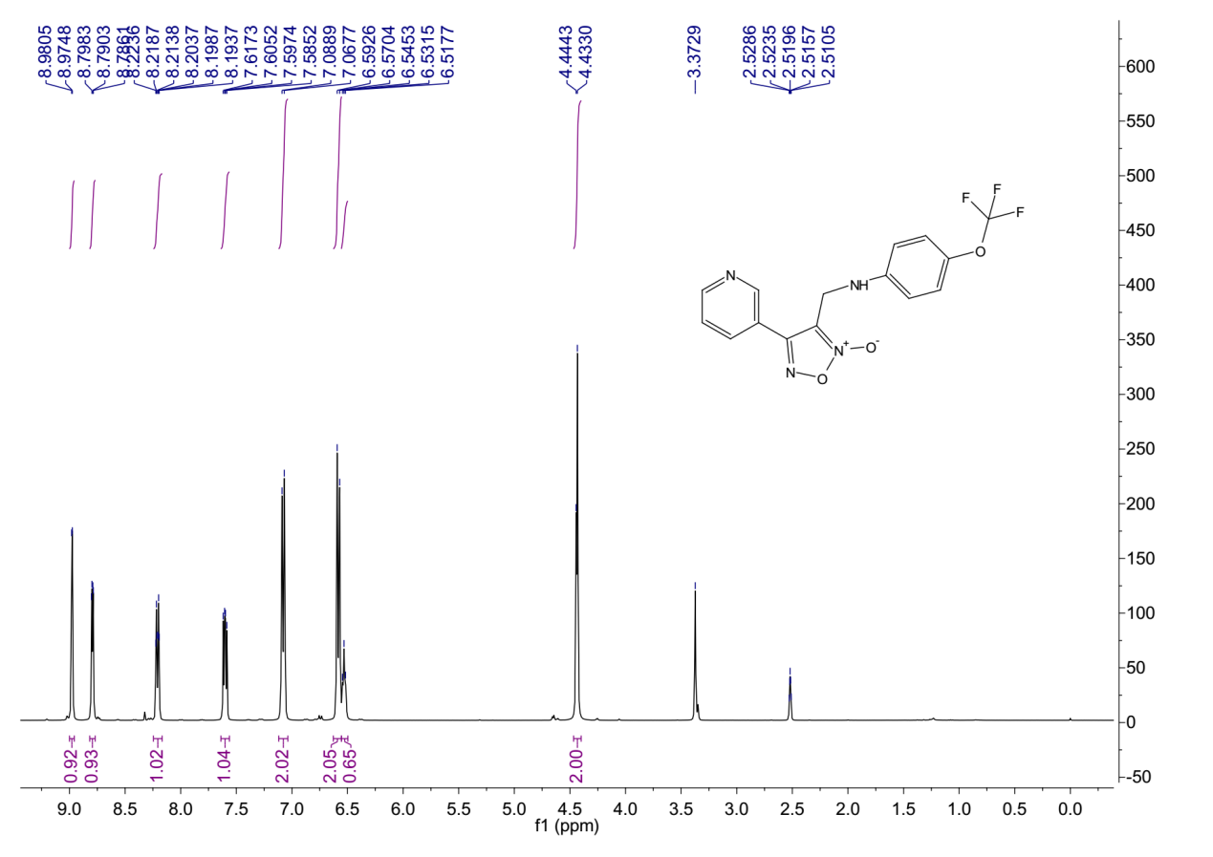
¹H-NMR (400 MHz, DMSO-d6) spectrum of 9bb.
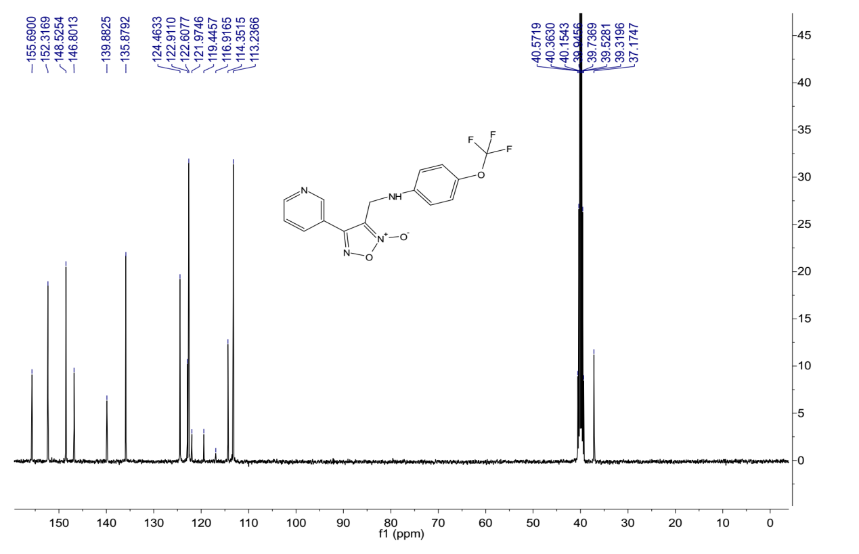
¹³C-NMR (101 MHz, DMSO-d6) spectrum of 9bb.
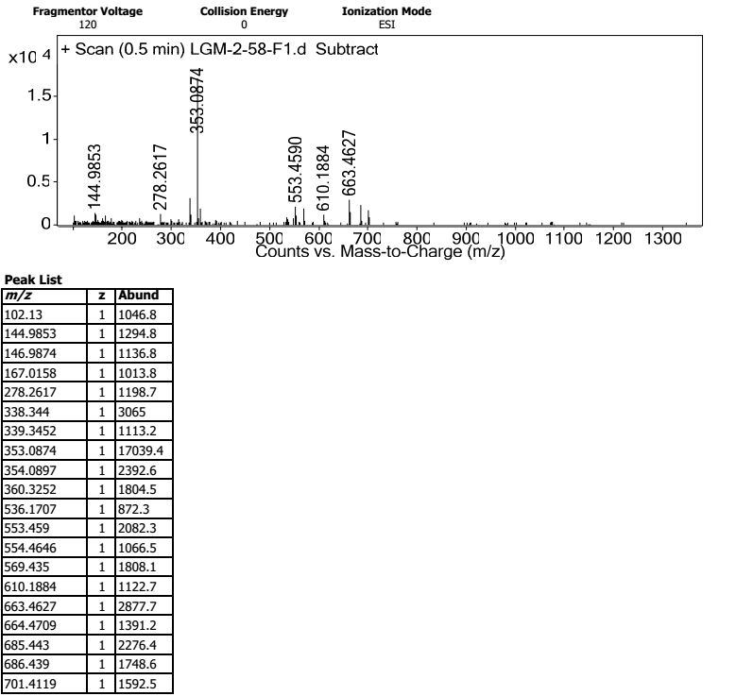
HRMS spectrum of 9bb.
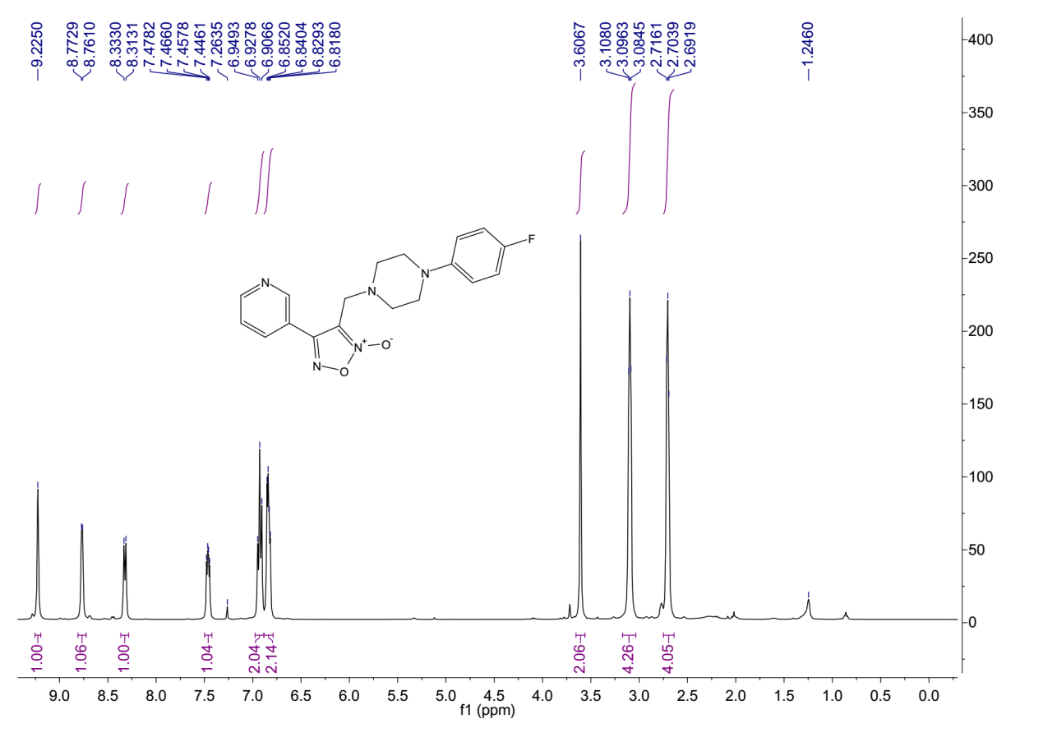
¹H-NMR (400 MHz, Chloroform-d) spectrum of 9bc.

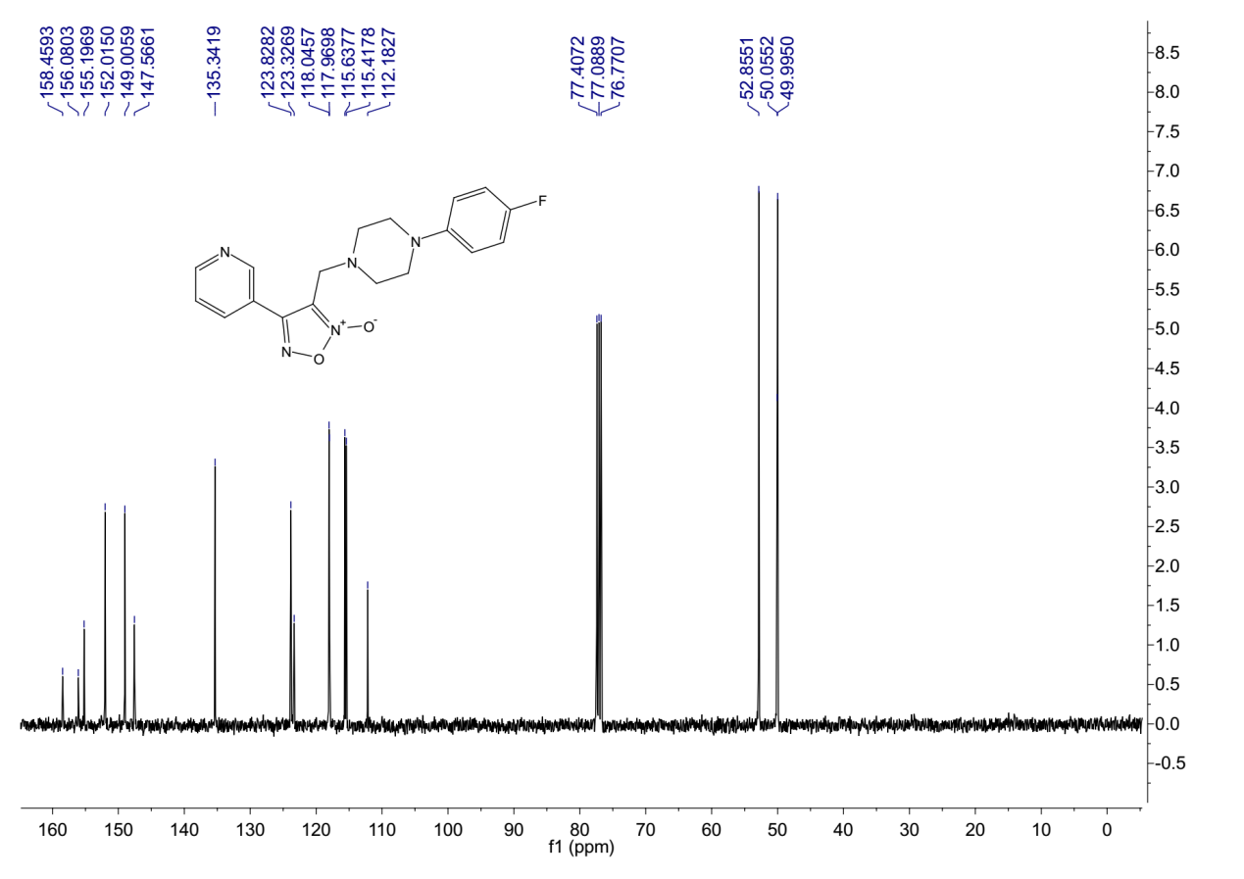
¹³C-NMR (101 MHz, Chloroform-d) spectrum of 9bc.
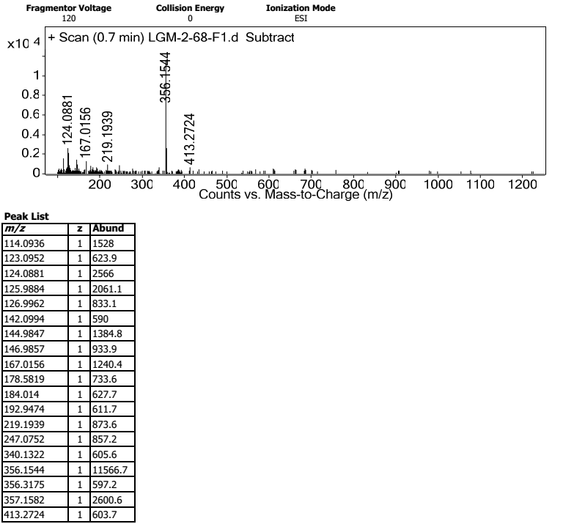
HRMS spectrum of 9bc.
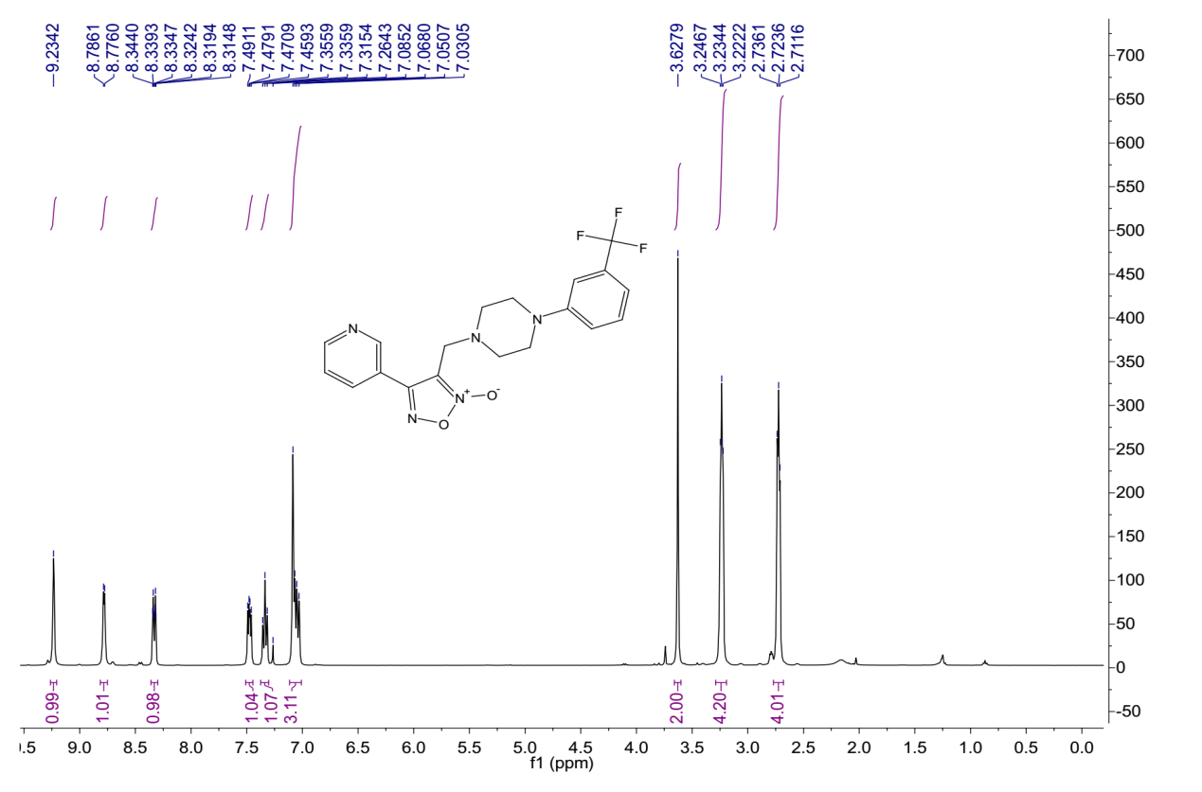
¹H-NMR (400 MHz, Chloroform-d) spectrum of 9bd.
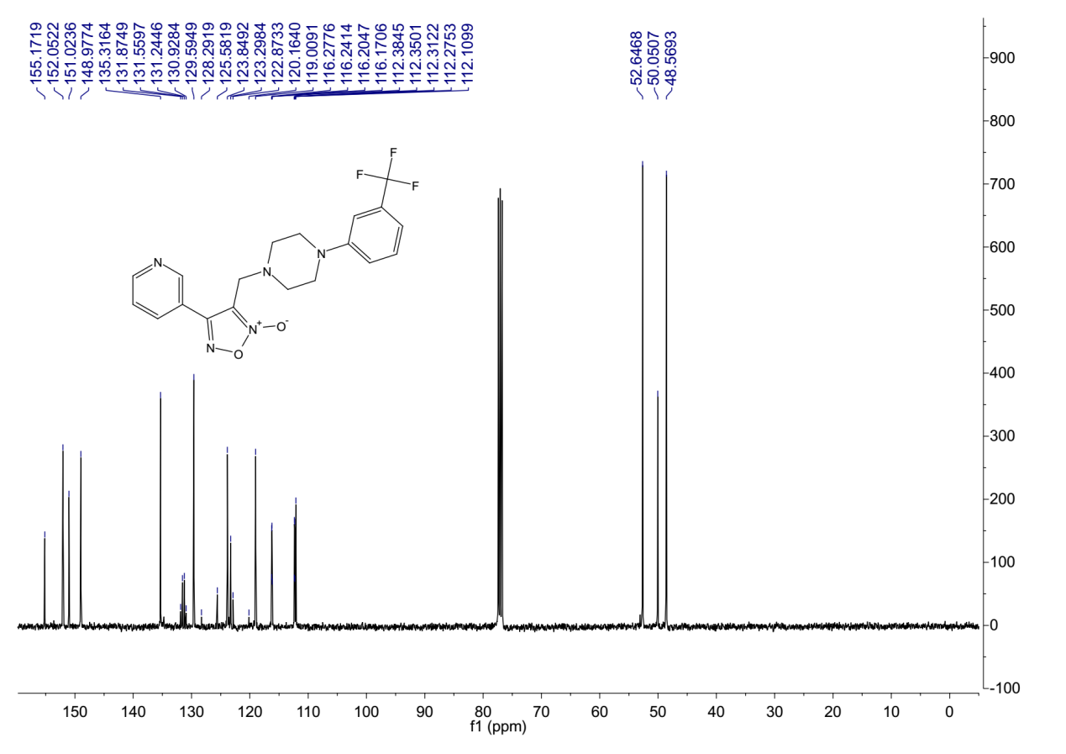
¹³C-NMR (101 MHz, Chloroform-d) spectrum of 9bd.
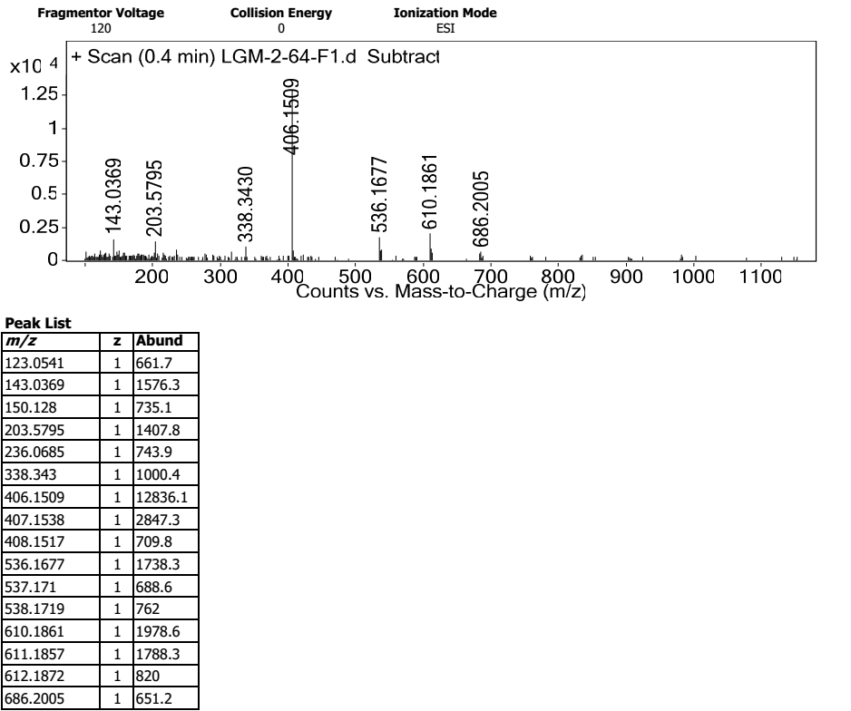
HRMS spectrum of 9bd.
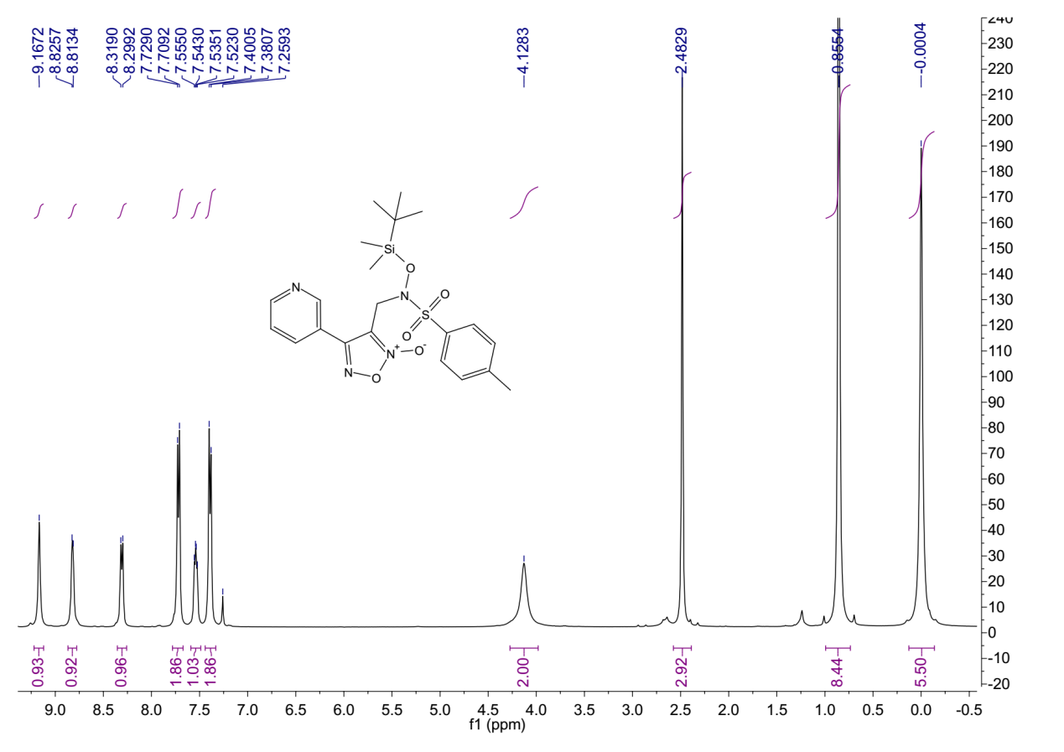
¹H-NMR (400 MHz, Chloroform-d) spectrum of 9be.

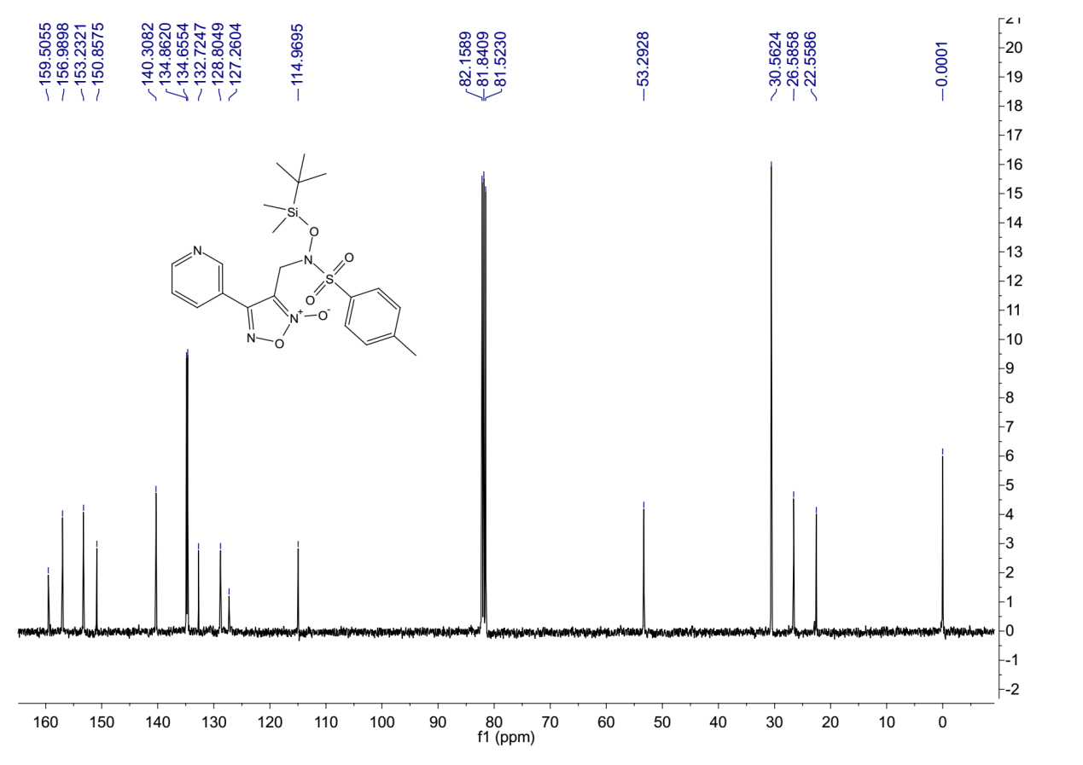
¹³C-NMR (101 MHz, Chloroform-d) spectrum of 9be.
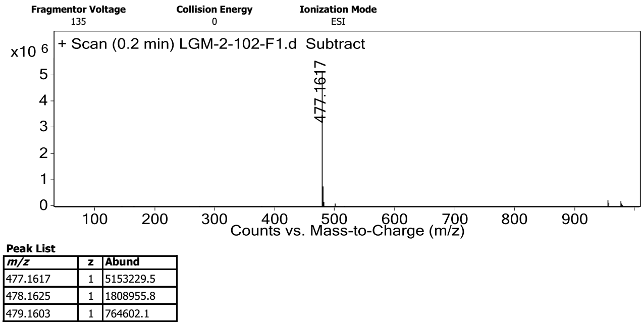
HRMS spectrum of 9be.

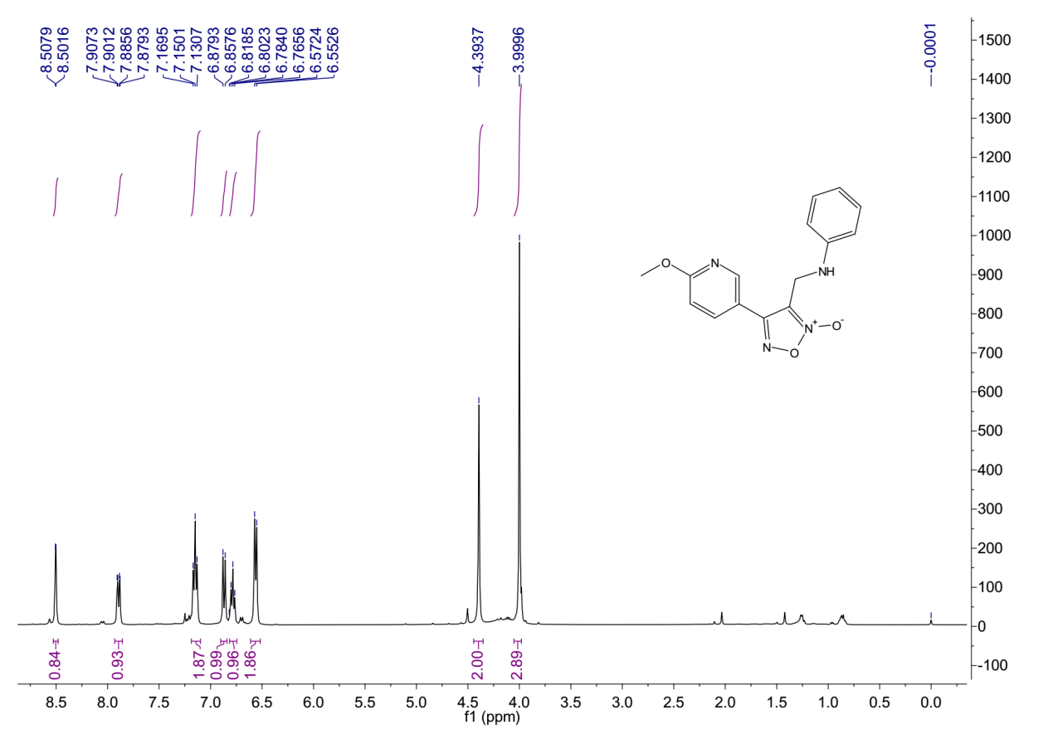
¹H-NMR (400 MHz, Chloroform-d) spectrum of 9ca.
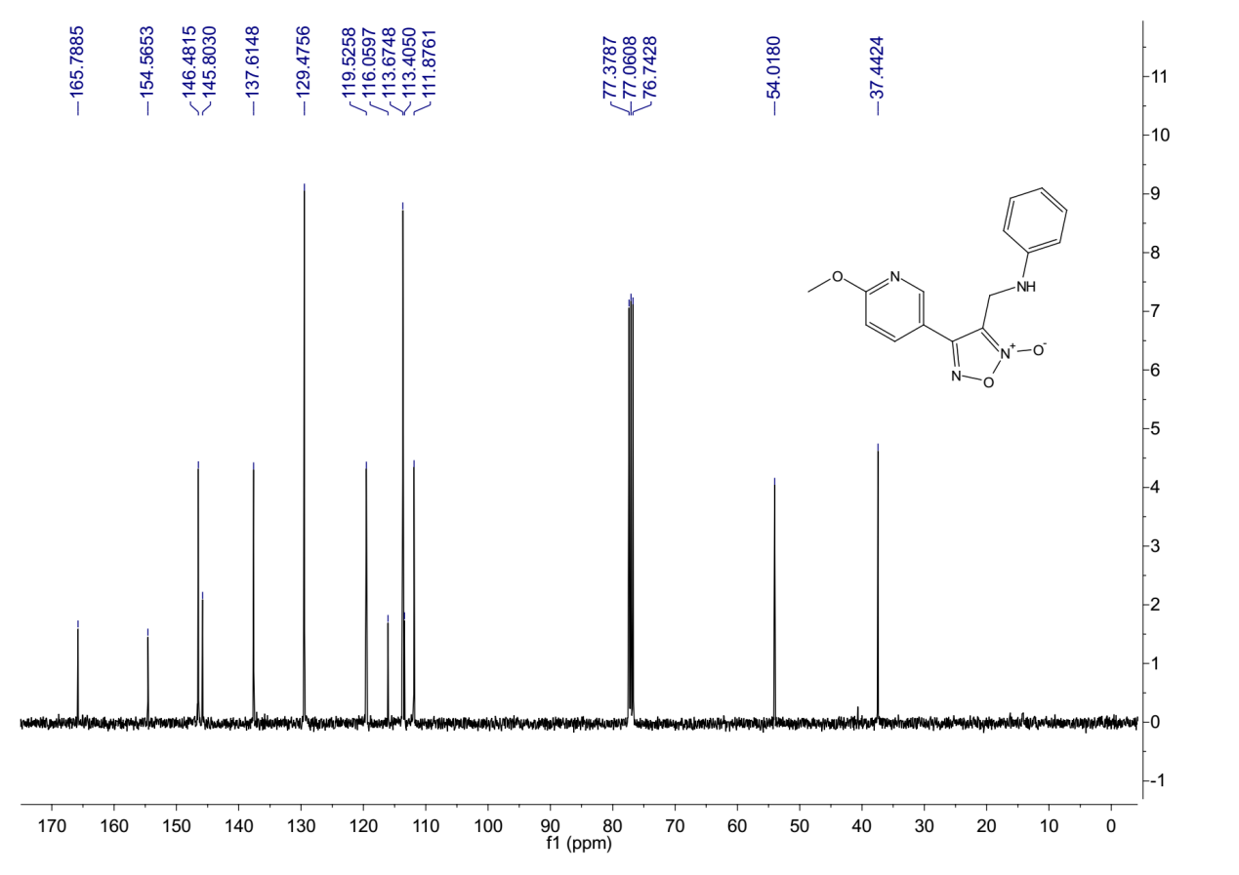
¹³C-NMR (101 MHz, Chloroform-d) spectrum of 9ca.

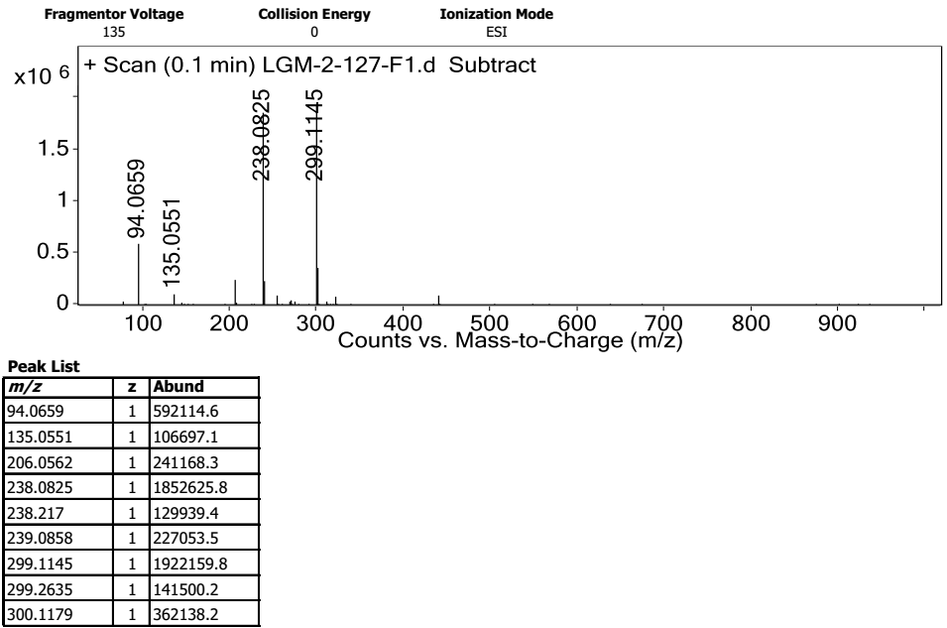
HRMS spectrum of 9ca.
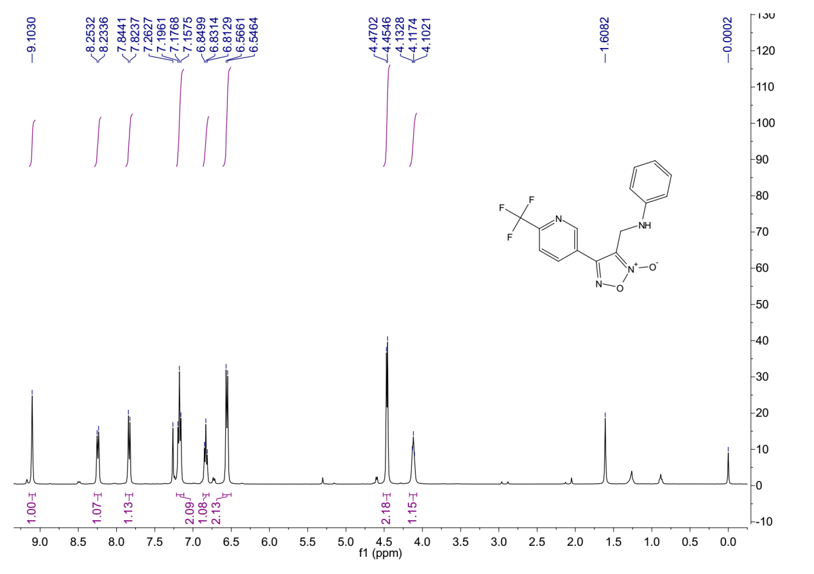
¹H-NMR (400 MHz, Chloroform-d) spectrum of 9da.

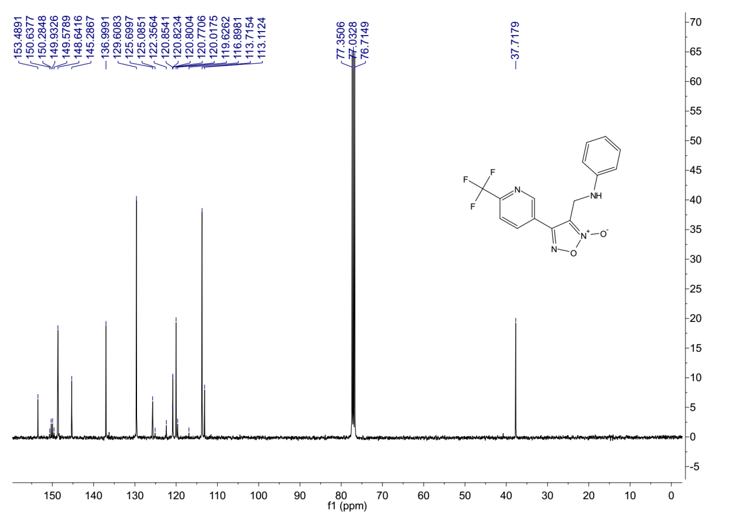
¹³C-NMR (101 MHz, Chloroform-d) spectrum of 9da.
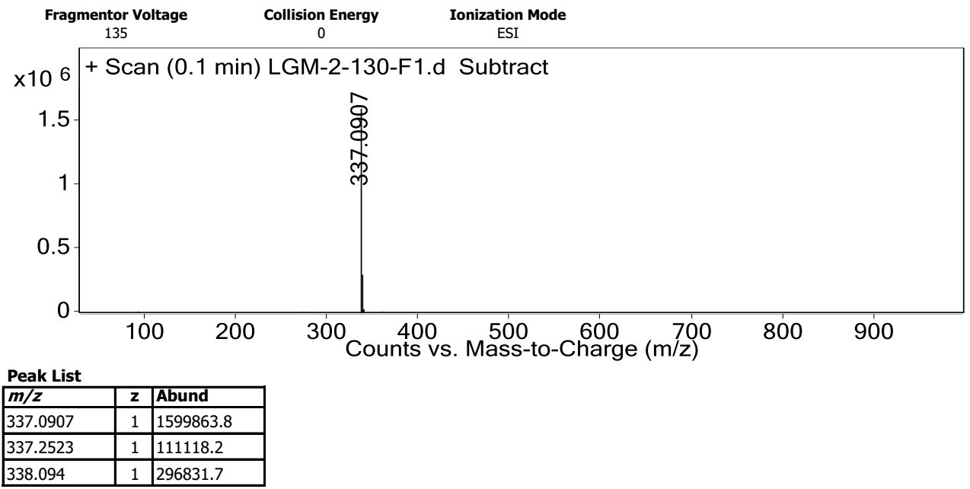
HRMS spectrum of 9da.

References
- Rai G, Thomas CJ, Leister W, Maloney DJ. Synthesis of Oxadiazole-2-oxide Analogues as Potential Antischistosomal Agents. Tetrahedron Letters. 2009;50:1710-3.
- Stambasky J, Malkov AV, Kocovsky P. Preparation of Boc-Protected Cinnamyl-Type Alcohols: A Comparison of the Suzuki-Miyaura Coupling, Cross-Metathesis, and Horner-Wadsworth-Emmons Approaches and Their Merit in Parallel Synthesis. Collection of Czechoslovak Chemical Communications. 2008;73:705-32.
- Jiang X, Hartwig JF. Iridium‐catalyzed enantioselective allylic substitution of aliphatic esters with silyl ketene acetals as the ester enolates. Angewandte Chemie International Edition. 2017;56:8887-91.
- Jung HJ, Park HJ, Shin YG, Kim YS, Yoon SH. Bioisoster of caffeic acid: syntheses of 1-hydroxy-2-pyridone analogues. Bulletin of the Korean Chemical Society 2008;29:2277-80.
- Thompson AM, Sutherland HS, Palmer BD, Kmentova I, Blaser A, Franzblau SG, Wan B, Wang Y, Ma Z, Denny WA. Synthesis and Structure–Activity Relationships of Varied Ether Linker Analogues of the Antitubercular Drug (6S)-2-Nitro-6-{[4-(trifluoromethoxy)benzyl]oxy}-6,7-dihydro-5H-imidazo[2,1-b][1,3]oxazine (PA-824). . Journal of Medicinal Chemistry. 2011;54:6563-85.
- Zartman AE, Duong lT, Fernandez-Metzler C, Hartman GD, Leu CT, Prueksaritanont T, Rodan GA, Rodan SB, Duggan ME, Meissner RS. Nonpeptide alpha(v)beta3 antagonists: identification of potent, chain-shortened 7-oxo RGD mimetics. Bioorganic and Medicinal Chemistry Letters. 2005;15:1647-50.

