Supplementary Figures
Suppl. Fig. 1. Number of differentially expressed genes (DEGs) shared within and among four Miscanthus species under well-watered conditions.
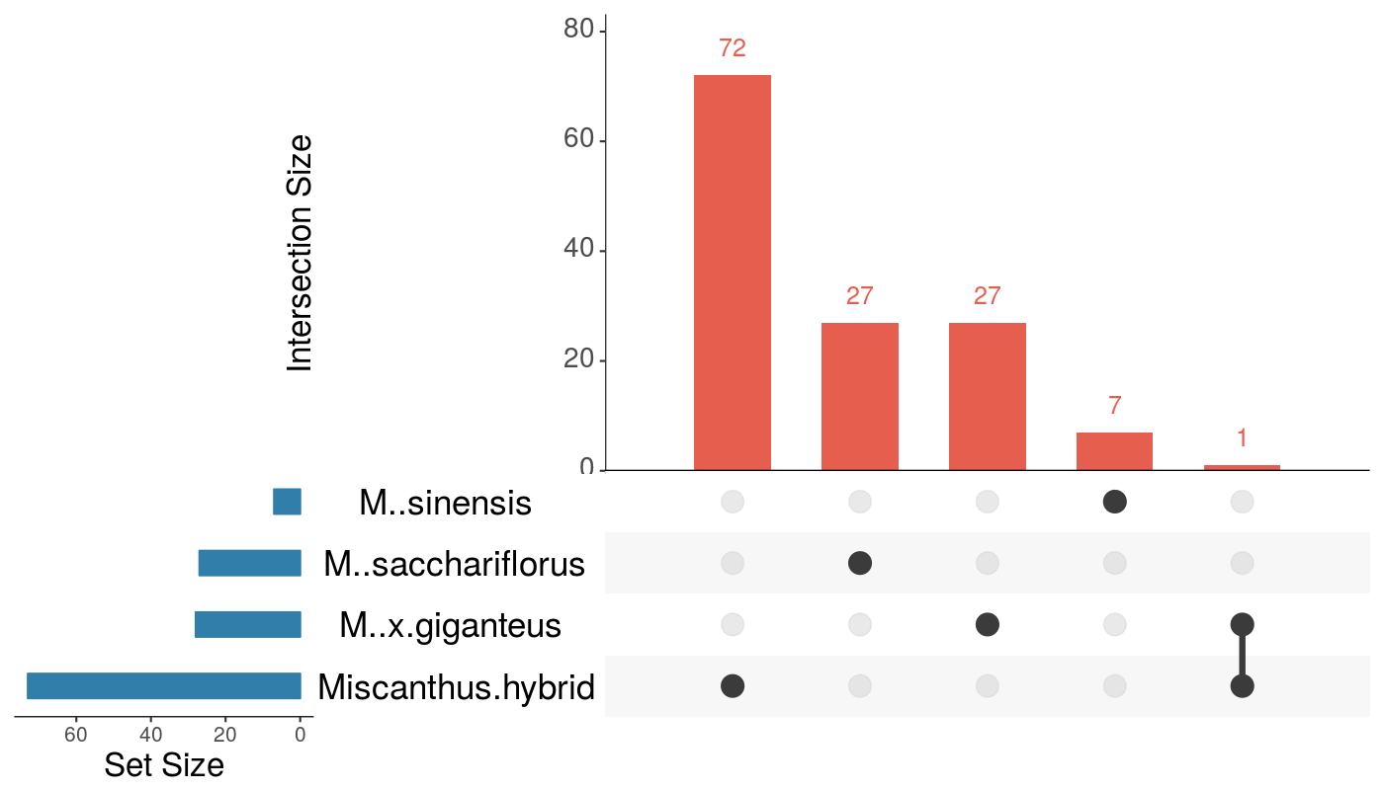

Suppl. Fig. 2. GO SLIM terms (rows) that were significantly enriched (p < 0.005) in each Miscanthus species (columns) among either up-regulated (top-pointing triangles) or down-regulated (bottom-pointing triangles) differentially expressed genes (DEGs) in drought conditions. The size of a triangle is proportional to the number of DEGs annotated with that GO term. Rows are sorted by descending p-value (F-fisher test) and the triangle colour is representative to the obtained p-value, from lower (dark colour) to higher (light colour). Yellow (p > 0.05) and white (p > 0.1) triangles were not significantly enriched.
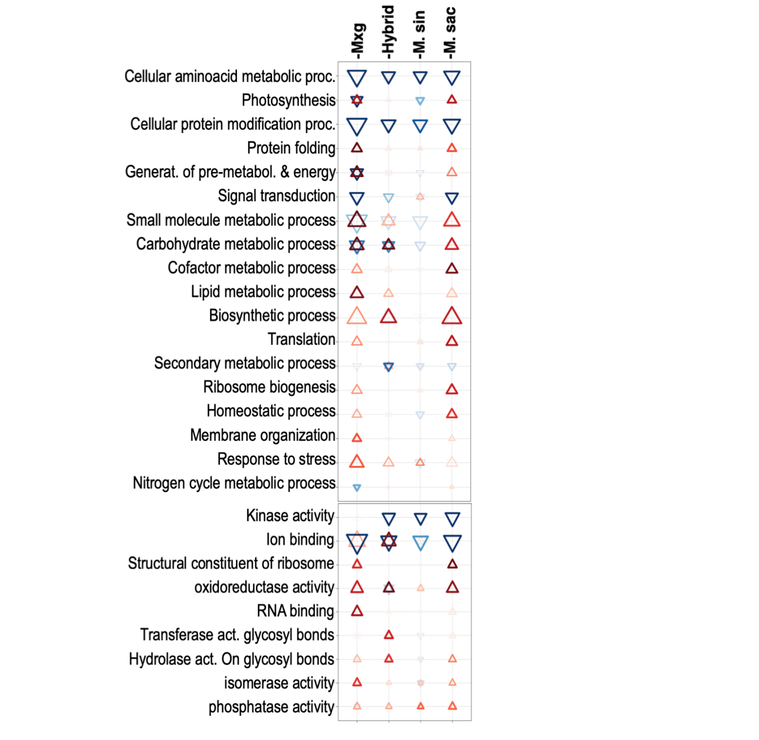

Suppl. Fig. 3. Reactions in the starch and sucrose metabolic pathways that were up-regulated (red boxes) during drought stress in at least one of the analysed Miscanthus genotypes.
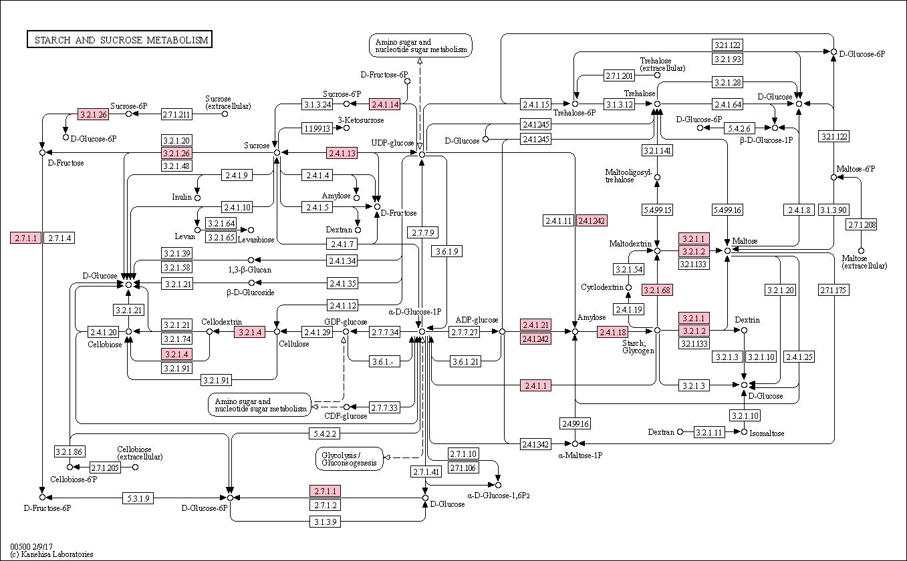

Suppl. Fig. 4. Mean soil moisture readings for all genotypes per treatment condition across 17 days.
