Appendix 2. Number of Puskesmas Without Internet by Province

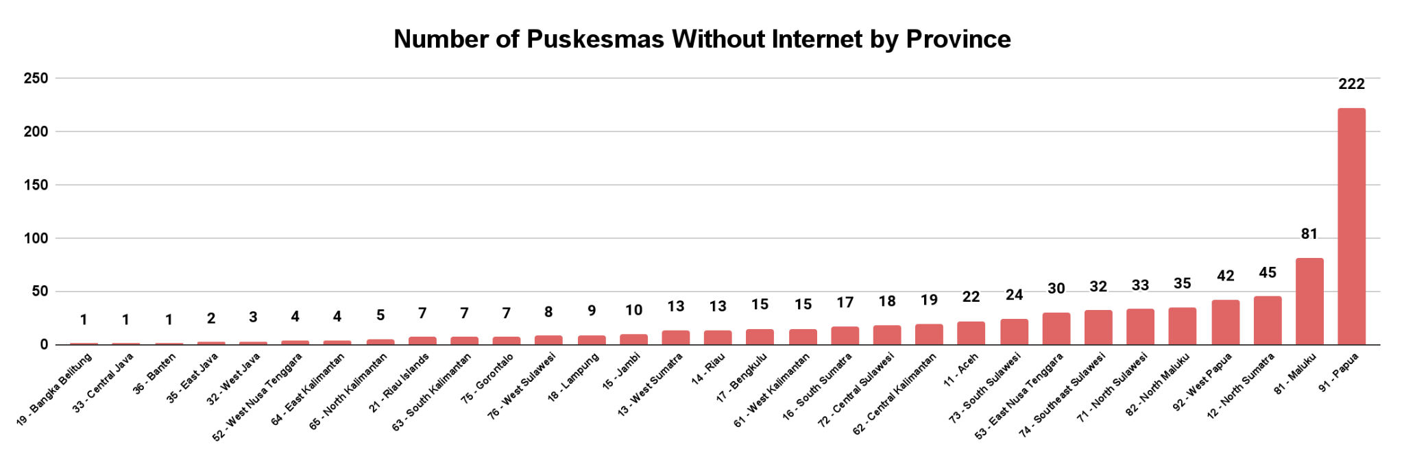

Area Code - Province | Puskesmas Without Internet | Area Code - Province | Puskesmas Without Internet
19 - Bangka Belitung Islands | 1 | 16 - South Sumatra | 17
33 - Central Java | 1 | 72 - Central Sulawesi | 18
36 - Banten | 1 | 62 - Central Kalimantan | 19
35 - East Java | 2 | 11 - Aceh | 22
32 - West Java | 3 | 73 - South Sulawesi | 24
52 - West Nusa Tenggara | 4 | 53 - East Nusa Tenggara | 30
64 - East Kalimantan | 4 | 74 - Southeast Sulawesi | 32
65 - North Kalimantan | 5 | 71 - North Sulawesi | 33
21 - Riau Islands | 7 | 82 - North Maluku | 35
63 - South Kalimantan | 7 | 92 - West Papua | 42
75 - Gorontalo | 7 | 12 - North Sumatra | 45
76 - West Sulawesi | 8 | 81 - Maluku | 81
18 - Lampung | 9 | 91 - Papua | 222
15 - Jambi | 10
13 - West Sumatra | 13
14 - Riau | 13
17 - Bengkulu | 15
61 - West Kalimantan | 15

