Similarity in the microbial community structure of tobacco from geographically similar regions
Li Zhengfeng^{1, a}, Qin Tian^{2, a}, Xia Yuzhen¹, Zhou Le², Wang Luoping¹, Duan Kai¹, Lei Jia², Yao Jianhua^{1*}, Xia Jianjun^{1*}, Li Juan^{2, *}
¹ China Tobacco Yunnan Industrial CO.,LTD, Kunming, 650032, China
² College of Agronomy, Hunan Agricultural University, Changsha, 410128, China
*Corresponding author. E-mail addresses: jhyao_2007@126.com (J. Yao), royalxia@126.com (J. Xia), adalee619@163.com (J. Li).
ª These authors contributed equally to this work.

Table S1 Differential analysis of microbial community structure in tobacco from different origins.
Type | Treatment | ADONIS |  | ANOSIM |  | MRPP
Type | Treatment | R² | P | R | P | δ | P
Bacterial | Brazil vs Chenzhou | 0.234 | 0.008 | 0.224 | 0.007 | 0.219 | 0.005
Bacterial | Brazil vs Zimbabwe | 0.214 | 0.001 | 0.227 | 0.001 | 0.223 | 0.003
Bacterial | Chenzhou vs Zimbabwe | 0.050 | 0.470 | -0.004 | 0.407 | 0.367 | 0.435
Fungi | Brazil vs Chenzhou | 0.312 | 0.001 | 0.628 | 0.001 | 0.470 | 0.002
Fungi | Brazil vs Zimbabwe | 0.556 | 0.001 | 1.000 | 0.001 | 0.400 | 0.001
Fungi | Chenzhou vs Zimbabwe | 0.476 | 0.001 | 0.771 | 0.001 | 0.514 | 0.001

Table S2 LDA values for linear discriminant analysis of tobacco microbial communities from different origins.
Type | Group | Phylum | Class | Order | Family | Genus | LDA score | P value
Bacterial | BX | p__Proteobacteria | c__Alphaproteobacteria | / | / | / | 5.06 | 0.029
Bacterial | BX | p__Proteobacteria | c__Alphaproteobacteria | o__Sphingomonadales | / | / | 4.82 | 0.039
Bacterial | BX | p__Proteobacteria | c__Alphaproteobacteria | o__Sphingomonadales | f__Sphingomonadaceae | / | 4.80 | 0.046
Bacterial | BX | p__Proteobacteria | c__Alphaproteobacteria | o__Sphingomonadales | f__Sphingomonadaceae | g__Sphingomonas | 4.78 | 0.048
Bacterial | BX | p__Proteobacteria | c__Alphaproteobacteria | o__Rhizobiales | / | / | 4.68 | 0.002
Bacterial | BX | p__Proteobacteria | c__Alphaproteobacteria | o__Rhizobiales | f__Methylobacteriaceae | / | 4.65 | 0.001
Bacterial | BX | p__Proteobacteria | c__Alphaproteobacteria | o__Rhizobiales | f__Methylobacteriaceae | g__Methylobacterium | 4.61 | 0.001
Bacterial | BX | p__Actinobacteria | / | / | / | / | 4.52 | 0.024
Bacterial | BX | p__Actinobacteria | c__Actinobacteria | / | / | / | 4.52 | 0.024
Bacterial | BX | p__Actinobacteria | c__Actinobacteria | o__Micrococcales | / | / | 4.23 | 0.014
Bacterial | BX | p__Proteobacteria | c__Alphaproteobacteria | o__Rhizobiales | f__Aurantimonadaceae | / | 3.86 | 0.028
Bacterial | BX | p__Proteobacteria | c__Alphaproteobacteria | o__Rhizobiales | f__Aurantimonadaceae | g__Aureimonas | 3.85 | 0.026
Bacterial | BX | p__Actinobacteria | c__Actinobacteria | o__Propionibacteriales | / | / | 3.76 | 0.035
Bacterial | BX | p__Actinobacteria | c__Actinobacteria | o__Propionibacteriales | f__Nocardioidaceae | / | 3.79 | 0.005
Bacterial | BX | p__Actinobacteria | c__Actinobacteria | o__Micrococcales | f__Micrococcaceae | / | 3.74 | 0.017
Bacterial | BX | p__Actinobacteria | c__Actinobacteria | o__Micrococcales | f__Micrococcaceae | g__Pseudarthrobacter | 3.70 | 0.004
Bacterial | BX | p__Actinobacteria | c__Actinobacteria | o__Mycobacteriales | / | / | 3.57 | 0.039
Bacterial | BX | p__Firmicutes | c__Bacilli | o__Bacillales | f__Paenibacillaceae1 | / | 3.66 | 0.005
Bacterial | BX | p__Actinobacteria | c__Actinobacteria | o__Geodermatophilales | / | / | 3.61 | 0.050
Bacterial | BX | p__Actinobacteria | c__Actinobacteria | o__Geodermatophilales | f__Geodermatophilaceae | / | 3.61 | 0.050
Bacterial | BX | p__Actinobacteria | c__Actinobacteria | o__Propionibacteriales | f__Nocardioidaceae | g__Marmoricola | 3.56 | 0.004
Bacterial | CZ | p__Proteobacteria | c__Gammaproteobacteria | o__Enterobacterales | / | / | 4.99 | 0.022
Bacterial | CZ | p__Proteobacteria | c__Gammaproteobacteria | o__Enterobacterales | f__Enterobacteriaceae | / | 4.89 | 0.011
Bacterial | CZ | p__Proteobacteria | c__Gammaproteobacteria | o__Enterobacterales | f__Enterobacteriaceae | g__Enterobacter | 4.90 | 0.010
Bacterial | CZ | p__Proteobacteria | c__Alphaproteobacteria | o__Sphingomonadales | f__Erythrobacteraceae | / | 3.70 | 0.045
Bacterial | CZ | p__Bacteroidetes | c__Sphingobacteriia | o__Sphingobacteriales | f__Sphingobacteriaceae | g__Sphingobacterium | 3.85 | 0.047
Bacterial | ZB | p__Actinobacteria | c__Actinobacteria | o__Micrococcales | f__Microbacteriaceae | / | 4.03 | 0.009
Bacterial | ZB | p__Actinobacteria | c__Actinobacteria | o__Micrococcales | f__Microbacteriaceae | g__Curtobacterium | 3.64 | 0.017
Bacterial | ZB | p__Firmicutes | c__Bacilli | o__Bacillales | f__Bacillaceae2 | / | 3.65 | 0.022
Bacterial | ZB | p__Actinobacteria | c__Actinobacteria | o__Micrococcales | f__Microbacteriaceae | g__Microbacterium | 3.60 | 0.015
Bacterial | ZB | p__Firmicutes | c__Bacilli | o__Bacillales | f__Bacillaceae2 | g__Terribacillus | 3.63 | 0.013
Bacterial | ZB | p__Actinobacteria | c__Actinobacteria | o__Streptosporangiales | / | / | 3.73 | 0.005
Bacterial | ZB | p__Actinobacteria | c__Actinobacteria | o__Streptosporangiales | f__Nocardiopsaceae | / | 3.71 | 0.005
Bacterial | ZB | p__Actinobacteria | c__Actinobacteria | o__Streptosporangiales | f__Nocardiopsaceae | g__Marinactinospora | 3.68 | 0.002
Bacterial | ZB | p__Actinobacteria | c__Actinobacteria | o__Kineosporiales | / | / | 3.58 | 0.012
Bacterial | ZB | p__Actinobacteria | c__Actinobacteria | o__Kineosporiales | f__Kineosporiaceae | / | 3.58 | 0.012
Bacterial | ZB | p__Actinobacteria | c__Actinobacteria | o__Streptosporangiales | f__Streptosporangiaceae | / | 3.71 | 0.038
Bacterial | ZB | p__Actinobacteria | c__Actinobacteria | o__Propionibacteriales | f__Propionibacteriaceae | g__Brevilactibacter | 3.78 | 0.011
Fungi | BX | p__Ascomycota | c__Dothideomycetes | o__Capnodiales | / | / | 4.62 | 0.006
Fungi | BX | p__Basidiomycota | c__Agaricomycetes | o__Cantharellales | / | / | 4.81 | 0.000
Fungi | BX | p__Ascomycota | c__Dothideomycetes | o__Pleosporales | f__Pleosporaceae | g__Alternaria | 4.68 | 0.001
Fungi | BX | p__Basidiomycota | / | / | / | / | 5.27 | 0.000
Fungi | BX | p__Ascomycota | c__Dothideomycetes | o__Pleosporales | f__Pleosporaceae | / | 4.68 | 0.000
Fungi | BX | p__Basidiomycota | c__Agaricomycetes | / | / | / | 4.80 | 0.001
Fungi | BX | p__Ascomycota | c__Dothideomycetes | o__Capnodiales | f__Cladosporiaceae | / | 4.62 | 0.006
Fungi | BX | p__Ascomycota | c__Dothideomycetes | o__Capnodiales | f__Cladosporiaceae | g__Cladosporium | 4.63 | 0.006
Fungi | BX | p__Basidiomycota | c__Agaricomycetes | o__Cantharellales | f__Ceratobasidiaceae | / | 4.81 | 0.000
Fungi | BX | p__Basidiomycota | c__Agaricomycetes | o__Cantharellales | f__Ceratobasidiaceae | g__Thanatephorus | 4.81 | 0.000
Fungi | CZ | p__Ascomycota | c__Leotiomycetes | o__Thelebolales | f__Pseudeurotiaceae | / | 4.05 | 0.000
Fungi | CZ | p__Ascomycota | c__Leotiomycetes | / | / | / | 4.19 | 0.000
Fungi | CZ | p__Ascomycota | c__Sordariomycetes | o__Hypocreales | / | / | 4.21 | 0.002
Fungi | CZ | p__Ascomycota | c__Sordariomycetes | o__Trichosphaeriales | f__Trichosphaeriaceae | g__Nigrospora | 4.37 | 0.000
Fungi | CZ | p__Basidiomycota | c__Microbotryomycetes | o__ | f__Chrysozymaceae | g__Sampaiozyma | 5.16 | 0.000
Fungi | CZ | p__Basidiomycota | c__Microbotryomycetes | o__ | / | / | 5.16 | 0.000
Fungi | CZ | p__Ascomycota | c__Dothideomycetes | o__Pleosporales | f__Phaeosphaeriaceae | / | 4.34 | 0.003
Fungi | CZ | p__Ascomycota | c__Sordariomycetes | o__Trichosphaeriales | / | / | 4.37 | 0.000
Fungi | CZ | p__Ascomycota | c__Leotiomycetes | o__Thelebolales | f__Pseudeurotiaceae | g__Pseudeurotium | 4.02 | 0.000
Fungi | CZ | p__Ascomycota | c__Dothideomycetes | o__Pleosporales | / | / | 4.78 | 0.011
Fungi | CZ | p__Basidiomycota | c__Microbotryomycetes | / | / | / | 5.16 | 0.000
Fungi | CZ | p__Ascomycota | c__Sordariomycetes | o__Trichosphaeriales | f__Trichosphaeriaceae | / | 4.37 | 0.000
Fungi | CZ | p__Ascomycota | c__Sordariomycetes | o__Hypocreales | f__Nectriaceae | g__Fusarium | 4.02 | 0.002
Fungi | CZ | p__Ascomycota | c__Sordariomycetes | / | / | / | 4.84 | 0.000
Fungi | CZ | p__Ascomycota | c__Sordariomycetes | o__Sordariales | / | / | 4.38 | 0.000
Fungi | CZ | p__Basidiomycota | c__Microbotryomycetes | o__ | f__Chrysozymaceae | / | 5.16 | 0.000
Fungi | CZ | p__Ascomycota | c__Leotiomycetes | o__Thelebolales | / | / | 4.05 | 0.000
Fungi | CZ | p__Ascomycota | c__Sordariomycetes | o__Hypocreales | f__Nectriaceae | / | 4.11 | 0.002
Fungi | ZB | p__Ascomycota | c__Eurotiomycetes | / | / | / | 4.98 | 0.001
Fungi | ZB | p__Ascomycota | c__Dothideomycetes | o__Mycosphaerellales | / | / | 5.25 | 0.000
Fungi | ZB | p__Ascomycota | c__Eurotiomycetes | o__Eurotiales | f__Aspergillaceae | / | 5.01 | 0.000
Fungi | ZB | p__Ascomycota | c__Eurotiomycetes | o__Eurotiales | / | / | 5.00 | 0.000
Fungi | ZB | p__Mucoromycota | c__Mucoromycetes | o__Mucorales | f__Rhizopodaceae | g__Rhizopus | 4.33 | 0.000
Fungi | ZB | p__Ascomycota | c__Dothideomycetes | o__Pleosporales | f__Coniothyriaceae | g__ | 4.07 | 0.002
Fungi | ZB | p__Mucoromycota | c__Mucoromycetes | / | / | / | 4.33 | 0.000
Fungi | ZB | p__Ascomycota | c__Dothideomycetes | o__Mycosphaerellales | f__Mycosphaerellaceae | / | 5.25 | 0.000
Fungi | ZB | p__Mucoromycota | / | / | / | / | 4.33 | 0.000
Fungi | ZB | p__Ascomycota | c__Dothideomycetes | o__Mycosphaerellales | f__Mycosphaerellaceae | g__Cercospora | 5.25 | 0.000
Fungi | ZB | p__Ascomycota | c__Dothideomycetes | o__Pleosporales | f__Coniothyriaceae | / | 4.07 | 0.002
Fungi | ZB | p__Mucoromycota | c__Mucoromycetes | o__Mucorales | f__Rhizopodaceae | / | 4.33 | 0.000
Fungi | ZB | p__Ascomycota | c__Eurotiomycetes | o__Eurotiales | f__Aspergillaceae | g__Aspergillus | 5.02 | 0.000
Fungi | ZB | p__Ascomycota | / | / | / | / | 5.22 | 0.001
Fungi | ZB | p__Mucoromycota | c__Mucoromycetes | o__Mucorales | / | / | 4.33 | 0.000

Table S3 Keystones and their taxonomic information in the interaction networks.
Type | OTU ID | Kingdom | Phylum | Class | Order | Family | Genus
CZ  Connectors | ATU455 | Fungi | Ascomycota | Sordariomycetes | Sordariales | Chaetomiaceae | Stellatospora
CZ  Connectors | OTU1403 | Eukaryota | Plantae | Liliopsida | Poales | Poaceae | Zea
CZ  Connectors | OTU1168 | Bacteria | Proteobacteria | Alphaproteobacteria | Sphingomonadales | Sphingomonadaceae | Sphingomonas
ZB  Modole hubs | ATU141 | Fungi | Ascomycota | Dothideomycetes | Mycosphaerellales | Mycosphaerellaceae | Cercospora
ZB  Modole hubs | ATU710 | Fungi | Ascomycota | Dothideomycetes | Pleosporales | Periconiaceae | Periconia
ZB  Connectors | OTU364 | Bacteria | Firmicutes | Bacilli | Bacillales | Alicyclobacillaceae | Tumebacillus
ZB  Connectors | OTU1244 | Bacteria | Proteobacteria | Alphaproteobacteria | Rhodobacterales | Rhodobacteraceae | Rubellimicrobium
ZB  Connectors | OTU1709 | Bacteria | Proteobacteria | Gammaproteobacteria | Xanthomonadales | Xanthomonadaceae | Stenotrophomonas
ZB  Connectors | OTU351 | Bacteria | Actinobacteria | Actinobacteria | Mycobacteriales | Mycobacteriaceae | Mycobacterium
ZB  Connectors | OTU623 | Bacteria | Proteobacteria | Gammaproteobacteria | Enterobacterales | Unclassified | Unclassified
ZB  Connectors | OTU784 | Bacteria | Proteobacteria | Alphaproteobacteria | Rhodobacterales | Rhodobacteraceae | Rubellimicrobium
ZB  Connectors | OTU1832 | Bacteria | Chloroplast | Chloroplast | Unclassified | Chloroplast | Streptophyta
ZB  Connectors | ATU313 | Fungi | Ascomycota | Eurotiomycetes | Eurotiales | Aspergillaceae | Aspergillus
ZB  Connectors | ATU667 | Fungi | Ascomycota | Dothideomycetes | Pleosporales | Phaeosphaeriaceae | Setophoma
ZB  Connectors | ATU329 | Fungi | Ascomycota | Dothideomycetes | Pleosporales | Didymellaceae | Didymella

Table S4 Correlation index and significance in Mantel analysis.
Type | chemical | r | P
Bacterial  community  structure | TS | 0.068 | 0.226
Bacterial  community  structure | RS | 0.059 | 0.228
Bacterial  community  structure | TN | 0.074 | 0.236
Bacterial  community  structure | TK | -0.024 | 0.332
Bacterial  community  structure | CL | 0.018 | 0.364
Bacterial  community  structure | KCL | 0.041 | 0.333
Bacterial  community  structure | NOC | -0.072 | 0.629
Bacterial  community  structure | SN | -0.031 | 0.5
Bacterial  community  structure | NN | -0.080 | 0.647
Bacterial  community  structure | protein | 0.057 | 0.178
Bacterial  community  structure | starch | -0.033 | 0.603
Fungal  Community  structure | TS | 0.353 | 0.001
Fungal  Community  structure | RS | 0.373 | 0.002
Fungal  Community  structure | TN | 0.301 | 0.003
Fungal  Community  structure | TK | 0.080 | 0.105
Fungal  Community  structure | CL | 0.521 | 0.001
Fungal  Community  structure | KCL | 0.186 | 0.054
Fungal  Community  structure | NOC | 0.019 | 0.38
Fungal  Community  structure | SN | 0.207 | 0.014
Fungal  Community  structure | NN | -0.067 | 0.791
Fungal  Community  structure | protein | 0.473 | 0.001
Fungal  Community  structure | starch | 0.269 | 0.005

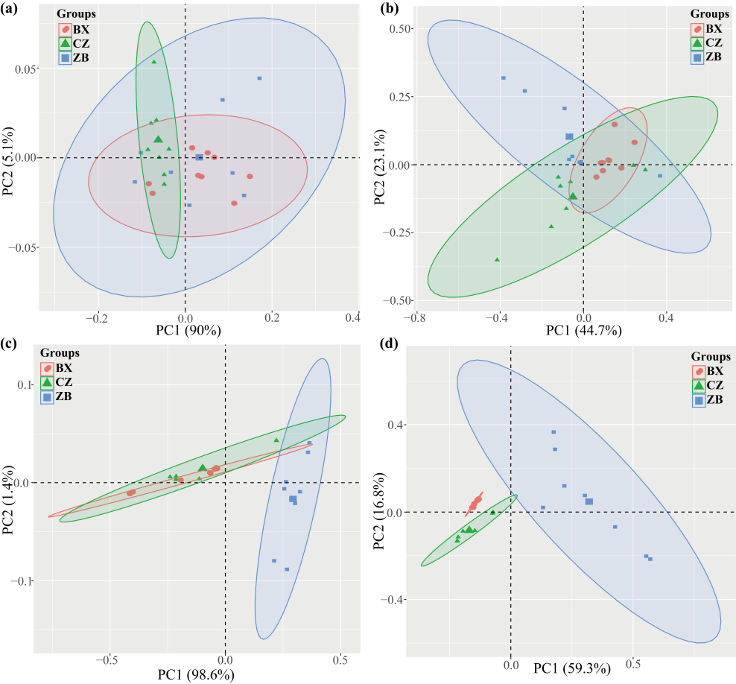
Figure S1 PCA difference analysis between the levels of phylum (a) and genus (b) of the tobacco bacterial community and the levels of phylum (c) and genus (d) of the fungal community in different origins.

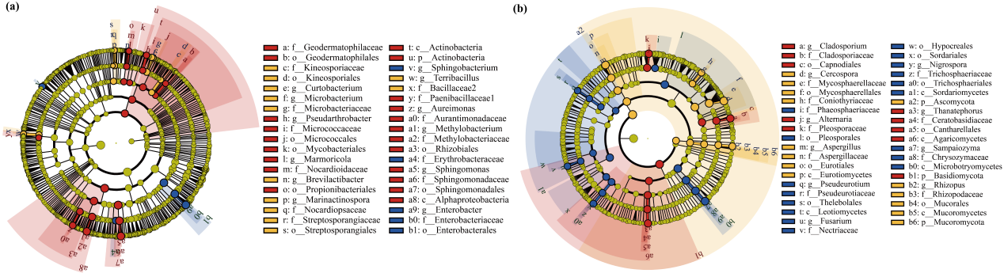
Figure S2 Linear discriminant analysis Effect Size (LEfSe) of tobacco (a) bacterial and (b) fungal community.

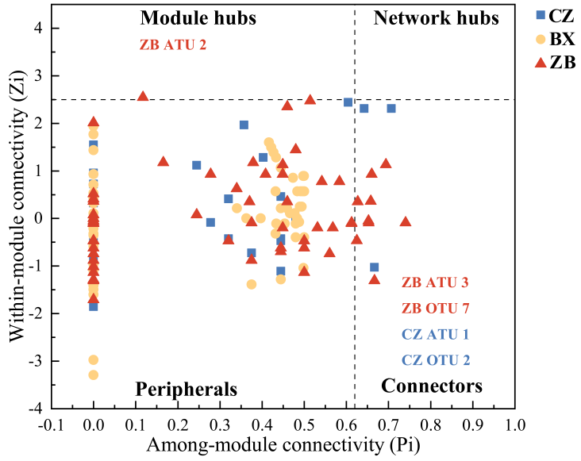
Figure S3 Zi-Pi plot of the molecular ecological network of bacterial-fungal interactions in tobacco from different origins.

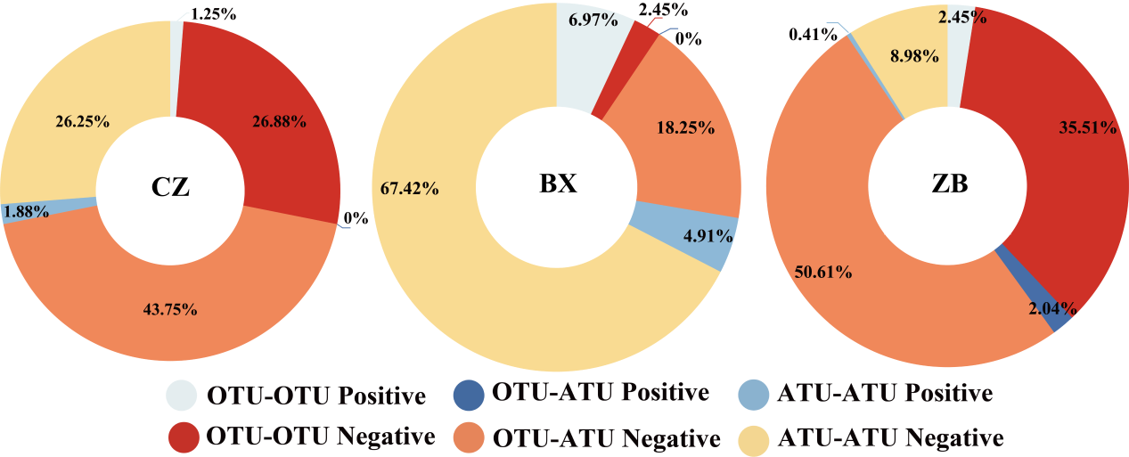
Figure S4 Types and percentage of interaction nodes in the molecular ecological network of tobacco bacterial-fungal interaction.

