Supplementary Table 1 Summary of body weights (g)
Groups | Dose |  | Study week - Treatment Period
Groups | Dose |  | 0 | 1 | 2 | 3
G1 | Untreated | Mean | 154.00 | 177.50 | 205.33 | 223.50
G1 | Untreated | ± SD | 7.95 | 8.64 | 7.63 | 7.82
G1 | Untreated | N | 6 | 6 | 6 | 6
G2 | Streptozotocin | Mean | 155.00 | 166.67 | 181.17 | 196.17
G2 | Streptozotocin | ± SD | 6.03 | 5.92 | 6.65 | 7.76
G2 | Streptozotocin | N | 6 | 6 | 6 | 6
G3 | Glibenclamide 10 mg/ kg | Mean | 154.67 | 172.00 | 194.50 | 216.17
G3 | Glibenclamide 10 mg/ kg | ± SD | 7.15 | 7.56 | 6.92 | 7.63
G3 | Glibenclamide 10 mg/ kg | N | 6 | 6 | 6 | 6
G4 | Formulation 250 mg/ kg | Mean | 154.00 | 172.17 | 194.67 | 214.67
G4 | Formulation 250 mg/ kg | ± SD | 9.38 | 7.68 | 8.21 | 7.09
G4 | Formulation 250 mg/ kg | N | 6 | 6 | 6 | 6
G5 | Formulation 500 mg/ kg | Mean | 155.00 | 170.67 | 191.00 | 213.83
G5 | Formulation 500 mg/ kg | ± SD | 7.92 | 8.66 | 9.12 | 7.36
G5 | Formulation 500 mg/ kg | N | 6 | 6 | 6 | 6
SD- Standard deviation, N-Normal level

Supplementary Table 2 Summary of Blood sugar level (mg/dl)
Groups | Dose | Study week - Treatment Period
Groups | Dose |  | 0 | 1 | 2 | 3
G1 | Untreated | Mean | 81.17 | 83.67 | 85.50 | 87.17
G1 | Untreated | ± SD | 6.43 | 7.45 | 7.01 | 7.11
G2 | Streptozotocin | Mean | 302.00 | 292.50 | 283.83 | 274.67**
G2 | Streptozotocin | ± SD | 4.20 | 3.94 | 4.17 | 5.28
G3 | Glibenclamide 10 mg/ kg | Mean | 294.00 | 277.67 | 159.50 | 85.17
G3 | Glibenclamide 10 mg/ kg | ± SD | 7.87 | 6.44 | 5.13 | 6.49
G4 | Formulation 250 mg/kg | Mean | 295.17 | 280.67 | 220.67 | 179.33*
G4 | Formulation 250 mg/kg | ± SD | 6.43 | 8.09 | 6.35 | 7.37
G5 | Formulation 500 mg/kg | Mean | 295.83 | 275.00 | 185.67 | 102.67*
G5 | Formulation 500 mg/kg | ± SD | 8.93 | 8.88 | 8.57 | 9.67
SD- Standard deviation, N-Normal level

Supplementary Table 3: The identified proteins in various study groups, represented in tabular format with details such as distinct summed MS/MS search score, % Amino Acid (AA) coverage, Mean peptide spectral intensity, % Scored Peak Intensity (SPI), Protein molecular weight, Protein isoelectric point (PI), Uniprot accession/identification code, Protein name and functional significance. (Proteins having direct correlation have been highlighted yellow)
Sample ID | Distinct Summed  MS/MS Search  Score | % AA  Coverage | Mean  Peptide  Spectral  Intensity | % SPI | Protein Molecular weight  (Dalton) | Protein  pI | Uniprot ID | Protein Name
Healthy control | 23.48 | 4.4 | 3.48E+04 | 96.3 | 135081 | 8.77 | P05539 | Collagen alpha-1(II) chain
Healthy control | 35.03 | 8.9 | 1.46E+06 | 83.3 | 47165 | 5.7 | Q68FX1 | Mannose-6-phosphate isomerase
Healthy control | 33.74 | 4.8 | 1.58E+03 | 80.8 | 120513 | 6.25 | O35346 | Focal adhesion kinase 1
Healthy control | 33.65 | 4.4 | 4.30E+05 | 83.7 | 70727 | 6.09 | P02770 | Serum albumin
Healthy control | 26.34 | 5 | 2.65E+04 | 58.1 | 92716 | 4.93 | O88884 | A-kinase anchor protein 1, mitochondrial
Healthy control | 25.69 | 16.1 | 4.53E+03 | 81.1 | 33812 | 5.32 | P85969 | Beta-soluble NSF attachment protein
Healthy control | 25.37 | 4.1 | 7.04E+03 | 78.1 | 111819 | 7.2 | Q2TA68 | Dynamin-like 120 kDa protein, mitochondrial
Healthy control | 23.58 | 6.4 | 1.57E+04 | 69.5 | 93265 | 5.01 | Q4V8B0 | Oxidation resistance protein 1
Healthy control | 23.45 | 4.9 | 2.46E+04 | 68.3 | 108591 | 6.28 | Q01812 | Glutamate receptor ionotropic, kainate 4
Healthy control | 22.59 | 0.6 | 1.80E+05 | 77.6 | 468200 | 5.8 | Q63170 | Dynein heavy chain 7, axonemal
Healthy control | 22.33 | 6.2 | 6.38E+04 | 86.5 | 41489 | 8.51 | Q3SWS8 | mRNA export factor
Healthy control | 22.15 | 4.6 | 2.77E+03 | 88.2 | 67129 | 9.26 | Q6UPE0 | Choline dehydrogenase, mitochondrial
Healthy control | 21.58 | 8.7 | 1.42E+03 | 84.2 | 53907 | 5.72 | P38062 | Methionine aminopeptidase 2
Healthy control | 20.75 | 4 | 5.11E+04 | 88.2 | 55143 | 5.52 | Q62698 | Cytoplasmic dynein 1 light intermediate chain 2
Healthy control | 20.45 | 0.8 | 2.26E+03 | 60.6 | 623583 | 5.28 | D3ZHV2 | Microtubule-actin cross-linking factor 1
Healthy control | 18.87 | 15.1 | 4.25E+04 | 70.3 | 47098 | 8.91 | P42571 | POU domain, class 2, transcription factor 3
Healthy control | 18.49 | 2.1 | 1.41E+03 | 87.9 | 179415 | 5.71 | O08873 | MAP kinase-activating death domain protein
Healthy control | 18.21 | 1.4 | 2.20E+04 | 69.1 | 420527 | 7.82 | O88778 | Protein bassoon
Healthy control | 16.92 | 1.8 | 5.50E+04 | 69.2 | 208587 | 5.82 | O35889 | Afadin
Healthy control | 13.97 | 13.7 | 2.03E+04 | 67.1 | 41094 | 11.32 | O88626 | Galanin receptor type 3
Healthy control | 30.23 | 7.5 | 5.74E+04 | 85 | 52701 | 6.37 | Q5PQQ1 | tRNA modification GTPase GTPBP3, mitochondrial
Healthy control | 25.38 | 0.7 | 4.84E+04 | 74.1 | 468200 | 5.8 | Q63170 | Dynein heavy chain 7, axonemal
Healthy control | 25.08 | 14.2 | 6.68E+03 | 84 | 28414 | 4.59 | P20942 | Phosducin
Healthy control | 24.9 | 2 | 1.53E+05 | 74.8 | 227703 | 5.5 | Q62812 | Myosin-9
Healthy control | 24.65 | 2.2 | 1.45E+04 | 67.2 | 293605 | 5.59 | D3ZHA0 | Filamin-C
Healthy control | 23.65 | 13.8 | 5.55E+03 | 70 | 39801 | 8.44 | Q5U2W4 | Centromere protein N
Healthy control | 22.96 | 1.6 | 2.21E+04 | 67.9 | 202484 | 9.38 | Q6Q760 | Sodium leak channel non-selective protein
Healthy control | 22.85 | 4.3 | 2.54E+04 | 66.4 | 112877 | 6.74 | Q5FVC2 | Rho guanine nucleotide exchange factor 2
Healthy control | 22 | 1.8 | 3.27E+04 | 69.5 | 267643 | 4.95 | F1MA98 | Nucleoprotein TPR
Healthy control | 20.83 | 5.6 | 5.52E+04 | 80.7 | 50747 | 8.6 | Q4KM52 | B-cell linker protein
Healthy control | 20.77 | 0.7 | 4.08E+04 | 69.7 | 519348 | 5.64 | Q63164 | Dynein heavy chain 1, axonemal
Healthy control | 20.38 | 2.6 | 1.88E+05 | 93.1 | 107462 | 7.14 | Q5XI83 | VPS35 endosomal protein sorting factor-like
Healthy control | 20.16 | 6.5 | 2.97E+04 | 67.3 | 82539 | 7.36 | Q63553 | SNF-related serine/threonine-protein kinase
Healthy control | 18.83 | 5 | 1.27E+03 | 75.4 | 70465 | 9.61 | Q66HE5 | NUAK family SNF1-like kinase 2
Healthy control | 16.97 | 2.1 | 2.30E+04 | 90.3 | 203602 | 6.36 | P15800 | Laminin subunit beta-2
Healthy control | 16.31 | 0.3 | 2.24E+04 | 89.9 | 571121 | 5.18 | F1LMY4 | Ryanodine receptor 1
Healthy control | 15.39 | 1.3 | 3.13E+03 | 75.3 | 258755 | 6.02 | Q99P84 | 1-phosphatidylinositol 4,5-bisphosphate phosphodiesterase epsilon-1
Healthy control | 14.44 | 2.7 | 7.11E+03 | 64.9 | 77625 | 6.39 | P82808 | Glutamine--fructose-6-phosphate aminotransferase [isomerizing] 1
Healthy control | 62.88 | 8.7 | 1.72E+05 | 80.4 | 70727 | 6.09 | P02770 | Serum albumin
Healthy control | 23.55 | 4.9 | 1.49E+05 | 81.2 | 104026 | 5.75 | P27881 | Hexokinase-2
Healthy control | 22.57 | 5.5 | 5.21E+03 | 70.3 | 122949 | 9.31 | D3ZUI5 | Protein cordon-bleu
Healthy control | 22.41 | 9 | 7.17E+03 | 83.4 | 57030 | 5.38 | O35462 | Angiopoietin-2
Healthy control | 21.93 | 5.4 | 4.71E+03 | 56.3 | 88931 | 9.11 | Q7TPK1 | E3 ubiquitin-protein ligase UHRF1
Healthy control | 19.76 | 0.6 | 1.53E+03 | 72.8 | 534981 | 6.07 | P38650 | Cytoplasmic dynein 1 heavy chain 1
Healthy control | 19.2 | 0.4 | 6.21E+03 | 70 | 495632 | 6.23 | Q9JJ79 | Cytoplasmic dynein 2 heavy chain 1
Healthy control | 18.94 | 1.8 | 2.49E+03 | 62.6 | 296566 | 8.92 | Q9QZR8 | PDZ domain-containing protein 2
Healthy control | 18.16 | 9 | 1.40E+04 | 69.7 | 81710 | 5.59 | O70196 | Prolyl endopeptidase
Healthy control | 17.62 | 9.2 | 1.35E+05 | 51.2 | 43308 | 6.34 | Q9JJM9 | Septin-5
Healthy control | 16.27 | 5 | 5.97E+03 | 72.7 | 79946 | 5.27 | O35920 | Calpain-9
Healthy control | 15.2 | 4.8 | 0.00E+00 | 100 | 34335 | 10.38 | P22509 | rRNA 2'-O-methyltransferase fibrillarin
Healthy control | 14.63 | 3.7 | 3.17E+03 | 73.5 | 79611 | 7.4 | P63319 | Protein kinase C gamma type
Healthy control | 13.58 | 7.8 | 3.75E+03 | 88.1 | 46971 | 9.85 | Q4V8G7 | Centromere protein U
Healthy control | 23.11 | 5.1 | 9.05E+03 | 82.1 | 117798.2 | 6.48 | Q10836 | Thyrotropin-releasing hormone-degrading ectoenzyme
Healthy control | 21.75 | 15.1 | 2.38E+05 | 65.4 | 26581.2 | 6.44 | P70595 | Neurogenin-1
Healthy control | 21.55 | 2.3 | 8.78E+04 | 79.4 | 161226.3 | 5.55 | Q4KLH6 | Centrosomal protein of 162 kDa
Healthy control | 21.42 | 1.3 | 9.50E+03 | 64.9 | 346773.3 | 4.79 | D4ACX8 | Protocadherin-16
Healthy control | 21.34 | 3.5 | 1.92E+03 | 96.1 | 120883.1 | 7.22 | Q6DTM3 | Jouberin
Healthy control | 21.29 | 2.9 | 5.74E+04 | 79.6 | 109980.8 | 6.04 | Q9JMK8 | Vacuolar protein sorting-associated protein 54
Healthy control | 20.66 | 4.6 | 1.86E+04 | 82.1 | 51383.1 | 5.38 | B2RYF7 | WASH complex subunit 1
Healthy control | 20.51 | 2.9 | 3.69E+04 | 77 | 181651.4 | 5.09 | P20909 | Collagen alpha-1(XI) chain
Healthy control | 19.46 | 9.7 | 5.40E+04 | 75.2 | 28252.4 | 11.37 | P62919 | 60S ribosomal protein L8
Healthy control | 19.29 | 3.2 | 6.20E+04 | 78.1 | 61121.8 | 10.15 | Q9Z2A6 | Mitogen-activated protein kinase 15
Healthy control | 17.66 | 1.5 | 9.05E+03 | 63.7 | 376488.8 | 6.14 | O35923 | Breast cancer type 2 susceptibility protein homolog
Healthy control | 16.23 | 3.9 | 2.38E+05 | 53.5 | 117755.6 | 5.39 | D3Z9Z9 | SWI/SNF-related matrix-associated actin-dependent regulator of chromatin subfamily A containing DEAD/H box 1
Healthy control | 15.99 | 1.1 | 8.78E+04 | 87.2 | 239540 | 6.85 | O08662 | Phosphatidylinositol 4-kinase alpha
Healthy control | 11.48 | 1.7 | 9.50E+03 | 57.3 | 225920.6 | 9.1 | F1LP64 | E3 ubiquitin-protein ligase TRIP12
Healthy control | 32.57 | 6.5 | 6.13E+04 | 75 | 80670.1 | 5.98 | Q8CJ99 | Sodium channel and clathrin linker 1
Healthy control | 29.05 | 2.6 | 6.03E+04 | 100 | 110125.7 | 9.74 | Q8VHN2 | Glutamate receptor ionotropic, NMDA 3B
Healthy control | 27.07 | 2.4 | 3.62E+04 | 68.1 | 251927.4 | 6.37 | F1LPQ2 | Activating signal cointegrator 1 complex subunit 3
Healthy control | 25.28 | 3.6 | 3.49E+04 | 68.7 | 138978 | 5.71 | P02454 | Collagen alpha-1(I) chain
Healthy control | 24.87 | 3.5 | 6.41E+04 | 84.8 | 142139 | 5.61 | P06494 | Receptor tyrosine-protein kinase erbB-2
Healthy control | 24.82 | 10.4 | 1.05E+04 | 70.7 | 57648.6 | 6.94 | P11715 | Steroid 17-alpha-hydroxylase/17,20 lyase
Healthy control | 24.14 | 13.7 | 9.80E+03 | 65.5 | 32913.5 | 4.86 | G3V9R8 | Heterogeneous nuclear ribonucleoprotein C
Healthy control | 23.4 | 1.9 | 7.08E+03 | 70.4 | 239826.8 | 6.56 | Q7TNJ2 | ATP-binding cassette sub-family A member 7
Healthy control | 23.24 | 3.6 | 1.48E+04 | 62.8 | 118983.8 | 5.36 | Q5U300 | Ubiquitin-like modifier-activating enzyme 1
Healthy control | 22.24 | 6.1 | 8.22E+04 | 81.7 | 85356.6 | 5.67 | B4F7E8 | Protein Niban 2
Healthy control | 22.11 | 1.3 | 4.16E+04 | 72.9 | 574329.4 | 6.3 | Q8K3K1 | Usherin
Healthy control | 21.81 | 7.1 | 2.31E+05 | 79 | 79109.7 | 9.54 | Q75NT5 | Aryl hydrocarbon receptor repressor
Healthy control | 21.73 | 2.3 | 7.11E+03 | 66.5 | 139197.8 | 5.86 | P10687 | 1-phosphatidylinositol 4,5-bisphosphate phosphodiesterase beta-1
Healthy control | 21.41 | 6.2 | 3.02E+03 | 59.3 | 63060 | 7.82 | Q0PMD2 | Anthrax toxin receptor 1
Healthy control | 20.55 | 4.2 | 4.52E+03 | 73.5 | 93645.5 | 5.8 | Q810H6 | Disrupted in schizophrenia 1 homolog
Healthy control | 19.27 | 1.1 | 7.07E+03 | 69.7 | 554531.3 | 6.13 | Q9JKS6 | Protein piccolo
Healthy control | 19.11 | 0.9 | 5.32E+04 | 83.7 | 357069.7 | 9.16 | Q63638 | Striated muscle-specific serine/threonine-protein kinase
Healthy control | 13.24 | 3.1 | 1.68E+04 | 61.7 | 134972 | 8.25 | F1LVW7 | Protein diaphanous homolog 3
Healthy control | 9.66 | 2.9 | 6.02E+03 | 88.1 | 83081.6 | 10.15 | P97616 | Double-stranded RNA-specific editase B2
Healthy control | 48.55 | 4.1 | 1.14E+05 | 78.4 | 165140 | 5.7 | P14046 | Alpha-1-inhibitor 3
Healthy control | 35.87 | 3.1 | 8.99E+04 | 65.3 | 166693 | 5.68 | Q03626 | Murinoglobulin-1
Healthy control | 33.24 | 2.2 | 5.12E+04 | 63.5 | 162955 | 6.16 | Q6IE52 | Murinoglobulin-2
Healthy control | 31.3 | 3.7 | 8.20E+04 | 85.4 | 84141 | 6.37 | Q07803 | Elongation factor G, mitochondrial
Healthy control | 26.61 | 9.2 | 4.00E+04 | 66.8 | 67697 | 5.03 | Q8R5M4 | Optineurin
Healthy control | 25.82 | 4.1 | 1.11E+04 | 61.1 | 149778 | 6.2 | Q5QE79 | Aldehyde oxidase 4
Healthy control | 24.34 | 5.8 | 5.29E+03 | 82.8 | 69786 | 9.59 | O70418 | RING finger protein 112
Healthy control | 23.44 | 4.8 | 1.65E+05 | 72.7 | 80252 | 6.34 | O35826 | Bifunctional UDP-N-acetylglucosamine 2-epimerase/N-acetylmannosamine kinase
Healthy control | 21.67 | 1.5 | 1.99E+04 | 71.6 | 159961 | 6.71 | Q7M6Z5 | Kinesin-like protein KIF27
Healthy control | 20.28 | 17.8 | 1.45E+04 | 78.2 | 21464 | 7.96 | P02529 | Gamma-crystallin C
Healthy control | 16.46 | 3.1 | 2.77E+04 | 68.4 | 122012 | 6.19 | Q5U2P0 | DIS3-like exonuclease 1
Healthy control | 16.36 | 8.1 | 8.79E+03 | 54.5 | 55015 | 9.06 | Q32PX9 | AFG1-like ATPase
Healthy control | 15.49 | 6.9 | 9.73E+03 | 80.2 | 77648 | 4.97 | O35314 | Secretogranin-1
Healthy control | 14.56 | 12.3 | 3.91E+04 | 53 | 28368 | 10.2 | Q5I0K8 | 28S ribosomal protein S7, mitochondrial
Disease control | 27.41 | 10.4 | 6.79E+04 | 64.4 | 29559 | 9.08 | Q5U1Y1 | Ras-related protein Rab-34
Disease control | 24.01 | 7.9 | 4.20E+04 | 74.4 | 88139 | 9.09 | Q8K3Y6 | Zinc finger CCCH-type antiviral protein 1
Disease control | 23.03 | 3.2 | 1.82E+05 | 86.1 | 107462 | 7.14 | Q5XI83 | VPS35 endosomal protein sorting factor-like
Disease control | 22.74 | 2.5 | 4.05E+04 | 81.2 | 109190 | 6.1 | Q8K4M9 | Oxysterol-binding protein-related protein 1
Disease control | 20.79 | 5 | 1.56E+04 | 70 | 123347 | 5.1 | Q6P7A2 | Ubiquitin conjugation factor E4 A
Disease control | 20.55 | 1.9 | 5.18E+04 | 69.6 | 285864 | 8.19 | O70511 | Ankyrin-3
Disease control | 19.76 | 12.8 | 1.64E+05 | 70.2 | 56472 | 5.3 | Q66H63 | Ganglioside-induced differentiation-associated-protein 2
Disease control | 16.69 | 7.7 | 2.16E+03 | 65.4 | 83686 | 6.23 | Q5XIN6 | Mitochondrial proton/calcium exchanger protein
Disease control | 14.73 | 13.9 | 1.09E+04 | 58.6 | 29801 | 5.56 | Q499R4 | YrdC domain-containing protein, mitochondrial
Disease control | 51.46 | 7 | 9.95E+05 | 86.7 | 70727 | 6.09 | P02770 | Serum albumin
Disease control | 34.41 | 1.1 | 2.47E+05 | 84 | 264532 | 6.77 | Q9EQ60 | Voltage-dependent T-type calcium channel subunit alpha-1H
Disease control | 23.7 | 0.9 | 7.09E+04 | 75.5 | 554531 | 6.13 | Q9JKS6 | Protein piccolo
Disease control | 22.16 | 9.7 | 3.42E+04 | 84.3 | 70661 | 6.07 | F1LRS8 | CD2-associated protein
Disease control | 22.12 | 1.1 | 1.20E+04 | 87.7 | 307191 | 6.08 | Q63269 | Inositol 1,4,5-trisphosphate receptor type 3
Disease control | 21.99 | 4.4 | 3.60E+03 | 48.6 | 141325 | 5.33 | Q9R0L4 | Cullin-associated NEDD8-dissociated protein 2
Disease control | 20.44 | 5.3 | 7.76E+03 | 72.2 | 76987 | 6.32 | Q3SWT0 | Platelet endothelial cell adhesion molecule
Disease control | 19.43 | 10.4 | 1.23E+05 | 51.9 | 66974 | 5.81 | Q9WU74 | Lipolysis-stimulated lipoprotein receptor
Disease control | 18.46 | 14.7 | 1.74E+05 | 69.4 | 29877 | 5.57 | P67779 | Prohibitin
Disease control | 15.86 | 5.3 | 4.14E+04 | 67.7 | 117712 | 5.56 | Q6QLM7 | Kinesin heavy chain isoform 5A
Disease control | 15.26 | 0.9 | 4.99E+04 | 81.8 | 399178 | 5.76 | M0R8U1 | Dynein heavy chain 5, axonemal (Fragment)
Disease control | 14.26 | 2.8 | 5.94E+03 | 74 | 168491 | 6.47 | Q63041 | Alpha-1-macroglobulin
Disease control | 14.09 | 5.2 | 3.28E+04 | 76.4 | 84298 | 7.81 | P97691 | Forkhead box protein M1
Disease control | 10.9 | 5.8 | 3.14E+03 | 56.9 | 89759 | 4.86 | O35274 | Neurabin-2
Disease control | 9.75 | 3.5 | 1.96E+04 | 95.1 | 67739 | 7 | D3ZU57 | Ribosomal oxygenase 1
Std Glibenclamide | 38.04 | 7.8 | 1.90E+04 | 81.1 | 83601 | 6.59 | Q7TMD5 | Zinc finger CCCH domain-containing protein 14
Std Glibenclamide | 24.76 | 9.3 | 1.01E+04 | 70.1 | 35192 | 8.89 | Q5M965 | Probable tRNA(His) guanylyltransferase
Std Glibenclamide | 24.26 | 5 | 1.48E+04 | 95.1 | 80688 | 6.57 | Q5XHZ0 | Heat shock protein 75 kDa, mitochondrial
Std Glibenclamide | 24.05 | 7.4 | 1.63E+03 | 60 | 69525 | 7.78 | Q6IG02 | Keratin, type II cytoskeletal 2 epidermal
Std Glibenclamide | 23.51 | 3.6 | 4.82E+03 | 72.3 | 164078 | 6.33 | O88902 | Tyrosine-protein phosphatase non-receptor type 23 (Fragment)
Std Glibenclamide | 23.38 | 1.5 | 6.54E+03 | 72.7 | 574329 | 6.3 | Q8K3K1 | Usherin
Std Glibenclamide | 23.05 | 3.8 | 2.61E+03 | 90.06 | 114113 | 5.74 | Q63226 | Glutamate receptor ionotropic, delta-2
Std Glibenclamide | 22.89 | 2.6 | 5.10E+04 | 81.7 | 191646 | 6.31 | Q5JCS6 | Signal-induced proliferation-associated 1-like protein 2
Std Glibenclamide | 22.82 | 8.4 | 3.48E+04 | 74 | 54354 | 5.02 | Q9ER24 | Ataxin-10
Std Glibenclamide | 22.43 | 1.1 | 8.51E+02 | 74.4 | 304936 | 5.32 | F1M3G7 | A-kinase anchor protein 13
Std Glibenclamide | 21.4 | 5.9 | 1.90E+04 | 100 | 85255 | 8.66 | A0A0G2JXN2 | Tripartite motif-containing protein 46
Std Glibenclamide | 20.85 | 1.6 | 1.76E+03 | 60.9 | 256915 | 4.95 | Q9WVC7 | A-kinase anchor protein 6
Std Glibenclamide | 20.13 | 9.8 | 1.81E+03 | 67.8 | 62953 | 5.45 | Q7TT51 | Lengsin
Std Glibenclamide | 19.43 | 9.9 | 3.44E+04 | 69.8 | 38857 | 9.98 | D3ZN43 | NADH dehydrogenase (ubiquinone) complex I, assembly factor 6
Std Glibenclamide | 19.26 | 3.2 | 4.36E+04 | 49.2 | 168491 | 6.47 | Q63041 | Alpha-1-macroglobulin
Std Glibenclamide | 15.24 | 5.2 | 2.27E+04 | 61.2 | 115452 | 6.52 | Q4V9H5 | PHD finger protein 20-like protein 1
Std Glibenclamide | 14.85 | 5.5 | 4.88E+04 | 60.7 | 79227 | 9.53 | P07896 | Peroxisomal bifunctional enzyme
Std Glibenclamide | 11.06 | 3.5 | 2.58E+04 | 61.4 | 90003 | 6.52 | P49620 | Diacylglycerol kinase gamma
Std Glibenclamide | 26.17 | 6.6 | 9.26E+04 | 100 | 67418.8 | 5.37 | P48998 | Involucrin
Std Glibenclamide | 30.85 | 0.8 | 1.87E+06 | 79 | 534980.6 | 6.07 | P38650 | Cytoplasmic dynein 1 heavy chain 1 (Cytoplasmic dynein heavy chain 1) (Dynein heavy chain, cytosolic)
Std Glibenclamide | 28.86 | 1.9 | 7.21E+04 | 87.2 | 253711.9 | 7.03 | O54898 | Voltage-dependent T-type calcium channel subunit alpha-1G (Voltage-gated calcium channel subunit alpha Cav3.1)
Std Glibenclamide | 27.29 | 1.8 | 6.31E+04 | 88.1 | 198477.2 | 5.83 | P49793 | Nuclear pore complex protein Nup98-Nup96 (EC 3.4.21.-)
Std Glibenclamide | 27.15 | 5.1 | 1.42E+05 | 85.4 | 110786.9 | 6.62 | Q8K3M6 | ERC protein 2 (CAZ-associated structural protein 1) (CAST1) (Cast) (Cytomatrix protein p110)
Std Glibenclamide | 25.34 | 0.9 | 5.84E+04 | 56.9 | 623583 | 5.28 | D3ZHV2 | Microtubule-actin cross-linking factor 1 (Actin cross-linking family 7)
Std Glibenclamide | 24.86 | 1 | 9.78E+03 | 78.8 | 580856.1 | 5.73 | Q2TL32 | E3 ubiquitin-protein ligase UBR4 (EC 2.3.2.27) (N-recognin-4) (RING-type E3 ubiquitin transferase UBR4) (Zinc finger UBR1-type protein 1)
Std Glibenclamide | 24.05 | 1.6 | 1.77E+04 | 82.3 | 260847.6 | 6.6 | E9PSU6 | Pecanex-like protein 1 (Pecanex 1) (Pecanex homolog protein 1)
Std Glibenclamide | 23.19 | 12.2 | 1.43E+03 | 71.2 | 45821.7 | 4.81 | P12368 | cAMP-dependent protein kinase type II-alpha regulatory subunit
Std Glibenclamide | 22.46 | 1.8 | 1.83E+04 | 82.6 | 161384.7 | 5.09 | P0C644 | Inositol hexakisphosphate and diphosphoinositol-pentakisphosphate kinase 1 (EC 2.7.4.21) (EC 2.7.4.24)
Std Glibenclamide | 19.43 | 5.2 | 1.95E+04 | 68.9 | 111212.5 | 5.87 | P35524 | Chloride channel protein 1 (ClC-1)
Std Glibenclamide | 18.97 | 1.1 | 2.00E+03 | 66.8 | 346773.3 | 4.79 | D4ACX8 | Protocadherin-16 (Protein dachsous homolog 1)
Std Glibenclamide | 18.66 | 1.5 | 6.42E+04 | 67.6 | 376488.8 | 6.14 | O35923 | Breast cancer type 2 susceptibility protein homolog (Fanconi anemia group D1 protein homolog)
Std Glibenclamide | 17.09 | 2.9 | 2.87E+04 | 98.5 | 96801.5 | 6.94 | Q66HR0 | Solute carrier family 12 member 9 (Cation-chloride cotransporter 6)
Std Glibenclamide | 16.33 | 3.3 | 8.55E+04 | 80.3 | 117744.2 | 8.85 | Q9ESV1 | Leucine zipper protein 1 (Leucine zipper motif-containing protein)
Std Glibenclamide | 13.54 | 2.5 | 4.24E+04 | 57.8 | 175484.5 | 7.27 | Q63563 | ATP-binding cassette sub-family C member 9 (Sulfonylurea receptor 2)
Std Glibenclamide | 10.79 | 1 | 1.07E+05 | 57 | 394484.8 | 5.48 | P58751 | Reelin (EC 3.4.21.-)
Std Glibenclamide | 92.15 | 13.8 | 1.68E+06 | 95.1 | 70726.5 | 6.09 | P02770 | Serum albumin
Std Glibenclamide | 24.37 | 4.4 | 1.12E+05 | 84.3 | 130075.2 | 9.62 | P02466 | Collagen alpha-2(I) chain
Std Glibenclamide | 28.03 | 19.2 | 9.72E+04 | 86.5 | 27859.7 | 6.2 | Q924B5 | Testis-expressed protein 101
Std Glibenclamide | 26.05 | 1.9 | 1.15E+04 | 72.5 | 285863.9 | 8.19 | O70511 | Ankyrin-3
Std Glibenclamide | 24.28 | 2.7 | 5.57E+02 | 80.3 | 142212.4 | 4.96 | Q9JKC9 | Synergin gamma
Std Glibenclamide | 23.55 | 3.2 | 5.59E+03 | 70.6 | 111288.8 | 9.21 | D4A1F2 | [F-actin]-monooxygenase MICAL2
Std Glibenclamide | 23.05 | 0.8 | 4.70E+04 | 82.1 | 483554.4 | 5 | O88277 | Protocadherin Fat 2
Std Glibenclamide | 21.93 | 8.3 | 1.43E+05 | 60.9 | 35809.9 | 5.23 | P02650 | Apolipoprotein E
Std Glibenclamide | 21.35 | 2.3 | 1.75E+04 | 72.8 | 126842.2 | 4.41 | Q9JK11 | Reticulon-4
Std Glibenclamide | 20.43 | 2.1 | 1.92E+05 | 78 | 174075.7 | 6.44 | Q62910 | Synaptojanin-1
Std Glibenclamide | 19.2 | 8.4 | 1.85E+04 | 71.2 | 19298.6 | 9.3 | P59647 | FXYD domain-containing ion transport regulator 5
Std Glibenclamide | 17.86 | 4.3 | 1.40E+04 | 68 | 110812.3 | 4.63 | Q5M7W5 | Microtubule-associated protein 4
Std Glibenclamide | 17.49 | 5.7 | 4.51E+03 | 70.2 | 89682.5 | 6.27 | Q5U2W5 | Transducin beta-like protein 3
Std Glibenclamide | 15.61 | 5.3 | 2.29E+04 | 83.9 | 30122.7 | 5.99 | P0C1X9 | Leukocyte-associated immunoglobulin-like receptor 1
Std Glibenclamide | 15.52 | 5.1 | 1.17E+03 | 54.8 | 74728.2 | 8.43 | D3ZTV3 | Leucine-rich repeat transmembrane protein FLRT2
Std Glibenclamide | 12.31 | 8.1 | 7.79E+03 | 70 | 50357 | 5.71 | Q5FVR2 | Thymidine phosphorylase
Formulation 250mg/kg | 40.04 | 7.1 | 1.89E+05 | 78.7 | 78562 | 7.31 | P12346 | Serotransferrin
Formulation 250mg/kg | 29.74 | 2.4 | 1.72E+05 | 85.9 | 109981 | 6.04 | Q9JMK8 | Vacuolar protein sorting-associated protein 54
Formulation 250mg/kg | 26.92 | 5.2 | 5.21E+05 | 73.3 | 80806 | 5.58 | P31016 | Disks large homolog 4
Formulation 250mg/kg | 25.73 | 2.1 | 2.01E+04 | 76.6 | 134453 | 7.18 | D4A0X3 | AP2-interacting clathrin-endocytosis protein
Formulation 250mg/kg | 25.04 | 4.1 | 2.92E+05 | 67 | 76482 | 5.78 | Q2VUH7 | Dixin
Formulation 250mg/kg | 24.69 | 4.3 | 1.62E+03 | 78.5 | 88282 | 5.63 | P0C865 | Mitogen-activated protein kinase 7
Formulation 250mg/kg | 24.68 | 2.6 | 5.88E+04 | 72.9 | 124172 | 9.32 | Q3T1I5 | Sterol regulatory element-binding protein 2
Formulation 250mg/kg | 24.12 | 0.9 | 2.58E+05 | 74.1 | 495632 | 6.23 | Q9JJ79 | Cytoplasmic dynein 2 heavy chain 1
Formulation 250mg/kg | 22.61 | 5.2 | 1.92E+03 | 65.6 | 70079 | 9.08 | O35548 | Matrix metalloproteinase-16
Formulation 250mg/kg | 22.59 | 6.9 | 1.86E+03 | 79.1 | 64343 | 9.56 | Q8K4B7 | Dimethylaniline monooxygenase [N-oxide-forming] 4
Formulation 250mg/kg | 21.94 | 3.9 | 3.36E+05 | 71.7 | 123913 | 7.42 | D3ZTD8 | Semaphorin-5A
Formulation 250mg/kg | 20.49 | 2.8 | 2.12E+04 | 68.7 | 181651 | 5.09 | P20909 | Collagen alpha-1(XI) chain
Formulation 250mg/kg | 20.46 | 1.3 | 1.30E+03 | 95.9 | 237813 | 5.52 | Q9QYP2 | Cadherin EGF LAG seven-pass G-type receptor 2 (Fragment)
Formulation 250mg/kg | 19.92 | 1.5 | 3.14E+04 | 76.3 | 141325 | 5.33 | Q9R0L4 | Cullin-associated NEDD8-dissociated protein 2
Formulation 250mg/kg | 19.37 | 2.8 | 1.20E+05 | 73.8 | 89185 | 9.28 | Q63704 | Carnitine O-palmitoyltransferase 1, muscle isoform
Formulation 250mg/kg | 18.64 | 19.4 | 1.70E+04 | 70.4 | 26503 | 6.92 | Q6AY80 | Ribosyldihydronicotinamide dehydrogenase [quinone]
Formulation 250mg/kg | 18.27 | 1.6 | 2.07E+04 | 60.6 | 208587 | 5.82 | O35889 | Afadin
Formulation 250mg/kg | 17.95 | 1 | 1.09E+04 | 62.2 | 211602 | 5.61 | P23739 | Sucrase-isomaltase, intestinal
Formulation 250mg/kg | 17.52 | 8.9 | 2.66E+04 | 79.3 | 49416 | 7.88 | Q7TNL4 | Serine/threonine-protein kinase 40
Formulation 250mg/kg | 17.2 | 4.3 | 1.00E+05 | 60 | 78039 | 5.72 | Q5BK65 | Transforming growth factor beta activator LRRC33
Formulation 250mg/kg | 16.11 | 1.9 | 4.93E+04 | 84.3 | 138978 | 5.71 | P02454 | Collagen alpha-1(I) chain
Formulation 250mg/kg | 15.72 | 4.5 | 1.83E+04 | 66.6 | 88335 | 9.28 | Q6MGA9 | Bromodomain-containing protein 2
Formulation 250mg/kg | 27.86 | 10.3 | 2.39E+04 | 74.3 | 67367 | 7.2 | Q32PX7 | Far upstream element-binding protein 1
Formulation 250mg/kg | 26.58 | 4.1 | 6.32E+04 | 74.8 | 117712 | 5.56 | Q6QLM7 | Kinesin heavy chain isoform 5A
Formulation 250mg/kg | 26.44 | 6.3 | 2.84E+03 | 79.2 | 79484 | 9.16 | P83829 | Intraflagellar transport protein 81 homolog
Formulation 250mg/kg | 26.11 | 0.6 | 1.20E+04 | 76.7 | 505445 | 4.72 | Q8R508 | Protocadherin Fat 3
Formulation 250mg/kg | 23.52 | 2.6 | 1.36E+05 | 74.9 | 87991 | 8.27 | O88496 | Vitamin K-dependent gamma-carboxylase
Formulation 250mg/kg | 22.04 | 4.7 | 4.15E+04 | 81.5 | 98066 | 7.36 | Q5PQP9 | Armadillo repeat-containing protein 5
Formulation 250mg/kg | 21.24 | 2.5 | 7.87E+03 | 61.6 | 188304 | 6.55 | Q9Z286 | Adenylate cyclase type 10
Formulation 250mg/kg | 21.02 | 2.8 | 1.94E+04 | 80.4 | 151377 | 5.87 | P97603 | Neogenin (Fragment)
Formulation 250mg/kg | 19.83 | 1.6 | 1.96E+03 | 90.7 | 204238 | 9.02 | O88457 | Sodium channel protein type 11 subunit alpha
Formulation 250mg/kg | 19.28 | 3.8 | 9.04E+04 | 75.4 | 104545 | 8.3 | D3ZTQ1 | Splicing factor, suppressor of white-apricot homolog
Formulation 250mg/kg | 19.27 | 0.9 | 7.02E+04 | 81.5 | 339719 | 5.67 | P97924 | Kalirin
Formulation 250mg/kg | 18.43 | 3.7 | 1.18E+03 | 75.7 | 105022 | 5.25 | O88453 | Scaffold attachment factor B1
Formulation 250mg/kg | 17.43 | 3.7 | 8.69E+03 | 53.9 | 69525 | 7.78 | Q6IG02 | Keratin, type II cytoskeletal 2 epidermal
Formulation 250mg/kg | 16.62 | 1.8 | 9.73E+03 | 71.9 | 256593 | 4.75 | Q62656 | Receptor-type tyrosine-protein phosphatase zeta
Formulation 250mg/kg | 14.05 | 4.6 | 1.43E+04 | 68.9 | 71372 | 6.69 | P31647 | Sodium- and chloride-dependent GABA transporter 3
Formulation 250mg/kg | 45.51 | 6.4 | 1.26E+06 | 88.1 | 70727 | 6.09 | P02770 | Serum albumin
Formulation 250mg/kg | 28.44 | 1.3 | 6.20E+04 | 74.6 | 306296 | 5.94 | D3ZA12 | Chromodomain-helicase-DNA-binding protein 6
Formulation 250mg/kg | 27.86 | 3.4 | 2.26E+03 | 68.6 | 130075 | 9.62 | P02466 | Collagen alpha-2(I) chain
Formulation 250mg/kg | 25.57 | 2 | 1.59E+04 | 74.8 | 202484 | 9.38 | Q6Q760 | Sodium leak channel non-selective protein
Formulation 250mg/kg | 24.48 | 7.5 | 4.88E+03 | 75 | 61951 | 7.26 | P07314 | Glutathione hydrolase 1 proenzyme
Formulation 250mg/kg | 23.67 | 1.1 | 3.19E+03 | 76.1 | 364141 | 6.15 | O88278 | Cadherin EGF LAG seven-pass G-type receptor 3
Formulation 250mg/kg | 23.59 | 5.6 | 6.70E+03 | 78.9 | 84770 | 6.34 | Q5U2Z7 | Rho GTPase-activating protein 24
Formulation 250mg/kg | 23.27 | 8.3 | 3.19E+05 | 66.6 | 35810 | 5.23 | P02650 | Apolipoprotein E
Formulation 250mg/kg | 19.34 | 1.2 | 1.56E+04 | 74 | 143863 | 6.58 | P28818 | Ras-specific guanine nucleotide-releasing factor 1
Formulation 250mg/kg | 18.92 | 0.6 | 1.72E+04 | 68.2 | 574329 | 6.3 | Q8K3K1 | Usherin
Formulation 250mg/kg | 18.75 | 6.1 | 4.12E+03 | 72.9 | 59390 | 5.28 | Q6P6U0 | Tyrosine-protein kinase Fgr
Formulation 250mg/kg | 18.17 | 2.3 | 1.95E+04 | 70.9 | 179415 | 5.71 | O08873 | MAP kinase-activating death domain protein
Formulation 250mg/kg | 13.21 | 5.4 | 3.32E+04 | 64.6 | 52701 | 6.37 | Q5PQQ1 | tRNA modification GTPase GTPBP3, mitochondrial
Formulation 250mg/kg | 8.66 | 3.7 | 4.30E+04 | 47.6 | 75609 | 6.05 | Q9JMI1 | Acetoacetyl-CoA synthetase
Formulation 500mg/kg | 47.93 | 5.4 | 1.42E+05 | 80.4 | 165140 | 5.7 | P14046 | Alpha-1-inhibitor 3
Formulation 500mg/kg | 45.3 | 1.8 | 1.02E+04 | 80.1 | 580856 | 5.73 | Q2TL32 | E3 ubiquitin-protein ligase UBR4
Formulation 500mg/kg | 29.39 | 2.4 | 4.65E+04 | 68.5 | 296566 | 8.92 | Q9QZR8 | PDZ domain-containing protein 2
Formulation 500mg/kg | 28.82 | 7.3 | 1.79E+04 | 81.8 | 108637 | 9.15 | P22756 | Glutamate receptor ionotropic, kainate 1
Formulation 500mg/kg | 25.65 | 4.7 | 2.72E+03 | 66.3 | 106958 | 9.46 | P97838 | Disks large-associated protein 3
Formulation 500mg/kg | 25.62 | 2.1 | 3.44E+04 | 73.4 | 84747 | 5.97 | P28840 | Neuroendocrine convertase 1
Formulation 500mg/kg | 25.52 | 9.2 | 5.53E+04 | 77.5 | 58612 | 8.67 | Q7TPB1 | T-complex protein 1 subunit delta
Formulation 500mg/kg | 25.22 | 11 | 1.90E+04 | 83.7 | 38593 | 5.16 | Q78PB6 | Nuclear distribution protein nudE-like 1
Formulation 500mg/kg | 24.71 | 3.4 | 7.40E+04 | 81.8 | 168491 | 6.47 | Q63041 | Alpha-1-macroglobulin
Formulation 500mg/kg | 24.19 | 2.7 | 1.41E+03 | 90.9 | 149257 | 6.55 | Q9Z0U5 | Aldehyde oxidase 1
Formulation 500mg/kg | 23.08 | 2.4 | 1.04E+04 | 75.2 | 126842 | 4.41 | Q9JK11 | Reticulon-4
Formulation 500mg/kg | 22.14 | 2.5 | 3.14E+03 | 74.5 | 167298 | 6.18 | F1M386 | Rap guanine nucleotide exchange factor 2
Formulation 500mg/kg | 21.99 | 4.3 | 2.37E+03 | 72.5 | 109045 | 9.39 | D4ACP5 | ATP-dependent DNA helicase Q5
Formulation 500mg/kg | 21.98 | 6.6 | 6.18E+03 | 69.3 | 64897 | 9.64 | Q499V8 | Specifically androgen-regulated gene protein
Formulation 500mg/kg | 21.74 | 14.5 | 1.10E+05 | 82.7 | 33728 | 10.04 | P42533 | Tissue factor
Formulation 500mg/kg | 20.64 | 6.9 | 5.62E+03 | 93.3 | 44069 | 5.13 | Q3B7U9 | Peptidyl-prolyl cis-trans isomerase FKBP8
Formulation 500mg/kg | 20.23 | 1.4 | 1.04E+03 | 92.5 | 184668 | 4.85 | Q9JI03 | Collagen alpha-1(V) chain
Formulation 500mg/kg | 17.94 | 2.3 | 1.76E+04 | 65.2 | 194502 | 9.63 | Q2Q0I9 | Fibronectin type III domain-containing protein 1
Formulation 500mg/kg | 17.92 | 8.1 | 2.43E+03 | 61..8 | 57140 | 7.32 | P80204 | TGF-beta receptor type-1
Formulation 500mg/kg | 17.19 | 3.5 | 4.53E+03 | 68.9 | 113528 | 5.79 | Q62682 | Contactin-3
Formulation 500mg/kg | 15.61 | 11.4 | 1.14E+05 | 56.5 | 46822 | 5.33 | P09006 | Serine protease inhibitor A3N
Formulation 500mg/kg | 14.39 | 0.5 | 6.94E+03 | 100 | 285864 | 8.19 | O70511 | Ankyrin-3
Formulation 500mg/kg | 13.98 | 3.1 | 1.47E+04 | 62.7 | 141610 | 7.08 | Q9Z258 | Potassium channel subfamily T member 1
Formulation 500mg/kg | 13.19 | 4.7 | 5.11E+03 | 82.9 | 58685 | 5.85 | Q4V8F9 | Hydroxysteroid dehydrogenase-like protein 2
Formulation 500mg/kg | 11.73 | 2.4 | 5.70E+03 | 72 | 157862 | 6.55 | P97846 | Contactin-associated protein 1
Formulation 500mg/kg | 53.71 | 7.8 | 4.58E+05 | 100 | 70727 | 6.09 | P02770 | Serum albumin
Formulation 500mg/kg | 35.02 | 25.2 | 5.19E+04 | 100 | 47698 | 9.13 | Q6IE14 | Transmembrane protease serine 11B-like protein
Formulation 500mg/kg | 37.26 | 1.7 | 1.26E+04 | 75.9 | 568137 | 5.74 | B0LPN4 | Ryanodine receptor 2
Formulation 500mg/kg | 28.34 | 3.9 | 9.74E+04 | 67.6 | 167780 | 6.42 | Q00960 | Glutamate receptor ionotropic, NMDA 2B
Formulation 500mg/kg | 27.01 | 2.3 | 1.52E+04 | 81.3 | 159436 | 5.66 | P15127 | Insulin receptor
Formulation 500mg/kg | 26.22 | 1.6 | 2.65E+04 | 70.4 | 253712 | 7.03 | O54898 | Voltage-dependent T-type calcium channel subunit alpha-1G
Formulation 500mg/kg | 25.93 | 3.8 | 1.21E+05 | 79.3 | 80090 | 6.67 | Q9ESY6 | Leucine-rich repeat neuronal protein 3
Formulation 500mg/kg | 23.82 | 10.8 | 2.87E+03 | 68.6 | 47469 | 6.16 | P04764 | Alpha-enolase
Formulation 500mg/kg | 23.81 | 5.1 | 5.46E+03 | 72.1 | 130075 | 9.62 | P02466 | Collagen alpha-2(I) chain
Formulation 500mg/kg | 22.88 | 1.7 | 1.96E+04 | 67.1 | 251186 | 5.81 | Q62770 | Protein unc-13 homolog C
Formulation 500mg/kg | 21.59 | 6.1 | 9.70E+04 | 78.8 | 103265 | 6.28 | Q1LZ53 | DNA (cytosine-5)-methyltransferase 3A
Formulation 500mg/kg | 19.53 | 6.4 | 5.98E+03 | 65.6 | 57237 | 6.6 | Q6AY96 | General transcription factor IIF subunit 1
Formulation 500mg/kg | 18.93 | 3.5 | 1.77E+04 | 69.9 | 141325 | 5.33 | Q9R0L4 | Cullin-associated NEDD8-dissociated protein 2
Formulation 500mg/kg | 14.39 | 9.3 | 2.90E+03 | 69.5 | 60788 | 8.59 | Q5BQE6 | Delta(24)-sterol reductase
Formulation 500mg/kg | 8.5 | 8.8 | 6.10E+03 | 100 | 30748 | 5.07 | P48769 | Deoxycytidine kinase
Formulation 500mg/kg | 40.1 | 1.5 | 9.60E+05 | 90 | 253712 | 7.03 | O54898 | Voltage-dependent T-type calcium channel subunit alpha-1G
Formulation 500mg/kg | 25.8 | 8.5 | 8.60E+04 | 65.5 | 57884 | 10.22 | Q7TQM3 | Fibroblast growth factor receptor-like 1
Formulation 500mg/kg | 25.51 | 2.2 | 9.89E+03 | 71.2 | 311217 | 5.72 | Q62671 | E3 ubiquitin-protein ligase UBR5
Formulation 500mg/kg | 22.51 | 5.9 | 1.12E+05 | 69.3 | 98867 | 5.26 | Q4AEF8 | Coatomer subunit gamma-1
Formulation 500mg/kg | 22.36 | 6.6 | 1.41E+05 | 85.4 | 47469 | 6.16 | P04764 | Alpha-enolase
Formulation 500mg/kg | 21.07 | 12.1 | 1.64E+04 | 96.2 | 32270 | 9.76 | Q6QI89 | Mortality factor 4-like protein 2
Formulation 500mg/kg | 20.91 | 23 | 1.70E+04 | 81.7 | 20424 | 10.03 | Q5BJY3 | INO80 complex subunit C
Formulation 500mg/kg | 19.93 | 2.9 | 3.09E+03 | 66 | 77203 | 4.67 | P13383 | Nucleolin
Formulation 500mg/kg | 18.42 | 7.1 | 1.08E+05 | 100 | 35218 | 7.98 | Q6PNM1 | B- and T-lymphocyte attenuator
Formulation 500mg/kg | 18.24 | 3.8 | 6.16E+03 | 70.9 | 153963 | 5.5 | Q3ZAV8 | Enhancer of mRNA-decapping protein 4
Formulation 500mg/kg | 17.72 | 2.9 | 9.13E+03 | 88.9 | 102227 | 9.57 | Q8VI60 | Extracellular sulfatase Sulf-1
Formulation 500mg/kg | 16.13 | 5.2 | 8.21E+03 | 56.2 | 93389 | 8.26 | P26433 | Sodium/hydrogen exchanger 3
Formulation 500mg/kg | 13.02 | 2.7 | 2.57E+03 | 61.7 | 151761 | 6.12 | P47820 | Angiotensin-converting enzyme

Supplementary Table 4: Protein-protein interaction analysis using STRING 11.0b tool.
Study group | Gene Name | Protein Name | Protein function
Healthy control | Mapk15 | Mitogen-activated protein kinase 15 | It inherently activates kinase which can suppress cell growth. In vitro, phosphorylates FOS.
Healthy control | Speg | Striated muscle-specific serine/threonine-protein kinase | It may have a role in the modulation of growth and differentiation in arterial smooth muscle cells; It is a member of the protein kinase superfamily. It belongs to CAMK Ser/Thr protein kinase family.
Healthy control | Myh10 | Myosin-10 | It may have a role in cytokinesis, and regulation of cell shape and also may perform some specialized functions such as secretion and capping.
Healthy control | Myh9l1 | Myosin, heavy chain 9 | Cytoplasmic myosin appears to play a role in cytokinesis, cell shape, and specialized functions such as secretion and capping. It is essential for cortical actin clearance prior to oocyte exocytosis. Promotes cell motility in combination with S100A4 (by similarity).  During cell spreading, it plays an important role in cytoskeletal reorganization, formation of focal contacts (at the ends rather than the central part of the spreading cell), and lamellipodial contraction. This function is mechanistically antagonized by MYH10 (by similarity).
Healthy control | Ush2a | Usherin | As a member of the USH2 complex, it is involved in hearing and vision. In the inner ear, it is required in developing cochlear hair cells for the knuckle formation of hair tufts that connect growing stereocilia. In retinal photoreceptors, the USH2 complex is required for the maintenance of the periciliary membrane complex, which appears to play a role in regulating intracellular protein trafficking.
Healthy control | Lamb2 | Laminin subunit beta-2 | Receptor-facilitated high-affinity Cell binding is necessary for embryonic neural development.
Healthy control | Ryr1 | Ryanodine receptor 1 | It is a calcium channel that mediates the release of Ca2+ from the sarcoplasmic reticulum into the cytoplasm and plays an important role in triggering muscle contraction after T-tubule depolarization.  Repeated training at very high levels increases the likelihood of channel opening and Ca2+ leakage into the cytoplasm (due to similarity).
Healthy control | Pi4ka | Phosphatidylinositol 4-kinase alpha | Converts phosphatidylinositol (PtdIns) to inositol-1,4,5-trisphosphate which is known as a secondary messenger.
Healthy control | Plce1 | 1-phosphatidylinositol 4,5-bisphosphate phosphodiesterase epsilon-1 | Required for the generation of secondary messengers diacylglycerol (DAG) and inositol-1,4,5-trisphosphate (IP3) via phospholipase C enzymes activation. It is thought to be involved in cell growth and survival, organization of actin, and activation of T cells.
Healthy control | Prkcg | Protein kinase C gamma type | It is a calcium-regulated, phospholipid, and diacylglycerol (DAG) dependent serine/threonine-protein kinase that plays diverse roles in neuronal cells as well as in eye tissues.
Healthy control | Plcb1 | 1-phosphatidylinositol 4,5-bisphosphate phosphodiesterase beta-1 | Plays a role in the inositol phospholipid signaling via hydrolysis of phosphatidylinositol 4,5-bisphosphate to produce the second messenger inositol 1,4,5-trisphosphate (IP3) and diacylglycerol.
Healthy control | Ptk2 | Focal adhesion kinase 1 | It belongs to the non-receptor protein tyrosine kinase family. It is known to perform an important role in cell cycle progression and regulation. It is essential for the overall growth and development of the embryo/fetus.
Healthy control | Col11a1 | Collagen alpha-1(XI) chain | May play an important role in fibrillogenesis by controlling the lateral growth of collagen II fibrils.
Healthy control | Col1a1 | Collagen alpha-1(I) chain | Type I collagen is a member of the group I collagen (fibrillar forming collagen); Belongs to the fibrillar collagen family.
Healthy control | Erbb2 | Receptor tyrosine-protein kinase erbB-2 | A protein tyrosine kinase that is part of several cell surface receptor complexes, but appears to require a co-receptor for ligand binding. Neuregulins do not interact alone but are essential components of the neuregulin receptor complex. Regulates peripheral microtubule (MT) growth and stabilization.
Healthy control | Angpt2 | Angiopoietin-2 | Binds TEK/TIE2, competes for the ANGPT1 binding site, and regulates ANGPT1 signaling. Tyrosine phosphorylation of TEK/TIE2 can be induced in the absence of ANGPT1. In the absence of angiogenic inducers such as VEGF, ANGPT2-mediated relaxation of cell-matrix contact could induce endothelial cell apoptosis and subsequent vascular regression. Together with VEGF, it promotes endothelial cell migration and proliferation and functions as a permissive angiogenic signal.
Healthy control | Alb | Serum albumin | Albumin is important in the stabilization of extracellular fluid volume, primarily by functioning as a carrier protein for circulating steroids, fatty acids, and thyroid hormones, and by contributing to plasma osmotic pressure (also known as colloid osmotic pressure).
Healthy control | A1i3 | Alpha-1-inhibitor 3 | A protease inhibitor with a broad spectrum of protein targets, which binds through its thioester function
Healthy control | Mug1 | Murinoglobulin-1 | The proteinase primes the inhibitor via bait region-specific proteolysis, and by a mysterious mechanism causes conformational changes, consequently trapping the proteinase and /or covalently attaching it to an inhibitor.
Healthy control | Grik4 | Glutamate receptor ionotropic, kainate 4 | Works as a stimulatory neurotransmitter at various synapses of the central nervous system. The postsynaptic effects of Glu are mediated through various receptors named after their selective agonists.
Healthy control | Grin3b | Glutamate receptor ionotropic, NMDA 3B | It is an NMDA receptor subtype of glutamate-gated ion channels which has low single-channel conductance, reduced calcium permeability, and reduced voltage-dependent sensitivity to magnesium. Mediated by glycine; Belongs to the glutamate-gated ion channel (TC 1.A.10.1) family. A member of NR3B/GRIN3B subfamily.
Healthy control | Uba1 | Ubiquitin-like modifier-activating enzyme 1 | Essential for activation of the ubiquitin-proteasome system. Essential for the maintenance of DNA.
Healthy control | Brca2 | Breast cancer type 2 susceptibility protein homolog | Binds TEK/TIE2, competes for the ANGPT1 binding site, and regulates ANGPT1 signaling. Tyrosine phosphorylation of TEK/TIE2 can be induced in the absence of ANGPT1. In the absence of angiogenic inducers such as VEGF, ANGPT2-mediated relaxation of cell-matrix contact could induce endothelial cell apoptosis and subsequent vascular regression. Together with VEGF, it promotes endothelial cell migration and proliferation and functions as a permissive angiogenic signal.
Healthy control | Trip12 | E3 ubiquitin-protein ligase TRIP12 | Plays a role in the regulation of DNA repair and ubiquitin fusion degradation (UFD) pathway. Part of the ubiquitin fusion degradation (UFD) pathway, is a process that mediates the ubiquitination of proteins at their N-terminus, regardless of the presence of lysine residues in target proteins. In healthy cells, it mediates ubiquitination and degradation of isoform p19ARF/ARF of CDKN2A, whereas a lysine-less tumor suppressor is required for p53/TP53 activation under oncogenic stress.
Healthy control | Tpr | Nucleoprotein TPR | Component of the nuclear pore complex (NPC), required for the transport of proteins and mRNAs in the nuclear envelope. plays a role in the establishment of nuclear-peripheral chromatin compartmentalization during mitosis. Required for the quality control and retention of unspliced mRNAs in the nucleus; in association with NUP153, regulates the nuclear export of unspliced mRNA.
Healthy control | Rae1 | mRNA export factor | Plays a role in mitotic bipolar spindle formation. Binds mRNA. It can operate in nucleocytoplasmic transport and in directly or indirectly attaching cytoplasmic mRNPs to the cytoskeleton; Belongs to the WD repeat rae1 family.
Healthy control | Fbl | rRNA 2'-O-methyltransferase fibrillarin | S-adenosyl-L-methionine-dependent methyltransferase; can methylate both RNAs as well as proteins. Plays a part in pre-rRNA processing.
Healthy control | Mrps7 | Mitochondrial ribosomal protein S7 | Is a part of the universal ribosomal protein uS7 family.
Healthy control | ENSRNOG00000048523 | 60S ribosomal protein L8 | Is a large ribosomal subunit component; Is a member of the universal ribosomal protein uL2 family.
Healthy control | Gfm1 | Elongation factor G, mitochondrial | Mitochondrial GTPase; catalyzes the GTP-dependent ribosomal translocation step during translation elongation.
Healthy control | Ascc3 | Activating signal cointegrator 1 complex subunit 3 | 3'-5' DNA helicase is involved in the repair of alkylated DNA. Facilitates DNA unwinding to generate the required single-stranded substrate for ALKBH3, allowing ALKBH3 to process alkylated N3-methylcytosine (3mC) within the double-stranded region. Enhances NF-κ-B, SRF, and AP1 transactivation. Belongs to the Helicase family.
Healthy control | Dync1li2 | Cytoplasmic dynein 1 light intermediate chain 2 | It is one of the non-catalytic accessory components of the cytoplasmic dynein-1 complex. It might be involved with dynein cargo loading and dynein regulator proteins. It functions as a motor for organelles and vesicular translocation along the microtubules.
Healthy control | Dync2h1 | Cytoplasmic dynein 2 heavy chain 1 | It can be involved in vesicular transport occurring between the endoplasmic reticulum and the Golgi body. It belongs to the dynein heavy chain family.
Healthy control | Dync1h1 | Cytoplasmic dynein 1 heavy chain 1 | Cytoplasmic dynein 1 functions as a motor for intracellular retrograde movement of vesicles and organelles along microtubules. Plays a role in mitotic spindle assembly and metaphase plate assembly. It belongs to the dynein heavy chain family.
Healthy control | Dlp7 | Dynein axonemal heavy chain 7 | A protein that produces the power of respiratory cilia. It generates a force towards the minus end of the microtubule.
Healthy control | Dnah1 | Dynein axonemal heavy chain 1 | A ciliary protein that produces the force necessary for the motility of sperm flagella. It generates a force towards the minus end of the microtubule. Dynein has ATPase activity. The force-producing power stroke is thought to occur upon the release of ADP. Required by sperm for dynein inner arm formation and axoneme biosynthesis
Healthy control | Pclo | Protein piccolo | A scaffolding protein in the presynaptic matrix of the active zone (CAZ), the location within the synapse where neurotransmitters are released. It participates in the formation of membraned vesicles from the Golgi apparatus called piccolo-fagot transport vesicles (PTVs), which are transported to evolving synaptic contact sites along axons.
Healthy control | Bsn | Protein bassoon | A scaffolding protein in the presynaptic matrix of the active zone (CAZ), the location within the synapse where neurotransmitters are released. It participates in the formation of membraned vesicles from the Golgi apparatus called piccolo-fagot transport vesicles (PTVs), which are transported to evolving synaptic contact sites along axons.
Healthy control | Flnc | Filamin-C | It has a central role in maintaining normal myogenesis and the structural integrity of muscle fibers. Operates in muscle cells, probably as a large actin-crosslinking protein.
Healthy control | Ahi1 | Jouberin | Involved in vesicle trafficking and necessary for ciliogenesis. Also, it is required in neuronal differentiation.
Healthy control | Cenpn | Centromere protein N | Involved in chromosomal segregation and protein complex assembly
Healthy control | Cenpu | Centromere protein U | A component of the CENPA-NAC (nucleosome-associated) complex. Crucial for the correct PLK1 localization to the mitotic kinetochores. It is a scaffold protein responsible for the initial recruitment and maintenance of the kinetochore PLK1 population until its degradation.
Disease control | Pzp | Alpha-1-macroglobulin | It has a unique 'trapping' mechanism (a bait region) that allows it to inhibit all four classes of proteinases.
Disease control | Foxm1 | Forkhead box protein M1 | It is a transcriptional factor regulating the expression of cell cycle genes essential for DNA replication and mitosis. Plays a role in the control of cell proliferation. It plays also a role in DNA break repair participating in the DNA damage checkpoint response.
Disease control | Alb | Serum albumin | Albumin is important in the stabilization of extracellular fluid volume, primarily by functioning as a carrier protein for circulating steroids, fatty acids, and thyroid hormones, and by contributing to plasma osmotic pressure (also known as colloid osmotic pressure).
Disease control | ENSRNOG00000048363 | Dynein axonemal heavy chain 5 | The protein that produces the force of the respiratory cilia; generates a force towards the minus end of the microtubule.
Disease control | Kif5a | Kinesin heavy chain isoform 5A | It is a motor dependent on the microtubule which is responsible for the gradual axonal transport of neurofilament proteins (NFH, NFM, and NFL).
Disease control | Ank3 | Ankyrin-3 | At the node of Ranvier and the first segment of the axon, it may be involved in the regulation of ion channels and cell adhesion molecules. In skeletal muscle, it is required for costameric localization of DMD and beta DAG1. Regulates KCNA1 channel activity in response to dietary Mg(2+), thereby contributing to the regulation of Mg(2+) reabsorption in the kidney.
Disease control | Itpr3 | Inositol 1,4,5-trisphosphate receptor type 3 | It acts as a second messenger that modulates the release of intracellular calcium.
Glibenclamide standard | Synj1 | Synaptojanin-1 | It is a phosphatase that acts on various phosphoinositides. Has a key role in clathrin-mediated endocytosis process.
Glibenclamide standard | Syng | Synergin gamma | It may be involved in endocytosis and/or membrane trafficking in the trans-Golgi network (TGN).
Glibenclamide standard | Apoe | Apolipoprotein E | It facilitates the overall metabolism of lipoproteins.
Glibenclamide standard | Alb | Serum albumin | Albumin is important in the stabilization of extracellular fluid volume, primarily by functioning as a carrier protein for circulating steroids, fatty acids, and thyroid hormones, and by contributing to plasma osmotic pressure (also known as colloid osmotic pressure).
Glibenclamide standard | Pzp | Alpha-1-macroglobulin | It has a unique 'trapping' mechanism (a bait region) that allows it to inhibit all four classes of proteinases.
Glibenclamide standard | Dync1h1 | Cytoplasmic dynein 1 heavy chain 1 | The cytoplasmic dynein 1 serves as a motor for the trafficking of vesicles and organelles along the microtubules.
Glibenclamide standard | Nup98 | Nuclear pore complex protein Nup98-Nup96 | It is responsible for the assembly and/or maintenance of the nuclear pore complex (NPC). It is engaged in bidirectional transport across the NPC. Is a part of the nucleoporin GLFG family (1816 aa)
Glibenclamide standard | Map4 | Microtubule-associated protein 4 | Non-neuronal microtubule-associated protein. Promotes microtubule assembly
Glibenclamide standard | Prkar2a | cAMP-dependent protein kinase type II-alpha regulatory subunit | Regulatory subunit of the cAMP-dependent protein kinases involved in cAMP signaling in cells.
250 mg/kg treatment | Dlg4 | Disks large homolog 4 | It is known to commune with the cytoplasmic tail of NMDA receptor subunits and shaker-type potassium channels. It is essential for synaptic plasticity associated with NMDA receptor signaling. In hippocampal neurons, the DLG4 levels are crucial for the modulation of the ratio of excitatory to inhibitory synapses.
250 mg/kg treatment | Kalrn | Kalirin | Facilitates the exchange of GDP to GTP. It is crucial for the normal growth and development of neurons which are mediated via action on the actin cytoskeleton.
250 mg/kg treatment | Neo 1 | Neogenin | It is a multi-functional cell surface receptor that regulates many diverse developmental processes by modulating cell adhesion.
250 mg/kg treatment | Ptprz1 | Receptor-type tyrosine-protein phosphatase zeta | Protein tyrosine phosphatase is essential for the normal growth of the spinal cord and its development in the embryo.
250 mg/kg treatment | Alb | Serum albumin | Albumin is important in the stabilization of extracellular fluid volume, primarily by functioning as a carrier protein for circulating steroids, fatty acids, and thyroid hormones, and by contributing to plasma osmotic pressure (also known as colloid osmotic pressure).
250 mg/kg treatment | Apoe | Apolipoprotein E | It facilitates the overall metabolism of lipoproteins.
250 mg/kg treatment | Ush2a | Usherin | Being a member of the USH2 complex is responsible for hearing and vision. In the inner ear, it is required in developing cochlear hair cells for knuckle formation of hair tufts that connect growing stereocilia. In retinal photoreceptors, the USH2 complex is required for the maintenance of the ciliary membrane complex, which appears to play a role in regulating intracellular protein trafficking.
250 mg/kg treatment | Col1a1 | Collagen alpha-1(I) chain | It belongs to group I collagens (fibrogenic collagens). It is a member of fibrillar collagens family.
250 mg/kg treatment | Col11a1 | Collagen alpha-1(XI) chain | It may perform a crucial role in fibrillogenesis via modulating the lateral growth of collagen II fibrils
250 mg/kg treatment | Col1a2 | Collagen alpha-2(I) chain | It belongs to group I collagens (fibrogenic collagens). It is a member of fibrillar collagens family.
250 mg/kg treatment | Mapk7 | Mitogen-activated protein kinase 7 | Plays a role in various cellular processes such as proliferation, differentiation (muscle cell), cell cycle regulation, and cell survival.
500 mg/kg treatment | Dlgap3 | Disks large-associated protein 3 | May play a role in the molecular organization of synapses and neuronal cell signaling. Could be an adapter protein linking the ion channel to the subsynaptic cytoskeleton. May induce enrichment of PSD-95/SAP90 at the plasma membrane; Belongs to the SAPAP family
500 mg/kg treatment | Pdzd2 | PDZ domain-containing protein 2 | It is involved in cell adhesion and signaling.
500 mg/kg treatment | Grin2b | Glutamate receptor ionotropic, NMDA 2B | Part of the NMDA receptor complex, it is a heterotetrameric voltage-dependent ligand-gated ion channel for calcium influx. The Channel activation is mediated by the binding of glutamate and glycine. It requires membrane depolarization to overcome the inhibition caused by Mg2+ binding.
500 mg/kg treatment | Grik1 | Glutamate receptor ionotropic, kainate 1 | It is an ionotropic glutamate receptor. In the central nervous system at many synapses L-glutamate acts as an excitatory neurotransmitter. It may be associated with the retina to the hypothalamus for the transmission of light information.
500 mg/kg treatment | Ryr2 | Ryanodine receptor 2 | It is a calcium channel that mediates the release of Ca2+ from the sarcoplasmic reticulum into the cytoplasm, thereby playing an important role in triggering myocardial contraction. Deviations in channel activation can lead to cardiac arrhythmias.
500 mg/kg treatment | Cacna1g | Voltage-dependent T-type calcium channel subunit alpha-1G | T-type calcium channels belong to the 'low voltage-activated (LVA)' group and are strongly blocked by nickel and mibefradil. Distinguishing features of this type of channel are the opening and voltage-dependent inactivation at very negative potentials.
500 mg/kg treatment | Pzp | Alpha-1-macroglobulin | It has a unique 'trapping' mechanism (a bait region) that allows it to inhibit all four classes of proteinases.
500 mg/kg treatment | Alb | Serum albumin | Albumin is important in the stabilization of extracellular fluid volume, primarily by functioning as a carrier protein for circulating steroids, fatty acids, and thyroid hormones, and by contributing to plasma osmotic pressure (also known as colloid osmotic pressure).
500 mg/kg treatment | A1i3 | Alpha-1-inhibitor 3 | It is a broad-spectrum protease inhibitor, which binds through its thioester function
500 mg/kg treatment | Mug1 | Murinoglobulin 1 | The proteinase primes the inhibitor via bait region-specific proteolysis, and by a mysterious mechanism causes conformational changes, consequently trapping the proteinase and /or covalently attaching it to an inhibitor.
500 mg/kg treatment | Lrrn3 | Leucine rich repeat neuronal 3
500 mg/kg treatment | Cntn3 | Contactin-3 | The Contactins are known to mediate cell surface interactions during the nervous system maturation.
500 mg/kg treatment | Ank3 | Ankyrin-3 | At the node of Ranvier and the first segment of the axon, it may be involved in the regulation of ion channels and cell adhesion molecules. In skeletal muscle, it is required for costameric localization of DMD and betaDAG1. Regulates KCNA1 channel activity in response to dietary Mg(2+), thereby contributing to the regulation of Mg(2+) reabsorption in the kidney.
500 mg/kg treatment | Cntnap1 | Contactin-associated protein 1 | It is required for the regulation of the radial and longitudinal organization of myelinated axons along with CNTNAP2. Restricts the paranodal region of axon-glial junctions. Related to contactin involved in signaling between axons and myelinating glial cells. (By similarity)
500 mg/kg treatment | Col5a1 | Collagen alpha-1(V) chain | It is a member of the group I collagens (fibrogenic collagens). It is a minor connective tissue component distributed almost everywhere.
500 mg/kg treatment | Col1a2 | Collagen alpha-2(I) chain | Type I collagen is a member of group I collagen (fibrillar forming collagen); Belongs to the fibrillar collagen family.

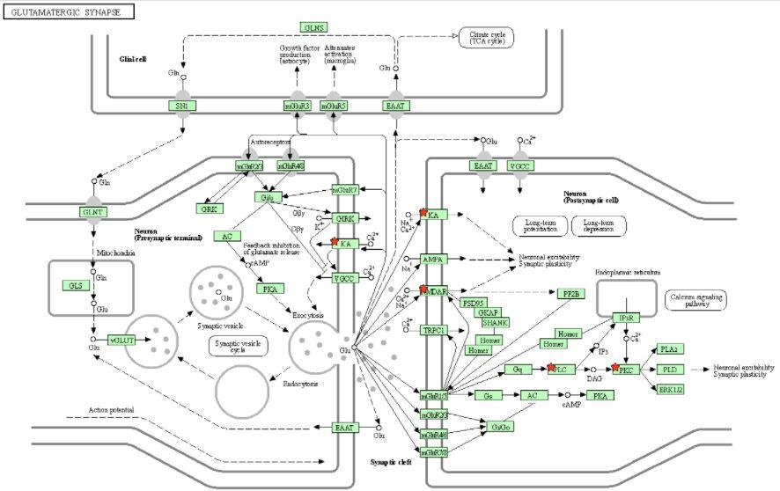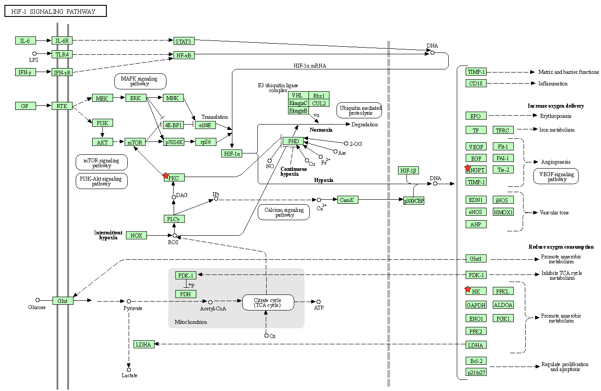 Supplementary Fig. 1 DAVID KEGG pathway analysis tool under heading A) HIF-1 signalling pathway interaction and B) Glutamatargic synapse pathway interaction in control study group, Red star ★ mark depicts the proteins which were identified in this study group.
A
B
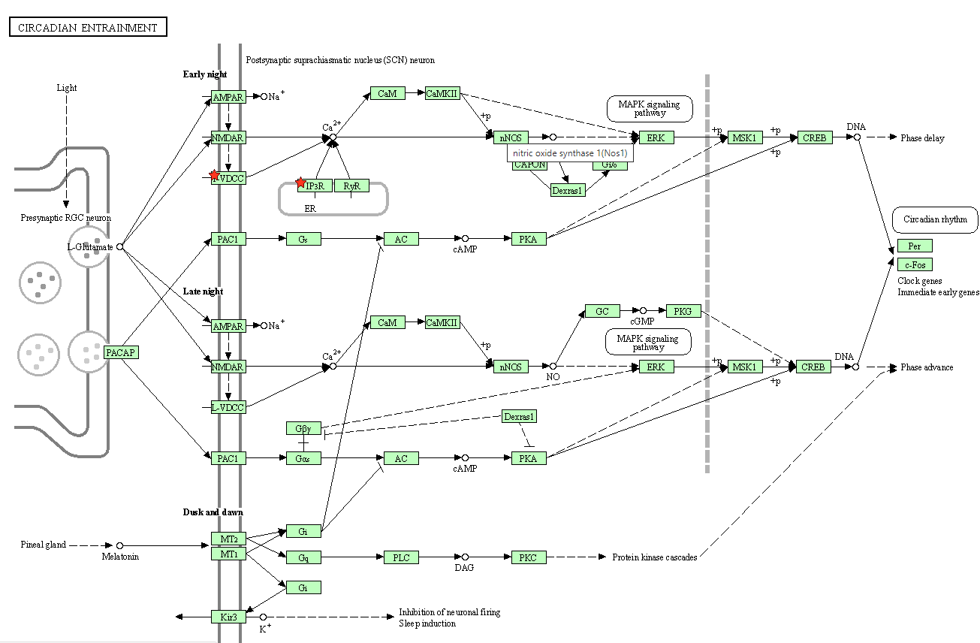
A
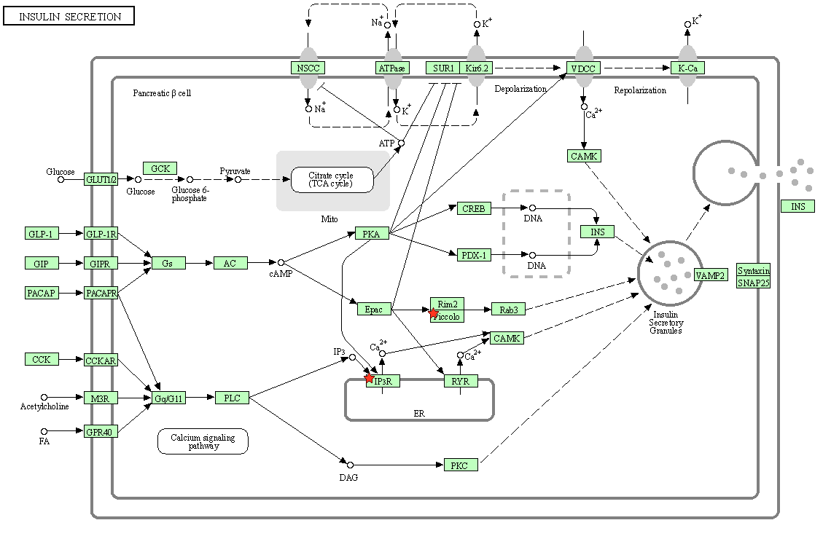
B
Supplementary Fig. 2 DAVID KEGG pathway analysis tool under heading A) Circadian entrainment pathway interaction and B) Insulin secretion signalling pathway interaction in disease control study group, Red star ★ mark depicts the proteins which were identified in this study group.

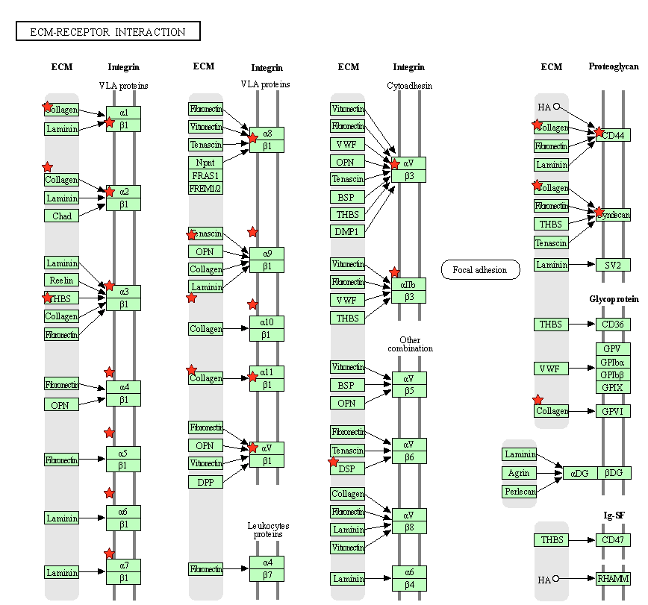 Supplementary Fig. 3 DAVID KEGG pathway analysis tool under heading EMC receptor interaction in 250 mg/kg study group, Red star ★ mark depicts the proteins which were identified in this study group.

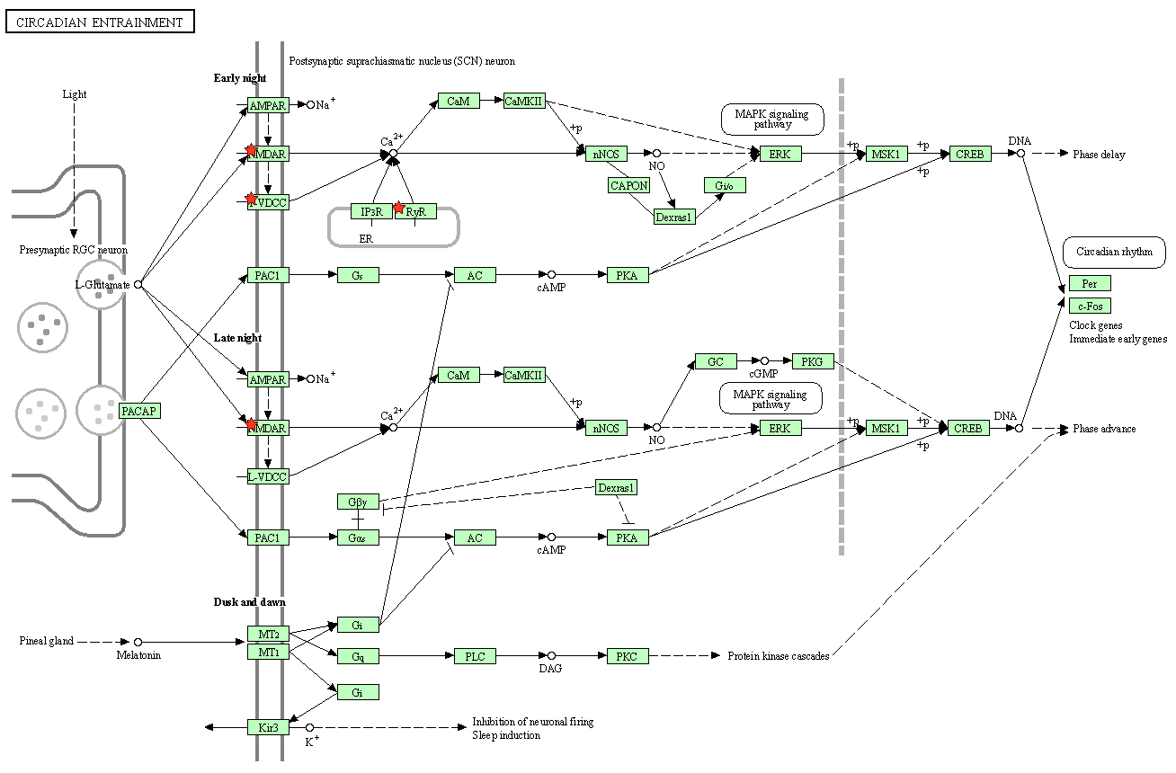 Supplementary Fig. 4 DAVID KEGG pathway analysis tool under heading Circadian entrainment interaction in 500 mg/kg study group, Red star ★ mark depicts the proteins which were identified in this study group.

