Supplementary Information
Corrinoid-dependent ethyl-transfer catalyzed by the methanol:coenzyme M methyl transferase from Methanosarcina acetivorans
Tejas Somvanshi^{1, #}, Jichen Bao^{1, #}, Silvan Scheller^{1,*}
¹Department of Bioproducts and Biosystems, School of Chemical Engineering, Aalto University, FI/02150, Espoo, Finland
* Corresponding author: Silvan Scheller (silvan.scheller@aalto.fi)

SI Text
Catalytic pocket simulations. The simulated structures of MtaB1C1, B2C2, B3C3 and B2C3 complexes were generated using AlphaFold2-multimer run on ColabFold (Mirdita et al. 2022), from the auto annotated amino-acid sequences of subunits B 1 to 3 and C 1 to 3 (F1SVL6_METAC, F1SVM6_METAC, Q8TQC8_METAC, F1SVM3_METAC, F1SVG6_METAC and F1SVI3_METAC respectively) using default parameters. The catalytic pockets were rendered on PyMOL (Suppl Fig S1) and their volumes calculated using the MSMS (Sanner et al. 1996)-based Pymol plugin PyVol (Smith et al. 2019) (Suppl Table S1). While structural changes can be observed, no clear assumption can be made regarding the size of the area hosting the catalytic core.

SI Figures
Fig. S1 Simulated catalytic pockets – Visual rendering (catalytic pockets are shown as surfaces in red, and the area where al
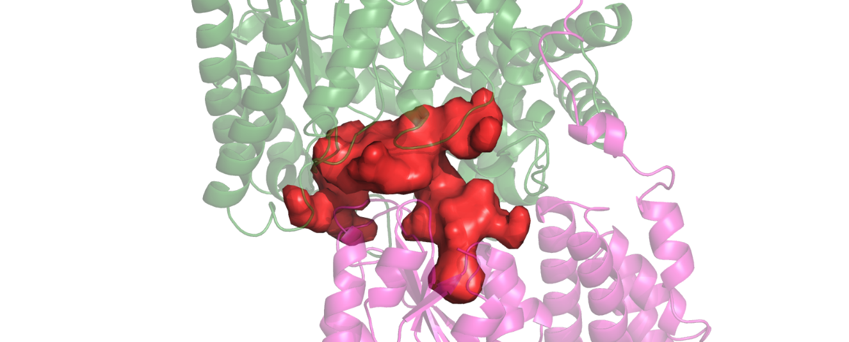
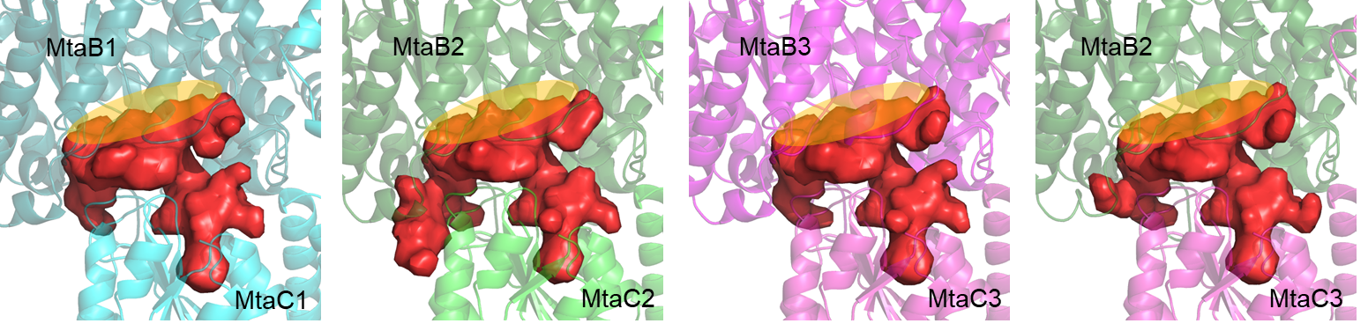
MtaB2
MtaC3

SI Tables
Table. S1 Simulated catalytic pockets – Volume estimations
Mta complexes | Catalytic pocket estimated volume (A³)
MtaB1C1 | 2662.0
MtaB2C2 | 2894.0
MtaB3C3 | 2620.0
MtaB2C3 | 2710.0

Table. S2 Primer Table
Primer | sequence (5'->3')
Pmtr_fusaro F | attataacccgggccctatatatggatccacattatgcaaggaaactaaatataaaaatccttctc
Pmtr_fusaro R | tcattttcctcctttgtattattacatgtaataagg
Tfpo_227 F | gttttgagtaaagctgcttttgtgg
Tfpo_227 R | cggcccacgtggccactagtacttctcgagcctgcagggcgagcattagtatagcggc
mtaA1 F | ccttattacatgtaataatacaaaggaggaaaatgaatggcagatccagatttaagagacc
mtaA1 R | ccacaaaagcagctttactcaaaacttatggcgaggcgcaatcatg
mtaA2 F | ccttattacatgtaataatacaaaggaggaaaatgaatgaccgatatgagcgaattcac
mtaA2 R | ccacaaaagcagctttactcaaaactcaggcgtagaattcgtttcttg
PmcrtetO1 F | cggcccacgtggccactagtacttctcgagcctgcagggcatgcttcatttatcggagaacac
PmcrtetO1 R | atgaatttcctccttaatttattaaaatcattttgggac
Tmcr_fusaro F | actcaataaattcaacagtttaaaacagagtaggcc
Tmcr_fusaro R | cgctatactaatgctcgccctgcaggaatagaattatatgagcctgtaacgggg
mtaC1 F | gtcccaaaatgattttaataaattaaggaggaaattcatatgttggactttacagaggcaag
mtaC1 R | ccatattttaacctccattagatcctcagtgcttgtggaatttctctcttaatg
mtaC2 F | gtcccaaaatgattttaataaattaaggaggaaattcatatgttggatttgacactggaagacatc
mtaC2 R | ccatattttaacctccattagatccttagtgcttgtggaattcctctcttaatttctc
mtaC3 F | gtcccaaaatgattttaataaattaaggaggaaattcatatggaggttaaatatttgatagatatagaccccag
mtaC3 R | ccatattttaacctccattagatcctcagtgtttatggaatttctccctcagctttac
mtaB1 F | aggatctaatggaggttaaaatatggcagcaaaaagatacacttcaatg
mtaB1 R | ggcctactctgttttaaactgttgaatttattgagtttagaagccgtagttctcggggag
mtaB2 F | aggatctaatggaggttaaaatatggtaaagaaatacacttcaatggcttac
mtaB2 R | ggcctactctgttttaaactgttgaatttattgagtttagagcccgtagttttctgtcttg
mtaB3 F | aggatctaatggaggttaaaatatggcagtaacaagatgtaccaagatg
mtaB3 R | ggcctactctgttttaaactgttgaatttattgagtttagaggccgtagttctccgg

References
Mirdita M, Schütze K, Moriwaki Y, et al (2022) ColabFold: making protein folding accessible to all. Nat Methods 19:679-682. https://doi.org/10.1038/s41592-022-01488-1
Sanner MF, Olson AJ, Spehner JC (1996) Reduced surface: An efficient way to compute molecular surfaces. Biopolymers 38:305-320. https://doi.org/10.1002/(sici)1097-0282(199603)38:3<305::aid-bip4>3.0.co;2-y
Smith RHB, Dar AC, Schlessinger A (2019) PyVOL: a PyMOL plugin for visualization, comparison, and volume calculation of drug-binding sites. bioRxiv 816702. https://doi.org/10.1101/816702

