Supplemental Table 1. Generalized Linear Mixed Models indicate that structure and attunement are independent constructs
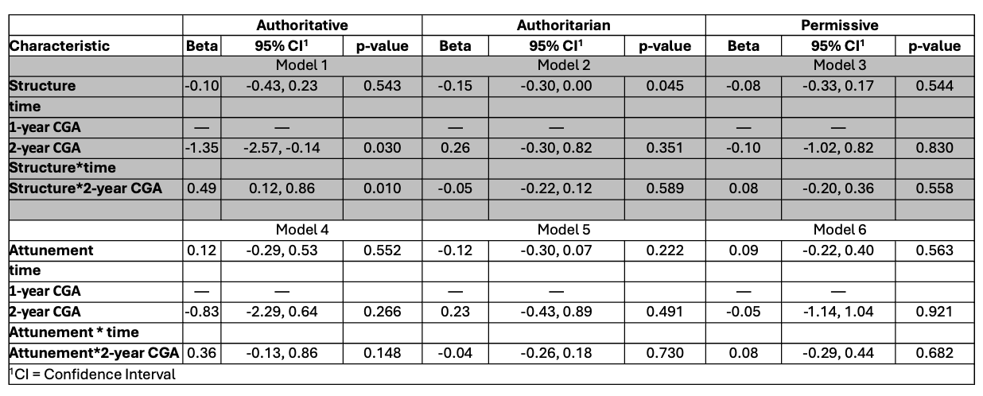
Structure and attunement map onto Authoritative, Authoritarian, and Permissive in unique patterns, indicating that structure and attunement are unique constructs.
CGA = corrected gestational age

Note: “Beta” for Structure or Attunement is the estimate of $β_{1}$in the following models.
Note: “Beta” for time 2-year CGA is the estimate of $β_{2}$in the following models.
Note: “Beta” for Structure*time or Attunement*time is the estimate of $β_{3}$in the following models.
Let $i$ be subject index, $t$ be time index (i.e., $t=0$for D2 and $t=1$ for D4), $b_{i}$ be the subject-specific random effect, $ε_{it}$ be the error term assumed to be normally distributed with a zero mean and a variance.
Model 1:
$${Authoritative}_{it}=β_{0}+β_{1}*{STRC}_{it}+β_{2}*t+β_{3}*{STRC}_{it}*t+b_{i}+ε_{it}$$
Model 2:
$${Authoritarian}_{it}=β_{0}+β_{1}*{STRC}_{it}+β_{2}*t+β_{3}*{STRC}_{it}*t+b_{i}+ε_{it}$$
Model 3:
$${Permissive}_{it}=β_{0}+β_{1}*{STRC}_{it}+β_{2}*t+β_{3}*{STRC}_{it}*t+b_{i}+ε_{it}$$
Model 4:
$${Authoritative}_{it}=β_{0}+β_{1}*{ATT}_{it}+β_{2}*t+β_{3}*{ATT}_{it}*t+b_{i}+ε_{it}$$
Model 5:
$${Authoritarian}_{it}=β_{0}+β_{1}*{ATT}_{it}+β_{2}*t+β_{3}*{ATT}_{it}*t+b_{i}+ε_{it}$$
Model 6:
$${Permissive}_{it}=β_{0}+β_{1}*{ATT}_{it}+β_{2}*t+β_{3}*{ATT}_{it}*t+b_{i}+ε_{it}$$

Supplemental Table 2. Multivariate Multiple Regression between early parenting constructs and 2-year parenting styles unadjusted for gestational age at birth

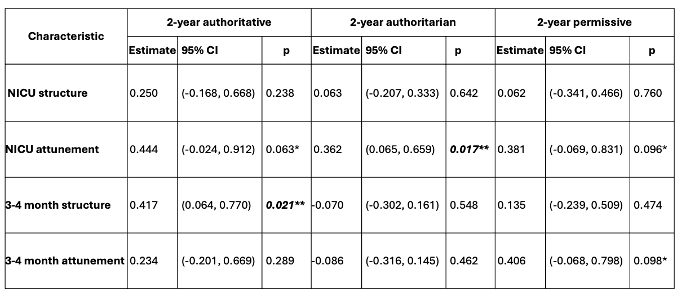
*p<0.1
**p<0.05

Supplemental Figure 1. Construct mapping between BCQ and PSDQ constructs
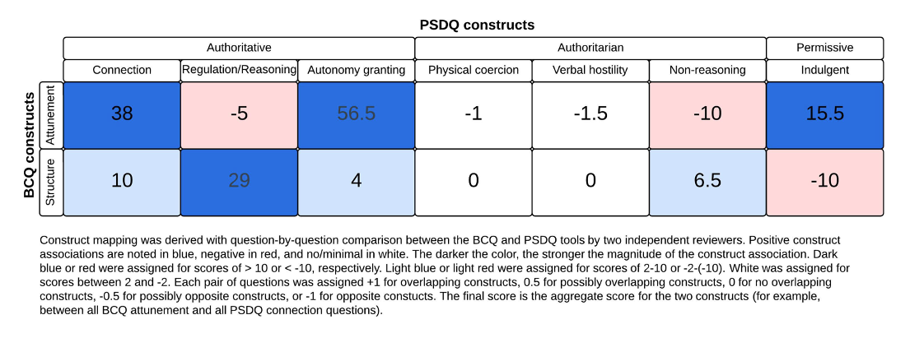
BCQ=Baby Care Questionnaire; PSDQ=Parenting Styles and Dimensions Questionnaire

