Supplementary Information (SI)
SI Table 1. Mineral nutrient concentrations and properties of the crushed glass mixture in the interstices between cone-tainers and soil within cone-tainers of each pot.
Soil characteristic* | Interstitial crushed glass mixture | Soil (within cone-tainers)
Phosphorus (μg g⁻¹) | 6.0 (Bray) | 10.2 (Olsen)
Potassium (μg g⁻¹) | 24.0 | 38
Nitrate (μg g⁻¹) | 0.7 | 9.4
Ammonium (μg g⁻¹) | 0.9 | 5.35
Magnesium (μg g⁻¹) | 39.0 | 147.9
Calcium (μg g⁻¹) | 323.0 | 2511.6
Sodium (μg g⁻¹) | 90.0 | 54.7
Manganese (μg g⁻¹) | 1.0 | 1.5
Iron (μg g⁻¹) | 5.0 | 153.8
pH | 7.9 | 7.6
Cation Exchange Capacity  (meq 100g⁻¹) | 1.0 | 14.22

SI Table 2. Principle components analysis (PCA) percentage of variance represented by the first axis, loadings on Axis 1 for the four PCA-summarized neighbor categories, and the correlation between Axis 1 and target whole-plant dry weights prior to rotation of Axis 1 for treatments with drought or watered conditions and with severed or intact common mycorrhizal networks (CMNs). For all treatments, the first axis was the only significant axis in explaining the variance among neighboring plants
 | Proportion of variance (P*) | Pearson's correlation coefficient with Axis 1†, r
Treatment | Axis 1 | Largest neighbor | 2nd largest neighbor | 3rd largest neighbor | 4th largest neighbor | Targets
Intact CMNs, Watered | 80.5% | -0.921 | -0.946 | -0.904 | -0.744 | -0.517
Intact CMNs, Watered | (0.001)
Intact CMNs, Drought | 92.9% | -0.956 | -0.983 | -0.986 | -0.897 | -0.561
Intact CMNs, Drought | (0.001)
Severed CMNs, Watered | 68.0% | 0.802 | 0.108 | -0.975 | 0.953 | 0.007
Severed CMNs, Watered | (0.011)
Severed CMNs, Drought | 76.6% | -0.966 | -0.971 | -0.5 | -0.529 | -0.101
Severed CMNs, Drought | (0.005)

SI Table 3. Two-way ANOVA results (degrees of freedom, F-statistics, and associated P values) for the main effect of watering conditions, CMN treatments (intact or severed), and their interaction on shoot mineral nutrient concentrations of pooled samples based upon shoot dry weights of Andropogon gerardii seedlings
 | Treatment |  | Value |  |  | Main Effect Water |  | Main Effect CMNs |  | Water x CMNs
Nutrient (unit) | Watering Condition | CMNs | Mean | SD | df | F | P | F | P | F | P
P (%) | Watered | Intact | 0.190 | 0.041 | 1,33 | 0.00 | 0.967 | 3.12 | 0.086 | 1.50 | 0.230
P (%) | Watered | Severed | 0.165 | 0.022
P (%) | Drought | Intact | 0.176 | 0.043
P (%) | Drought | Severed | 0.146 | 0.033
K (%) | Watered | Intact | 0.960 | 0.233 | 1,33 | 0.78 | 0.384 | 2.09 | 0.158 | 0.04 | 0.853
K (%) | Watered | Severed | 1.140 | 0.187
K (%) | Drought | Intact | 1.014 | 0.161
K (%) | Drought | Severed | 1.057 | 0.164
Ca (%) | Watered | Intact | 0.882 | 0.215 | 1,33 | 5.13 | 0.030 | 2.57 | 0.118 | 2.74 | 0.108
Ca (%) | Watered | Severed | 1.170 | 0.277
Ca (%) | Drought | Intact | 0.928 | 0.173
Ca (%) | Drought | Severed | 0.878 | 0.134
Mg (%) | Watered | Intact | 0.323 | 0.046 | 1,33 | 0.04 | 0.835 | 0.05 | 0.819 | 0.00 | 0.976
Mg (%) | Watered | Severed | 0.323 | 0.042
Mg (%) | Drought | Intact | 0.326 | 0.038
Mg (%) | Drought | Severed | 0.319 | 0.040
S* (%) | Watered | Intact | 0.171^{AB} | 0.036 | 1,32 | 15.66 | 0.004 | 2.19 | 0.149 | 5.47 | 0.026
S* (%) | Watered | Severed | 0.251^{A} | 0.023
S* (%) | Drought | Intact | 0.191^{B} | 0.026
S* (%) | Drought | Severed | 0.159^{C} | 0.020
Cu* (ppm) | Watered | Intact | 21.2 | 4.12 | 1,31 | 2.10 | 0.157 | 2.40 | 0.132 | 0.00 | 0.960
Cu* (ppm) | Watered | Severed | 25.9 | 2.97
Cu* (ppm) | Drought | Intact | 23.3 | 3.58
Cu* (ppm) | Drought | Severed | 23.4 | 2.66
Fe* (ppm) | Watered | Intact | 913^{C} | 417 | 1,33 | 24.59 | <0.0001 | 37.18 | <0.0001 | 12.71 | 0.001
Fe* (ppm) | Watered | Severed | 5532^{A} | 2505
Fe* (ppm) | Drought | Intact | 1134^{BC} | 472
Fe* (ppm) | Drought | Severed | 1420^{B} | 718
Mn* (ppm) | Watered | Intact | 20.5 | 9.4 | 1,33 | 40.84 | <0.0001 | 0.32 | 0.574 | 3.17 | 0.084
Mn* (ppm) | Watered | Severed | 63.4 | 15.8
Mn* (ppm) | Drought | Intact | 54.0 | 27.7
Mn* (ppm) | Drought | Severed | 14.0 | 11.9
Zn* (ppm) | Watered | Intact | 56.3^{B} | 16.6 | 1,32 | 1.83 | 0.186 | 4.36 | 0.045 | 6.49 | 0.016
Zn* (ppm) | Watered | Severed | 48.1^{B} | 3.8
Zn* (ppm) | Drought | Intact | 119.6^{A} | 82.2
Zn* (ppm) | Drought | Severed | 61.8^{B} | 22.7
* indicates data were transformed (as described in Statistical Methods) prior to analysis
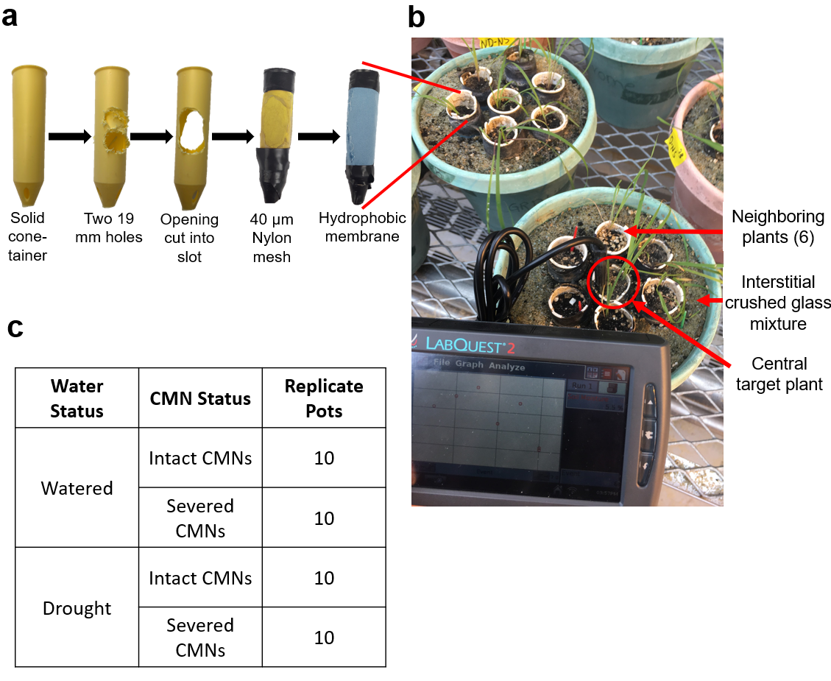
SI Figure 1: Experiment design of modified Ray Leach Cone-tainers ™ (a) as they were modified with openings, 40 µm nylon silk screen mesh, and a Gore-Tex ™ hydrophobic membrane. Individual Andropogon gerardii seedlings were grown in modified cone-tainers with nylon mesh and hydrophobic membranes that were placed into pots (b) in which a central target plant was surrounded by six equidistant neighboring. The interstices were filled with a 4:1 nutrient-poor fine crushed glass (20-40 grade, Harsco Corporation, Camp Hill, PA, USA) and glass bead (12-20 grade, Industrial Supply, Inc, Twin Falls, ID, USA) mixture. Modified cone-tainers were filled with a sandy soil mixture. Nutrient concentrations of media can be found in SI Table 1. The photo (b) additionally depicts the frequent soil moisture measurements that were conducted with using a LabQuest 2 Vernier Data Logger and soil moisture probe (Beaverton, OR, USA) on both the interstitial crushed glass mixture and soil within cone-tainers. If the values fell below our target range, water was added to the pots by hand. (c) The experiment was a factorial experiment in which watering was manipulated to be under well-watered (25-30% soil moisture) or drought (15-20% soil moisture) conditions and CMNs were kept either intact or severed through weekly rotation of cone-tainers.

