Supplementary information

This supplementary information contains:
Supplementary Discussion:
Supplementary Figures 1-7

Supplementary Discussion
Supplementary Figure 1. a, Images of a CNTs-PVA hydrogel fiber undergoing cyclic training (20% strain for 10000 cycles) in water. Scale bars: xx mm. b, Representative plots of force versus cycle number of a CNTs-PVA hydrogel fiber under cyclic tensile test. c, Zoomed in plot from cycle 5000 to 5010 in c.

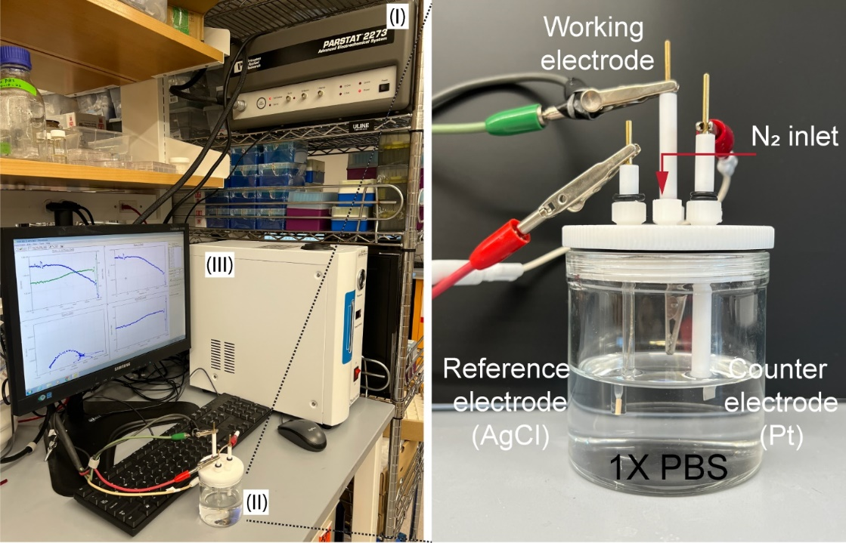
Supplementary Figure 2. The electrochemical workstation system comprises three main components: (I) the workstation console, (II) an electrochemical sink, and (III) a nitrogen generator. For characterization in PBS solution, a three-electrode setup was utilized, incorporating a reference electrode, a counter electrode, and a working electrode.

Supplementary Figure 3. a, Water content fraction in TRAIN CNTs-PVA hydrogel microelectrodes after different cycles of training at 20% strain. b, Fiber diameter of TRAIN CNTs-PVA hydrogel microelectrodes after different cycles of training at 20% strain. One-way ANOVA was used to determine the statistical significance, Water content fraction: F_{5,18}=5.858, **p=0.0022, n=4 individual TRAIN hydrogel microelectrodes; Fiber diameter: F_{5,24}=0.7050, non-significant (n.s.), p=0.6253, n=5 individual TRAIN hydrogel fibers.

Supplementary Figure 4. Normalized impedance of TRAIN hydrogel films measured in three directions: a, Direction along with the training direction on the training plane. b, Direction perpendicular to the training direction on the training plane. c, Direction along with the thickness of the TRAIN hydrogel films. Two-tailed paired student’s t-test was used to determine statistical significance. X: t=3.807, df=5, α=0.05, *p= 0.0125. Y: t=0.3202, df=5, α=0.05, non-significant (n.s.) p= 0.7618. Z: t=5.846, df=5, α=0.05, **p= 0.0021. n=6 independent hydrogel films.

Supplementary Figure 5. Normalized dimensions of TRAIN hydrogel films: a, Direction along with the training direction on the training plane. b, Direction perpendicular to the training direction on the training plane. c, Direction along with the thickness of the TRAIN hydrogel films. Two-tailed paired student’s t-test was used to determine statistical significance. d, Volume calculated from x, y, and z. x: t=3.510, df=5, α=0.05, *p= 0.0171. y: t=3.873, df=5, α=0.05, *p= 0.0117. z: t=3.088, df=5, α=0.05, *p= 0.0272. volume: t=1.676, df=5, α=0.05, n.s. p= 0.1546. n=6 independent hydrogel films.

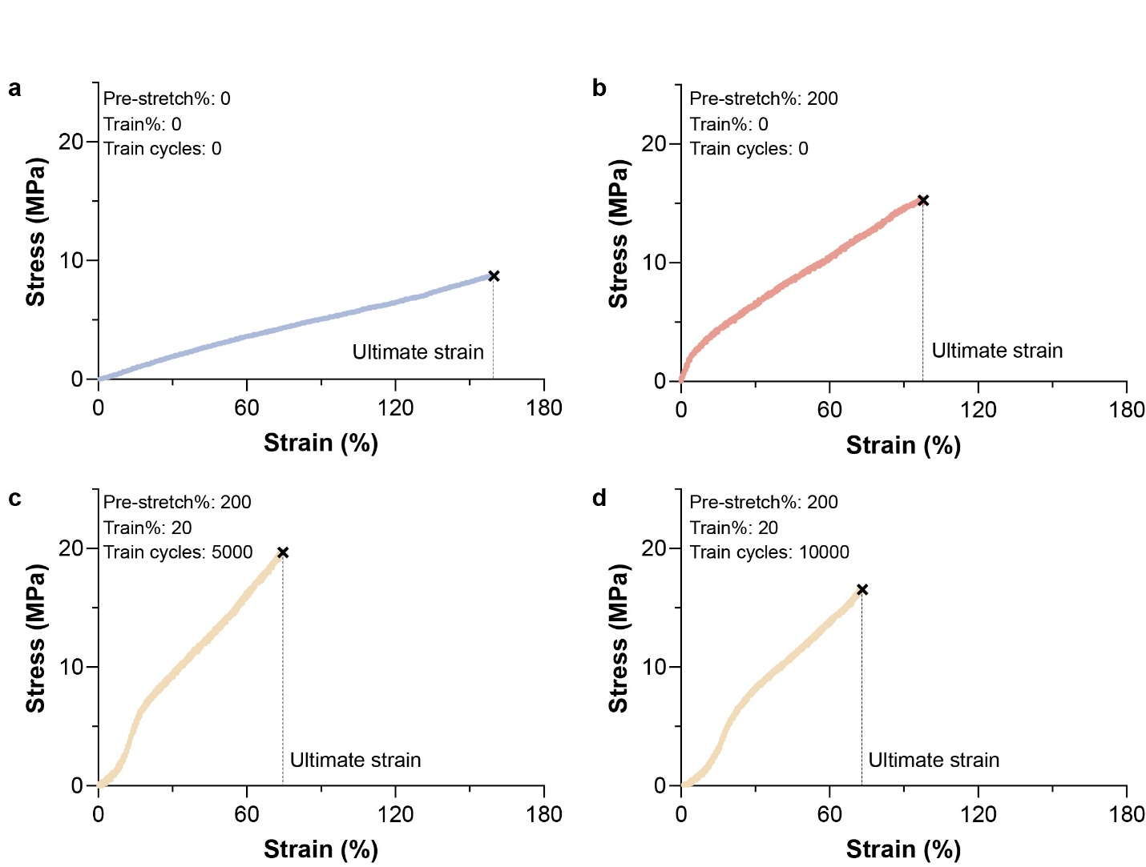
Supplementary Figure 6. Representative stress-strain curves of CNTs-PVA hydrogel fibers. a, Non-pre-stretched and untrained fiber. b, 200% pre-stretched and untrained fibers. c, 200% pre-stretched and TRAIN fibers (20% for 5000 cycles). d, 200% pre-stretched and TRAIN fibers (20% for 10000 cycles).

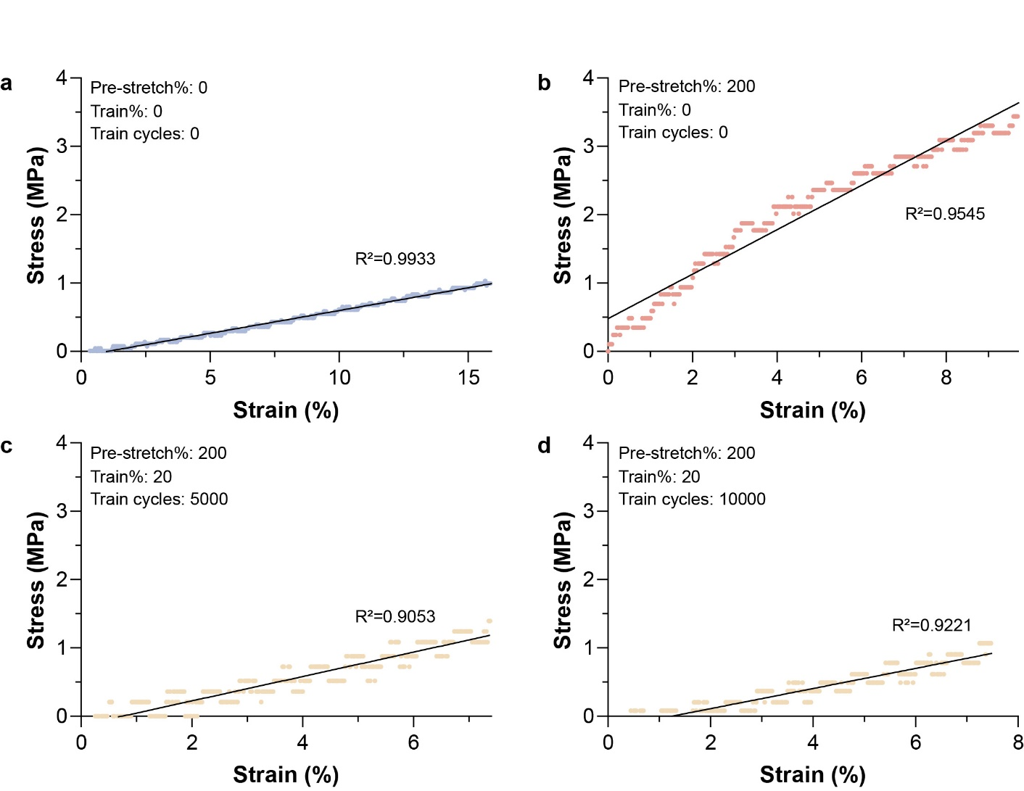
Supplementary Figure 7. Representative linear regression (first 10% strain) for Young’s modulus calculation of CNTs-PVA hydrogel fibers. a, Non-pre-stretched and untrained fiber. b, 200% pre-stretched and untrained fibers. c, 200% pre-stretched and TRAIN fibers (20% for 5000 cycles). d, 200% pre-stretched and TRAIN fibers (20% for 10000 cycles).

