Supplementary Information
Microenvironment engineering by targeted delivery of activated Ag NPs for boosting electrocatalytic CO₂ reduction reaction
Ting Xu^{1,5}, Hao Yang^{2,5}, Tianrui Lu^{1,5}, Rui Zhong¹, Jing-Jing Lv^{1,*}, Shaojun Zhu¹, Mingming Zhang, Zheng-Jun Wang¹, Yifei Yuan¹, Jun Li¹, Jichang Wang⁴, Huile Jin¹, Shuang Pan¹, Xin Wang^{3,*}, Tao Cheng^{2,*}, Shun Wang^{1,*}
¹Zhejiang Province Key Lab of Leather Engineering, Institute of New Materials and Industrial Technologies, Wenzhou University, Wenzhou, Zhejiang, 325035, China
²Institute of Functional Nano and Soft Materials (FUNSOM), Soochow University, Suzhou, 215123, China
³Department of Chemistry, City University of Hong Kong, Hong Kong, 999077, China
⁴Department of Chemistry and Biochemistry, University of Windsor, Windsor, M4Y1M7, Canada
Email: Shunwang@wzu.edu.cn, tcheng@suda.edu.cn, jjlyu@wzu.edu.cn
⁵These authors contributed equally.

Experimental Section
Chemicals and reagents: All chemicals were used as received without further treatments. Silver nitrate (AgNO₃) and silver tetrafluoroborate (AgBF₄) (HISPEC3000, Johnson Matthey), Ag nanoparticles (Ag NPs), Ag microparticles (Ag MPs), iridium oxide (IrO₂, 99.9%, Xiya Agent), Titanium mesh (Ti-mesh, Shang Te company), Nafion (10 wt% aqueous solution, Fuel Cell Store) and gas diffusion layer (GDL, Sigracet 29 BC, Fuel Cell Store) were used as received. Ethanol (EA), Isopropyl alcohol (IPA), and potassium hydroxide (KOH) were purchased from Sinopharm Chemical Reagent Co., Ltd. Potassium hydroxide (KOH), Potassium bicarbonate (KHCO₃), and potassium chloride (KCl) were purchased from Innochem. High purity carbon dioxide (CO₂, 99.993%) was purchased from Wenzhou Haichang gas company.
Catalyst preparation:
Preparation of Ag NPs-Skeleton. AgNO₃ (24 mg) was dissolved in EA (4 mL). The solution was stirred using a magnetic stir bar until there was no visible powder. AgNO₃ ink was then directly coated on GDL with an area of 1 cm×2 cm to get a loading of 0.5 mg cm⁻² as the working electrode. The GDL used in this work contains a microporous layer (MPL) of carbon nanoparticles blending with ~20% polytetrafluoroethylene coated onto a macroporous carbon fiber substrate (CFS) to create a hydrophobic interface and facilitate gas diffusion to the catalytic surface.¹ The GDL was weighed before and after drop-casting to record its actual catalyst loading.
Preparation of commercial Ag NPs. To prepare the catalyst ink, 25 mg of Ag NPs was ultrasonically dispersed in the mixture of 3 mL of n-propanol and 20 µL of Nafion. Then, the mixture was sonicated for 30 min. The ink was then dropcasted onto the GDL to get a loading of 0.3 mg cm⁻².
Preparation of commercial Ag MPs. To prepare the catalyst ink, 25 mg of Ag MPs was ultrasonically dispersed in the mixture of 3 mL of n-propanol and 20 µL of Nafion. Then, the mixture was sonicated for 30 min. The ink was then dropcasted onto the GDL to get a loading of 0.3 mg cm⁻².
Structure characterization: Surface morphology of the samples was characterized using a Tescan Mira LMS scanning electron microscopy (SEM) operated at 20.0 kV. The transmission electron microscopy (TEM), and high resolution TEM (HRTEM) using a JEM-2100F TEM operating at 200 kV. X-ray diffraction (XRD) patterns (Bruker D8 Advanced) were obtained to determine the crystal structures of the samples. X-ray photoelectron spectroscopy (XPS) experiment was carried out using Thermo Scientific K-Alpha. All spectra were calibrated according to the C 1s binding energy at 284.8 eV. Contact angle measurements was tested on a Contact Angle Measuring Device (SDC-100S, Dynetech) with a drop of aqueous electrolyte. The gas bubble formation was characterized by an in-situ cell through an optical microscope (OLYMPUS, DSX1000).
Electrochemical measurements: Electrochemical measurements were conducted on an Autolab potentiostat (PG128N) in a three-electrode system. The IrO₂ coated Ti-mesh (loading: 0.5 mg cm⁻²) was used as the counter electrode for oxygen evolution reaction (OER) and Ag/AgCl (saturated KCl, CHI111) as the reference electrode.
The eCO₂RR performance was measured in a three-channel flow cell with three compartments of dimension 2 × 0.5 × 0.15 cm³. The electrode area was 1 cm² and the electrode to membrane distance was 2 mm. An external Ag/AgCl reference electrode located ≈ 5 cm from the cathode was used to measure the cathodic half-cell potential. All potential measurements were converted to the reversible hydrogen electrode (RHE) based on the following formula: E_{RHE} = E_{Ag/AgCl} + E^{θ}_{Ag/AgCl} + 0.059 × pH (in volts). The pH values of bulk electrolyte after electrolysis were used for RHE conversions unless stated otherwise. The device was fabricated from acrylic plastic and contained a gas compartment for flowing CO₂, the anode and cathode channels for flowing electrolyte, the membrane for separating the anode and cathode, and solid end pieces. Poly(tetrafluoroethylene) (PTFE) gaskets were placed between each component for sealing and the device was tightened using six bolts.
The gas flow rate into the flow cell was set via a mass flow controller (Alicat Scientific), and the CO₂ flow rate was set at 15 sccm if not otherwise described. The catholyte flow rates were controlled via a peristaltic pump (YZ1515x, Baoding Chuangrui Precision Pump CO., LTD), with the catholyte flow rate ranging from 0.1 to 1 mL min⁻¹ depending on the current densities (lower flow rates were used at lower current densities to allow for sufficient accumulation of liquid products). The anolyte flow rate was 2 mL min⁻¹. An anion exchange membrane (FAA-3, Fumatech) was used in 1 M KOH and 1 M KHCO₃ electrolyte, and a proton exchange membrane (Nafion, Fumatech) was used in 20 mM H₂SO₄ in 1M KCl electrolyte. The backpressure of the gas in the flow cell was tuned to atmospheric pressure as controlled by a backpressure controller (Alicat Scientific). Each reported data point reflected the mean of at least three measurements, where the error bars were the standard deviation.
Gas products were quantified on a Multigas #5 gas chromatography (GC, SRI Instruments) equipped with a HayeSep D and Molsieve 5A columns connected to a thermal conductivity detector (TCD) and a HayeSep D column connected to a flame ionization detector (FID).
Liquid products were quantified using a Bruker AVIII 500 MHz NMR spectrometer. Typically, 500 μL of collected catholyte exiting the reactor was mixed with 100 μL D₂O containing 20 ppm (m/m) dimethyl sulphoxide (≥ 99.9%; Alfa) as the internal standard. The one-dimensional ¹HNMR spectrum was measured with water suppression using a pre-saturation method.
Faradaic efficiency (FE) measurements: Based on the definition of Faradaic efficiency: FE = Q_{CO} /Q_{total} = (Z × n × F)/Q_{total} (Eq. S1), where Z is the number of electrons transferred (Z = 2 for CO and H₂ production), n is the number of moles for a given product, F is the Faraday's constant (96 485 C mol⁻¹), and Q is the total charge passed throughout the electrolysis process (measured by calculating the curve area of current density vs. time plot). CO and H₂ mole fractions of injected samples were calculated based on the GC calibration curve.
The single-pass CO₂ conversion efficiency (SPCE) is calculated as follows:
SPCE =$\frac{∑eCO2RRproducts (\frac{Jtotal× FECO}{nF} ×N × \frac{RT}{P})}{CO2 flow rate}$ (S1)
where n is the number of transferred electrons of the product, F is the Faraday constant, R is the gas constant, T is the reaction temperature, P is the reaction pressure, and N is the number of C in products.
COMSOL Multiphysics simulations
COMSOL Multiphysics finite element model was employed to investigate the characteristics of the interfacial liquid and gas fluid field^{2, 3, 4}. This model mainly focuses on studying the dynamic characteristics of bubbles generated during the transportation of mixed gases (CO₂, CO and H₂) under the application of electric field force. The phase field method was used to track the gas/liquid interface. The electric field force source term was added to the N-S equation as the volume force by the Maxwell equation. The flow characteristics of the gas film, pressure and other physical features were obtained through simulation calculations of the two-phase flow process during the eCO₂RR process. The corresponding control equation is as follows:
(1) Electric field equations
Bubbles exhibit behavioral characteristics such as movement, deformation, oscillation, coalescence, fragmentation, and splitting under the electric field. Therefore, it is crucial to accurately describe the electric field force's effect on fluid movement and morphological changes. In electrohydrodynamics, due to the small dynamic current, the magnetic induction effect can be neglected, and the electric field intensity is non-rotational ($∇$×E=0). The relationship between volume charge density and electric field intensity is established based on the differential form of Gauss's law, where D represents the electric flux density, $ρ_{v}$ represents the volume free charge density of the fluid, ε0 represents the vacuum permittivity (8.85e⁻¹² F/m), $ε_{0}$ represents the relative permittivity, and the electric field intensity E is equal to the negative gradient of the electric potential.
$∇×D=ρ_{v}$ (S2)
$D=εE$ $ε=ε_{0}ε_{r}$ (S3)
$E=-∇φ$ (S4)

For two-phase flow, the relative permittivity of the fluid needs to be distinguished through a phase function to obtain the relative permittivity of fluid 1, fluid 2, and at the fluid-phase interface. The formula is as follows. The subscripts 1 and 2 represent the parameters of fluid 1 (CO₂, CO and H₂) and fluid 2 (liquid), respectively.
$ε_{r}=ε_{r1}Vf_{1}+ε_{r2}Vf_{2}$ (S5)
Based on the calculated charge density and electric field intensity distribution, the electric field force of the liquid near the interface can be determined by solving the divergence of the Maxwell stress tensor ($T^{M}$). By adding the electric field force as a source term of volume force into the N-S equation, the fluid is subject to force to produce motion and deformation. The motion of the fluid and the change of the phase interface will cause the redistribution of charges, and the redistribution of charges will in turn change the electric field force, further affecting the motion process of the fluid. Therefore, the electric field and fluid field are a bidirectional coupling process.
$T^{M}=ε\left(EE-\frac{{\left|E\right|}^{2}}{2}I\right)$ (S6)
$F_{E}=∇T^{M}=Ep_{v}-\frac{1}{2}{\left|E\right|}^{2}∇ε$ (S7)
(2) Flow control equations
The mass conservation equation (continuity equation) reflects the relationship between fluid movement and fluid mass distribution:
$\frac{∂ρ}{∂t}+∇∙\left(ρu\right)=0$ (S8)
$∇∙u=0$ (S9)
Where $ρ$is the fluid density, $t$ is the flow time and $u$is the flow velocity.
The momentum conservation equation (N-S equation), which reflects the basic mechanical law of viscous fluid flow, indicates that the increment of fluid momentum in the control body per unit time is equal to the sum of the external forces acting on it per unit time.
$\frac{∂\left(ρu\right)}{∂t}+∇∙\left(ρuu\right)=∇∙\left[μ\left(∇u+∇u^{T}\right)\right]-∇p+F$ (S10)
$F=ρg+F_{st}$ (S11)
$ρ=ρ_{1}Vf_{1}+ρ_{2}Vf_{2}$ $μ=μ_{1}Vf_{1}+μ_{2}Vf_{2}$ (S12)
where g is the gravitational acceleration. $F$ is the volumetric force, $F_{st}$ represents the surface tension term, and $Vf$ is the volume fraction.
(3) Phase field method interface tracking
In the phase field, the value of the phase variable $ϕ$ is between (-1, 1), $ϕ$= -1 represents fluid 1 (CO₂, CO and H₂), $ϕ$ = 1 represents fluid 2 (liquid), and -1 < $ϕ$ < 1 represents the gas/liquid interface.
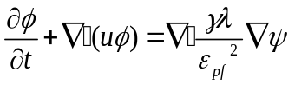 (S13)
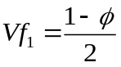 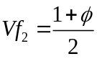 (S14)
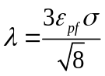 $γ=χ{ε_{pf}}^{2}$ (S15)
$ψ$ is the phase field auxiliary variable,$λ$ is the mixture energy, $γ$ is the migration rate, $σ$ is the surface tension coefficient, and $χ$ is the migration adjustment parameter of 1 m∙s/kg. The interface thickness parameter ($ε_{pf}$) defaults to half the maximum grid size, so a reasonable interface thickness parameter can be obtained by refining the grid.
(4) Surface tension calculation
A continuous surface tension (CSF) model was proposed to determine the surface tension. The surface tension jump conditions were transformed into equivalent singular volume forces and then added to the N-S equation. The gradient of the phase fraction ($ϕ$) was used to calculate the interface normal vector ($n_{s}$). At present, the chemical potential () and the interface normal vector are widely used in the phase field method to calculate the surface tension and are added to the N-S equation as the volume force source term.
$n_{s}=∇ϕ$ (S16)
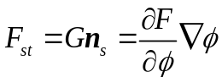 (S17)
Density functional theory (DFT) calculations
The ab initio quantum mechanical (QM) calculations were performed using the Vienna Ab initio Simulation Package (VASP) version 5.4.4 with the projector augmented wave (PAW) method and a plane wave basis set. The method used was DFT with generalized gradient approximations (GGA) of the Perdew-Burke-Ernzerhof (PBE) functional⁵. A dispersion correction, the DFT-D3 method with Becke–Jonson damping⁶, was included in the calculations. The energy cutoff was set to 400 eV. A larger energy cutoff does not produce more accurate predictions based on our benchmark calculations. The reciprocal space was sampled by the Γ-centered Monkhorst-Pack scheme with a 3×3×1 grid. A finer K spacing does not produce a more accurate prediction basin in our benchmark calculation. The partial occupancies for each orbital are set with the first-order Methfessel-Paxton scheme at a smearing width of 0.2 eV. The dipole moment corrections for the total energy are considered in the direction normal to the surface. A self-consistent electronic step is considered to converge when the change in the total energy and the change in the eigenvalues between the two steps are both smaller than 1 e⁻⁶ eV. A conjugate-gradient algorithm is used to relax the ions in energy minimization. The minimization was considered converged when all the atomic forces were smaller than 0.01 eV/Å, where convergence to an energy minimum was confirmed in all cases with frequency calculations to verify that all imaginary frequencies were eliminated. The frequencies and normal modes are determined from the Hessian matrix. To calculate the Hessian matrix, finite differences are used. Each ion is displaced ± 0.04 Å in the direction of each Cartesian coordinate, and from the forces, the Hessian matrix is determined.
A p (4×4) supercell including 3 atomic layers was used, and the vacuum thickness was set to 15 Å. In our calculations, the bottom atomic layer of Ag(111) was fixed at its original atomic position in the bulk structure, while all remaining layers together with the adsorbates were fully relaxed during structural optimization. Ag(111)-v was constructed by simply removing one of the surface Ag atoms within other settings, similar to Ag(111). The temperature is 298 K, and the pressure is 1 bar. The CO₂/H₂O ratio is estimated based on the CO₂ solubility in the 20 mM H₂SO₄ solution and the measured humidity data. The free energies for all the structures were computed using standard statistical mechanics formulas that account for translational, rotational, vibrational, and electronic degrees of freedom.^{7, 8} Translational and rotational contributions to the free energy were omitted for all surface adsorbed species. The partition function under the harmonic oscillator approximation is as follows:
$q_{vib}=\underset{i}{∏}\frac{e^{-hv_{i}/2kT}}{1-e^{-hv_{i}/kT}}$ (S18)
where k is a force constant and ν is the vibrational frequency. After substituting the partition function q_{vib}, the internal energy correction is as follows:
$U_{vib}(T)=R\underset{i}{∑}\left(\frac{hv_{i}}{k}\right)\left(\frac{1}{2}+\frac{e^{-\frac{hv_{i}}{kT}}}{1-e^{-\frac{hv_{i}}{kT}}}\right).$ (S19)
The first term is the contribution of zero-point energy (ZPE), and the second term is the contribution of internal energy correction from 0 K to 298 K. The correction of entropy (S) is as follows:
$S_{vib}(T)=R\underset{i}{∑}\left\{\frac{hv_{i}}{kT}\frac{e^{-\frac{hv_{i}}{kT}}}{1-e^{-\frac{hv_{i}}{kT}}}-ln\left[1-e^{-\frac{hv_{i}}{kT}}\right]\right\}$ (S20)
Here, the first term exactly cancels with the second term of the internal energy shown above. Therefore, only the second term of the entropy needs to be corrected. For adsorbed species, the six degrees of freedom of translation and rotation are frustrated and considered vibrations. This approximation fails when the vibration is extremely low, which significantly contributes to the correction. To avoid such overestimation, the contributions of frequencies below 50 cm⁻¹ are all considered to be 50 cm⁻¹.
The zero-point energy (ZPE) in thermoenergy correction is as follows:
$ε_{ZPE}=\frac{hν}{2}$ (S21)
The Gibbs free energy G can be derived as follows:
$G=E_{ZPE}+E+k_{B}T-TS$ (S22)
The above correction is obtained by using the VASPKIT code for postprocessing of the VASP calculated data.⁹

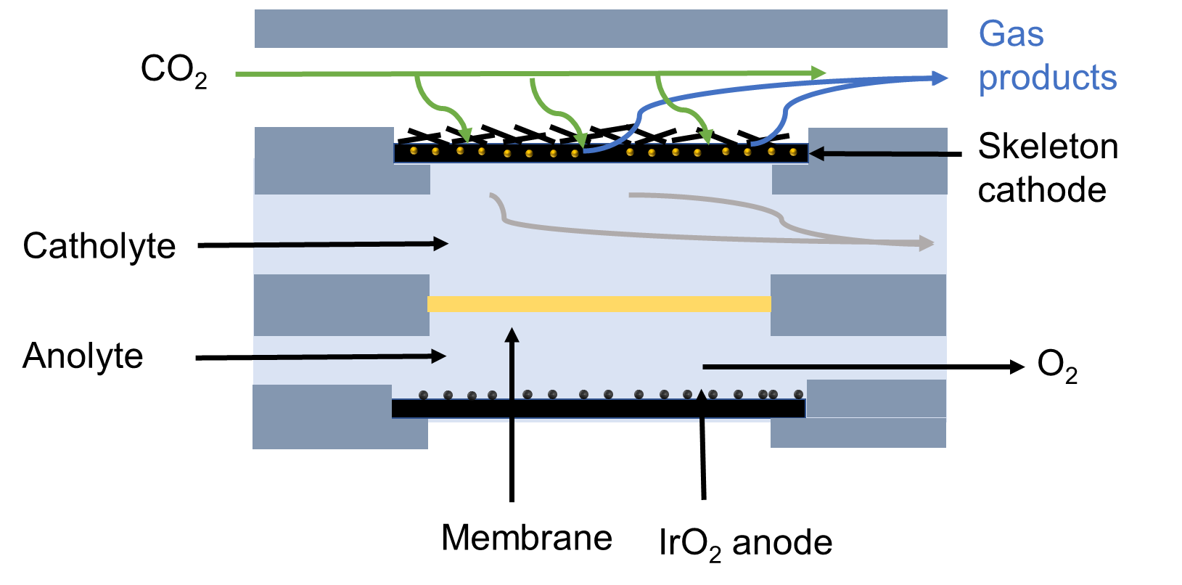
Figure S1. Schematic illustration of the microfluidic flow electrolyzer set-up for the eCO₂RR.

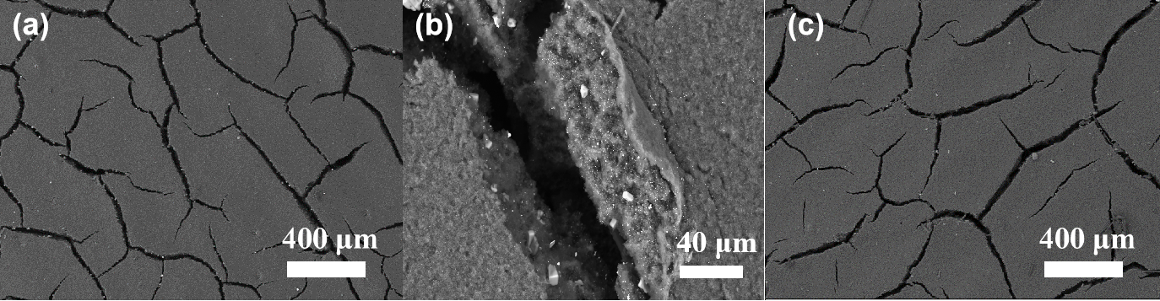
Figure S2. SEM images for the surface of (a-b) Ag NPs-Skeleton and (c) bare GDL.

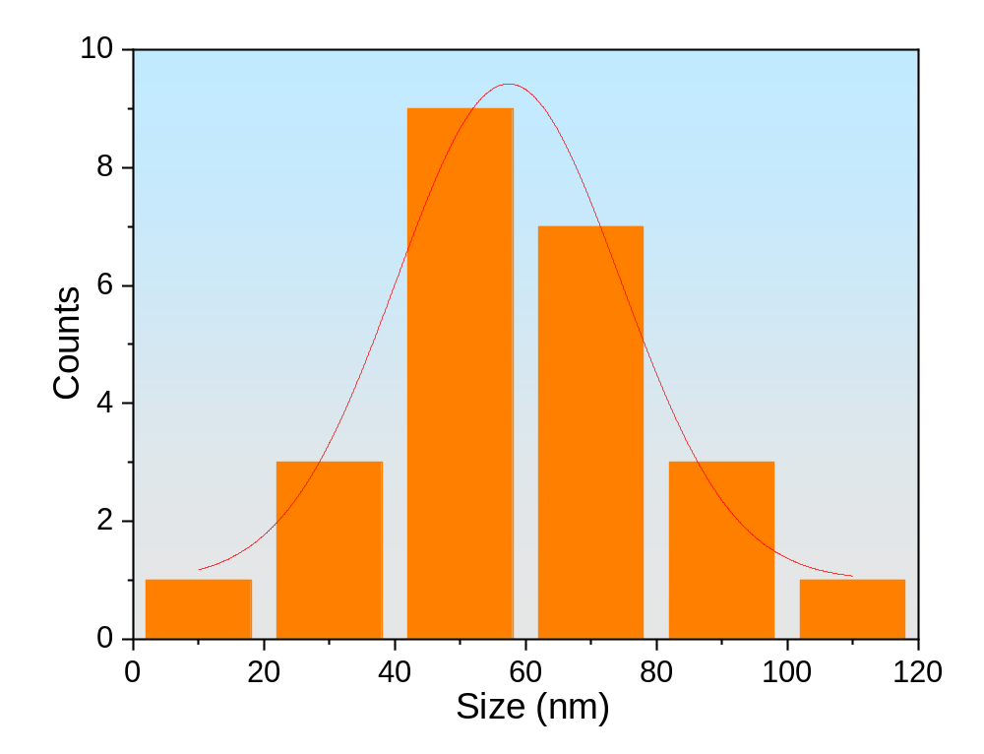
Figure S3. Size distribution of Ag NPs-Skeleton.

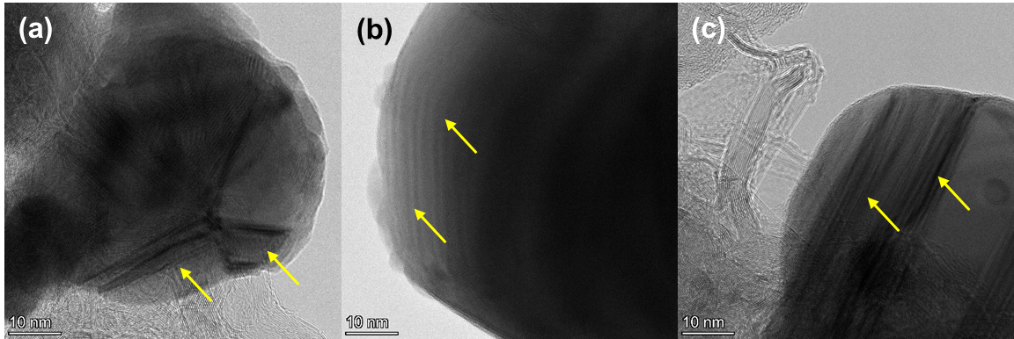
Figure S4. HRTEM images for Ag NPs-Skeleton of the defects on different Ag NPs.

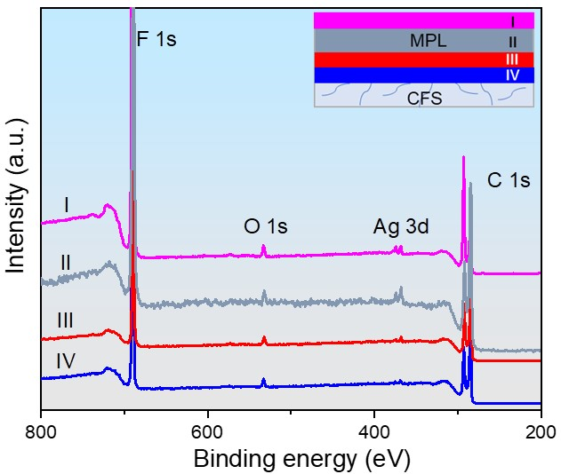
Figure S5. Survey XPS spectra for the Ag NPs-Skeleton of I: MPL surface (magenta), II: MPL skeleton (grey), III: MPL back (red), and IV: CFS surface (blue).

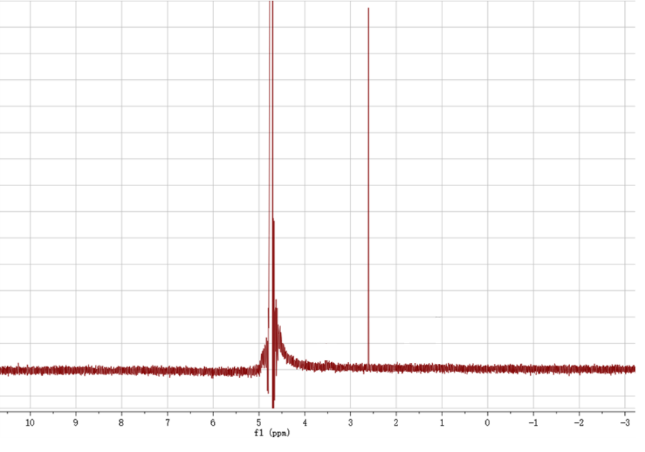
Figure S6. ¹H NMR spectrum of the solution collected by the Ag NPs-Skeleton for eCO₂RR at a current density of 100 mA cm⁻² for 600 s.

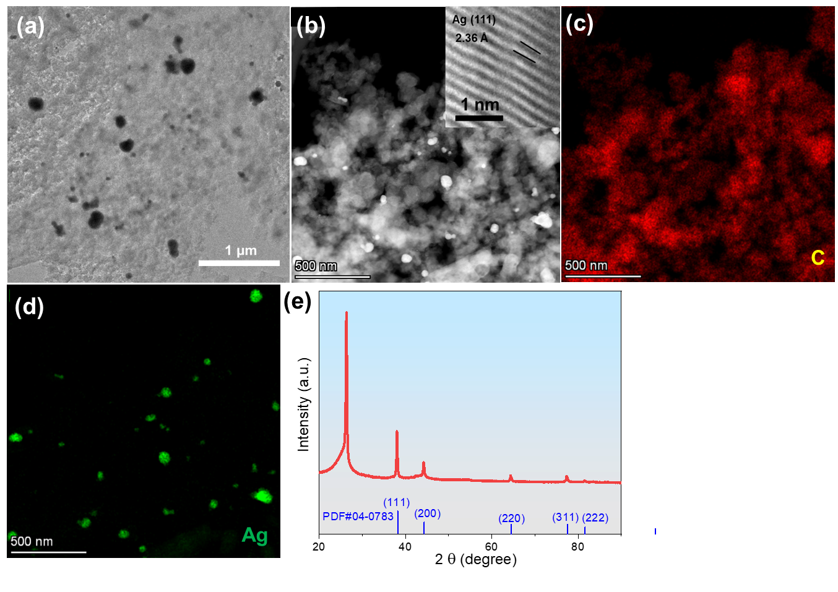
Figure S7. (a) TEM, (b) HRTEM (inset) images and the corresponding EDS mapping images for (c) C, (d) Ag elements and (e) XRD pattern of Ag NPs-Skeleton after eCO₂RR stability measurement.

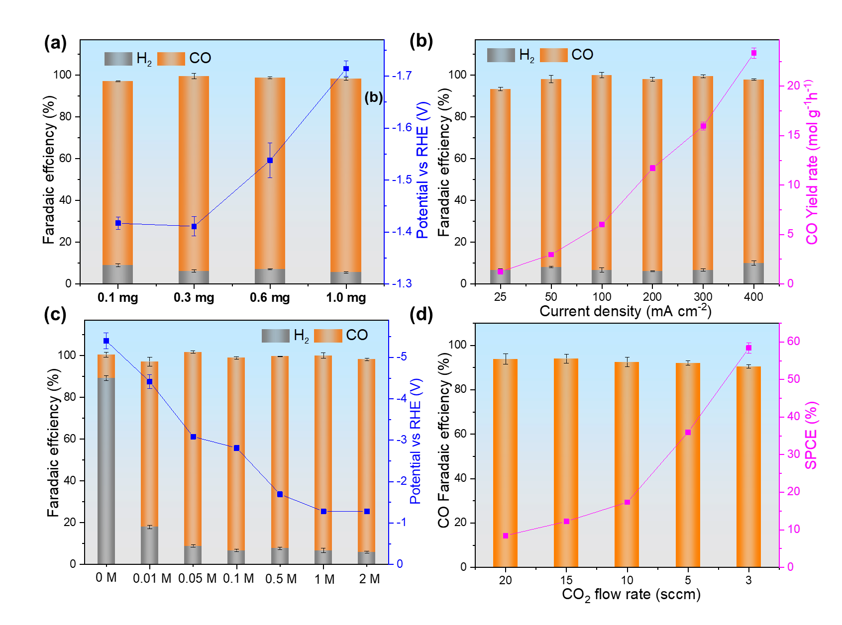
Figure S8. eCO₂RR performance in 20 mM H₂SO₄ + 1 M KCl of Ag NPs-Skeleton. (a) The influence of catalyst loading on the applied potentials and FEs at a constant current density of 100 mA cm⁻², (b) FE and corresponding CO yield rate, (c) different K⁺ concentrations. (d) FEco and corresponding SPCE at 100 mA cm⁻² with different CO₂ flow rates.

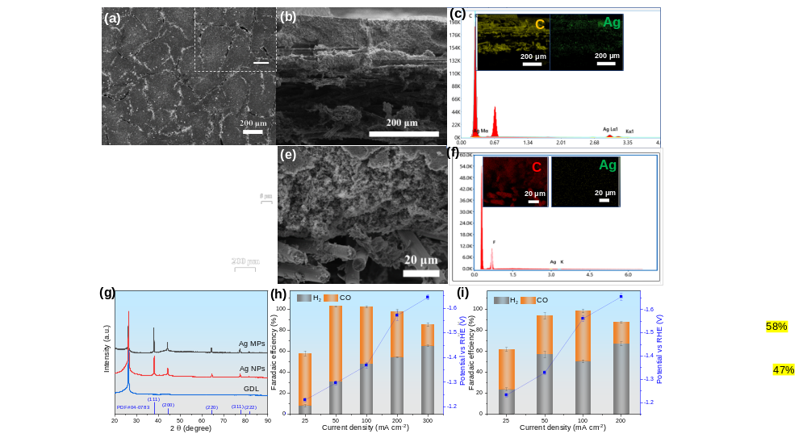
Figure S9. SEM image of (a) Ag NPs and (d) Ag MPs on GDL, Cross-sectional FESEM image of (b) Ag NPs and (e) Ag MPs, EDS spectra of (c) Ag NPs and (f) Ag MPs and the corresponding EDS mapping images for C and Ag elements in the insets, (g) XRD patterns of Ag NPs, Ag MPs and GDL, product FEs and potential of (h) Ag NPs and (i) Ag MPs in 20 mM H₂SO₄ + 1 M KCl at various current densities.

Table S1 The performance comparison of recent reported catalysts for eCO₂RR to CO in acidic media.

Catalyst | Electrolyte | pH | Current density  (mA cm⁻²) | FE_{CO} (%) | Ref.
Au | H₂SO₄ + 1 M Cs₂SO₄ | 2 | 200 | 72 | 10
Fe NPs-NC | 0.2 mM H₂SO₄ + 0.1 M KCl | 3.4 | 100 | 30 | 11
Ag NPs | 0.2 mM H₂SO₄ + 0.1 M KCl | 3.4 | 34 | 3.4 | 11
Ag/PTFE | 10 mM H₂SO₄ + 10 mM Cs₂SO₄ | 1.7 | 140 | 53 | 12
Ni₅@NCN | 1 mM H₂SO₄ + 0.25 mM Na₂SO₄ | 2.5 | 135 | 72 | 13
Ag/PTFE | 5 mM H₂SO₄ + 1 M K₂SO₄ | 2 | 220 | 53 | 14
Ni-N-C/60% PTFE | 5 mM H₂SO₄ + 1 M Cs₂SO₄ | 2 | 250 | 99.52 | 15
Au/C | 0.1 M H₂SO₄ + 0.4 M K₂SO₄ | 0.7 | 250 | 91 | 16
Ni₃N/MCNT | HCl + 0.5 M NaCl | 3.7 | 6.5 | 85.6 | 17
Co:P₄VP | 0.01 M H₂SO₄ +0.1 M  Na₂SO₄ | 2.6 | 110 | 83 | 18
Co protoporphyrin | 1 mM HClO₄ +99 mM  NaClO₄ | 3 | 0.8 | 40 | 19
Ag iRDE | 0.1 M K₂SO₄ (saturated  with CO₂) | 4.17 | 2.5 | 83 | 20
Co PPc@PANI | H₂SO₄ + 0.4 M Cs₂SO₄ | 3 | 270 | 87.4 | 21
HPH–Cu | 0.05 M H₂SO₄ in 0.45 M K₂SO₄ | 1.9 | / | 70 | 22
PDDA-GO-modified Ag | 0.01 M H₂SO₄ | 2.6 | 300 | 70 | 23
Ag NPs-Skeleton | 20 mM H₂SO₄ + 0.1 M KCl | 1.4 | 400 | 92 | This work
Ag NPs | 20 mM H₂SO₄ + 0.1 M KCl | 1.4 | 300 | 20 | This work
Ag MPs | 20 mM H₂SO₄ + 0.1 M KCl | 1.4 | 200 | 20 | This work

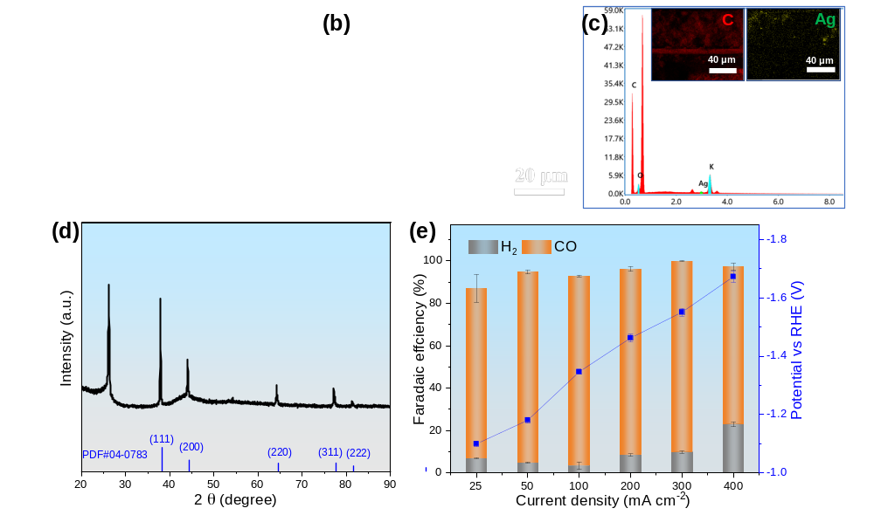
Figure S10. Structural characterization and eCO₂RR performance for Ag NPs-Skeleton with AgBF₄ as a precursor. (a) SEM image, (b) Cross-sectional FESEM image, (c) EDS spectrum and the corresponding EDS mapping images for C and Ag elements in the inset, (d) XRD pattern and (e) product FEs in 20 mM H₂SO₄ + 1 M KCl.
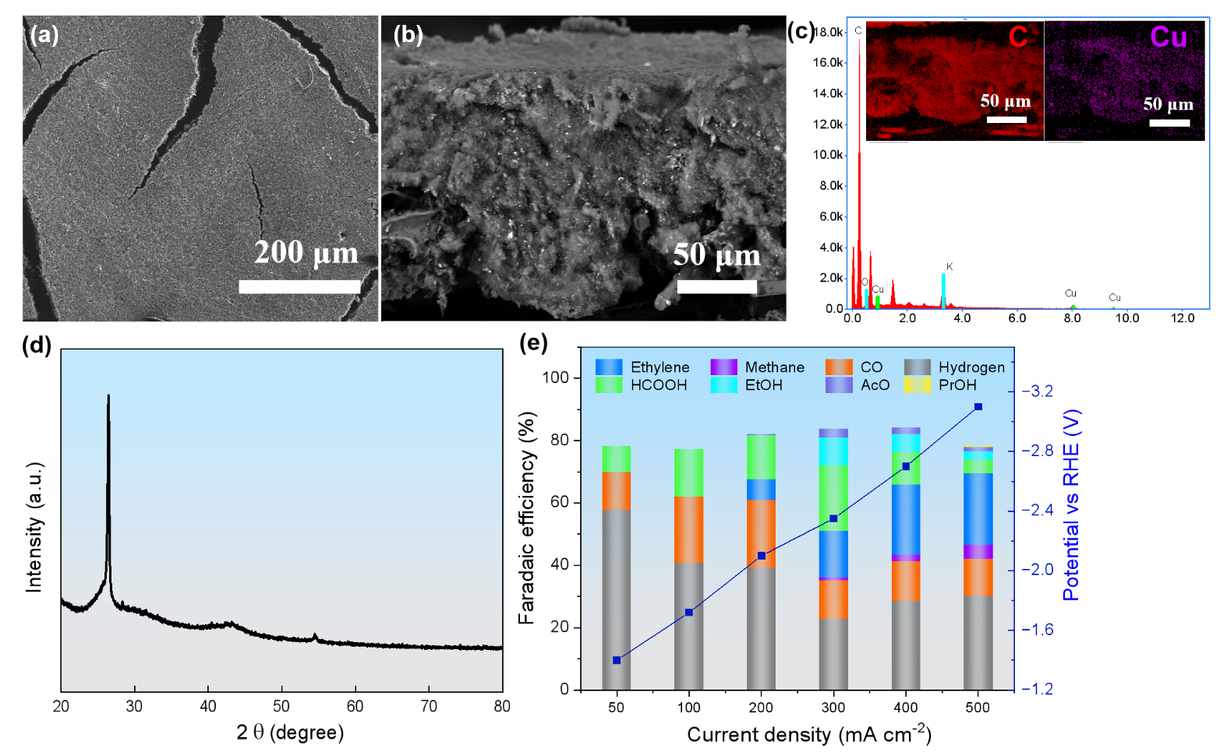
Figure S11. Structural characterizations for Cu NPs-Skeleton with Cu(NO₃)₂ as a precursor. (a) SEM image, (b) Cross-sectional FESEM image, (c) EDS spectrum and the corresponding EDS mapping images for C and Ag elements in the inset, (d) XRD pattern and (e) product selectivity in 20 mM H₂SO₄ + 1 M KCl. The XRD signal of the metallic Cu in (d) was not achieved, which might be due to the low concentration of Cu within the porous carbon nanoparticles, and the its low sensitivity for XRD detector.

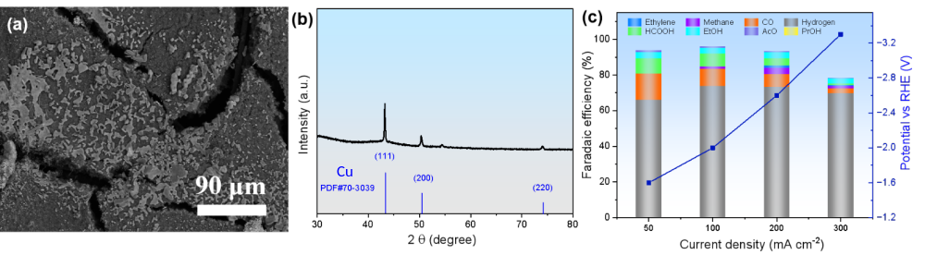
Figure S12. Structural characterizations for commercial surface Cu NPs. (a) SEM image, (b) XRD pattern, and (c) product selectivity in 20 mM H₂SO₄ + 1 M KCl.

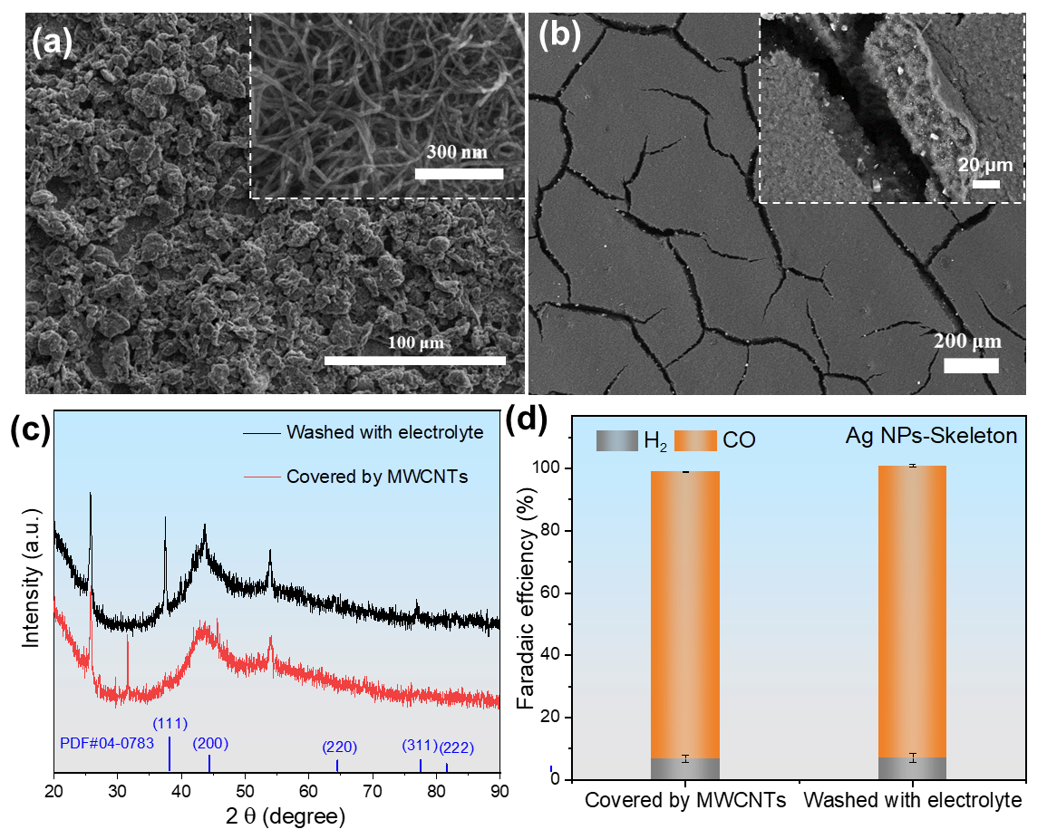
Figure S13. SEM images of (a) Ag NPs-Skeleton covered by MWCNTs and (b) Ag NPs-Skeleton washed with electrolyte for 1 h and electroreduced at 25 mA cm⁻² for 10 min with their corresponding high-resolution insets. (c) XRD patterns and (d) product FEs of Ag NPs-Skeleton in 20 mM H₂SO₄ + 1 M KCl at 100 mA cm⁻².

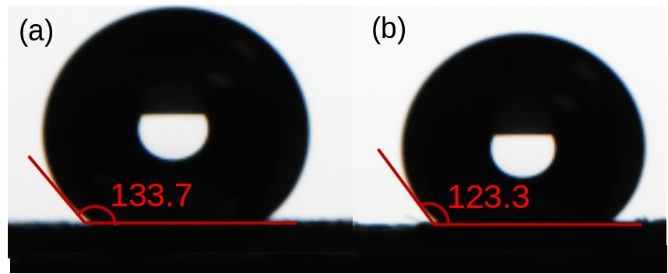
Figure S14. Contact angles of GDL (a) before and (b) after 1000 s wettability regulation via anodic voltage at 2 V vs Ag/AgCl.

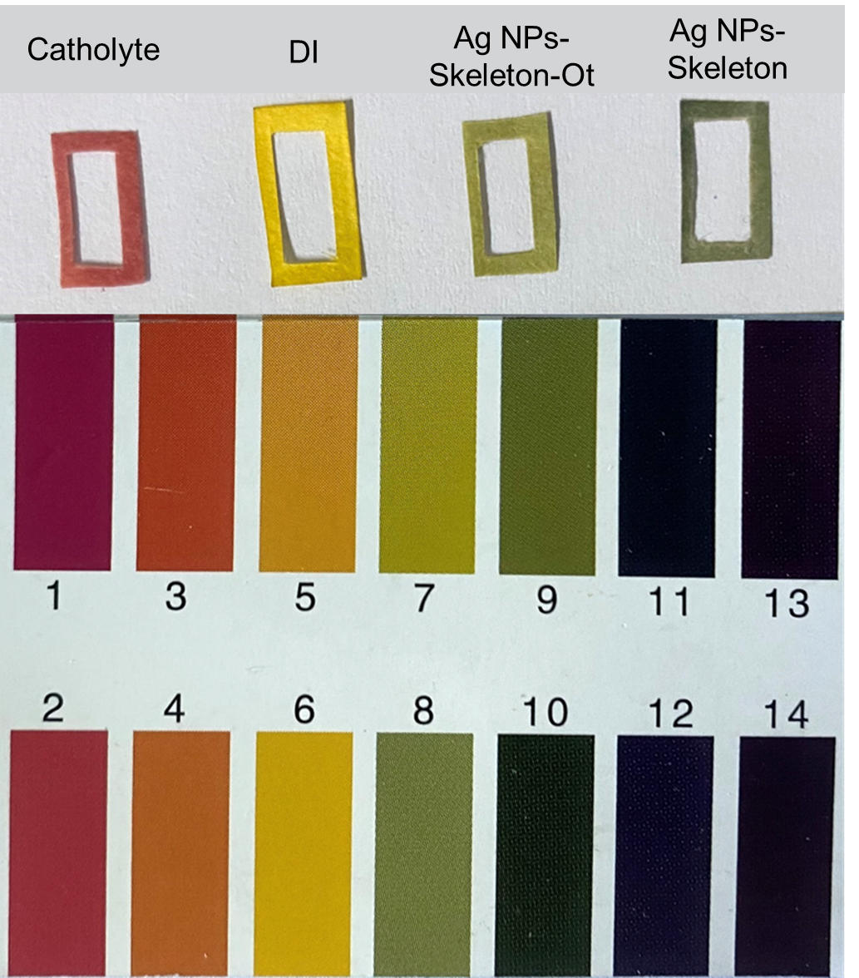
Figure S15. pH test strips of the different solutions and pasted to the GDL back for the Ag NPs-Skeleton-Ot and Ag NPs-Skeleton samples during eCO₂RR electrolysis.

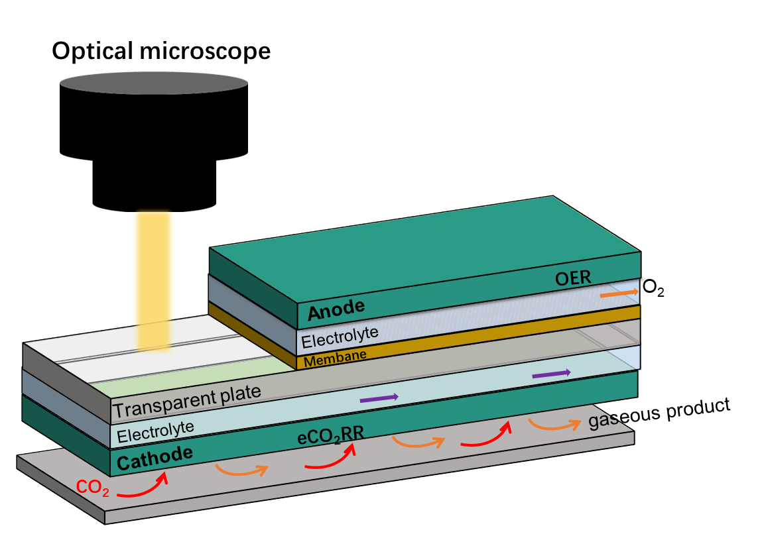
Figure S16. Schematic illustration of eCO₂RR electrolysis setup for the in-situ optical microscopy experiment.

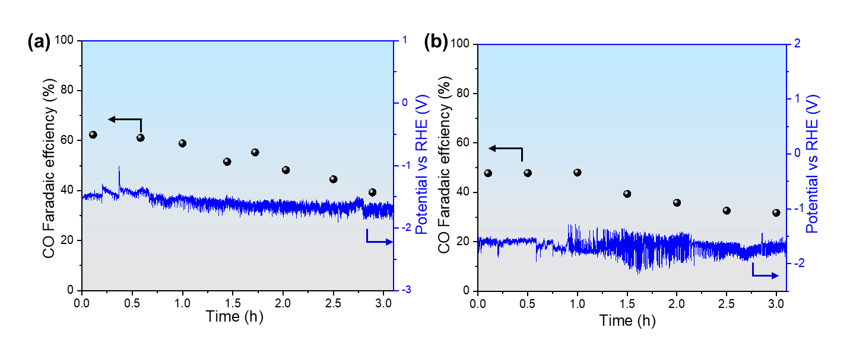
Figure S17. Potential and FE_{CO} of (a) Ag NPs and (b) Ag MPs during the long-term eCO₂RR electrolysis in 20 mM H₂SO₄ + 1 M KCl at 100 mA cm⁻².

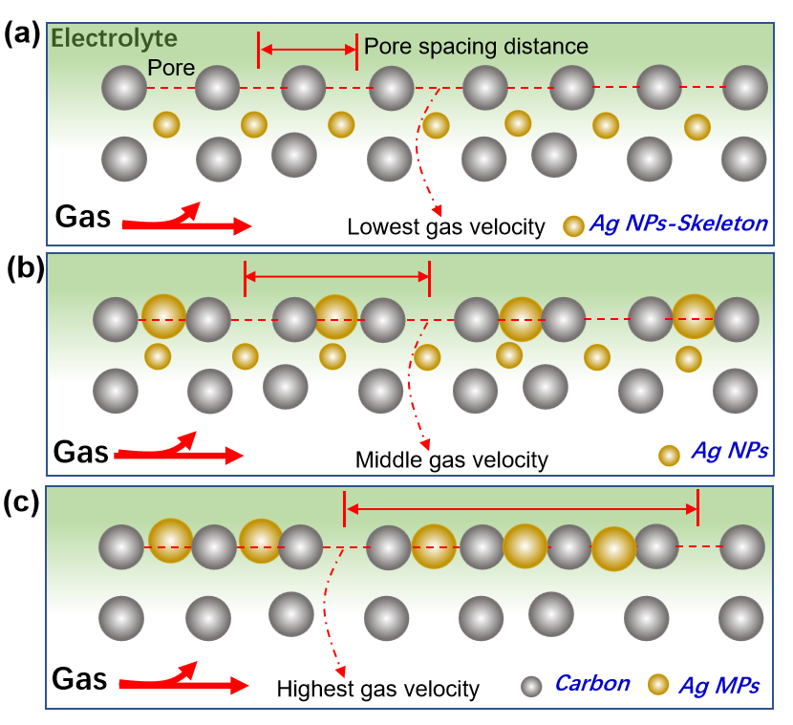
Figure S18. Schematic illustration of gas inlet velocity, pore quantity and pore separation distance on the overall gas film flow process of Ag NPs-Skeleton, Ag NPs and Ag MPs.

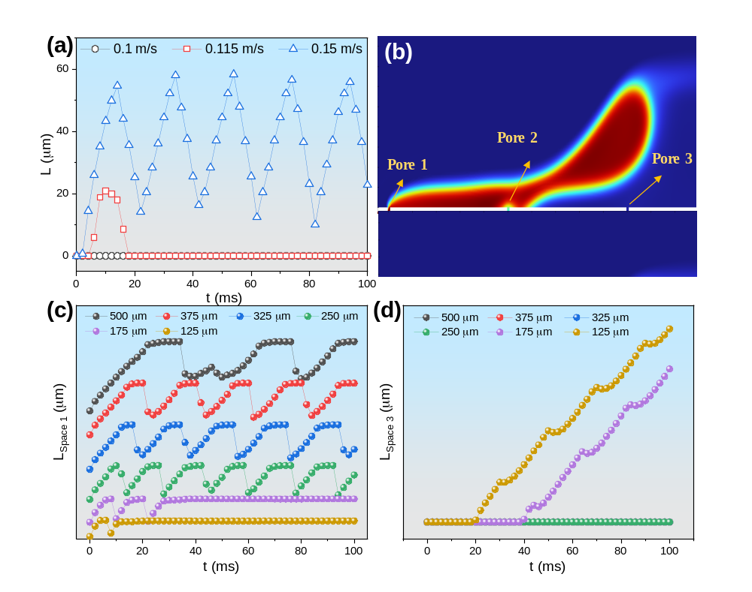
Figure S19. COMSOL Multiphysics simulation of Ag NPs-Skeleton. (a) Gas spreading film length curve at various gas velocity of 0.1 m/s, 0.115 m/s and 0.15 m/s. (b) Schematic illustration of 3 pores on the three-phase interface. (c) Change curve of gas film length between pore 1 and pore 2. (d) Change curve of gas film length after pore 3.

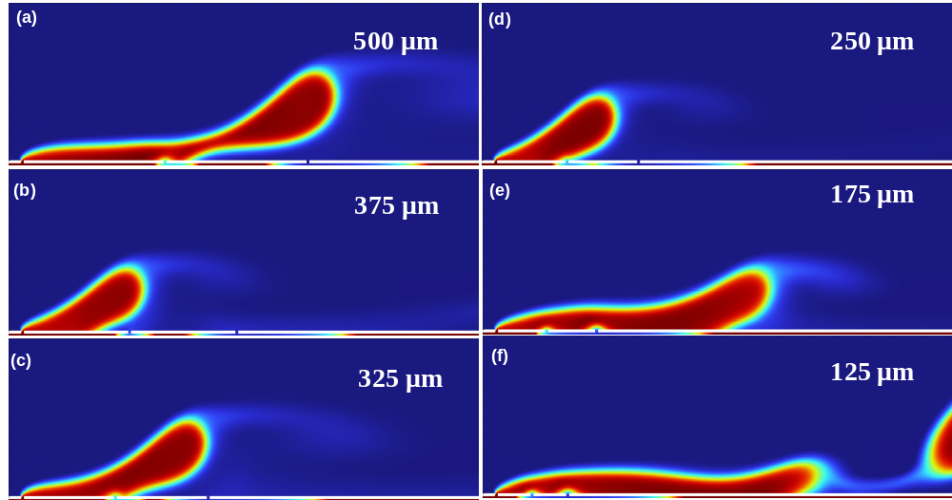

Figure S20. Volume fraction of fluid images for Ag NPs-Skeleton with the single gas inlet with different pore distance of (a) 500, (b) 375, (c) 325, (d) 250, (e) 175 and (f) 125 μm.

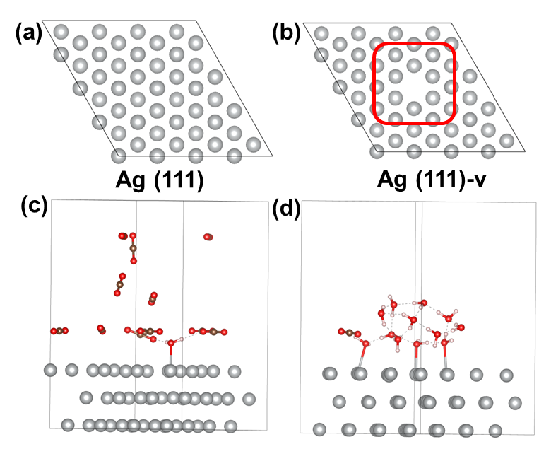
Figure S21. The atomic structures catalyst models in DFT calculations. Top configuration view of the (a) Ag(111) and (b) Ag(111)-v models. Theoretical CO₂/H₂O ratios of the (c) Ag(111)-v-CO₂-rich and (d) Ag(111)-v-H₂O-rich samples.

References
1. Schwartz N, Harrington J, Ziegler KJ, Cox P. Effects of electrode support structure on electrode microstructure, transport properties, and gas diffusion within the gas diffusion layer. ACS Omega 7, 29832-29839 (2022).
2. Wen G, et al. Continuous CO₂ electrolysis using a CO₂ exsolution-induced flow cell. Nat Energy 7, 978-988 (2022).
3. Zhou L, et al. Two-dimensional Cu plates with steady fluid fields for high-rate nitrate electroreduction to ammonia and efficient Zn-nitrate batteries. Angew Chem Int Ed 63, e202401924 (2024).
4. Liu W, et al. Electrochemical CO₂ reduction to ethylene by ultrathin CuO nanoplate arrays. Nat Commun 13, 1877 (2022).
5. Grimme S, Ehrlich S, Goerigk L. Effect of the damping function in dispersion corrected density functional theory. J Comput Chem 32, 1456-1465 (2011).
6. Perdew JP, Burke K, Ernzerhof M. Generalized gradient approximation made simple. Phys Rev Lett 77, 3865-3868 (1996).
7. Chen LD, Urushihara M, Chan K, Nørskov JK. Electric field effects in electrochemical CO₂ reduction. ACS Catal 6, 7133-7139 (2016).
8. Lejaeghere K, et al. Reproducibility in density functional theory calculations of solids. Science 351, aad3000 (2016).
9. Wang V, Xu N, Liu J-C, Tang G, Geng W-T. A user-friendly interface facilitating high-throughput computing and analysis using VASP code. Comput Phys Commun 267, 108033 (2021).
10. Monteiro MCO, Philips MF, Schouten KJP, Koper MTM. Efficiency and selectivity of CO₂ reduction to CO on gold gas diffusion electrodes in acidic media. Nat Commun 12, 4943 (2021).
11. Fan Q, Bao G, Chen X, Meng Y, Zhang S, Ma X. Iron nanoparticles tuned to catalyze CO₂ electroreduction in acidic solutions through chemical microenvironment engineering. ACS Catal 12, 7517-7523 (2022).
12. Pan B, et al. Close to 90% single-pass conversion efficiency for CO₂ electroreduction in an acid-fed membrane electrode assembly. ACS Energy Lett 7, 4224-4231 (2022).
13. Liu Z, Yan T, Shi H, Pan H, Cheng Y, Kang P. Acidic electrocatalytic CO₂ reduction using space-confined nanoreactors. ACS Appl Mater Interfaces 14, 7900-7908 (2022).
14. Xu Z, et al. Steering the selectivity of electrochemical CO₂ reduction in acidic media. ChemCatChem 14, e202200052 (2022).
15. Sheng X, Ge W, Jiang H, Li C. Engineering the Ni-N-C catalyst microenvironment enabling CO₂ electroreduction with nearly 100% CO selectivity in acid. Adv Mater 34, e2201295 (2022).
16. Gu J, Liu S, Ni W, Ren W, Haussener S, Hu X. Modulating electric field distribution by alkali cations for CO₂ electroreduction in strongly acidic medium. Nat Catal 5, 268-276 (2022).
17. Wang Z, Hou P, Wang Y, Xiang X, Kang P. Acidic electrochemical reduction of CO₂ using nickel nitride on multiwalled carbon nanotube as selective catalyst. ACS Sustain Chem Eng 7, 6106-6112 (2019).
18. Fujinuma N, Ikoma A, Lofland SE. Highly efficient electrochemical CO₂ reduction reaction to CO with one-pot synthesized co-pyridine-derived catalyst incorporated in a nafion-based membrane electrode assembly. Adv Energy Mater 10, 2001645 (2020).
19. Shen J, et al. Electrocatalytic reduction of carbon dioxide to carbon monoxide and methane at an immobilized cobalt protoporphyrin. Nat Commun 6, 8177 (2015).
20. Moreno-García P, Kovács N, Grozovski V, Gálvez-Vázquez MdJ, Vesztergom S, Broekmann P. Toward CO₂ electroreduction under controlled mass flow conditions: A combined inverted RDE and gas chromatography approach. Anal Chem 92, 4301-4308 (2020).
21. Liu L-Y, et al. Boosting oxygen-resistant CO₂ electroreduction reaction in acidic media over conjugated frameworks. J Mater Chem A 12, 9486-9493, (2024).
22. Zhang Y, et al. In situ formed copper nanoparticles via strong electronic interaction with organic skeleton for pH-universal electrocatalytic CO₂ reduction. J Mater Chem A 11, 22992-23000 (2023).
23. Fan J, et al. Immobilized tetraalkylammonium cations enable metal-free CO₂ electroreduction in acid and pure water. Angew Chem Int Ed 63, e202317828 (2024).

