Sequencing depth (coverage) can bias intraspecies diversity estimates
Esteban Bustos-Caparros¹*, Tomeu Viver^{1,2}, Stephanus N. Venter³, Rafael Bosch⁴, Konstantinos T. Konstantinidis⁵, Luis M. Rodriguez-R^{6,7}*, Ramon Rossello-Mora¹*.

¹ Marine Microbiology Group (MMG), Department of Animal and Microbial Biodiversity, Mediterranean Institute for Advanced Studies (IMEDEA, CSIC-UIB), Esporles, Spain.
² Department of Molecular Ecology, Max-Planck-Institute für Marine Mikrobiologie, Bremen D-28359, Germany.
³ Department of Biochemistry, Genetics and Microbiology, and Forestry and Agricultural Biotechnology Institute (FABI), University of Pretoria, Pretoria, South Africa.
⁴ Microbiologia, Departament de Biologia, Edifici Guillem Colom, Universitat de les Illes Balears, Campus UIB, 07122 Palma de Mallorca, Spain.
⁵ School of Civil and Environmental Engineering, Georgia Institute of Technology, Atlanta, GA, USA.
⁶ Department of Microbiology, University of Innsbruck, Innsbruck, Austria.
⁷ Digital Science Center (DiSC), University of Innsbruck, Innsbruck, Austria.

*Correspondence: ebustos@imedea.uib-csic.es, lmrodriguezr@gmail.com

Supplementary Table S1: Sample metadata and accession numbers of the 53 metagenomes corresponding to hypersaline, marine and human gut projects used for evaluate the influence of sequencing depth on nucleotide diversity estimations

Supplementary Table S2: Sample metadata and accession numbers of the 30 MAGs used for evaluate the influence of sequencing depth on nucleotide diversity estimations, corresponding to hypersaline, marine and human gut projects (i.e. 10 MAGs for each sample kind).

Supplementary Figure S1: Model plot representing the correlation between nucleotide diversity and sequencing depth. Each line represents the nucleotide diversity (y-axis), represented as log₂(Diversity ratio), and sequencing depth (x-axis) obtained for a single MAG across each metagenome. The log₂(Diversity ratio) was calculated by dividing the nucleotide diversity obtained from each fraction of a metagenome by the nucleotide diversity obtained from the entire metagenome (100% of reads). Green lines indicate positive correlations (i.e. increasing diversity with coverage), and red lines indicate negative correlations (i.e. decreasing diversity with increasing coverage).

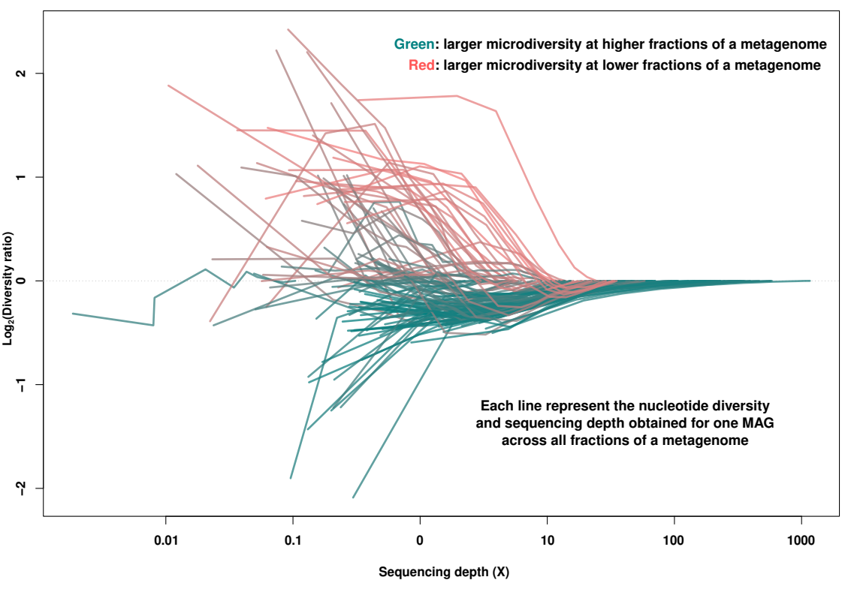

Supplementary Figure S2: Frequency of correlations between sequencing depth and nucleotide diversity, represented as log₂(Diversity ratio), before (A) and after (B) filtering data below 10X along Illumina, PacBio and Oxford Nanopore sequencing projects. Green bars indicate positive correlations (i.e. larger microdiversity at greater fractions of a metagenome) and red bars indicate negative correlations (i.e. larger microdiversity at lower fractions of a metagenome).

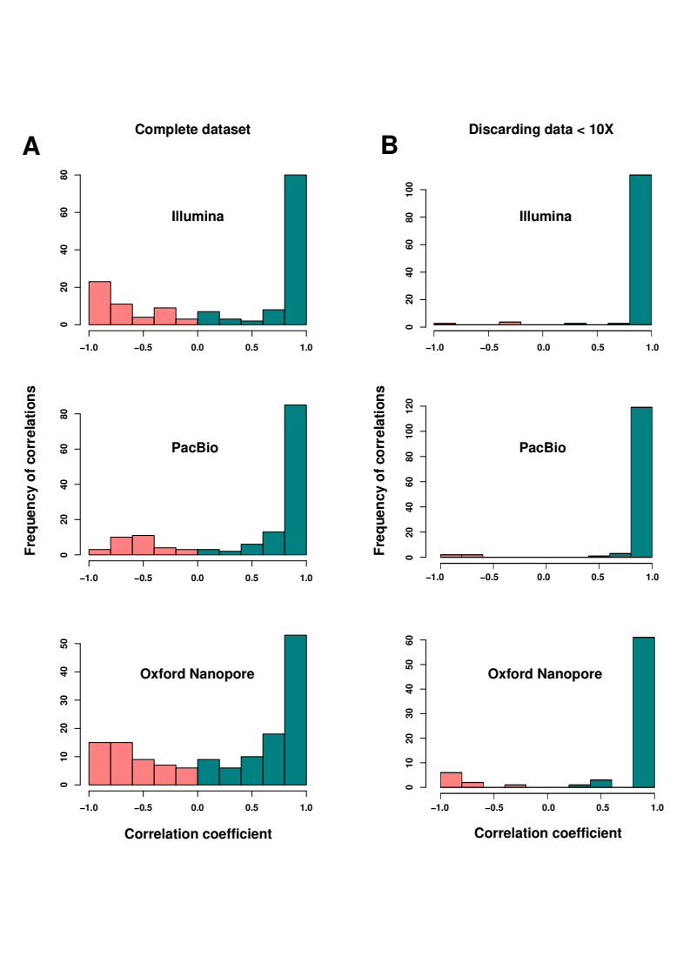

Supplementary Figure S3: Correlations and frequency of correlations between sequencing depth and nucleotide diversity represented as log₂(Diversity ratio) before and after filtering data below 10X along four A) Illumina and B) PacBio metagenomes within the marine project. The diversity ratio represents the nucleotide diversity obtained for each fraction of a metagenome divided by the nucleotide diversity of the whole-metagenome. Green lines and bars indicated positive correlations (i.e. larger microdiversity at greater fractions of a metagenome) and red lines and bars indicated negative correlations (i.e. larger microdiversity at lower fractions of a metagenome).

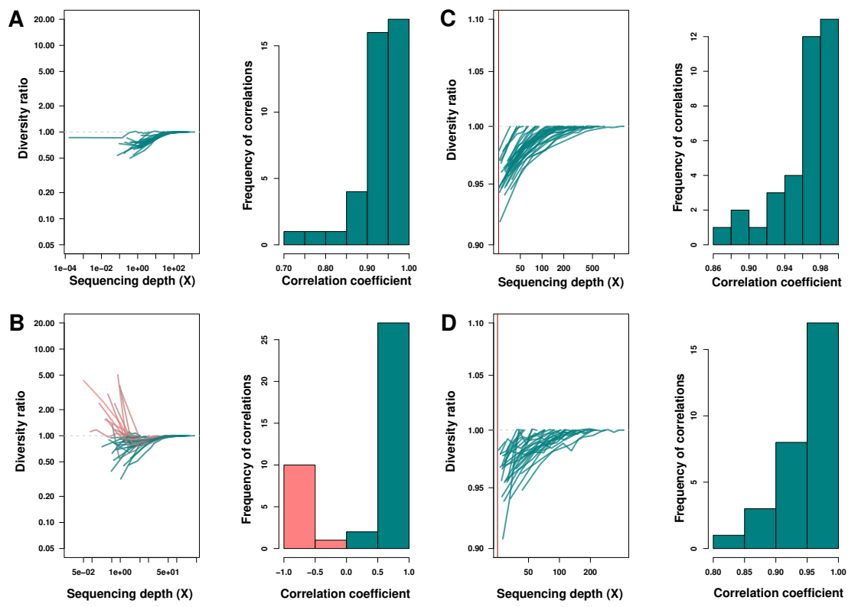

Supplementary Figure S4: Correlations and frequency of correlations between sequencing depth and nucleotide diversity represented as log₂(Diversity ratio) before and after filtering data below 10X along four A) Illumina and B) Oxford Nanopore metagenomes within the human gut project. The diversity ratio represents the nucleotide diversity obtained for each fraction of a metagenome divided by the nucleotide diversity of the whole-metagenome. Green lines and bars indicated positive correlations (i.e. larger microdiversity at greater fractions of a metagenome) and red lines and bars indicated negative correlations (i.e. larger microdiversity at lower fractions of a metagenome).

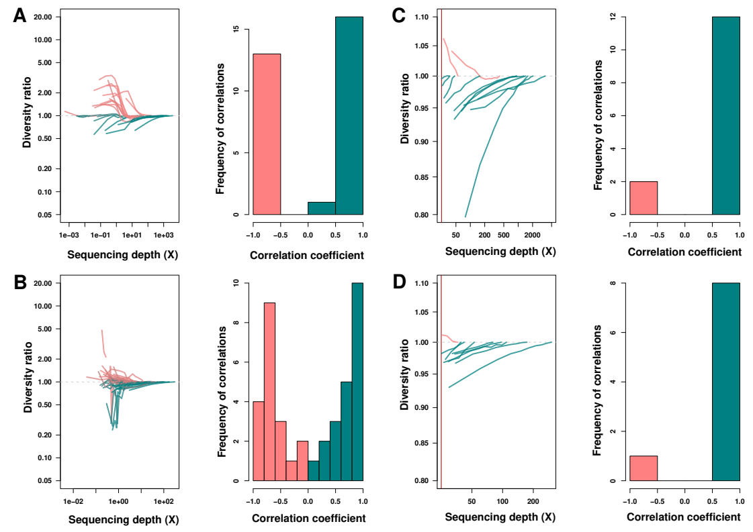

Supplementary Figure S5: Correlation between non-interpolated and interpolated (200X) nucleotide diversity of the 10 most abundant MAGs on Illumina, PacBio and Oxford Nanopore sequencing platforms.

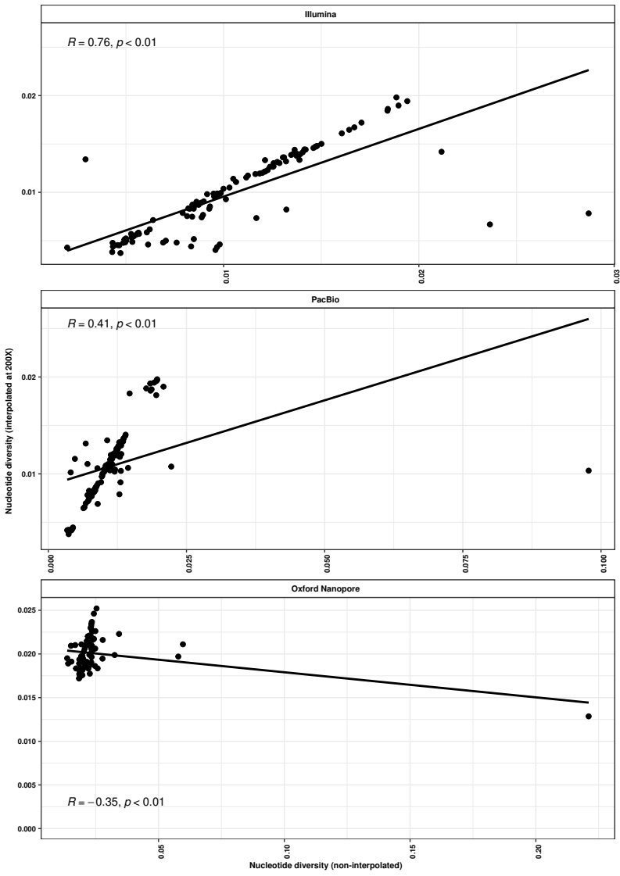

Supplementary Figure S6: Barplots representing the comparison of non-interpolated (black bars) and interpolated (grey bars; 200X) nucleotide diversity in Illumina metagenomes. The lack of grey bars in some samples are the consequence of their low sequencing depth (<10X).

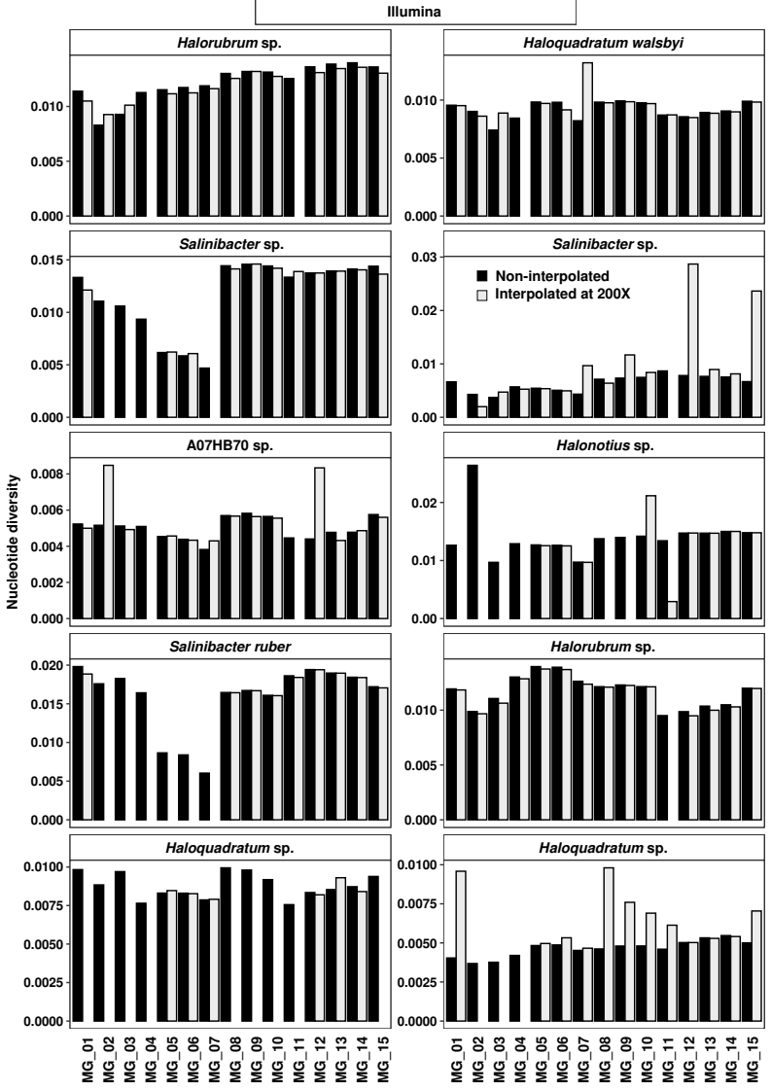

Supplementary Figure S7: Barplots representing the comparison of non-interpolated (black bars) and interpolated (grey bars; 200X) nucleotide diversity in PacBio metagenomes. The lack of grey bars in some samples are the consequence of their low sequencing depth (<10X).
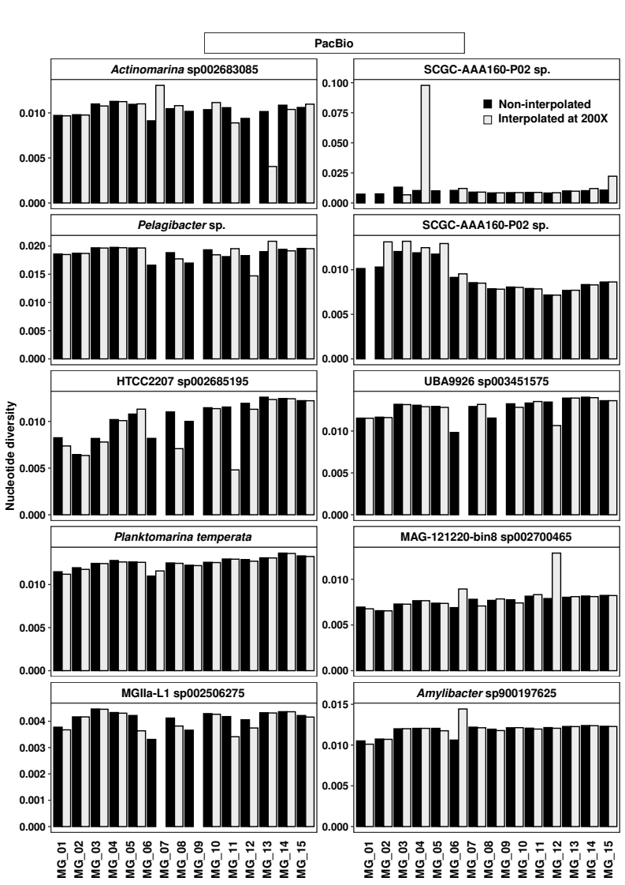

Supplementary Figure S8: Barplots representing the comparison of non-interpolated (black bars) and interpolated (grey bars; 200X) nucleotide diversity in Oxford Nanopore metagenomes. The lack of grey bars in some samples are the consequence of their low sequencing depth (<10X).

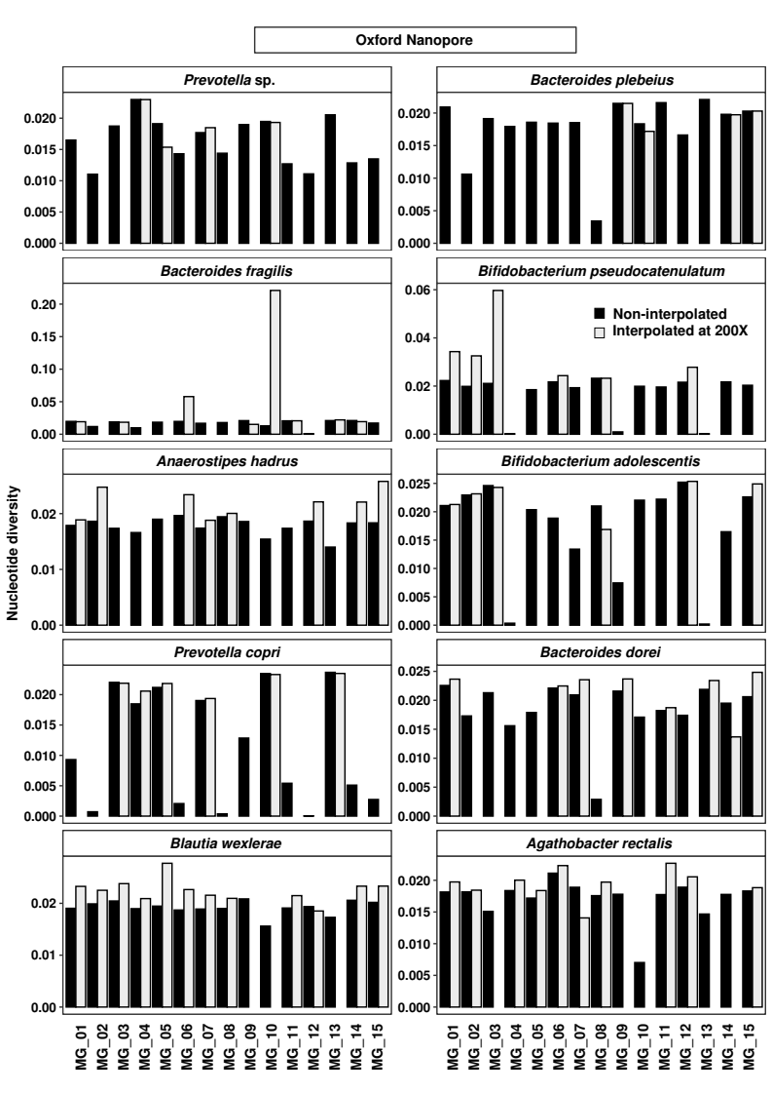

Supplementary Figure S9: Model plot representing the correlation between ANIr and sequencing depth. Each line represents the ANIr (y-axis), represented as log₂(ANIr ratio), and sequencing depth (x-axis) obtained for a single MAG across each metagenome. The log₂(ANIr ratio) was calculated by dividing the ANIr obtained from each fraction of a metagenome by the ANIr obtained from the entire metagenome (100% of reads). Green lines indicate positive correlations (i.e. increasing diversity with coverage), and red lines indicate negative correlations (i.e. decreasing diversity with increasing coverage).

