Current Dermatology Reports

Short Term Efficacy of Biological Treatment for Moderate-to-Severe Plaque Psoriasis: A Systematic Review and Network Meta-Analysis
O. Ismail¹*, K. Jaber¹, Y. Jaber¹, U. Froukh¹, A. Younis¹, K. Albdour¹, Y. Momani¹, N. Almaani²
- School of Medicine, University of Jordan, Jordan
- Department of Dermatology, School of Medicine, University of Jordan, Jordan
* Corresponding author details:
Email: omar.moh.isml@gmail.com
Phone number: 00962791301329
Address: School of Medicine, University of Jordan, Amman 11972, Jordan

Contents
Abbreviations 2
R1. Minimally contextualized framework 4
R2. Direct comparison heterogeneity 34
R3. Comparison-adjusted funnel plots 58

Abbreviations
Abbreviation | Term
Pla | Placebo
Ada-1 | Adalimumab - 40mg Q2W
Ada-2 | Adalimumab - 40mg QW
Apre | Apremilast
Bim | Bimekizumab - 320mg Q4W
Bro-1 | Brodalumab - 140mg Q2W
Bro-2 | Brodalumab - 210mg Q2W
CZP-1 | Certolizumab Pegol - 200mg Q2W
CZP-2 | Certolizumab Pegol - 400mg Q2W
CZP-3 | Certolizumab Pegol - 400mg Q4W
Eta-1 | Etanercept - 25mg BIW
Eta-2 | Etanercept - 25mg QW
Eta-3 | Etanercept - 50mg BIW
Eta-4 | Etanercept - 50mg QW
Gus-1 | Guselkumab - 50mg at weeks 0,4,8
Gus-2 | Guselkumab - 100mg at weeks 0,4
Gus-3 | Guselkumab - 100mg at weeks 0,4,8
Gus-4 | Guselkumab - 100mg at weeks 0,4,12
Gus-5 | Guselkumab - 100mg Q4W
Gus-6 | Guselkumab - 100mg Q8W
Inf-1 | Infliximab - 3mg/kg at weeks 0,2,6
Inf-2 | Infliximab - 5mg/kg at weeks 0,2,6
Inf-3 | Infliximab - 10mg/kg at weeks 0,2,6
Ixe-1 | Ixekizumab - 80mg Q2W
Ixe-2 | Ixekizumab - 80mg Q4W
Ixe-3 | Ixekizumab - 160mg Q4W
Mtx | Methotrexate
Ris-1 | Risankizumab - 75mg at weeks 0,4
Ris-2 | Risankizumab - 150mg at weeks 0,4
Sec-1 | Secukinumab - 75mg Q4W
Sec-2 | Secukinumab - 150mg Q4W
Sec-3 | Secukinumab - 300mg Q4W
Til-1 | Tildrakizumab - 100mg at weeks 0,4
Til-2 | Tildrakizumab - 200mg at weeks 0,4
Ust-1 | Ustekinumab - 45mg at weeks 0,4
Ust-2 | Ustekinumab - 90mg at weeks 0,4
PASI | Psoriasis area severity index
IGA | Investigator global assessment
DLQI | Dermatology life quality index
AE | Adverse event
PsA | Psoriatic arthritis

R1. Minimally contextualized framework
R1.1.1 Achieving 75% reduction on the PASI scale estimates
Arm 1 | Arm 2 | k | n | Direct estimate | Indirect estimate | Network meta-analysis | Incoherence
Ada-1 | Pla | 11 | 3639 | 7.28 (5.50 To 9.62) | 7.77 (5.00 To 12.09) | 7.42 (5.86 To 9.39) | 0.806
Eta-3 | Pla | 9 | 3908 | 9.90 (7.60 To 12.90) | 5.83 (4.61 To 7.38) | 7.37 (6.18 To 8.78) | 0.003*
Inf-2 | Pla | 8 | 1558 | 20.67 (12.45 To 34.31) | 15.13 (7.11 To 32.19) | 18.76 (12.31 To 28.57) | 0.502
Sec-3 | Pla | 8 | 2259 | 18.29 (12.78 To 26.19) | 11.17 (7.73 To 16.12) | 14.37 (11.12 To 18.58) | 0.060
Sec-2 | Pla | 7 | 2006 | 14.25 (10.06 To 20.20) | 10.46 (6.98 To 15.65) | 12.49 (9.59 To 16.26) | 0.255
Ust-1 | Pla | 7 | 2194 | 11.17 (8.00 To 15.59) | 8.30 (5.32 To 12.93) | 10.03 (7.68 To 13.10) | 0.295
Ixe-2 | Pla | 6 | 2494 | 13.05 (9.50 To 17.92) | 13.89 (10.02 To 19.24) | 13.45 (10.71 To 16.88) | 0.789
Sec-2 | Sec-3 | 6 | 1924 | 0.88 (0.73 To 1.04) | 0.72 (0.30 To 1.71) | 0.87 (0.73 To 1.03) | 0.658
Ust-1 | Ust-2 | 6 | 2630 | 0.92 (0.76 To 1.10) | 0.88 (0.14 To 5.56) | 0.92 (0.76 To 1.10) | 0.963
Ixe-1 | Ixe-2 | 5 | 2087 | 1.05 (0.87 To 1.28) | 0.77 (0.32 To 1.87) | 1.04 (0.86 To 1.26) | 0.494
Ixe-1 | Pla | 5 | 1622 | 11.54 (7.97 To 16.69) | 15.77 (11.77 To 21.13) | 13.98 (11.12 To 17.58) | 0.194
Ris-2 | Pla | 5 | 1468 | 11.10 (7.04 To 17.51) | 9.11 (5.60 To 14.82) | 10.12 (7.26 To 14.11) | 0.562
Ust-2 | Pla | 5 | 2045 | 12.53 (8.76 To 17.92) | 9.14 (6.05 To 13.80) | 10.94 (8.35 To 14.34) | 0.257
Bro-2 | Pla | 4 | 2364 | 14.50 (10.06 To 20.92) | 9.57 (0.34 To 266.58) | 14.43 (10.03 To 20.77) | 0.808
CZP-1 | CZP-2 | 4 | 794 | 0.90 (0.73 To 1.12) | . | 0.90 (0.72 To 1.12) | .
CZP-1 | Pla | 4 | 582 | 9.47 (5.36 To 16.75) | 9.09 (5.71 To 14.48) | 9.24 (6.45 To 13.25) | 0.914
CZP-2 | Pla | 4 | 578 | 10.30 (5.83 To 18.19) | 10.20 (6.42 To 16.20) | 10.24 (7.15 To 14.66) | 0.980
Bro-1 | Bro-2 | 3 | 2916 | 0.77 (0.61 To 0.98) | 0.05 (0.00 To 15.10) | 0.77 (0.60 To 0.97) | 0.354
Bro-1 | Pla | 3 | 2302 | 11.08 (7.65 To 16.04) | 9.95 (0.85 To 116.08) | 11.05 (7.66 To 15.94) | 0.933
Eta-1 | Pla | 3 | 777 | 10.20 (5.45 To 19.10) | 4.18 (2.70 To 6.48) | 5.60 (3.91 To 8.03) | 0.022*
Eta-4 | Pla | 3 | 429 | 1.76 (1.22 To 2.56) | 15.92 (9.75 To 25.99) | 3.93 (2.93 To 5.29) | < 0.001*
Ada-1 | Gus-4 | 2 | 1407 | 0.80 (0.60 To 1.07) | 0.00 (0.00 To 0.03) | 0.77 (0.57 To 1.03) | <0.001*
Ada-1 | Mtx | 2 | 429 | 2.25 (1.60 To 3.18) | 15.12 (3.66 To 62.52) | 2.51 (1.79 To 3.51) | 0.011*
Eta-1 | Eta-3 | 2 | 716 | 0.69 (0.49 To 0.97) | 3.09 (0.86 To 11.02) | 0.76 (0.55 To 1.05) | 0.026*
Eta-3 | Ixe-1 | 2 | 1476 | 0.53 (0.40 To 0.72) | 0.52 (0.37 To 0.73) | 0.53 (0.42 To 0.66) | 0.894
Eta-3 | Ixe-2 | 2 | 1473 | 0.58 (0.43 To 0.79) | 0.50 (0.36 To 0.71) | 0.55 (0.44 To 0.69) | 0.515
Gus-4 | Pla | 2 | 1247 | 369.47 (51.08 To 2672.39) | 8.46 (5.78 To 12.38) | 9.68 (6.66 To 14.07) | <0.001*
Inf-1 | Inf-2 | 2 | 825 | 0.87 (0.65 To 1.18) | 2.23 (0.34 To 14.71) | 0.89 (0.66 To 1.20) | 0.337
Inf-1 | Pla | 2 | 671 | 22.42 (10.22 To 49.17) | 13.94 (7.46 To 26.08) | 16.77 (10.28 To 27.36) | 0.354
Mtx | Pla | 2 | 324 | 1.87 (1.11 To 3.15) | 5.11 (2.89 To 9.03) | 2.96 (2.01 To 4.34) | 0.011*
Til-1 | Pla | 2 | 927 | 10.80 (6.32 To 18.45) | 9.23 (5.51 To 15.43) | 9.95 (6.86 To 14.42) | 0.678
Til-2 | Pla | 2 | 933 | 11.05 (6.47 To 18.88) | 9.45 (5.66 To 15.77) | 10.18 (7.03 To 14.75) | 0.678
Til-1 | Til-2 | 2 | 1238 | 0.98 (0.72 To 1.32) | . | 0.98 (0.72 To 1.32) | .
Ada-1 | Ada-2 | 1 | 97 | 0.66 (0.40 To 1.10) | 0.45 (0.07 To 3.16) | 0.64 (0.39 To 1.05) | 0.714
Ada-1 | Ixe-1 | 1 | 127 | 0.49 (0.28 To 0.84) | 0.55 (0.38 To 0.79) | 0.53 (0.39 To 0.72) | 0.716
Ada-1 | Ixe-2 | 1 | 141 | 0.45 (0.26 To 0.77) | 0.60 (0.42 To 0.86) | 0.55 (0.41 To 0.74) | 0.372
Ada-1 | Ris-2 | 1 | 605 | 0.79 (0.52 To 1.20) | 0.65 (0.38 To 1.09) | 0.73 (0.53 To 1.01) | 0.562
Ada-2 | Pla | 1 | 104 | 14.00 (4.31 To 45.50) | 10.94 (6.01 To 19.89) | 11.50 (6.75 To 19.61) | 0.714
Apre | Eta-4 | 1 | 166 | 0.82 (0.48 To 1.41) | 0.89 (0.17 To 4.69) | 0.83 (0.50 To 1.38) | 0.933
Apre | Pla | 1 | 167 | 3.34 (1.57 To 7.12) | 3.19 (1.43 To 7.12) | 3.27 (1.88 To 5.67) | 0.933
CZP-1 | Eta-3 | 1 | 335 | 1.28 (0.82 To 1.99) | 1.22 (0.70 To 2.11) | 1.25 (0.89 To 1.77) | 0.890
CZP-2 | Eta-3 | 1 | 337 | 1.40 (0.90 To 2.17) | 1.38 (0.79 To 2.39) | 1.39 (0.99 To 1.96) | 0.965
Eta-1 | Eta-2 | 1 | 322 | 2.36 (1.30 To 4.28) | 2.62 (0.48 To 14.29) | 2.39 (1.36 To 4.19) | 0.909
Eta-2 | Eta-3 | 1 | 324 | 0.29 (0.16 To 0.52) | 0.71 (0.13 To 3.95) | 0.32 (0.18 To 0.55) | 0.336
Eta-2 | Pla | 1 | 326 | 3.98 (1.52 To 10.41) | 1.77 (0.88 To 3.57) | 2.35 (1.33 To 4.13) | 0.183
Eta-3 | Eta-4 | 1 | 752 | 0.56 (0.36 To 0.89) | 5.09 (3.37 To 7.71) | 1.87 (1.38 To 2.54) | <0.001*
Eta-3 | Inf-2 | 1 | 48 | 0.48 (0.23 To 1.01) | 0.35 (0.21 To 0.60) | 0.39 (0.25 To 0.61) | 0.493
Eta-3 | Sec-2 | 1 | 653 | 0.65 (0.42 To 1.00) | 0.55 (0.39 To 0.79) | 0.59 (0.45 To 0.77) | 0.568
Eta-3 | Sec-3 | 1 | 653 | 0.57 (0.37 To 0.88) | 0.48 (0.34 To 0.67) | 0.51 (0.39 To 0.67) | 0.523
Eta-3 | Til-1 | 1 | 620 | 0.79 (0.51 To 1.21) | 0.65 (0.34 To 1.22) | 0.74 (0.52 To 1.06) | 0.618
Eta-3 | Til-2 | 1 | 627 | 0.74 (0.48 To 1.13) | 0.70 (0.37 To 1.32) | 0.72 (0.51 To 1.03) | 0.896
Eta-3 | Ust-1 | 1 | 556 | 0.84 (0.55 To 1.29) | 0.67 (0.46 To 0.96) | 0.73 (0.56 To 0.97) | 0.414
Eta-3 | Ust-2 | 1 | 694 | 0.77 (0.51 To 1.17) | 0.61 (0.42 To 0.88) | 0.67 (0.51 To 0.89) | 0.408
Gus-1 | Gus-3 | 1 | 128 | 1.06 (0.69 To 1.63) | . | 1.06 (0.69 To 1.63) | .
Gus-1 | Pla | 1 | 129 | 14.28 (5.07 To 40.21) | . | 14.28 (5.07 To 40.21) | .
Gus-2 | Ixe-1 | 1 | 1025 | 0.95 (0.63 To 1.43) | 1.16 (0.68 To 1.97) | 1.02 (0.74 To 1.41) | 0.569
Gus-2 | Pla | 1 | 78 | 25.61 (1.62 To 405.72) | 14.16 (10.00 To 20.06) | 14.30 (10.12 To 20.19) | 0.677
Gus-2 | Sec-3 | 1 | 1048 | 1.06 (0.70 To 1.59) | 0.90 (0.53 To 1.53) | 0.99 (0.72 To 1.38) | 0.639
Gus-3 | Pla | 1 | 127 | 13.46 (4.77 To 37.99) | . | 13.46 (4.77 To 37.99) | .
Inf-2 | Inf-3 | 1 | 22 | 0.90 (0.53 To 1.52) | 13.97 (1.27 To 154.08) | 1.02 (0.61 To 1.71) | 0.029*
Inf-3 | Pla | 1 | 22 | 5.00 (1.32 To 18.92) | 27.21 (13.10 To 56.54) | 18.37 (9.68 To 34.88) | 0.029*
Ixe-2 | Ixe-3 | 1 | 865 | 0.93 (0.62 To 1.40) | 0.33 (0.09 To 1.18) | 0.84 (0.57 To 1.24) | 0.132
Ixe-3 | Pla | 1 | 864 | 22.60 (12.17 To 41.97) | 11.74 (6.54 To 21.08) | 15.99 (10.45 To 24.47) | 0.132
Ris-1 | Pla | 1 | 116 | 10.40 (4.08 To 26.50) | 9.39 (5.13 To 17.18) | 9.67 (5.82 To 16.07) | 0.857
Sec-1 | Pla | 1 | 217 | 7.85 (3.68 To 16.77) | 16.16 (8.62 To 30.30) | 12.04 (7.42 To 19.55) | 0.151
Ris-1 | Ris-2 | 1 | 113 | 0.95 (0.62 To 1.44) | 1.14 (0.16 To 8.42) | 0.96 (0.63 To 1.44) | 0.857
Sec-1 | Sec-2 | 1 | 216 | 1.06 (0.67 To 1.67) | 0.33 (0.07 To 1.52) | 0.96 (0.62 To 1.49) | 0.151

R1.1.2 Achieving 75% reduction on the PASI scale certainty
Arm 1 | Arm 2 | Risk of bias | Inconsistency | Indirectness | Publication bias | Intransitivity | Incoherence | Imprecision | Final rating | Reasons for downgrading
Ada-1 | Pla | Not serious | Serious | Not serious | Not serious | Not serious | Not serious | Not Serious | MODERATE | Inconsistency
Eta-3 | Pla | Not serious | Not serious | Not serious | Not serious | Not serious | Serious | Not Serious | MODERATE | Incoherence
Inf-2 | Pla | Not serious | Not serious | Not serious | Not serious | Not serious | Not serious | Not Serious | HIGH
Sec-3 | Pla | Not serious | Not serious | Not serious | Not serious | Not serious | Not serious | Not Serious | HIGH
Sec-2 | Pla | Not serious | Not serious | Not serious | Not serious | Not serious | Not serious | Not Serious | HIGH
Ust-1 | Pla | Not serious | Not serious | Not serious | Not serious | Not serious | Not serious | Not Serious | HIGH
Sec-2 | Sec-3 | Not serious | Not serious | Not serious | Not serious | Not serious | Not serious | Serious | MODERATE | Imprecision
Ust-1 | Ust-2 | Not serious | Not serious | Not serious | Not serious | Not serious | Not serious | Serious | MODERATE | Imprecision
Ixe-2 | Pla | Not serious | Not serious | Not serious | Not serious | Not serious | Not serious | Not Serious | HIGH
Ris-2 | Pla | Not serious | Not serious | Not serious | Not serious | Not serious | Not serious | Not Serious | HIGH
Ust-2 | Pla | Not serious | Not serious | Not serious | Not serious | Not serious | Not serious | Not Serious | HIGH
Bro-2 | Pla | Not serious | Not serious | Not serious | Not serious | Not serious | Not serious | Not Serious | HIGH
CZP-1 | CZP-2 | Not serious | Not serious | Not serious | Not serious | Not serious | Not serious | Serious | MODERATE | Imprecision
CZP-1 | Pla | Not serious | Not serious | Not serious | Not serious | Not serious | Not serious | Not Serious | HIGH
CZP-2 | Pla | Not serious | Not serious | Not serious | Not serious | Not serious | Not serious | Not Serious | HIGH
Ixe-1 | Ixe-2 | Not serious | Not serious | Not serious | Not serious | Not serious | Not serious | Serious | MODERATE | Imprecision
Ixe-1 | Pla | Not serious | Not serious | Not serious | Not serious | Not serious | Not serious | Not Serious | HIGH
Bro-1 | Bro-2 | Not serious | Not serious | Not serious | Not serious | Not serious | Not serious | Not Serious | HIGH
Bro-1 | Pla | Not serious | Not serious | Not serious | Not serious | Not serious | Not serious | Not Serious | HIGH
Eta-1 | Pla | Not serious | Not serious | Not serious | Not serious | Not serious | Serious | Not Serious | MODERATE | Incoherence
Eta-4 | Pla | Not serious | Serious | Not serious | Not serious | Not serious | Serious | Not Serious | LOW | Inconsistency, Incoherence
Ada-1 | Gus-4 | Not serious | Not serious | Not serious | Not serious | Not serious | Serious | Serious | LOW | Imprecision, Incoherence
Ada-1 | Mtx | Not serious | Not serious | Not serious | Not serious | Not serious | Serious | Not Serious | MODERATE | Incoherence
Eta-1 | Eta-3 | Not serious | Not serious | Not serious | Not serious | Not serious | Serious | Serious | LOW | Imprecision, Incoherence
Eta-3 | Ixe-1 | Not serious | Serious | Not serious | Not serious | Not serious | Not serious | Not Serious | MODERATE | Inconsistency
Eta-3 | Ixe-2 | Not serious | Not serious | Not serious | Not serious | Not serious | Not serious | Not Serious | HIGH
Gus-4 | Pla | Not serious | Not serious | Not serious | Not serious | Not serious | Serious | Not Serious | MODERATE | Incoherence
Inf-1 | Inf-2 | Not serious | Not serious | Not serious | Not serious | Not serious | Not serious | Serious | MODERATE | Imprecision
Inf-1 | Pla | Not serious | Not serious | Not serious | Not serious | Not serious | Not serious | Not Serious | HIGH
Mtx | Pla | Not serious | Not serious | Not serious | Not serious | Not serious | Serious | Not Serious | MODERATE | Incoherence
Til-1 | Pla | Not serious | Not serious | Not serious | Not serious | Not serious | Not serious | Not Serious | HIGH
Til-2 | Pla | Not serious | Not serious | Not serious | Not serious | Not serious | Not serious | Not Serious | HIGH
Til-1 | Til-2 | Not serious | Not serious | Not serious | Not serious | Not serious | Not serious | Serious | MODERATE | Imprecision
Ada-1 | Ada-2 | Not serious | Not serious | Not serious | Not serious | Not serious | Not serious | Very serious | LOW | Imprecisionx2
Ada-1 | Ixe-1 | Not serious | Not serious | Not serious | Not serious | Not serious | Not serious | Serious | MODERATE | Imprecision
Ada-1 | Ixe-2 | Not serious | Not serious | Not serious | Not serious | Not serious | Not serious | Serious | MODERATE | Imprecision
Ada-1 | Ris-2 | Not serious | Not serious | Not serious | Not serious | Not serious | Not serious | Serious | MODERATE | Imprecision
Ada-2 | Pla | Not serious | Not serious | Not serious | Not serious | Not serious | Not serious | Serious | MODERATE | Imprecision
Apre | Eta-4 | Not serious | Not serious | Not serious | Not serious | Not serious | Not serious | Very serious | LOW | Imprecisionx2
Apre | Pla | Not serious | Not serious | Not serious | Not serious | Not serious | Not serious | Serious | MODERATE | Imprecision
CZP-1 | Eta-3 | Not serious | Not serious | Not serious | Not serious | Not serious | Not serious | Serious | MODERATE | Imprecision
CZP-2 | Eta-3 | Not serious | Not serious | Not serious | Not serious | Not serious | Not serious | Serious | MODERATE | Imprecision
Eta-1 | Eta-2 | Not serious | Not serious | Not serious | Not serious | Not serious | Not serious | Serious | MODERATE | Imprecision
Eta-2 | Eta-3 | Not serious | Not serious | Not serious | Not serious | Not serious | Not serious | Serious | MODERATE | Imprecision
Eta-2 | Pla | Not serious | Not serious | Not serious | Not serious | Not serious | Not serious | Serious | MODERATE | Imprecision
Eta-3 | Eta-4 | Not serious | Not serious | Not serious | Not serious | Not serious | Serious | Serious | LOW | Imprecision, Incoherence
Eta-3 | Inf-2 | Serious | Not serious | Not serious | Not serious | Not serious | Not serious | Serious | LOW | RoB, Imprecision
Eta-3 | Sec-2 | Not serious | Not serious | Not serious | Not serious | Not serious | Not serious | Serious | MODERATE | Imprecision
Eta-3 | Sec-3 | Not serious | Not serious | Not serious | Not serious | Not serious | Not serious | Serious | MODERATE | Imprecision
Eta-3 | Til-1 | Not serious | Not serious | Not serious | Not serious | Not serious | Not serious | Serious | MODERATE | Imprecision
Eta-3 | Til-2 | Not serious | Not serious | Not serious | Not serious | Not serious | Not serious | Serious | MODERATE | Imprecision
Eta-3 | Ust-1 | Not serious | Not serious | Not serious | Not serious | Not serious | Not serious | Serious | MODERATE | Imprecision
Eta-3 | Ust-2 | Not serious | Not serious | Not serious | Not serious | Not serious | Not serious | Serious | MODERATE | Imprecision
Gus-1 | Gus-3 | Not serious | Not serious | Not serious | Not serious | Not serious | Not serious | Serious | MODERATE | Imprecision
Gus-1 | Pla | Not serious | Not serious | Not serious | Not serious | Not serious | Not serious | Serious | MODERATE | Imprecision
Gus-2 | Ixe-1 | Not serious | Not serious | Not serious | Not serious | Not serious | Not serious | Serious | MODERATE | Imprecision
Gus-2 | Pla | Not serious | Not serious | Not serious | Not serious | Not serious | Not serious | Serious | MODERATE | Imprecision
Gus-2 | Sec-3 | Not serious | Not serious | Not serious | Not serious | Not serious | Not serious | Serious | MODERATE | Imprecision
Gus-3 | Pla | Not serious | Not serious | Not serious | Not serious | Not serious | Not serious | Serious | MODERATE | Imprecision
Ixe-2 | Ixe-3 | Not serious | Not serious | Not serious | Not serious | Not serious | Not serious | Serious | MODERATE | Imprecision
Ixe-3 | Pla | Not serious | Not serious | Not serious | Not serious | Not serious | Not serious | Serious | MODERATE | Imprecision
Ris-1 | Pla | Not serious | Not serious | Not serious | Not serious | Not serious | Not serious | Serious | MODERATE | Imprecision
Sec-1 | Pla | Not serious | Not serious | Not serious | Not serious | Not serious | Not serious | Serious | MODERATE | Imprecision
Ris-1 | Ris-2 | Not serious | Not serious | Not serious | Not serious | Not serious | Not serious | Very serious | LOW | Imprecisionx2
Sec-1 | Sec-2 | Not serious | Not serious | Not serious | Not serious | Not serious | Not serious | Serious | MODERATE | Imprecision

R1.2.1 Achieving 90% reduction on the PASI scale estimates
Arm 1 | Arm 2 | k | n | Direct estimate | Indirect estimate | Network meta-analysis | Incoherence
Eta-3 | Pla | 8 | 3784 | 15.33 (9.64 To 24.39) | 10.69 (7.72 To 14.79) | 12.03 (9.22 To 15.70) | 0.212
Sec-3 | Pla | 8 | 2210 | 37.11 (21.93 To 62.79) | 23.80 (17.52 To 32.32) | 26.63 (20.44 To 34.69) | 0.152
Ada-1 | Pla | 7 | 3009 | 14.14 (9.71 To 20.59) | 10.34 (7.56 To 14.13) | 11.75 (9.24 To 14.94) | 0.209
Ris-2 | Pla | 7 | 2170 | 8.53 (6.04 To 12.05) | 23.92 (15.86 To 36.08) | 13.07 (10.03 To 17.02) | <0.001*
Sec-2 | Pla | 6 | 1874 | 25.48 (15.10 To 43.01) | 18.59 (13.22 To 26.14) | 20.42 (15.35 To 27.17) | 0.323
Inf-2 | Pla | 5 | 1233 | 34.02 (13.47 To 85.92) | 112.29 (15.02 To 839.24) | 41.93 (18.07 To 97.27) | 0.291
Ixe-2 | Pla | 5 | 2359 | 37.51 (20.99 To 67.04) | 33.32 (23.94 To 46.39) | 34.30 (25.73 To 45.73) | 0.729
Sec-2 | Sec-3 | 5 | 1791 | 0.75 (0.64 To 0.88) | 1.24 (0.58 To 2.67) | 0.77 (0.66 To 0.89) | 0.205
CZP-1 | CZP-2 | 4 | 794 | 0.85 (0.70 To 1.04) | . | 0.85 (0.70 To 1.04) | .
CZP-1 | Pla | 4 | 582 | 19.55 (6.82 To 56.06) | 12.81 (7.94 To 20.68) | 13.77 (8.91 To 21.30) | 0.474
CZP-2 | Pla | 4 | 578 | 21.91 (7.65 To 62.76) | 15.20 (9.45 To 24.47) | 16.18 (10.48 To 24.95) | 0.535
Ixe-1 | Ixe-2 | 4 | 1951 | 1.10 (0.95 To 1.28) | 1.08 (0.43 To 2.73) | 1.10 (0.95 To 1.28) | 0.966
Ixe-1 | Pla | 4 | 1487 | 30.76 (16.27 To 58.16) | 39.73 (29.09 To 54.27) | 37.81 (28.57 To 50.03) | 0.479
Ust-1 | Pla | 3 | 1036 | 35.55 (14.53 To 86.96) | 17.76 (11.40 To 27.67) | 20.36 (13.69 To 30.29) | 0.173
Ust-1 | Ust-2 | 3 | 1502 | 0.81 (0.66 To 1.00) | 2.74 (0.08 To 88.31) | 0.82 (0.66 To 1.01) | 0.495
Ada-1 | Gus-4 | 2 | 1407 | 0.67 (0.55 To 0.83) | 0.26 (0.08 To 0.85) | 0.65 (0.53 To 0.80) | 0.123
Bim | Pla | 2 | 839 | 23.87 (9.84 To 57.93) | . | 23.87 (9.84 To 57.93) | .
Eta-1 | Eta-3 | 2 | 716 | 0.53 (0.35 To 0.79) | 14.84 (0.27 To 800.62) | 0.54 (0.37 To 0.81) | 0.103
Eta-1 | Pla | 2 | 717 | 20.07 (4.83 To 83.42) | 5.70 (3.44 To 9.43) | 6.55 (4.08 To 10.53) | 0.103
Eta-3 | Ixe-1 | 2 | 1476 | 0.32 (0.25 To 0.41) | 0.31 (0.22 To 0.46) | 0.32 (0.26 To 0.39) | 0.920
Eta-3 | Ixe-2 | 2 | 1473 | 0.35 (0.28 To 0.45) | 0.34 (0.22 To 0.52) | 0.35 (0.29 To 0.43) | 0.859
Gus-4 | Pla | 2 | 1247 | 27.29 (14.77 To 50.43) | 15.66 (11.02 To 22.25) | 17.96 (13.24 To 24.36) | 0.124
Inf-1 | Inf-2 | 2 | 825 | 0.81 (0.63 To 1.03) | 1.87 (0.04 To 86.28) | 0.81 (0.63 To 1.04) | 0.669
Inf-1 | Pla | 2 | 671 | 42.17 (10.44 To 170.35) | 29.64 (9.84 To 89.29) | 33.94 (14.29 To 80.64) | 0.698
Til-1 | Pla | 2 | 927 | 17.71 (7.77 To 40.33) | 21.80 (13.74 To 34.59) | 20.74 (13.87 To 31.03) | 0.666
Til-2 | Pla | 2 | 933 | 17.61 (7.73 To 40.12) | 21.32 (13.42 To 33.86) | 20.36 (13.60 To 30.48) | 0.692
Ust-2 | Pla | 2 | 915 | 45.87 (16.87 To 124.76) | 22.29 (14.57 To 34.12) | 24.90 (16.83 To 36.83) | 0.193
Til-1 | Til-2 | 2 | 1238 | 1.02 (0.80 To 1.29) | . | 1.02 (0.80 To 1.29) | .
Ada-1 | Ixe-1 | 1 | 127 | 0.38 (0.22 To 0.67) | 0.29 (0.21 To 0.40) | 0.31 (0.23 To 0.42) | 0.398
Ada-1 | Ixe-2 | 1 | 141 | 0.42 (0.24 To 0.74) | 0.32 (0.22 To 0.45) | 0.34 (0.25 To 0.46) | 0.384
Ada-1 | Mtx | 1 | 218 | 4.07 (2.31 To 7.17) | 502.75 (7.06 To 35784.28) | 4.43 (2.53 To 7.75) | 0.028*
Ada-1 | Ris-2 | 1 | 605 | 0.65 (0.49 To 0.88) | 1.83 (1.17 To 2.86) | 0.90 (0.70 To 1.15) | <0.001*
Ada-1 | Sec-3 | 1 | 417 | 0.54 (0.38 To 0.78) | 0.35 (0.24 To 0.52) | 0.44 (0.34 To 0.57) | 0.112
CZP-1 | Eta-3 | 1 | 335 | 1.14 (0.75 To 1.75) | 1.16 (0.56 To 2.37) | 1.14 (0.79 To 1.65) | 0.977
CZP-2 | Eta-3 | 1 | 337 | 1.26 (0.83 To 1.91) | 1.66 (0.79 To 3.48) | 1.34 (0.93 To 1.93) | 0.528
Eta-1 | Eta-2 | 1 | 322 | 3.75 (1.39 To 10.16) | 3.31 (0.09 To 117.24) | 3.72 (1.42 To 9.71) | 0.947
Eta-2 | Eta-3 | 1 | 324 | 0.14 (0.06 To 0.37) | 0.40 (0.00 To 119.25) | 0.15 (0.06 To 0.37) | 0.724
Eta-2 | Pla | 1 | 326 | 5.19 (0.60 To 44.64) | 1.34 (0.45 To 3.96) | 1.76 (0.67 To 4.65) | 0.271
Eta-3 | Eta-4 | 1 | 752 | 1.52 (0.92 To 2.52) | 1.94 (0.25 To 14.89) | 1.55 (0.95 To 2.52) | 0.822
Eta-3 | Inf-2 | 1 | 48 | 0.11 (0.01 To 0.80) | 0.36 (0.14 To 0.95) | 0.29 (0.12 To 0.68) | 0.289
Eta-3 | Sec-2 | 1 | 653 | 0.49 (0.34 To 0.71) | 0.71 (0.49 To 1.02) | 0.59 (0.46 To 0.76) | 0.162
Eta-3 | Sec-3 | 1 | 653 | 0.38 (0.27 To 0.55) | 0.51 (0.37 To 0.71) | 0.45 (0.36 To 0.57) | 0.228
Eta-3 | Til-1 | 1 | 620 | 0.55 (0.38 To 0.80) | 0.72 (0.33 To 1.55) | 0.58 (0.42 To 0.81) | 0.542
Eta-3 | Til-2 | 1 | 627 | 0.58 (0.40 To 0.85) | 0.62 (0.29 To 1.33) | 0.59 (0.42 To 0.82) | 0.892
Eta-3 | Ust-1 | 1 | 556 | 0.63 (0.44 To 0.92) | 0.48 (0.26 To 0.91) | 0.59 (0.43 To 0.82) | 0.465
Eta-3 | Ust-2 | 1 | 694 | 0.52 (0.37 To 0.74) | 0.35 (0.17 To 0.73) | 0.48 (0.35 To 0.66) | 0.349
Eta-4 | Pla | 1 | 142 | 6.23 (0.83 To 46.99) | 7.93 (4.48 To 14.03) | 7.79 (4.50 To 13.49) | 0.822
Gus-1 | Gus-3 | 1 | 128 | 1.01 (0.72 To 1.43) | . | 1.01 (0.72 To 1.43) | .
Gus-1 | Pla | 1 | 129 | 91.58 (5.69 To 1473.24) | . | 91.58 (5.69 To 1473.24) | .
Gus-2 | Ixe-1 | 1 | 1025 | 0.77 (0.58 To 1.02) | 0.90 (0.59 To 1.36) | 0.81 (0.64 To 1.02) | 0.544
Gus-2 | Pla | 1 | 78 | 18.22 (1.16 To 285.33) | 30.71 (22.47 To 41.98) | 30.51 (22.36 To 41.62) | 0.712
Gus-2 | Sec-3 | 1 | 1048 | 1.21 (0.92 To 1.58) | 1.02 (0.67 To 1.54) | 1.15 (0.91 To 1.44) | 0.501
Gus-3 | Pla | 1 | 127 | 90.40 (5.62 To 1454.77) | . | 90.40 (5.62 To 1454.77) | .
Ixe-2 | Ixe-3 | 1 | 865 | 0.91 (0.69 To 1.21) | 0.05 (0.00 To 0.86) | 0.89 (0.67 To 1.17) | 0.047*
Ixe-3 | Pla | 1 | 864 | 152.79 (37.34 To 625.23) | 34.43 (22.78 To 52.03) | 38.73 (26.06 To 57.57) | 0.047*
Mtx | Pla | 1 | 163 | 1.20 (0.48 To 3.04) | 4.70 (2.14 To 10.35) | 2.65 (1.46 To 4.84) | 0.028*
Ris-1 | Pla | 1 | 116 | 44.00 (6.16 To 314.34) | 12.78 (8.26 To 19.78) | 13.54 (8.84 To 20.74) | 0.229
Sec-1 | Pla | 1 | 217 | 13.37 (4.84 To 36.93) | 24.01 (14.29 To 40.35) | 21.27 (13.40 To 33.77) | 0.315
Ris-1 | Ris-2 | 1 | 113 | 1.02 (0.73 To 1.43) | 10.99 (0.23 To 522.47) | 1.04 (0.74 To 1.45) | 0.229
Sec-1 | Sec-2 | 1 | 216 | 1.08 (0.73 To 1.59) | 0.38 (0.05 To 2.82) | 1.04 (0.71 To 1.52) | 0.315

R1.2.2 Achieving 90% reduction on the PASI scale certainty
Arm 1 | Arm 2 | Risk of bias | Inconsistency | Indirectness | Publication bias | Intransitivity | Incoherence | Imprecision | Final rating | Reasons for downgrading
Eta-3 | Pla | Not serious | Not serious | Not serious | Not serious | Not serious | Not serious | Not Serious | HIGH
Sec-3 | Pla | Not serious | Not serious | Not serious | Not serious | Not serious | Not serious | Not Serious | HIGH
Ada-1 | Pla | Not serious | Not serious | Not serious | Not serious | Not serious | Not serious | Not Serious | HIGH
Ris-2 | Pla | Not serious | Serious | Not serious | Not serious | Not serious | Serious | Not Serious | LOW | Inconsistency, Incoherence
Sec-2 | Pla | Not serious | Not serious | Not serious | Not serious | Not serious | Not serious | Not Serious | HIGH
Inf-2 | Pla | Not serious | Not serious | Not serious | Not serious | Not serious | Not serious | Not Serious | HIGH
Sec-2 | Sec-3 | Not serious | Not serious | Not serious | Not serious | Not serious | Not serious | Serious | MODERATE | Imprecision
CZP-1 | CZP-2 | Not serious | Not serious | Not serious | Not serious | Not serious | Not serious | Not Serious | HIGH
CZP-1 | Pla | Not serious | Not serious | Not serious | Not serious | Not serious | Not serious | Not Serious | HIGH
CZP-2 | Pla | Not serious | Not serious | Not serious | Not serious | Not serious | Not serious | Serious | MODERATE | Imprecision
Ixe-2 | Pla | Not serious | Not serious | Not serious | Not serious | Not serious | Not serious | Not Serious | HIGH
Ixe-1 | Ixe-2 | Not serious | Not serious | Not serious | Not serious | Not serious | Not serious | Serious | MODERATE | Imprecision
Ixe-1 | Pla | Not serious | Not serious | Not serious | Not serious | Not serious | Not serious | Serious | MODERATE | Imprecision
Ust-1 | Pla | Not serious | Not serious | Not serious | Not serious | Not serious | Not serious | Not Serious | HIGH
Ust-1 | Ust-2 | Not serious | Not serious | Not serious | Not serious | Not serious | Not serious | Not Serious | HIGH
Ada-1 | Gus-4 | Not serious | Not serious | Not serious | Not serious | Not serious | Not serious | Serious | MODERATE | Imprecision
Bim | Pla | Not serious | Not serious | Not serious | Not serious | Not serious | Not serious | Serious | MODERATE | Imprecision
Eta-1 | Eta-3 | Not serious | Not serious | Not serious | Not serious | Not serious | Not serious | Serious | MODERATE | Imprecision
Eta-1 | Pla | Not serious | Not serious | Not serious | Not serious | Not serious | Not serious | Serious | MODERATE | Imprecision
Eta-3 | Ixe-1 | Not serious | Not serious | Not serious | Not serious | Not serious | Not serious | Not Serious | HIGH
Eta-3 | Ixe-2 | Not serious | Not serious | Not serious | Not serious | Not serious | Not serious | Serious | MODERATE | Imprecision
Gus-4 | Pla | Not serious | Not serious | Not serious | Not serious | Not serious | Not serious | Not Serious | HIGH
Inf-1 | Inf-2 | Not serious | Not serious | Not serious | Not serious | Not serious | Not serious | Not Serious | HIGH
Inf-1 | Pla | Not serious | Not serious | Not serious | Not serious | Not serious | Not serious | Serious | MODERATE | Imprecision
Til-1 | Pla | Not serious | Not serious | Not serious | Not serious | Not serious | Not serious | Serious | MODERATE | Imprecision
Til-2 | Pla | Not serious | Not serious | Not serious | Not serious | Not serious | Not serious | Not Serious | HIGH
Ust-2 | Pla | Not serious | Not serious | Not serious | Not serious | Not serious | Not serious | Serious | MODERATE | Imprecision
Til-1 | Til-2 | Not serious | Not serious | Not serious | Not serious | Not serious | Not serious | Not Serious | HIGH
Ada-1 | Ixe-1 | Not serious | Not serious | Not serious | Not serious | Not serious | Not serious | Serious | MODERATE | Imprecision
Ada-1 | Ixe-2 | Not serious | Not serious | Not serious | Not serious | Not serious | Not serious | Serious | MODERATE | Imprecision
Ada-1 | Mtx | Not serious | Not serious | Not serious | Not serious | Not serious | Serious | Serious | LOW | Imprecision, Incoherence
Ada-1 | Ris-2 | Not serious | Not serious | Not serious | Not serious | Not serious | Not serious | Serious | MODERATE | Imprecision
Ada-1 | Sec-3 | Not serious | Not serious | Not serious | Not serious | Not serious | Not serious | Serious | MODERATE | Imprecision
CZP-1 | Eta-3 | Not serious | Not serious | Not serious | Not serious | Not serious | Not serious | Serious | MODERATE | Imprecision
CZP-2 | Eta-3 | Not serious | Not serious | Not serious | Not serious | Not serious | Not serious | Serious | MODERATE | Imprecision
Eta-1 | Eta-2 | Not serious | Not serious | Not serious | Not serious | Not serious | Not serious | Serious | MODERATE | Imprecision
Eta-2 | Eta-3 | Not serious | Not serious | Not serious | Not serious | Not serious | Not serious | Serious | MODERATE | Imprecision
Eta-2 | Pla | Not serious | Not serious | Not serious | Not serious | Not serious | Not serious | Serious | MODERATE | Imprecision
Eta-3 | Eta-4 | Not serious | Not serious | Not serious | Not serious | Not serious | Not serious | Serious | MODERATE | Imprecision
Eta-3 | Inf-2 | Serious | Not serious | Not serious | Not serious | Not serious | Not serious | Serious | LOW | RoB, Imprecision
Eta-3 | Sec-2 | Not serious | Not serious | Not serious | Not serious | Not serious | Not serious | Serious | MODERATE | Imprecision
Eta-3 | Sec-3 | Not serious | Not serious | Not serious | Not serious | Not serious | Not serious | Serious | MODERATE | Imprecision
Eta-3 | Til-1 | Not serious | Not serious | Not serious | Not serious | Not serious | Not serious | Serious | MODERATE | Imprecision
Eta-3 | Til-2 | Not serious | Not serious | Not serious | Not serious | Not serious | Not serious | Serious | MODERATE | Imprecision
Eta-3 | Ust-1 | Not serious | Not serious | Not serious | Not serious | Not serious | Not serious | Serious | MODERATE | Imprecision
Eta-3 | Ust-2 | Not serious | Not serious | Not serious | Not serious | Not serious | Not serious | Serious | MODERATE | Imprecision
Eta-4 | Pla | Not serious | Not serious | Not serious | Not serious | Not serious | Not serious | Serious | MODERATE | Imprecision
Gus-1 | Gus-3 | Not serious | Not serious | Not serious | Not serious | Not serious | Not serious | Serious | MODERATE | Imprecision
Gus-1 | Pla | Not serious | Not serious | Not serious | Not serious | Not serious | Not serious | Serious | MODERATE | Imprecision
Gus-2 | Ixe-1 | Not serious | Not serious | Not serious | Not serious | Not serious | Not serious | Serious | MODERATE | Imprecision
Gus-2 | Pla | Not serious | Not serious | Not serious | Not serious | Not serious | Not serious | Serious | MODERATE | Imprecision
Gus-2 | Sec-3 | Not serious | Not serious | Not serious | Not serious | Not serious | Not serious | Serious | MODERATE | Imprecision
Gus-3 | Pla | Not serious | Not serious | Not serious | Not serious | Not serious | Not serious | Serious | MODERATE | Imprecision
Ixe-2 | Ixe-3 | Not serious | Not serious | Not serious | Not serious | Not serious | Not serious | Serious | MODERATE | Imprecision
Ixe-3 | Pla | Not serious | Not serious | Not serious | Not serious | Not serious | Not serious | Serious | MODERATE | Imprecision
Mtx | Pla | Not serious | Not serious | Not serious | Not serious | Not serious | Serious | Serious | LOW | Imprecision, Incoherence
Ris-1 | Pla | Not serious | Not serious | Not serious | Not serious | Not serious | Not serious | Serious | MODERATE | Imprecision
Sec-1 | Pla | Not serious | Not serious | Not serious | Not serious | Not serious | Not serious | Serious | MODERATE | Imprecision
Ris-1 | Ris-2 | Not serious | Not serious | Not serious | Not serious | Not serious | Not serious | Serious | MODERATE | Imprecision
Sec-1 | Sec-2 | Not serious | Not serious | Not serious | Not serious | Not serious | Not serious | Serious | MODERATE | Imprecision

R1.3.1 Achieving 100% reduction on the PASI scale estimates
Arm 1 | Arm 2 | k | n | Direct estimate | Indirect estimate | Network meta-analysis | Incoherence
Ris-2 | Pla | 6 | 1625 | 21.95 (9.94 To 48.45) | 32.22 (16.79 To 61.83) | 27.59 (16.68 To 45.64) | 0.463
Ada-1 | Pla | 5 | 2005 | 14.21 (6.89 To 29.28) | 18.28 (9.44 To 35.38) | 16.30 (10.01 To 26.54) | 0.614
Ixe-2 | Pla | 5 | 2359 | 59.15 (20.70 To 169.04) | 40.10 (20.50 To 78.47) | 44.89 (25.50 To 79.03) | 0.541
Ixe-1 | Ixe-2 | 4 | 1951 | 1.18 (1.04 To 1.33) | 1.30 (0.13 To 13.04) | 1.18 (1.04 To 1.33) | 0.935
Ixe-1 | Pla | 4 | 1487 | 55.69 (17.94 To 172.94) | 52.00 (27.22 To 99.34) | 52.89 (30.15 To 92.78) | 0.918
Sec-3 | Pla | 4 | 860 | 43.21 (12.48 To 149.60) | 23.29 (12.03 To 45.09) | 26.69 (14.90 To 47.83) | 0.389
Eta-3 | Pla | 3 | 1570 | 13.81 (3.38 To 56.43) | 7.95 (3.98 To 15.89) | 8.85 (4.76 To 16.48) | 0.491
Sec-2 | Pla | 3 | 511 | 20.71 (5.05 To 84.92) | 14.42 (6.90 To 30.14) | 15.59 (8.11 To 29.96) | 0.656
Sec-2 | Sec-3 | 3 | 647 | 0.58 (0.43 To 0.79) | 3.24 (0.01 To 1333.81) | 0.58 (0.43 To 0.79) | 0.576
Bim | Pla | 2 | 839 | 69.53 (14.13 To 342.16) | . | 69.53 (14.13 To 342.16) | .
Bro-1 | Bro-2 | 2 | 2475 | 0.65 (0.58 To 0.73) | . | 0.65 (0.58 To 0.73) | .
Bro-1 | Pla | 2 | 1863 | 51.27 (16.51 To 159.17) | . | 52.80 (17.01 To 163.86) | 0.045*
Bro-2 | Pla | 2 | 1860 | 81.67 (26.37 To 252.97) | . | 81.04 (26.16 To 251.01) | .
Eta-3 | Ixe-1 | 2 | 1476 | 0.17 (0.13 To 0.22) | 0.17 (0.02 To 1.25) | 0.17 (0.13 To 0.22) | 0.984
Eta-3 | Ixe-2 | 2 | 1473 | 0.20 (0.15 To 0.26) | 0.28 (0.04 To 1.83) | 0.20 (0.15 To 0.26) | 0.696
Ust-1 | Pla | 2 | 940 | 42.03 (5.70 To 309.62) | . | 42.03 (5.70 To 309.62) | .
Ada-1 | Ixe-1 | 1 | 127 | 0.36 (0.19 To 0.69) | 0.23 (0.10 To 0.55) | 0.31 (0.18 To 0.52) | 0.423
Ada-1 | Ixe-2 | 1 | 141 | 0.47 (0.24 To 0.91) | 0.24 (0.10 To 0.56) | 0.36 (0.22 To 0.61) | 0.231
Ada-1 | Mtx | 1 | 218 | 2.29 (1.04 To 5.05) | 22.49 (0.02 To 28279.01) | 2.36 (1.07 To 5.16) | 0.533
Ada-1 | Ris-2 | 1 | 605 | 0.58 (0.45 To 0.74) | 0.85 (0.31 To 2.29) | 0.59 (0.46 To 0.75) | 0.463
Eta-3 | Inf-2 | 1 | 48 | 0.22 (0.01 To 4.29) | . | 0.22 (0.01 To 4.29) | .
Eta-3 | Til-1 | 1 | 620 | 0.39 (0.22 To 0.70) | 0.18 (0.00 To 8.79) | 0.39 (0.22 To 0.68) | 0.690
Eta-3 | Til-2 | 1 | 627 | 0.41 (0.23 To 0.73) | 0.18 (0.00 To 9.49) | 0.41 (0.23 To 0.72) | 0.690
Gus-1 | Gus-3 | 1 | 128 | 1.19 (0.70 To 2.02) | . | 1.19 (0.70 To 2.02) | .
Gus-1 | Pla | 1 | 129 | 42.34 (2.62 To 684.38) | . | 42.34 (2.62 To 684.38) | .
Gus-2 | Ixe-1 | 1 | 1025 | 0.60 (0.50 To 0.72) | 0.80 (0.22 To 2.94) | 0.60 (0.50 To 0.72) | 0.676
Gus-2 | Pla | 1 | 78 | 10.30 (0.66 To 161.73) | 33.67 (18.66 To 60.73) | 31.96 (17.95 To 56.90) | 0.410
Gus-2 | Sec-3 | 1 | 1048 | 1.20 (1.07 To 1.35) | 0.65 (0.16 To 2.64) | 1.20 (1.07 To 1.34) | 0.391
Gus-3 | Pla | 1 | 127 | 35.55 (2.18 To 578.63) | . | 35.55 (2.18 To 578.63) | .
Ixe-2 | Ixe-3 | 1 | 865 | 0.95 (0.79 To 1.14) | 0.02 (0.00 To 5.19) | 0.95 (0.79 To 1.14) | 0.178
Ixe-3 | Pla | 1 | 864 | 305.58 (19.09 To 4891.92) | 43.39 (23.64 To 79.66) | 47.45 (26.21 To 85.89) | 0.178
Mtx | Pla | 1 | 163 | 3.85 (0.49 To 30.03) | 7.99 (2.89 To 22.11) | 6.92 (2.78 To 17.22) | 0.533
Ris-1 | Pla | 1 | 116 | 27.00 (1.64 To 443.70) | 18.69 (8.35 To 41.82) | 19.22 (8.86 To 41.68) | 0.805
Til-1 | Pla | 1 | 463 | 39.19 (2.42 To 633.64) | 21.64 (9.13 To 51.28) | 22.79 (10.00 To 51.97) | 0.690
Til-2 | Pla | 1 | 470 | 37.32 (2.31 To 603.77) | 20.60 (8.67 To 48.92) | 21.71 (9.50 To 49.58) | 0.690
Ust-2 | Pla | 1 | 821 | 150.63 (9.37 To 2422.26) | 10.76 (0.59 To 196.19) | 42.68 (5.74 To 317.58) | 0.198
Ris-1 | Ris-2 | 1 | 113 | 0.69 (0.38 To 1.26) | 1.74 (0.00 To 2539.19) | 0.70 (0.38 To 1.26) | 0.805
Til-1 | Til-2 | 1 | 621 | 1.05 (0.69 To 1.60) | . | 1.05 (0.69 To 1.60) | .
Ust-1 | Ust-2 | 1 | 820 | 0.99 (0.74 To 1.32) | 0.01 (0.00 To 15.01) | 0.98 (0.74 To 1.31) | 0.198

R1.3.2 Achieving 100% reduction on the PASI scale certainty
Arm 1 | Arm 2 | Risk of bias | Inconsistency | Indirectness | Publication bias | Intransitivity | Incoherence | Imprecision | Rating | Reasons for downgrading
Ris-2 | Pla | Not serious | Not serious | Not serious | Not serious | Not serious | Not serious | Not Serious | HIGH
Ada-1 | Pla | Not serious | Not serious | Not serious | Not serious | Not serious | Not serious | Not Serious | HIGH
Ixe-2 | Pla | Not serious | Not serious | Not serious | Not serious | Not serious | Not serious | Not Serious | HIGH
Sec-3 | Pla | Not serious | Not serious | Not serious | Not serious | Not serious | Not serious | Not Serious | HIGH
Eta-3 | Pla | Not serious | Not serious | Not serious | Not serious | Not serious | Not serious | Not Serious | HIGH
Ixe-1 | Ixe-2 | Not serious | Not serious | Not serious | Not serious | Not serious | Not serious | Not Serious | HIGH
Ixe-1 | Pla | Not serious | Not serious | Not serious | Not serious | Not serious | Not serious | Serious | MODERATE | Imprecision
Sec-2 | Pla | Not serious | Not serious | Not serious | Not serious | Not serious | Not serious | Not Serious | HIGH
Sec-2 | Sec-3 | Not serious | Serious | Not serious | Not serious | Not serious | Not serious | Not Serious | MODERATE | Inconsistency
Bim | Pla | Not serious | Not serious | Not serious | Not serious | Not serious | Not serious | Serious | MODERATE | Imprecision
Bro-1 | Bro-2 | Not serious | Serious | Not serious | Not serious | Not serious | Not serious | Not Serious | MODERATE | Inconsistency
Bro-1 | Pla | Not serious | Not serious | Not serious | Not serious | Not serious | Serious | Serious | LOW | Imprecision, Incoherence
Bro-2 | Pla | Not serious | Not serious | Not serious | Not serious | Not serious | Not serious | Serious | MODERATE | Imprecision
Eta-3 | Ixe-1 | Not serious | Not serious | Not serious | Not serious | Not serious | Not serious | Not Serious | HIGH
Eta-3 | Ixe-2 | Not serious | Not serious | Not serious | Not serious | Not serious | Not serious | Not Serious | HIGH
Ust-1 | Pla | Not serious | Not serious | Not serious | Not serious | Not serious | Not serious | Serious | MODERATE | Imprecision
Ada-1 | Ixe-1 | Not serious | Not serious | Not serious | Not serious | Not serious | Not serious | Serious | MODERATE | Imprecision
Ada-1 | Ixe-2 | Not serious | Not serious | Not serious | Not serious | Not serious | Not serious | Serious | MODERATE | Imprecision
Ada-1 | Mtx | Not serious | Not serious | Not serious | Not serious | Not serious | Not serious | Serious | MODERATE | Imprecision
Ada-1 | Ris-2 | Not serious | Not serious | Not serious | Not serious | Not serious | Not serious | Serious | MODERATE | Imprecision
Eta-3 | Inf-2 | Serious | Not serious | Not serious | Not serious | Not serious | Not serious | Serious | LOW | RoB, Imprecision
Eta-3 | Til-1 | Not serious | Not serious | Not serious | Not serious | Not serious | Not serious | Serious | MODERATE | Imprecision
Eta-3 | Til-2 | Not serious | Not serious | Not serious | Not serious | Not serious | Not serious | Serious | MODERATE | Imprecision
Gus-1 | Gus-3 | Not serious | Not serious | Not serious | Not serious | Not serious | Not serious | Serious | MODERATE | Imprecision
Gus-1 | Pla | Not serious | Not serious | Not serious | Not serious | Not serious | Not serious | Serious | MODERATE | Imprecision
Gus-2 | Ixe-1 | Not serious | Not serious | Not serious | Not serious | Not serious | Not serious | Serious | MODERATE | Imprecision
Gus-2 | Pla | Not serious | Not serious | Not serious | Not serious | Not serious | Not serious | Serious | MODERATE | Imprecision
Gus-2 | Sec-3 | Not serious | Not serious | Not serious | Not serious | Not serious | Not serious | Serious | MODERATE | Imprecision
Gus-3 | Pla | Not serious | Not serious | Not serious | Not serious | Not serious | Not serious | Serious | MODERATE | Imprecision
Ixe-2 | Ixe-3 | Not serious | Not serious | Not serious | Not serious | Not serious | Not serious | Serious | MODERATE | Imprecision
Ixe-3 | Pla | Not serious | Not serious | Not serious | Not serious | Not serious | Not serious | Serious | MODERATE | Imprecision
Mtx | Pla | Not serious | Not serious | Not serious | Not serious | Not serious | Not serious | Serious | MODERATE | Imprecision
Ris-1 | Pla | Not serious | Not serious | Not serious | Not serious | Not serious | Not serious | Serious | MODERATE | Imprecision
Til-1 | Pla | Not serious | Not serious | Not serious | Not serious | Not serious | Not serious | Serious | MODERATE | Imprecision
Til-2 | Pla | Not serious | Not serious | Not serious | Not serious | Not serious | Not serious | Serious | MODERATE | Imprecision
Ust-2 | Pla | Not serious | Not serious | Not serious | Not serious | Not serious | Not serious | Serious | MODERATE | Imprecision
Ris-1 | Ris-2 | Not serious | Not serious | Not serious | Not serious | Not serious | Not serious | Serious | MODERATE | Imprecision
Til-1 | Til-2 | Not serious | Not serious | Not serious | Not serious | Not serious | Not serious | Serious | MODERATE | Imprecision
Ust-1 | Ust-2 | Not serious | Not serious | Not serious | Not serious | Not serious | Not serious | Serious | MODERATE | Imprecision

R1.4.1 Achieving IGA score of 0 or 1 estimates
Arm 1 | Arm 2 | k | n | Direct estimate | Indirect estimate | Network meta-analysis | Incoherence
Sec-3 | Pla | 7 | 2128 | 23.63 (15.90 To 35.11) | 16.80 (1.18 To 239.01) | 23.45 (15.85 To 34.70) | 0.804
Sec-2 | Sec-3 | 6 | 1924 | 0.82 (0.77 To 0.88) | 2.63 (0.18 To 38.12) | 0.82 (0.77 To 0.88) | 0.394
Sec-2 | Pla | 5 | 1657 | 21.36 (13.79 To 33.07) | 12.49 (5.00 To 31.19) | 19.33 (13.03 To 28.68) | 0.300
Ada-1 | Gus-4 | 2 | 1407 | 0.79 (0.74 To 0.84) | . | 0.79 (0.74 To 0.84) | .
Ada-1 | Pla | 2 | 1004 | 8.53 (6.12 To 11.91) | 1.15 (0.00 To 335.37) | 8.48 (6.08 To 11.82) | 0.490
Bim | Pla | 2 | 839 | 23.44 (9.93 To 55.35) | . | 23.44 (9.93 To 55.35) | .
Gus-4 | Pla | 2 | 1247 | 10.74 (7.73 To 14.92) | . | 10.74 (7.73 To 14.92) | .
Eta-3 | Inf-2 | 1 | 48 | 0.40 (0.21 To 0.77) | . | 0.40 (0.21 To 0.77) | .
Eta-3 | Pla | 1 | 652 | 9.78 (5.01 To 19.08) | 10.57 (6.01 To 18.59) | 10.23 (6.64 To 15.75) | 0.862
Eta-3 | Sec-2 | 1 | 653 | 0.53 (0.43 To 0.65) | 0.53 (0.30 To 0.95) | 0.53 (0.44 To 0.64) | 0.970
Eta-3 | Sec-3 | 1 | 653 | 0.44 (0.36 To 0.53) | 0.42 (0.19 To 0.97) | 0.44 (0.36 To 0.53) | 0.943
Gus-1 | Gus-3 | 1 | 128 | 1.04 (0.93 To 1.16) | . | 1.04 (0.93 To 1.16) | .
Gus-1 | Pla | 1 | 129 | 11.82 (5.08 To 27.49) | . | 11.82 (5.08 To 27.49) | .
Gus-2 | Pla | 1 | 78 | 22.44 (1.46 To 345.72) | 26.71 (17.90 To 39.88) | 26.62 (17.91 To 39.56) | 0.902
Gus-2 | Sec-3 | 1 | 1048 | 1.14 (1.07 To 1.21) | . | 1.13 (1.07 To 1.21) | .
Gus-3 | Pla | 1 | 127 | 11.38 (4.88 To 26.52) | . | 11.38 (4.88 To 26.52) | .

R1.4.2 Achieving IGA score of 0 or 1 certainty
Arm 1 | Arm 2 | Risk of bias | Inconsistency | Indirectness | Publication bias | Intransitivity | Incoherence | Imprecision | Final rating | Reasons for downgrading
Sec-3 | Pla | Not serious | Not serious | Not serious | Not serious | Not serious | Not serious | Not Serious | HIGH
Sec-2 | Sec-3 | Not serious | Not serious | Not serious | Not serious | Not serious | Not serious | Not Serious | HIGH
Sec-2 | Pla | Not serious | Not serious | Not serious | Not serious | Not serious | Not serious | Not Serious | HIGH
Ada-1 | Gus-4 | Not serious | Not serious | Not serious | Not serious | Not serious | Not serious | Not Serious | HIGH
Ada-1 | Pla | Not serious | Not serious | Not serious | Not serious | Not serious | Not serious | Not Serious | HIGH
Bim | Pla | Not serious | Not serious | Not serious | Not serious | Not serious | Not serious | Not Serious | HIGH
Gus-4 | Pla | Not serious | Not serious | Not serious | Not serious | Not serious | Not serious | Not Serious | HIGH
Eta-3 | Inf-2 | Serious | Not serious | Not serious | Not serious | Not serious | Not serious | Very serious | VERY LOW | RoB, Imprecisionx2
Eta-3 | Pla | Not serious | Not serious | Not serious | Not serious | Not serious | Not serious | Serious | MODERATE | Imprecision
Eta-3 | Sec-2 | Not serious | Not serious | Not serious | Not serious | Not serious | Not serious | Serious | MODERATE | Imprecision
Eta-3 | Sec-3 | Not serious | Not serious | Not serious | Not serious | Not serious | Not serious | Serious | MODERATE | Imprecision
Gus-1 | Gus-3 | Not serious | Not serious | Not serious | Not serious | Not serious | Not serious | Serious | MODERATE | Imprecision
Gus-1 | Pla | Not serious | Not serious | Not serious | Not serious | Not serious | Not serious | Serious | MODERATE | Imprecision
Gus-2 | Pla | Not serious | Not serious | Not serious | Not serious | Not serious | Not serious | Serious | MODERATE | Imprecision
Gus-2 | Sec-3 | Not serious | Not serious | Not serious | Not serious | Not serious | Not serious | Serious | MODERATE | Imprecision
Gus-3 | Pla | Not serious | Not serious | Not serious | Not serious | Not serious | Not serious | Serious | MODERATE | Imprecision

R1.5.1 Reduction in the Dermatology Life Quality Index estimates
Arm 1 | Arm 2 | k | n | Direct estimate | Indirect estimate | Network meta-analysis | Incoherence
Ada-1 | Pla | 6 | 1538 | -0.70 (-0.95 To -0.45) | -0.83 (-2.19 To 0.53) | -0.70 (-0.95 To -0.46) | 0.851
Inf-2 | Pla | 4 | 855 | -1.31 (-1.62 To -0.99) | . | -1.31 (-1.63 To -0.99) | .
Ixe-2 | Pla | 4 | 2219 | -0.80 (-1.08 To -0.53) | -0.32 (-1.45 To 0.81) | -0.77 (-1.04 To -0.51) | 0.417
Ust-1 | Pla | 4 | 1546 | -1.30 (-1.60 To -1.01) | -3.97 (-12.49 To 4.54) | -1.31 (-1.60 To -1.01) | 0.539
Eta-3 | Pla | 3 | 1570 | -0.35 (-0.67 To -0.04) | -1.50 (-2.22 To -0.79) | -0.54 (-0.83 To -0.25) | 0.004*
Eta-4 | Pla | 3 | 415 | -0.54 (-0.90 To -0.18) | . | -0.54 (-0.90 To -0.18) | .
Ixe-1 | Ixe-2 | 3 | 1819 | -0.05 (-0.36 To 0.26) | -0.85 (-2.04 To 0.34) | -0.10 (-0.40 To 0.20) | 0.202
Ixe-1 | Pla | 3 | 1361 | -0.97 (-1.29 To -0.65) | -0.25 (-1.07 To 0.58) | -0.87 (-1.17 To -0.57) | 0.110
Ust-2 | Pla | 3 | 1426 | -1.29 (-1.63 To -0.96) | -1.87 (-3.21 To -0.53) | -1.33 (-1.65 To -1.00) | 0.414
Ust-1 | Ust-2 | 3 | 1457 | 0.05 (-0.27 To 0.38) | -0.61 (-2.05 To 0.82) | 0.02 (-0.30 To 0.33) | 0.376
CZP-1 | CZP-2 | 2 | 284 | -0.00 (-0.44 To 0.43) | . | -0.00 (-0.44 To 0.43) | .
CZP-1 | Pla | 2 | 220 | -0.82 (-1.29 To -0.36) | . | -0.83 (-1.29 To -0.36) | .
CZP-2 | Pla | 2 | 218 | -0.83 (-1.29 To -0.36) | 5.48 (-11.11 To 22.08) | -0.82 (-1.29 To -0.36) | 0.456
Eta-3 | Ixe-1 | 2 | 1476 | 0.13 (-0.24 To 0.51) | 1.04 (0.33 To 1.75) | 0.33 (-0.00 To 0.67) | 0.028*
Eta-3 | Ixe-2 | 2 | 1473 | 0.09 (-0.29 To 0.47) | 0.59 (-0.01 To 1.19) | 0.23 (-0.09 To 0.55) | 0.167
Gus-4 | Pla | 2 | 1247 | -1.36 (-1.74 To -0.97) | -0.26 (-1.30 To 0.78) | -1.23 (-1.59 To -0.86) | 0.053
Inf-1 | Inf-2 | 2 | 825 | 0.13 (-0.26 To 0.53) | -0.37 (-1.60 To 0.85) | 0.08 (-0.29 To 0.46) | 0.441
Inf-1 | Pla | 2 | 671 | -1.28 (-1.69 To -0.87) | -0.79 (-1.91 To 0.34) | -1.22 (-1.61 To -0.84) | 0.415
Til-1 | Pla | 2 | 927 | -0.50 (-0.88 To -0.11) | -0.86 (-1.96 To 0.25) | -0.54 (-0.90 To -0.17) | 0.545
Til-2 | Pla | 2 | 933 | -0.51 (-0.89 To -0.12) | -0.87 (-1.97 To 0.24) | -0.55 (-0.91 To -0.18) | 0.545
Til-1 | Til-2 | 2 | 1238 | 0.01 (-0.37 To 0.39) | . | 0.01 (-0.37 To 0.39) | .
Ada-1 | Gus-4 | 1 | 663 | 0.26 (-0.28 To 0.80) | 0.83 (0.25 To 1.41) | 0.52 (0.13 To 0.92) | 0.159
Ada-1 | Mtx | 1 | 211 | -0.40 (-0.98 To 0.18) | -0.48 (-1.66 To 0.71) | -0.41 (-0.94 To 0.11) | 0.911
Apre | Eta-4 | 1 | 166 | -0.08 (-0.67 To 0.52) | -0.27 (-1.65 To 1.11) | -0.11 (-0.65 To 0.44) | 0.800
Apre | Pla | 1 | 167 | -0.68 (-1.28 To -0.08) | -0.48 (-1.85 To 0.88) | -0.65 (-1.19 To -0.10) | 0.800
Eta-3 | Til-1 | 1 | 620 | 0.08 (-0.46 To 0.61) | -0.12 (-0.73 To 0.50) | -0.01 (-0.41 To 0.40) | 0.646
Eta-3 | Til-2 | 1 | 627 | 0.08 (-0.45 To 0.62) | -0.10 (-0.72 To 0.52) | 0.00 (-0.40 To 0.41) | 0.662
Gus-1 | Gus-3 | 1 | 128 | 0.03 (-0.59 To 0.65) | . | 0.03 (-0.59 To 0.65) | .
Gus-1 | Pla | 1 | 129 | -1.23 (-1.86 To -0.60) | . | -1.23 (-1.86 To -0.60) | .
Gus-3 | Pla | 1 | 127 | -1.26 (-1.89 To -0.63) | . | -1.26 (-1.89 To -0.63) | .
Ixe-2 | Ixe-3 | 1 | 865 | 0.02 (-0.51 To 0.55) | -0.79 (-1.90 To 0.32) | -0.13 (-0.61 To 0.35) | 0.197
Ixe-3 | Pla | 1 | 864 | -0.49 (-1.02 To 0.04) | -1.30 (-2.41 To -0.19) | -0.64 (-1.12 To -0.16) | 0.197
Mtx | Pla | 1 | 161 | -0.27 (-0.88 To 0.34) | -0.34 (-1.39 To 0.71) | -0.29 (-0.82 To 0.24) | 0.911
Ris-2 | Pla | 1 | 50 | -0.87 (-1.77 To 0.03) | . | -0.87 (-1.77 To 0.03) | .
Sec-3 | Pla | 1 | 122 | -1.41 (-2.07 To -0.75) | . | -1.41 (-2.07 To -0.75) | .

R1.5.2 Reduction in the Dermatology Life Quality Index certainty
Arm 1 | Arm 2 | Risk of bias | Inconsistency | Indirectness | Publication bias | Intransitivity | Incoherence | Imprecision | Final rating | Reasons for downgrading
Ada-1 | Pla | Not serious | Serious | Not serious | Not serious | Not serious | Not serious | Not Serious | MODERATE | Inconsistency
Inf-2 | Pla | Not serious | Not serious | Not serious | Not serious | Not serious | Not serious | Not Serious | HIGH
Ust-1 | Pla | Not serious | Not serious | Not serious | Not serious | Not serious | Not serious | Not Serious | HIGH
Eta-3 | Pla | Not serious | Not serious | Not serious | Not serious | Not serious | Not serious | Not Serious | HIGH
Eta-4 | Pla | Not serious | Serious | Not serious | Not serious | Not serious | Not serious | Not Serious | MODERATE | Inconsistency
Ixe-2 | Pla | Not serious | Serious | Not serious | Not serious | Not serious | Not serious | Not Serious | MODERATE | Inconsistency
Ust-2 | Pla | Not serious | Not serious | Not serious | Not serious | Not serious | Not serious | Not Serious | HIGH
Ust-1 | Ust-2 | Not serious | Not serious | Not serious | Not serious | Not serious | Not serious | Serious | MODERATE | Imprecision
CZP-1 | CZP-2 | Not serious | Not serious | Not serious | Not serious | Not serious | Not serious | Serious | MODERATE | Imprecision
CZP-1 | Pla | Not serious | Not serious | Not serious | Not serious | Not serious | Not serious | Not Serious | HIGH
CZP-2 | Pla | Not serious | Not serious | Not serious | Not serious | Not serious | Not serious | Not Serious | HIGH
Eta-3 | Ixe-1 | Not serious | Not serious | Not serious | Not serious | Not serious | Not serious | Serious | MODERATE | Imprecision
Eta-3 | Ixe-2 | Not serious | Not serious | Not serious | Not serious | Not serious | Not serious | Serious | MODERATE | Imprecision
Gus-4 | Pla | Not serious | Not serious | Not serious | Not serious | Not serious | Serious | Not Serious | MODERATE | Incoherence
Inf-1 | Inf-2 | Not serious | Not serious | Not serious | Not serious | Not serious | Not serious | Serious | MODERATE | Imprecision
Inf-1 | Pla | Not serious | Not serious | Not serious | Not serious | Not serious | Not serious | Not Serious | HIGH
Ixe-1 | Ixe-2 | Not serious | Not serious | Not serious | Not serious | Not serious | Not serious | Serious | MODERATE | Imprecision
Ixe-1 | Pla | Not serious | Serious | Not serious | Not serious | Not serious | Not serious | Not Serious | MODERATE | Inconsistency
Til-1 | Pla | Not serious | Not serious | Not serious | Not serious | Not serious | Not serious | Not Serious | HIGH
Til-2 | Pla | Not serious | Not serious | Not serious | Not serious | Not serious | Not serious | Not Serious | HIGH
Til-1 | Til-2 | Not serious | Not serious | Not serious | Not serious | Not serious | Not serious | Serious | MODERATE | Imprecision
Ada-1 | Gus-4 | Not serious | Not serious | Not serious | Not serious | Not serious | Serious | Serious | LOW | Imprecision, Incoherence
Ada-1 | Mtx | Not serious | Not serious | Not serious | Not serious | Not serious | Not serious | Serious | MODERATE | Imprecision
Apre | Eta-4 | Not serious | Not serious | Not serious | Not serious | Not serious | Not serious | Serious | MODERATE | Imprecision
Apre | Pla | Not serious | Not serious | Not serious | Not serious | Not serious | Not serious | Serious | MODERATE | Imprecision
Eta-3 | Til-1 | Not serious | Not serious | Not serious | Not serious | Not serious | Not serious | Serious | MODERATE | Imprecision
Eta-3 | Til-2 | Not serious | Not serious | Not serious | Not serious | Not serious | Not serious | Serious | MODERATE | Imprecision
Gus-1 | Gus-3 | Not serious | Not serious | Not serious | Not serious | Not serious | Not serious | Serious | MODERATE | Imprecision
Gus-1 | Pla | Not serious | Not serious | Not serious | Not serious | Not serious | Not serious | Serious | MODERATE | Imprecision
Gus-3 | Pla | Not serious | Not serious | Not serious | Not serious | Not serious | Not serious | Serious | MODERATE | Imprecision
Ixe-2 | Ixe-3 | Not serious | Not serious | Not serious | Not serious | Not serious | Not serious | Serious | MODERATE | Imprecision
Ixe-3 | Pla | Not serious | Not serious | Not serious | Not serious | Not serious | Not serious | Serious | MODERATE | Imprecision
Mtx | Pla | Not serious | Not serious | Not serious | Not serious | Not serious | Not serious | Serious | MODERATE | Imprecision
Ris-2 | Pla | Not serious | Not serious | Not serious | Not serious | Not serious | Not serious | Serious | MODERATE | Imprecision
Sec-3 | Pla | Not serious | Not serious | Not serious | Not serious | Not serious | Not serious | Serious | MODERATE | Imprecision

R1.6.1 Withdrawals due to adverse events estimates
Arm 1 | Arm 2 | k | n | Direct estimate | Indirect estimate | Network meta-analysis | Incoherence
Sec-3 | Pla | 10 | 2478 | 1.27 (0.56 To 2.90) | 0.54 (0.28 To 1.01) | 0.74 (0.45 To 1.23) | 0.104
Ada-1 | Pla | 8 | 3386 | 1.11 (0.61 To 2.01) | 1.09 (0.50 To 2.39) | 1.10 (0.69 To 1.77) | 0.976
Eta-3 | Pla | 8 | 3578 | 1.68 (0.83 To 3.43) | 0.89 (0.50 To 1.56) | 1.14 (0.73 To 1.77) | 0.166
Sec-2 | Pla | 8 | 2142 | 0.96 (0.49 To 1.85) | 0.61 (0.17 To 2.16) | 0.87 (0.48 To 1.56) | 0.535
Sec-2 | Sec-3 | 7 | 2061 | 1.24 (0.58 To 2.69) | 1.04 (0.34 To 3.17) | 1.17 (0.62 To 2.21) | 0.794
Inf-2 | Pla | 6 | 836 | 1.46 (0.64 To 3.33) | 1.57 (0.27 To 9.13) | 1.48 (0.70 To 3.12) | 0.937
Ixe-2 | Pla | 6 | 2638 | 1.34 (0.73 To 2.45) | 1.18 (0.44 To 3.17) | 1.29 (0.77 To 2.17) | 0.832
Ris-2 | Pla | 6 | 2539 | 0.37 (0.13 To 1.07) | 0.49 (0.12 To 2.03) | 0.41 (0.18 To 0.96) | 0.773
Ust-1 | Pla | 6 | 2164 | 0.56 (0.33 To 0.95) | 1.07 (0.33 To 3.53) | 0.62 (0.38 To 1.01) | 0.324
Ust-1 | Ust-2 | 6 | 2630 | 1.10 (0.62 To 1.94) | 1.06 (0.15 To 7.66) | 1.09 (0.63 To 1.89) | 0.973
CZP-2 | Pla | 5 | 852 | 0.87 (0.23 To 3.29) | 0.18 (0.02 To 1.43) | 0.55 (0.18 To 1.67) | 0.214
Ixe-1 | Ixe-2 | 5 | 2196 | 1.11 (0.62 To 1.99) | 0.35 (0.08 To 1.60) | 0.96 (0.55 To 1.65) | 0.165
Ixe-1 | Pla | 5 | 1767 | 1.25 (0.62 To 2.50) | 1.22 (0.55 To 2.69) | 1.23 (0.73 To 2.08) | 0.966
Ust-2 | Pla | 5 | 2045 | 0.57 (0.34 To 0.94) | 0.58 (0.17 To 1.99) | 0.57 (0.35 To 0.91) | 0.973
Bro-2 | Pla | 4 | 2364 | 1.25 (0.47 To 3.36) | 0.30 (0.01 To 14.95) | 1.15 (0.44 To 2.99) | 0.489
CZP-1 | CZP-2 | 4 | 794 | 1.28 (0.39 To 4.24) | 0.22 (0.00 To 66.83) | 1.19 (0.37 To 3.84) | 0.556
CZP-1 | Pla | 4 | 582 | 0.77 (0.18 To 3.37) | 0.49 (0.07 To 3.28) | 0.65 (0.20 To 2.09) | 0.715
Bro-1 | Bro-2 | 3 | 2916 | 1.01 (0.48 To 2.10) | 10.96 (0.04 To 3326.31) | 1.05 (0.51 To 2.17) | 0.417
Bro-1 | Pla | 3 | 2302 | 1.24 (0.41 To 3.70) | 1.04 (0.08 To 13.37) | 1.20 (0.44 To 3.30) | 0.903
Eta-4 | Pla | 3 | 429 | 0.61 (0.23 To 1.61) | 1.46 (0.45 To 4.74) | 0.87 (0.41 To 1.84) | 0.261
Ada-1 | Gus-4 | 2 | 1407 | 0.73 (0.28 To 1.92) | 0.69 (0.12 To 4.03) | 0.73 (0.31 To 1.69) | 0.957
Bim | Pla | 2 | 839 | 0.37 (0.12 To 1.13) | . | 0.37 (0.12 To 1.13) | .
Eta-1 | Pla | 2 | 449 | 1.38 (0.27 To 6.96) | 1.87 (0.11 To 31.29) | 1.49 (0.37 To 6.05) | 0.854
Eta-3 | Ixe-1 | 2 | 1476 | 0.75 (0.31 To 1.82) | 1.09 (0.49 To 2.44) | 0.92 (0.51 To 1.67) | 0.548
Eta-3 | Ixe-2 | 2 | 1473 | 0.65 (0.28 To 1.51) | 1.17 (0.52 To 2.65) | 0.88 (0.49 To 1.58) | 0.324
Gus-4 | Pla | 2 | 1247 | 1.60 (0.52 To 4.97) | 1.41 (0.36 To 5.52) | 1.52 (0.64 To 3.63) | 0.886
Til-1 | Pla | 2 | 927 | 0.53 (0.11 To 2.52) | 0.49 (0.06 To 4.07) | 0.52 (0.15 To 1.81) | 0.954
Til-2 | Pla | 2 | 933 | 1.17 (0.33 To 4.13) | 0.68 (0.09 To 5.13) | 1.00 (0.34 To 2.93) | 0.658
Til-1 | Til-2 | 2 | 1238 | 0.58 (0.14 To 2.35) | 0.11 (0.00 To 16.47) | 0.52 (0.13 To 1.98) | 0.530
Ada-1 | Ada-2 | 1 | 97 | 0.77 (0.13 To 4.41) | 0.21 (0.01 To 7.89) | 0.60 (0.13 To 2.91) | 0.532
Ada-1 | Ixe-1 | 1 | 127 | 0.58 (0.10 To 3.34) | 0.96 (0.47 To 1.94) | 0.89 (0.46 To 1.72) | 0.600
Ada-1 | Ixe-2 | 1 | 141 | 1.07 (0.16 To 7.41) | 0.83 (0.41 To 1.69) | 0.85 (0.44 To 1.67) | 0.804
Ada-1 | Mtx | 1 | 218 | 0.17 (0.02 To 1.39) | 0.45 (0.04 To 5.25) | 0.25 (0.05 To 1.26) | 0.558
Ada-1 | Ris-2 | 1 | 605 | 2.31 (0.60 To 8.85) | 3.00 (0.94 To 9.59) | 2.68 (1.11 To 6.46) | 0.773
Ada-1 | Sec-3 | 1 | 853 | 1.61 (0.82 To 3.18) | 1.33 (0.59 To 3.01) | 1.49 (0.88 To 2.51) | 0.723
Ada-2 | Pla | 1 | 104 | 3.00 (0.32 To 27.91) | 1.08 (0.11 To 10.60) | 1.82 (0.37 To 8.98) | 0.532
Apre | Eta-4 | 1 | 166 | 2.00 (0.18 To 21.63) | 0.82 (0.05 To 14.78) | 1.39 (0.22 To 8.77) | 0.640
Apre | Pla | 1 | 167 | 1.01 (0.15 To 7.02) | 3.35 (0.03 To 342.47) | 1.21 (0.20 To 7.22) | 0.640
CZP-1 | Eta-3 | 1 | 335 | 0.34 (0.05 To 2.15) | 0.82 (0.18 To 3.80) | 0.57 (0.18 To 1.86) | 0.474
CZP-2 | CZP-3 | 1 | 273 | 0.98 (0.10 To 9.29) | 0.02 (0.00 To 13.04) | 0.64 (0.08 To 5.38) | 0.269
CZP-2 | Eta-3 | 1 | 337 | 0.34 (0.05 To 2.13) | 0.60 (0.14 To 2.53) | 0.48 (0.16 To 1.50) | 0.633
CZP-3 | Pla | 1 | 271 | 3.02 (0.12 To 73.53) | 0.23 (0.01 To 5.87) | 0.85 (0.09 To 8.22) | 0.269
Eta-1 | Eta-3 | 1 | 390 | 1.48 (0.25 To 8.79) | 1.06 (0.10 To 10.79) | 1.31 (0.32 To 5.38) | 0.822
Eta-3 | Eta-4 | 1 | 752 | 0.84 (0.29 To 2.49) | 2.03 (0.69 To 5.95) | 1.31 (0.61 To 2.81) | 0.261
Eta-3 | Inf-2 | 1 | 48 | 0.72 (0.13 To 3.96) | 0.78 (0.30 To 2.01) | 0.77 (0.34 To 1.75) | 0.937
Eta-3 | Sec-2 | 1 | 653 | 3.01 (0.61 To 14.80) | 1.07 (0.49 To 2.33) | 1.31 (0.65 To 2.62) | 0.254
Eta-3 | Sec-3 | 1 | 653 | 1.50 (0.43 To 5.28) | 1.54 (0.76 To 3.13) | 1.53 (0.83 To 2.84) | 0.972
Eta-3 | Til-1 | 1 | 620 | 1.96 (0.50 To 7.77) | 3.39 (0.22 To 52.05) | 2.19 (0.64 To 7.49) | 0.727
Eta-3 | Til-2 | 1 | 627 | 2.01 (0.51 To 7.95) | 0.47 (0.09 To 2.58) | 1.13 (0.39 To 3.30) | 0.195
Eta-3 | Ust-1 | 1 | 556 | 1.20 (0.37 To 3.95) | 2.12 (1.05 To 4.27) | 1.83 (1.00 To 3.35) | 0.424
Eta-3 | Ust-2 | 1 | 694 | 2.00 (0.61 To 6.58) | 2.00 (1.00 To 4.00) | 2.00 (1.10 To 3.64) | >0.999
Gus-1 | Gus-3 | 1 | 128 | 1.94 (0.18 To 20.85) | . | 1.94 (0.18 To 20.85) | .
Gus-1 | Pla | 1 | 129 | 0.33 (0.07 To 1.57) | . | 0.33 (0.07 To 1.57) | .
Gus-2 | Ixe-1 | 1 | 1025 | 0.55 (0.23 To 1.28) | 0.37 (0.12 To 1.13) | 0.47 (0.24 To 0.93) | 0.589
Gus-2 | Pla | 1 | 78 | 0.09 (0.00 To 2.06) | 0.65 (0.31 To 1.35) | 0.59 (0.29 To 1.19) | 0.227
Gus-2 | Sec-3 | 1 | 1048 | 0.79 (0.33 To 1.88) | 0.80 (0.27 To 2.39) | 0.79 (0.40 To 1.57) | 0.987
Gus-3 | Pla | 1 | 127 | 0.17 (0.02 To 1.37) | . | 0.17 (0.02 To 1.37) | .
Inf-1 | Inf-2 | 1 | 198 | 2.33 (0.62 To 8.77) | 2.51 (0.12 To 54.41) | 2.36 (0.70 To 7.96) | 0.966
Inf-1 | Pla | 1 | 150 | 3.61 (0.46 To 28.52) | 3.40 (0.60 To 19.18) | 3.48 (0.92 To 13.13) | 0.966
Inf-2 | Inf-3 | 1 | 22 | 1.00 (0.07 To 14.05) | 2.33 (0.02 To 293.80) | 1.22 (0.12 To 12.35) | 0.763
Inf-3 | Pla | 1 | 22 | 1.00 (0.07 To 14.05) | 2.33 (0.02 To 293.80) | 1.22 (0.12 To 12.35) | 0.763
Ixe-2 | Ixe-3 | 1 | 865 | 1.00 (0.42 To 2.38) | 0.50 (0.06 To 4.44) | 0.91 (0.41 To 2.04) | 0.564
Ixe-3 | Pla | 1 | 864 | 1.66 (0.61 To 4.52) | 0.96 (0.20 To 4.63) | 1.42 (0.61 To 3.30) | 0.564
Mtx | Pla | 1 | 163 | 2.89 (0.36 To 23.41) | 7.61 (0.64 To 90.67) | 4.32 (0.87 To 21.38) | 0.558
Ris-1 | Pla | 1 | 116 | 0.13 (0.01 To 2.31) | 17032.18 (0.00 To 58761662682000560.00) | 0.14 (0.01 To 2.57) | 0.425
Sec-1 | Pla | 1 | 217 | 0.83 (0.36 To 1.91) | 4.23 (0.32 To 56.22) | 0.97 (0.43 To 2.15) | 0.239
Ris-1 | Ris-2 | 1 | 113 | 0.95 (0.02 To 46.97) | 0.08 (0.00 To 8.57) | 0.34 (0.02 To 6.88) | 0.425
Sec-1 | Sec-2 | 1 | 216 | 1.50 (0.55 To 4.07) | 0.45 (0.08 To 2.54) | 1.11 (0.47 To 2.64) | 0.239

R1.6.2 Withdrawals due to adverse events certainty
Arm 1 | Arm 2 | Risk of bias | Inconsistency | Indirectness | Publication bias | Intransitivity | Incoherence | Imprecision | Final rating | Reasons for downgrading
Sec-3 | Pla | Not serious | Not serious | Not serious | Not serious | Not serious | Not serious | Serious | MODERATE | Imprecision
Ada-1 | Pla | Not serious | Not serious | Not serious | Not serious | Not serious | Not serious | Serious | MODERATE | Imprecision
Eta-3 | Pla | Not serious | Not serious | Not serious | Not serious | Not serious | Not serious | Serious | MODERATE | Imprecision
Sec-2 | Pla | Not serious | Not serious | Not serious | Not serious | Not serious | Not serious | Serious | MODERATE | Imprecision
Sec-2 | Sec-3 | Not serious | Not serious | Not serious | Not serious | Not serious | Not serious | Serious | MODERATE | Imprecision
Inf-2 | Pla | Not serious | Not serious | Not serious | Not serious | Not serious | Not serious | Serious | MODERATE | Imprecision
Ris-2 | Pla | Not serious | Not serious | Not serious | Not serious | Not serious | Not serious | Not Serious | HIGH
Ust-1 | Pla | Not serious | Not serious | Not serious | Not serious | Not serious | Not serious | Serious | MODERATE | Imprecision
Ust-1 | Ust-2 | Not serious | Not serious | Not serious | Not serious | Not serious | Not serious | Serious | MODERATE | Imprecision
CZP-2 | Pla | Not serious | Not serious | Not serious | Not serious | Not serious | Not serious | Serious | MODERATE | Imprecision
Ixe-2 | Pla | Not serious | Not serious | Not serious | Not serious | Not serious | Not serious | Serious | MODERATE | Imprecision
Ust-2 | Pla | Not serious | Not serious | Not serious | Not serious | Not serious | Not serious | Not Serious | HIGH
Bro-2 | Pla | Not serious | Not serious | Not serious | Not serious | Not serious | Not serious | Serious | MODERATE | Imprecision
CZP-1 | CZP-2 | Not serious | Not serious | Not serious | Not serious | Not serious | Not serious | Serious | MODERATE | Imprecision
CZP-1 | Pla | Not serious | Not serious | Not serious | Not serious | Not serious | Not serious | Serious | MODERATE | Imprecision
Ixe-1 | Ixe-2 | Not serious | Not serious | Not serious | Not serious | Not serious | Not serious | Serious | MODERATE | Imprecision
Ixe-1 | Pla | Not serious | Not serious | Not serious | Not serious | Not serious | Not serious | Serious | MODERATE | Imprecision
Bro-1 | Bro-2 | Not serious | Not serious | Not serious | Not serious | Not serious | Not serious | Serious | MODERATE | Imprecision
Bro-1 | Pla | Not serious | Not serious | Not serious | Not serious | Not serious | Not serious | Serious | MODERATE | Imprecision
Eta-4 | Pla | Not serious | Not serious | Not serious | Not serious | Not serious | Not serious | Serious | MODERATE | Imprecision
Ada-1 | Gus-4 | Not serious | Not serious | Not serious | Not serious | Not serious | Not serious | Serious | MODERATE | Imprecision
Bim | Pla | Not serious | Not serious | Not serious | Not serious | Not serious | Not serious | Serious | MODERATE | Imprecision
Eta-1 | Pla | Not serious | Not serious | Not serious | Not serious | Not serious | Not serious | Serious | MODERATE | Imprecision
Eta-3 | Ixe-1 | Not serious | Not serious | Not serious | Not serious | Not serious | Not serious | Serious | MODERATE | Imprecision
Eta-3 | Ixe-2 | Not serious | Not serious | Not serious | Not serious | Not serious | Not serious | Serious | MODERATE | Imprecision
Gus-4 | Pla | Not serious | Not serious | Not serious | Not serious | Not serious | Not serious | Serious | MODERATE | Imprecision
Til-1 | Pla | Not serious | Not serious | Not serious | Not serious | Not serious | Not serious | Serious | MODERATE | Imprecision
Til-2 | Pla | Not serious | Not serious | Not serious | Not serious | Not serious | Not serious | Serious | MODERATE | Imprecision
Til-1 | Til-2 | Not serious | Not serious | Not serious | Not serious | Not serious | Not serious | Serious | MODERATE | Imprecision
Ada-1 | Ada-2 | Not serious | Not serious | Not serious | Not serious | Not serious | Not serious | Very serious | LOW | Imprecisionx2
Ada-1 | Ixe-1 | Not serious | Not serious | Not serious | Not serious | Not serious | Not serious | Very serious | LOW | Imprecisionx2
Ada-1 | Ixe-2 | Not serious | Not serious | Not serious | Not serious | Not serious | Not serious | Very serious | LOW | Imprecisionx2
Ada-1 | Mtx | Not serious | Not serious | Not serious | Not serious | Not serious | Not serious | Very serious | LOW | Imprecisionx2
Ada-1 | Ris-2 | Not serious | Not serious | Not serious | Not serious | Not serious | Not serious | Very serious | LOW | Imprecisionx2
Ada-1 | Sec-3 | Not serious | Not serious | Not serious | Not serious | Not serious | Not serious | Very serious | LOW | Imprecisionx2
Ada-2 | Pla | Not serious | Not serious | Not serious | Not serious | Not serious | Not serious | Very serious | LOW | Imprecisionx2
Apre | Eta-4 | Not serious | Not serious | Not serious | Not serious | Not serious | Not serious | Very serious | LOW | Imprecisionx2
Apre | Pla | Not serious | Not serious | Not serious | Not serious | Not serious | Not serious | Very serious | LOW | Imprecisionx2
CZP-1 | Eta-3 | Not serious | Not serious | Not serious | Not serious | Not serious | Not serious | Very serious | LOW | Imprecisionx2
CZP-2 | CZP-3 | Not serious | Not serious | Not serious | Not serious | Not serious | Not serious | Very serious | LOW | Imprecisionx2
CZP-2 | Eta-3 | Not serious | Not serious | Not serious | Not serious | Not serious | Not serious | Very serious | LOW | Imprecisionx2
CZP-3 | Pla | Not serious | Not serious | Not serious | Not serious | Not serious | Not serious | Very serious | LOW | Imprecisionx2
Eta-1 | Eta-3 | Not serious | Not serious | Not serious | Not serious | Not serious | Not serious | Very serious | LOW | Imprecisionx2
Eta-3 | Eta-4 | Not serious | Not serious | Not serious | Not serious | Not serious | Not serious | Very serious | LOW | Imprecisionx2
Eta-3 | Inf-2 | Not serious | Not serious | Not serious | Not serious | Not serious | Not serious | Very serious | LOW | Imprecisionx2
Eta-3 | Sec-2 | Not serious | Not serious | Not serious | Not serious | Not serious | Not serious | Very serious | LOW | Imprecisionx2
Eta-3 | Sec-3 | Not serious | Not serious | Not serious | Not serious | Not serious | Not serious | Very serious | LOW | Imprecisionx2
Eta-3 | Til-1 | Not serious | Not serious | Not serious | Not serious | Not serious | Not serious | Very serious | LOW | Imprecisionx2
Eta-3 | Til-2 | Not serious | Not serious | Not serious | Not serious | Not serious | Not serious | Very serious | LOW | Imprecisionx2
Eta-3 | Ust-1 | Not serious | Not serious | Not serious | Not serious | Not serious | Not serious | Very serious | LOW | Imprecisionx2
Eta-3 | Ust-2 | Not serious | Not serious | Not serious | Not serious | Not serious | Not serious | Very serious | LOW | Imprecisionx2
Gus-1 | Gus-3 | Not serious | Not serious | Not serious | Not serious | Not serious | Not serious | Very serious | LOW | Imprecisionx2
Gus-1 | Pla | Not serious | Not serious | Not serious | Not serious | Not serious | Not serious | Very serious | LOW | Imprecisionx2
Gus-2 | Ixe-1 | Not serious | Not serious | Not serious | Not serious | Not serious | Not serious | Very serious | LOW | Imprecisionx2
Gus-2 | Pla | Not serious | Not serious | Not serious | Not serious | Not serious | Not serious | Very serious | LOW | Imprecisionx2
Gus-2 | Sec-3 | Not serious | Not serious | Not serious | Not serious | Not serious | Not serious | Very serious | LOW | Imprecisionx2
Gus-3 | Pla | Not serious | Not serious | Not serious | Not serious | Not serious | Not serious | Very serious | LOW | Imprecisionx2
Inf-1 | Inf-2 | Not serious | Not serious | Not serious | Not serious | Not serious | Not serious | Very serious | LOW | Imprecisionx2
Inf-1 | Pla | Not serious | Not serious | Not serious | Not serious | Not serious | Not serious | Very serious | LOW | Imprecisionx2
Inf-2 | Inf-3 | Not serious | Not serious | Not serious | Not serious | Not serious | Not serious | Very serious | LOW | Imprecisionx2
Inf-3 | Pla | Not serious | Not serious | Not serious | Not serious | Not serious | Not serious | Very serious | LOW | Imprecisionx2
Ixe-2 | Ixe-3 | Not serious | Not serious | Not serious | Not serious | Not serious | Not serious | Very serious | LOW | Imprecisionx2
Ixe-3 | Pla | Not serious | Not serious | Not serious | Not serious | Not serious | Not serious | Very serious | LOW | Imprecisionx2
Mtx | Pla | Not serious | Not serious | Not serious | Not serious | Not serious | Not serious | Very serious | LOW | Imprecisionx2
Ris-1 | Pla | Not serious | Not serious | Not serious | Not serious | Not serious | Not serious | Very serious | LOW | Imprecisionx2
Sec-1 | Pla | Not serious | Not serious | Not serious | Not serious | Not serious | Not serious | Very serious | LOW | Imprecisionx2
Ris-1 | Ris-2 | Not serious | Not serious | Not serious | Not serious | Not serious | Not serious | Very serious | LOW | Imprecisionx2
Sec-1 | Sec-2 | Not serious | Not serious | Not serious | Not serious | Not serious | Not serious | Very serious | LOW | Imprecisionx2

R2. Direct comparison heterogeneity
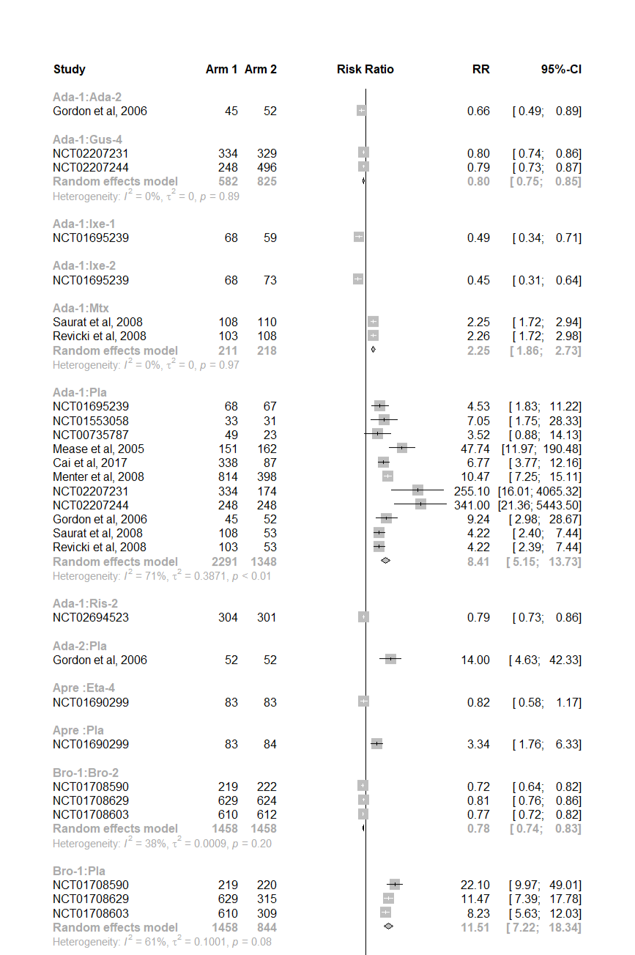
R2.1 Achieving 75% reduction on the PASI scale
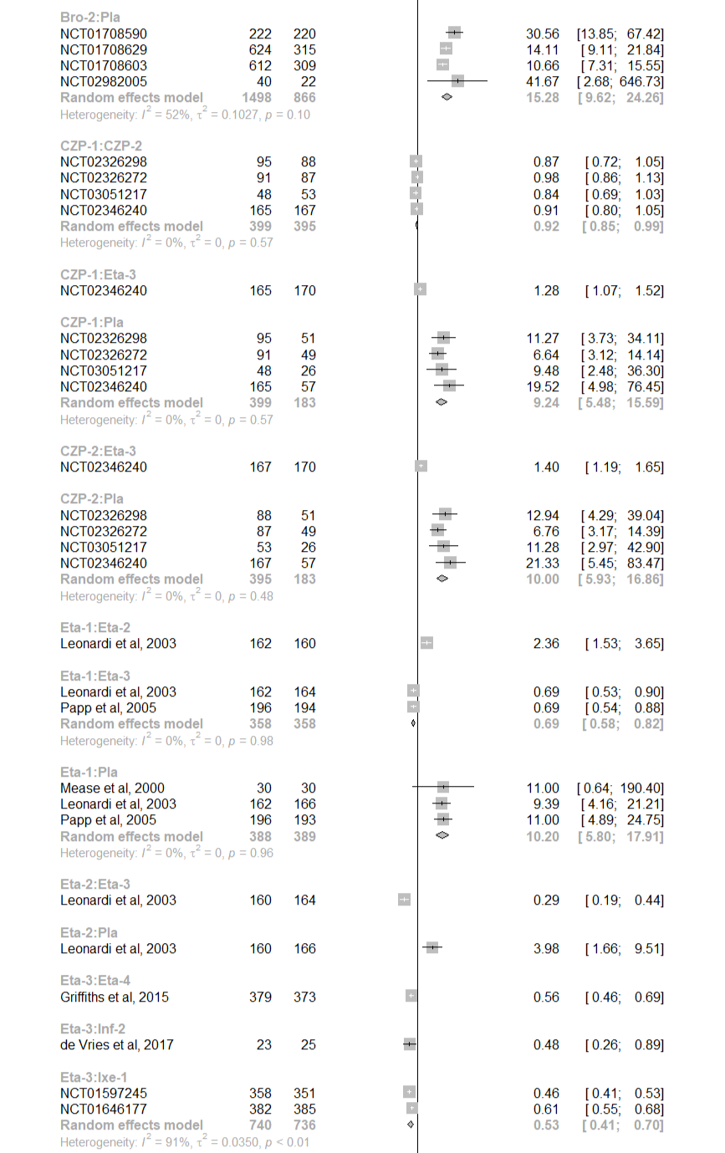

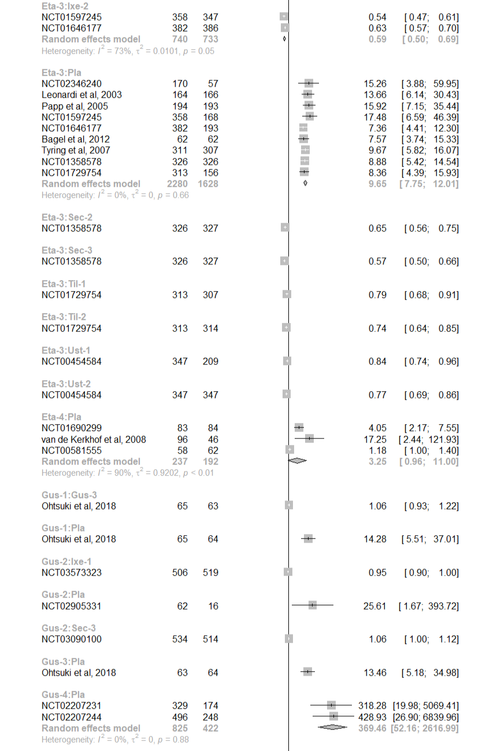

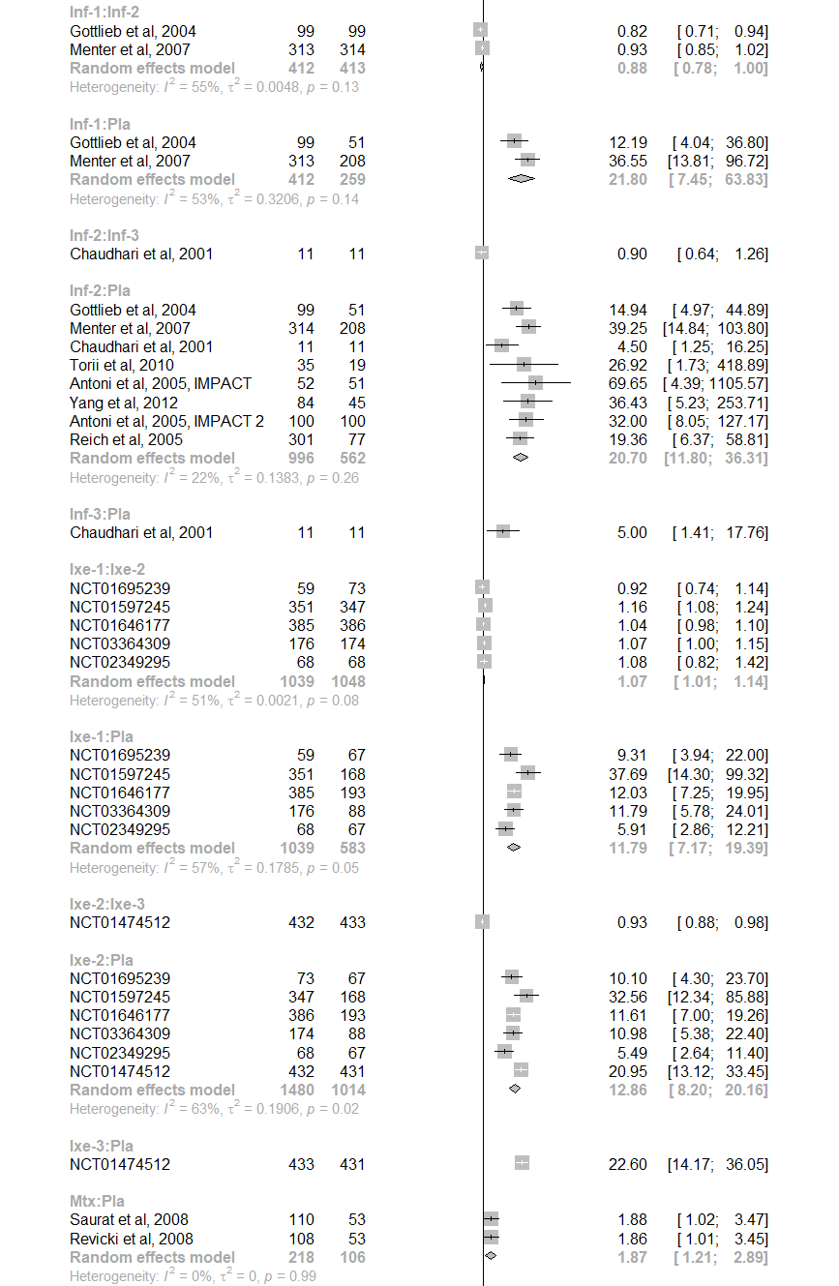
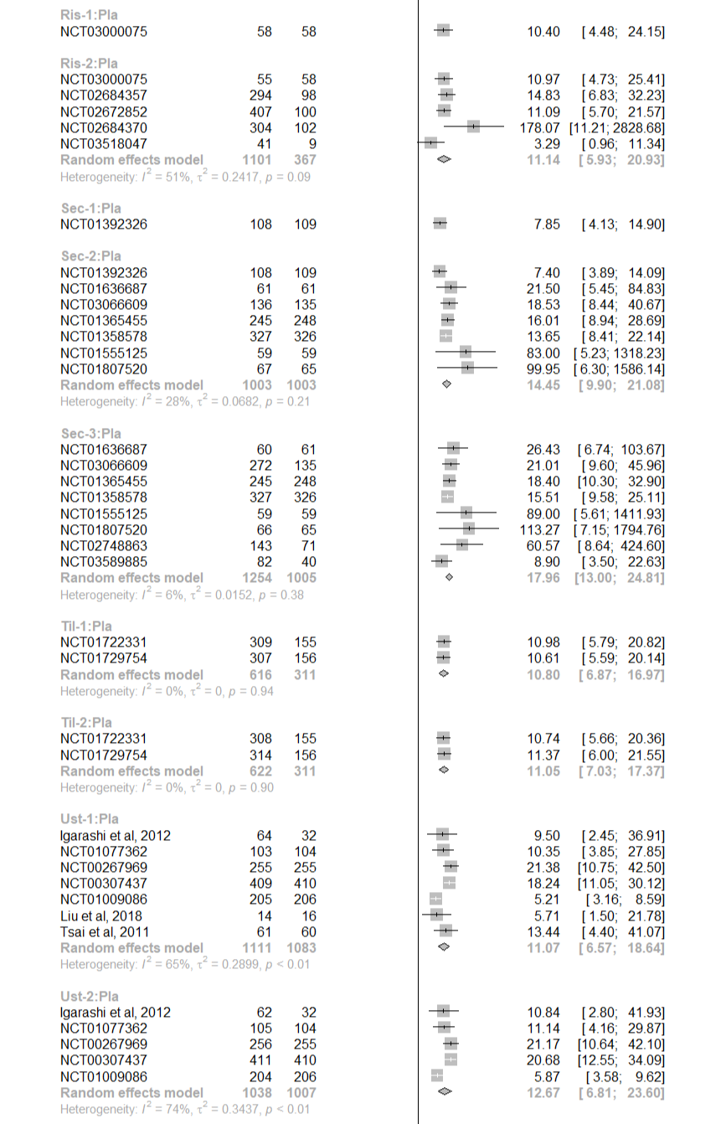
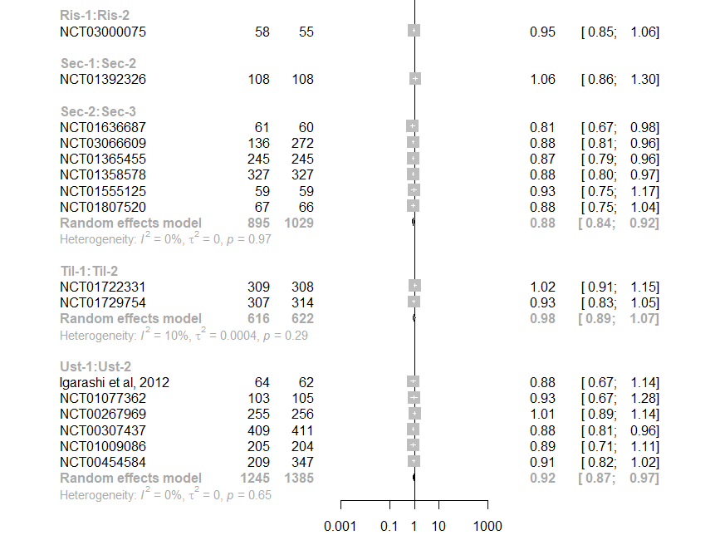

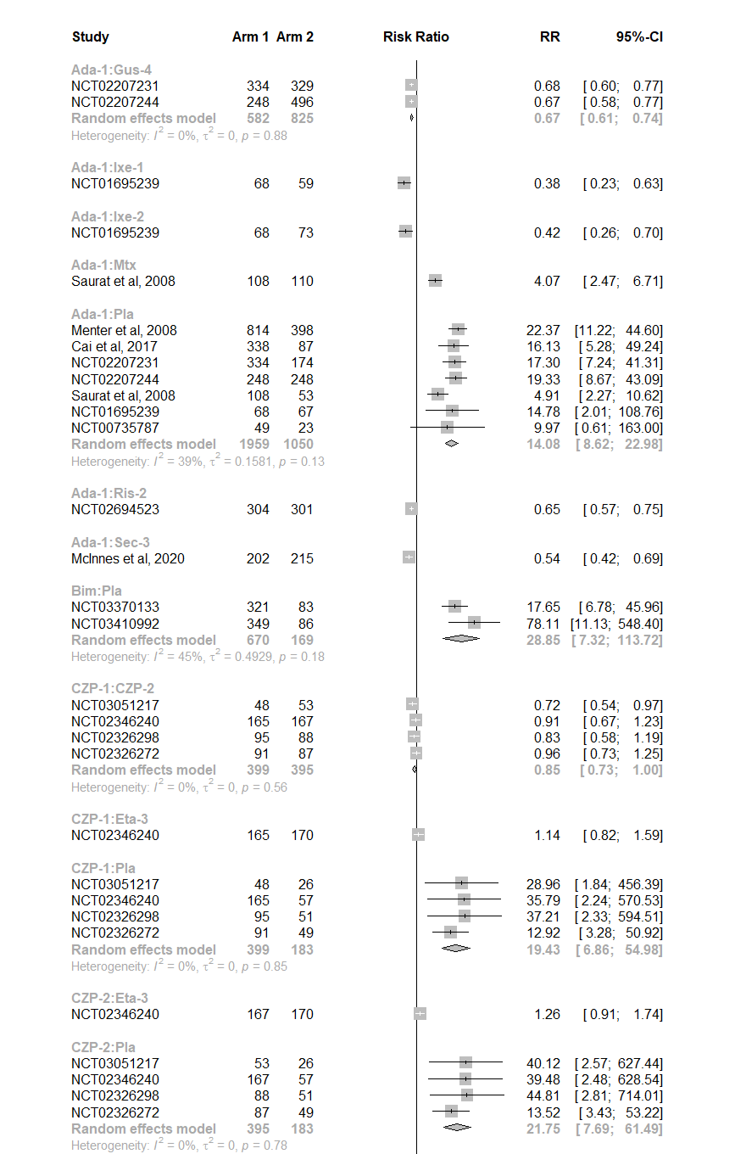
R2.2 Achieving 90% reduction on the PASI scale

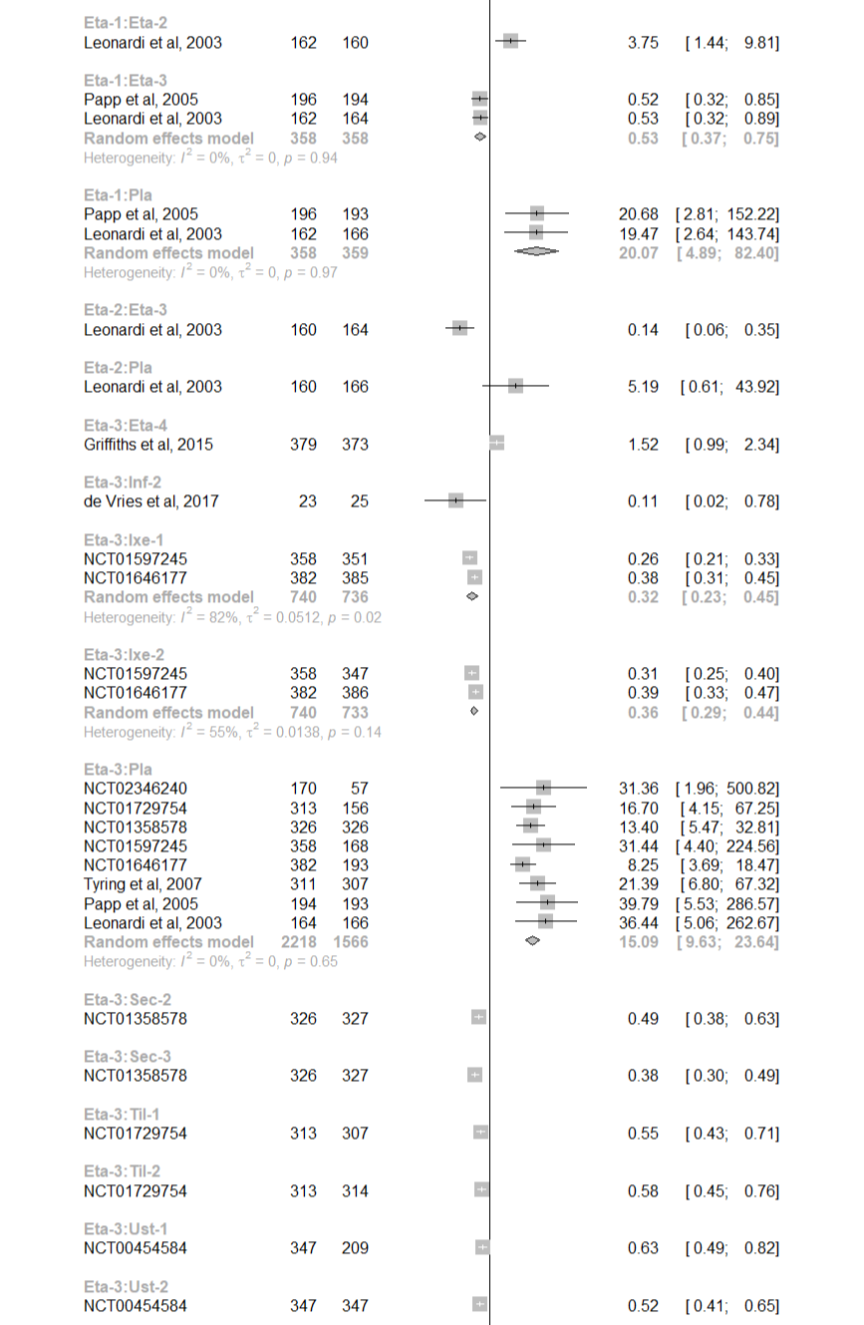
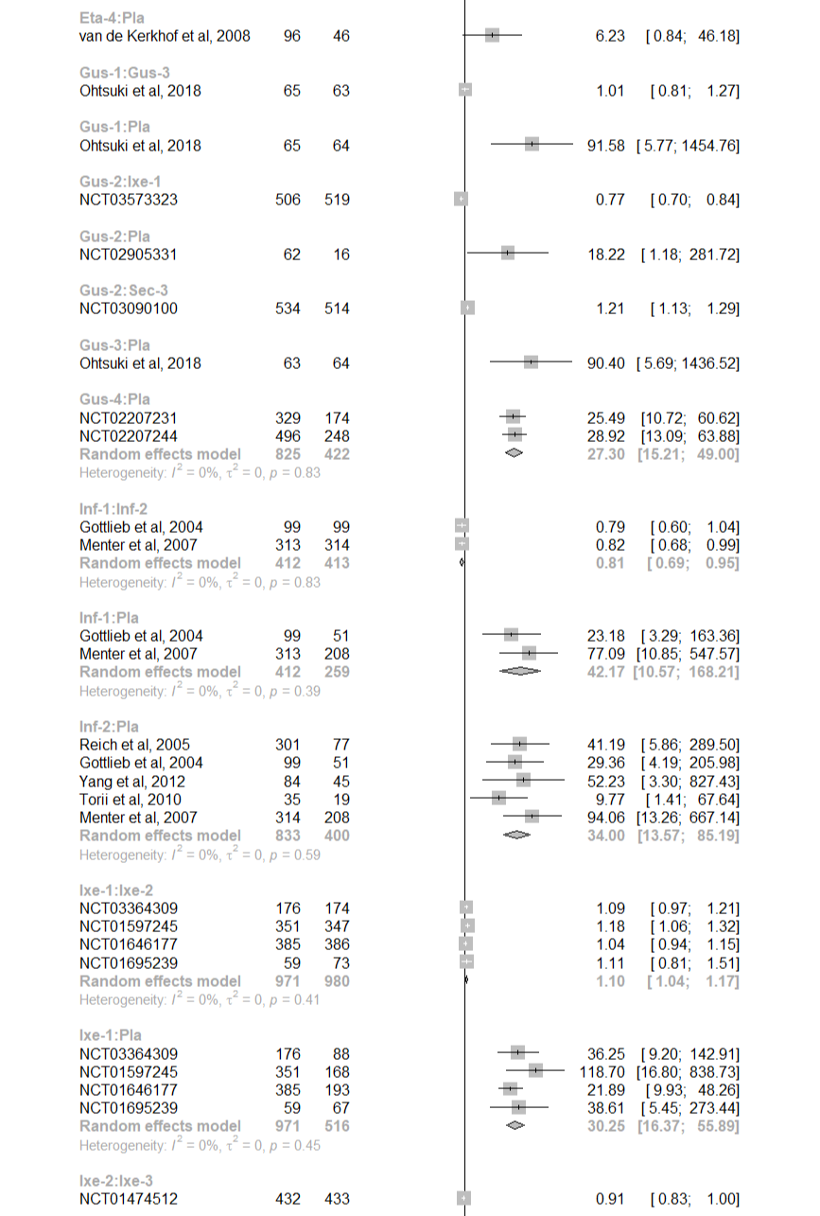

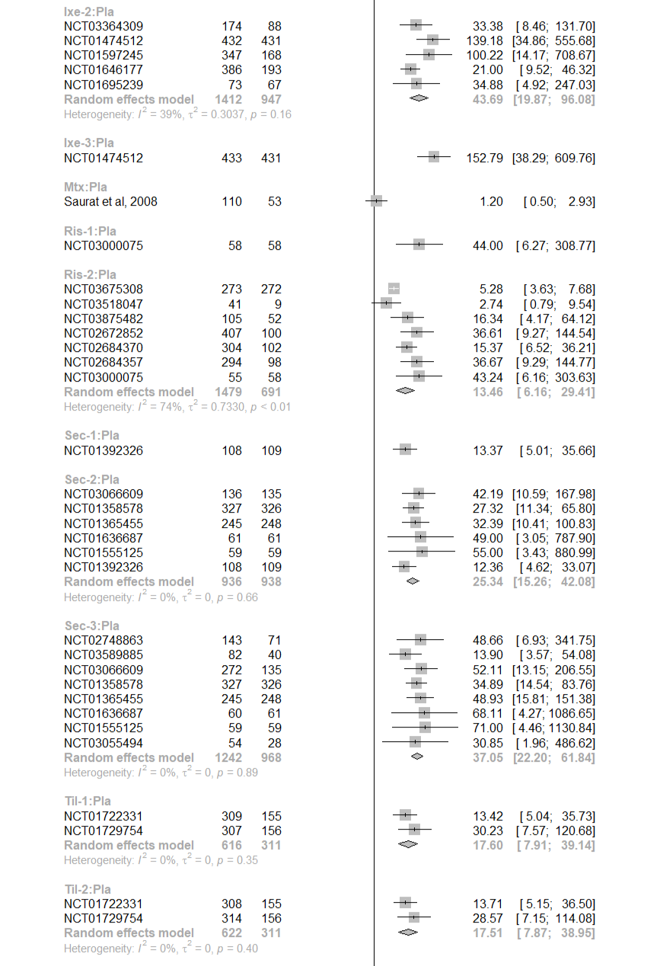

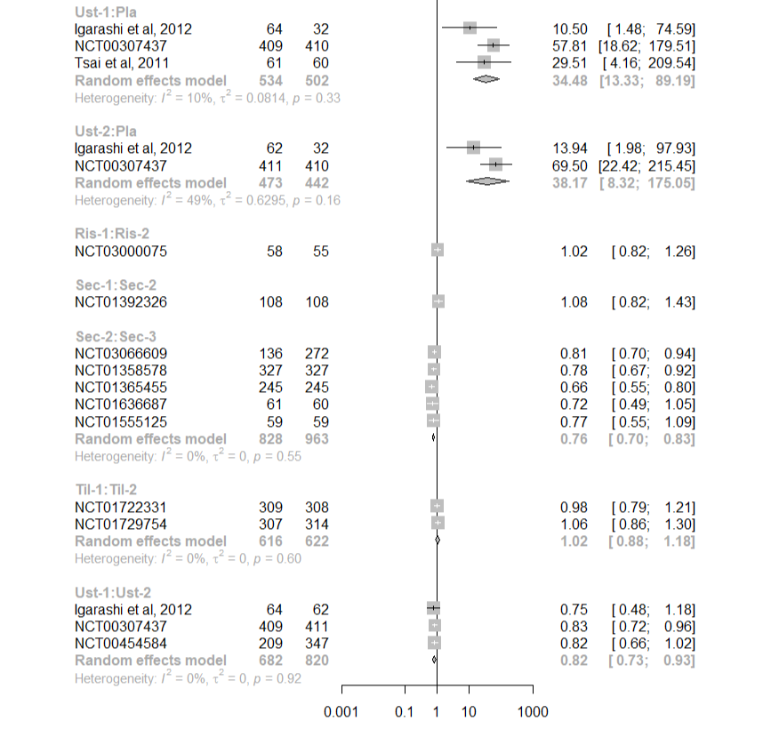

R2.3 Achieving 100% reduction on the PASI scale
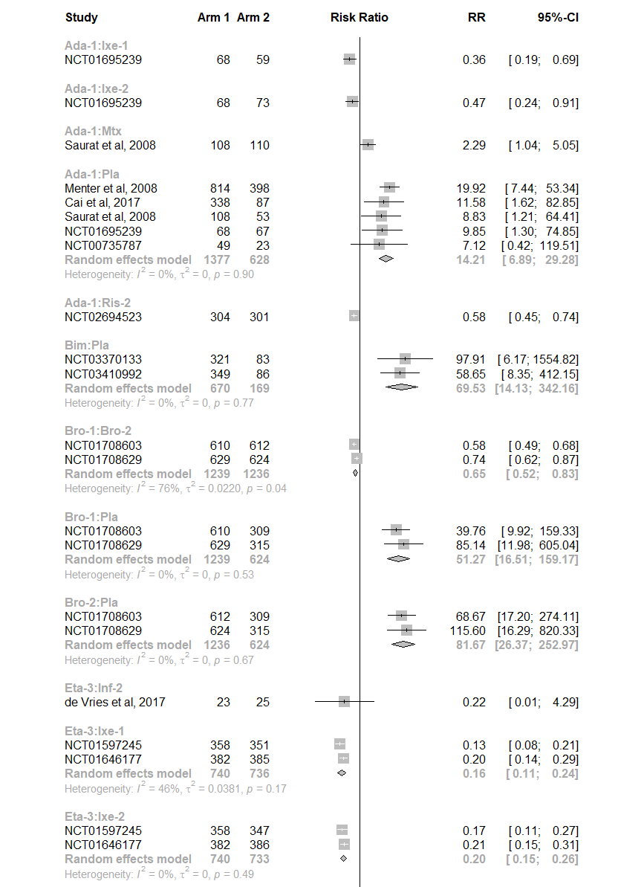

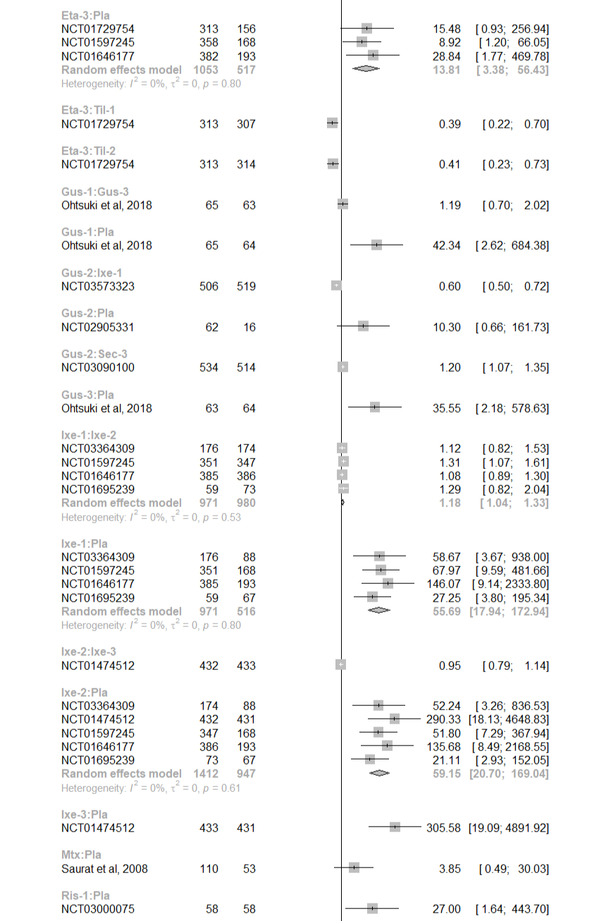
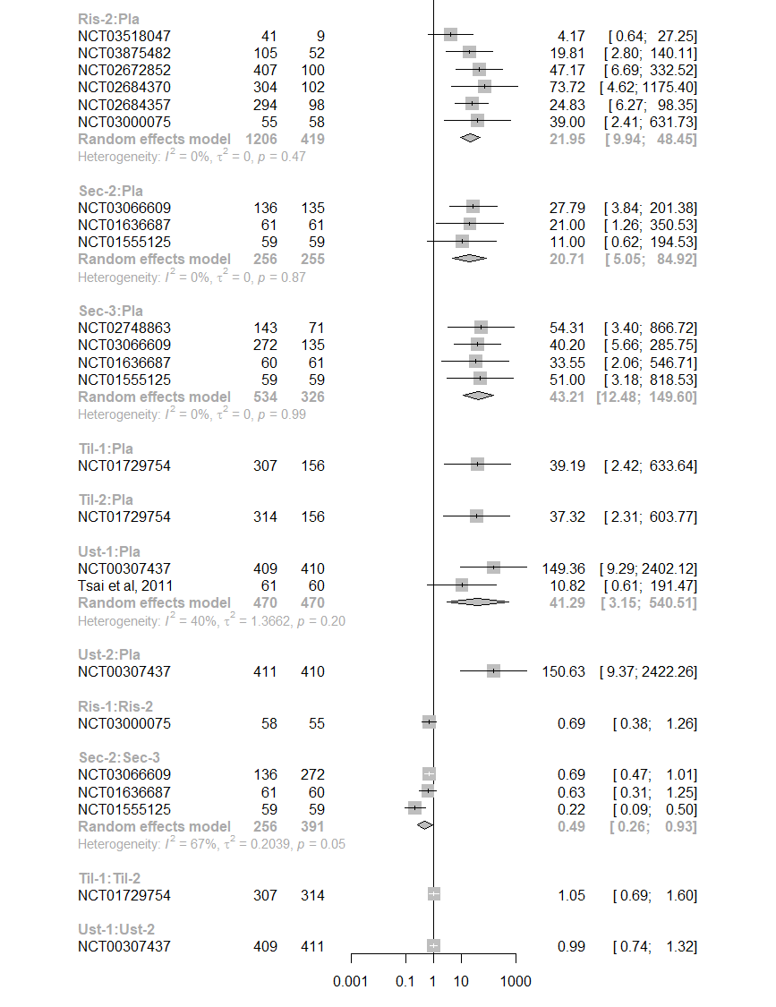
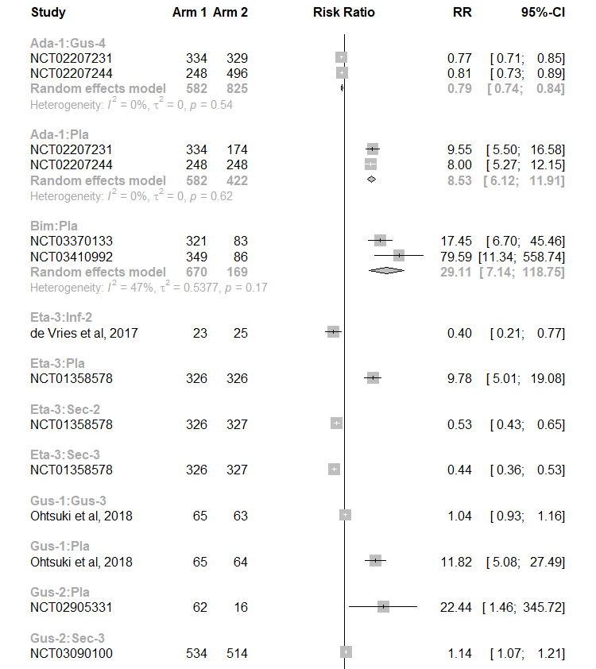
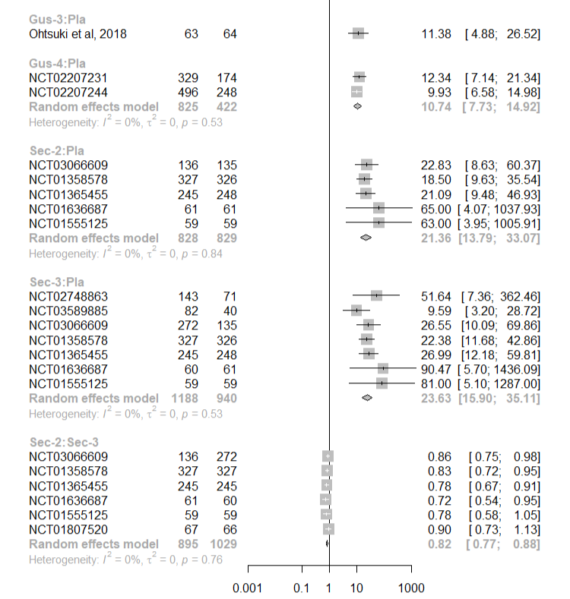
R2.4 Achieving IGA score of 0 or 1

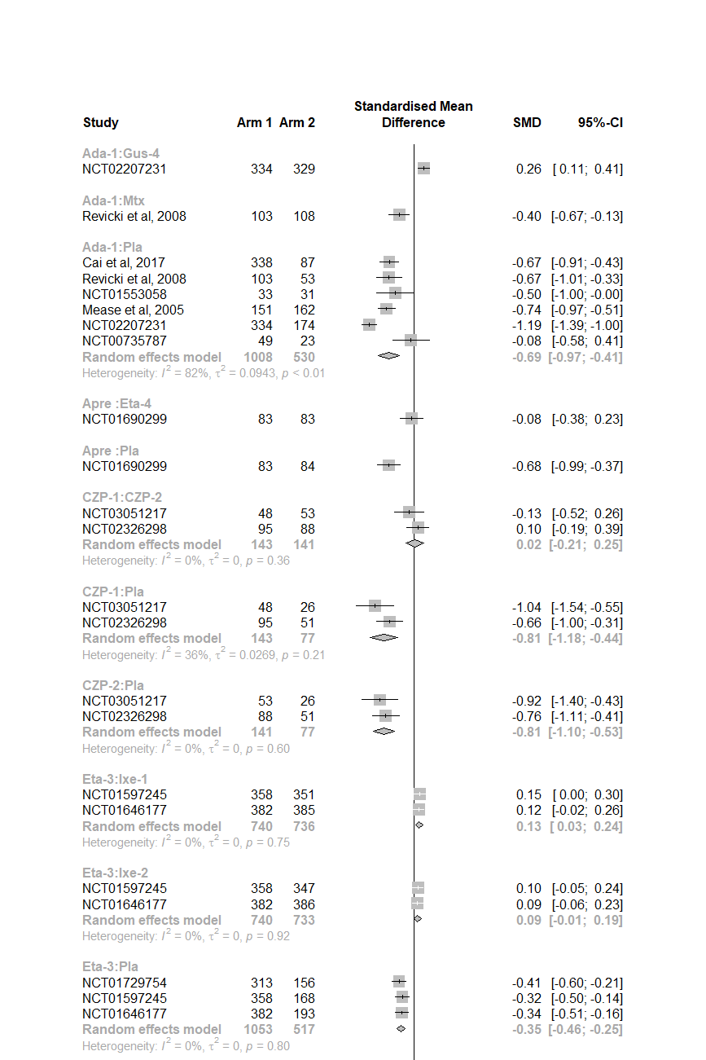
R2.5 Reduction in the Dermatology Life Quality Index

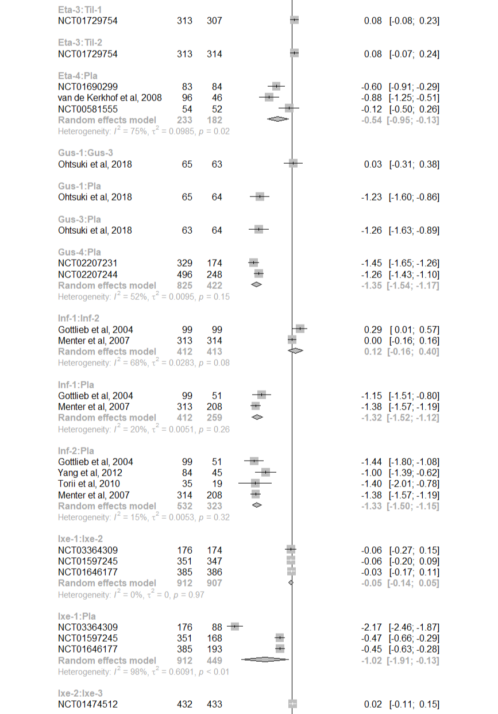
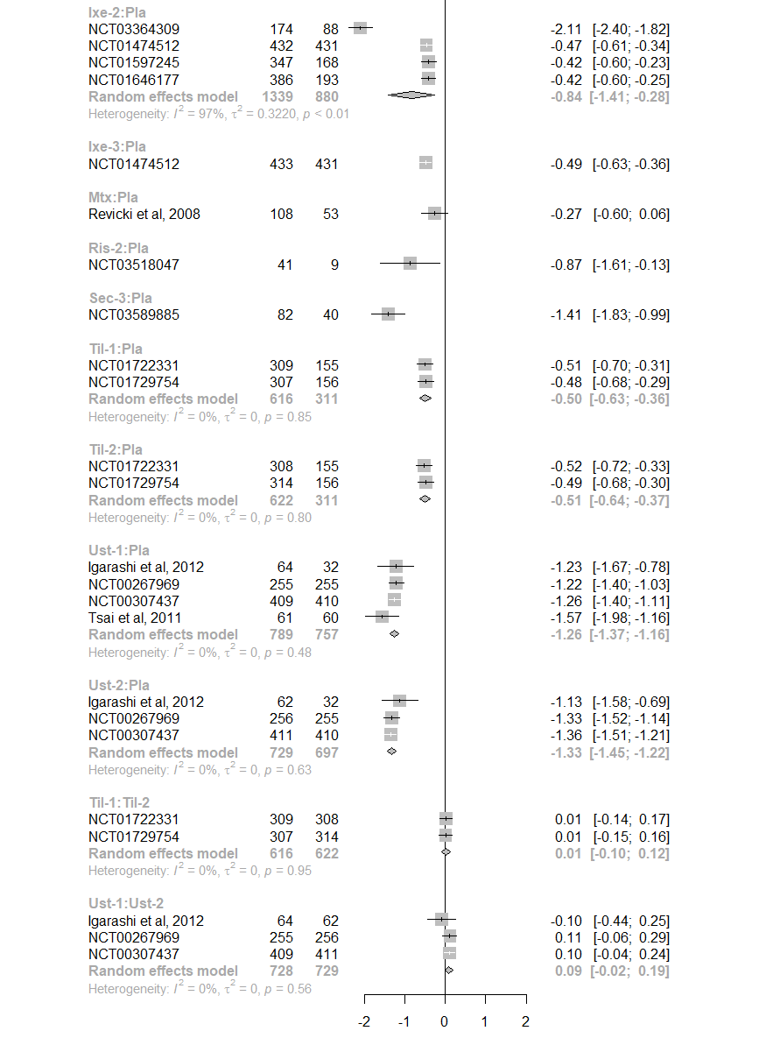
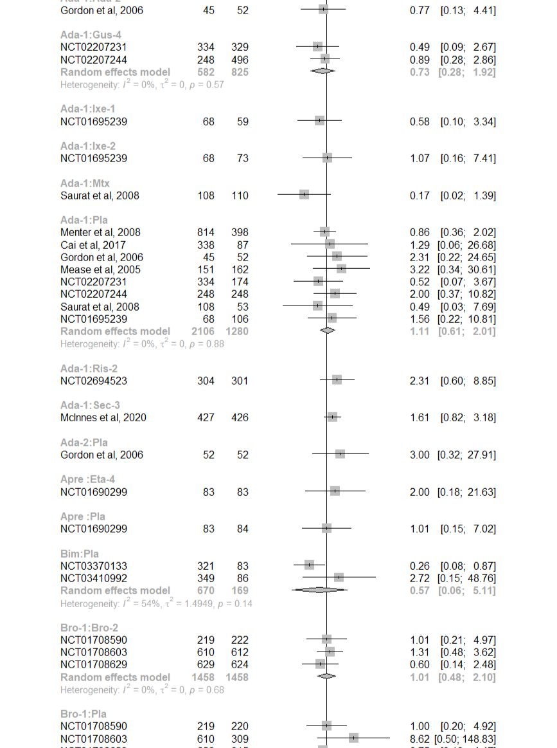
R2.6 Withdrawals due to adverse events

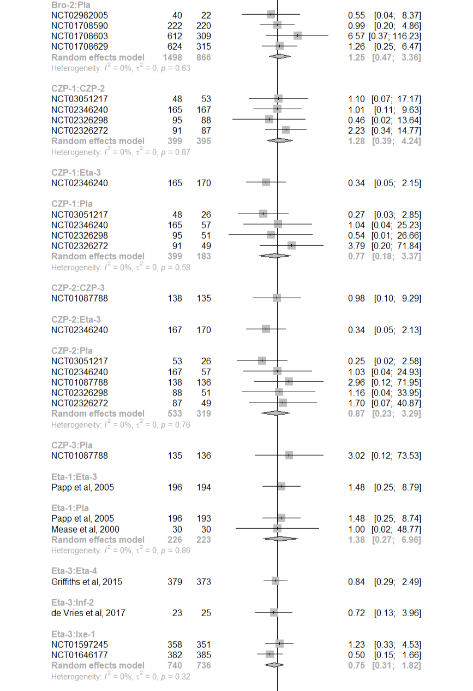

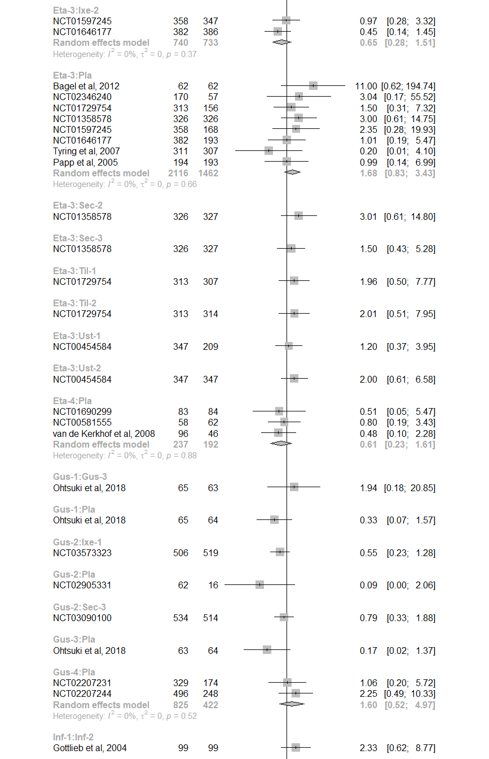

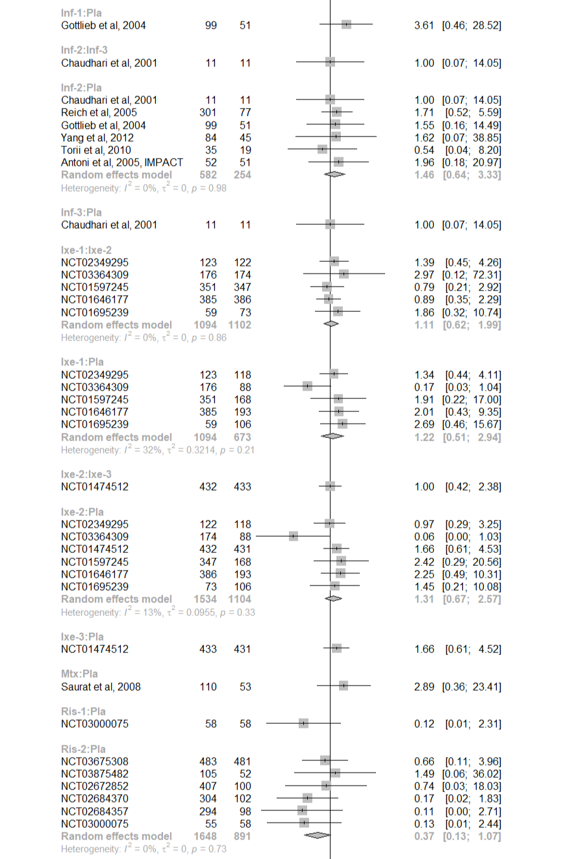
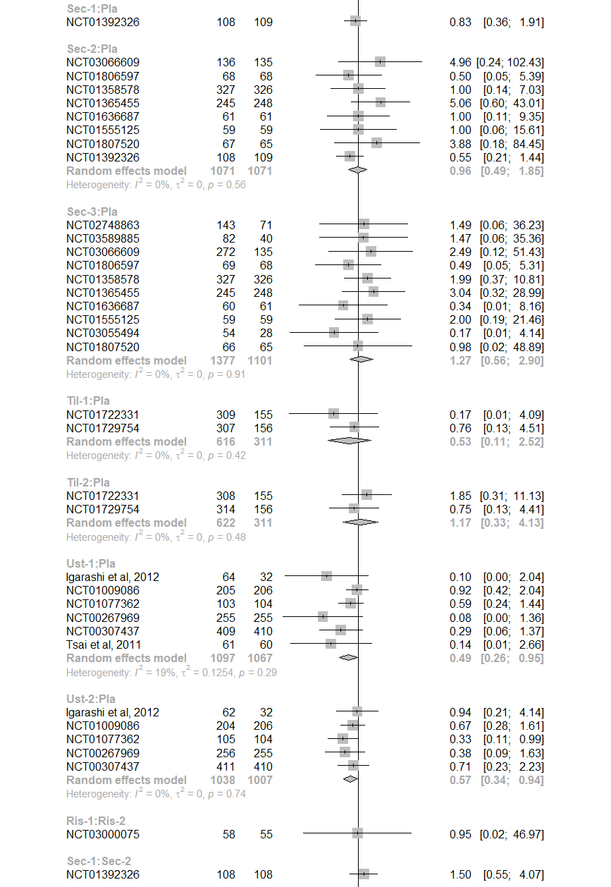
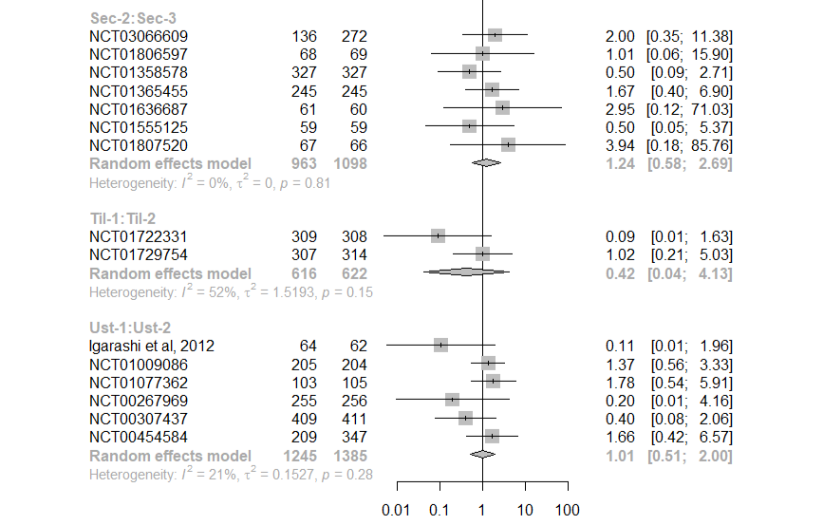

R3. Comparison-adjusted funnel plots
R3.1 Achieving 75% reduction on the PASI scale
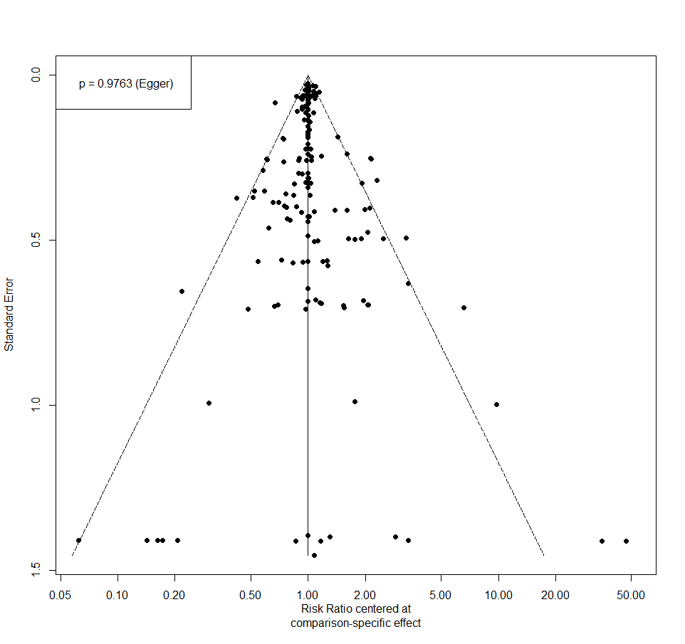
R3.2 Achieving 90% reduction on the PASI scale

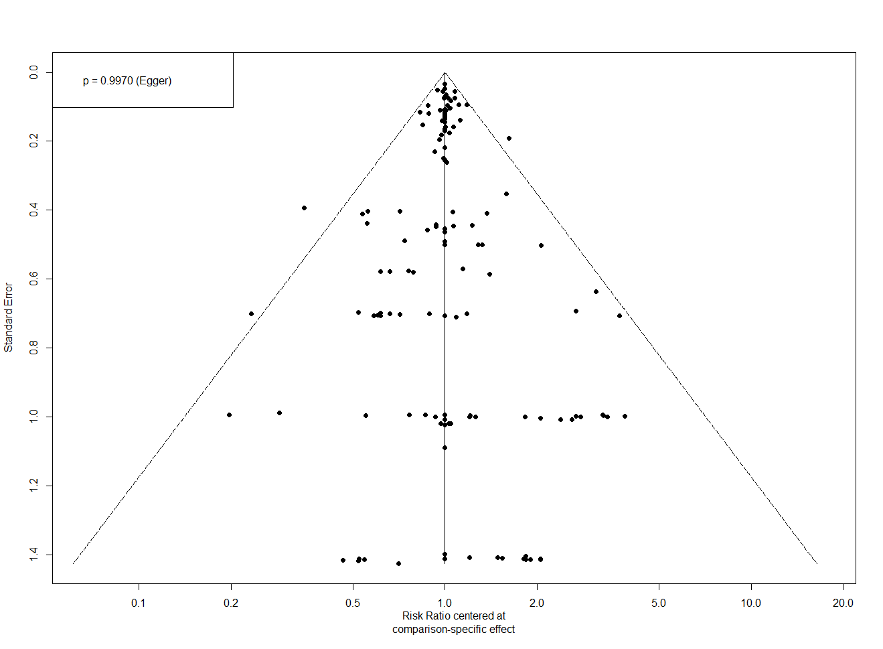
R3.3 Achieving 100% reduction on the PASI scale
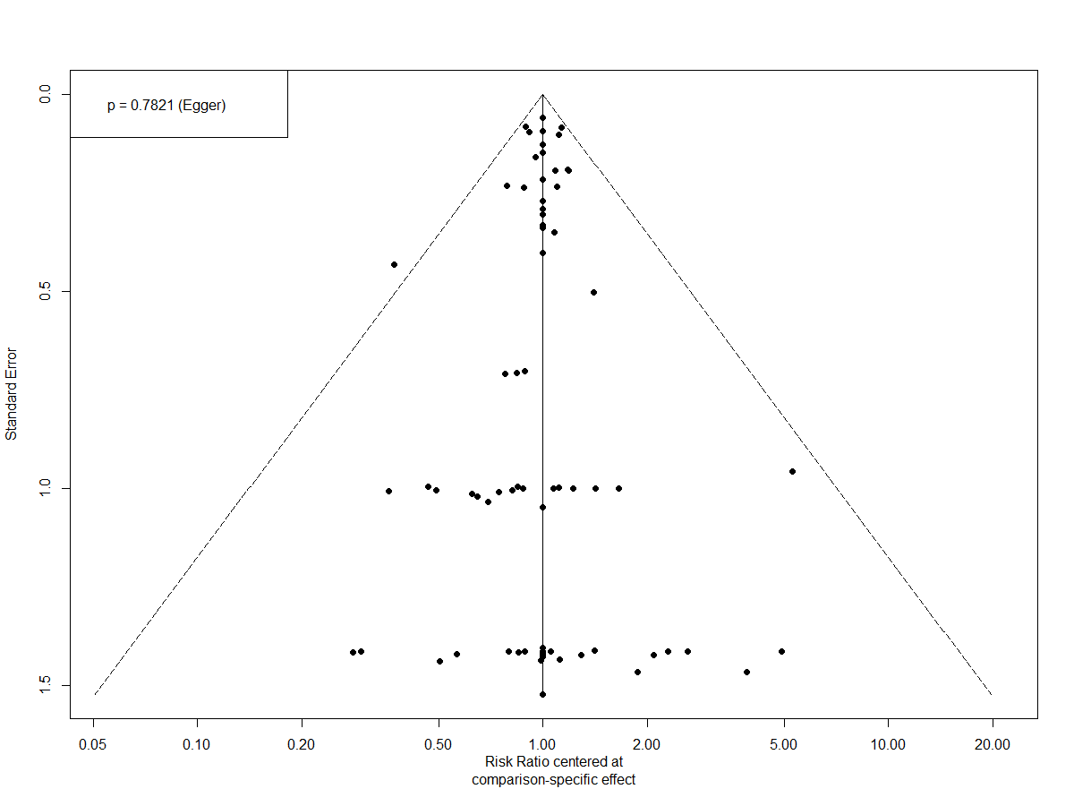
R3.4 Achieving IGA score of 0 or 1
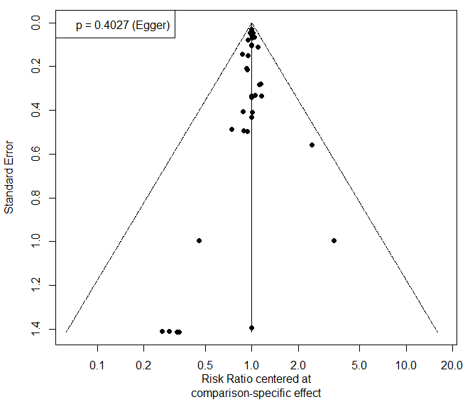

R3.5 Reduction in the Dermatology Life Quality Index
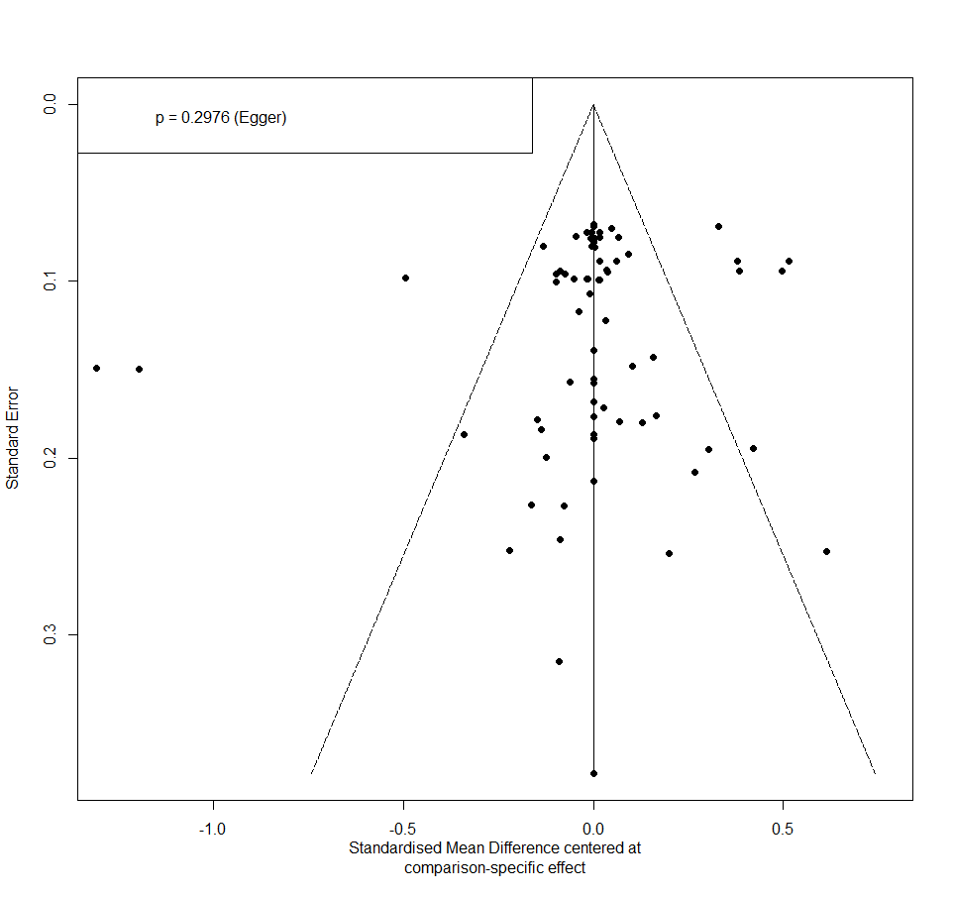

R3.6 Withdrawals due to adverse events

