Current Dermatology Reports

Short Term Efficacy of Biological Treatment for Moderate-to-Severe Plaque Psoriasis: A Systematic Review and Network Meta-Analysis
O. Ismail¹*, K. Jaber¹, Y. Jaber¹, U. Froukh¹, A. Younis¹, K. Albdour¹, Y. Momani¹, N. Almaani²
- School of Medicine, University of Jordan, Jordan
- Department of Dermatology, School of Medicine, University of Jordan, Jordan
* Corresponding author details:
Email: omar.moh.isml@gmail.com
Phone number: 00962791301329
Address: School of Medicine, University of Jordan, Amman 11972, Jordan

Contents
Abbreviations 3
Characteristics of included studies 5
Trial-level data for each outcome 9
Risk of bias assessment 23
References 34

Abbreviations
Abbreviation | Term
Pla | Placebo
Ada-1 | Adalimumab - 40mg Q2W
Ada-2 | Adalimumab - 40mg QW
Apre | Apremilast
Bim | Bimekizumab - 320mg Q4W
Bro-1 | Brodalumab - 140mg Q2W
Bro-2 | Brodalumab - 210mg Q2W
CZP-1 | Certolizumab Pegol - 200mg Q2W
CZP-2 | Certolizumab Pegol - 400mg Q2W
CZP-3 | Certolizumab Pegol - 400mg Q4W
Eta-1 | Etanercept - 25mg BIW
Eta-2 | Etanercept - 25mg QW
Eta-3 | Etanercept - 50mg BIW
Eta-4 | Etanercept - 50mg QW
Gus-1 | Guselkumab - 50mg at weeks 0,4,8
Gus-2 | Guselkumab - 100mg at weeks 0,4
Gus-3 | Guselkumab - 100mg at weeks 0,4,8
Gus-4 | Guselkumab - 100mg at weeks 0,4,12
Gus-5 | Guselkumab - 100mg Q4W
Gus-6 | Guselkumab - 100mg Q8W
Inf-1 | Infliximab - 3mg/kg at weeks 0,2,6
Inf-2 | Infliximab - 5mg/kg at weeks 0,2,6
Inf-3 | Infliximab - 10mg/kg at weeks 0,2,6
Ixe-1 | Ixekizumab - 80mg Q2W
Ixe-2 | Ixekizumab - 80mg Q4W
Ixe-3 | Ixekizumab - 160mg Q4W
Mtx | Methotrexate
Ris-1 | Risankizumab - 75mg at weeks 0,4
Ris-2 | Risankizumab - 150mg at weeks 0,4
Sec-1 | Secukinumab - 75mg Q4W
Sec-2 | Secukinumab - 150mg Q4W
Sec-3 | Secukinumab - 300mg Q4W
Til-1 | Tildrakizumab - 100mg at weeks 0,4
Til-2 | Tildrakizumab - 200mg at weeks 0,4
Ust-1 | Ustekinumab - 45mg at weeks 0,4
Ust-2 | Ustekinumab - 90mg at weeks 0,4
PASI | Psoriasis area severity index
IGA | Investigator global assessment
DLQI | Dermatology life quality index
AE | Adverse event
PsA | Psoriatic arthritis

Characteristics of included studies
Trial | Year of completion | Continent | Duration of follow up | Sample Size | Male:Female Ratio | Psoriasis type | Sponsor
Menter et al, 2008¹ | 2008 | North America | 16 weeks | 1212 | 1.96 | Moderate-Severe | Abbott
Chaudhari et al, 2001² | 2001 | North America | 10 weeks | 22 | 2.14 | Moderate-Severe | Centocor
Reich et al, 2005³ | 2005 | North America | 24 weeks | 378 | 2.44 | Moderate-Severe | Centocor
Cai et al, 2017⁴ | 2016 | Asia | 12 weeks | 425 | 2.76 | Moderate-Severe | AbbVie
Igarashi et al, 2012⁵ | 2012 | Asia | 12 weeks | 158 | 4.65 | Moderate-Severe | Janssen Pharmaceutical
Gordon et al, 2006⁶ | 2006 | North America | 12 weeks | 147 | 2.06 | Moderate-Severe | Abbott
Gottlieb et al, 2004⁷ | 2003 | North America | 10 weeks | 249 | 2.32 | Severe | Centocor
Bagel et al, 2012⁸ | 2011 | North America | 12 weeks | 124 | 1.25 | Moderate-Severe + Scalp involvement | Immunex
Revicki et al, 2008⁹ | 2007 | International | 16 weeks | 271 | 1.90 | Moderate-Severe | Abbott
Yang et al, 2012¹⁰ | 2012 | Asia | 10 weeks | 129 | 2.79 | Moderate-Severe | None
Torii et al, 2010¹¹ | 2010 | Asia | 10 weeks | 54 | 2.00 | Moderate-Severe + PsA | None
Antoni et al, 2005¹² | 2004 | International | 16 weeks | 104 | 1.36 | Mild-Severe + PsA | Centocor and Schering-Plough
NCT01553058 | 2012 | North America | 12 weeks | 64 | 2.20 | Moderate-Severe | University of Pennsylvania
NCT01722331 | 2018 | International | 12 weeks | 772 | 2.23 | Moderate-Severe | Sun Pharmaceutical Industries Limited
Mease et al, 2005¹³ | 2005 | International | 24 weeks | 313 | 1.25 | Moderate-Severe + PsA | Abbott
NCT03675308 | 2020 | International | 24 weeks | 964 | 1.02 | Moderate-Severe + PsA | AbbVie
NCT03518047 | 2020 | Asia | 16 weeks | 50 | 1.17 | Moderate-Severe + PsA | AbbVie
NCT03051217 | 2022 | Asia | 16 weeks | 127 | 3.54 | Moderate-Severe | UCB Biopharma S.P.R.L.
NCT02207231 | 2017 | International | 16 weeks | 837 | 2.66 | Moderate-Severe | Janssen Research & Development, LLC
NCT02349295 | 2016 | International | 12 weeks | 363 | 0.87 | Moderate-Severe + PsA | Eli Lilly and Company
NCT02207244 | 2015 | International | 16 weeks | 992 | 2.31 | Moderate-Severe | Janssen Research & Development, LLC
NCT03364309 | 2020 | Asia | 12 weeks | 438 | 3.25 | Moderate-Severe | Eli Lilly and Company
NCT02748863 | 2017 | International | 12 weeks | 214 | 1.64 | Moderate-Severe | Novartis Pharmaceuticals
NCT03875482 | 2020 | International | 16 weeks | 157 | 1.24 | Moderate-Severe | AbbVie
NCT02982005 | 201 | Asia | 12 weeks | 62 | 1.58 | Moderate-Severe | Kyowa Kirin Korea Co., Ltd.
NCT02346240 | 2016 | International | 16 weeks | 559 | 2.14 | Moderate-Severe | UCB Biopharma S.P.R.L.
NCT02672852 | 2017 | International | 16 weeks | 507 | 2.36 | Moderate-Severe | AbbVie
NCT02684370 | 2016 | International | 16 weeks | 506 | 2.49 | Moderate-Severe | AbbVie
NCT02684357 | 2016 | International | 16 weeks | 491 | 2.17 | Moderate-Severe | AbbVie
NCT01729754 | 2021 | International | 12 weeks | 1090 | 2.50 | Moderate-Severe | Sun Pharmaceutical Industries Limited
Menter et al, 2007¹⁴ | 2006 | International | 10 weeks | 835 | 1.97 | Moderate-Severe | Centocor, Inc.
Antoni et al, 2005¹⁵ | 2005 | International | 14 weeks | 200 | 1.56 | Moderate-Severe + PsA | Centocor, Inc.
NCT03370133 | 2019 | International | 16 weeks | 567 | 2.52 | Moderate-Severe | UCB Biopharma SRL
NCT03410992 | 2020 | International | 16 weeks | 435 | 2.57 | Moderate-Severe | UCB Biopharma SRL
McInnes et al, 2020¹⁶ | 2019 | International | 12 weeks | 853 | 1.05 | Any degree of psoriasis + PsA | Novartis Pharmaceuticals
NCT03589885 | 2020 | International | 12 weeks | 122 | 2.30 | Moderate-Severe | Novartis Pharmaceuticals
NCT03066609 | 2018 | International | 12 weeks | 543 | 3.15 | Moderate-Severe | Novartis Pharmaceuticals
NCT02905331 | 2018 | International | 12 weeks | 78 | 2.12 | Moderate-Severe | Janssen Research & Development, LLC
Ohtsuki et al, 2018¹⁷ | 2016 | Asia | 16 weeks | 192 | 3.09 | Moderate-Severe | Janssen Pharmaceutical
NCT01087788 | 2015 | International | 16 weeks | 409 | 0.81 | Moderate-Severe + PsA | UCB BIOSCIENCES GmbH
NCT03000075 | 2017 | Asia | 16 weeks | 171 | 5.11 | Moderate-Severe | AbbVie
NCT02694523 | 2017 | International | 16 weeks | 605 | 2.31 | Moderate-Severe | AbbVie
NCT01752634 | 2014 | International | 16 weeks | 397 | 0.94 | Moderate-Severe + PsA | Novartis Pharmaceuticals
NCT01690299 | 2016 | International | 16 weeks | 250 | 1.69 | Moderate-Severe | Amgen
Griffiths et al, 2015¹⁸ | 2008 | International | 12 weeks | 752 | 1.70 | Moderate-Severe + PsA | Wyeth Research
NCT01806597 | 2016 | International | 16 weeks | 205 | 1.20 | Moderate-Severe | Novartis Pharmaceuticals
van de Kerkhof et al, 2008¹⁹ | 2008 | International | 12 weeks | 143 | 1.42 | Moderate-Severe | Wyeth Pharmaceuticals
NCT01009086 | 2014 | North America | 24 weeks | 615 | 1.16 | Moderate-Severe + PsA | Janssen Research & Development, LLC
NCT01077362 | 2014 | North America | 24 weeks | 312 | 0.90 | Moderate-Severe + PsA | Janssen Research & Development, LLC
Saurat et al, 2008²⁰ | 2005 | North America | 16 weeks | 271 | 1.91 | Moderate-Severe | Abbott Laboratories
NCT01708590 | 2020 | North America | 12 weeks | 661 | 2.73 | Moderate-Severe | Bausch Health Americas, Inc.
NCT03090100 | 2019 | North America | 12 weeks | 1048 | 2.07 | Moderate-Severe | Janssen Research & Development, LLC
de Vries et al, 2017²¹ | 2008 | Europe | 24 Weeks | 48 | 1.82 | Moderate-Severe | Netherlands Organization for Scientific Research-Medical Sciences
NCT00267969 | 2012 | North America | 12 weeks | 766 | 2.26 | Moderate-Severe | Centocor Research & Development, Inc.
NCT00307437 | 2012 | North America | 12 weeks | 1230 | 2.15 | Moderate-Severe | Centocor Research & Development, Inc.
NCT01708603 | 2020 | North America | 12 weeks | 1831 | 2.20 | Moderate-Severe | Bausch Health Americas, Inc.
NCT01708629 | 2020 | North America | 12 Weeks | 1881 | 2.17 | Moderate-Severe | Bausch Health Americas, Inc.
NCT01358578 | 2015 | Europe | 12 Weeks | 1306 | 2.46 | Moderate-Severe | Novartis Pharmaceuticals
NCT01365455 | 2015 | Europe | 12 Weeks | 738 | 2.22 | Moderate-Severe | Novartis Pharmaceuticals
NCT01636687 | 2018 | Europe | 12 weeks | 182 | 2.19 | Moderate-Severe | Novartis Pharmaceuticals
NCT01555125 | 2018 | Europe | 12 weeks | 177 | 1.95 | Moderate-Severe | Novartis Pharmaceuticals
NCT01474512 | 2016 | International | 12 Weeks | 1296 | 2.14 | Moderate-Severe | Eli Lilly and Company
NCT01597245 | 2016 | International | 12 Weeks | 1224 | 2.04 | Moderate-Severe | Eli Lilly and Company
NCT01646177 | 2016 | International | 12 Weeks | 1346 | 2.14 | Moderate-Severe | Eli Lilly and Company
NCT01695239 | 2016 | International | 12 weeks | 417 | 0.85 | Moderate-Severe + PsA | Eli Lilly and Company
NCT02326298 | 2018 | International | 16 Weeks | 234 | 2.25 | Moderate-Severe | UCB Biopharma S.P.R.L.
NCT02326272 | 2018 | International | 16 Weeks | 227 | 1.27 | Moderate-Severe | UCB Biopharma S.P.R.L.
NCT03573323 | 2020 | International | 12 weeks | 1027 | 1.74 | Moderate-Severe | Eli Lilly and Company
NCT00735787 | 2010 | North America | 16 Weeks | 72 | 0.67 | Moderate-Severe + Hand and Feet involvement | Abbott
NCT03055494 | 2020 | North America | 12 Weeks | 82 | 1.73 | Moderate-Severe | Novartis Pharmaceuticals
NCT01807520 | 2018 | International | 16 Weeks | 198 | 4.21 | Moderate-Severe + nail involvement | Novartis Pharmaceuticals
NCT00581555 | 2012 | Europe | 12 weeks | 120 | 2.24 | Moderate-Severe who have achieved an adequate response with ciclosporin | Pfizer
Tsai et al, 2011²² | 2010 | Asia | 12 Weeks | 121 | 5.72 | Moderate-Severe | Centocor, Inc.
NCT00454584 | 2010 | International | 12 Weeks | 903 | 2.11 | Moderate-Severe | Centocor, Inc.
Reich et al, 2009²³ | 2009 | Europe | 12 Weeks | 142 | 1.45 | Moderate-Severe | Wyeth Research
Feldman et al, 2005²⁴ | 2005 | North America | 12 Weeks | 652 | 1.86 | Severe | Amgen Inc and its subsidiaries
Tyring et al, 2007²⁵ | 2005 | North America | 12 Weeks | 618 | 2.09 | Moderate-Severe | Immunex Corporation
Papp et al, 2005²⁶ | 2003 | International | 12 Weeks | 583 | 1.90 | Severe | Immunex Corporation
Leonardi et al, 2003²⁷ | 2003 | North America | 12 Weeks | 652 | 2.05 | Severe | Immunex Corporation
Krueger et al, 2005²⁸ | 2005 | International | 12 Weeks | 583 | 1.89 | Severe | None
Mease et al, 2000²⁹ | 2000 | North America | 12 Weeks | 60 | 1.31 | Moderate-Severe + PsA | Immunex Corporation
NCT01392326 | 2016 | International | 24 Weeks | 606 | 0.83 | Moderate-Severe + PsA | Novartis Pharmaceuticals
Liu et al, 2018³⁰ | 2019 | Asia | 12 weeks | 30 | 3.29 | Moderate-Severe | National Natural Science Foundation of China and Zhejiang Provincial Health Technology Planning Project

Trial-level data for each outcome
S3.1 Achieving 75% reduction on the PASI scale
Trial | Arm 1 | n 1 | Events 1 | Arm 2 | n 2 | Events 2 | Arm 3 | n 3 | Events 3 | Arm 4 | n 4 | Events 4
NCT02346240 | CZP-2 | 167 | 125 | CZP-1 | 165 | 113 | Eta-3 | 170 | 91 | Pla | 57 | 2
Leonardi et al, 2003 | Eta-2 | 160 | 23 | Eta-1 | 162 | 55 | Eta-3 | 164 | 81 | Pla | 166 | 6
NCT01358578 | Sec-2 | 327 | 219 | Sec-3 | 327 | 249 | Eta-3 | 326 | 142 | Pla | 326 | 16
NCT01729754 | Til-2 | 314 | 206 | Til-1 | 307 | 188 | Eta-3 | 313 | 151 | Pla | 156 | 9
NCT01695239 | Ada-1 | 68 | 23 | Ixe-2 | 73 | 55 | Ixe-1 | 59 | 41 | Pla | 67 | 5
NCT01597245 | Eta-3 | 358 | 149 | Ixe-2 | 347 | 269 | Ixe-1 | 351 | 315 | Pla | 168 | 4
NCT01646177 | Eta-3 | 382 | 204 | Ixe-2 | 386 | 325 | Ixe-1 | 385 | 336 | Pla | 193 | 14
NCT02207231 | Ada-1 | 334 | 244 | Gus-4 | 329 | 300 | Pla | 174 | 0
NCT02207244 | Ada-1 | 248 | 170 | Gus-4 | 496 | 428 | Pla | 248 | 0
Gordon et al, 2006 | Ada-2 | 52 | 42 | Ada-1 | 45 | 24 | Pla | 52 | 3
NCT01708590 | Bro-2 | 222 | 185 | Bro-1 | 219 | 132 | Pla | 220 | 6
NCT01708629 | Bro-2 | 624 | 531 | Bro-1 | 629 | 435 | Pla | 315 | 19
NCT01708603 | Bro-2 | 612 | 528 | Bro-1 | 610 | 406 | Pla | 309 | 25
NCT02326298 | CZP-1 | 95 | 63 | CZP-2 | 88 | 67 | Pla | 51 | 3
NCT02326272 | CZP-1 | 91 | 74 | CZP-2 | 87 | 72 | Pla | 49 | 6
NCT03051217 | CZP-2 | 53 | 46 | CZP-1 | 48 | 35 | Pla | 26 | 2
Papp et al, 2005 | Eta-3 | 194 | 96 | Eta-1 | 196 | 67 | Pla | 193 | 6
NCT01690299 | Eta-4 | 83 | 40 | Apre | 83 | 33 | Pla | 84 | 10
Ohtsuki et al, 2018 | Gus-1 | 65 | 58 | Gus-3 | 63 | 53 | Pla | 64 | 4
Gottlieb et al, 2004 | Inf-1 | 99 | 71 | Inf-2 | 99 | 87 | Pla | 51 | 3
Menter et al, 2007 | Inf-1 | 313 | 220 | Inf-2 | 314 | 237 | Pla | 208 | 4
Chaudhari et al, 2001 | Inf-2 | 11 | 9 | Inf-3 | 11 | 10 | Pla | 11 | 2
NCT03364309 | Ixe-1 | 176 | 165 | Ixe-2 | 174 | 152 | Pla | 88 | 7
NCT02349295 | Ixe-1 | 68 | 42 | Ixe-2 | 68 | 39 | Pla | 67 | 7
NCT01474512 | Ixe-2 | 432 | 357 | Ixe-3 | 433 | 386 | Pla | 431 | 17
Saurat et al, 2008 | Mtx | 110 | 39 | Ada-1 | 108 | 86 | Pla | 53 | 10
Revicki et al, 2008 | Mtx | 108 | 38 | Ada-1 | 103 | 82 | Pla | 53 | 10
NCT03000075 | Ris-2 | 55 | 52 | Ris-1 | 58 | 52 | Pla | 58 | 5
NCT01392326 | Sec-1 | 108 | 70 | Sec-2 | 108 | 66 | Pla | 109 | 9
NCT01636687 | Sec-2 | 61 | 43 | Sec-3 | 60 | 52 | Pla | 61 | 2
NCT03066609 | Sec-2 | 136 | 112 | Sec-3 | 272 | 254 | Pla | 135 | 6
NCT01365455 | Sec-2 | 245 | 174 | Sec-3 | 245 | 200 | Pla | 248 | 11
NCT01555125 | Sec-2 | 59 | 41 | Sec-3 | 59 | 44 | Pla | 59 | 0
NCT01807520 | Sec-2 | 67 | 51 | Sec-3 | 66 | 57 | Pla | 65 | 0
NCT01722331 | Til-1 | 309 | 197 | Til-2 | 308 | 192 | Pla | 155 | 9
Igarashi et al, 2012 | Ust-1 | 64 | 38 | Ust-2 | 62 | 42 | Pla | 32 | 2
NCT01077362 | Ust-1 | 103 | 41 | Ust-2 | 105 | 45 | Pla | 104 | 4
NCT00267969 | Ust-1 | 255 | 171 | Ust-2 | 256 | 170 | Pla | 255 | 8
NCT00307437 | Ust-1 | 409 | 273 | Ust-2 | 411 | 311 | Pla | 410 | 15
NCT01009086 | Ust-1 | 205 | 83 | Ust-2 | 204 | 93 | Pla | 206 | 16
NCT00454584 | Ust-2 | 347 | 256 | Eta-3 | 347 | 197 | Ust-1 | 209 | 141
NCT01553058 | Ada-1 | 33 | 15 | Pla | 31 | 2
NCT00735787 | Ada-1 | 49 | 15 | Pla | 23 | 2
Mease et al, 2005 | Ada-1 | 151 | 89 | Pla | 162 | 2
Cai et al, 2017 | Ada-1 | 338 | 263 | Pla | 87 | 10
Menter et al, 2008 | Ada-1 | 814 | 578 | Pla | 398 | 27
NCT02982005 | Bro-2 | 40 | 37 | Pla | 22 | 0
Mease et al, 2000 | Eta-1 | 30 | 5 | Pla | 30 | 0
Bagel et al, 2012 | Eta-3 | 62 | 53 | Pla | 62 | 7
Tyring et al, 2007 | Eta-3 | 311 | 147 | Pla | 307 | 15
Griffiths et al, 2015 | Eta-3 | 379 | 98 | Eta-4 | 373 | 171
van de Kerkhof et al, 2008 | Eta-4 | 96 | 36 | Pla | 46 | 1
NCT00581555 | Eta-4 | 58 | 52 | Pla | 62 | 47
NCT02905331 | Gus-2 | 62 | 48 | Pla | 16 | 0
NCT03090100 | Gus-2 | 534 | 452 | Sec-3 | 514 | 412
Torii et al, 2010 | Inf-2 | 35 | 24 | Pla | 19 | 0
Antoni et al, 2005 | Inf-2 | 52 | 35 | Pla | 51 | 0
Yang et al, 2012 | Inf-2 | 84 | 68 | Pla | 45 | 1
Antoni et al, 2005 | Inf-2 | 100 | 64 | Pla | 100 | 2
Reich et al, 2005 | Inf-2 | 301 | 227 | Pla | 77 | 3
de Vries et al, 2017 | Inf-2 | 25 | 18 | Eta-3 | 23 | 8
NCT03573323 | Ixe-1 | 519 | 453 | Gus-2 | 506 | 420
NCT02684357 | Ris-2 | 294 | 267 | Pla | 98 | 6
NCT02672852 | Ris-2 | 407 | 361 | Pla | 100 | 8
NCT02694523 | Ris-2 | 301 | 273 | Ada-1 | 304 | 218
NCT02684370 | Ris-2 | 304 | 264 | Pla | 102 | 0
NCT03518047 | Ris-2 | 41 | 30 | Pla | 9 | 2
NCT02748863 | Sec-3 | 143 | 122 | Pla | 71 | 1
NCT03589885 | Sec-3 | 82 | 73 | Pla | 40 | 4
Liu et al, 2018 | Ust-1 | 14 | 10 | Pla | 16 | 2
Tsai et al, 2011 | Ust-1 | 61 | 41 | Pla | 60 | 3

S3.2 Achieving 90% reduction on the PASI scale
Trial | Arm 1 | n 1 | Events 1 | Arm 2 | n 2 | Events 2 | Arm 3 | n 3 | Events 3 | Arm 4 | n 4 | Events 4
NCT02346240 | CZP-2 | 167 | 57 | CZP-1 | 165 | 51 | Eta-3 | 170 | 46 | Pla | 57 | 0
NCT01729754 | Til-2 | 314 | 115 | Til-1 | 307 | 119 | Eta-3 | 313 | 67 | Pla | 156 | 2
NCT01358578 | Sec-2 | 327 | 137 | Sec-3 | 327 | 175 | Eta-3 | 326 | 67 | Pla | 326 | 5
Leonardi et al, 2003 | Eta-2 | 160 | 5 | Eta-1 | 162 | 19 | Eta-3 | 164 | 36 | Pla | 166 | 1
NCT01597245 | Eta-3 | 358 | 67 | Ixe-2 | 347 | 207 | Ixe-1 | 351 | 248 | Pla | 168 | 1
NCT01646177 | Eta-3 | 382 | 98 | Ixe-2 | 386 | 252 | Ixe-1 | 385 | 262 | Pla | 193 | 6
NCT01695239 | Ada-1 | 68 | 15 | Ixe-2 | 73 | 38 | Ixe-1 | 59 | 34 | Pla | 67 | 1
Igarashi et al, 2012 | Ust-1 | 64 | 21 | Ust-2 | 62 | 27 | Pla | 32 | 1
Gottlieb et al, 2004 | Inf-1 | 99 | 45 | Inf-2 | 99 | 57 | Pla | 51 | 1
NCT01722331 | Til-1 | 309 | 107 | Til-2 | 308 | 109 | Pla | 155 | 4
NCT03051217 | CZP-2 | 53 | 40 | CZP-1 | 48 | 26 | Pla | 26 | 0
NCT02207231 | Ada-1 | 334 | 166 | Gus-4 | 329 | 241 | Pla | 174 | 5
NCT02207244 | Ada-1 | 248 | 116 | Gus-4 | 496 | 347 | Pla | 248 | 6
NCT03364309 | Ixe-1 | 176 | 145 | Ixe-2 | 174 | 132 | Pla | 88 | 2
Menter et al, 2007 | Inf-1 | 313 | 116 | Inf-2 | 314 | 142 | Pla | 208 | 1
NCT03066609 | Sec-2 | 136 | 85 | Sec-3 | 272 | 210 | Pla | 135 | 2
Ohtsuki et al, 2018 | Gus-1 | 65 | 46 | Gus-3 | 63 | 44 | Pla | 64 | 0
NCT03000075 | Ris-2 | 55 | 41 | Ris-1 | 58 | 44 | Pla | 58 | 1
Saurat et al, 2008 | Mtx | 110 | 15 | Ada-1 | 108 | 60 | Pla | 53 | 6
NCT00307437 | Ust-1 | 409 | 173 | Ust-2 | 411 | 209 | Pla | 410 | 3
NCT01365455 | Sec-2 | 245 | 96 | Sec-3 | 245 | 145 | Pla | 248 | 3
NCT01636687 | Sec-2 | 61 | 24 | Sec-3 | 60 | 33 | Pla | 61 | 0
NCT01555125 | Sec-2 | 59 | 27 | Sec-3 | 59 | 35 | Pla | 59 | 0
NCT01474512 | Ixe-2 | 432 | 279 | Ixe-3 | 433 | 307 | Pla | 431 | 2
NCT02326298 | CZP-1 | 95 | 34 | CZP-2 | 88 | 38 | Pla | 51 | 0
NCT02326272 | CZP-1 | 91 | 48 | CZP-2 | 87 | 48 | Pla | 49 | 2
Papp et al, 2005 | Eta-3 | 194 | 40 | Eta-1 | 196 | 21 | Pla | 193 | 1
NCT01392326 | Sec-1 | 108 | 53 | Sec-2 | 108 | 49 | Pla | 109 | 4
NCT00454584 | Ust-2 | 347 | 154 | Eta-3 | 347 | 80 | Ust-1 | 209 | 76
Menter et al, 2008 | Ada-1 | 814 | 366 | Pla | 398 | 8
Reich et al, 2005 | Inf-2 | 301 | 161 | Pla | 77 | 1
Cai et al, 2017 | Ada-1 | 338 | 188 | Pla | 87 | 3
Yang et al, 2012 | Inf-2 | 84 | 48 | Pla | 45 | 0
Torii et al, 2010 | Inf-2 | 35 | 18 | Pla | 19 | 1
NCT03675308 | Ris-2 | 273 | 143 | Pla | 272 | 27
NCT03518047 | Ris-2 | 41 | 25 | Pla | 9 | 2
NCT02748863 | Sec-3 | 143 | 98 | Pla | 71 | 1
NCT03875482 | Ris-2 | 105 | 66 | Pla | 52 | 2
NCT02672852 | Ris-2 | 407 | 298 | Pla | 100 | 2
NCT02684370 | Ris-2 | 304 | 229 | Pla | 102 | 5
NCT02684357 | Ris-2 | 294 | 220 | Pla | 98 | 2
NCT03370133 | Bim | 321 | 273 | Pla | 83 | 4
NCT03410992 | Bim | 349 | 317 | Pla | 86 | 1
McInnes et al, 2020 | Sec-3 | 215 | 116 | Ada-1 | 202 | 59
NCT03589885 | Sec-3 | 82 | 57 | Pla | 40 | 2
NCT02905331 | Gus-2 | 62 | 34 | Pla | 16 | 0
NCT02694523 | Ris-2 | 301 | 218 | Ada-1 | 304 | 144
Griffiths et al, 2015 | Eta-3 | 379 | 48 | Eta-4 | 373 | 31
van de Kerkhof et al, 2008 | Eta-4 | 96 | 13 | Pla | 46 | 1
NCT03090100 | Gus-2 | 534 | 451 | Sec-3 | 514 | 360
de Vries et al, 2017 | Inf-2 | 25 | 10 | Eta-3 | 23 | 1
NCT03573323 | Ixe-1 | 519 | 379 | Gus-2 | 506 | 284
NCT00735787 | Ada-1 | 49 | 10 | Pla | 23 | 0
NCT03055494 | Sec-3 | 54 | 29 | Pla | 28 | 0
Tsai et al, 2011 | Ust-1 | 61 | 30 | Pla | 60 | 1
Tyring et al, 2007 | Eta-3 | 311 | 65 | Pla | 307 | 3

S3.3 Achieving 100% reduction on the PASI scale
Trial | Arm 1 | n 1 | Events 1 | Arm 2 | n 2 | Events 2 | Arm 3 | n 3 | Events 3 | Arm 4 | n 4 | Events 4
NCT01729754 | Til-2 | 314 | 37 | Til-1 | 307 | 38 | Eta-3 | 313 | 15 | Pla | 156 | 0
NCT01597245 | Eta-3 | 358 | 19 | Ixe-2 | 347 | 107 | Ixe-1 | 351 | 142 | Pla | 168 | 1
NCT01646177 | Eta-3 | 382 | 28 | Ixe-2 | 386 | 135 | Ixe-1 | 385 | 145 | Pla | 193 | 0
NCT01695239 | Ada-1 | 68 | 10 | Ixe-2 | 73 | 23 | Ixe-1 | 59 | 24 | Pla | 67 | 1
NCT03364309 | Ixe-1 | 176 | 58 | Ixe-2 | 174 | 51 | Pla | 88 | 0
NCT03066609 | Sec-2 | 136 | 28 | Sec-3 | 272 | 81 | Pla | 135 | 1
Ohtsuki et al, 2018 | Gus-1 | 65 | 21 | Gus-3 | 63 | 17 | Pla | 64 | 0
NCT03000075 | Ris-2 | 55 | 18 | Ris-1 | 58 | 13 | Pla | 58 | 0
Saurat et al, 2008 | Mtx | 110 | 8 | Ada-1 | 108 | 18 | Pla | 53 | 1
NCT00307437 | Ust-1 | 409 | 74 | Ust-2 | 411 | 75 | Pla | 410 | 0
NCT01708603 | Bro-2 | 612 | 272 | Bro-1 | 610 | 157 | Pla | 309 | 2
NCT01708629 | Bro-2 | 624 | 229 | Bro-1 | 629 | 170 | Pla | 315 | 1
NCT01636687 | Sec-2 | 61 | 10 | Sec-3 | 60 | 16 | Pla | 61 | 0
NCT01555125 | Sec-2 | 59 | 5 | Sec-3 | 59 | 25 | Pla | 59 | 0
NCT01474512 | Ixe-2 | 432 | 145 | Ixe-3 | 433 | 153 | Pla | 431 | 0
Menter et al, 2008 | Ada-1 | 814 | 163 | Pla | 398 | 4
Cai et al, 2017 | Ada-1 | 338 | 45 | Pla | 87 | 1
NCT03518047 | Ris-2 | 41 | 19 | Pla | 9 | 1
NCT02748863 | Sec-3 | 143 | 54 | Pla | 71 | 0
NCT03875482 | Ris-2 | 105 | 40 | Pla | 52 | 1
NCT02672852 | Ris-2 | 407 | 192 | Pla | 100 | 1
NCT02684370 | Ris-2 | 304 | 109 | Pla | 102 | 0
NCT02684357 | Ris-2 | 294 | 149 | Pla | 98 | 2
NCT03370133 | Bim | 321 | 188 | Pla | 83 | 0
NCT03410992 | Bim | 349 | 238 | Pla | 86 | 1
NCT02905331 | Gus-2 | 62 | 19 | Pla | 16 | 0
NCT02694523 | Ris-2 | 301 | 120 | Ada-1 | 304 | 70
NCT03090100 | Gus-2 | 534 | 311 | Sec-3 | 514 | 249
de Vries et al, 2017 | Inf-2 | 25 | 2 | Eta-3 | 23 | 0
NCT03573323 | Ixe-1 | 519 | 215 | Gus-2 | 506 | 126
NCT00735787 | Ada-1 | 49 | 7 | Pla | 23 | 0
Tsai et al, 2011 | Ust-1 | 61 | 5 | Pla | 60 | 0

S3.4 Achieving IGA score of 0 or 1
Trial | Arm 1 | n 1 | Events 1 | Arm 2 | n 2 | Events 2 | Arm 3 | n 3 | Events 3 | Arm 4 | n 4 | Events 4
NCT01358578 | Sec-2 | 327 | 167 | Sec-3 | 327 | 202 | Eta-3 | 326 | 88 | Pla | 326 | 9
NCT02207231 | Ada-1 | 334 | 220 | Gus-4 | 329 | 280 | Pla | 174 | 12
NCT02207244 | Ada-1 | 248 | 168 | Gus-4 | 496 | 417 | Pla | 248 | 21
NCT03066609 | Sec-2 | 136 | 92 | Sec-3 | 272 | 214 | Pla | 135 | 4
Ohtsuki et al, 2018 | Gus-1 | 65 | 60 | Gus-3 | 63 | 56 | Pla | 64 | 5
NCT01365455 | Sec-2 | 245 | 125 | Sec-3 | 245 | 160 | Pla | 248 | 6
NCT01636687 | Sec-2 | 61 | 32 | Sec-3 | 60 | 44 | Pla | 61 | 0
NCT01555125 | Sec-2 | 59 | 31 | Sec-3 | 59 | 40 | Pla | 59 | 0
NCT02748863 | Sec-3 | 143 | 104 | Pla | 71 | 1
NCT03370133 | Bim | 321 | 270 | Pla | 83 | 4
NCT03410992 | Bim | 349 | 323 | Pla | 86 | 1
NCT03589885 | Sec-3 | 82 | 59 | Pla | 40 | 3
NCT02905331 | Gus-2 | 62 | 42 | Pla | 16 | 0
NCT03090100 | Gus-2 | 534 | 454 | Sec-3 | 514 | 385
de Vries et al, 2017 | Inf-2 | 25 | 19 | Eta-3 | 23 | 7
NCT01807520 | Sec-2 | 67 | 45 | Sec-3 | 66 | 49

S3.5 Reduction in the Dermatology Life Quality Index
Trial | Arm 1 | n 1 | DLQI1 | SD1 | Arm 2 | n 2 | DLQI2 | SD2 | Arm 3 | n 3 | DLQI3 | SD3 | Arm 4 | n 4 | DLQI4 | SD4
NCT01729754 | Til-2 | 314 | -10.3 | 17.72 | Til-1 | 307 | -10.2 | 17.52 | Eta-3 | 313 | -8.9 | 17.69 | Pla | 156 | -2 | 12.49
NCT01597245 | Eta-3 | 358 | -7.7 | 18.6 | Ixe-2 | 347 | -9.4 | 18.38 | Ixe-1 | 351 | -10.4 | 18.52 | Pla | 168 | -2 | 12.65
NCT01646177 | Eta-3 | 382 | -8 | 19.39 | Ixe-2 | 386 | -9.6 | 19.36 | Ixe-1 | 385 | -10.2 | 19.42 | Pla | 193 | -1.7 | 13.82
Igarashi et al, 2012 | Ust-1 | 64 | -8 | 6.5 | Ust-2 | 62 | -7.4 | 6.5 | Pla | 32 | -0.3 | 5.3
Gottlieb et al, 2004 | Inf-1 | 99 | -8 | 6.7 | Inf-2 | 99 | -10 | 6.97 | Pla | 51 | 0 | 7.28
Revicki et al, 2008 | Mtx | 108 | -5.7 | 10.39 | Ada-1 | 103 | -9.1 | 6.71 | Pla | 53 | -3.4 | 7.21
NCT01722331 | Til-1 | 309 | -9.8 | 12.56 | Til-2 | 308 | -10 | 17.55 | Pla | 155 | -2.3 | 12.41
NCT03051217 | CZP-2 | 53 | -6.4 | 7.1 | CZP-1 | 48 | -7.2 | 5.8 | Pla | 26 | -0.7 | 4.9
NCT02207231 | Ada-1 | 334 | -9.3 | 7.8 | Gus-4 | 329 | -11.2 | 7.2 | Pla | 174 | -0.6 | 6.4
NCT03364309 | Ixe-1 | 176 | -8.86 | 4.54 | Ixe-2 | 174 | -8.6 | 4.51 | Pla | 88 | 0.92 | 4.48
Menter et al, 2007 | Inf-1 | 313 | -9.35 | 6.7 | Inf-2 | 314 | -9.35 | 6.7 | Pla | 208 | -0.74 | 4.52
Ohtsuki et al, 2018 | Gus-1 | 65 | -8.3 | 5.87 | Gus-3 | 63 | -8.5 | 6.95 | Pla | 64 | -0.8 | 5.4
NCT01690299 | Eta-4 | 83 | -7.8 | 6.5 | Apre | 83 | -8.3 | 7.7 | Pla | 84 | -3.8 | 5.6
NCT00267969 | Ust-1 | 255 | -7.05 | 6.71 | Ust-2 | 256 | -7.7 | 5.97 | Pla | 255 | 0 | 4.47
NCT00307437 | Ust-1 | 409 | -8.7 | 7.44 | Ust-2 | 411 | -9.35 | 6.7 | Pla | 410 | -0.5 | 5.21
NCT01474512 | Ixe-2 | 432 | -10.7 | 20.52 | Ixe-3 | 433 | -11.1 | 20.66 | Pla | 431 | -1 | 20.52
NCT02326298 | CZP-1 | 95 | -9.3 | 9.75 | CZP-2 | 88 | -10.2 | 9.38 | Pla | 51 | -3.3 | 7.14
Cai et al, 2017 | Ada-1 | 338 | -9.07 | 7.36 | Pla | 87 | -4.17 | 7.28
Yang et al, 2012 | Inf-2 | 84 | -8 | 7.1 | Pla | 45 | -1.5 | 5.1
Torii et al, 2010 | Inf-2 | 35 | -9.9 | 7.1 | Pla | 19 | -0.4 | 6.2
NCT01553058 | Ada-1 | 33 | -7.9 | 8.8 | Pla | 31 | -3.7 | 8
Mease et al, 2005 | Ada-1 | 151 | -6.1 | 7.36 | Pla | 162 | -0.7 | 7.28
NCT03518047 | Ris-2 | 41 | -13.2 | 11.75 | Pla | 9 | -3.5 | 7.28
NCT02207244 | Gus-4 | 496 | -11.23 | 6.82 | Pla | 248 | -2.6 | 6.85
NCT03589885 | Sec-3 | 82 | -12.58 | 7.76 | Pla | 40 | -1.97 | 6.97
van de Kerkhof et al, 2008 | Eta-4 | 96 | -7.4 | 6.93 | Pla | 46 | -1.2 | 7.28
NCT00735787 | Ada-1 | 49 | -4.78 | 7.27 | Pla | 23 | -4.22 | 4.94
NCT00581555 | Eta-4 | 54 | -3 | 7.35 | Pla | 52 | -2.1 | 7.87
Tsai et al, 2011 | Ust-1 | 61 | -11.2 | 7.1 | Pla | 60 | -0.5 | 6.5

S3.6 Withdrawals due to adverse events
Trial | Arm 1 | n 1 | Events 1 | Arm 2 | n 2 | Events 2 | Arm 3 | n 3 | Events 3 | Arm 4 | n 4 | Events 4
NCT02346240 | CZP-2 | 167 | 1 | CZP-1 | 165 | 1 | Eta-3 | 170 | 4 | Pla | 57 | 0
NCT01729754 | Til-2 | 314 | 3 | Til-1 | 307 | 3 | Eta-3 | 313 | 6 | Pla | 156 | 2
NCT01358578 | Sec-2 | 327 | 2 | Sec-3 | 327 | 4 | Eta-3 | 326 | 6 | Pla | 326 | 2
NCT01597245 | Eta-3 | 358 | 5 | Ixe-2 | 347 | 5 | Ixe-1 | 351 | 4 | Pla | 168 | 1
NCT01646177 | Eta-3 | 382 | 4 | Ixe-2 | 386 | 9 | Ixe-1 | 385 | 8 | Pla | 193 | 2
NCT01695239 | Ada-1 | 68 | 2 | Ixe-2 | 73 | 2 | Ixe-1 | 59 | 3 | Pla | 106 | 2
Chaudhari et al, 2001 | Inf-2 | 11 | 1 | Inf-3 | 11 | 1 | Pla | 11 | 1
Igarashi et al, 2012 | Ust-1 | 64 | 0 | Ust-2 | 62 | 4 | Pla | 32 | 2
Gordon et al, 2006 | Ada-2 | 52 | 3 | Ada-1 | 45 | 2 | Pla | 52 | 1
Gottlieb et al, 2004 | Inf-1 | 99 | 7 | Inf-2 | 99 | 3 | Pla | 51 | 1
NCT01722331 | Til-1 | 309 | 0 | Til-2 | 308 | 5 | Pla | 155 | 1
NCT03051217 | CZP-2 | 53 | 1 | CZP-1 | 48 | 1 | Pla | 26 | 2
NCT02207231 | Ada-1 | 334 | 2 | Gus-4 | 329 | 4 | Pla | 174 | 2
NCT02349295 | Ixe-1 | 123 | 7 | Ixe-2 | 122 | 5 | Pla | 118 | 5
NCT02207244 | Ada-1 | 248 | 4 | Gus-4 | 496 | 9 | Pla | 248 | 2
NCT03364309 | Ixe-1 | 176 | 1 | Ixe-2 | 174 | 0 | Pla | 88 | 4
NCT03066609 | Sec-2 | 136 | 2 | Sec-3 | 272 | 2 | Pla | 135 | 0
Ohtsuki et al, 2018 | Gus-1 | 65 | 2 | Gus-3 | 63 | 1 | Pla | 64 | 6
NCT01087788 | CZP-3 | 135 | 1 | CZP-2 | 138 | 1 | Pla | 136 | 0
NCT03000075 | Ris-2 | 55 | 0 | Ris-1 | 58 | 0 | Pla | 58 | 4
NCT01690299 | Eta-4 | 83 | 1 | Apre | 83 | 2 | Pla | 84 | 2
NCT01806597 | Sec-3 | 69 | 1 | Sec-2 | 68 | 1 | Pla | 68 | 2
NCT01009086 | Ust-1 | 205 | 11 | Ust-2 | 204 | 8 | Pla | 206 | 12
NCT01077362 | Ust-1 | 103 | 7 | Ust-2 | 105 | 4 | Pla | 104 | 12
Saurat et al, 2008 | Mtx | 110 | 6 | Ada-1 | 108 | 1 | Pla | 53 | 1
NCT01708590 | Bro-2 | 222 | 3 | Bro-1 | 219 | 3 | Pla | 220 | 3
NCT00267969 | Ust-1 | 255 | 0 | Ust-2 | 256 | 2 | Pla | 255 | 6
NCT00307437 | Ust-1 | 409 | 2 | Ust-2 | 411 | 5 | Pla | 410 | 7
NCT01708603 | Bro-2 | 612 | 6 | Bro-1 | 610 | 8 | Pla | 309 | 0
NCT01708629 | Bro-2 | 624 | 5 | Bro-1 | 629 | 3 | Pla | 315 | 2
NCT01365455 | Sec-2 | 245 | 5 | Sec-3 | 245 | 3 | Pla | 248 | 1
NCT01636687 | Sec-2 | 61 | 1 | Sec-3 | 60 | 0 | Pla | 61 | 1
NCT01555125 | Sec-2 | 59 | 1 | Sec-3 | 59 | 2 | Pla | 59 | 1
NCT01474512 | Ixe-2 | 432 | 10 | Ixe-3 | 433 | 10 | Pla | 431 | 6
NCT02326298 | CZP-1 | 95 | 0 | CZP-2 | 88 | 1 | Pla | 51 | 0
NCT02326272 | CZP-1 | 91 | 3 | CZP-2 | 87 | 1 | Pla | 49 | 0
NCT01807520 | Sec-2 | 67 | 2 | Sec-3 | 66 | 0 | Pla | 65 | 0
Papp et al, 2005 | Eta-3 | 194 | 2 | Eta-1 | 196 | 3 | Pla | 193 | 2
NCT01392326 | Sec-1 | 108 | 9 | Sec-2 | 108 | 6 | Pla | 109 | 11
NCT00454584 | Ust-2 | 347 | 4 | Eta-3 | 347 | 8 | Ust-1 | 209 | 4
Menter et al, 2008 | Ada-1 | 814 | 14 | Pla | 398 | 8
Reich et al, 2005 | Inf-2 | 301 | 20 | Pla | 77 | 3
Cai et al, 2017 | Ada-1 | 338 | 2 | Pla | 87 | 0
Bagel et al, 2012 | Eta-3 | 62 | 5 | Pla | 62 | 0
Yang et al, 2012 | Inf-2 | 84 | 1 | Pla | 45 | 0
Torii et al, 2010 | Inf-2 | 35 | 1 | Pla | 19 | 1
Antoni et al, 2005 | Inf-2 | 52 | 2 | Pla | 51 | 1
Mease et al, 2005 | Ada-1 | 151 | 3 | Pla | 162 | 1
NCT03675308 | Ris-2 | 483 | 2 | Pla | 481 | 3
NCT02748863 | Sec-3 | 143 | 1 | Pla | 71 | 0
NCT03875482 | Ris-2 | 105 | 1 | Pla | 52 | 0
NCT02982005 | Bro-2 | 40 | 1 | Pla | 22 | 1
NCT02672852 | Ris-2 | 407 | 1 | Pla | 100 | 0
NCT02684370 | Ris-2 | 304 | 1 | Pla | 102 | 2
NCT02684357 | Ris-2 | 294 | 0 | Pla | 98 | 1
NCT03370133 | Bim | 321 | 5 | Pla | 83 | 5
NCT03410992 | Bim | 349 | 5 | Pla | 86 | 0
McInnes et al, 2020 | Sec-3 | 426 | 13 | Ada-1 | 427 | 21
NCT03589885 | Sec-3 | 82 | 1 | Pla | 40 | 0
NCT02905331 | Gus-2 | 62 | 0 | Pla | 16 | 1
NCT02694523 | Ris-2 | 301 | 3 | Ada-1 | 304 | 7
Griffiths et al, 2015 | Eta-3 | 379 | 6 | Eta-4 | 373 | 7
NCT03090100 | Gus-2 | 534 | 9 | Sec-3 | 514 | 11
de Vries et al, 2017 | Inf-2 | 25 | 3 | Eta-3 | 23 | 2
NCT03573323 | Ixe-1 | 519 | 15 | Gus-2 | 506 | 8
NCT03055494 | Sec-3 | 54 | 0 | Pla | 28 | 1
NCT00581555 | Eta-4 | 58 | 3 | Pla | 62 | 4
Tsai et al, 2011 | Ust-1 | 61 | 0 | Pla | 60 | 3
Tyring et al, 2007 | Eta-3 | 311 | 0 | Pla | 307 | 2
Mease et al, 2000 | Eta-1 | 30 | 0 | Pla | 30 | 0
van de Kerkhof et al, 2008 | Eta-4 | 96 | 3 | Pla | 46 | 3

Risk of bias assessment
S4.1 Achieving 75% reduction on the PASI scale
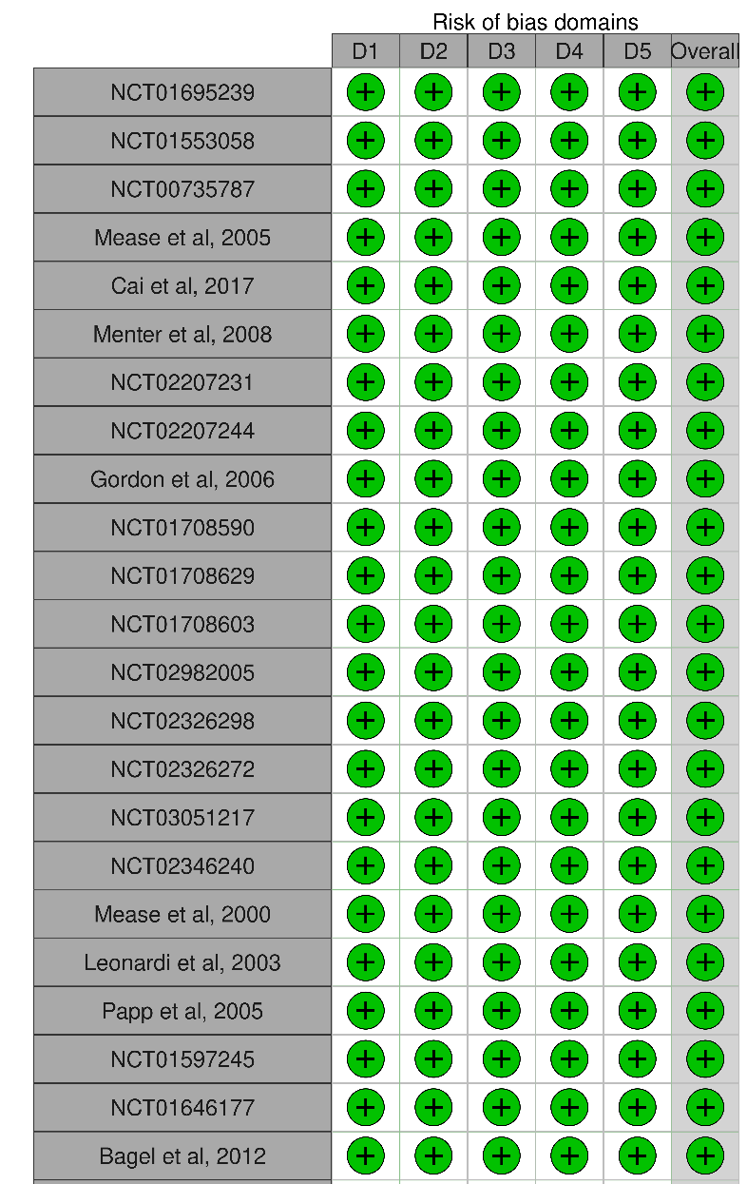
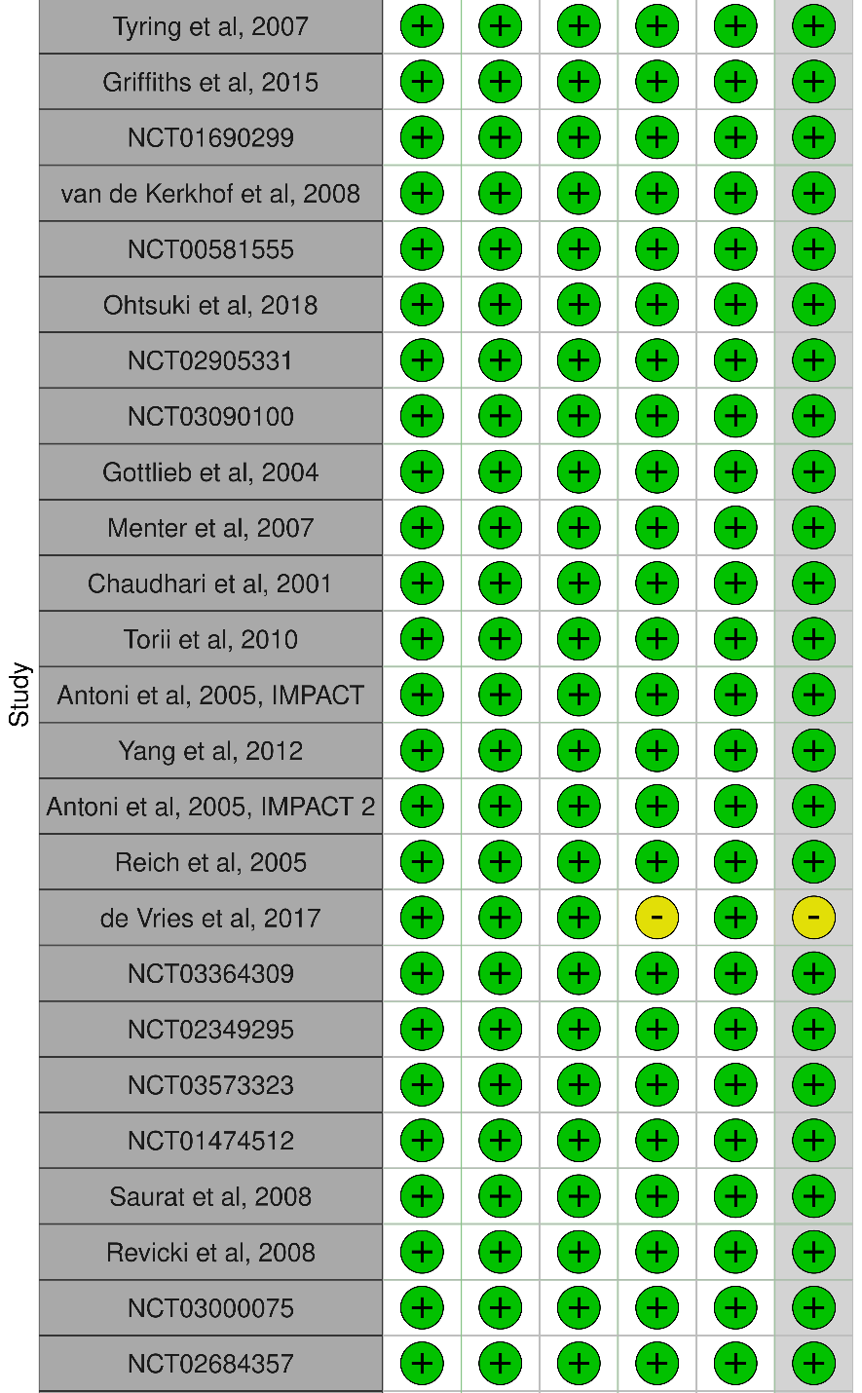
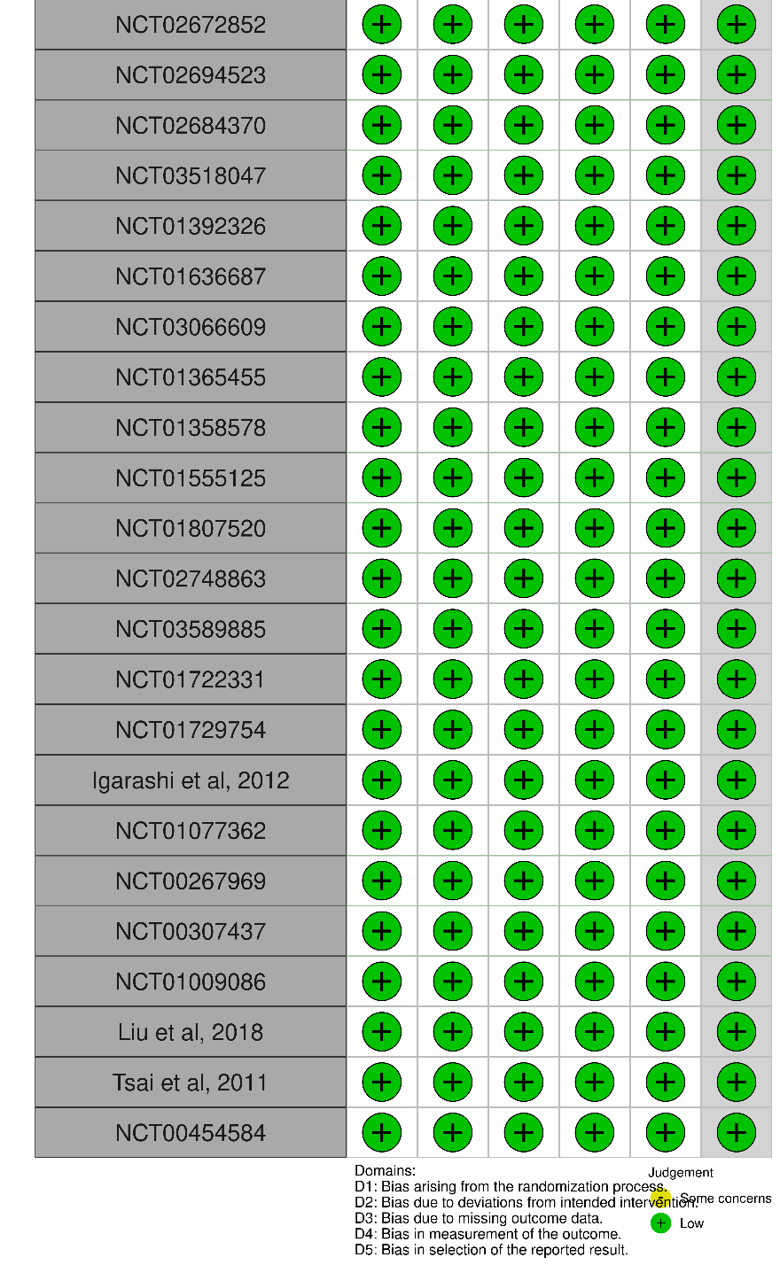
S4.2 Achieving 90% reduction on the PASI scale
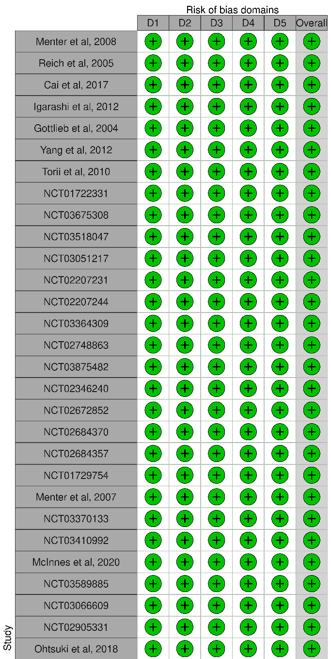
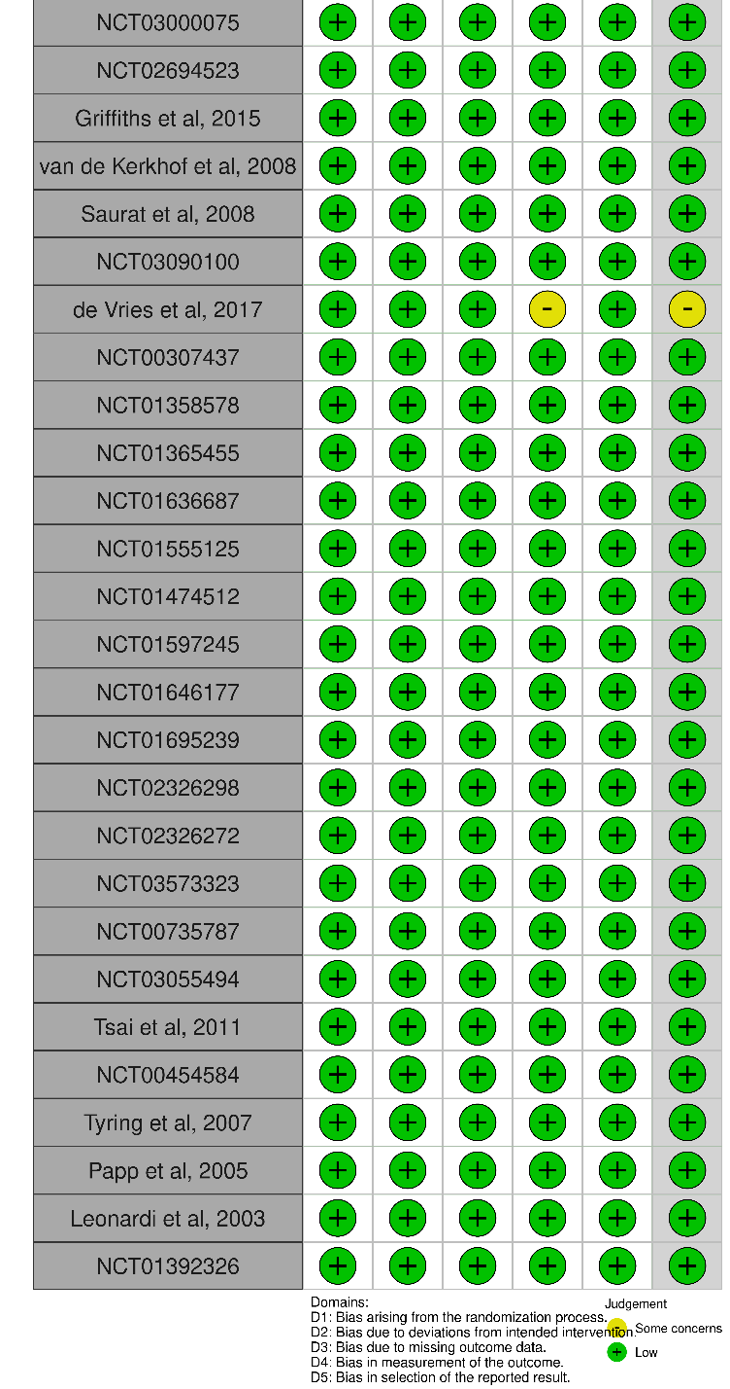
S4.3 Achieving 100% reduction on the PASI scale
S4.4 Achieving IGA score of 0 or 1
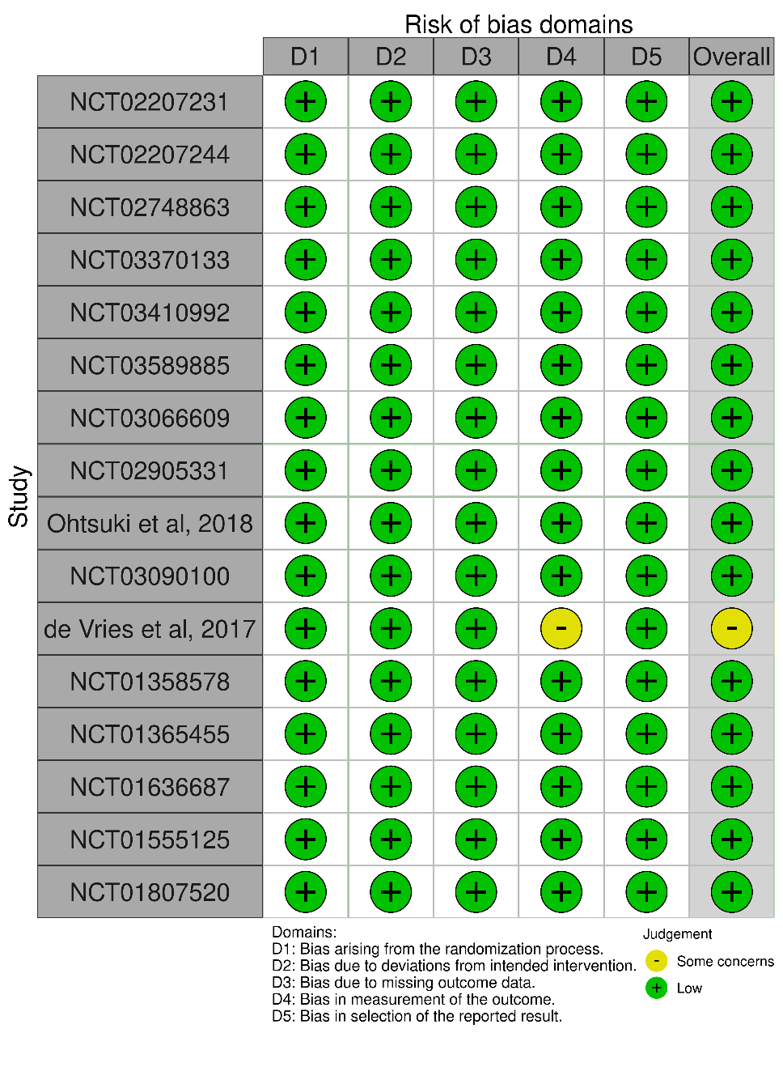
S4.5 Reduction in the Dermatology Life Quality Index
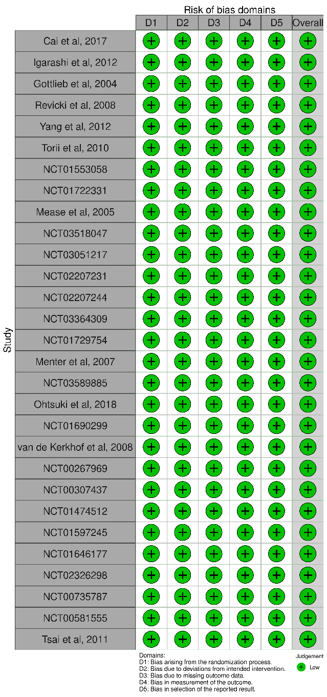
S4.6 Withdrawals due to adverse events
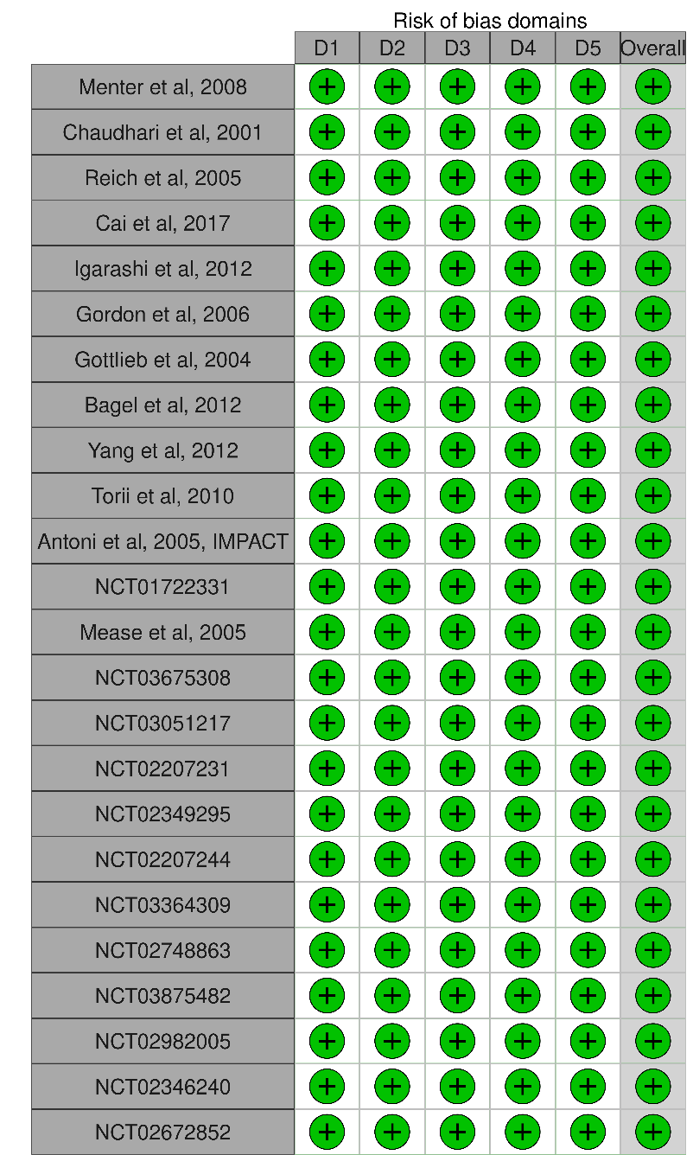
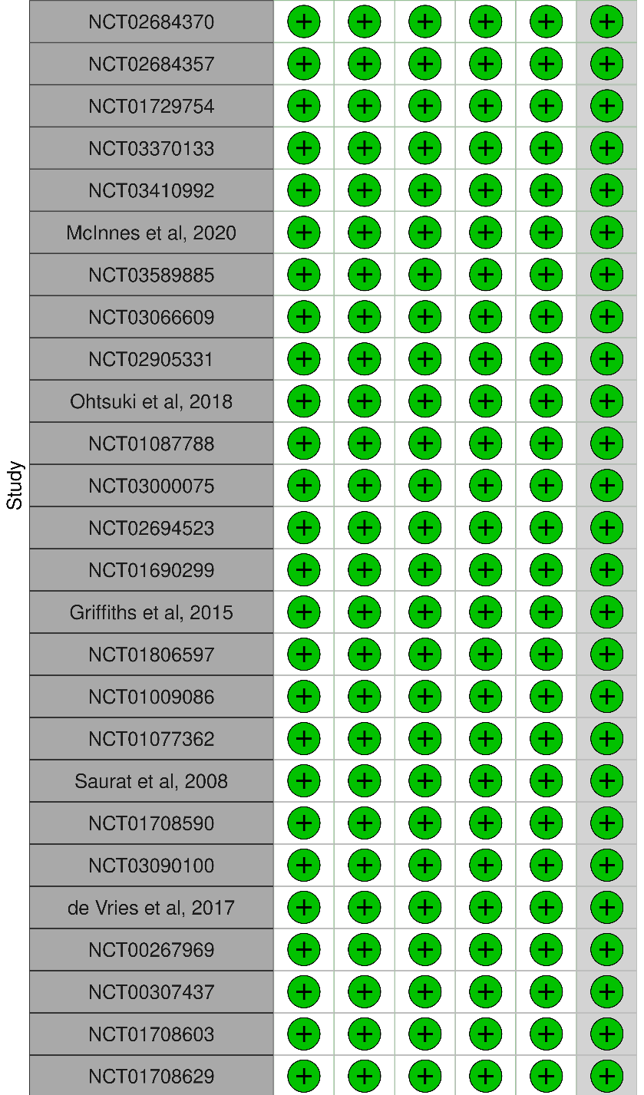
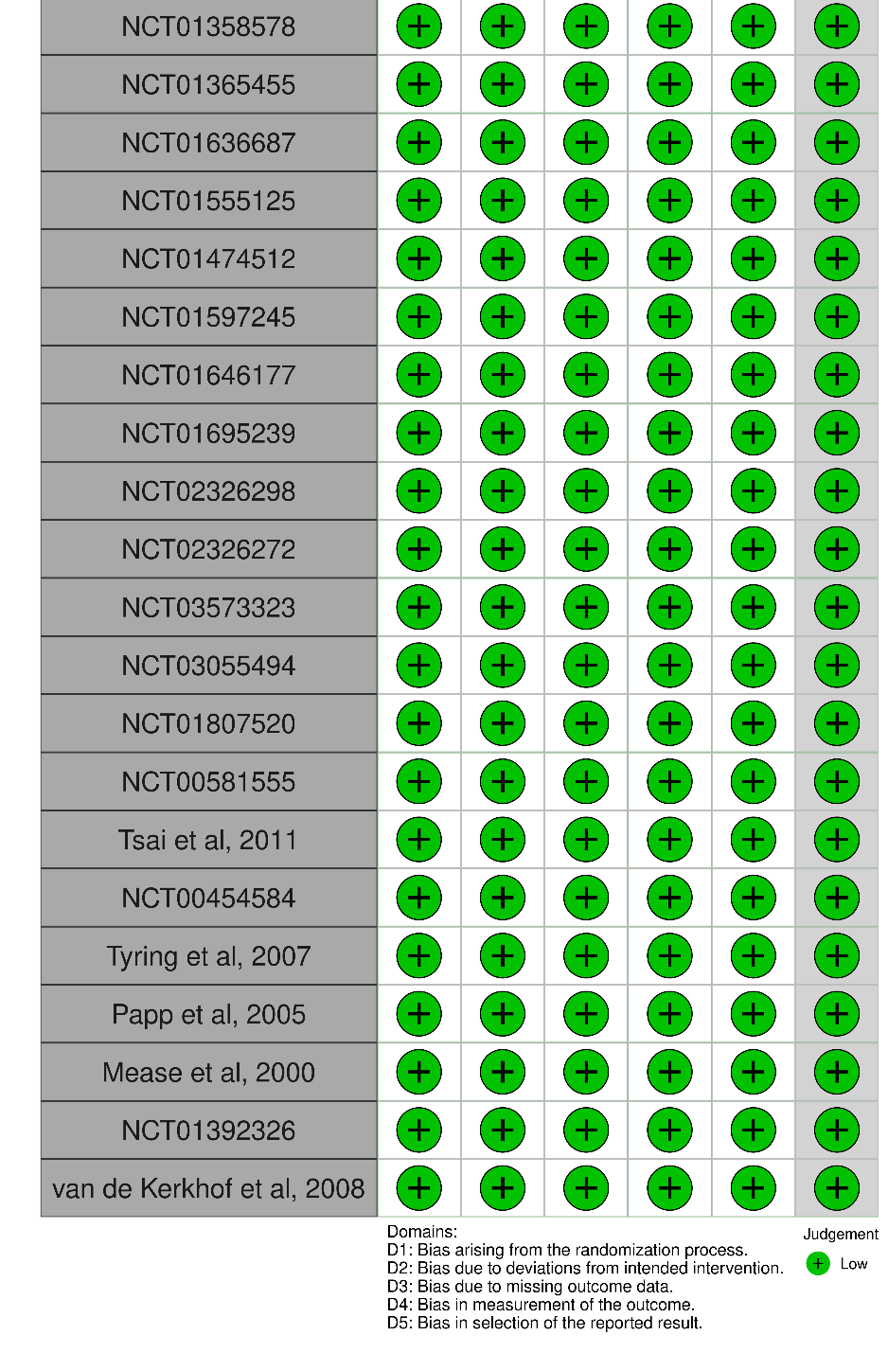

References
1. Menter A, Tyring SK, Gordon K, et al. Adalimumab therapy for moderate to severe psoriasis: A randomized, controlled phase III trial. J Am Acad Dermatol. 2008;58(1):106-115. doi:10.1016/j.jaad.2007.09.010
2. Chaudhari U, Romano P, Mulcahy LD, Dooley LT, Baker DG, Gottlieb AB. Efficacy and safety of infliximab monotherapy for plaque-type psoriasis: a randomised trial. Lancet Lond Engl. 2001;357(9271):1842-1847. doi:10.1016/s0140-6736(00)04954-0
3. Reich K, Nestle FO, Papp K, et al. Infliximab induction and maintenance therapy for moderate-to-severe psoriasis: a phase III, multicentre, double-blind trial. Lancet Lond Engl. 2005;366(9494):1367-1374. doi:10.1016/S0140-6736(05)67566-6
4. Cai L, Gu J, Zheng J, et al. Efficacy and safety of adalimumab in Chinese patients with moderate-to-severe plaque psoriasis: results from a phase 3, randomized, placebo-controlled, double-blind study. J Eur Acad Dermatol Venereol JEADV. 2017;31(1):89-95. doi:10.1111/jdv.13746
5. Igarashi A, Kato T, Kato M, Song M, Nakagawa H, Japanese Ustekinumab Study Group. Efficacy and safety of ustekinumab in Japanese patients with moderate-to-severe plaque-type psoriasis: long-term results from a phase 2/3 clinical trial. J Dermatol. 2012;39(3):242-252. doi:10.1111/j.1346-8138.2011.01347.x
6. Gordon KB, Langley RG, Leonardi C, et al. Clinical response to adalimumab treatment in patients with moderate to severe psoriasis: double-blind, randomized controlled trial and open-label extension study. J Am Acad Dermatol. 2006;55(4):598-606. doi:10.1016/j.jaad.2006.05.027
7. Gottlieb AB, Evans R, Li S, et al. Infliximab induction therapy for patients with severe plaque-type psoriasis: a randomized, double-blind, placebo-controlled trial. J Am Acad Dermatol. 2004;51(4):534-542. doi:10.1016/j.jaad.2004.02.021
8. Bagel J, Lynde C, Tyring S, Kricorian G, Shi Y, Klekotka P. Moderate to severe plaque psoriasis with scalp involvement: a randomized, double-blind, placebo-controlled study of etanercept. J Am Acad Dermatol. 2012;67(1):86-92. doi:10.1016/j.jaad.2011.07.034
9. Revicki D, Willian MK, Saurat JH, et al. Impact of adalimumab treatment on health-related quality of life and other patient-reported outcomes: results from a 16-week randomized controlled trial in patients with moderate to severe plaque psoriasis. Br J Dermatol. 2008;158(3):549-557. doi:10.1111/j.1365-2133.2007.08236.x
10. Yang HZ, Wang K, Jin HZ, et al. Infliximab monotherapy for Chinese patients with moderate to severe plaque psoriasis: a randomized, double-blind, placebo-controlled multicenter trial. Chin Med J (Engl). 2012;125(11):1845-1851.
11. Torii H, Nakagawa H, Japanese Infliximab Study investigators. Infliximab monotherapy in Japanese patients with moderate-to-severe plaque psoriasis and psoriatic arthritis. A randomized, double-blind, placebo-controlled multicenter trial. J Dermatol Sci. 2010;59(1):40-49. doi:10.1016/j.jdermsci.2010.04.014
12. Antoni C, Krueger GG, de Vlam K, et al. Infliximab improves signs and symptoms of psoriatic arthritis: results of the IMPACT 2 trial. Ann Rheum Dis. 2005;64(8):1150-1157. doi:10.1136/ard.2004.032268
13. Mease PJ, Gladman DD, Ritchlin CT, et al. Adalimumab for the treatment of patients with moderately to severely active psoriatic arthritis: results of a double-blind, randomized, placebo-controlled trial. Arthritis Rheum. 2005;52(10):3279-3289. doi:10.1002/art.21306
14. Menter A, Feldman SR, Weinstein GD, et al. A randomized comparison of continuous vs. intermittent infliximab maintenance regimens over 1 year in the treatment of moderate-to-severe plaque psoriasis. J Am Acad Dermatol. 2007;56(1):31.e1-15. doi:10.1016/j.jaad.2006.07.017
15. Antoni CE, Kavanaugh A, Kirkham B, et al. Sustained benefits of infliximab therapy for dermatologic and articular manifestations of psoriatic arthritis: results from the infliximab multinational psoriatic arthritis controlled trial (IMPACT). Arthritis Rheum. 2005;52(4):1227-1236. doi:10.1002/art.20967
16. McInnes IB, Behrens F, Mease PJ, et al. Secukinumab versus adalimumab for treatment of active psoriatic arthritis (EXCEED): a double-blind, parallel-group, randomised, active-controlled, phase 3b trial. Lancet Lond Engl. 2020;395(10235):1496-1505. doi:10.1016/S0140-6736(20)30564-X
17. Ohtsuki M, Kubo H, Morishima H, Goto R, Zheng R, Nakagawa H. Guselkumab, an anti-interleukin-23 monoclonal antibody, for the treatment of moderate to severe plaque-type psoriasis in Japanese patients: Efficacy and safety results from a phase 3, randomized, double-blind, placebo-controlled study. J Dermatol. 2018;45(9):1053-1062. doi:10.1111/1346-8138.14504
18. Griffiths CEM, Sterry W, Brock F, et al. Pattern of response in patients with moderate-to-severe psoriasis treated with etanercept. Br J Dermatol. 2015;172(1):230-238. doi:10.1111/bjd.13139
19. van de Kerkhof PCM, Segaert S, Lahfa M, et al. Once weekly administration of etanercept 50 mg is efficacious and well tolerated in patients with moderate-to-severe plaque psoriasis: a randomized controlled trial with open-label extension. Br J Dermatol. 2008;159(5):1177-1185. doi:10.1111/j.1365-2133.2008.08771.x
20. Saurat JH, Stingl G, Dubertret L, et al. Efficacy and safety results from the randomized controlled comparative study of adalimumab vs. methotrexate vs. placebo in patients with psoriasis (CHAMPION). Br J Dermatol. 2008;158(3):558-566. doi:10.1111/j.1365-2133.2007.08315.x
21. de Vries ACQ, Thio HB, de Kort WJA, et al. A prospective randomized controlled trial comparing infliximab and etanercept in patients with moderate-to-severe chronic plaque-type psoriasis: the Psoriasis Infliximab vs. Etanercept Comparison Evaluation (PIECE) study. Br J Dermatol. 2017;176(3):624-633. doi:10.1111/bjd.14867
22. Tsai TF, Ho JC, Song M, et al. Efficacy and safety of ustekinumab for the treatment of moderate-to-severe psoriasis: a phase III, randomized, placebo-controlled trial in Taiwanese and Korean patients (PEARL). J Dermatol Sci. 2011;63(3):154-163. doi:10.1016/j.jdermsci.2011.05.005
23. Reich K, Segaert S, Van de Kerkhof P, et al. Once-weekly administration of etanercept 50 mg improves patient-reported outcomes in patients with moderate-to-severe plaque psoriasis. Dermatol Basel Switz. 2009;219(3):239-249. doi:10.1159/000237871
24. Feldman SR, Kimball AB, Krueger GG, Woolley JM, Lalla D, Jahreis A. Etanercept improves the health-related quality of life of patients with psoriasis: results of a phase III randomized clinical trial. J Am Acad Dermatol. 2005;53(5):887-889. doi:10.1016/j.jaad.2005.06.053
25. Tyring S, Gordon KB, Poulin Y, et al. Long-term safety and efficacy of 50 mg of etanercept twice weekly in patients with psoriasis. Arch Dermatol. 2007;143(6):719-726. doi:10.1001/archderm.143.6.719
26. Papp KA, Tyring S, Lahfa M, et al. A global phase III randomized controlled trial of etanercept in psoriasis: safety, efficacy, and effect of dose reduction. Br J Dermatol. 2005;152(6):1304-1312. doi:10.1111/j.1365-2133.2005.06688.x
27. Leonardi CL, Powers JL, Matheson RT, et al. Etanercept as monotherapy in patients with psoriasis. N Engl J Med. 2003;349(21):2014-2022. doi:10.1056/NEJMoa030409
28. Krueger GG, Langley RG, Finlay AY, et al. Patient-reported outcomes of psoriasis improvement with etanercept therapy: results of a randomized phase III trial. Br J Dermatol. 2005;153(6):1192-1199. doi:10.1111/j.1365-2133.2005.06948.x
29. Mease PJ, Goffe BS, Metz J, VanderStoep A, Finck B, Burge DJ. Etanercept in the treatment of psoriatic arthritis and psoriasis: a randomised trial. Lancet Lond Engl. 2000;356(9227):385-390. doi:10.1016/S0140-6736(00)02530-7
30. Liu LF, Chen JS, Shen JY, et al. Ustekinumab treats psoriasis by suppressing RORC and T-box but its suppression of GATA restrains its efficacy. Braz J Pharm Sci. 2019;54:e17349. doi:10.1590/s2175-97902018000417349

