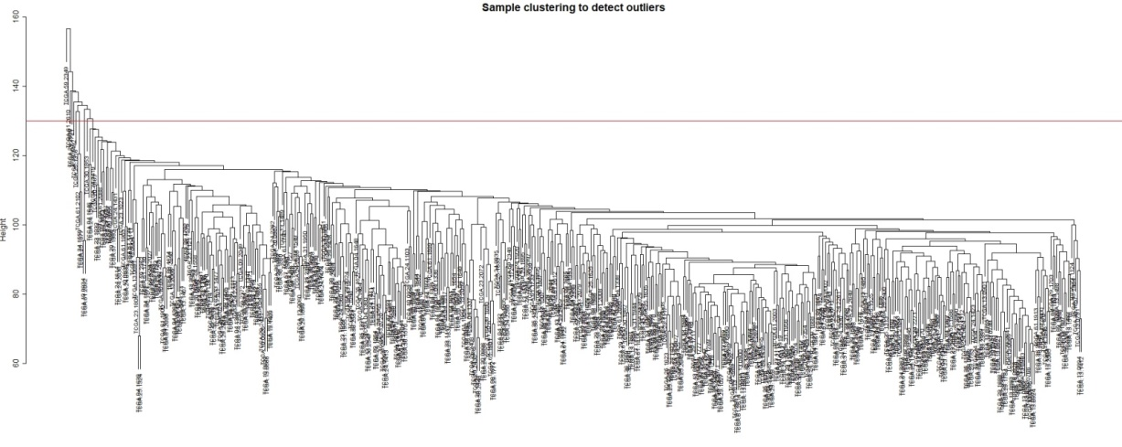
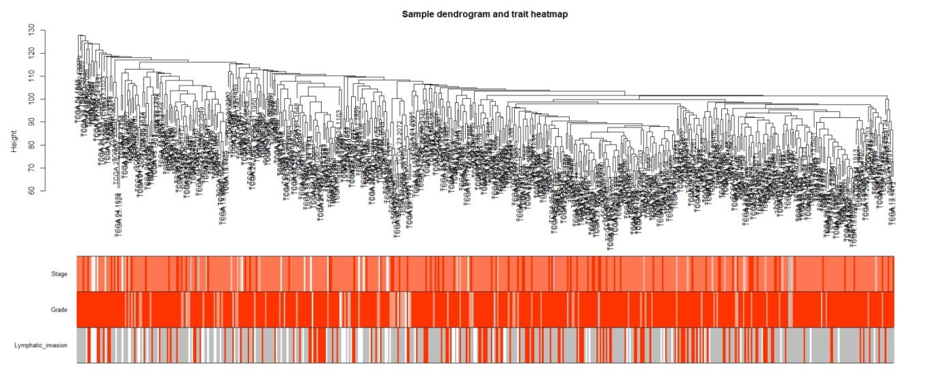
Supplementary Figure Legends
Figure S1 Identification of clustering in ovarian cancer samples. (a) Sample clustering of TCGA samples to detect outliers. (b) A sample dendrogram and trait indicator. The clustering was based on the gene expression data. The color intensity was proportional to higher clinical stages and grades. For lymphatic invasion, white indicates no lymphatic invasion, and red indicates lymphatic invasion.

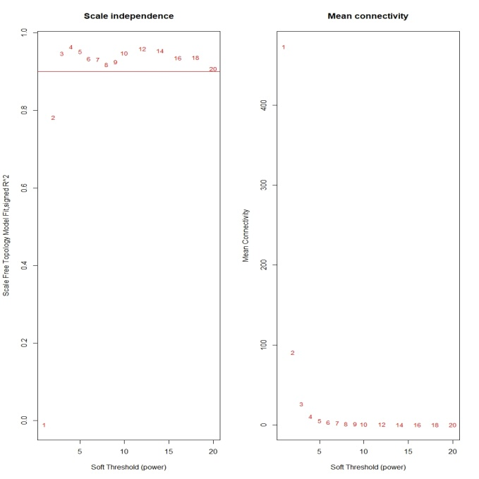
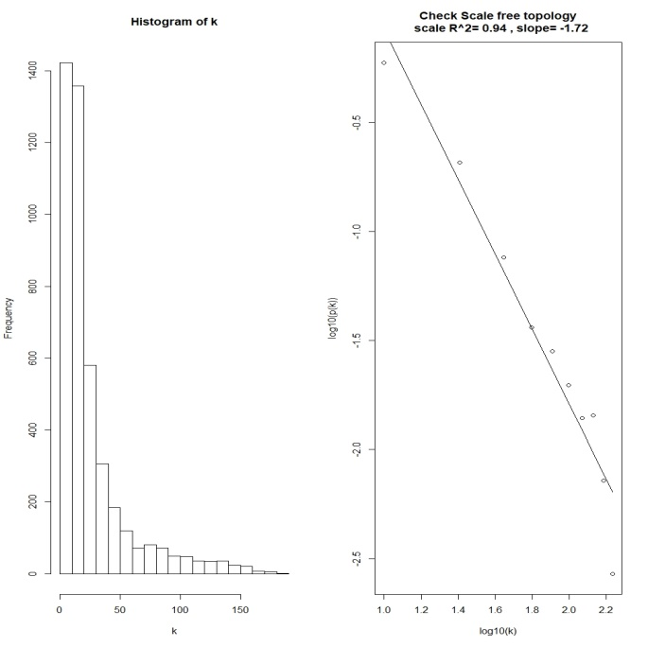
Figure S2 The determination of a soft-thresholding power in weighted gene co-expression network analysis (WGCNA). (a) Screening for the appropriate soft-thresholding power in WGCNA. An analysis of the scale-free fit index for various soft-thresholding powers (β). An analysis of the mean connectivity for various soft-thresholding powers. (b) A histogram of the connectivity distribution when β = 3. Scale-free topology when β = 3.

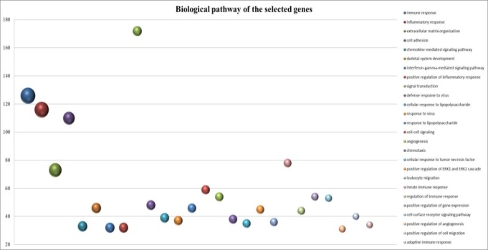
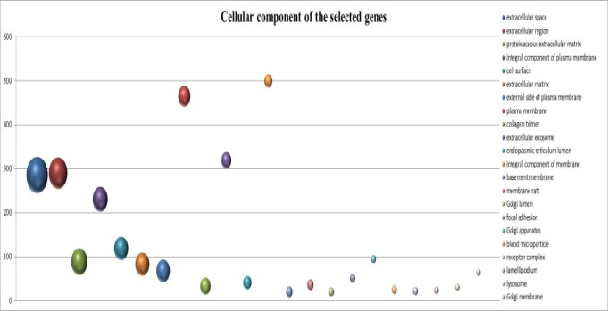
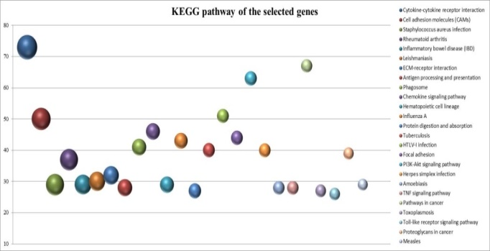
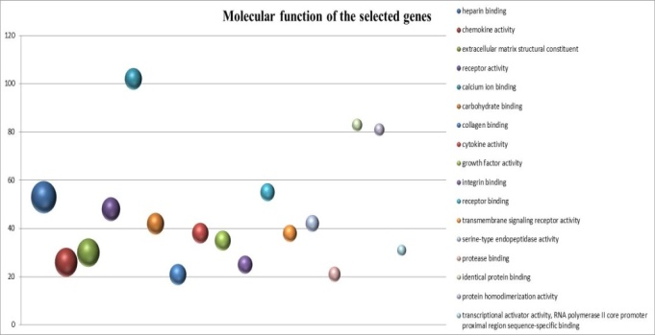
Figure S3 Gene Ontology enrichment analysis and KEGG pathway enrichment analysis of genes in the turquoise and blue modules. The size of the balls represents the p-value of each term, the smaller the p-value, the bigger the size. Y-axis represents the number of related genes. (a) Biological process enrichment. (b) Molecular function enrichment. (c) Cellular component enrichment. (d) KEGG pathway enrichment.

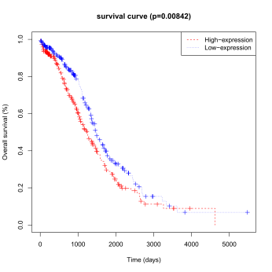
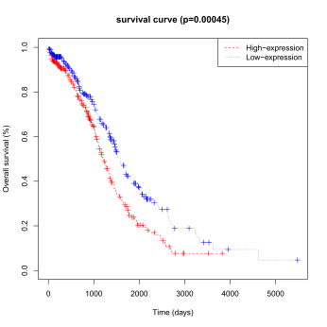
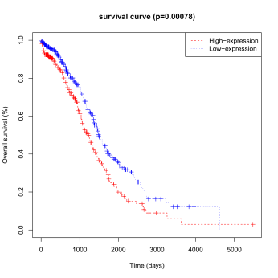
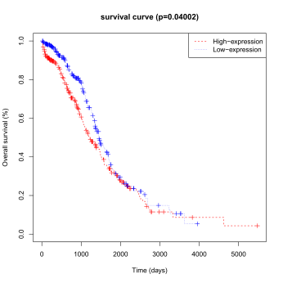
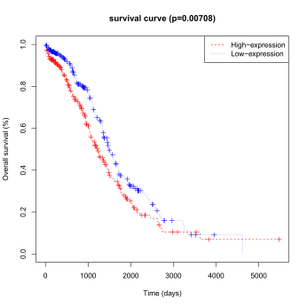
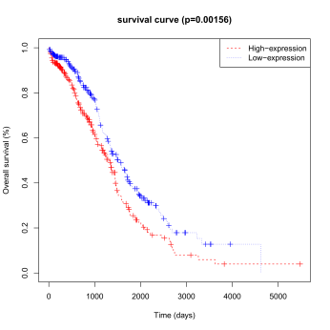
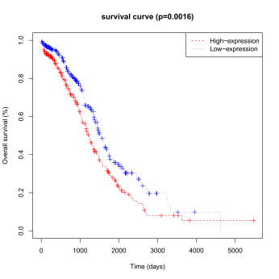
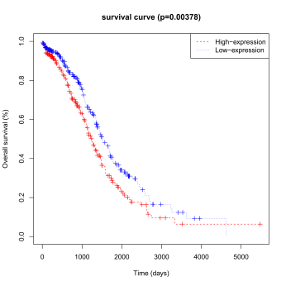
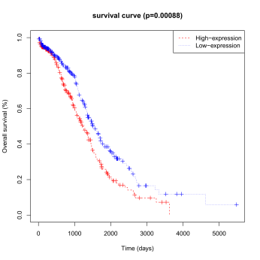
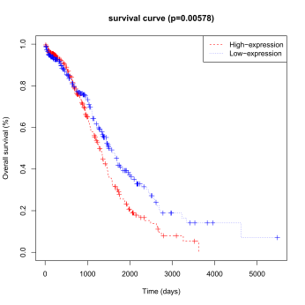
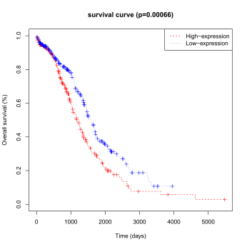
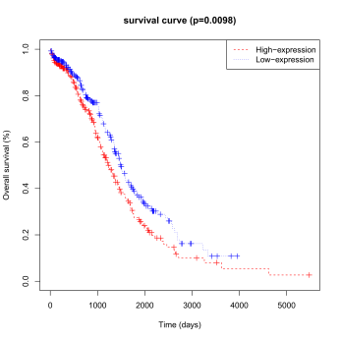
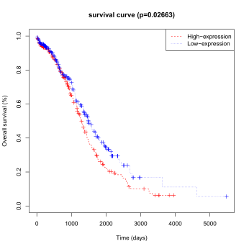
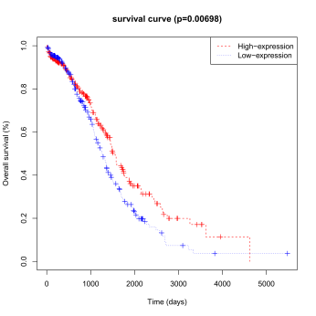
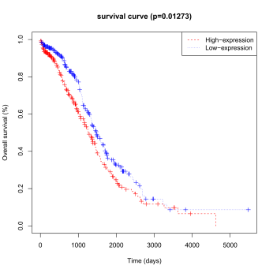
Figure S4 Kaplan-Meier curve for overall survival of candidate genes in ovarian cancer. (a) HSPB7, (b) PPM2C, (c) ZFHX4, (d) ADH1B, (e) CH25H, (f) GFPT2, (g) OGN, (h) SUSD5, (i) CCDC80. (j) ZNF521, (k) PHLDB2, (l) PTGER3, (m) C1QTNF7, (n) LOC158830, and (o) PTGIS.

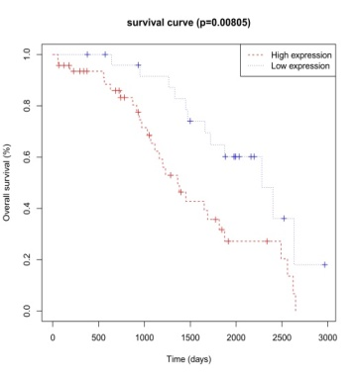
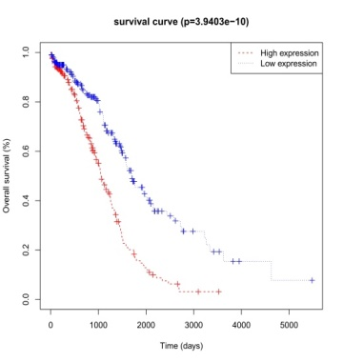
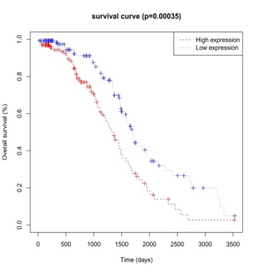
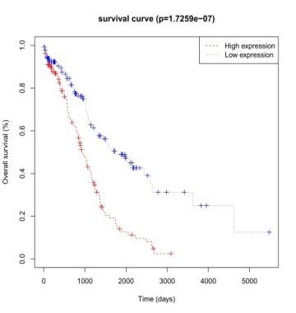
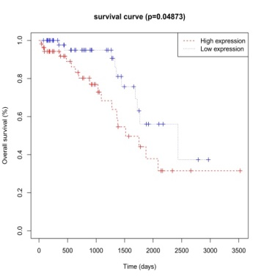
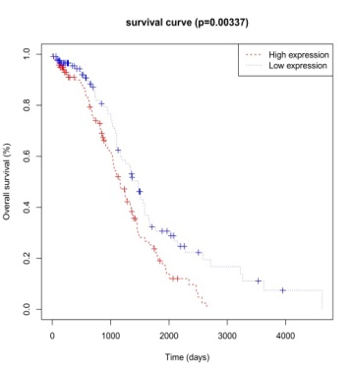
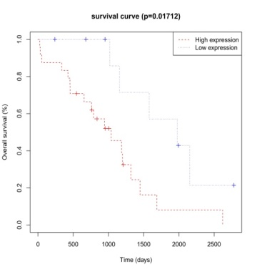
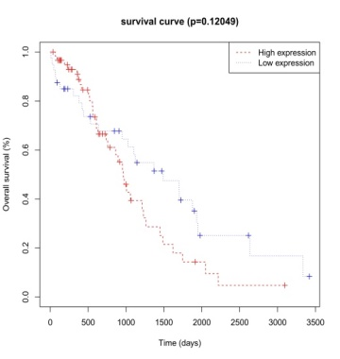
Figure S5 The overall survival of the signature in the cohorts stratified by grades (a-b), ages (c-d), and residual tumor sizes (e-h).

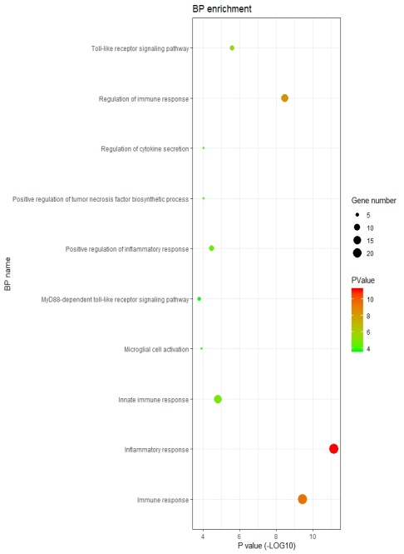
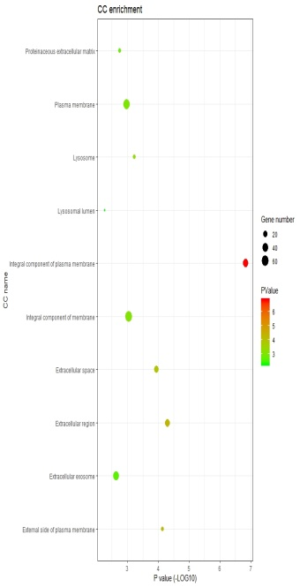
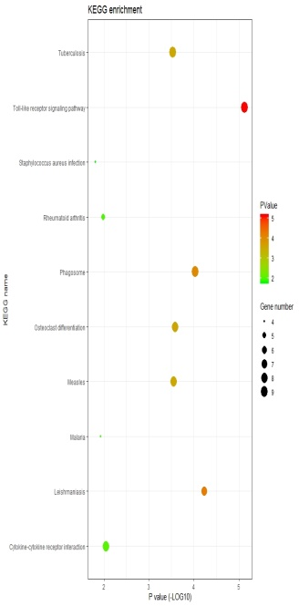
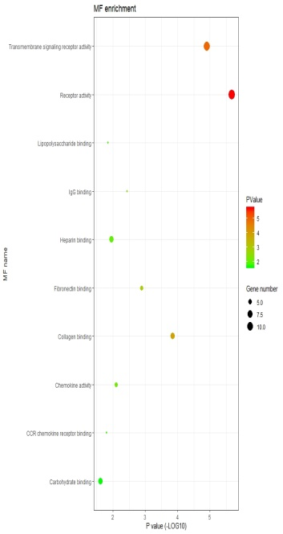
Figure S6 Gene Ontology (GO) enrichment analysis and Kyoto Encyclopedia of Genes and Genomes (KEGG) pathway enrichment analyses of differently expressed genes in the signature. The size of the balls represents the number of related genes. The color of the balls represents the p-value of each term; the red color indicates the smallest p-value. (a) Biological process enrichment. (b) Cellular component enrichment. (c) Molecular function enrichment. (d) KEGG pathway enrichment.

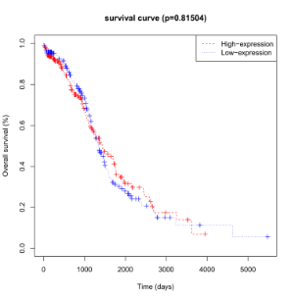
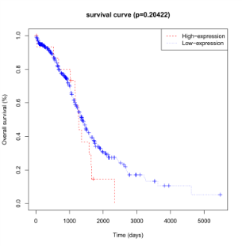
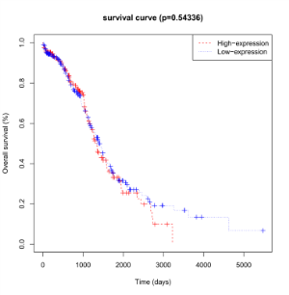
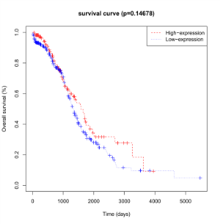
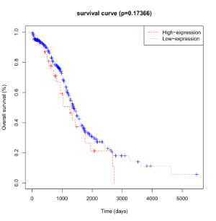
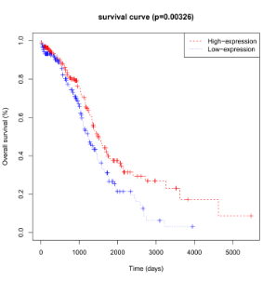
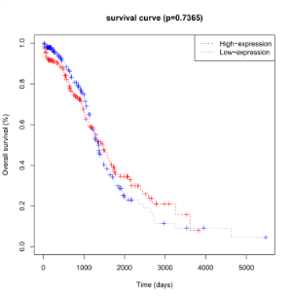
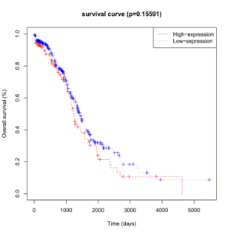
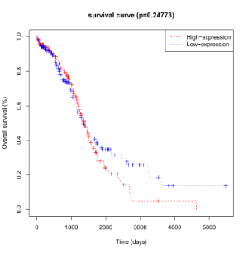
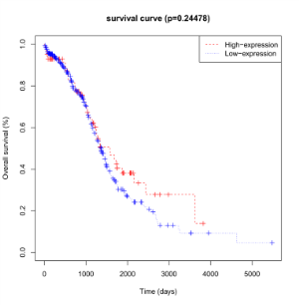
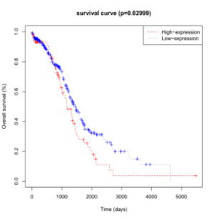
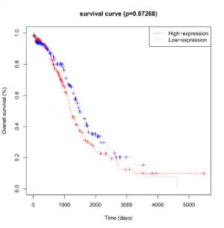
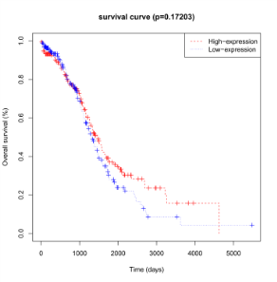
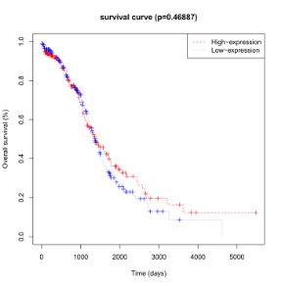
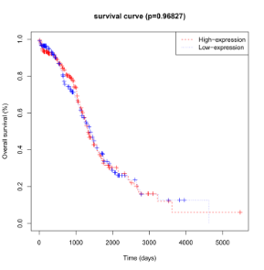
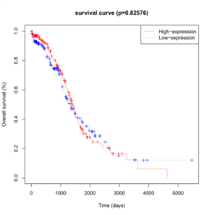
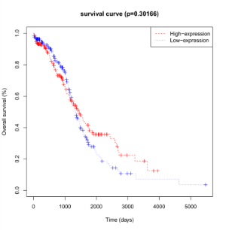
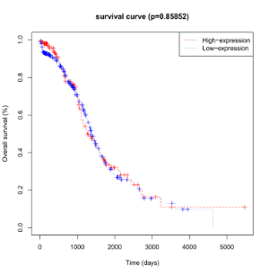
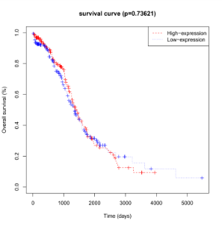
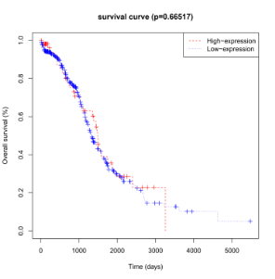
Figure S7 Kaplan-Meier curves for overall survival (OS) of ovarian cancer patients looking at 20 immune cell types. (a) Memory B cells, (b) Naïve B cells, (c) Activated dendritic cells, (d) Resting dendritic cells, (e) Eosinophils, (f) M0 macrophages, (g) M1 macrophages, (h) M2 macrophages, (i) Activated mast cells, (j) Resting mast cells, (k) Monocytes, (l) Neutrophils, (m) Activated natural killer (NK) cells, (n) Plasma cells, (o) Activated memory CD4 T cells, (p) Resting memory CD4 T cells, (q) CD8 T cells, (r) Follicular T helper cells, (s) Gamma delta T cells, and (t) Regulatory T cells (Tregs).
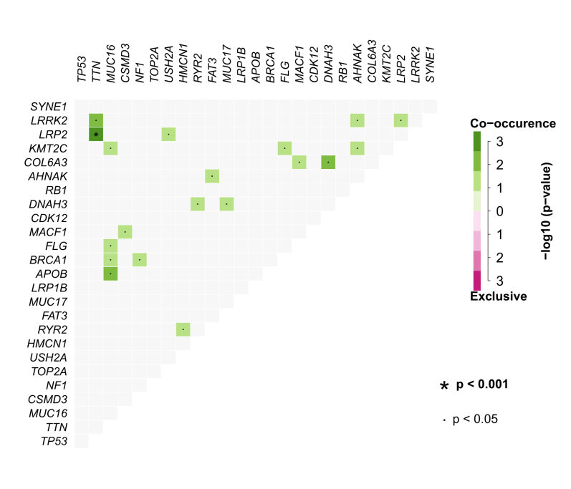
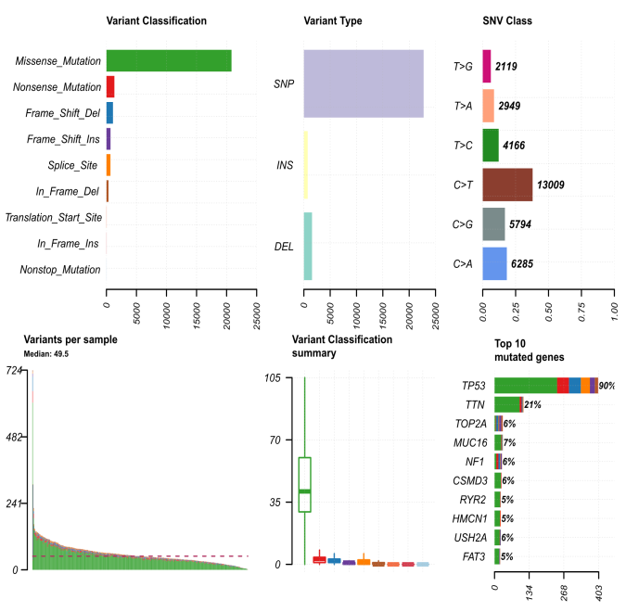
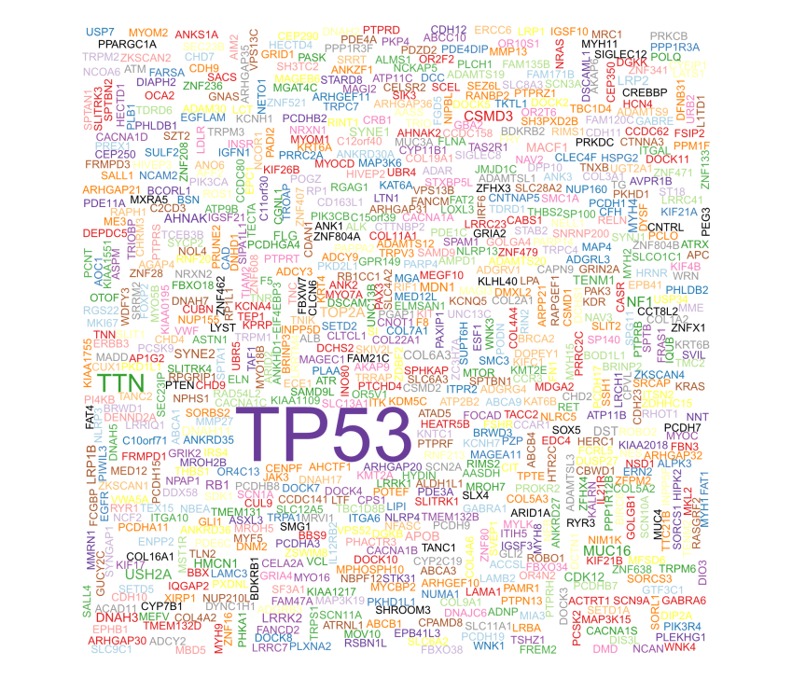
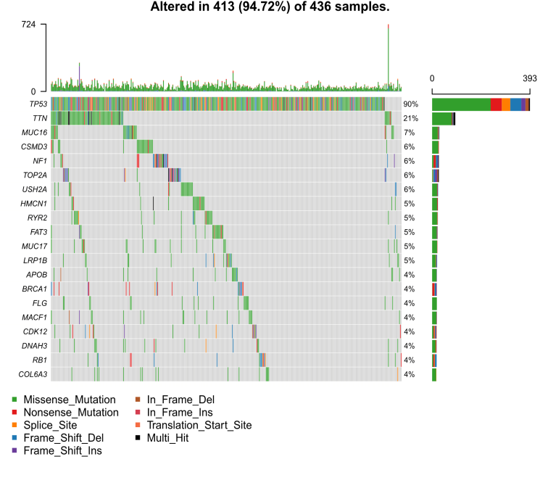
Figure S8 The mutational gene status in the ovarian cancer samples. (a) The waterfall of the top 20 mutational genes in the ovarian cancer datasets. (b) The geneCloud of the ovarian cancer patients. (c) The interaction of the top 25 mutated genes in the ovarian cancer datasets. (d) The basic summary of mutated genes in ovarian cancer patients.

