Supplemental material
A dip-and-read impedimetric electrochemical sensor for orthophosphate monitoring

Geisianny Moreira¹, Alex B. Shaw², Nafisa Amin³, Wei Gao³, Eric McLamore^{1,4}*

¹ Clemson University, Department of Agricultural Sciences, Clemson SC, USA
² Arizona State University, Phoenix AZ, USA
³ North Carolina State University, Department of Fiber and Polymer Science, Raleigh NC, USA
⁴ Clemson University, Environmental Engineering and Earth Sciences, Clemson SC, USA
* Corresponding author: emclamo@clemson.edu

Sensor functionalization
Fig. S1 shows an electrochemical characterization of LIG functionalization with GO-PDDA. These preliminary results show a slight change in the response variables (area between curve and electroactive surface area) in response to the drop-cast of a GO-PDDA solution. Coating LIG surface with GO-PDDA increases electrochemical parameters, such as conductivity (ESA) and capacity to store charge (ABC). Based on these results, we increase the mass of GO-PDDA into LIG working electrode surface by using a GO-PDDA solution at 1mg/ml, and drop-casting the solution for five times after surface was complete dried.
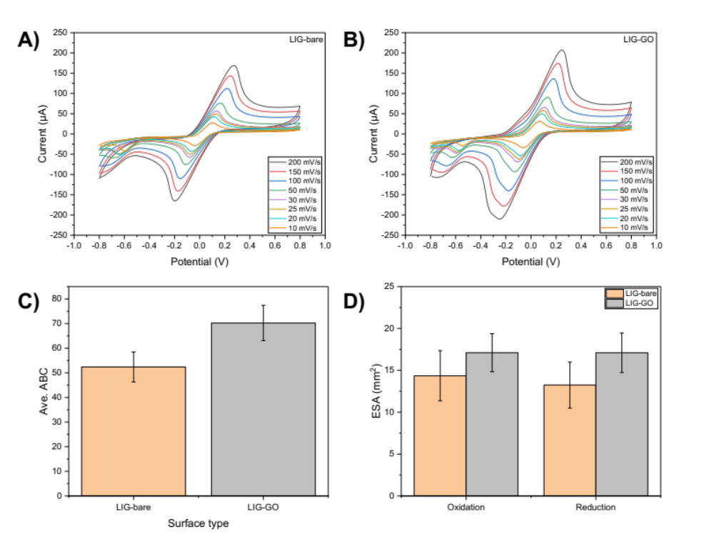
Figure S1. Electrochemical characterization of LIG functionalization with GO-PDDA. Representative voltammogram of LIG-bare (A) and LIG-GO-PDDA (B) at several scan rates (10, 20, 25, 30, 50, 100, 150, and 200 mV/s) conducted in a redox solution (100 mM KCl, 2.5 mM K₃[Fe(CN)₆], and 2.5 mM K₄[Fe(CN)₆]) with a potential range from −0.8 to 0.8 V. (C) Area between curve (ABC) for LIG-bare and LIG-GO-PDDA. Errors bar shows standard deviation of a mean measurements (n=3). (D) Electroactive surface area (ESA) for oxidation and reduction peaks of LIG-bare and LIG-GO. Errors bar shows standard deviation of a mean measurements (n=3).
Impedimetric sensing of ortho-P
For electrochemical sensing, we applied a signal-to-noise approach to perform the data analysis of EIS output. Fig. S2 shows the sensor key performance indicators demonstrating that the ortho-P sensing seems to be frequency dependent with an optimum response at 0.4 Hz.

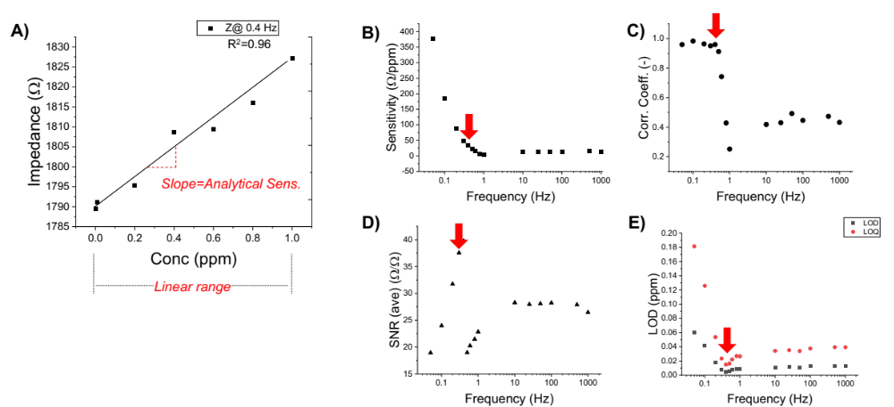
Figure S2. Sensor key performance indicators based on signal-to-noise approach.
- Representative calibration curve using total impedance at a cutoff frequency of 0.4 Hz. B) Analytical sensitivity. C) Correlation coefficient (R²). D) Average signal-to-noise ratio (SNR). E) LOD and LOB calculated using Desimoni et al. 2015 approach. Red arrow indicates frequency associated with peak SNR in the presence of ortho-P.

Voltammetric sensing of ortho-P
Cyclic voltammetry was performed by immersing the LIG-GOp sensor in the Sodium chloride/sodium bicarbonate solution, followed by the gradual injection of analyte solution to be tested for sensitivity towards ortho-P and selectivity against chloride, nitrate and sulfate, with electrochemical measurement after each injection. Briefly, aliquots of analyte working solution (100 ppm) were successively injected into the electrochemical cell (15 ml of sodium chloride/sodium bicarbonate solution) to obtain concentrations of 0, 0.01, 1, 2, 3, 4, and 5 ppm. CV testing was conducted with a potential range from −0.8 to 0.8 V at a scan rate of 200 mV/s. Each analyte addition generated a change in electrochemical signal, which was recorded using the MultiTrace software (PalmSens, Houten, Netherlands). Figure S3 shows non-linear and linear regression modeling for the sensing or ortho-P from CV output.
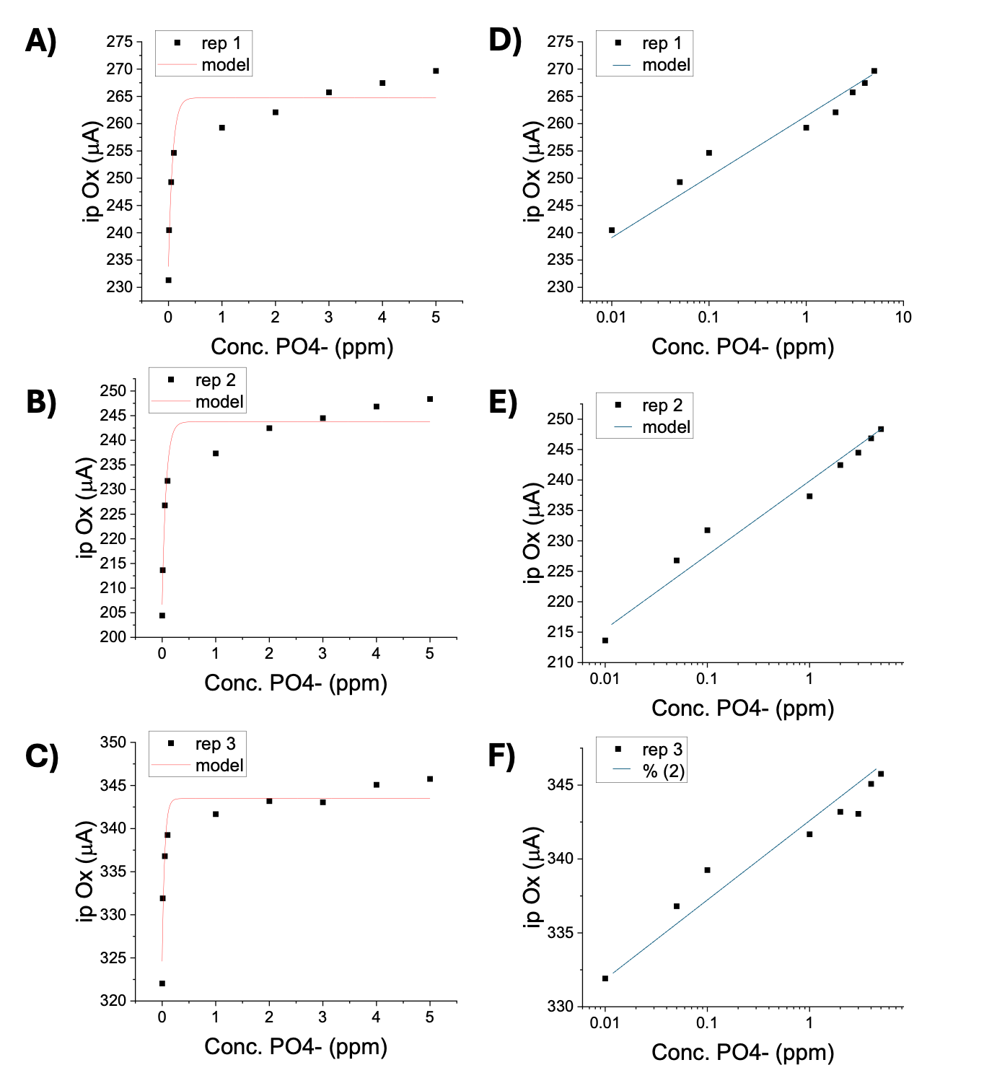
Figure S3. Calibration curves prepared using peak oxidation current (ip_{ox}) toward ortho-P (CV conducted at 200 mV/sec). A-C) Non-linear modeling of calibration curves. D-F) Linear regression for calibration curve below 0.1 ppm.

Figure S4 shows the performance metrics calculated based on the non-linear modeling. The non-linear analysis indicates that the sensor is not selective for ortho-P across the 0.01 to 5 ppm range using CV as the response variable (200 mV/sec).
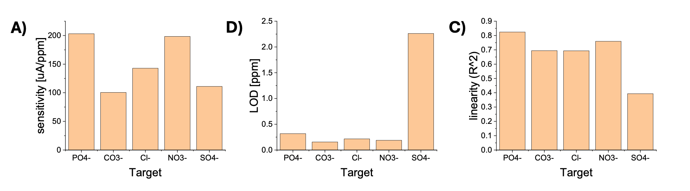
Figure S4. Performance metrics based on CV conducted at 200 mV/sec using non-linear analysis from 0.01 to 5 ppm. Calibration curves prepared using peak oxidation current (ip_{ox}). A) Sensitivity toward various anions, B) Limit of detection, and C) Linearity (R²).

Figure S5 shows the performance metrics calculated based on the non-linear modeling. Linear regression analysis indicates that the sensor is highly selective for ortho-P across the range of 0.01 to 0.1 ppm using CV as the response variable (200 mV/sec). Both anodic peak current (ip_{ox}) and area between anodic/cathodic current (ABC) were analyzed.
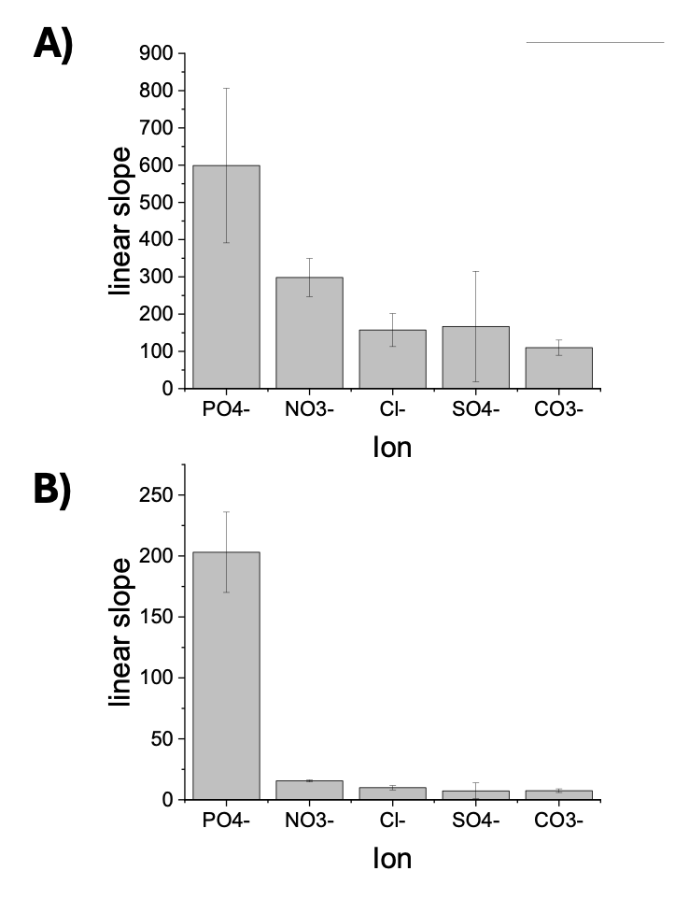
Figure S5. Performance metrics based on CV conducted at 200 mV/sec using linear regression below 0.1 ppm. Equimolar selectivity tests were performed in various single-salt solutions. Calibration curves prepared using peak oxidation current (ip_{ox}).
A) Sensitivity toward various anions, B) Limit of detection, and C) Linearity (R²).

Table S1 summarizes the selectivity analysis using CV output as the response variable (200 mV/sec). The chemosensor is at least 90% selective over all anions tested between 0.01 to 0.1 ppm, but above this concentration, the calibration curves are non-linear, and the selectivity decreases considerably. The response toward ortho-P is linear in the range of 0.01 to 0.1 ppm, but all other anions had no linearity R²<0.5.

Table S1. Summary of selectivity analysis using peak oxidation current (ip_{ox}) as the response variable at 200mV/sec. Equimolar selectivity tests were performed in various single-salt solutions.
Ion | Selectivity  [%] | Change in signal  [μA] | Sensitivity  [μA/ppm] | R²  (ip_{ox})
Phosphate | 100% | 35.3 ± 6.0 | 203.0 ± 32.9 | 0.82
Nitrate | 7.7% | 3.3 ± 1.2 | 15.5 ± 0.89 | 0.50
Chloride | 4.9% | 2.2 ± 3.0 | 10.0 ± 1.7 | 0.36
Sulfate | 3.7% | 2.7 ± 1.7 | 7.3 ± 6.5 | 0.31
Carbonate | 3.9% | 1.7 ± 2.7 | 7.45 ± 1.5 | 0.42

