Whole-Body Physiologically-Based Pharmacokinetic Modeling of GalNAc conjugated siRNAs
Journal of Pharmacokinetics and Pharmacodynamics
Emilie Langeskov Salim ^{1,2}, Kim Kristensen², Erik Sjögren¹
¹ Department of Pharmaceutical Bioscience, Translational Drug Discovery and Development, Uppsala University, SE-75124, Uppsala, Sweden;
² Novo address,Department of Discovery PKPD & QSP Modelling, Novo Nordisk A/S, DK-2760 Måløv Denmark.

Corresponding author:
Erik Sjögren, PhD
Associate Professor
Department of Pharmaceutical Bioscience
Uppsala University
Box 591
SE-75124 Uppsala, Sweden
Email: erik.sjogren@uu.se
Phone: +46 – 18 471 41 54

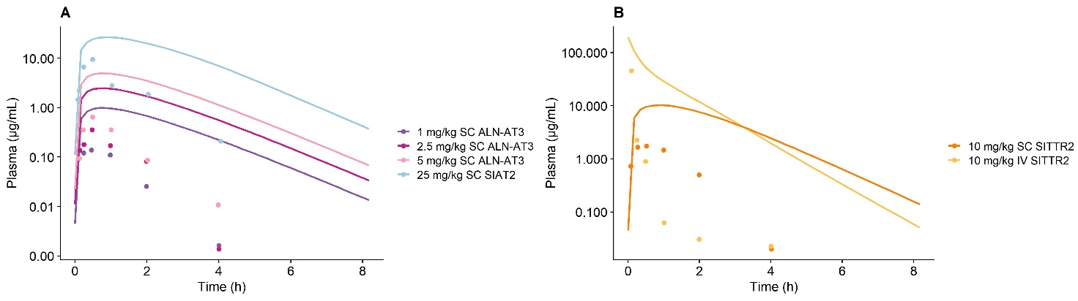
Supplementary 2
Figure S1 Model simulated plasma concentration time profiles simulated with default radius solute, previously reported ASGPR TMDD model parameters and generic endosomal uptake/recycling rates vs. observed data for GalNAc-siRNAs targeting A) antithrombin (ALN-AT3/SIAT-2) and B) targeting transthyretin protein (SITTR-2). Solid lines represent model simulations and dots represent observations. A) Dark purple line represents 1 mg/kg subcutaneous administered ALN-AT3; Dark pink represents 2.5 mg/kg administered subcutaneous ALN-AT3; Light pink line represents 5 mg/kg administered subcutaneous ALN-AT3; Light blue line represents 25 mg/kg subcutaneous administered SIAT-2. B) Orange line represents 10 mg/kg subcutaneous administered SITTR2; Yellow line represents 10 mg/kg intravenously administered SITTR2.

