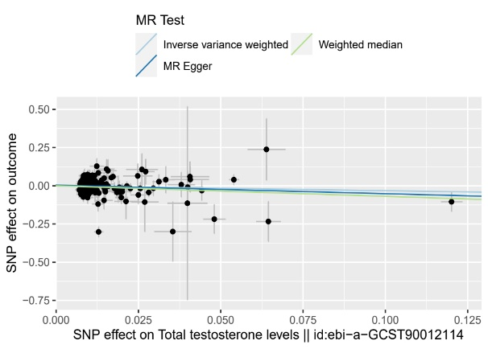
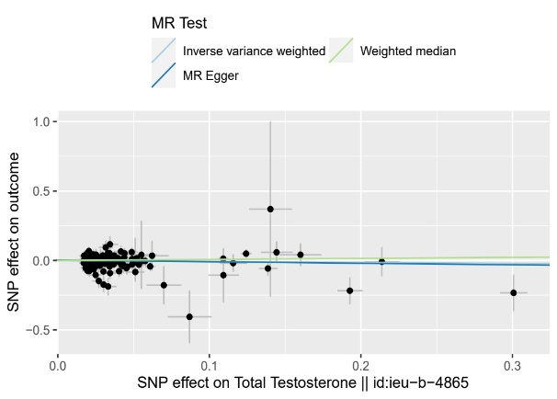
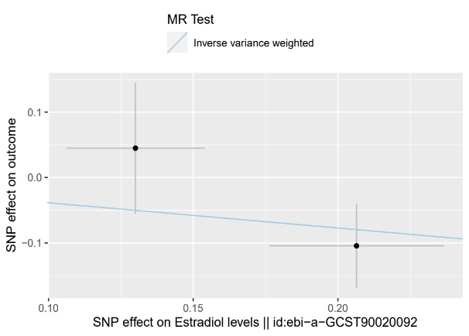
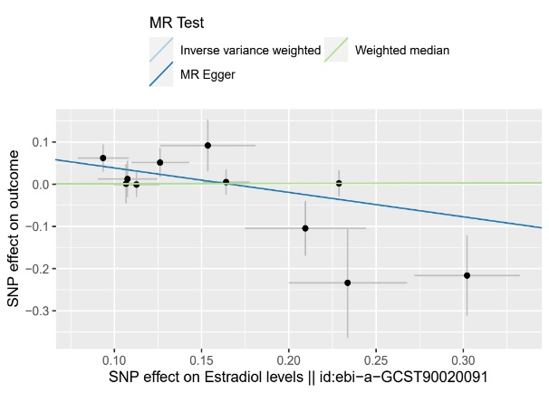
A B
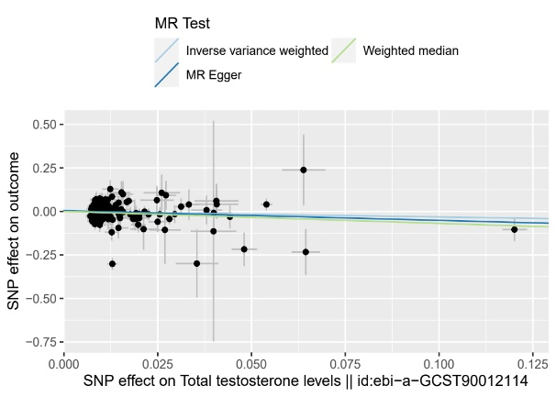
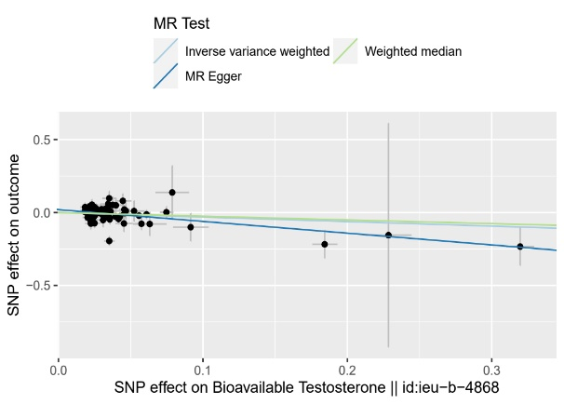
C D
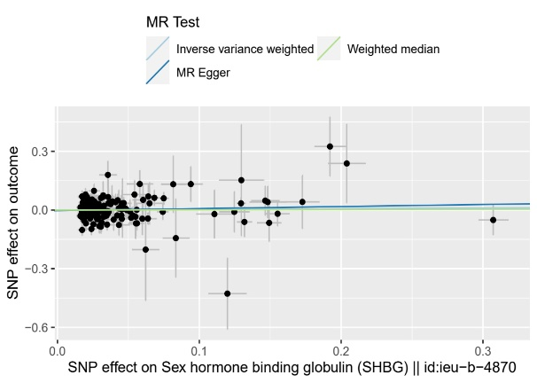
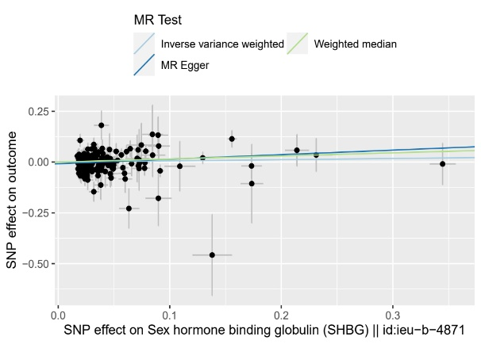
E F
G H

Figure S1 Scatter plot
Note: (A) Scatter plot of causality between E2 (males) and SS, (B) Scatter plot of causality between E2 (females) and SS, (C) Scatter plot of causality between TT and SS, (D) Scatter plot of causality between TT (males) and SS, (E) Scatter plot of causality between BT (males) and SS, (F) Scatter plot of causality between SHBG and SS, (G) Scatter plot of causality between SHBG (males) and SS, (H) Scatter plot of causality between SHBG (females) and SS.

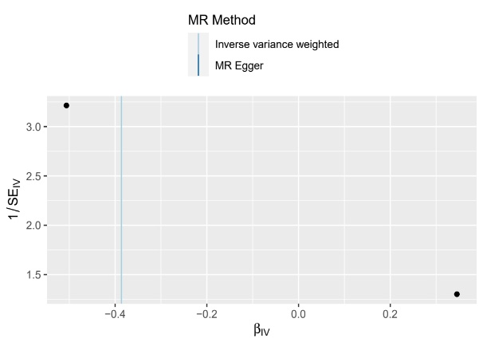
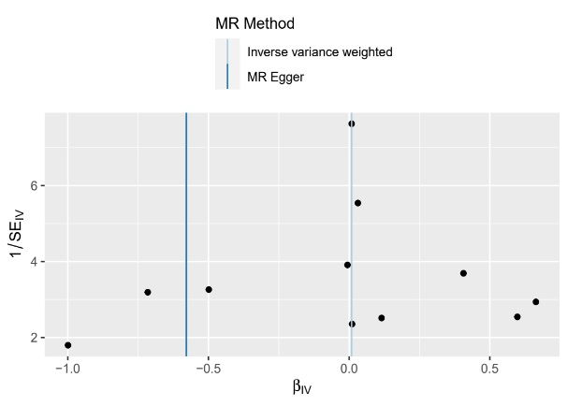
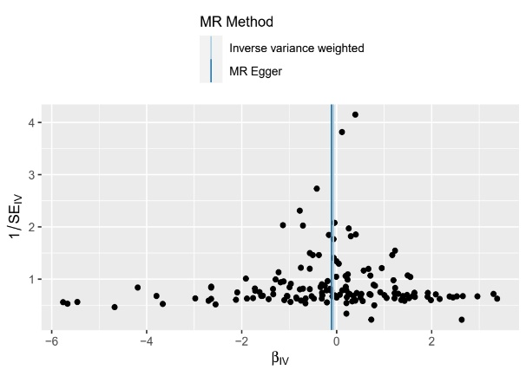
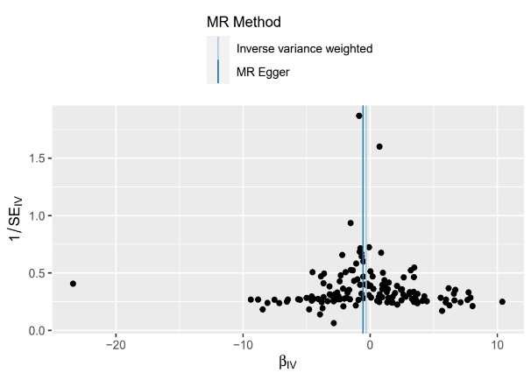
A B
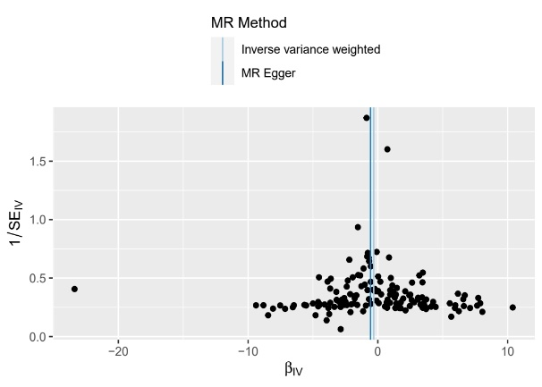
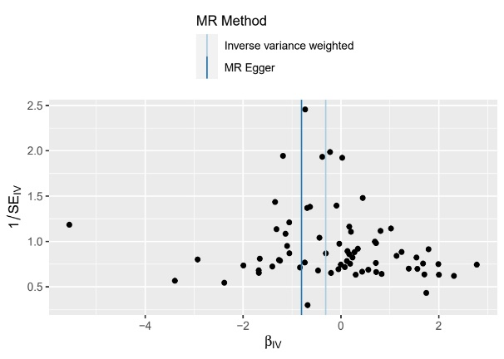
C D
E F

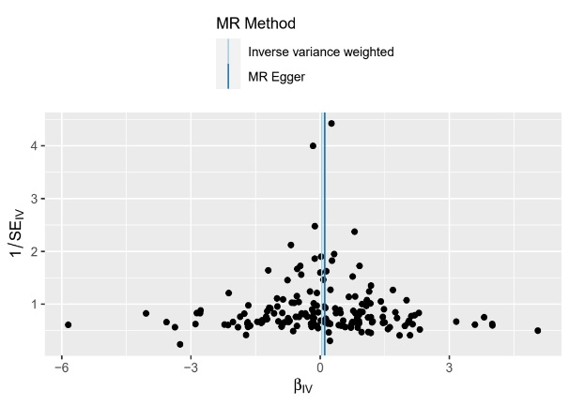
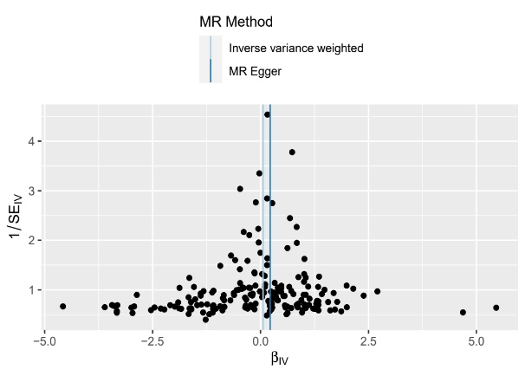
G H
Figure S2 Funnel plot
Note: (A) Funnel plot of causality between E2 (males) and SS, (B) Funnel plot of causality between E2 (females) and SS, (C) Funnel plot of causality between TT and SS, (D) Funnel plot of causality between TT (males) and SS, (E) Funnel plot of causality between BT (males) and SS, (F) Funnel plot of causality between SHBG and SS, (G) Funnel plot of causality between SHBG (males) and SS, (H) Funnel plot of causality between SHBG (females) and SS.

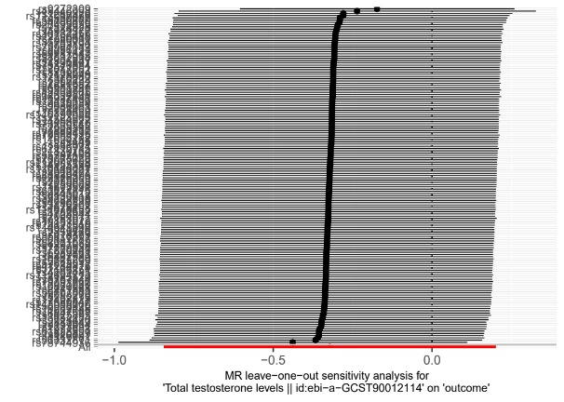
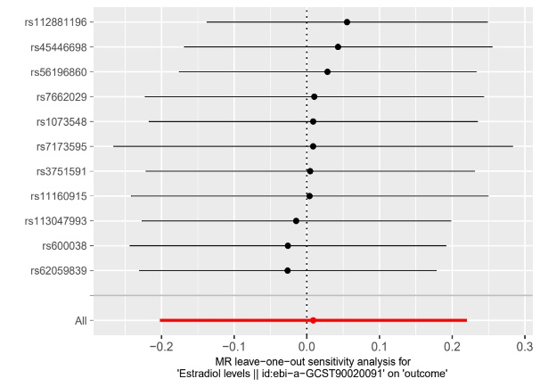
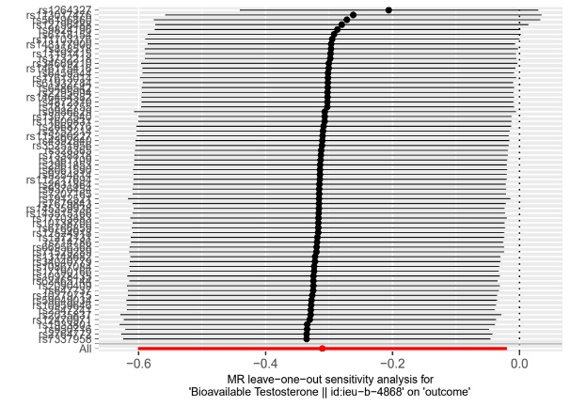
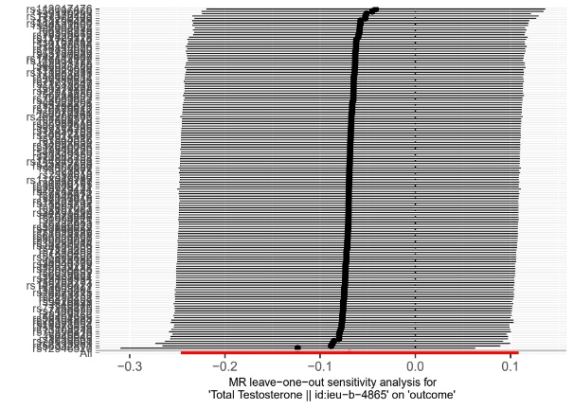
A B
C D

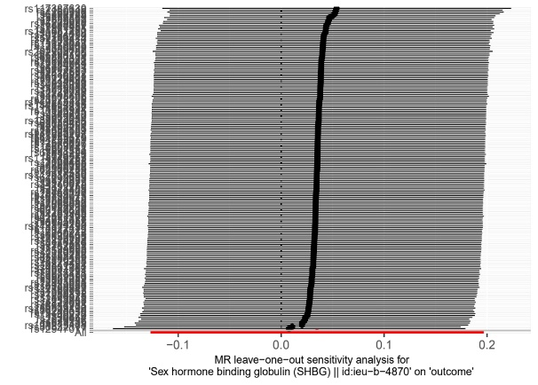
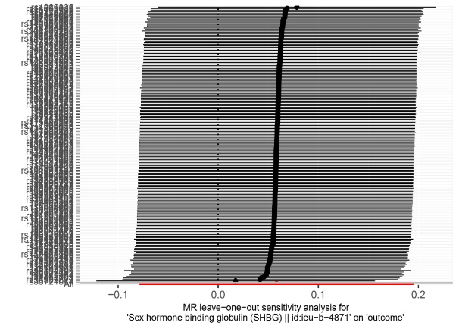
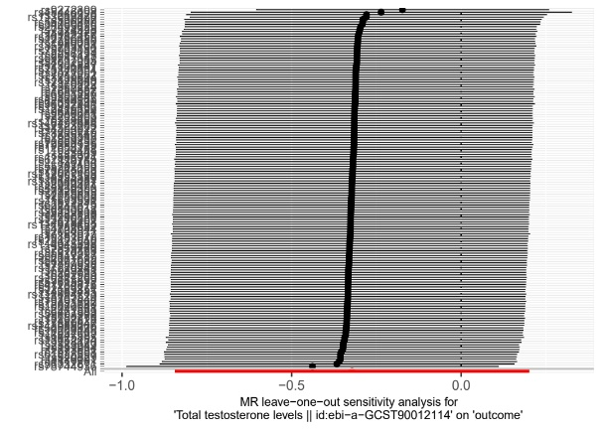
E F
G
Figure S3 Leave-one-out analysis
Note: (A) Leave-one-out analysis between E2 (males) and SS, (B) Leave-one-out analysis between TT and SS, (C) Leave-one-out analysis between TT (males) and SS, (D) Leave-one-out analysis between BT (males) and SS, (E) Leave-one-out analysis between SHBG and SS, (F) Leave-one-out analysis between SHBG (males) and SS, (G) Leave-one-out analysis between SHBG (females) and SS.

