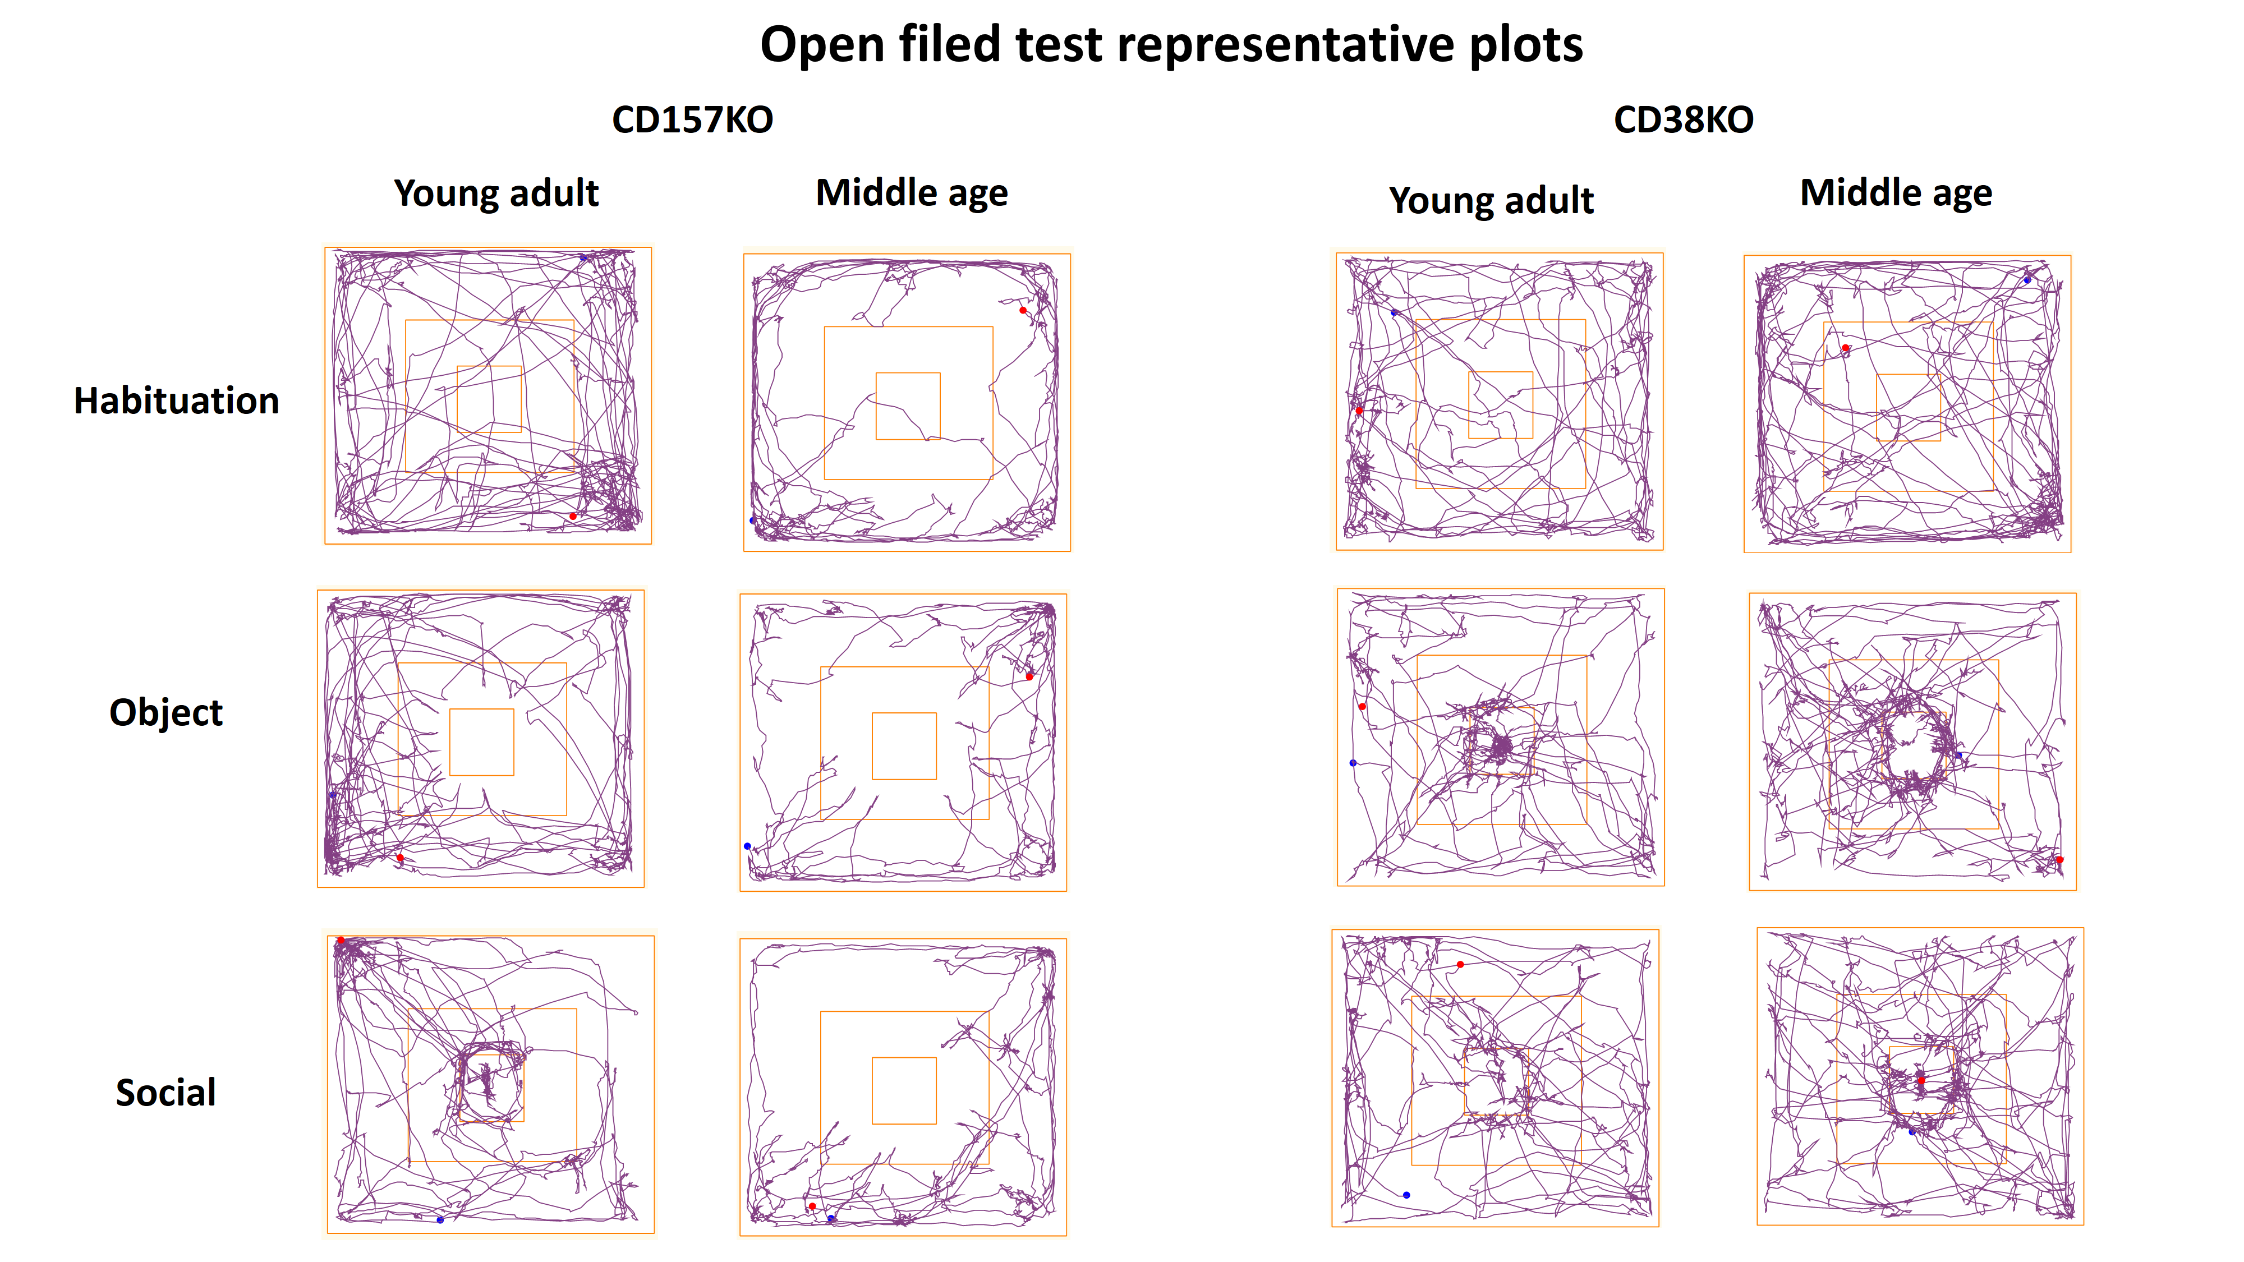
Supplementary Fig. 1. Representative plots of CD157KO and CD38KO mice in the open field test

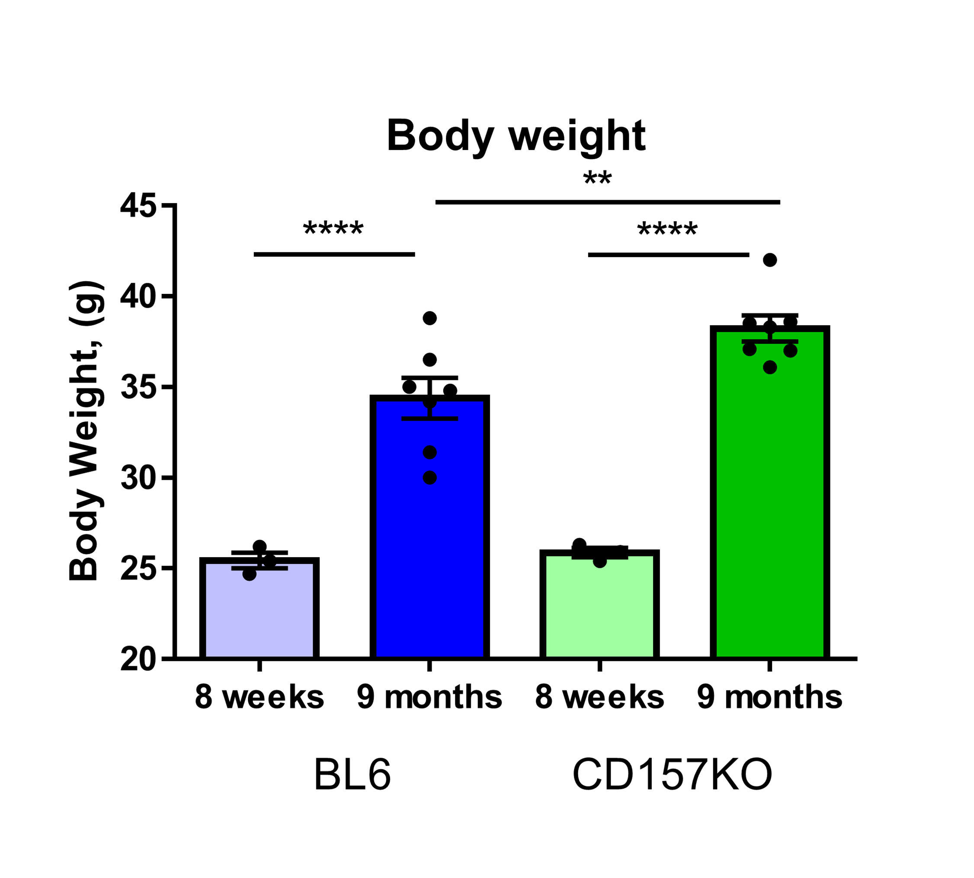
Supplementary Fig. 2. Body weight of BL6 and CD157KO mice at the age of 8 weeks and 9 months. Bonferroni’s post hoc comparison, **p < 0.01, ****p < 0.0001.

