Supplementary Figures and Figure Legend

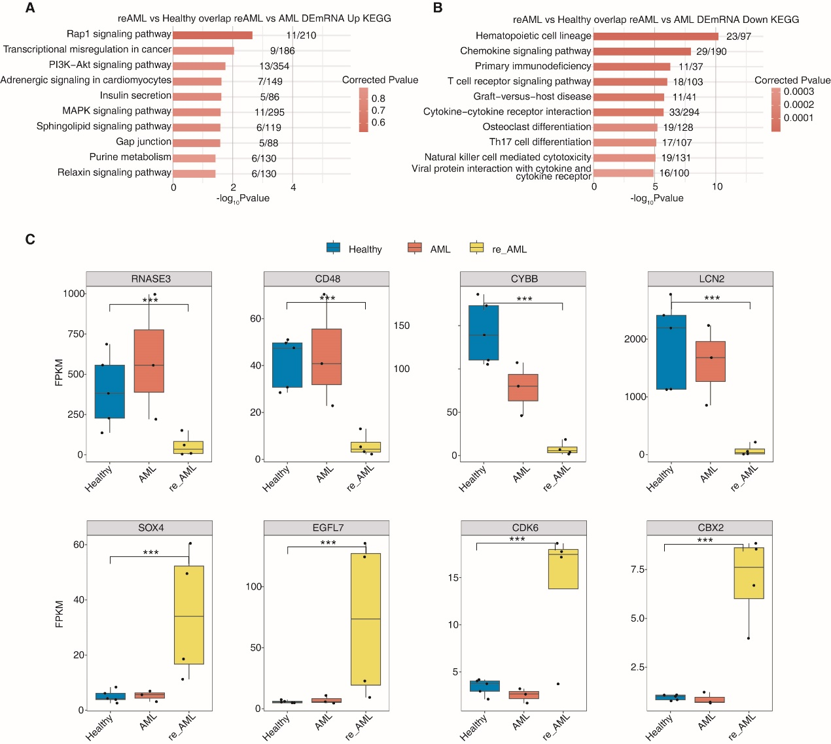
Fig. S1 Transcription profiles analysis of AML drug-resistant patients.
A Bar plot exhibiting the most enriched KEGG results of the co-upregulated DEGs in two comparison groups (reAML vs Healthy & reAML vs AML).
B Bar plot exhibiting the most enriched KEGG results of the co-downregulated DEGs in two comparison groups (reAML vs Healthy & reAML vs AML).
C Box plot showing the expression level of EGFL7, CBX2, SOX4, CDK6, LCN2, CYBB, RNAS, and CD48 in the indicated groups. Error bars represent means ± SEM. ***p<0.001; **p<0.01; *p<0.05.
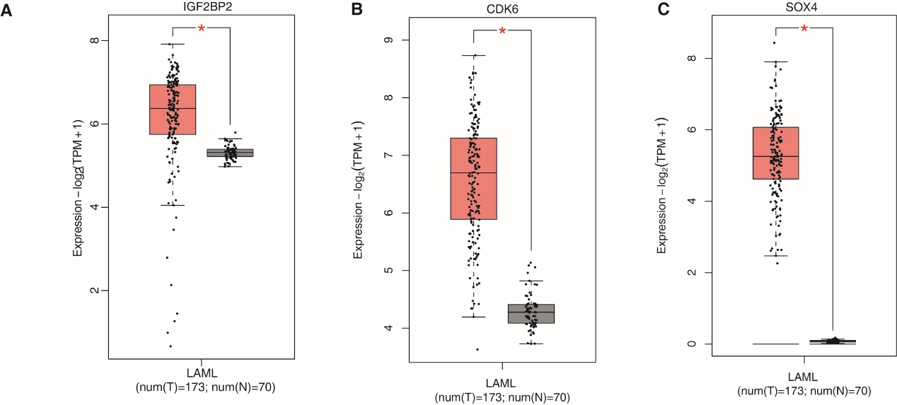
Fig. S2 The expression level of IGF2BP2, CDK6, and SOX4 of LAML in TCGA database.
A Box plot showing the expression level of IGF2BP2 in LAML clinical data from TCGA.
B Box plot showing the expression level of CDK6 in LAML clinical data from TCGA.
C Box plot showing the expression level of SOX4 in LAML clinical data from TCGA.

