Supporting Information
for
Integrated metabolomic and transcriptomic analyses of flavonoid accumulation in different cultivars of Platostoma palustre

Figures: S1-S2

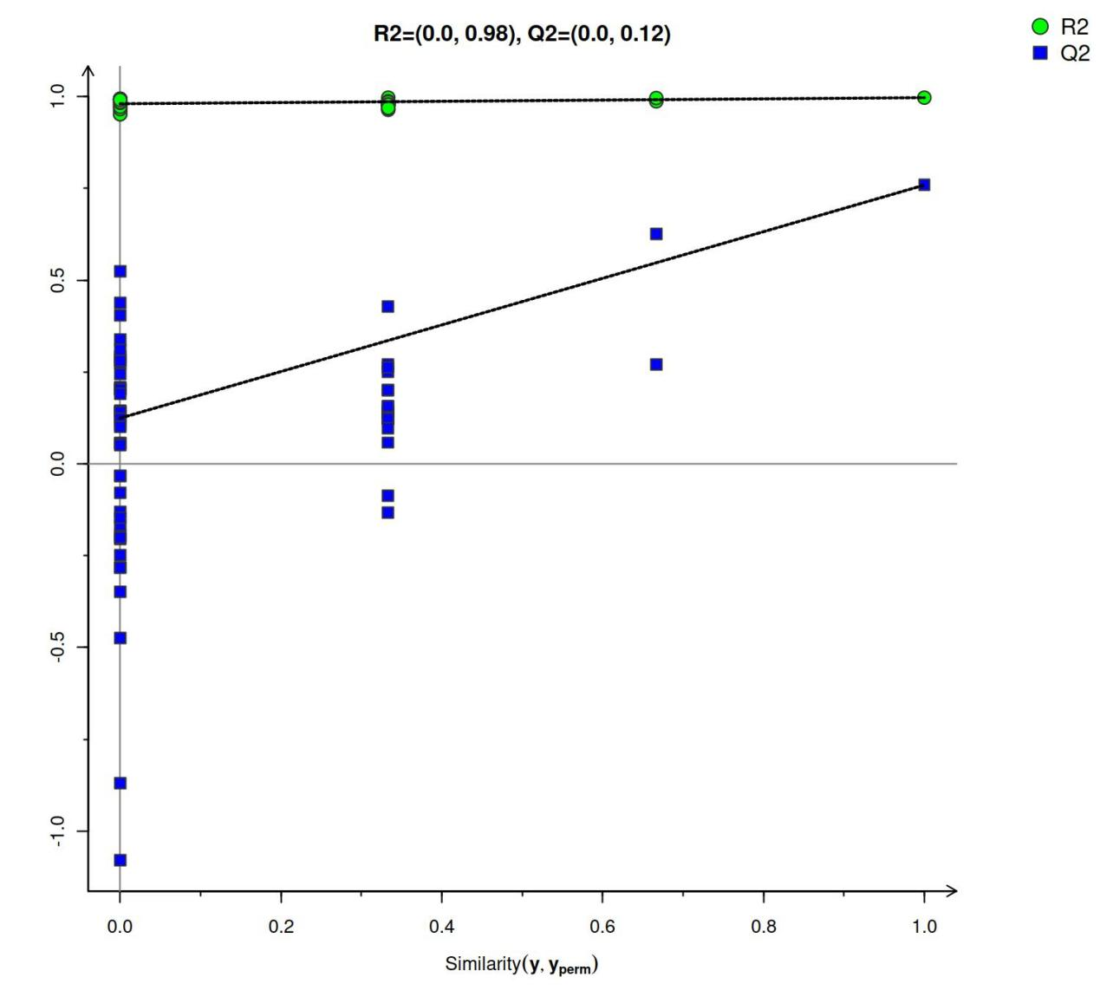
Fig. S1 Permutation test plot of OPLS-DA

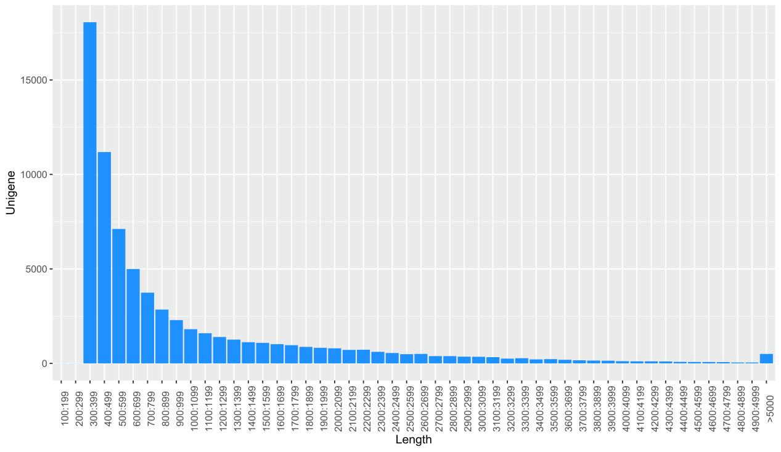
Fig. S2 Length distribution map of annotated gene

