Electrochemiluminescence Biosensor for MMP-2 Analysis Using CRISPR/Cas13a and EXPAR Amplification: A Novel Approach for Anti-Aging Research

Qiang Tangª, Jie Wangª, Jiayi Zhang^{b}, Hongyu Zengª, Zhixue Suª, Xiying Zhuª, Jihua Weiª, Yuanxun Gongª, Qianli Tang^{a,} *, Kai Zhang^{c,} *, Xianjiu Liao^{b,} *

ª Guangxi Key Laboratory for Preclinical and Translational Research on Bone and Joint Degenerative Diseases, Affiliated Hospital of Youjiang Medical University for Nationalities, Baise, Guangxi 533000, China.
^{b} West Guangxi Key Laboratory for Prevention and Treatment of High-incidence Diseases, Youjiang Medical University for Nationalities, Baise, Guangxi 533000, China.
^{c} School of Chemistry and Materials Science, Nanjing University of Information Science and Technology. Nanjing, 210044, P. R. China.

* Corresponding authors.
E-mail addresses: lxj2006910@163.com (X. Liao), kaizhang@nuist.edu.cn (K. Zhang), htmgx919@163.com (Q. Tang)

Table S1. The nucleic acid sequences used in this experiment.

note | sequence (5’-3’)
T7 promoter | CTC ATC AGG AGA TGC TAATACGACTCACTATAGGG
PNA | K-caa agt gct tac GPLGVRGt gca ggt ag-K  (the capital letter denotes amino acid, small letter denotes PNA base)
RNA transcript | CAAAGUGCUUACAGUGCAGGUAG
DNA template | CTA CCT GCA CTG TAA GCA CTT TG CCC TAT AGT GAG TCG TAT TAG CAT CTC CTG ATG AG
Pre-Trigger DNA | TTGGATGGATATTGT-rUrU-CATA - C3 spacer
crRNA | GACCACCCCAAAAAUGAAGGGGACUAAAACCUACCUGCACUGUAAGCACUUUG
Trigger-DNA | TTGGATGGATATTGT
DNA1 template | AACTATCAACAATATCCATCCAAACAGACTCAAACTATCAACAATATCCATCCAA - C3 space

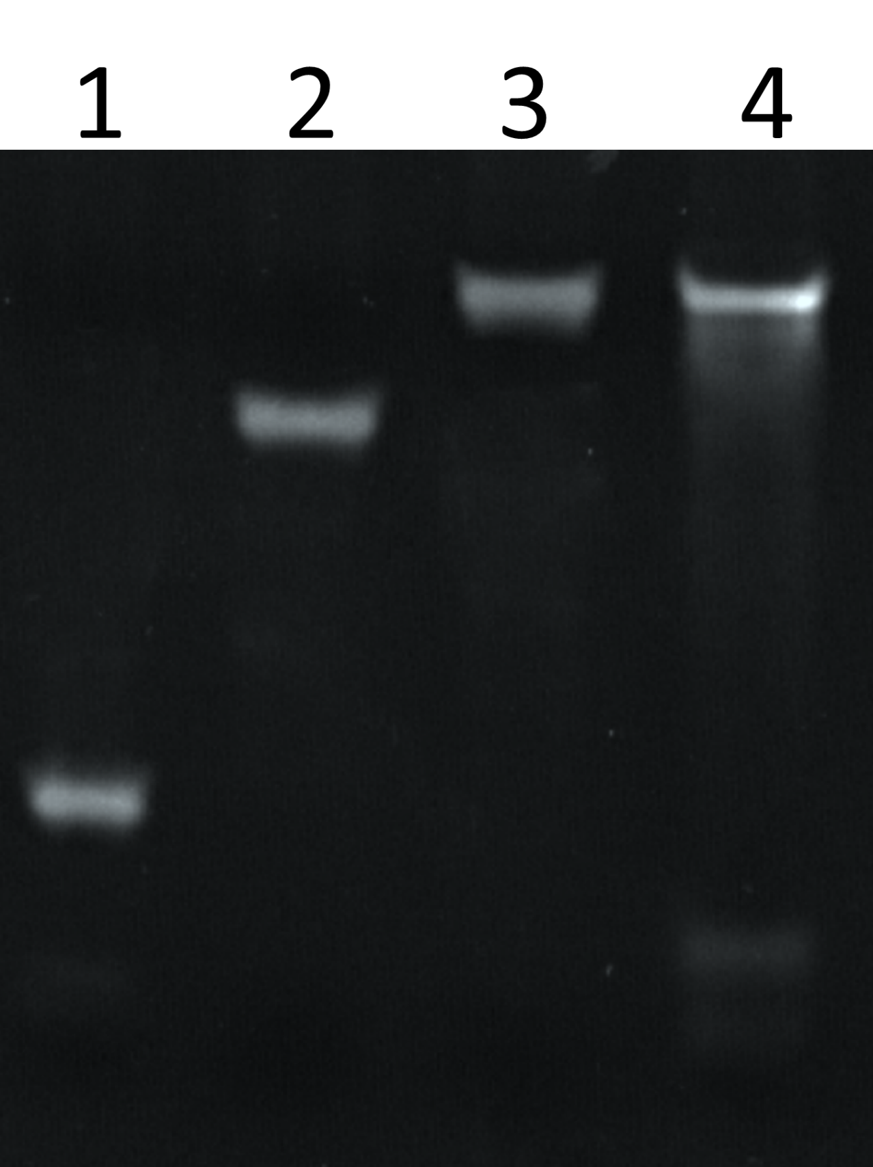

Figure S1. Electrophoresis identification of the T7 RNA polymerase transcription-mediated amplification process. Lane 1: T7 promoter, Lane 2: DNA template, Lane 3: DNA template/T7 promoter duplex, and Lane 4: After T7 promoter amplification reaction based on DNA template/T7 promoter duplex.

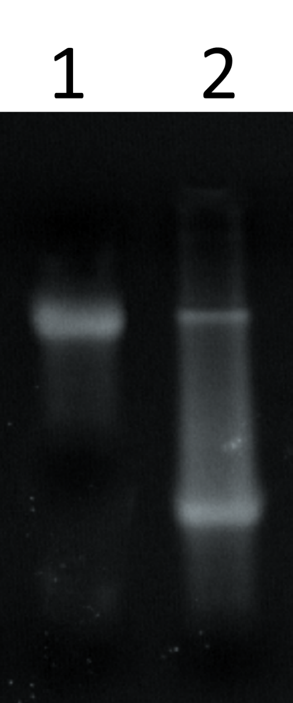
Figure S2. Electrophoresis identification of the CRISPR/Cas13a cleavage. Lane 1: Pre-Trigger DNA and Lane 2: CRISPR/Cas13a treated Pre-Trigger DNA.

