Table S1. Joinpoint analysis of age-standardized incidence, deaths, and DALYs in Fujian Province, China, and Global, 1990-2019 (Year, APC, P-value)
 | DALYs |  |  |  | Deaths |  |  |  | Incidence
 | Year | APC(95% CI) | P |  | Year | APC(95% CI) | P |  | Year | APC(95% CI) | P
Global | 1990-1994 | 0.23(-0.10,0.55) | 0.160 |  | 1990-1994 | 0.42(0.10,0.74) | 0.013 |  | 1990-1994 | 0.67(0.29,1.04) | 0.002
Global | 1994-1998 | -1.08(-1.59,-0.57) | <0.001 |  | 1994-1998 | -0.58(-1.08,-0.08) | 0.027 |  | 1994-1997 | -0.50(-1.66,0.67) | 0.378
Global | 1998-2002 | -0.28(-0.80,0.23) | 0.258 |  | 1998-2002 | 0.14(-0.36,0.65) | 0.556 |  | 1997-2010 | 0.10(0.03,0.17) | 0.008
Global | 2002-2010 | -0.65(-0.79,-0.52) | 0.000 |  | 2002-2010 | -0.25(-0.38,-0.11) | 0.002 |  | 2010-2017 | -0.79(-0.98,-0.59) | <0.001
Global | 2010-2016 | -1.14(-1.37,-0.92) | 0.000 |  | 2010-2017 | -0.88(-1.05,-0.72) | <0.001 |  | 2017-2019 | 0.43(-0.74,1.61) | 0.453
Global | 2016-2019 | -0.24(-0.76,0.27) | 0.328 |  | 2017-2019 | 0.24(-0.77,1.25) | 0.620
China | 1990-1996 | 0.19(-0.02,0.41) | 0.08 |  | 1990-1997 | 0.71(0.51,0.91) | <0.001 |  | 1990-1997 | 0.82(0.63,1.02) | <0.001
China | 1996-2004 | 1.78(1.61,1.96) | <0.001 |  | 1997-2004 | 2.61(2.36,2.87) | <0.001 |  | 1997-2004 | 2.87(2.61,3.12) | <0.001
China | 2004-2007 | -0.66(-1.93,0.63) | 0.286 |  | 2004-2007 | -0.17(-1.63,1.31) | 0.808 |  | 2004-2007 | 0.41(-1.05,1.89) | 0.558
China | 2007-2010 | 0.57(-0.72,1.87) | 0.360 |  | 2007-2010 | 1.37(-0.11,2.88) | 0.067 |  | 2007-2010 | 2.00(0.52,3.51) | 0.012
China | 2010-2015 | -1.18(-1.58,-0.78) | <0.001 |  | 2010-2016 | -0.87(-1.19,-0.54) | <0.001 |  | 2010-2016 | -0.42(-0.75,-0.09) | 0.016
China | 2015-2019 | -0.00(-0.41,0.41) | 0.995 |  | 2016-2019 | 0.32(-0.42,1.06) | 0.372 |  | 2016-2019 | 0.98(0.24,1.72) | 0.013
Fujian | 1990-1995 | -0.85(-1.23,-0.47) | <0.001 |  | 1990-1995 | -0.71(-1.12,-0.29) | <0.001 |  | 1990-1995 | -0.56(-0.99,-0.14) | 0.014
Fujian | 1995-1998 | 0.68(-1.03,2.42) | 0.408 |  | 1995-1998 | 0.82(-1.06,2.74) | 0.364 |  | 1995-1998 | 1.01(-0.90,2.96) | 0.274
Fujian | 1998-2002 | 3.27(2.39,4.15) | <0.001 |  | 1998-2001 | 4.25(2.30,6.23) | <0.001 |  | 1998-2001 | 4.41(2.43,6.42) | <0.001
Fujian | 2002-2010 | 0.19(-0.04,0.42) | 0.102 |  | 2001-2010 | 1.20(0.99,1.41) | <0.001 |  | 2001-2010 | 1.78(1.57,2.00) | <0.001
Fujian | 2010-2014 | -1.69(-2.53,-0.85) | <0.001 |  | 2010-2014 | -1.11(-2.03,-0.17) | 0.024 |  | 2010-2014 | -0.51(-1.46,0.44) | 0.265
Fujian | 2014-2019 | -0.04(-0.42,0.35) | 0.846 |  | 2014-2019 | 0.21(-0.21,0.64) | 0.292 |  | 2014-2019 | 0.82(0.39,1.25) | 0.001

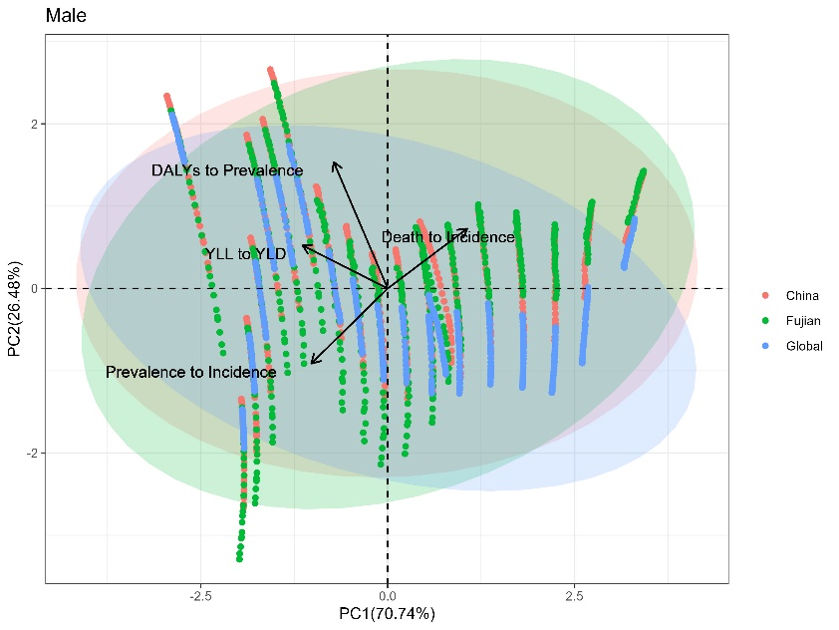
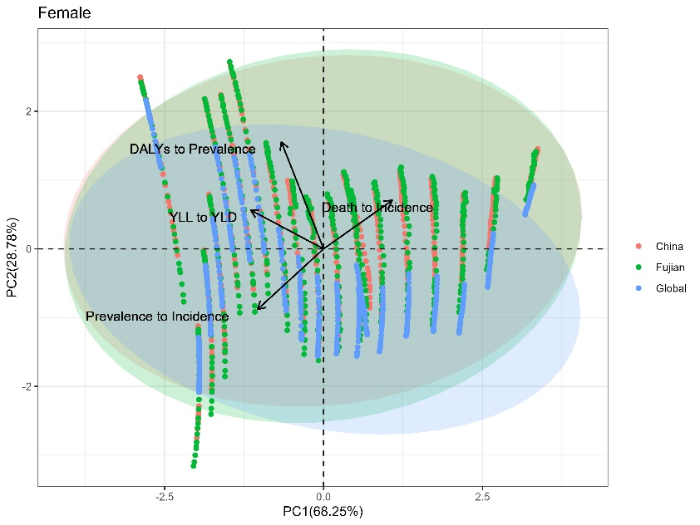
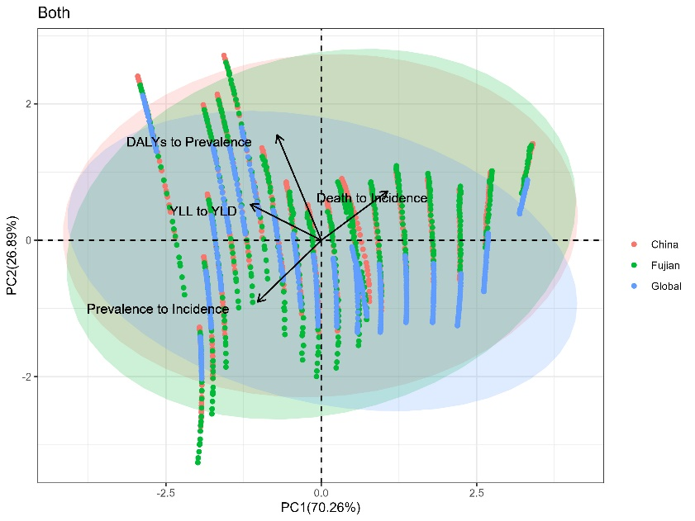
Table S2. The actual explained variance and the standard deviation of the he first two principal components estimated with the bootstrap procedure (n=500 bootstrap iterations).
Age-standardized | Principle components (PC)Age-standardized | Variance(%) | Standard deviation of valiance
Both sexes | PC1 | 0.7026 | 1.6764
Both sexes | PC2 | 0.2689 | 1.0371
Female | PC1 | 0.6825 | 1.6523
Female | PC2 | 0.2878 | 1.0730
Male | PC1 | 0.7074 | 1.6822
Male | PC2 | 0.2648 | 1.0293

To ease the interpretation and comparison, the loading scores of the first component of PCA were calculated, and rescaled to 0 to 100 spectra following the formula showing below.
QCI(x)=$\frac{{PCA}_{score}(x)- min {PCA}_{score}(x)}{max{PCA}_{score}- min {PCA}_{score}}$ * 100

Figure S1. Number of incidences, deaths and DALYs and ASRs double Y-bar plus line graph (Both, Male, Female) in China and Global, 1990-2019

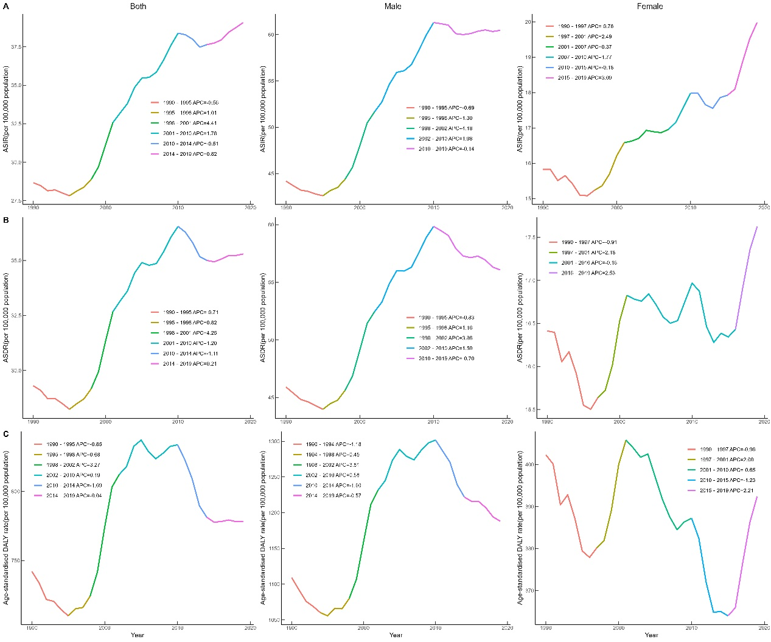
Figure S2. APCs line chart of (A) Incidence, (B) Deaths, and (C) DALYs in Fujian Province, 1990-2019 (Both, Male, Female)
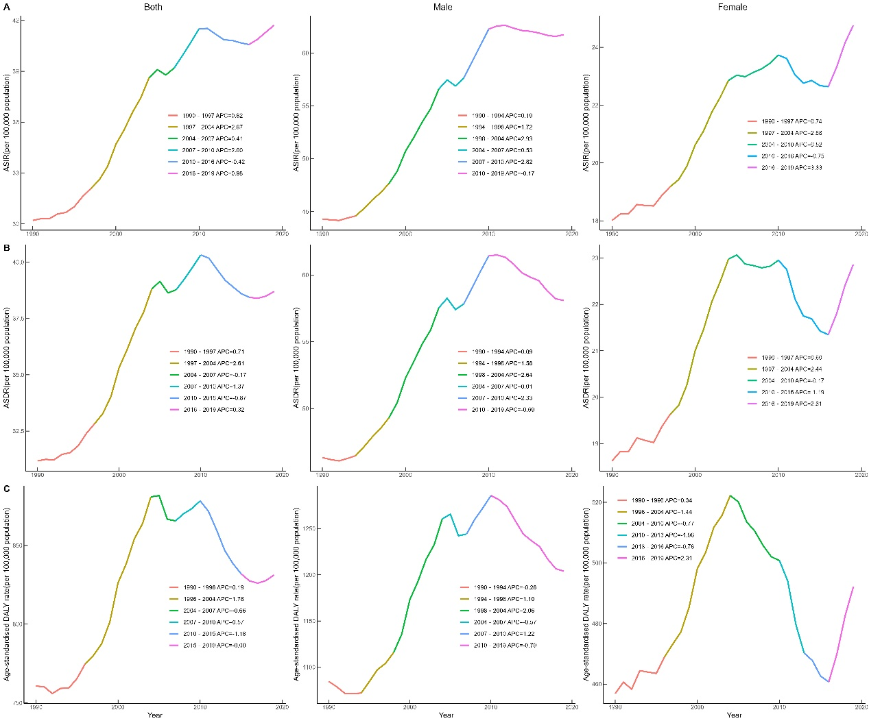
Figure S3. APCs line chart of (A) Incidence, (B) Deaths, and (C) DALYs in China Province, 1990-2019 (Both, Male, Female)
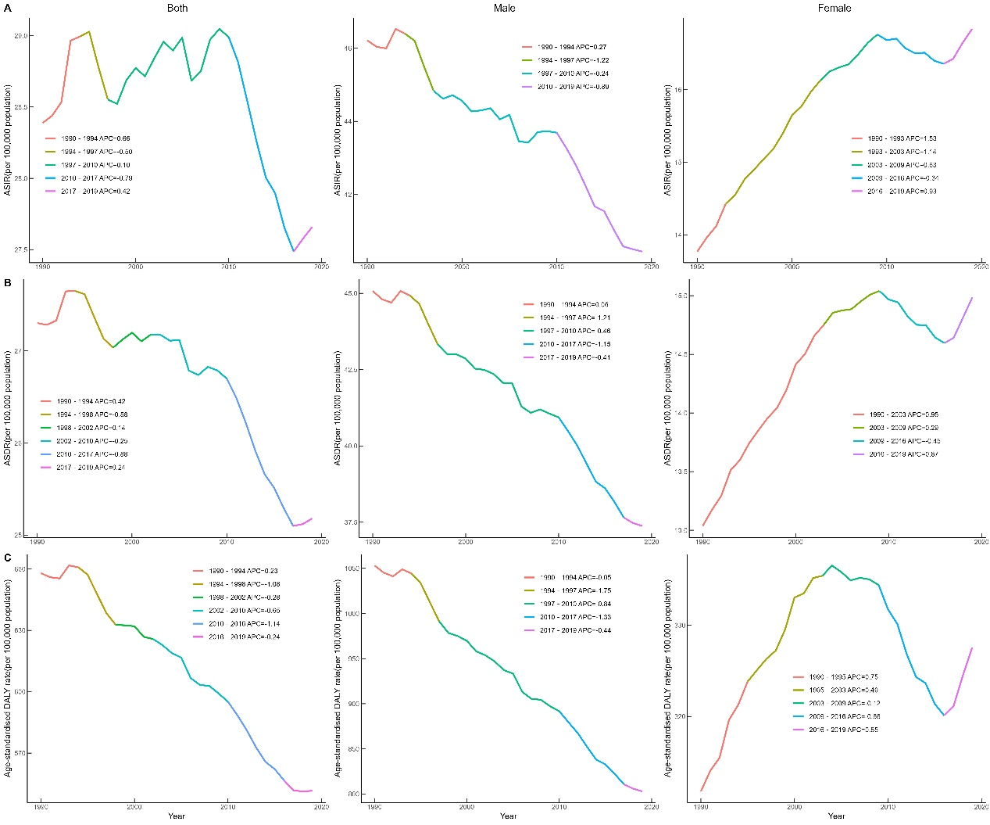
Figure S4. APCs line chart of (A) Incidence, (B) Deaths, and (C) DALYs in Global, 1990-2019 (Both, Male, Female)
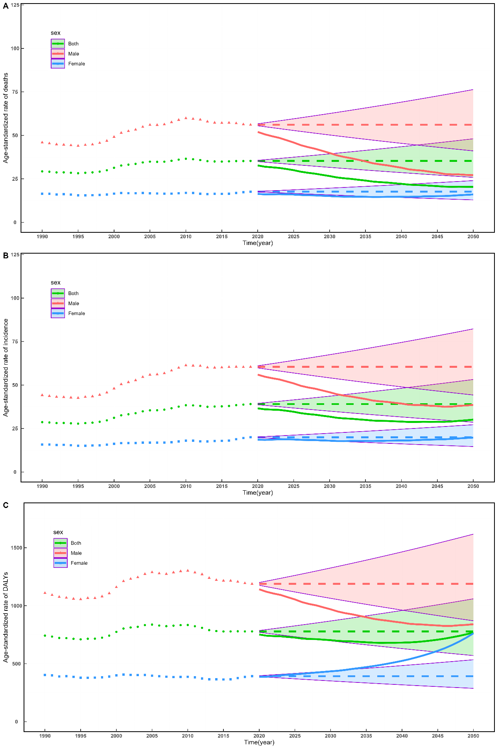
Figure S5. Projections of (A) incidence, (B) death, and (C) DALY age-standardized rates of tracheal, bronchial, and lung cancer in Fujian Province under the SSP1 model (Both, Male, Female). The dashed line before 2019 represented the actual values, while the dashed line after 2019 indicated a constant age-standardized rate. The upper and lower shaded intervals represented the range of rate varying by 1% annually from the 2019 baseline. The solid line represented the forecasted values derived from the model.
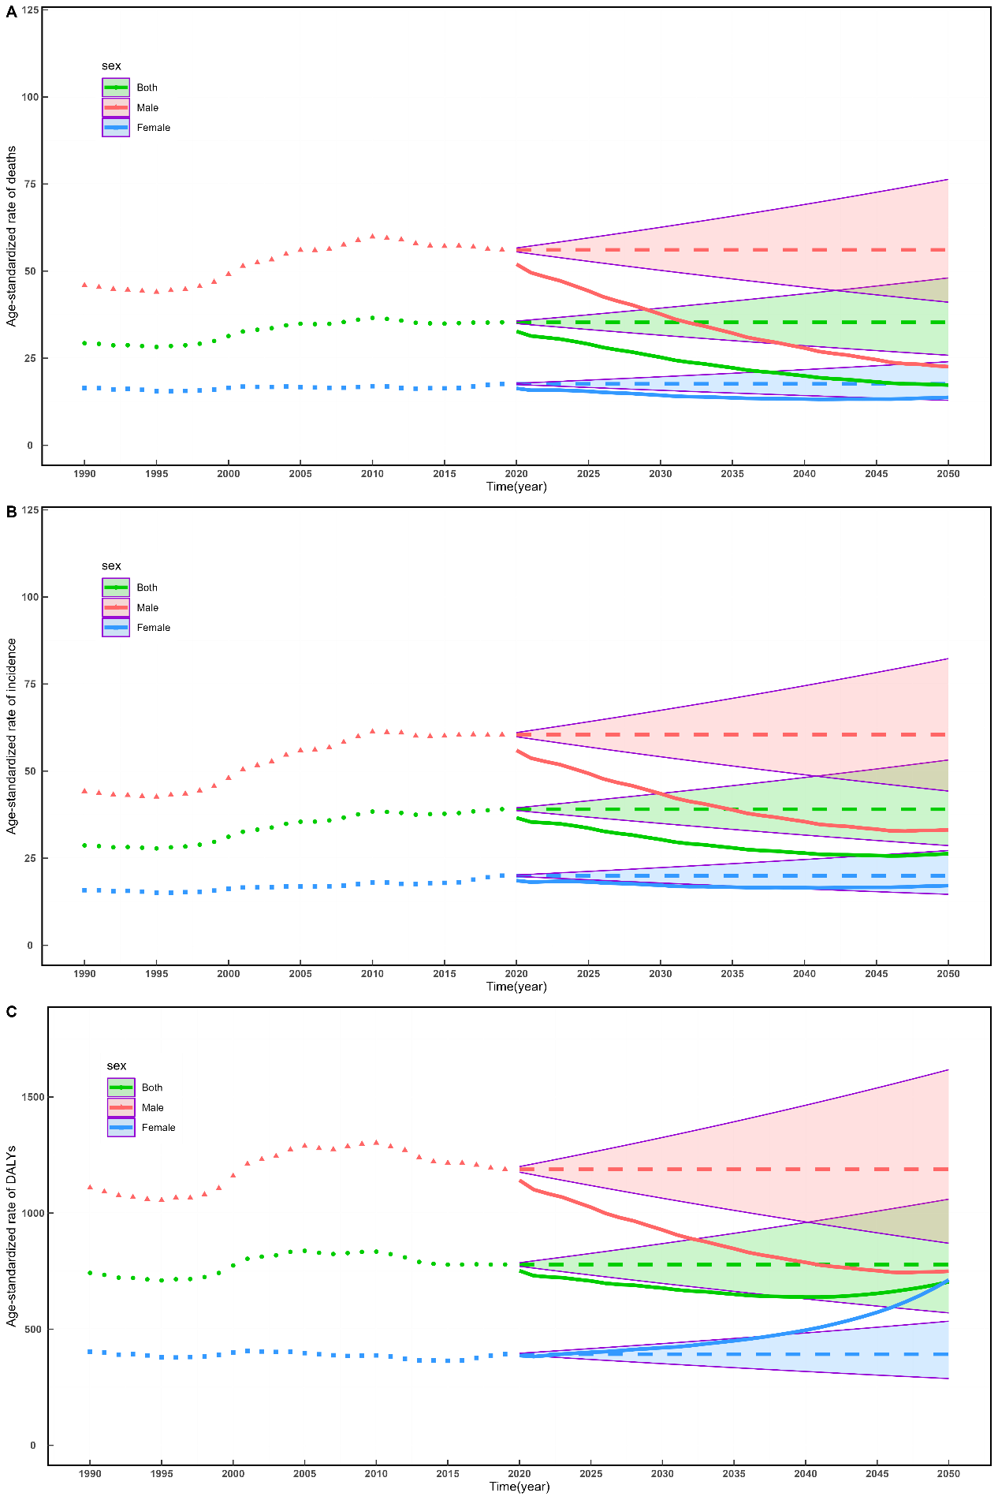
Figure S6. Projections of (A) incidence, (B) death, and (C) DALY age-standardized rates of tracheal, bronchial, and lung cancer in Fujian Province under the SSP3 model (Both, Male, Female). The dashed line before 2019 represented the actual values, while the dashed line after 2019 indicated a constant age-standardized rate. The upper and lower shaded intervals represented the range of rate varying by 1% annually from the 2019 baseline. The solid line represented the forecasted values derived from the model.
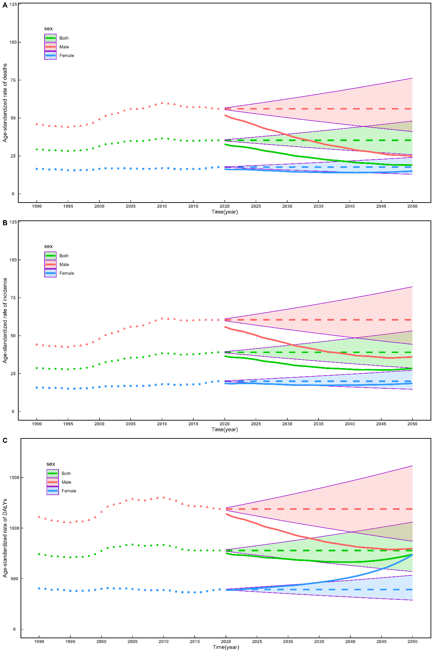
Figure S7. Projections of (A) incidence, (B) death, and (C) DALY age-standardized rates of tracheal, bronchial, and lung cancer in Fujian Province under the SSP4 model (Both, Male, Female). The dashed line before 2019 represented the actual values, while the dashed line after 2019 indicated a constant age-standardized rate. The upper and lower shaded intervals represented the range of rate varying by 1% annually from the 2019 baseline. The solid line represented the forecasted values derived from the model.
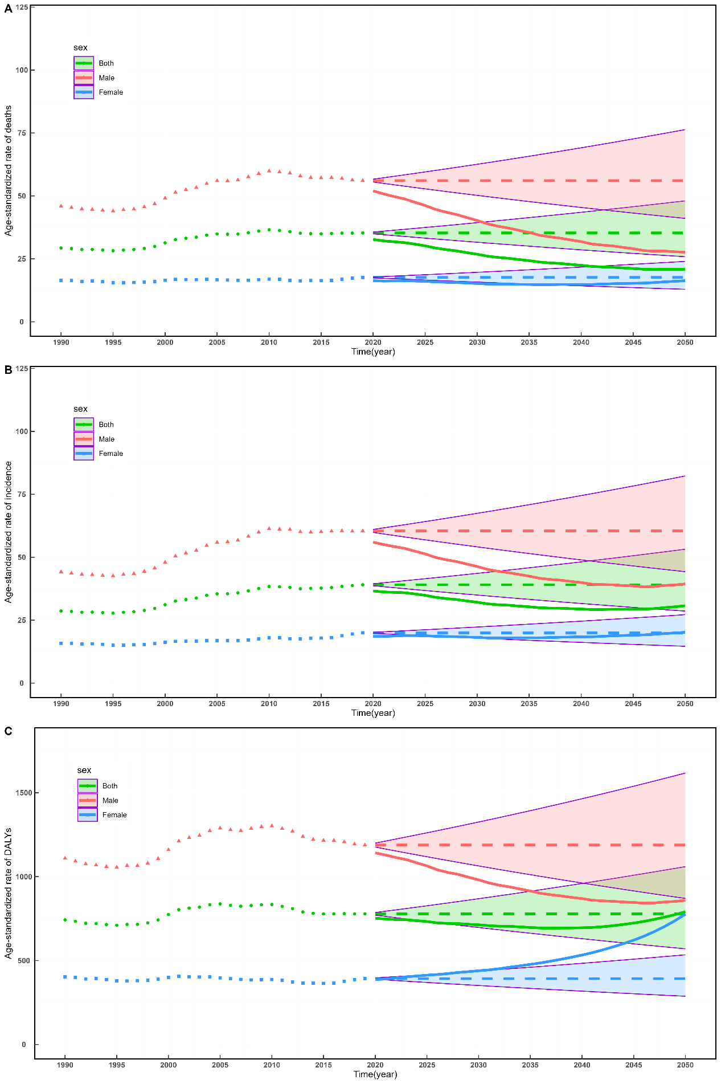
Figure S8. Projections of (A) incidence, (B) death, and (C) DALY age-standardized rates of tracheal, bronchial, and lung cancer in Fujian Province under the SSP5 model (Both, Male, Female). The dashed line before 2019 represented the actual values, while the dashed line after 2019 indicated a constant age-standardized rate. The upper and lower shaded intervals represented the range of rate varying by 1% annually from the 2019 baseline. The solid line represented the forecasted values derived from the model.
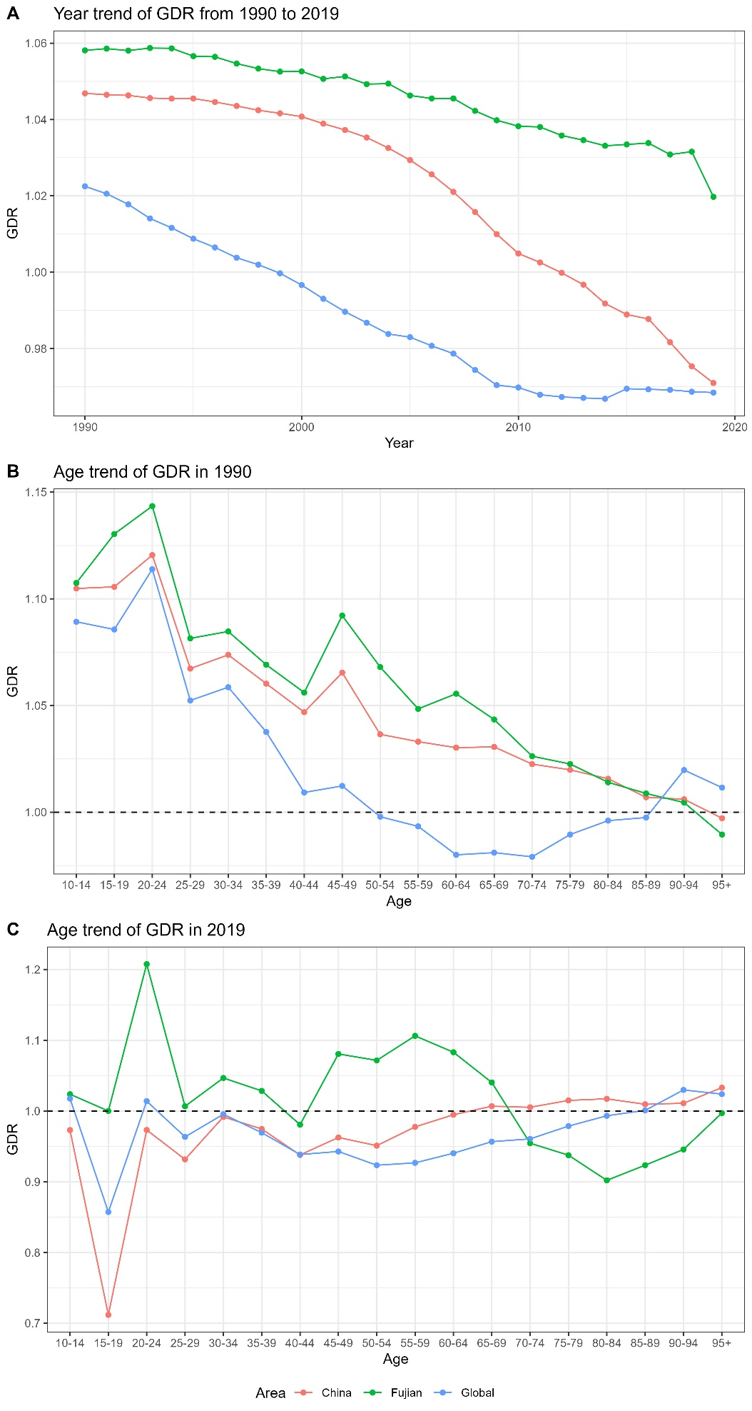
Figure S9. (A)Temporal GDR from 1990 to 2019. (B) Age trend of GDR in 1990. (C) Age trend of GDR in 2019.

