Supporting Information

Versatile and potent insecticide scavengers based on locust cell membrane-adapted mesoporous silicon microparticles to protect managed pollinators

Zuliang Huangª, Jiakun Guoª, Suhui Lv^{b}, Jie Gui^{b}, Jing Chen^{b,c,}*, Zhiyuan Zhong ^{a,}*, and Chao Deng^{a,}*

ªBiomedical Polymers Laboratory, College of Chemistry, Chemical Engineering and Materials Science, and State Key Laboratory of Radiation Medicine and Protection, Soochow University, Suzhou 215123, China.
^{b}National Key Laboratory on Technologies for Chinese Medicine Pharmaceutical Process Control and Intelligent Manufacture, Nanjing University of Chinese Medicine, Nanjing 210023, China
^{c}College of Pharmacy, Nanjing University of Chinese Medicine, Nanjing 210023, China.

*Corresponding authors. E-mails: jingchen3236@njucm.edu.cn (J. Chen), zyzhong@suda.edu.cn (Z. Zhong), cdeng@suda.edu.cn (C. Deng).

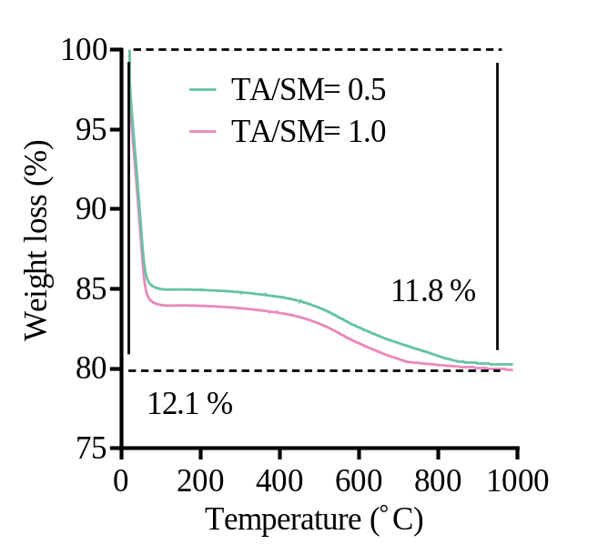
Supplementary Figure 1. Thermogravimetric curves of TSM prepared at TA/SM weight ratios of 0.5 and 1.0.

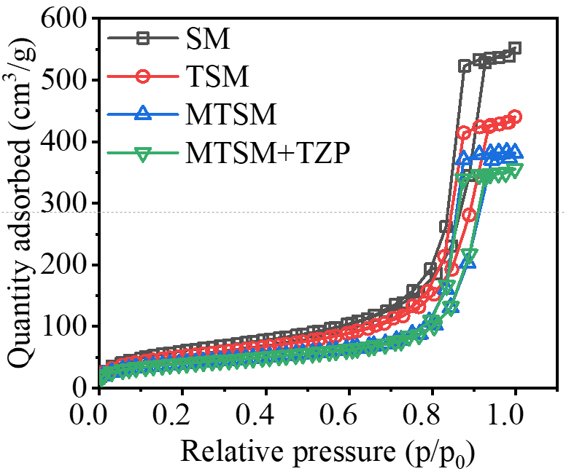
Supplementary Figure 2. N₂ adsorption-desorption isotherms of SM, TSM, MTSM and MTSM with TZP.

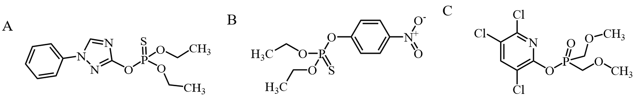
Supplementary Figure 3. Structural formula of organophosphorus insecticide. A. triazophos. B. methyl parathion. C. chlorpyrifos

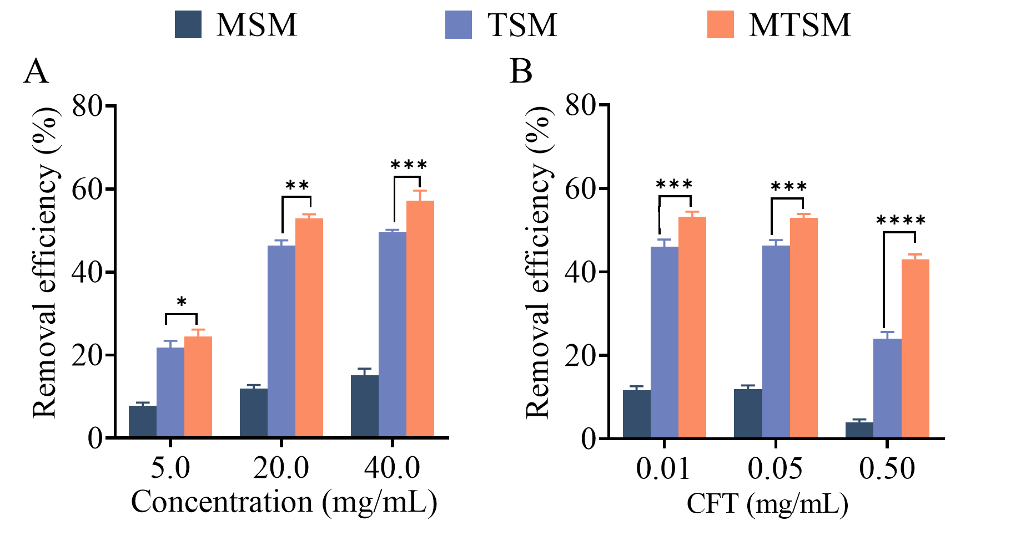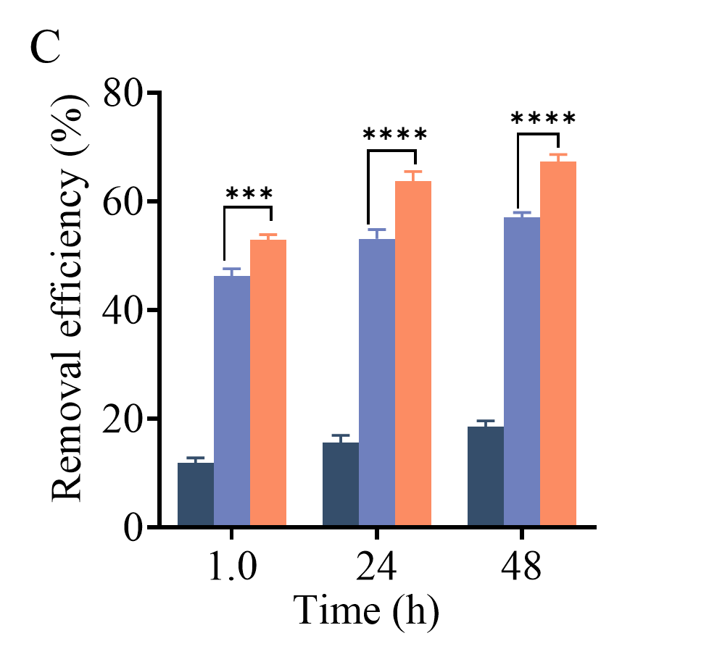
Supplementary Figure 4. Removal efficiency of PY insecticides (CFT). (A) Effect of microparticle concentrations. The concentrations of CFT were 50 μg/mL and the incubation time was 60 mins. (B) Effect of CFT concentrations. The concentrations of microparticles were 20 mg/mL and the incubation time was 60 mins. (C) Effect of incubation time. The concentrations of CFT and microparticles were 50 μg/mL and 20 mg/mL, respectively.

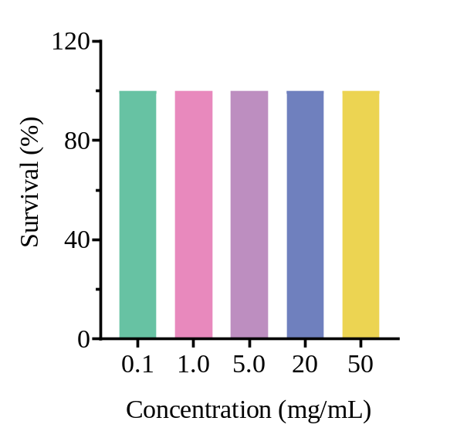
Supplementary Figure 5. Biosecurity of MTSM (0.1-50 mg/mL in sucrose solution) for bumblebees.

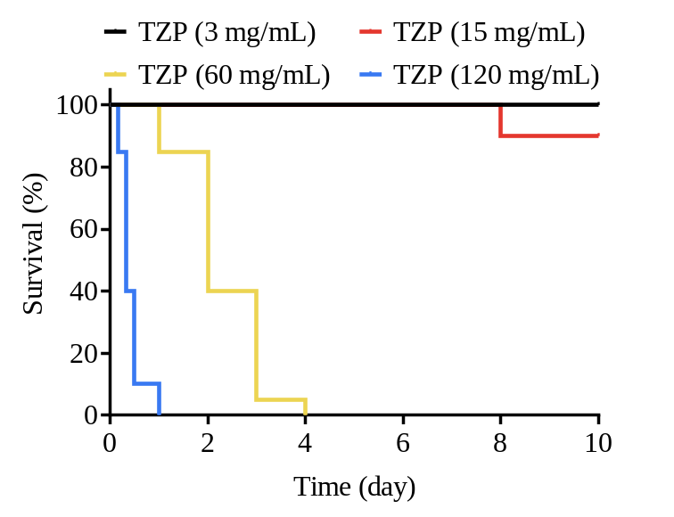
Supplementary Figure 6. Survival rate of bumblebees treated with various concentrations of TZP in pollens.
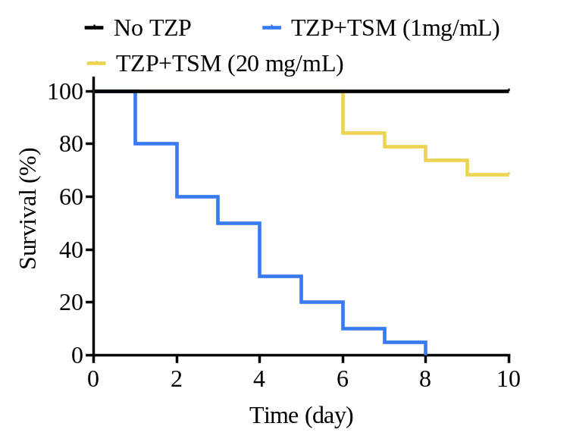
Supplementary Figure 7. In vivo detoxicity of TZP in bumblebee using various concentration of TSM.

